

Agile Business Analysis

A Digital Assistant for Students at FHNW

Marc Beutler

Anton Lorvi

Lorenzo Niggli

Luca Mueller

Supervisor

Prof. Dr. Knut Hinkelmann

Prof. Dr. Holger Wache

Maja Spahic

Beat Fraefel

October 24, 2019

**Master of Science in Business Information Systems**

**Table of Contents**

1. Introduction and Definitions 1

2. Perspectives 1

3. Initiative 2

3.1 Current state 2

3.2 Stakeholder Analysis 2

3.3 Desired State 3

4. Methodology 4

5. Sprints 8

5.1 Sprint 1 8

5.2 Sprint 2 13

5.3 Sprint 3 13

6. Final Product presentation 14

7. Recap: 14

List of Figures 15

Bibliography 15

# Introduction and Definitions

This report was realized as part of the module Agile Business Analysis in the program MSc in Business Information Systems at University of Applied Sciences Northwestern Switzerland (FHNW). During this module groups of 4 person were challenged to form agile teams and conduct agile business analysis projects. Each team member should perform in the role of a business analyst and solving together a concrete use case using agile project management methods. The Agile Business Analysis project is divided into four phases. The first phase is designated to find the problem, the team formation, selection of a use case and pitching the idea. Then there will be three sprints at which each team has to show intermediate results. The result of all sprints will be finally pitched at the end of the module. After each sprint, the lecturers provide students with feedback and suggestions for improvement. The whole progress is documented in this report, providing a coherent and consistent description of all sprints, explaining used techniques reflecting the Guide to the Business Analysis Body of Knowledge (BABOK) (International Institute of Business Analysis, 2015) and its Agile Extension Version 1 (International Institute of Business Analysis & Agile Alliance, 2013).

The project topic was provided by the FHNW and aims in solving a problem of an overwhelming number of various requests from students to the FHNW. It is foreseen that the number of requests reaching the FHNW’s administration and requiring human involvement could be reduced with a digital assistant. More information was not given at the time being and therefore the scope was not clearly defined. It lied within the responsibility of the agile team to further define and plan the project activities.

Digital assistant refers to a concept of a chatbot, which can be defined as follows:

*“A computer program designed to simulate conversation with human users, especially over the Internet.”* (Oxford University Press (OUP), 2019).

# Perspectives

As stated in the assignment, the project topic should cover at least one of the business analysis perspectives mentioned in the BABOK guide (2015, pp. 368–424). Aiming on simplify the processing of student requests applying a chatbot, the project covers clearly at least the following two business analysis perspectives:

* Information Technology (2015, pp. 394–407)
* Business Process Management (2015, pp. 424–439)

Furthermore, processing of student requests is an operational task and the chatbot should support operational, and not strategic or tactical, decisions. To have a clear focus within the project, the team decided to scope the project on the process level.

# Initiative

This chapter describe the initial knowledge about the challenge. The information was gathered immediately after the initiative was accepted and therefore the information is expected to change due the iterative nature of selected methodology.

## Current state

The FHNW receives a large number of requests from students regarding different aspects of their studies. The following three topics were communicated in the original problem statement:

* **Administrative questions**: module changes, questions about the curriculum, applications for study confirmations, etc.
* **Curriculum-related questions**: questions about the double degree, questions about pre-courses, etc.
* **Module-related questions**: support during lectures, filing documents in Moodle, questions about tasks, etc.

Answering these questions takes a lot of time and sometimes students must wait a long time for an answer.

## Stakeholder Analysis

The stakeholders can be divided into two main categories.

* Students
  + Current Students: matriculated students who already studying at the FHNW
  + Potential Students: interested, considering, or applying students
* Employees of the FHNW
  + Administrative Employees: school’s administration
  + Module Director / Lecturers

The stakeholder analysis aiming in identification of the students’ needs and requirements is rationally limited to those students who are already studying at the FHNW, are already matriculated, and currently enrolled in some modules. The limitation is applied for the following two reasons: firstly, the serious data collection of interested students is difficult in the short-time period and secondly, the group does not want to get bogged down with too many different stakeholders. The second reason leads to further refinement of the stakeholder group to the Business Information Systems students.

Since the FHNW employees are living the pain point having to answer the most questions, which are repetitive in nature, they are considered as the most important stakeholder. This due the believe that in the end a chatbot will facilitate the greatest value for this stakeholder group.

## Desired State

The current state shows that the situation as it is today is not satisfactory for any of the stakeholders. With the use of technology this will no longer be necessary. The ABA-project team 02 has the following vision:

*We want to reduce the effort for FHNW and its students related to administrative questions with the use of smart technology.*

When fully functional, implemented and trained the solution, in the shape of a chatbot, will be able to answer questions related to all interlinked applications. While repetitive questions that need no further consultation can directly be answered with the correct information, request my need redirection. Some questions or request can only be processed by a FHNW employee. The registration or deregistration of modules outside of the registration period for example. Other requests can be done independent, but only through a specific application or tool. The download of transcripts of records for example. In this or other such cases the digital assistant will still be helpful by directing the student to the right person or tool in order to get his question answered or request processed.

The potential goes even further than simply for administrative tasks. When implementing Moodle, semester schedules of a module and the content of lecture, module-related questions can be processed as well. One can easily imagine questions like when a deadline is or what day which topic will be thought. But when thinking further the content could be integrated and specific questions regarding it could be answered. Especially when studying for final exams or writing a summary that could be helpful, but also more complex to implement and therefore only possible in the long-run.

The chatbot is also one of the classic applications of artificial intelligence (AI). The more they get to answer questions, the more they can answer tricky and more complex questions. While some fear jobs being taken away by the AI-bots, FHNW does not have to fear such cases. Many tasks are not intended to be replaced by technology at the current state, apart from the answering of repetitive questions of students or recurring requests.

The Mission, based on the Vision and future outlook is the following:

*We want to increase the efficiency of the dialog between FHWN and students with administration-related questions by reducing the effort with a digital assistant.*

# Methodology

The selection of appropriate methodology was guided by the Stacey-Matrix (Ballarin Latre, 2019), which helps to sort out the projects that particularly suit to the agile practices.

|  |  |
| --- | --- |
| Figure 1: Stacey Matrix (Ballarin Latre, 2019) | The Stacey-Matrix brings the following three dimensions in correlation with each other:   * Requirements * Technology * People   The scale used goes from “Close to Certainty/Agreement”, which means that almost all information that is required is already given, to “Far from Certainty/Agreement” which is the exact opposite, almost no information is given to start with. |

Depending on the clarity of information and knowledge given for a project in relation to the dimensions mentioned above, it then can be classified in one of the following areas regarding to the complexity (see Figure 2):

Ein Bild, das Screenshot enthält.

Figure 2: Complexity Areas Stacey Matrix (Maretzke, 2019)

The group made following considerations while analysing the dimensions of the Stacey-Matrix:

|  |  |
| --- | --- |
| Requirements: | At the beginning the group had no idea about the possible requirements and as there is a variety of chatbot implementation possibilities, the team decided to shift the scale towards “Far from Agreement”. |
| Technology: | There was a better understanding of applicable technologies than the requirements, so the group placed the project quite in the middle of the scale between “Far from Certainty” and “Close to Certainty”. |
| People: | Team members summed up with totally different backgrounds and knowledge about the chatbots varied in the team. It was not clear at the beginning if technical implementation of a chatbot would be realizable at all. |

Taking everything into account the project characterized as a “Complex”. Furthermore, the timeframes and the probability of changes in the gathered requirements supported the constant readiness to a repetitive and rapid change.

According to the second version of the agile extension to the BABOK guide (2017, pp. 8–9), agile frameworks have some common characteristics:

* respect for people and the importance of creativity in delivering value,
* the importance of rapid delivery, feedback, and learning to ensure the product or service being produced meets real customer needs,
* collaboration and communication among the team members and the stakeholder community in order to build shared understanding, and
* break work into small slices of business value and deliver them incrementally and iteratively.

This acknowledgement further assured the selection of agile methodology as a right choice. Meaning that an agile approach is recommendable, as it embraces learning, collaboration, incrementality and refinement of work, as well as iterative nature of the progress, thus preparing the team to the repetitive and rapid change. Applying this approach, the team aims in agile business analysis activities: learning and identifying what is truly valuable, what does not add value, and facilitate the learning and communication needed to continually deliver the right value to the stakeholders. (International Institute of Business Analysis & Agile Alliance, 2017, pp. 8–9)

Further business analysis approach, stakeholder engagement and information management are described. The business analysis governance and performance improvement plans, known from the BABOK guide, are not discussed as there is no governing organization involved, the team is small and autonomous, and aims in reduction of unnecessary formalities. The decision making is described in the stakeholder engagement part. Performance improvements are analysed and reviewed during each retrospective. (International Institute of Business Analysis, 2015, pp. 24–55)

**Business Analysis Approach**

The business analysis approach was defined pre and during the first sprint. The sprint planning was started with a Kanban board exploring incremental and iterative principles of Scrum without daily stand-ups and with a strong self-initiative and autonomy of an individual. The Scrum roles were assigned (see chapter 5.1) and it was agreed that the team aimed in equal and fair work-load distribution. There are three roles in Scrum (International Institute of Business Analysis & Agile Alliance, 2017, p. 12):

* **Product Owner:** maintains overall vision and direction of the product and is responsible for defining and prioritizing the product backlog according to customer value.
* **Scrum Master:** ensures the team's Scrum processes are followed and the team functions well shielding them from external interferences.
* **The Team:** is responsible for developing and delivering the product in a collaborative manner according to the sprint goals and the definition-of-done.

Each team member should participate in each role, but the main responsibility, the ultimate decision power, is given to the person officially appointed to the role.

The team applies following Scrum-ceremonies and techniques (International Institute of Business Analysis & Agile Alliance, 2013, pp. 10–13; 17–18; 105–106):

* Backlog Management: a backlog is a list of things that should be done. The team agreed calling them items sticking to two types of them: user stories and requirements. The requirements are seen as sub-item of a user story, the acceptance criteria, which defines when the user story is fulfilled. Handling both requirements prioritization and change management is conducted over a Kanban board, which visualizes the progress and change management. MoSCoW-prioritization is applied whenever prioritization of the items is necessary.
* Retrospectives: Retrospectives allow a team to reflect their ways of working and are applied for sprint reviews and planning as well. Feedback on the requirements and the improvement possibilities are analysed and the next sprint is adjusted accordingly.
* Weeklies: instead of daily scrum stand-ups, where the current status is shared, decisions are made and further steps are accepted collectively, the team was destinated to run weeklies. Each Friday after the lessons.

The sprints were predefined according to the study plan:

* 04.10.2019 Pitching Project Idea
* 05.10 - 25.10.2019 Sprint 1
* 26.10 - 22.11.2019 Sprint 2
* 23.11 - 13.12.2019 Sprint 3
* 20.12.2019 Final Pitch and Submission

Each sprint has its own definition-of-done formulated in the Kanban board, which is based on the user stories initiated during the first sprint. Sprints are treated as milestones. It is expected that the user stories will mature during sprints as there will be more requirements and new acceptance criteria. By the end of the second sprint the Minimum Viable Product (MVP) in a form of a prototype (International Institute of Business Analysis, 2015, pp. 323–325) should be realized. The third sprint should therefore be used for further exploration and formulation of user stories, requirements and acceptance criteria.

**Stakeholder Engagement**

The stakeholder engagement is conducted as follows:

* Students

The team decided to focus only on current students as the potential students are out of the reach and would require extensive effort for successful engagement. As the team consists of current students, team members can self-reflect remarkable amount of input. To confirm the emerging assumptions, the team can always bring these to the fellow students for evaluation. In this case the assumptions validating information can be elicited by interviewing or with a questionnaire. The current students are engaged periodically during each iteration on a weekly basis. They are often busy with their group works and therefore it has to be evaluated on a situation basis when it is the best moment for elicitation.

* Employees of the FHNW

Each FHNW employee group is interviewed separately on weekly basis. The interviews are conducted in non-structured, semi-structured and structured formats directly and via mail. As the initiative is owned by the FHNW, each stakeholder is motived to participate in elicitation. These elicitations should be planned and agreed upon ahead.

The situation is optimal, as the owner of the initiative, as well as, the majority of the stakeholders are available during each weekly meet-up. There is a possibility to review, align and confirm the results on a weekly basis. Weeklies are devoted to standard and routinized decision making.

**Business Analysis Information Management**

The information is managed applying the following technologies:

* Communication: Email, Skype, Whatsapp
* Kanban, Sprint Management (Scrum): Trello
* Detailed Documentation: Dropbox, Github, Word
* Requirement Management: Excel

The team is relatively small and therefore applying simply information management and decision-making patterns in order to avoid waste.

# Sprints

The following chapters will give an overview of the three Sprints that have been conducted. It will give insights about the different stages that our team has gone, which methods have been used and the results of each Sprint will be discussed.

## Sprint 1

Sprint 1 served us to get an initial idea about the requirements of the different stakeholders, to get a first impression of the tools we use (especially Trello and Github) and to create our first dialogue with the chatbot to improve our ability to estimate further development in the subsequent Sprints.

As a first task we set up our Product Backlog in Trello with all Tasks that came into our minds and to have a clear overview we structured the Trello board by introduction a new list element “Milestones / Explanation” (see Table 1 and Figure 3):

Table 1: Descriptions of Milestones/Explanation elements in Trello

|  |  |
| --- | --- |
| Initial Pitch: | All cards that define tasks concerning the initial pitch. |
| Sprint 1: | All cards that define a task shall be done for Sprint 1. |
| Sprint 2: | All cards that define a task shall be done for Sprint 2. |
| Sprint 3: | All cards that define a task shall be done for Sprint 3. |
| Final Pitch: | All cards that define tasks concerning the final pitch. |
| Deliverable: | All cards that represent some sort of deliverable/artefact. |
| Meetings: | All cards that include a specifically planned meeting to be conducted. |

All cards created have been marked with at least one of the elements listed in Table 1. Furthermore, the roles of our team have been defined as follows due to the fact that Anton and Marc already had some experience with agile methods and Scrum:

* Anton: Product Owner
* Marc: Scrum Master
* Anton, Lorenzo, Luca, Marc: Development Team

The initial Product Backlog looked as follows (see Figure 3):

Figure 3: Initial Product Backlog in Trello

All tasks concerning the initial pitch already have been done before the first Sprint Planning and are therefore already marked as “Done”.

Having a look at the tasks in the Backlog and the BABOK guide, we had a clear focus on the knowledge areas “Business Analysis Planning and Monitoring” as well as “Elicitation and Collaboration”:

|  |  |
| --- | --- |
| Knowledge Area: | Tasks: |
| Business Analysis Planning and Monitoring | * Plan Business Analysis Approach: Was discussed during the creation of the Product Backlog and the corresponding tasks. We decided to perform a survey with the students of the ABA class and have an interview with an administrative FHNW employee, as representative of a FHNW employee, who is responsible for answering the student requests. The goal was to involve the stakeholder at a very early stage to get a first impression regarding their needs. * Governance: Roles have been defined within the team and how we should make decisions. * Plan Business Information Management Approach: We’ve also discussed the possibilities of requirements management. As it was very hard to find requirements engineering tools without having to pay for licensing fees, we decided to work with Microsoft Excel and use a corresponding template as Requirements Traceability Matrix (Morphy, 2019). * Identify Business Analysis Performance Improvements: At the end of the Sprint we conducted a Sprint Review with our Agile Business Analysis Coaches and a Sprint Retrospective to clarify weaknesses in the processes we used during our work. |
| Elicitation and Collaboration | * Prepare for Elicitation / Conduct Elicitation: We’ve created a survey for students with a questionnaire (see Github: 02_TEAM\Sprint 1\students survey answers) including questions about the stakeholder’s previous experiences regarding their administrative requests. The results of the survey have been used to derive the needs of the students. Additionally, a structured interview with an administrative FHNW employee has been planned and conducted to get the needs of an FHNW employee. So, both sides have been considered. * Confirm Elicitation Results / Communicate Business Analysis Information / Manage Stakeholder Collaboration: Based on the identified needs a first simple chatbot iteration was developed. TODO: To confirm the elicitation results and to communicate the BA information, the first chatbot iteration will be shown to the stakeholders and based on the collaboration with them the subsequent development will be planned. |

**Survey with students**In order to get an input from the stakeholder group students we decided to use the approach of a survey to reach the numerous persons efficiently. The full documentation of the questions and answers is uploaded to Github in an excel spreadsheet. For space reasons, there will no graphics or tables be shown in the documentation but can be found in the folder on Github. Some findings of relevance for the definition of the needs and user stories are summarized in the following:

* Only one student has never contacted the administration. The majority contacted the administration between 1 and 5, and 27.3% contacted them even more than 5 times.
* Answering time varies greatly. While sometimes it only takes a day it for 38.1% also took more than 5 days in at least some case. Some E-Mails have even never been answered.
* Almost 2/3 have resent the answer
* Reasons for contacting the administration are (descending by numbers of mentions): Module enrolment or cancelation, Request for documents or confirmations, change of address, miscellaneous questions about curriculum, invoice, process or reservations.
* Positive are perceived that in most cases the question was answered, or the request processed
* Negative perceived was the long waiting time, the need to send reminders or putting others on CC, lack of communication in case of delays and that the answer not always was helpful

Based on the students survey and the FHNW employee interview (see Github: 02_TEAM\Sprint 1\Interview FHNE employee), we’ve tried to derive and sort the needs of the stakeholders in an evaluation session (see Figure 4):

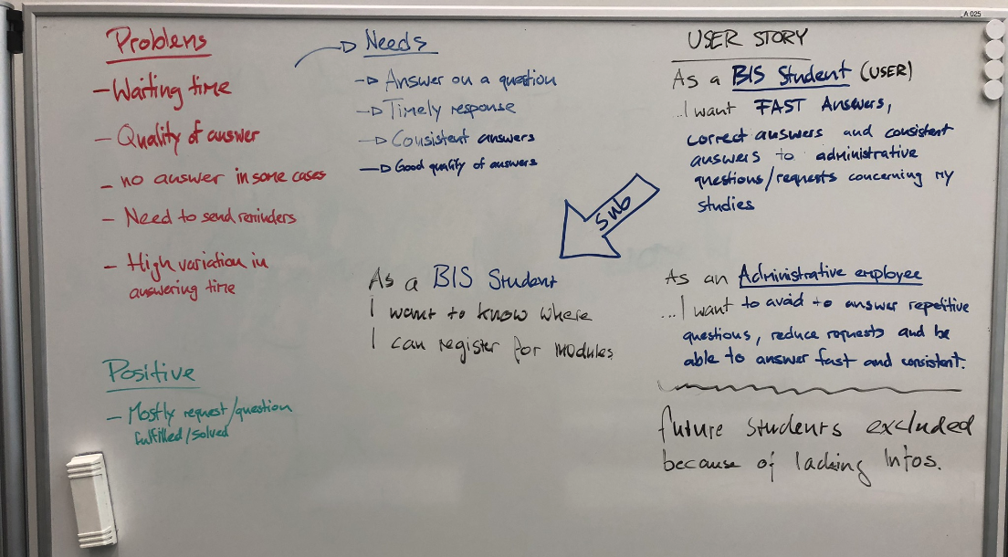

Figure 4: Evaluation Overview Stakeholder Problems, Needs and possible User Stories

During the evaluation session we were able to identify the following needs:

* Get an answer to my question
* Timely response
* Consistent answers -> Same answer to the same question
* Good quality of the answer -> Correct information given

Out of these needs we created two top level User Stories one from the view of a student and the other one from the view of the FHNW employee:

*“As a BIS student…*

* *…I want fast answers,*
* *…correct answers,*
* *…consistent answers to administrative questions/requests concerning my studies.”*

*“As an administrative employee at FHNW…*

* *…I want to avoid answering repetitive questions,*
* *…reduce students requests I have to answer,*
* *…be able to answer fast and consistent.”*

As both User Stories are formulated at a very high level, it was not yet possible to make clear estimations about the effort and probability to develop a possible solution. Therefore, we decided to create a Sub-User-Story which we could use for the development of the first chatbot iteration as a deliverable of Sprint 1:

“As a BIS student…

* …I want to know where I can register for modules.”

Based on this Sub-User-Story we developed our deliverable of Sprint 1, which is a simple chatbot (see Figure 5) that it only able to provide an answer to the question above.

Link to the chatbot prototype: <https://fhnw-aba.herokuapp.com/>

Use key words: hi, registration, module

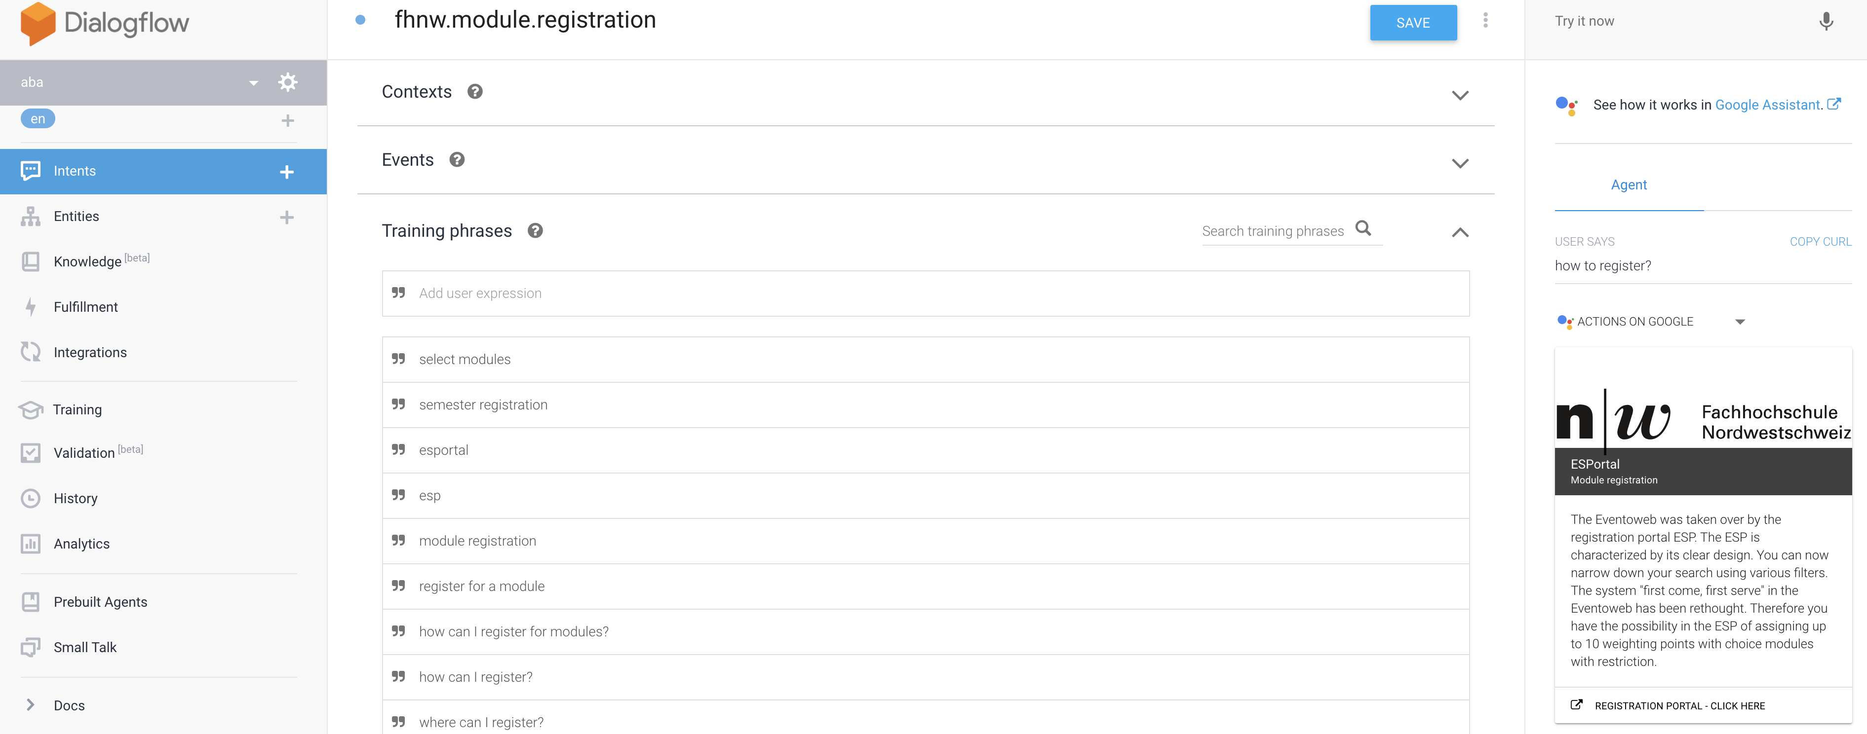

Figure 5: Dialogflow - Registration for Modules

For the first Sprint Retrospective a simple method has been chosen, as there is a generally lack of knowledge in the team in how to perform a Sprint Retrospective. Therefore, the following Sprint Retrospective template was chosen (see Figure 6):

Figure 6: Quick Retrospective Template (Morales, 2017)

The general idea in the Quick Retrospective is, that the team is asked direct questions regarding the last Sprint:

1. What was good in the last Sprint?
2. What was bad in the last Sprint?
3. Which ideas exist to improve the next Sprint?
4. Which actions will be tried out in the next Sprint?

The task is then that all participants list their thoughts for questions 1-3 in the corresponding section. Afterwards, the team discusses what shall be tried out in the next Sprint which is then recorded in the “Actions” box.

**Interview with administrative employee**

Neyyer Sheikh is one of the administrative employees of the FHNW. He is responsible for the BIS programme and answers students' questions accordingly. In an interview with him we found out that these requests are most frequently asked:

* Date on various topics of education (exams, results, etc.)
* Change of module registration
* Change of billing delivery address
* registration confirmations
* Questions about the interview (assessment)

It is worth mentioning that foreign students in particular have many concerns. Swiss students have fewer concerns.

With regard to data sources, Mr. Sheikh mentions the following two instruments that are very important to him:

* academic calendar
* evento

The "academic calendar" is a list of all dates relevant to the FHNW. These are made available to administrative employees as hard copies, but can also be requested as Excel files. It is worth mentioning that the administrative employees from the respective study programmes only receive those appointments which are relevant for their study programme.

"Evento" is a software package with a database. It manages all the modules that are available in a study programme. The software "evento" is administered by the department in Brugg.

## Sprint 2

* + Consider feedback from previous Retrospective
  + Product Backlog
  + Sprint Planning / Estimation -> Sprint Backlog, Define Deliverable
  + Sprint Goal
  + Sprint Review: Analyse Deliverable
  + Sprint Retrospective

## Sprint 3

* + Consider feedback from previous Retrospective
  + Product Backlog
  + Sprint Planning / Estimation -> Sprint Backlog, Define Deliverable
  + Sprint Goal
  + Sprint Review: Analyse Deliverable
  + Sprint Retrospective

# Final Product presentation

# Recap:

* + What went well/bad?
  + Things to change for the next time?
  + Possible future work

# List of Figures

Figure 1: Stacey Matrix (Ballarin Latre, 2019) 4

Figure 2: Complexity Areas Stacey Matrix (Maretzke, 2019) 4

Figure 3: Initial Product Backlog in Trello 9

Figure 4: Evaluation Overview Stakeholder Problems, Needs and possible User Stories 11

Figure 5: Dialogflow - Registration for Modules 12

Figure 6: Quick Retrospective Template (Morales, 2017) 12

# Bibliography

Ballarin Latre, A. (2019, April 28). Scrum.org. Retrieved from https://www.scrum.org/resources/blog/contextless-scrum-principles-or-rules-driven-framework

Hinkelmann, K. (2019). Assignment Agile Business Analysis. University of Applied Sciences and Arts Northwestern Switzerland - School of Business.

International Institute of Business Analysis. (2015). A Guide to the Business Analysis Body of Knowledge (BABOK) (3 edition). Toronto: International Institute of Business Analysis.

International Institute of Business Analysis, & Agile Alliance. (2013). Agile Extension to the BABOK Guide: Version 1 (Version ed. edition). International Institute of Business Analysis.

International Institute of Business Analysis, & Agile Alliance. (2017). Agile Extension to the BABOK Guide: Version 2 (Print ed. edition). International Institute of Business Analysis.

Maretzke, M. (2019, March 12). Agile-Minds. Retrieved from http://www.agile-minds.com/when-to-use-waterfall-when-agile/

Morphy, T. (2019). stakeholdermap.com. Retrieved October 16, 2019, from https://www.stakeholdermap.com/project-templates/requirements-traceability-matrix.html#template

Oxford University Press (OUP). (2019). Lexico.com. Retrieved from https://www.lexico.com/en/definition/chatbot

St John's Innovation Centre. (2012). About St John's Innovation Centre. Retrieved 05 23, 2012, from http://www.stjohns.co.uk/about/