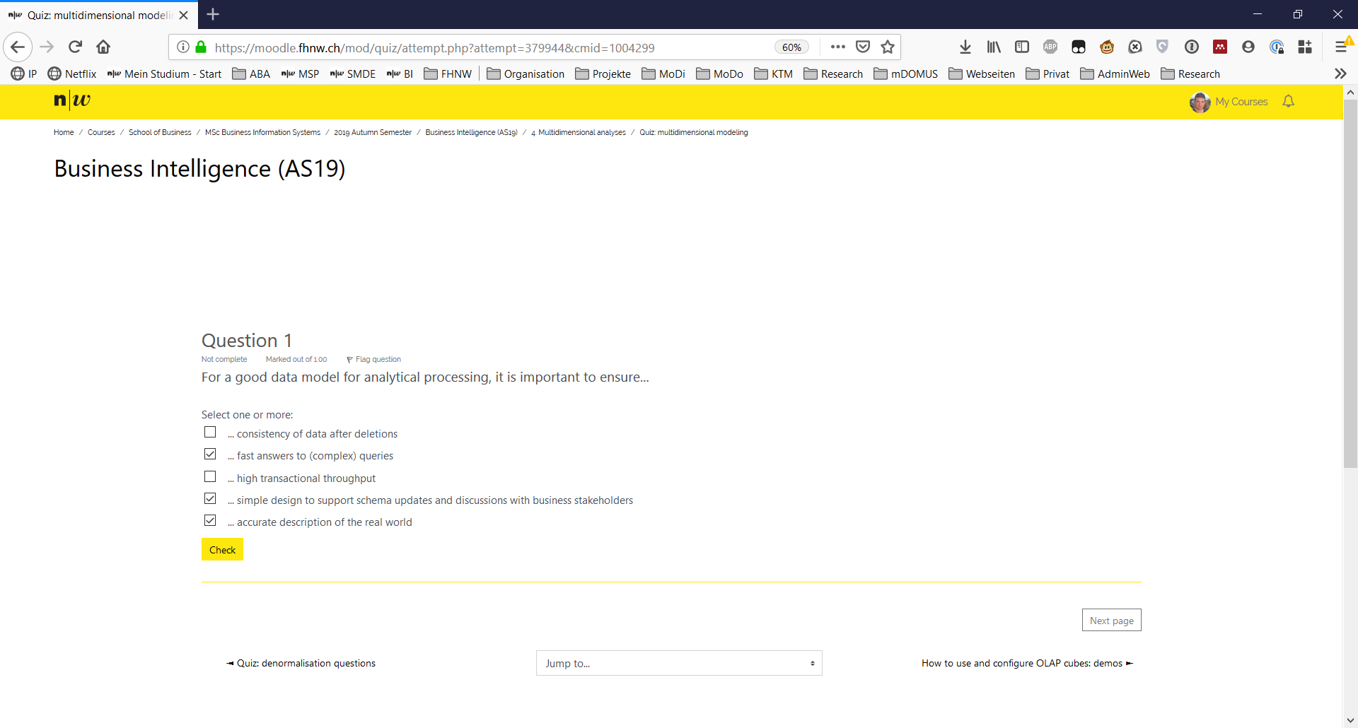

Ask bot why?

|  |  |  |  |  |
| --- | --- | --- | --- | --- |
| Student utterance | DSSA utterance | Constraint (triggers are bold) | Additional required knowledge (domain model) | Comment |
|  | **Name me something which is important when you model a data model for analytical processing.** |  |  |  |
| To ensure that the system answers fast to complex queries |  |  |  |  |
|  | **This is correct. Can you name one more?** |  |  |  |
| It should even work when a lot of transaction get executed. |  |  |  |  |
|  | **This is not correct. You have another change.** |  |  |  |
| It should represent the real world correctly. |  |  |  |  |
|  | **Yes this is correct.** |  |  |  |
|  |  |  |  |  |

The company YourFood produces and packages food products. Because the products are perishable, on time shipment of orders is very important to YourFood. For the delivery, they work together with several carriers in the different regions. Currently, their KPI “on time shipment ratio” is off-target. For analyzing this situation, they need answers to questions like the following ones:

* In the last quarter, how many deliveries were delayed, how many on time?
* What was the average delay of late deliveries?
* Was there a carrier for which we can see a negative trend over the last quarters in terms of late deliveries?
* Are there any specific delivery destinations or whole destination regions or countries which were particularly affected by late deliveries?

Therefore, YourFood has decided to capture, for each delivery, the delay (if any). The deliveries and their delays are stored in a database, each being described by the carrier, the destination and date of the delivery and the commissioning factory. Destinations and commissioning factories are further grouped by region and country.

**Task**: classify the following entities as to whether they are facts, measures, dimensions or dimension hierarchy levels.

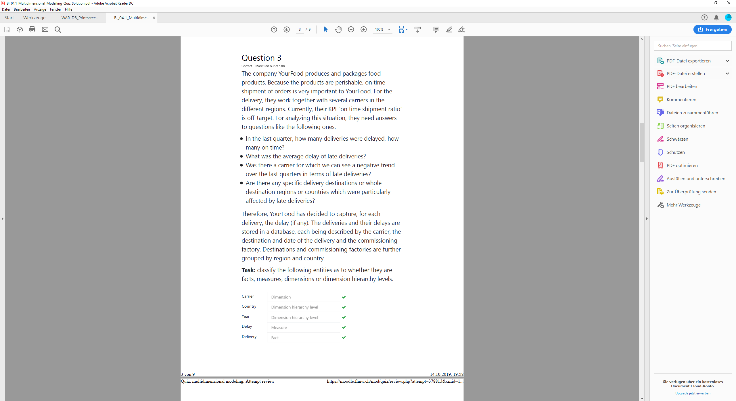

|  |  |  |  |  |
| --- | --- | --- | --- | --- |
| Student utterance | DSSA utterance | Constraint (triggers are bold) | Additional required knowledge (domain model) | Comment |
|  | The company YourFood produces packages food which is perishable. Do you think on time shipment is important for them? |  |  |  |
| Yes |  |  |  |  |
|  | **Yes, this is correct. But currently the “on time shipment ratio” of carriers is off target. May you know some questions YourFood could ask itself?** |  |  |  |
| In the last quarter, how many deliveries were delayed, how many on time? |  |  |  |  |
| What was the average delay of late deliveries |  |  |  |  |
| Was there a carrier for which we can see a negative trend over the last quarters in terms of late deliveries? |  |  |  |  |
| Are there any specific delivery destinations or whole destination regions or countries which were particularly affected by late deliveries? |  |  |  |  |
|  | **Ok, I think this is good enough.** |  |  |  |
|  | **What do you have to measure to answer those questions? Name also the fact?** |  |  |  |
| Delay of Deliveries |  |  |  |  |
|  | **This is correct. What is the main dimension you would like to group the delay?** |  |  |  |
| Carrier |  |  |  |  |
|  | **Correct! To have a time history what kind of sub dimension may you choose?** |  |  |  |
| Year or Quarter |  |  |  |  |
|  | **To understand whether specific destinations or whole regions are affected. What might be an additional sub dimension?** |  |  |  |
| Country, Region, Territory |  |  |  |  |
|  | **Correct!** |  |  |  |

