**Agile Business Analysis**

***Report for Sprint 3***

Organization: University of Applied Sciences and Arts Northwestern Switzerland

Authors: Simon Drabert, Franck Polin, Celia Schmid,  
Christopher Vogel

Place, Date: Olten, 12.12.2019

|  |  |
| --- | --- |
| **Agile Business Analysis**  Student Chatbot for the Module Business Intelligence Documentation Sprint 3 |  |
| **Authors** |  |
| Simon A. Drabert Parkstrasse 38 4102 Binningen +4176 560 77 15 [simon.drabert@stuedents.fhnw.ch](mailto:simon.drabert@stuedents.fhnw.ch)  Celia Schmid Hohlstrasse 482 8048 Zürich +4176 234 17 08 [celia.schmid@students.fhnw.ch](mailto:celia.schmid@students.fhnw.ch)  Christopher Vogel Bahnhofplatz 2 4133 Pratteln +41 78 883 99 12 [christopher.vogel@students.fhnw.ch](mailto:christopher.vogel@students.fhnw.ch)  Franck Polin Holeestrasse 116 4054 Basel +41 76 524 27 82 [franck.polin@students.fhnw.ch](mailto:franck.polin@students.fhnw.ch) |  |

|  |  |
| --- | --- |
| **Contact** |  |
| Prof. Dr. Knut Hinkelmann  University of Applied Sciences and Arts Northwestern Switzerland Hochschule für Wirtschaft |  |
| **Organization** |  |
| University of Applied Sciences and Arts Northwestern Switzerland Riggenbachstrasse 16 4600 Olten |  |
| Olten, 12.12.2019 |  |

Declaration of Authenticity

We, the undersigned, declare that all material presented in this paper is our work or fully and specifically acknowledged wherever adapted from other sources. We understand that if at any time it is shown that we have significantly misrepresented material presented here, any degree or credits awarded to us based on that material may be revoked. We declare that all statements and information contained herein are true, correct and accurate to the best of my knowledge and belief. This paper, or part of it, has not been published to date. It has thus not been made available to other interested parties or examination boards.

Name Celia Simone Drabert Christopher Vogel

Place and Date Olten, 12.12.2019 Olten, 12.12.2019 Olten, 12.12.2019





Signature

Name Franck

Place and Date Olten, 12.12.2019



Signature

Index

Declaration of Authenticity IV

Index V

1 Introduction 7

2 Retrospective of Sprint 2 8

2.1 Coaching with Maya 8

2.2 Sprint Retrospective of the Project Team Members 8

3 Gathering Data for Chatbot Development 12

3.1 Data Collection 12

3.2 Compiling the Data into Clusters for Dessa 12

4 Discussion with Project Sponsor Knut Hinkelmann 17

5 Identifying question types and their Corresponding Answer Form 18

5.1 Identification of Question Types 18

5.2 Implementation into Dessa’s Prototype 19

6 Outlook 20

# Introduction

The following chapter is supposed to provide an introduction regarding this documentation. To be more precise this particular report did become established concerning the conducted as well as executed tasks of the project concerning the student chatbot assistant for the University of Applied Sciences Northwestern Switzerland´s module Business Intelligence. Therefore, the authors will summarize in short, the most relevant information regarding this report.

As a first step, the authors will provide an overview regarding the conducted retrospective of the second sprint. Hereby, this retrospective will become sub-divided into two sections. First, the conducted retrospective with the project coach Maja will become displayed including the most important aspects detected. Afterward, the authors do visualize the outcomes of their own conducted reflection on the past sprint, with its respective implications outlined regarding the third sprint.

In a further chapter, the authors will turn over towards the actual third sprint task, and visualize how additional data had been gathered for the chatbot development. This chapter includes sub-divisions which do concern specific sub-aspects of it as for example the agreements taken with the stakeholder, how actual the data has been gathered as well as the data has become compiled for the purpose.

When this has been completed, the project team will display in the fourth chapter the insights on how the gained data did become clustered for the chatbot prototype. Hereby, the authors do present the detected clusters during the analysis effort by the project customers as well as its relevance for the overall project.

Afterwards, the authors will summarize the most important outcomes regarding a meeting with the project sponsor Knut Hinkelmann in a further chapter. Since this meeting has been very important for the overall project and especially for the current third sprint, the most important facets will become displayed.

In the fifth chapter the identifying question types and their corresponding answer form will become examined. Therefore, the project team will provide an explanation regarding the identification of question types. Additionally, it will become stated as well, how these question times including their specific answers did become implemented into the chatbot solution prototype.

After these chapters did become complete, the project team will provide and outlook regarding a possible further sprint which can become conducted in order to achieve a successful result the project. Additionally, an overview regarding the tasks to do for the final pitch of this project will become explained.

# Retrospective of Sprint 2

The following chapter is supposed to review the second sprint, which was executed by the project team. This review will be conducted by summarizing the essential activities, meetings, and outcomes with the involved stakeholders as well as coaches. Therefore, this chapter did become sub-divided into the single meetings which were executed.

## Coaching with Maya

This sub-chapter is dedicated to provide the most relevant information and outcomes regarding the conducted retrospective meeting with the project coach Maja.

However, on the first Friday after the second sprint documentation has been delivered, the authors had a coaching session with the project coach Maya. Hereby, Maja advised the project team, to place a higher focus on having clearly defined roles for each individual project team members. This should provide a solid base or foundation as well as ensuring that each member knows exactly what their respective tasks are, since these aspects will be very important in the final report. In addition, Maya emphasized the importance of Trello as a project management tool and that the project team member should take more advantage out of it. This is since this application did not become used to its full potential so far concerning the chatbot solution for the FHNW´s module Business Intelligence. Therefore, the team member should use it more extensively and especially as their only tool documenting the specific actions taken during all project sprint. Hereby, the project team has become advised further to create a separate “done” section for each sprint, since this would become a useful source to document the executed tasks in each iteration.

## Sprint Retrospective of the Project Team Members

As the next sub-chapter of the retrospective, the authors will summarize their own conducted reflection. For the retrospective of the second sprint the project team took advantage of the so-called SKS framework, for noting the most important aspects and findings. For clarification reasons, the sprint retrospective of the team member was conducted throughout a skype call.

The following table visualizes the results of the project team member´s retrospective according to the SKS framework:

|  |  |
| --- | --- |
| **Phase:** | **Feedback:** |
| Start | * Knut Hinkelmann is the team´s project sponsor for the process, at the same time Mr. Hinkelmann represents a potential stakeholder and coach. Therefore, Mr. Hinkelmann plays a crucial role in our project. This results that the project team decided to involve him more into this project and especially in the last sprint. * As the project is executed in an agile approach, the project team decided to set up the scrum roles for each individual member. This allocation of rolls and team members can be seen below:   + Product Owner: Franck Polin   + Scrum Master: Simon Drabert   + Developer Team: Christoph Vogel, Celia Schmid * Use Trello more intensely, for allocating tasks, collect information: Trello as primary information as well as project management tool. The overall goal should be to establish only additional word documents when they are necessary or required. |
| Keep | Peer review. Even though everyone has its role we want to keep reviewing each other's work to exchange opinions and stay on the same page. |
| Stop | No conclusive findings. |

# Gathering Data for Chatbot Development

This chapter is dedicated to display the relevant information regarding the requirements gathering using the therefore developed prototype. Thus, these findings will become evaluated as well with relevant stakeholders and coaches of this particular project. However, the overall goal of these activities was to cluster the data into specific patterns for the chatbot prototype.

## Data Collection

As the first section of this chapter, the authors of this report will provide a short overview regarding the data collection for the chatbot development.

In order to possess a wide range of possible data to input into the chatbot prototype, the project team members decided to take a survey. This survey has been conducted in the module of investigation (Business Intelligence), with real students who needed to state potential question which he or she might ask a given final chatbot solution. By taking such an approach, the project team member can enforce to have the desired quality data for their further tasks.

## Compiling the Data into Clusters for Dessa

This sub-chapter is dedicated to revise the compilation of the gathered questions asked by the potential end users. In addition, the results of the further clustering activities of the project team will become displayed.

However, after the data has become collected, the project team members started to decompile the gathered data from the survey in an excel sheet and started to cluster them into specific cluster types. These cluster types were set up according to the received input of the coaches as well as towards the overall business need.

The following table visualizes four clustering types that the team agreed upon as well as a description about what is to be expected:

|  |  |  |
| --- | --- | --- |
| **No.:** | **Cluster Type:** | **Description:** |
| 1 | Templates (wording/ type of question) | The question is analyzed according to the received wording. |
| 2 | To which BI chapter does the question belong? | This indicates in which particular chapter of the module Business Intelligence the information can be found. |
| 3 | Document type | This reflects the certain document type in which the information can be found. For example: (slides, primers, exercises, YouTube video) |
| 4 | What does it represent? Purpose e.g. user manual for tools | Indication of the purpose of this particular information. |

The following table is supposed to visualize the identified clusters for each cluster type:

|  |  |  |
| --- | --- | --- |
| **No.:** | **Cluster Type:** | **Identified Clusters:** |
| 1 | Templates (Wording/ Type of question) | * How to? * Explain * How to? * Tell me more * What is? * Compare * How to use? * Why? * How to choose between * What is required? * What is ... used for? * Which tool? * Give me * How long? * When is? |
| 2 | To which BI chapter does the question belong? | * Data Mining * Multidimensional Modelling * Business Performance Management * Data Warehousing * Introduction * Reporting and Dashboarding * All * Big Data * Administrative |
| 3 | Document type | * Primer * Example * Slide * Link * Use Case * User Manual * Tutorial * Exercise * Video Tutorial * Links to products * Quiz |
| 4 | What does it represent? Purpose e.g. user manual for tools | * Exam Preparation * Basic Knowledge * Dependent Knowledge * Exercises * User Manual for Tools * Tool Evaluation * Tutorial * Objectives * Method Evaluation * Product Evaluation * Tutorial to Tools * Tool Description * Organization Stuff * Apply Methods * Structure of Course * Holistic Approach |

The following table visualizes some functional requirements for Dessa and which were derived with the help of the identified clusters.

|  |  |
| --- | --- |
| **No.:** | **Requirement:** |
| 1 | Chatbot should deliver samples of exam questions. |
| 2 | Chatbot should give examples to concepts. |
| 3 | Chatbot should deliver more/deeper information about concepts. |
| 4 | Chatbot should show exercises with solutions to concepts. |
| 5 | Chatbot should show best practices to concepts. |
| 6 | Chatbot should show how to apply and understand concepts in used software tools. |
| 7 | Chatbot should show which software tool can be used to apply a concept. |
| 8 | Chatbot should explain basic concepts to the user. |
| 9 | Chatbot should show exercises with solutions to concepts. |
| 10 | Chatbot should inform the lecturer that a student needs more exercises. |
| 11 | Chatbot should show how a software tool can be used (showing a link to a tutorial). |
| 12 | Chatbot should show the objectives of the module. |
| 13 | Chatbot should show which concept has the biggest value for a specific use case. |
| 14 | Chatbot should explain how to interpret the result of an applied concept. |
| 15 | Chatbot should deliver basic information about used tools. |
| 16 | Chatbot should list basic information about used tools. |
| 17 | Chatbot should list sub-concept of an explained concept. |
| 18 | Chatbot should show examples where a concept is used in practice. |
| 19 | Chatbot should explain the difference between two or more similar concepts. |
| 20 | Chatbot should show which skills are needed. |
| 21 | Chatbot should provide the correct information to all concepts mentioned in the question. |
| 22 | Chatbot should explain the difference between two similar concepts. |
| 23 | Chatbot should explain how long it takes to apply a concept. |
| 24 | Chatbot should show if there are any guest speakers. |
| 25 | Chatbot should show how the course is structured. |
| 26 | Chatbot should explain why a concept is useful. |
| 27 | Chatbot should explain best practices to apply concepts. |
| 28 | Chatbot should explain what should be avoided when applying concepts correctly. |
| 29 | Chatbot should list advantages and disadvantages of a concept. |

# Discussion with Project Sponsor Knut Hinkelmann

This chapter of the third sprint report is dedicated to summarize the most important aspects and outcomes of a meeting with project sponsor Knut Hinkelmann.

First Mr. Hinkelmann highlighted the importance of the project management tool Trello, which is used for this particular project. Hereby, Mr. Hinkelmann explained the project team members the importance of such an application in his own words based on his experiences in different projects over the years. Moreover, he provided recommendations to the team member to use this tool in a certain way and helped to have better overview. Thus, by having a walk through the noted tasks in Trello, the team redefined some stories in need.

Second, the project sponsor reviewed the excel-sheet containing the clustered data and put forward the idea that the chatbot should be capable to determine of what type a specific question belonged. From the defined type of question, the chatbot would be able to determine in what form the answer should be given.

In addition, Mr. Hinkelmann emphasized the module description document, which exists for every module offered by FHNW and entailed examples of things that students were expected to have learned by the end of the specific module (learning goals). In order that a possible chatbot solution might provide support for this particular module (Business Intelligence), a large data quantity is required. Although the required data which has been collected by the project team for this purpose, is in large part questions about concept definitions, there might be more complex questions asked by students. To find out how these more complex questions should be about, the project sponsor advised the project team to refer to the learning goals described in the module description document for the Business Intelligence module.

# Identifying question types and their corresponding answer form

The following section of the third sprint report is dedicated visualizing two important aspects of this report. At first the approach on how the individual question types did become identified. Afterwards, the resulting further implementation of it into the chatbot prototype called Dessa will be explained.

## Identification of Question Types

This sub-chapter will briefly display the most important aspects concerning the identification of the question types.

Based on the advice given by the project sponsor, the project team tried to derive question types based on the learning goals described in the module description document for the Business Intelligence module and relate them to the identified functional requirements identified so far. Then, the project team would look for examples of questions that would be asked to the chatbot, that fit to one of the question types found. For each of the question types, a corresponding form of answer would be defined.

Example 1

Let’s consider the following learning goal  
“The student should be able to judge and select appropriate Big Data technologies for given business scenarios”. Also, one of the identified functional requirements states as follows “Chatbot should show which concept has the biggest value for a specific use case”.

Linking these two observations, we can identify a question type that deals with knowing when and in which situation, the application of a specific concept is motivated.

Considering the selected question data collected so far, examples for this question type would be, "When is Data-driven BI useful?”, “When is Business driven BI useful?" or “When do I need to discretize numeric values?”.

The form of answer that the Chatbot would give to this question type might be a direct list of examples of use for the relevant concept. Plus, the Chatbot could point to the corresponding module documents where additional information about the concept can be found.

Example 2

A student might have a question regarding the learning goal “understand the whole diversity of requirements of the business towards BI analysis tools”. Also, one of the functional requirement sates as follows: “Chatbot should show which software tool can be used to apply a concept”

Considering the selected question data collected so far, example of questions of this type would be, “Which tool should I use for multiple regression?

The answer of the chatbot would be a list of tools that support multiple regression with a short description, why the student should use it. Plus, the Chatbot could point to the corresponding module documents where additional information about the concept can be found

Example 3

Let’s consider the following learning goal “be able to derive multidimensional models from a description of business information needs”. The identified requirement from students would be “Chatbot should show exercises with solutions to concepts”

Questions so far could be: “Could you give me more exercises to practice cost matrix/multidimensional models/star schema/lift/regression?” or “How to draw a multidimensional model?”

The chatbot should could provide a link to the exercises and its solutions about multidimensional models.

## Implementation into Dessa’s Prototype

This particular sub-chapter is supposed to display the reader of this report valuable information regarding the followed implementations into the prototype called Dessa.

After the linkage of some specific question types and their corresponding form of answer, the project team decided to implement one of these into Dessa’s prototype. The main idea behind this approach is that this example would be used in the final presentation for demonstration purposes.

In order to fulfil all the requirements identified in Sprint 2 with the first prototype and in Sprint 3 with the interviews and the questionnaire, we realized that a mere chatbot will probably not be enough. That’s why our prototype consists of an interface where one can navigate including a chatbot. At the same time, PowerPoint gives us limitations in the creation of the prototype and it’s not possible to show solutions for all requirements.

To start, we decided that the solution should include a screen where the student can choose what he wants to do.

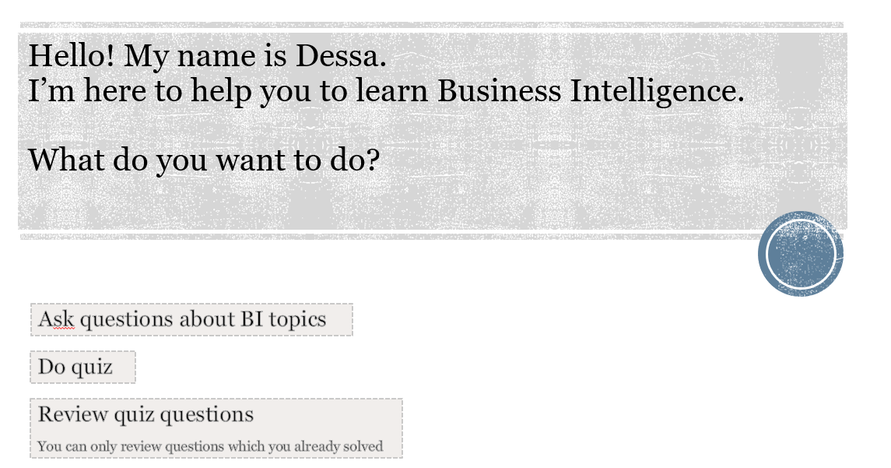

Figure 1: Start screen of Dessa

In the section “Ask questions about BI topics” (Figure 2), the student can ask a question and the chatbot will give answers derived from the sources identified in chapter 3.2 Compiling the Data into Clusters for Dessa. The chatbot can also give examples of of concepts applied and lead the student to further sources if he/she want to know more about the topic.

With the option “See most popular questions” (Figure 3) the lecturer can identify where most students have problems or a lack of understanding and eventually review the topics with the class.

In the “Do quiz” section (Figure 4 and 5), the student will be asked questions by the chatbot and he/she can choose the answers. Other questions can also include open text answers, where the chatbot interprets the answer ans evaluates its correctness. After answering the question the student has the option to dig deeper into the solutions and ask questions about it or he/she can proceed to the next question.

Finally, the “Review quiz questions” allows the students to see all the questions they have solved with the chatbot including the solutions they wrote/chose and what what the actual solution is.

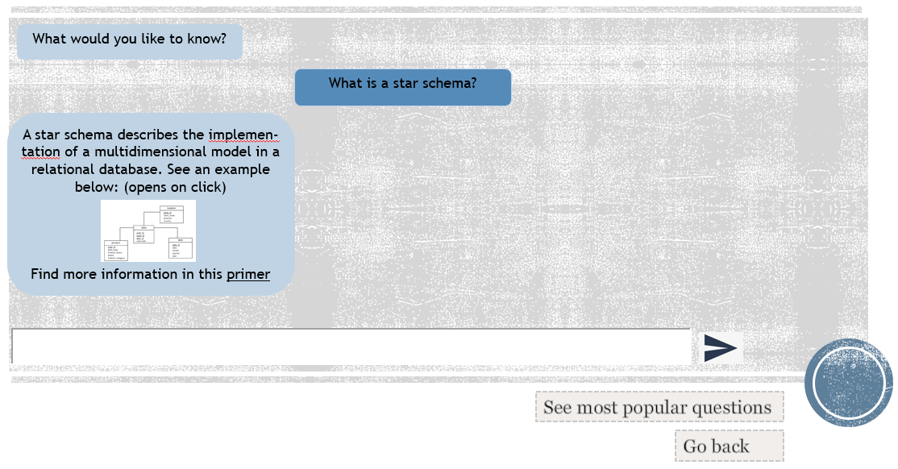

Figure 2: Screen of section "Ask questions about BI topics"

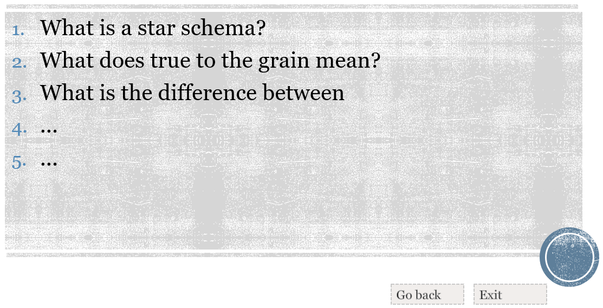

Figure 3: Screen of "See most popular questions"

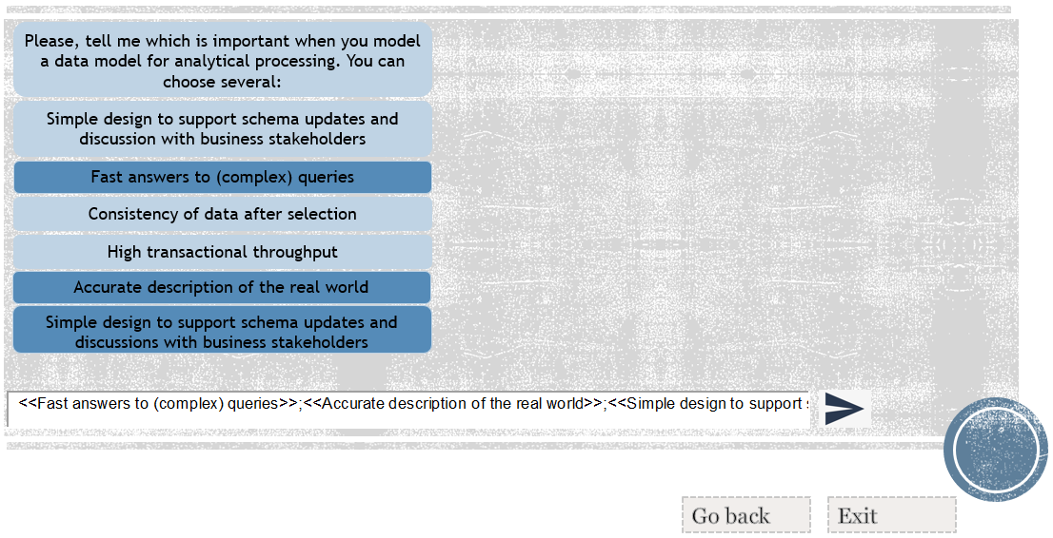

Figure 4: Screen 1 of "Do quiz"

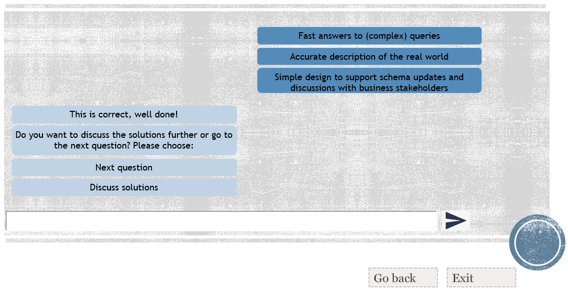

Figure 5: Screen 3 of "Do quiz"

# Outlook

This chapter of the third sprint reports is supposed to visualize an outlook regarding a possible further sprint as well as the preparations to be conducted for the final pitch of the idea. Therefore, the authors will summarize in a first section these thoughts for a possible further sprint, whereas a later section will provide insight about the approach for the final pitching of the project

Since the overall project was limited to three single iterations, the project team members need to close their investigations on how a possible chatbot solution might provide additional value for the module Business Intelligence. Nevertheless, the project offers to conduct a fourth sprint in order to derive further insights, in order to enhance the final outcome of such a solution. If the team members would have the possibility to continue with this project, the following tasks would be predestinated to become executed:

|  |  |
| --- | --- |
| **Number:** | **Potential Task:** |
| 1 | The team members would conduct further tests with the potential end-user. This would be done in order to collect additional feedback, which can become implemented into the chatbot prototype. |
| 2 | The project team member would review and assess the strengths and weaknesses of current MPV, in order to develop the chatbot prototype further. |
| 3 | The team members would focus on identifying additional opportunities for further development in the next sprints. |
| 4 | The elaboration of a so-called Risk Matrix would enhance the project. |
| 5 | The team would elaborate and might conduct a so-called SWOT analysis and a SOAR analysis, if they would deliver additional value for the project purpose. |

However, due to the fact that there will be no more sprint for this particular project, the team members will focus on the final pitch of the developed solution during the next two weeks. This means the authors will target to summarize the elaborated documents and findings and combine them in a comprehensive pitch. In addition, the members will start to develop the final report for the overall project. Important to mention here is that this particular report will differ quite a lot compared to the current structure, since it will be the final deliverable and a predefined arrangement required by the coaches.