ANAGROCI · CASHEW (RCN) TRACKING
Procurement Floor Guide
How raw cashew nuts are bought, received, checked, stored, dried and moved, and how the tracking application records every step. Written for someone who has never seen any of it.
Who it is for: new staff, managers, auditors and developers joining the project.
What you need to know first: nothing. Every word is explained the first time it appears and again in the glossary at the end.
Companion document: the Production Floor Guide covers what happens to the nuts in the factory.

Version 1.1 · October 2026

Contents
1. Welcome: what this guide is for
2. Cashew and RCN in two minutes
3. The places: sites, stores and bins
4. The people: roles and approvals
5. Procurement at a glance
6. Before the truck: suppliers and delivery plans
7. The truck's journey, step by step
8. Weights: gross, net, paid and GRN
9. Quality: the cut test and KOR
10. Lots and bins
11. GRN, stock and record locking
12. The status of a truck
13. Drying
14. Other warehouse activities
15. Transfers between warehouses (BKT)
16. Jute bags
17. Getting data in and out
18. The dashboard and supplier analytics
19. System IDs: how to read a number
20. Rules the system always follows
21. A worked example: one truck from gate to Yakro
22. Glossary: every word explained

1. Welcome: what this guide is for
ANAGROCI buys raw cashew nuts from suppliers, stores them in its warehouses and turns them into packed cashew kernels in its factory. This guide explains the first half of that story, the procurement floor: everything from the moment a supplier is expected to deliver, to the moment the nuts are handed to the factory.
It explains two things side by side:
- The real-world work: what the people at the gate, the weighbridge, the quality desk and the warehouse actually do, and why.
- The tracking application: which screen records each step, who is allowed to fill it, and what the system works out by itself.
How to read this guide
Read chapters 2 to 5 first: they give the whole picture in a few pages. The later chapters zoom into one topic each and can be read in any order.
Words in bold are explained in the glossary (chapter 22). Diagrams are numbered; numbers in them come from the client's real 2026 workbooks unless they are marked as an example.
Screen and button names are written exactly as they appear in the application, for example Reception or Finalise bin allocation.

2. Cashew and RCN in two minutes
The cashew tree grows a soft fruit called the cashew apple. Hanging under it is a hard, kidney-shaped nut in a shell. That nut, still in its shell and not yet processed, is called RCN: Raw Cashew Nut. It is what farmers harvest, what suppliers collect and sell, and what ANAGROCI buys.
Inside each shell is one kernel: the cashew nut people eat. The shell itself is not food (it contains a caustic oil) and makes up most of the weight. So the most important question when buying RCN is: how much good kernel is inside? That is measured by the KOR (Kernel Outturn Ratio), explained in chapter 9.
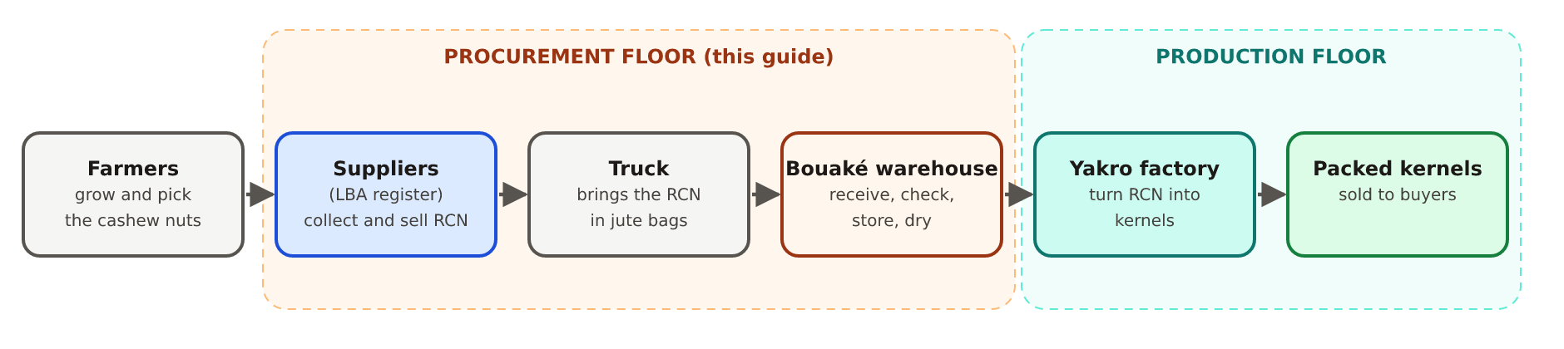
Figure 1. Where procurement sits: from the farmer's nuts to packed kernels.
Three more things matter when buying RCN:
- Moisture: wet nuts go mouldy and lose weight as they dry, so they are checked and, if needed, dried (chapter 13).
- Nut count: how many nuts make up a fixed weight. Fewer, bigger nuts usually mean bigger kernels.
- Weight: the supplier is paid on weight, so every truck is weighed full and empty (chapter 8).
The nuts travel and are stored in jute bags (sacks). The bags are valuable too, so they are counted and tracked in their own ledgers (chapter 16).

3. The places: sites, stores and bins
ANAGROCI has two sites in Côte d'Ivoire. Each has its own warehouse code, which appears inside every number the system issues there (chapter 19).
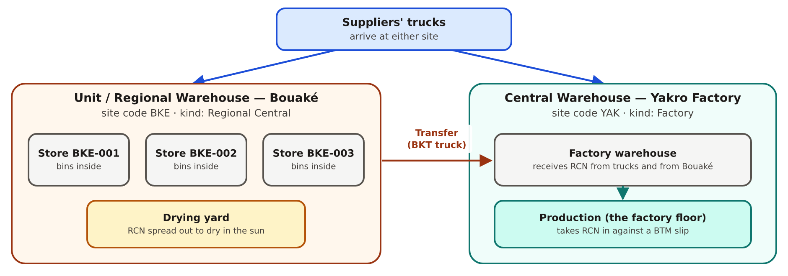
Figure 2. The two sites, their stores, and the transfer route between them.
Site | Code | Kind | What happens there
Unit / Regional Warehouse — Bouaké | BKE | Regional Central | Receives most supplier trucks.  Three physical stores: BKE-001, BKE-002, BKE-003.  Has a drying yard. Sends RCN on to Yakro.
Central Warehouse — Yakro Factory (Yamoussoukro) | YAK | Factory | Receives trucks from suppliers and from Bouaké.  Hands RCN to the production floor.

Store, bin, site: three levels of “where”
- Site: a whole location (Bouaké, Yakro). In the application, each site has its own section; a Warehouse Incharge only sees their own site.
- Store: one building or hall inside a site (BKE-002). Bouaké has three; Yakro has one.
- Bin: a marked storage position inside a store where bags are stacked (for example BIN-03). A bin can hold several Lots at once (chapter 10).
The register also records a warehouse kind: Village, Regional Central or Factory. It describes the role of a site in the supply chain.

4. The people: roles and approvals
Everyone signs in with their own account. What they can see and do depends on their role and, except for Admin, on the site they belong to.
Role | Typical person | What they do in the application
Admin | Head office, IT | Everything, at every site.  Creates users, reopens locked records, sees all data.
Warehouse Incharge | The manager of one warehouse | Edits truck records directly (no approval needed).  Approves or rejects what others submit.  Records Pass / Fail, finalises bins, runs transfers, uploads workbooks.  Never sees prices or amounts, anywhere in the application or its Excel files.
Branch Manager | Commercial / purchasing contact | Submits reception details: vehicle number, supplier, LBA code, fiche.  Sets the negotiated price directly on the truck, with no approval.  Sees and requests their own suppliers.
QFS Officer | The quality controller | Submits the quality form: moisture, nut count, cut-test grams (KOR) and the bag count.  Cannot change the truck directly.

A Branch Manager or QFS Officer never writes straight into a truck's record. They submit a form, and the Warehouse Incharge approves or rejects it on the Approvals screen. Only an approved form changes the truck, and the record keeps who submitted, who approved and when. The one exception is the price: the Branch Manager saves it straight onto the truck, because the Warehouse Incharge who approves forms does not see prices.
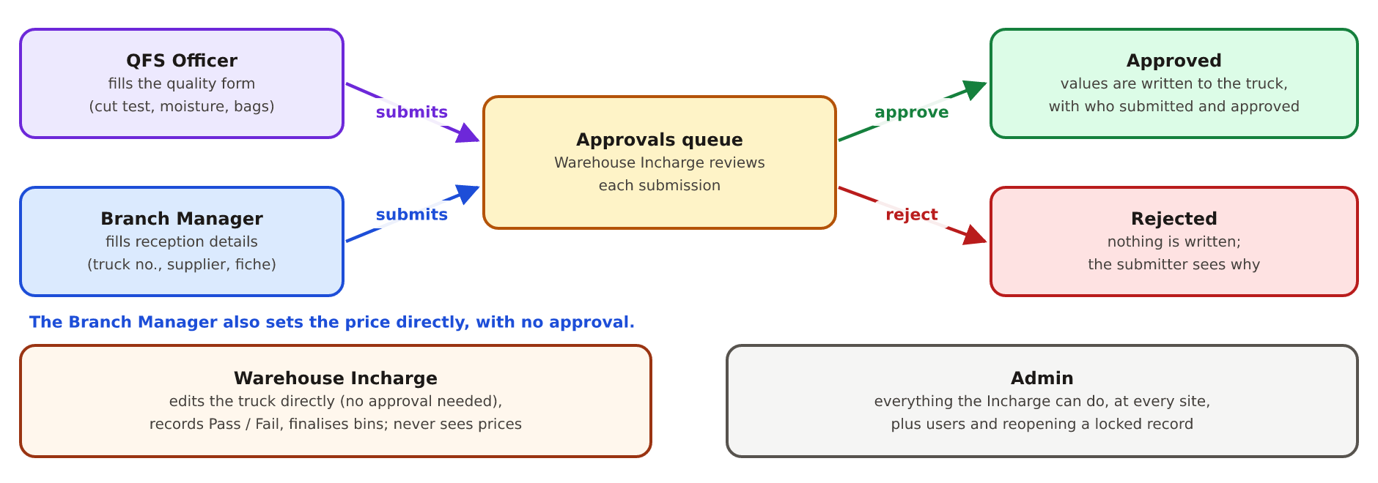
Figure 3. Who enters what, and the approval step in between.

5. Procurement at a glance
Everything on the procurement floor fits into five blocks. Each block is a chapter (or a few) later in this guide.
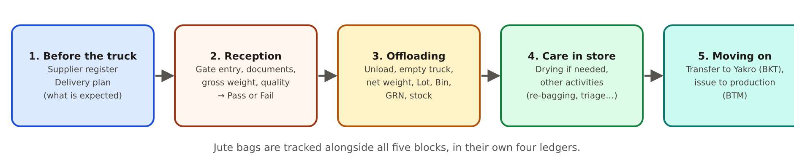
Figure 4. Procurement in five blocks.
Block | In one sentence | Chapters
1. Before the truck | Know who the supplier is and what they promised to deliver. | 6
2. Reception | Let the truck in, check its papers, weigh it full and empty and test the nuts; accept or reject. | 7, 8, 9
3. Offloading | Unload and count the bags, give the nuts a Lot number and a bin, record the GRN. | 7, 8, 10, 11
4. Care in store | Dry the nuts if they are too wet; record other work done on them. | 13, 14
5. Moving on | Send Lots to the factory warehouse and hand them to production. | 15

The one idea to remember
The application is organised around the truck's record (called a receipt internally). Once the truck passes quality, its nuts get a Lot number, and from then on the Lot is what everyone follows: into a bin, through drying, onto a transfer truck and into production, long after the truck itself has driven away.

6. Before the truck: suppliers and delivery plans

6.1 Suppliers (the LBA register)
A supplier is a person or business that sells RCN to ANAGROCI. Every supplier has an LBA code: its key in ANAGROCI's supplier register (the LBA register). The code is what links a truck to its supplier; the supplier's name alone is too loose to rely on.
- Each supplier also gets a permanent system number (SUP-0001, SUP-0002 …) that never changes, even if the LBA code does.
- The register holds contact, registration and bank details. Bank details are only visible on the supplier's own page, to Admin and Warehouse Incharge.
- A supplier is active, suspended (a warning shows when their truck is entered, but it is still allowed) or inactive (no longer offered in pickers). Suspended or inactive needs a written reason.
- Names are stored without the leading “RCN” the old workbooks used (“RCN SCOOPS DIENE” becomes “SCOOPS DIENE”); the original name is kept.
- A supplier already used by trucks, plans or jute movements is never deleted, only made inactive, so its history stays complete.
The supplier's page shows figures worked out from its records: trucks, bags, GRN and weighed kg, average KOR and moisture, rejection rate, target and achievement from its plans, and jute bags still with the supplier. Money owed or advanced is not tracked in the application.

6.2 Delivery plans
A delivery plan records what a supplier is expected to bring: how many kilograms, roughly how many trucks, between which dates, and to which site and store. Each plan gets a number such as DP-BKE-2026-001.
- When a truck arrives, it can be linked to its plan. The plan then shows, by itself, what has actually arrived, been accepted or rejected, and the GRN quantity received.
- A plan's status is worked out, never typed: Planned (nothing arrived), Partially received, Delivered (the expected trucks or kilograms have arrived) or Cancelled (the only status a person sets).
- A truck that arrives with no plan (unplanned) is allowed. It is flagged as an exception that the Warehouse Incharge can approve.
Why plans matter
They let the dashboard compare expected against received, and the supplier page show an achievement % (received on its plans ÷ planned).

7. The truck's journey, step by step
When a truck reaches the warehouse, its record is created and goes through up to 15 steps. The application shows them on the truck's page as sections that can be filled in any order, because real life does not always follow the textbook. The diagram shows the usual order.
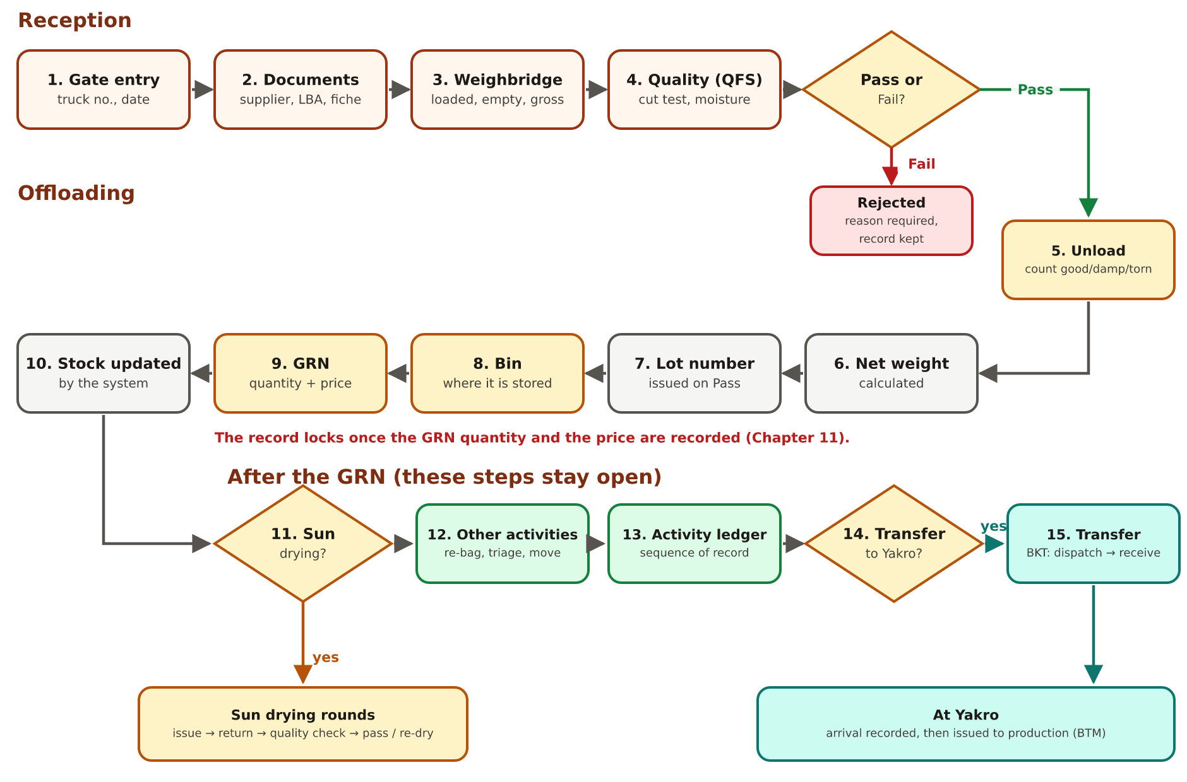
Figure 5. The 15 steps of one truck, from the gate to the transfer to Yakro.

7.1 Reception: from the gate to the quality decision
# | Step (as named in the app) | What happens and what is recorded | Who
1 | Truck arrives at warehouse (Gate entry) | The truck is let in. Vehicle number, arrival date (filled in by itself), warehouse.  Creating the record issues the receipt number REC-BKE-2026-0001. | Gate / Branch Manager
2 | Verify supplier documents | Supplier name, LBA code, fiche number (the delivery slip), origin of the nuts, credit or cash.  Can be linked to a delivery plan. | Branch Manager
3 | Weight truck (Gross weight) | The loaded truck is weighed on arrival and the empty truck (tare) after unloading; both readings are entered in this one step.  Gross weight = loaded − empty, calculated once both are in, or typed straight from the weighbridge ticket (chapter 8). | Weighbridge
4 | Quality analysis (QFS) | A sample is cut open: moisture, nut count, cut-test grams, KOR (chapter 9).  Then the decision: Pass or Fail. | QFS Officer, decision by Warehouse Incharge
– | Reject / Hold and inform procurement in charge | Only on Fail: the truck is rejected with a required reason. The record is never deleted. | Warehouse Incharge

7.2 Offloading: from unloading to the GRN
# | Step (as named in the app) | What happens and what is recorded | Who
5 | Unload RCN at warehouse | Bags are taken off and counted: good (BON SACS), damp (HUMID SACS), torn (Sacs déchirés). Date of offloading (filled in by itself), refraction, manpower, tally clerk count, pallets.  Total bags = good + damp + torn (calculated). | Warehouse team
6 | Calculate net weight | Net = gross − 1 kg per bag; paid weight = net − refraction. Calculated, never typed. | System
7 | Assign Lot Number to truck | Issued automatically the moment the truck passes quality: LOT-BKE-2026-0001. | System
8 | Allocate Bin (physical storage location) | Which bin the nuts go into. Finalise bin allocation stamps the date and who did it, and closes the step. | Warehouse Incharge
9 | Generate RCN reception record (GRN) | The GRN quantity (officially taken into stock), recorded by the Warehouse Incharge.  The price, set directly by the Branch Manager; amount = price × paid weight (calculated). Neither is shown to the Warehouse Incharge. | Warehouse Incharge; price by Branch Manager
10 | Update warehouse RCN stock (System) | The stock goes up by itself. | System

7.3 After the GRN
# | Step | What it is for
11 | Sun drying: does this truck/lot need drying? | Yes (direct to the yard, or store first then dry) or No; drying runs in rounds with a quality check. See chapter 13.
12 | Other warehouse activities | Re-bagging, triage, moving between locations and similar work. See chapter 14.
13 | Activity ledger (sequence of record) | The ordered history of those activities.
14 | Transfer to central / factory warehouse? | Stays here, or goes to Yakro on a transfer truck. See chapter 15.

Dates fill themselves
The date of arrival and the date of offloading are filled in automatically when the step is first saved; the bin allocation date is stamped by Finalise. They can still be corrected until the record locks.
Every date in the application is shown the same way: DD/MM/YYYY (19/10/2026), with a calendar button next to each date box.

7.4 The Reception screen
The Reception screen lists every truck at the site, newest first, with search (vehicle, supplier, LBA code, fiche, Lot, bin, receipt number), a store filter, a date range and a status filter. The status filter also has two group choices: Reception (trucks still being checked) and Offloading (accepted trucks being unloaded and recorded up to the GRN). Click a row to open the truck's page. Add entries opens a grid for entering one or many trucks quickly.

8. Weights: gross, net, paid and GRN
Four different weights are recorded for every truck. They are deliberately kept separate, because they answer different questions and are not always equal.
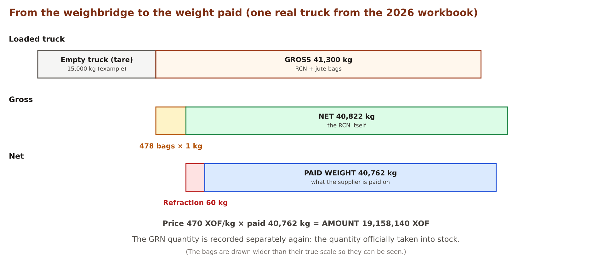
Figure 6. How the weights relate, using a real truck from the 2026 workbook.
Weight | How it is obtained | What it answers
Gross weight | Loaded truck − empty truck (tare): both readings are entered in the Weight step. Typed from the weighbridge ticket when the readings aren't. | How much did the truck bring, bags included?
Net weight | Gross − 1 kg for every jute bag. Calculated. | How much RCN is actually there?
Paid weight (PAID WT) | Net − refraction. Calculated. | How many kilograms is the supplier paid for?
GRN quantity | Recorded at the GRN step. | How much was officially taken into stock?

- Refraction is a weight deduction (in kg) applied before payment; the real 2026 rows record it at unloading.
- Amount = price per kg × paid weight. The application records it at the GRN step, but money owed, advances and payments are not tracked. Price and amount are shown only to the Branch Manager and Admin, never to the Warehouse Incharge.
- Every formula above was checked against all the rows of the real 2026 workbook before it was adopted. A calculation only runs when all its inputs are present, so an imported truck that has a gross weight but no truck readings keeps its real value instead of being blanked.
Why the GRN quantity is separate
Net, paid and GRN quantities can differ for real reasons (a deduction, a correction, a partial acceptance). Keeping all of them means nobody has to guess which one a report used. “Delivered” in reports always means the GRN quantity.
Many trucks imported from the 2026 workbook have no GRN quantity yet. Reports therefore show trucks awaiting GRN and the net weighed kg next to the GRN figure, so a GRN of 0 reads as “not recorded yet”.

9. Quality: the cut test and KOR
Because the kernel is hidden inside the shell, quality is measured by cutting a sample open. This is the job of the QFS Officer, on the form called “QFS Officer — quality analysis & jute bag check”.

9.1 The cut test
A 1000 g sample of nuts is taken from the truck. Each nut is cut open and its contents sorted and weighed:
Part | What it is
Good kernel | A sound, healthy kernel. This is what ANAGROCI wants.
Immature | An under-developed kernel: usable, but worth less.
Spotted | A kernel with spots or stains: usable, but worth less.
Rejection | A kernel that cannot be used.
Void | A shell with nothing inside.
Oil | A kernel spoiled by the shell's oil.
Shell | The shell itself; most of the weight.

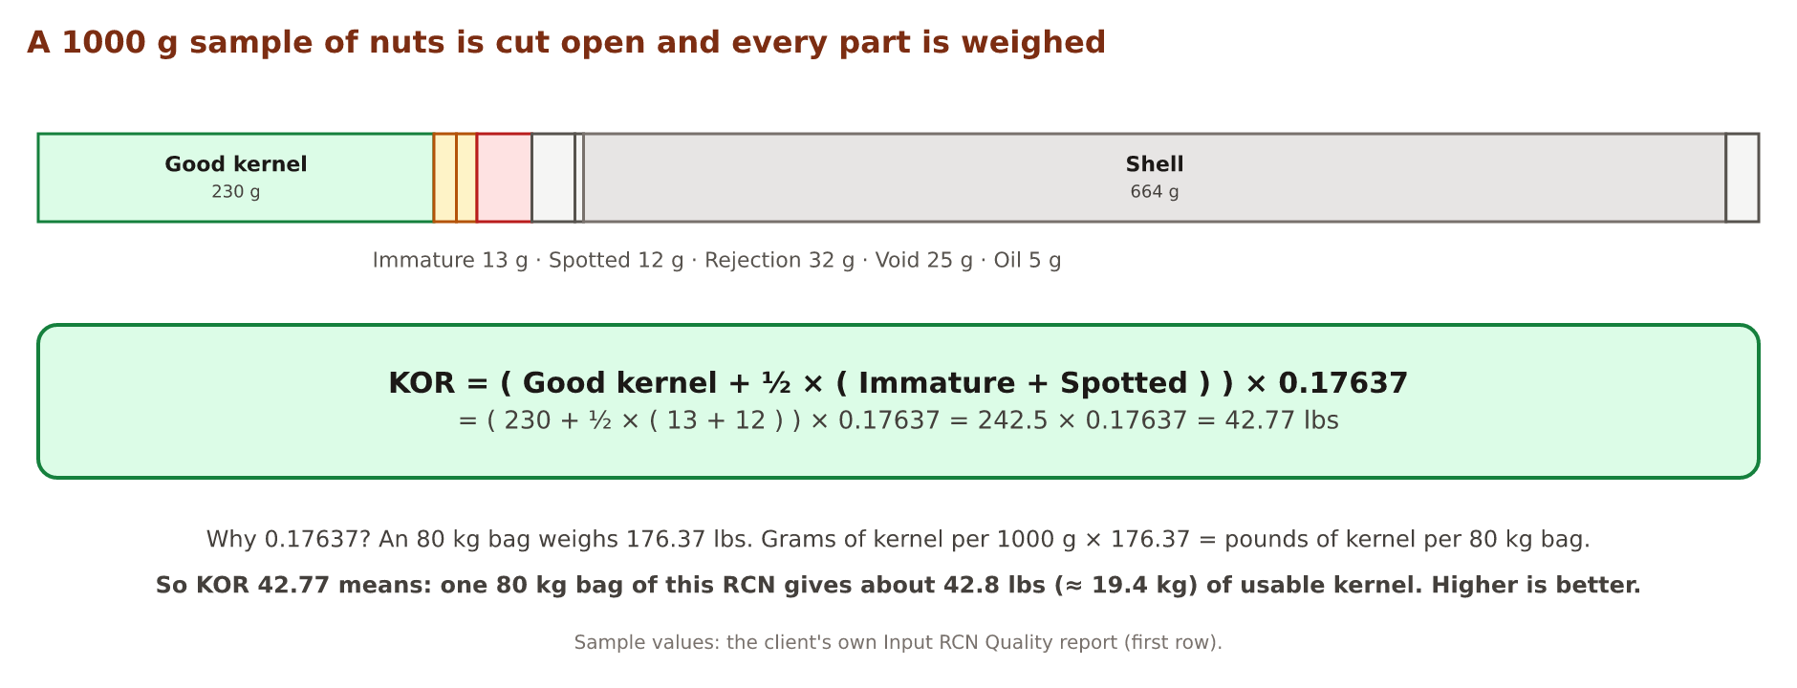
Figure 7. The cut test and the KOR calculation, on real sample values.

9.2 KOR: Kernel Outturn Ratio
KOR says how many pounds (lbs) of good kernel one 80 kg bag of this RCN would give. It is the single most important quality number: the higher it is, the more kernel ANAGROCI gets for the same weight of nuts.
The formula (the client's own)
KOR = ( good kernel + ½ × ( immature + spotted ) ) × 0.17637
Immature and spotted kernels count for half. 0.17637 converts “grams of kernel in a 1000 g sample” into “pounds of kernel in an 80 kg bag” (80 kg = 176.37 lbs).

- The test can be done twice: the sample cut test gives KOR, a repeat gives FINAL KOR. Wherever both exist, reports use the final one.
- When the grams are entered, the application calculates KOR and shows it read-only. When they are not (as on every 2026 truck), KOR can still be typed.
- Moisture (%) and nut count are recorded on the same form.

9.3 Pass or Fail
The QFS Officer submits the form; the Warehouse Incharge approves it, and then records the decision:
- Pass: the truck is accepted and its Lot number is issued immediately; it moves on to offloading.
- Fail: the truck is rejected. A reason is required, and the rejected truck stays on record for good: rejections are part of a supplier's history.

10. Lots and bins
A Lot is the nuts from one accepted truck, given a number so they can be followed wherever they go. The rule is absolute: one truck = one Lot. Two trucks are never merged into one Lot, and one truck is never split into two.
A bin is the physical place where the bags are stacked. Unlike a Lot, a bin can hold several Lots at the same time.
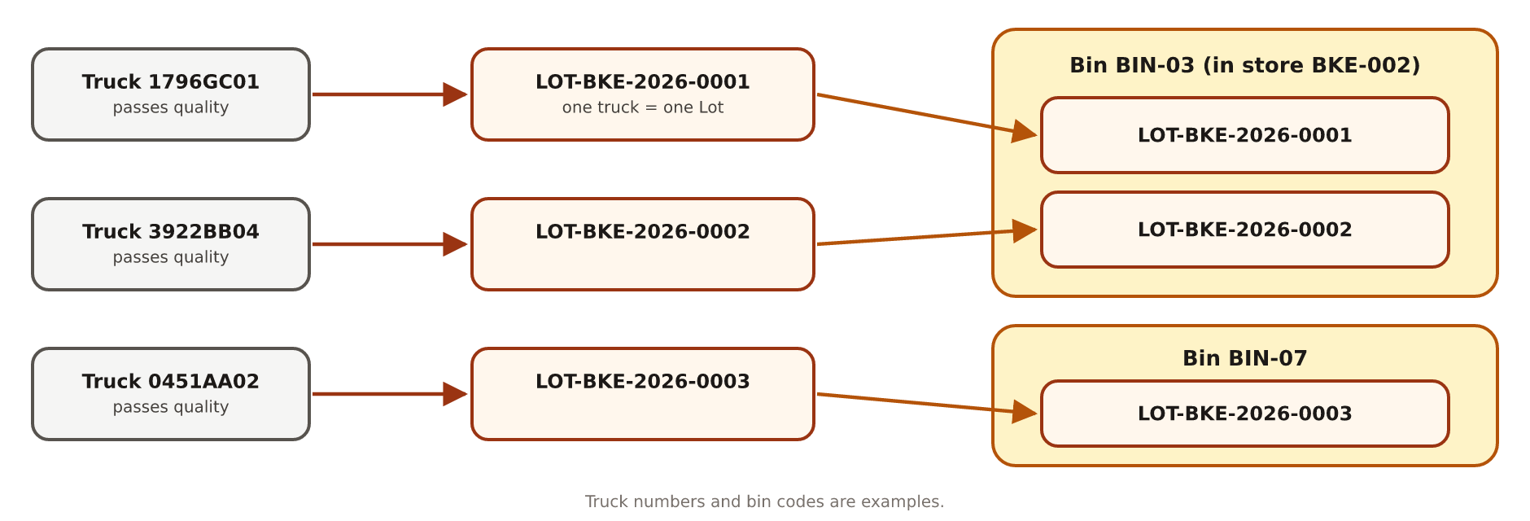
Figure 8. Each accepted truck becomes one Lot; a bin can hold several Lots.
- The Lot number (LOT-BKE-2026-0001) is issued by the system when the truck passes quality. Nobody types it.
- A Lot number only means something together with its site: the same physical nuts can carry a different Lot number at Yakro after a transfer, and the application links the two.
- Bins are managed on the Bins screen (Masters): Add bin with a code and the store it belongs to. On a truck's Allocate Bin step the bins of that store are offered first.
- Finalise bin allocation closes the step and stamps the date and the person. After that, only an Admin can reopen it.
- Drying is always done per Lot, never per bin, because a bin can mix Lots of different quality.

11. GRN, stock and record locking
GRN stands for Goods Received Note: the official record that ANAGROCI has taken the nuts into stock. In the application it is the step Generate RCN reception record (GRN): the GRN quantity (recorded by the Warehouse Incharge) and the price per kg (set by the Branch Manager). When the GRN is recorded, the stock goes up by itself.

11.1 The record lock
Once a truck's GRN is complete, its reception record locks: nobody can change it any more from the screens or by an Excel upload. This protects the numbers that payments and stock are based on.
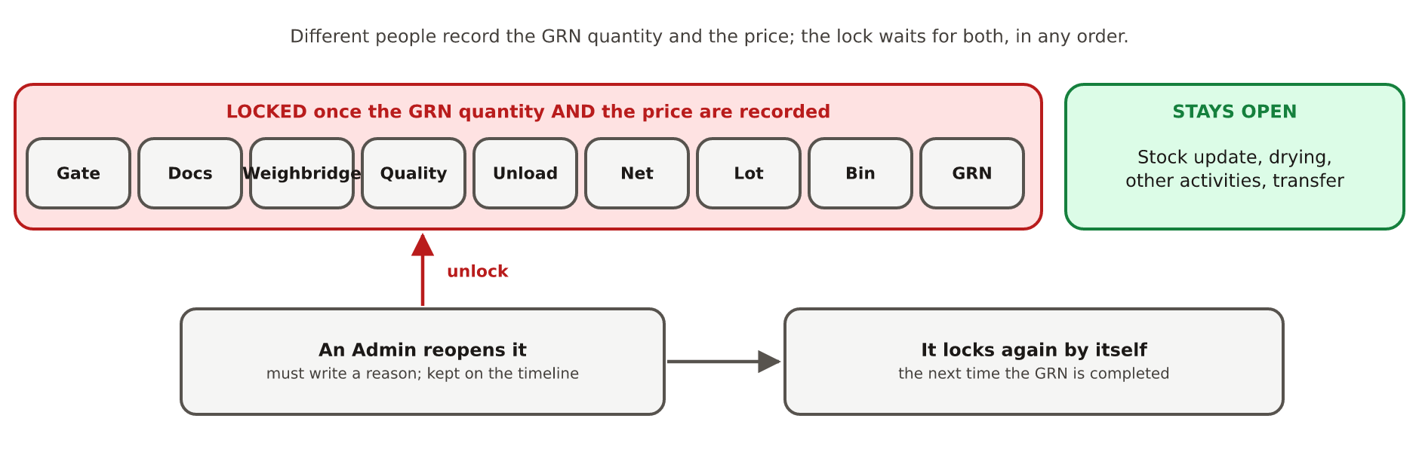
Figure 9. What locks, what stays open, and how an Admin reopens a record.
- When: as soon as both the GRN quantity and the price are recorded, in any order: the Warehouse Incharge enters the quantity, the Branch Manager the price. The lock waits for both even though the Incharge never sees the price.
- What locks: everything from the gate to the GRN, including the Pass / Fail decision.
- What stays open: what naturally happens later: the stock update, drying, other activities and the transfer.
- Reopening: only an Admin can, and must write a reason, which is kept on the truck's timeline. The record locks again by itself the next time its GRN is completed.
- Records that existed before locking was introduced were not locked retroactively.

12. The status of a truck
Each truck shows one status: a short label saying where it is in its journey. Nobody types a status: the application works it out from what has been recorded so far, so it can never be out of date.
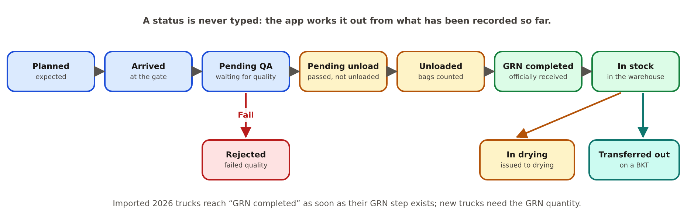
Figure 10. The ten statuses and how a truck moves between them.
Status | Means
Planned | Expected (on a delivery plan) but not arrived.
Arrived | At the gate; checks not finished.
Pending QA | Waiting for the quality decision.
Rejected | Failed quality; the reason is on the record.
Pending unload | Passed quality, not unloaded yet.
Unloaded | Bags taken off and counted.
GRN completed | Officially received into stock.
In stock | In the warehouse, stock updated.
In drying | Issued for drying.
Transferred out | Sent to another warehouse on a transfer.

The dashboard counts trucks by these statuses; clicking a count opens the list already filtered.

13. Drying
RCN that is too wet can rot and loses weight as it dries, so wet Lots are sun-dried: spread out in the sun on the drying yard. After the GRN, the Warehouse Incharge answers “Does this Lot need sun drying?”
Answer | Meaning
No — no drying needed | Recorded as a decision only; the Lot carries on and its status does not change.
Direct to drying | The yard has space: the Lot goes straight there.
Warehouse → Drying | The yard is full: the Lot is stored first and issued to drying later.

13.1 Drying in rounds
Sun drying happens in rounds. A Lot that is still too wet after one round goes back out for another, starting from what came back. Each round has three moments:
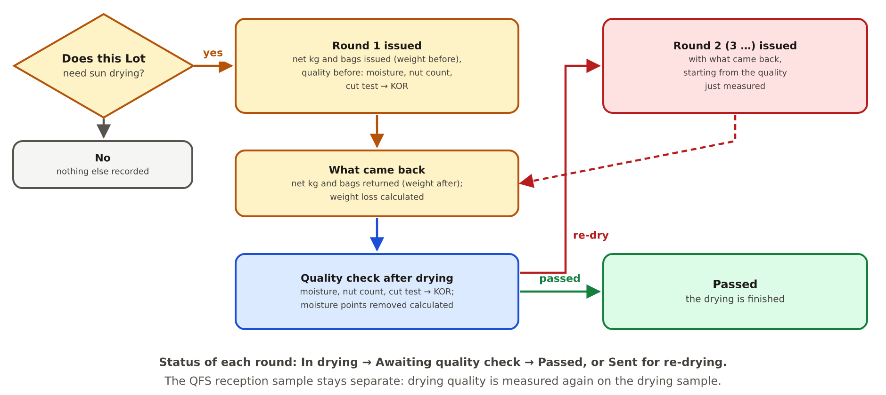
Figure 11. Sun drying: a round is issued, comes back, and is checked; a re-dry starts the next round.
Moment | What is recorded | Round status after it
1. Issue | Date, how it goes (direct / via the warehouse), drying type, source and destination bin.  Weight before drying: net kg and bags issued.  Quality before drying: moisture (required), nut count, cut-test grams; KOR is calculated from the grams. | In drying
2. What came back | Weight after drying: net kg and bags returned. The weight loss (kg and %) is calculated. | Awaiting quality check
3. Quality check | Quality after drying: moisture (required), nut count, cut test, KOR.  The result: Passed, or Dry it again. | Passed, or Sent for re-drying

- Dry it again closes the round and immediately opens the next one (round 2, 3 …) with the weight that came back as its weight before drying, and the quality just measured as its quality before drying.
- Passed finishes the drying. A Lot can still be dried again later; that starts a new round 1.
- Calculated, never typed: weight loss (kg and %), moisture points removed, and KOR wherever the cut-test grams are recorded.
- The kg returned can never be more than the kg issued, and moisture must be between 0 and 100 %.
- Only one round per Lot can be open at a time. Drying is always per Lot, never per bin.
The QFS sample stays separate
The quality measured at reception (the QFS sample, chapter 9) is never copied into or changed by drying. Before and after each round, the quality is measured again on the drying sample, so the two can be compared.

Each round is shown on the truck's page with its status, weights, quality before and after, and who issued, received and checked it. The Drying screen lists every round of the site (with its round number and moisture before → after), together with the batches imported from the client's drying workbooks.

14. Other warehouse activities
Between arrival and departure, warehouse teams do other work on the nuts. Each piece of work is recorded on the Warehouse Activity Ledger with Record an activity, under one of these categories:
Category | Examples / notes
Offloading | Discharging bags
Stacking / Destacking | Building or taking down stacks of bags
Re-bagging / reconditioning | Replacing or mending bags
Drying | Opens the drying form (chapter 13)
Triage / cleaning | Sorting out foreign matter; quality and moisture are recorded
Movement between locations | From one place to another; both locations are recorded
Bin rearranging / repair | Work on the bin itself
Other | Anything else

Rows imported from the old workbook keep their original free text. The application only suggests a category for them on screen; it never rewrites what was recorded.

15. Transfers between warehouses (BKT)
Lots are moved from Bouaké to Yakro by truck. One truck is one transfer, numbered BKT-2026-001 and so on (the client's own numbering, which continues the old BKT001 series). Each warehouse fills in only its own half: the sender records what left, the receiver records what arrived.
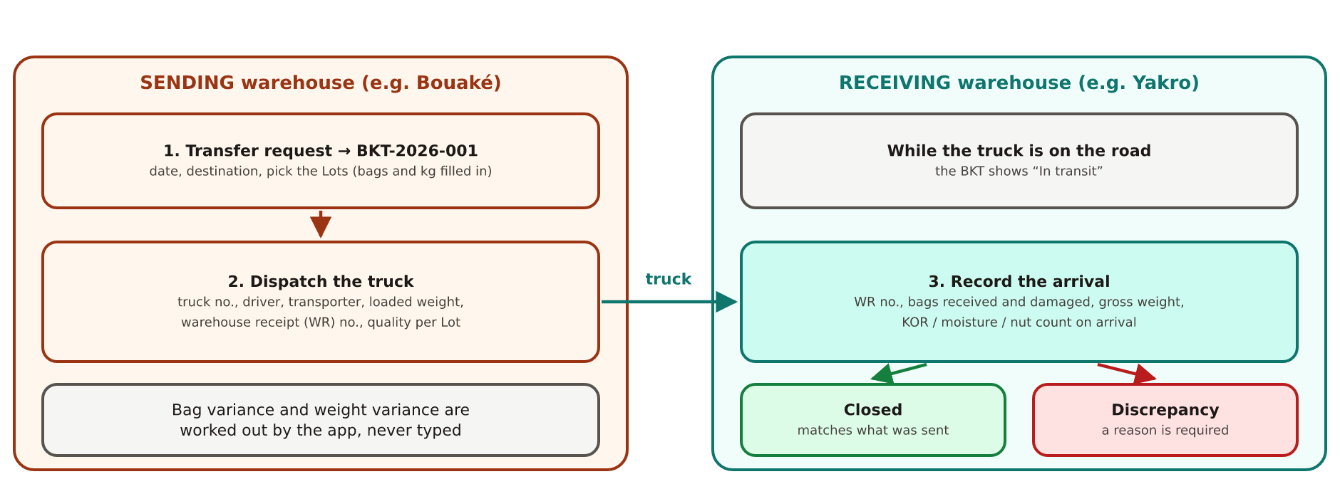
Figure 12. A transfer from request to arrival.
- New transfer request (sending site): date, destination, and the Lots to send. Bags and net kg are taken from each Lot's own record, so nothing is typed twice. The Lots' status becomes Transferred out.
- Dispatch truck (sending site): truck number, transporter, driver and phone, loaded weight, the warehouse receipt (WR) number, and the quality of each Lot (moisture, KOR, nut count), pre-filled from its own quality test.
- Record arrival (receiving site): its own WR number, bags received and damaged, gross weight received, KOR / moisture / nut count on arrival, and its own Lot number if it gives one.
The application calculates the bag variance and weight variance between what was sent and what arrived. If they differ, the receiver must write why (damaged bags, short load, weighing difference). The transfer then shows Closed (matches) or Discrepancy. Click any row on the Transfers screen to open the transfer's own page.

16. Jute bags
RCN is bagged in jute bags. Bags are given to suppliers to fill, come back full on their trucks, are stored, moved between sites and issued to the factory. Because they are an asset, they have four ledgers (running lists of movements), on the Jute Bag Management screen.
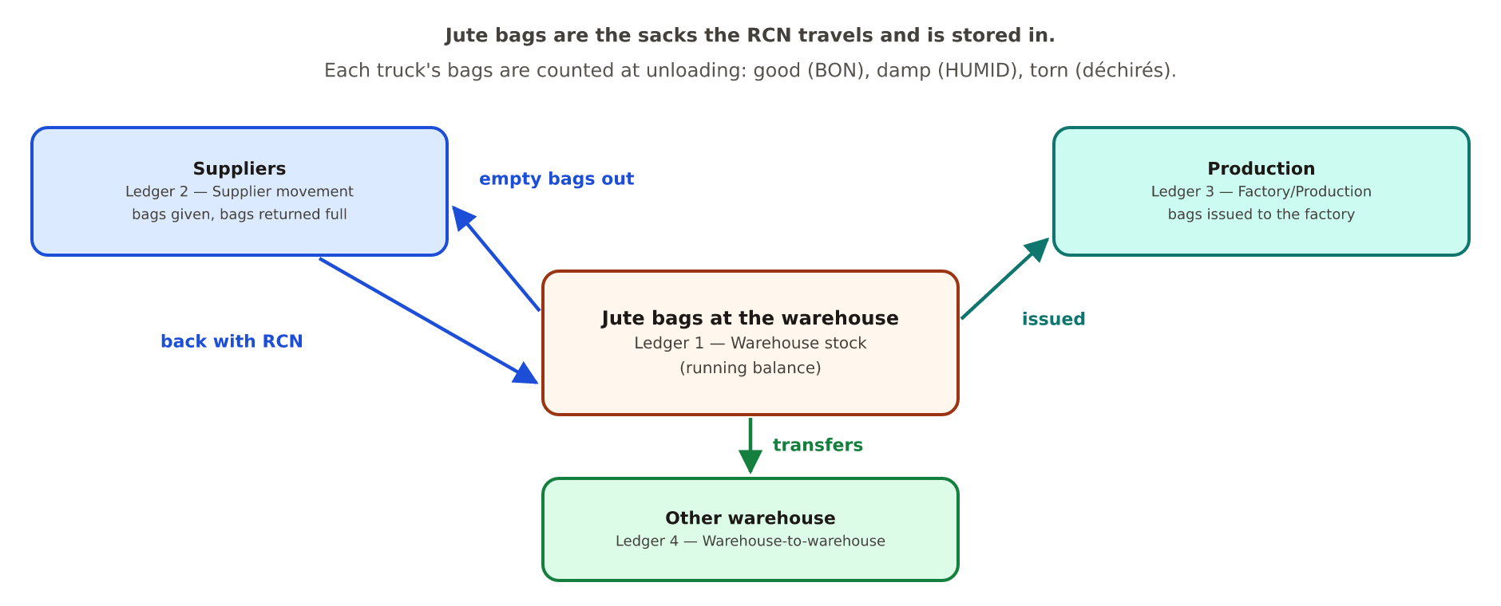
Figure 13. The four jute bag ledgers.
Ledger | Records | Source today
1. Warehouse stock | Bags in and out of the warehouse, with a running balance worked out by the database. | 298 real rows from the 2026 workbook, plus anything entered since.
2. Supplier movement | Bags given to suppliers and returned via deliveries. | No row-by-row source exists yet; filled as it is entered.
3. Factory/Production tracking | Bags issued to production. | No row-by-row source yet.
4. Warehouse-to-warehouse | Bags moving between sites. | 415 real rows from the Receiving at Factory report.

Real data is shown as it is
The client's own warehouse balance goes negative at one point. That is what the workbook says, so it is shown and reported, never “corrected”. Columns marked new on screen are fields the workbooks do not have yet.

17. Getting data in and out
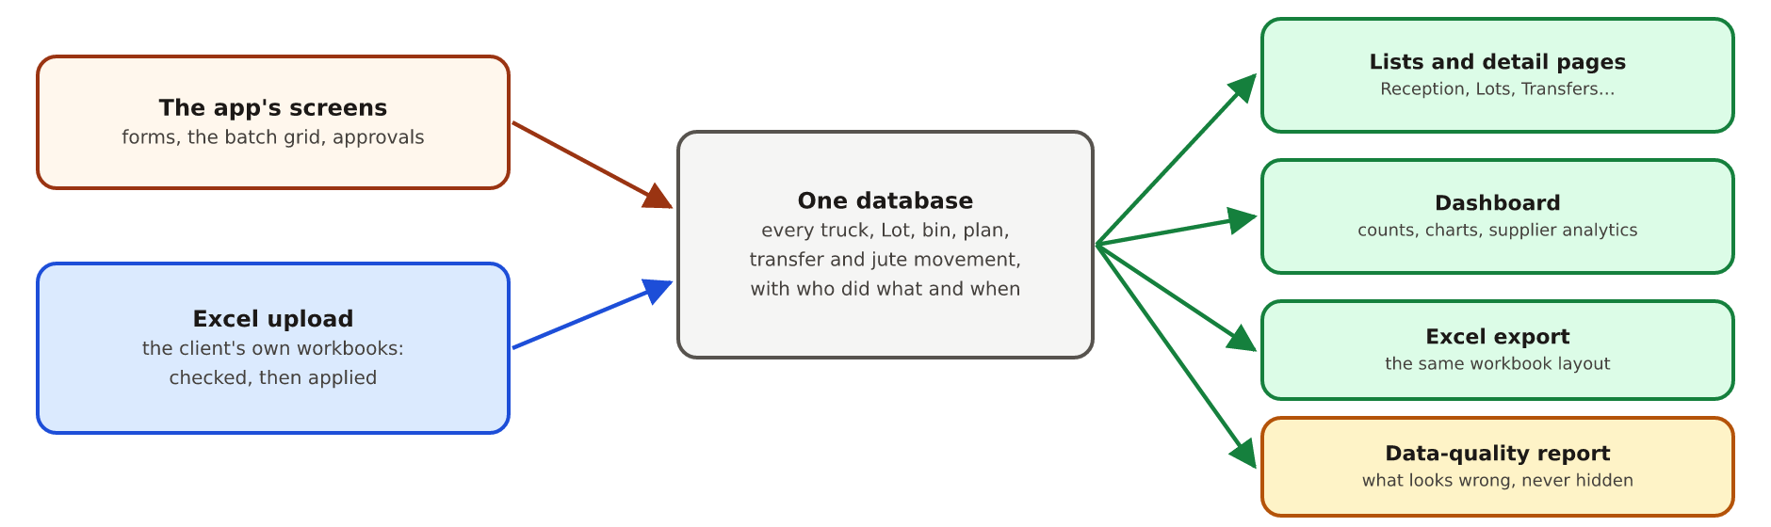
Figure 14. How data enters the system and where it shows up.

17.1 Entering data
- Screens: the truck page, the Add entries grid (many trucks at once), the forms for drying, transfers, activities, plans, suppliers and bins.
- Excel upload (Upload on Reception): the client's own workbooks are read, checked row by row and applied. A row that would break a rule, or change a locked record, is reported as an error instead of being forced in.
- Approvals: forms submitted by Branch Managers and QFS Officers wait there for the Warehouse Incharge.

17.2 Getting data out
- Export on Reception downloads the site's data in the same workbook layout, optionally for a date range. For the Warehouse Incharge the price and amount columns are left out, and if a file with those columns is uploaded by the Incharge they are ignored (and the upload says so).
- Every list can be searched, filtered per column (the funnel icon in a column header) and opened row by row.
- Upload issues on a truck's page list things that looked wrong in an upload (accepted anyway) until someone marks them reviewed.

17.3 Imported versus entered
Every truck carries its source: imported (from the client's 2026 workbooks, 986 truck rows) or entered (typed into the application). Imported history is real data, never invented: when a workbook has no value, the field stays empty.

17.4 Data quality report
The real workbooks contain known problems: duplicate serial numbers, a broken formula column, a negative balance, codes that do not match between sheets. These are never silently fixed. They are stored exactly as found and listed with counts on the data-quality report, so they can be corrected at the source.

18. The dashboard and supplier analytics
The Dashboard is the first screen for Admin and Warehouse Incharge. A date filter at the top (From / To) applies to everything on it.
- Status tiles: trucks arrived, accepted & unloaded, GRN completed, pending QA, pending unload after QA, rejected. Each opens the filtered list.
- Receipts by status: a chart of all ten statuses.
- Jute bag warehouse stock: the current balance and its trend.
- Recent activity: the latest trucks.

18.1 Supplier analytics
The Suppliers section shows one line per supplier for the selected dates (and, for Admin, a chosen site), plus totals, a chart of the top 10 suppliers by GRN kg, and a searchable table. Trucks without an LBA code get their own line, so the lines always add up to every truck.
Figure | Meaning
Trucks · Rejected | Trucks arrived; trucks failed at quality, as a count and a percentage.
Bags · Damaged bags | Bags counted on accepted trucks (good / damp / torn); damp + torn as a share of bags.
GRN kg | Quantity officially received: what “delivered” means.
Awaiting GRN | Accepted trucks with no GRN quantity yet.
Net weighed kg · Paid kg | Weighed on arrival; the weight paid on.
Avg KOR · Avg moisture % | Averaged by weight over accepted trucks.
Target kg · Achievement | Kilograms on the supplier's delivery plans, and the share received.
Jute bags with supplier | Bags given minus bags returned.
Last delivery | Arrival date of the latest accepted truck.

Each supplier's line is calculated exactly like the figures on that supplier's own page, so the two never disagree. Money is not shown.

19. System IDs: how to read a number
Every important record gets a number made of readable parts. They are issued by the system and never change.
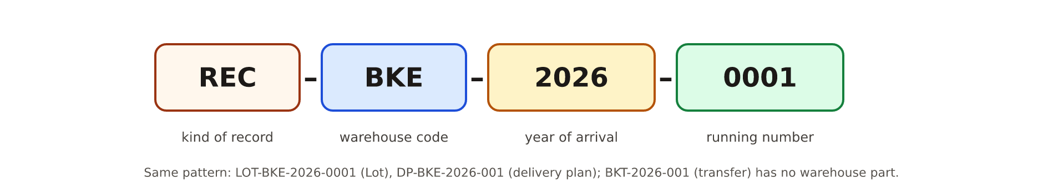
Figure 15. The four parts of a receipt number.
Number | Example | Issued when | Notes
Receipt | REC-BKE-2026-0001 | The truck's arrival is recorded | Every truck, accepted or rejected.
Lot | LOT-BKE-2026-0001 | The truck passes quality | One accepted truck, one Lot.
Delivery plan | DP-BKE-2026-001 | A plan is created
Transfer | BKT-2026-001 | A transfer is requested | One BKT = one truck. Continues the client's BKT001 series.
Supplier | SUP-0001 | A supplier is registered | Never changes, even if the LBA code does.

The year is the year of the arrival (or plan, or transfer) date, not the day it was typed. The warehouse code (BKE, YAK) comes from the warehouse register. Trucks imported from 2026 also keep the number they had before, so old links still work.

20. Rules the system always follows
- One truck = one Lot, always.
- A bin can hold many Lots; a Lot is in one bin.
- Drying is per Lot, never per bin.
- A rejected truck is kept, with a written reason.
- Net, paid and GRN quantities are separate; “delivered” means the GRN quantity.
- Calculated values are never typed: net weight, total bags, paid weight, amount, KOR (when grams exist), drying loss, variances and every status.
- Approvals before changes for Branch Manager and QFS Officer forms.
- A completed GRN locks the reception record; only an Admin reopens it, with a reason.
- Nothing is invented: a missing value stays empty and is reported.
- Data problems are reported, never silently fixed.
- Each site sees its own data; Admin sees all.
- Every date reads DD/MM/YYYY.
- Price and amount are for the Branch Manager and Admin only; the Warehouse Incharge never sees them.
- The QFS sample is never overwritten; drying measures its own quality before and after.

21. A worked example: one truck from gate to Yakro
A walk through the whole floor with one imaginary truck. The weights and quality figures are the real values used in the diagrams; the truck and people are examples.
- Before: supplier SCOOP A has delivery plan DP-BKE-2026-004 for 120,000 kg in October.
- 08:10 — gate. Truck 1796GC01 arrives at Bouaké. The gate creates the record: REC-BKE-2026-0312, arrival date filled in by itself. Status: Arrived.
- Documents. The Branch Manager submits the supplier, LBA code, fiche 004512 and links plan DP-BKE-2026-004. The Warehouse Incharge approves it.
- Weighbridge. The loaded reading on arrival and the empty reading after unloading, both entered in the Weight step, give a gross weight of 41,300 kg.
- Quality. The QFS Officer cuts a 1000 g sample: good kernel 230 g, immature 13 g, spotted 12 g, moisture 9.8 %. KOR is calculated: 42.77 lbs. The Incharge approves the form and records Pass. Lot LOT-BKE-2026-0298 is issued. Status: Pending unload.
- Unloading. 463 good, 0 damp and 15 torn bags: 478 bags. Net weight = 41,300 − 478 = 40,822 kg; with 60 kg refraction, paid weight = 40,762 kg. Status: Unloaded.
- Bin. The Lot goes to bin BIN-03 in store BKE-002; the Incharge presses Finalise bin allocation.
- GRN. The Branch Manager saves the price (470 XOF/kg) directly; the Warehouse Incharge, who never sees it, records the GRN quantity. Status: GRN completed, then In stock. The record locks.
- Drying. Moisture is fine: the answer is No — no drying needed.
- Transfer. Next week the Lot is put on transfer BKT-2026-018 to Yakro, dispatched with WR number 1187 and its quality pre-filled. Status: Transferred out.
- Arrival at Yakro. Yakro records 477 bags received, 1 damaged, and writes the reason for the one-bag difference. The transfer shows Discrepancy with the reason on record.
- Production. Yakro issues the Lot to production against a BTM slip; the Production Floor Guide picks up the story from there.
Throughout, the dashboard's counts, the delivery plan's progress and supplier SCOOP A's page update by themselves.

22. Glossary: every word explained
Alphabetical. Words used on screens are written as they appear there.
Word | Meaning
Achievement % | Kilograms received on a supplier's delivery plans ÷ kilograms planned.
Activity ledger | The ordered list of work done in a warehouse (chapter 14).
Admin | The role that can do everything at every site, including reopening locked records.
Amount | Price per kg × paid weight, recorded at the GRN step. Shown to the Branch Manager and Admin only.
Approval / Approvals | The Warehouse Incharge's check of a form submitted by a Branch Manager or QFS Officer; the screen where they wait.
BKT | A transfer between warehouses, one truck each (BKT-2026-001).
BON SACS | Good bags (French). Counted at unloading.
Branch Manager | Role that submits reception details (truck, supplier, LBA code, fiche) and sets the price directly.
BTM | Bordereau de Transfert: the slip under which RCN is handed to production. Starts the Production Floor Guide.
Bin | A storage position in a store (BIN-03); can hold several Lots.
Calculated (field) | A value the application works out and shows read-only.
Cashew apple | The fruit the cashew nut hangs from. Not bought by ANAGROCI.
Cut test | Cutting a 1000 g sample open and weighing every part (chapter 9).
Dashboard | The overview screen with counts, charts and supplier analytics.
Data-quality finding | A problem found in real data, reported with a count and never silently fixed.
Delivery plan (DP) | What a supplier is expected to deliver, and when (DP-BKE-2026-001).
Discrepancy | A transfer where what arrived differs from what was sent; a reason is required.
Drying / sun drying / drying yard | Removing moisture from wet RCN in the sun on the yard, in rounds (chapter 13).
Drying loss | Kg issued to drying − kg returned; also as a % of kg issued.
Entered / Imported | Typed into the application / loaded from the client's workbooks.
Fail | The quality decision that rejects a truck; a reason is required.
Fiche | The delivery slip number that comes with the truck (French “fiche” = form, slip).
Fiche CCA | A fiche number referring to the CCA, Côte d'Ivoire's cotton and cashew regulator (Conseil du Coton et de l'Anacarde); used to link procurement to production bins.
Finalise (bin allocation) | Closes the bin step and stamps its date and the person.
FINAL KOR | KOR from a repeated cut test; used instead of KOR when present.
Good kernel | A sound kernel in the cut test.
GRN | Goods Received Note: the official record of RCN taken into stock (chapter 11).
GRN quantity | The kilograms officially received. “Delivered” in reports.
Gross weight | Loaded truck − empty truck: RCN plus bags.
HUMID SACS | Damp bags (French).
Immature | An under-developed kernel; counts half in KOR.
Jute bag | The sack RCN travels and is stored in; tracked in four ledgers.
Kernel | The edible nut inside the shell.
KOR | Kernel Outturn Ratio: lbs of good kernel per 80 kg bag of RCN. Higher is better.
LBA code / LBA register | A supplier's code in ANAGROCI's supplier register, and the register itself.
Ledger | A running list of movements with a balance (jute bags, activities).
Lot | The nuts of one accepted truck, followed by number (LOT-BKE-2026-0001).
Lock (record lock) | A completed GRN makes the reception record read-only; Admin reopens with a reason.
Moisture | Water content of the nuts, in %.
Net weight | Gross − 1 kg per bag: the RCN itself.
Nut count | How many nuts make up the sample weight; fewer usually means bigger.
Offloading | Unloading a truck and everything up to the GRN; also a filter choice on Reception.
Oil | A kernel spoiled by shell oil (cut test).
Origin | Where the nuts were grown or collected.
Paid weight (PAID WT) | Net − refraction: the weight the supplier is paid on.
Pass | The quality decision that accepts a truck and issues its Lot number.
QFS / QFS Officer | The quality analysis step, and the role that performs it.
RCN | Raw Cashew Nut: the nut in its shell, as bought.
Receipt (REC) | The record of one truck (REC-BKE-2026-0001).
Reception | The screen listing every truck; also the part of the journey from gate to quality decision.
Re-dry | Sending a Lot back for another round of sun drying after its quality check.
Refraction | A weight deduction (kg) applied before payment.
Rejection (cut test) | A kernel that cannot be used.
Sacs déchirés | Torn bags (French).
Round (drying) | One pass of sun drying: issue, what came back, quality check (chapter 13).
Shell | The hard outer case of the nut; most of its weight.
Site | A whole location: Bouaké (BKE) or Yakro Factory (YAK).
Spotted | A stained kernel; counts half in KOR.
Status | Where a truck is in its journey, worked out automatically (chapter 12).
Store | A building inside a site (BKE-001/002/003).
Supplier | Seller of RCN, identified by an LBA code and a SUP number.
Suspended / Inactive | Supplier states: a warning on entry / removed from pickers.
Tare | The weight of the empty truck, entered in the Weight step with the loaded weight.
Transfer | Moving Lots to another warehouse on one truck (BKT).
Unplanned truck | A truck with no delivery plan; allowed, flagged as an exception.
Variance | The difference between what was sent and what arrived (bags, kg).
Void | A shell with nothing inside (cut test).
Warehouse Incharge | Role that manages one warehouse: edits directly, approves, decides Pass/Fail. Does not see prices or amounts.
WR number | Warehouse receipt number, required when a transfer is dispatched and received.
XOF | The West African CFA franc, the currency of prices.

