ANAGROCI · CASHEW (RCN) TRACKING
Production Floor Guide
How raw cashew nuts become packed cashew kernels in the Yakro factory, what is measured at every step, and how the tracking application records it. Written for someone who has never seen any of it.
Who it is for: new staff, managers, auditors and developers joining the project.
What you need to know first: nothing. Every word is explained the first time it appears and again in the glossary at the end.
Companion document: the Procurement Floor Guide covers how the nuts are bought, received and stored before they reach the factory. Terms explained there (RCN, KOR, Lot, Bin, GRN …) are repeated briefly here.

Version 1 · October 2026

Contents
1. Welcome: what this guide is for
2. From raw nut to packed kernel in two minutes
3. Where production stands in the application
4. The handover from procurement
5. What production follows: BTM, Bin and Lot
6. Phase 1 · Intake from the warehouse
7. Phase 2 · Calibration and sizing
8. Phase 3 · Cooking
9. Phase 4 · Shelling
10. Phase 5 · Colour sorting
11. Phase 6 · Borma ovens
12. Phase 7 · Peeling and grading
13. Phase 8 · Packing and finished goods
14. Utilities: water, steam and the shell loop
15. The twelve quality checks
16. The status of a BTM and a Lot
17. Plant-level trackers
18. The workbooks and where each one fits
19. Things to know when reading the numbers
20. What is not recorded yet
21. Glossary: every word explained

1. Welcome: what this guide is for
The production floor is the factory at Yakro (Yamoussoukro), where ANAGROCI turns RCN (Raw Cashew Nut: the nut still in its shell) into clean, graded, packed kernels (the cashew nuts people eat). This guide walks through that factory phase by phase: what happens physically, why, what is measured, which of the client's workbooks records it, and how the tracking application models it.
How to read this guide
Chapters 2 to 5 give the whole picture: read them first. Chapters 6 to 14 follow the nuts through the factory, one phase each. Chapters 15 to 20 are reference: quality checks, statuses, workbooks, data notes and gaps. The glossary is chapter 21.
Workbook names are written exactly as the client's files are named, for example 6. Cooking Process Report. Example values come from those workbooks.

Words you will meet everywhere
RCN: raw cashew nut in its shell. Kernel: the nut inside. Shell: the hard case around it (not food). Testa (or husk): the thin brown skin on the kernel.
KOR: Kernel Outturn Ratio, the pounds (lbs) of good kernel one 80 kg bag of RCN gives. Higher is better.
BTM: Bordereau de Transfert, the slip under which RCN is handed from the warehouse to production. Lot: a production batch, born at cooking. Bin: a storage position or silo.

2. From raw nut to packed kernel in two minutes
A cashew kernel is locked inside a hard shell full of a caustic oil, and wrapped in a thin skin. The factory's whole job is to get it out whole, clean and dry, sort it, and pack it, losing as little as possible on the way. Whole kernels sell for much more than broken pieces, so every step tries to avoid breaking them.
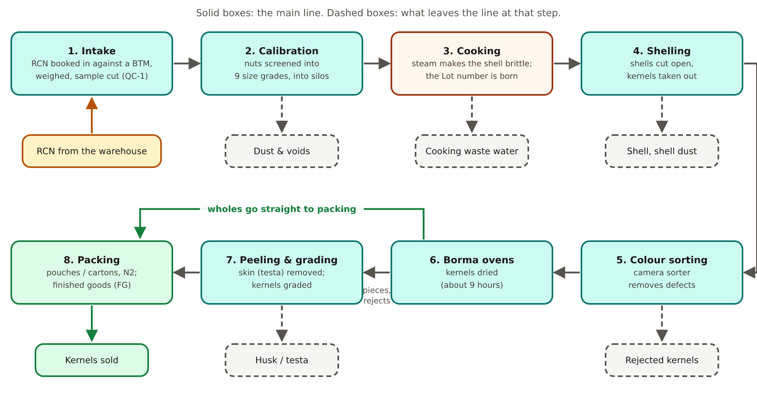
Figure 1. The production line in eight phases, and what leaves it at each step.
Two side flows run alongside: utilities (water, steam, and a boiler that burns the factory's own shells, chapter 14) and by-products sold or disposed of (dust, voids, shells, cooking waste water, husk, rejects).
Phase | What happens, in plain words
1. Intake | RCN arrives from the warehouse on pallets, is weighed, and a sample is cut open to check quality.
2. Calibration | Machines screen the nuts by size into nine grades, which are stored in silos. Same-sized nuts shell better.
3. Cooking | Steam under pressure makes the shell brittle so it cracks cleanly. The production Lot number is created here.
4. Shelling | Machines cut each shell open and the kernel is scooped out. Shells that did not open go round again.
5. Colour sorting | A camera machine throws out discoloured and defective kernels.
6. Borma ovens | Kernels are dried in ovens (the Borma) for about nine hours, which loosens the skin.
7. Peeling & grading | The skin is removed and kernels are graded into the many grades they are sold under.
8. Packing | Kernels are packed in pouches and cartons, flushed with nitrogen, and become finished goods.

3. Where production stands in the application
Read this first
In the application's menu, Production currently shows a placeholder marked Soon. The procurement module is the one in daily use.
Behind that placeholder, the production model is already built: its data structure (25 tables transcribed from the client's workbooks), the screens for BTMs, Bins and Lots, and the real data loaded from the production workbooks. These pages exist but are not linked from the menu while the module is being revisited. Bringing them back is a menu change only.

What the application already does for production:
- BTM pages: the list of BTMs and, for each, its receipt lines, QC-1 sample cut and calibration runs.
- Bin pages: production bins (silos) with their stock movements and progress through the phases.
- Lot pages: each production Lot with its cooking, shelling, Borma and packing records.
- Plant-level tables: boiler consumption, shell dispatch, waste dispatch, work-in-progress stock.
- Statuses for BTMs and Lots, worked out from the records (chapter 16), never typed.
- Admin and Warehouse Incharge only.
Everything in chapters 6 to 14 describes both the factory and how the model records it. Where no workbook exists for a step, the guide says so (chapter 20); nothing is invented to fill the gap.

4. The handover from procurement
Production starts where procurement ends: dry RCN sitting in a bin of the Yakro factory warehouse. Three records connect the two floors.
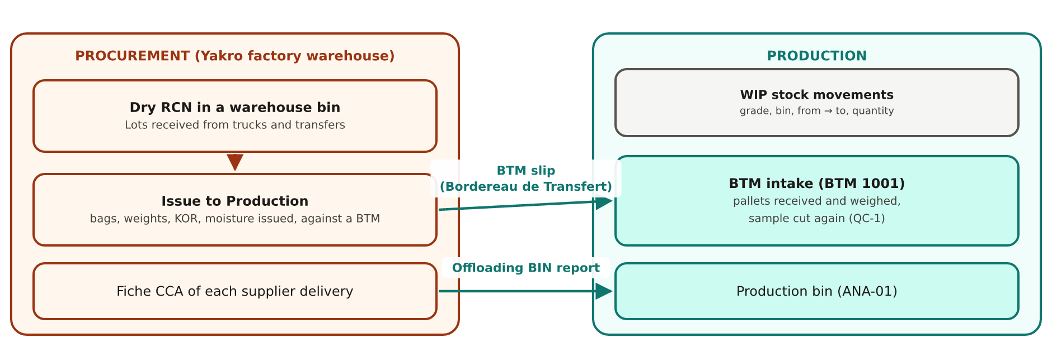
Figure 2. The three bridges between the procurement and production records.
Bridge | Workbook | What it records
Issue to Production (the BTM slip) | Factory Warehouse RCN Transfer to Production Report | The warehouse hands dry RCN to production against a BTM number: source bin, dry bin, bags and pallets, gross and net weights before and after drying, the KOR and quality issued, and what production received.  Diff in Issue shows any difference between what was issued and what production received.
Offloading BIN report | Theoretical Export Yield Prediction - Anagroci | Ties each supplier delivery's Fiche CCA number to the production bin it landed in, with its KOR, moisture, nut count and cut-test grams. A second, independent link back to procurement.
WIP stock movements | Daily production report | The work-in-progress log: date, grade, type, from, to, bin, quantity. How material moves between production locations day by day.

BTM
BTM = Bordereau de Transfert (French: transfer slip). The BTM number written by the warehouse on the slip (for example 1001) is the number production works from in phases 1 and 2.

5. What production follows: BTM, Bin and Lot
In procurement, everything follows one Lot per truck. Production is different: the nuts are mixed, sized and re-batched along the way, so the factory follows three things in turn.
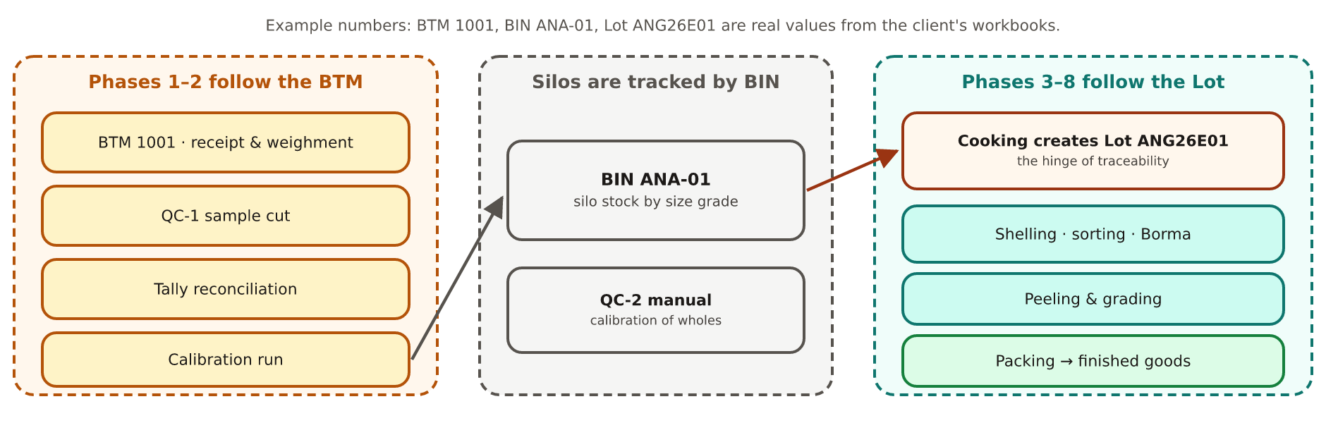
Figure 3. Phases 1–2 follow the BTM, the silos follow the bin, phases 3–8 follow the production Lot.
Thing | Example | What it is | Followed in
BTM | 1001 | One handover of RCN from the warehouse. | Phase 1 (intake) and phase 2 (calibration).
Bin (production) | ANA-01 | A storage position or silo in the factory. Calibrated nuts are stored by bin and by size grade. | Silo stock, QC-2, offloading BIN report.
Lot (production) | ANG26E01 | A cooking batch. Created when the nuts are cooked; everything after cooking is tracked by it. | Phases 3 to 8: cooking, shelling, sorting, Borma, peeling, packing.

Two different kinds of “Lot”
A procurement Lot (LOT-BKE-2026-0001) is the nuts of one accepted supplier truck. A production Lot (ANG26E01, ANG26E02 …) is one cooking batch in the factory.
They are different things with different numbering. Production links back to procurement through the BTM, the bins and the Fiche CCA, not through the Lot number.

Cooking is the hinge of traceability: before it, records are kept per BTM or bin; from it onwards, per production Lot.

6. Phase 1 · Intake from the warehouse

6.1 Receiving and weighing
RCN arrives from the warehouse on pallets and is booked in against its BTM. Every pallet is weighed (1. RCN Receipts):
- Received gross quantity (everything on the pallets) − pallets + bags weight = net weight of RCN.
- Each row also records the date, crop year, BTM number, the source bin it left in the warehouse and the production bin it goes to.
A pallet-by-pallet balance check is kept in 19. RCN Receipts Tally Sheet (bags, bag weight, pallet weight, net weight, dust and voids): did what went in match what came out?

6.2 Quality Check-1: the sample cut (QC-1)
Production cuts its own sample, independent of procurement's test (2. Input RCN Quality report). A 1000 g sample is cut open and every part weighed:
Measured | Example (real first row) | Meaning
Nut count · Moisture | 180 · 9.8 % | Nuts in the sample weight; water content.
GK (good kernel) | 230 g | Sound kernels.
Spot · Immature | 12 g · 13 g | Usable but lower-value kernels.
Oil · Rejection · Voids | 5 g · 32 g · 25 g | Spoiled, unusable, empty.
Shell · Fruit waste | 664 g · 19 g | The shell; bits of fruit and debris.

From those grams the sheet works out three outturn figures, all in lbs per 80 kg bag (the factor 0.17637 converts grams per 1000 g into lbs per 80 kg bag):
Figure | Calculated as (checked on the real first row) | Example
KOR | (GK + ½ × (spot + immature)) × 0.17637: the same formula procurement uses | 42.77 lbs
SHOT | (GK + spot + immature) × 0.17637: every usable kernel at full weight | 44.97 lbs
FOT | (GK + spot + immature + oil + rejection) × 0.17637: every kernel, usable or not | 51.50 lbs
GK-Yield % · Total Yield % | (GK + spot + immature) ÷ 1000 · (all kernels) ÷ 1000 | 25.5 % · 29.2 %

The workbooks name SHOT and FOT but never spell out what the letters stand for; the formulas above are what the numbers actually are. If QC-1 is out of specification the BTM is put on quality hold (chapter 16).

6.3 RCN stock
3. RCN Stock Report is a running daily balance of RCN in the factory: received (phase 1) and issued into calibration (phase 2) on the same row.

7. Phase 2 · Calibration and sizing
Nuts of the same size crack the same way, so before cooking they are screened into nine size grades by their size in millimetres. The input side is recorded in 4. Calibration Process report: gross weight, bags and pallet weight, net RCN, BIN, BTM, and what was screened out.
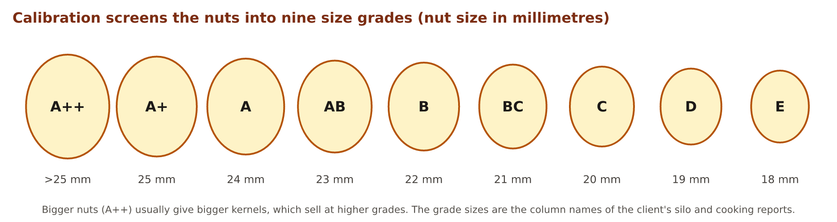
Figure 4. The nine calibration grades.
- Dust: shell grit knocked off during screening. Voids: shells with no nut inside. Both are weighed off (kg and %) and trucked away.
- Net weight of RCN issued to silos = what remains after dust and voids.
- The empty pallets, jute bags, dust and voids are weighed too, so the balance can be checked.

7.1 The silos
The sized nuts are stored in silos, by bin (5. Calibrated RCN Silos Stock report). This is where the nine grades get their own columns: opening stock + sized RCN in − cooked quantity out = closing stock, per grade.

7.2 Quality Check-2: manual calibration of wholes (QC-2)
Oversize nuts are pulled out by hand and counted back into the nine grades (24. Wholes Manual Calibration), a manual cross-check on the automatic screens.

8. Phase 3 · Cooking
Nuts from the silos are steam-cooked under pressure (6. Cooking Process Report). Cooking makes the shell brittle and the oil less aggressive, so the shell cracks cleanly in the next phase without damaging the kernel.
The Lot is born here
Each cooking batch gets a production Lot number (ANG26E01, ANG26E02 …). Everything downstream is tracked by this Lot, not by BTM. The cooking row records the date, bin, Lot number, the quantity of each of the nine size grades cooked, the total quantity and the number of bags.

- Cooking waste water is the plant's largest waste stream by weight. It is tankered off site by a contractor and weighed in and out (15. Waste Management Dispatch Tracker, which now also covers other waste such as calibration dust).
- After cooking, the nuts are meant to rest 24 hours in cooling silos, with a moisture and temperature check. No workbook records this today (chapter 20).

9. Phase 4 · Shelling
Shelling machines cut each cooked shell open and the kernel is scooped out (7. Shelling process Report). One row per Lot holds the whole mass balance: what went in, and every stream that came out.
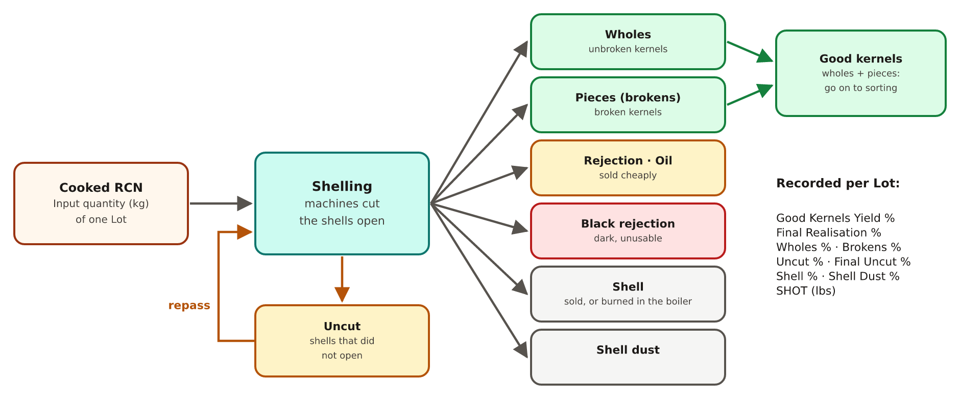
Figure 5. Shelling: one input, many outputs, and the repass loop for uncut nuts.
Stream | What it is | Where it goes
Wholes | Unbroken kernels: the most valuable. | On to colour sorting.
Pieces (brokens) | Kernels broken in the process. | On to colour sorting.
Rejection · Oil | Unusable or oil-spoiled kernels. | Sold separately at a much lower price.
Black rejection | Dark, burnt-looking kernels. | Set aside.
Uncut | Shells that did not open, kernel still inside. | Counted and sent back through shelling (repass). What is still uncut after that is the final uncut.
Shell · Shell dust | The broken shells and their dust. | Sold to contractors or burned in the plant's boiler (chapter 14).

The same row records the yields: Good Kernels Yield %, Final Realisation %, Wholes %, Brokens %, Uncut %, Final Uncut %, Shell %, Shell Dust %, and the SHOT in lbs.

9.1 Quality Check-5: the machines (QC-5)
Each shelling machine is sampled per line and per shift (13. Shelling Machine Quality Reports, the most detailed sheet in the set). Uncut and unscoop percentages per machine show a badly-set machine quickly. A companion sheet (21. Shelling Frequency Machine Report) records nuts processed per machine per minute and per hour, and 23. Shelling Line wise Processing Data follows the uncut / repass loop by production line.

9.2 Shell handling and sales
- Quality Check-6 (QC-6): shell samples are cut at three points (direct line, before conveyor, after conveyor) to measure kernel being thrown away with the shell (11. Shell Waste Sample Report).
- Shell is sold steadily all season. A buyer's truck arrives, its documents are checked, it is weighed empty, positioned under the shell silo, loaded, weighed full, and the paperwork is completed (16. Shell Dispatch Tracker).

10. Phase 5 · Colour sorting
A colour sorter, a machine with cameras, throws out discoloured and defective kernels.
Quality Check-7 (QC-7) samples each Lot twice, before and after the sorter, so the machine's own effect can be measured (12. Shelled Kernels Quality Report). Each sample records nut count, moisture and grams of wholes, brokens, butts, back-cut, rejection, adhering matter / oil, edge cut, uncut, unscoop and shell, with percentages. The drop in rejection between the two samples is the sorter's yield.

11. Phase 6 · Borma ovens
Sorted kernels still carry their skin and some moisture. They are loaded onto trays and trolleys and dried in the Borma ovens. Drying loosens the skin for peeling and gives the kernel its keeping quality.
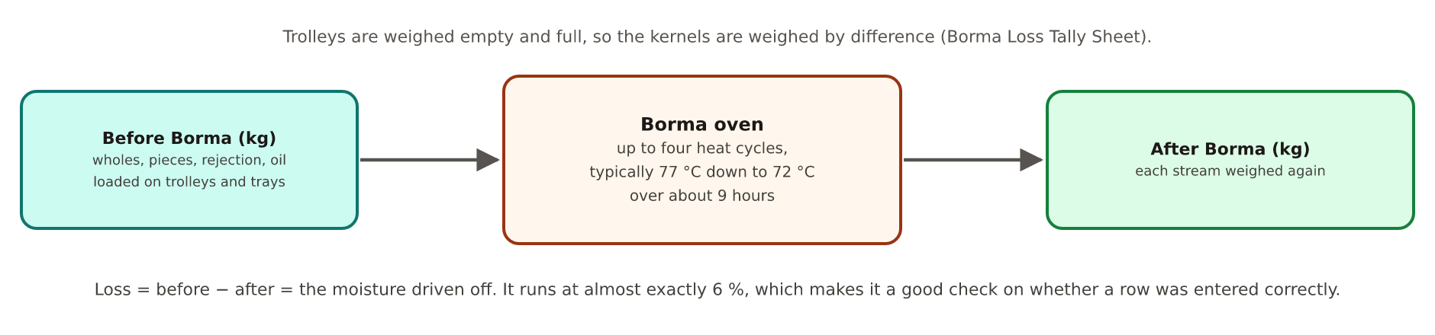
Figure 6. The Borma oven by weight.
- Trolleys are weighed empty and full, so the kernels are weighed by difference (18. Borma Loss Tally Sheet). The same sheet records where each trolley goes next.
- Oven settings: up to four heat cycles per run, each with its own temperature and duration (20. Borma Machine Monitoring report).
- 8. Borma Process Report records, per Lot, wholes, pieces, rejection and oil before and after the oven, and the loss (≈ 6 %, the moisture driven off).

11.1 Quality Check-8 and the fork (QC-8)
A 1000 g sample straight out of the oven gets a full defect breakdown (14. Final Output Analysis Report): good kernels, pieces, butts, scorched, spotted, PUK3, shrivelled, blemish, dessert, oil, dirty, mechanical damage, rejection, husk.
Then the flow splits, as the client's own Borma tally sheet records:
- To Packing — Wholes (6,242 of 6,940 routed trolley rows): wholes skip peeling and go straight to packing (phase 8a).
- To Peeling — Pieces / Rejects (698 rows): go to peeling and grading (phase 7), then packing (phase 8b).

12. Phase 7 · Peeling and grading
The testa (thin brown skin) is removed and the kernels are sorted into the grades they are sold under.
Step | What happens | Recorded?
Humidification | A little moisture is put back so kernels do not shatter when the skin is rubbed off. | No workbook
Quality Check-10 | Moisture check before peeling. | No workbook
Peeling | The skin comes off. | Manual Peeling Individual performance
Husk winnowing | Air is blown through the husk to recover good pieces caught in it. | No workbook
Colour sorter, dicing, manual peeling, Taiho | Four finishing routes that together produce the 50 to 60 sale grades; dicing cuts kernels into even pieces. | Only manual peeling
Quality Check-12 | Is the grading right? | No workbook

Manual Peeling Individual performance logs daily output by grade code, total kilos, manpower, average per head and recoverability %, and rates individual workers' productivity from GOOD to V.POOR. Its grade codes are kept exactly as the sheet names them:
Grade code | Usual meaning in the cashew trade
WW | White wholes: whole kernels, white colour (the top grades)
SW · SSW | Scorched wholes · slightly scorched wholes
DW | Dessert wholes: lower-quality wholes
LWP · SP | Large white pieces · scorched pieces
CW, PUK1–3, SS, LP, DP, OW, DW2, FB, SB, FS, OP, SSP2, KTP, SP2, Powder | As named in the client's sheet; meanings to be confirmed with the factory team

Grade names
Only the meanings in the first rows are standard across the cashew trade. The application stores every code exactly as the workbook writes it and never translates or merges them.

13. Phase 8 · Packing and finished goods
Kernels are filled into pouches or cartons, flushed with nitrogen (N2) to keep them fresh, and become finished goods (FG). Wholes arrive straight from the Borma (8a); peeled and graded kernels from phase 7 (8b).
Packing Traceability FG Aging Report records each packing: date, grade, material code, SKU (the sellable product), Lot and BIN, quantity packed and dispatched (pieces and kg), contract number, closing quantity, status and aging (how long the finished goods have been in store).
- Quality Check-9 at packing has no workbook today.
- Quality Check-11, the final check, uses the same final output analysis as QC-8.
- A Lot counts as dispatched once any of its packed quantity has actually been shipped (chapter 16).

14. Utilities: water, steam and the shell loop
Cooking needs steam, and steam needs water and fuel.
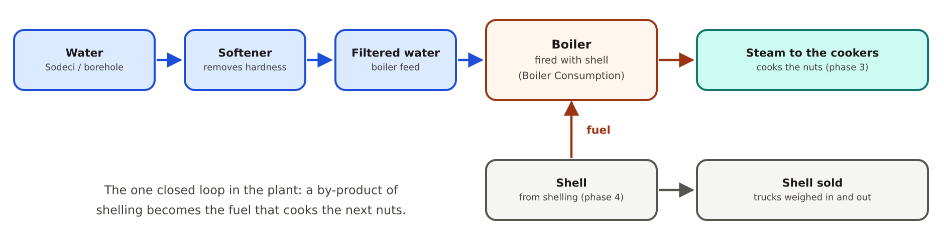
Figure 7. Water to steam, and the shell that fuels it.
- Water comes from the public supply (Sodeci) or a borehole, passes a softener (so the boiler does not scale) and a filter.
- The boiler is fired with the factory's own shell, recorded daily in 21. Boiler Consumption (material and kg consumed).
- This is the one closed loop in the plant: a by-product of shelling (phase 4) becomes the fuel for cooking (phase 3).
- Packaging materials (pouches, cartons, nitrogen) are consumed at packing; no consumption report for them is in the workbook set.

15. The twelve quality checks
The client's flow chart places twelve quality checks along the line. Seven have a real workbook today; five are gaps.
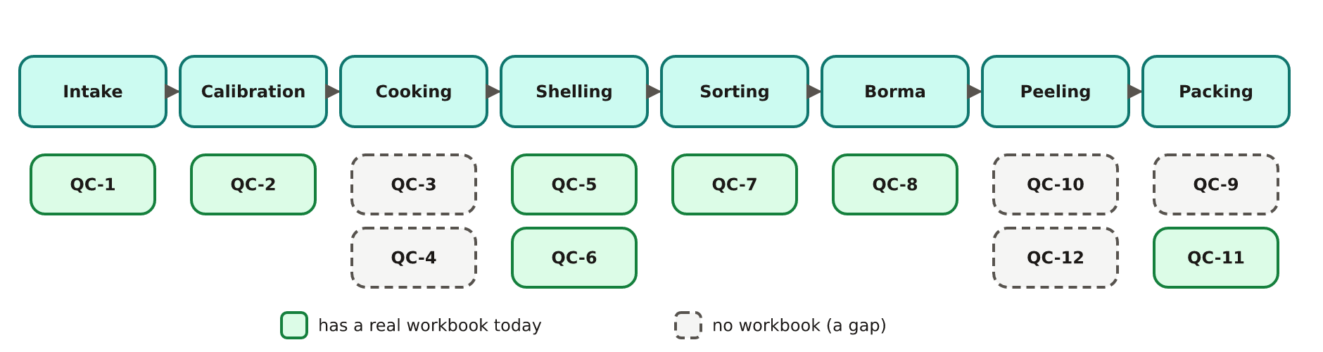
Figure 8. Where each quality check sits, and which are recorded.
Check | Where | What is checked | Workbook
QC-1 | Intake | Sample cut: KOR, SHOT, FOT, moisture, nut count | 2. Input RCN Quality report
QC-2 | Calibration | Oversize wholes counted back into grades by hand | 24. Wholes Manual Calibration
QC-3 | After the cooker | — | none (17. Cooking Cycles Monitoring was removed)
QC-4 | Cooling | Moisture and temperature before shelling | none
QC-5 | Shelling | Machine uncut / unscoop %, frequency and capacity | 13. Shelling Machine Quality Reports; 21. Shelling Frequency
QC-6 | Shell handling | Kernel lost with the shell | 11. Shell Waste Sample Report
QC-7 | Colour sorting | Before and after the sorter | 12. Shelled Kernels Quality Report
QC-8 | After the Borma | Full defect breakdown; routes to packing or peeling | 14. Final Output Analysis Report
QC-9 | Packing | In-process packing quality | none (its workbook was removed)
QC-10 | Before peeling | Moisture | none
QC-11 | Final | Final output analysis | 14. Final Output Analysis Report
QC-12 | Grading | Is the grading right? | none

16. The status of a BTM and a Lot
As in procurement, nobody types a status: the application works it out from which records exist.
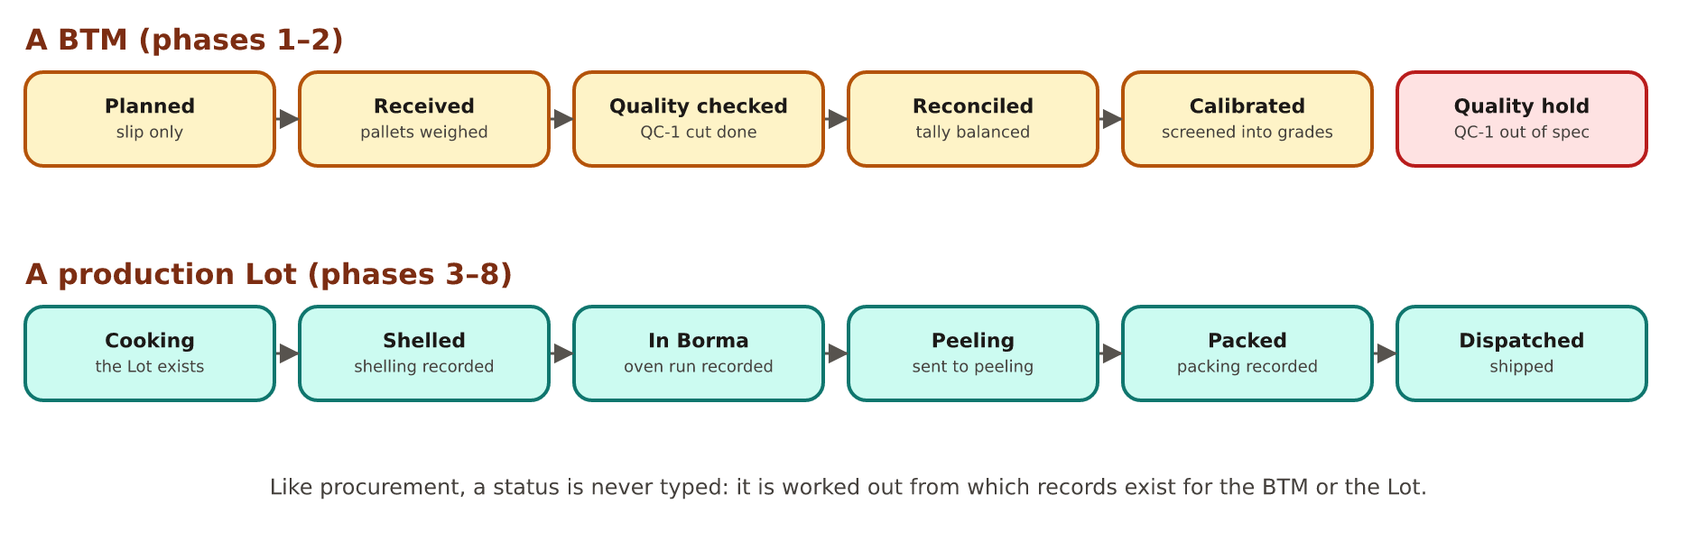
Figure 9. The statuses of a BTM and of a production Lot.
Status | Means
BTM · Planned | Only the slip exists; nothing received yet.
BTM · Received | Pallets booked in and weighed.
BTM · Quality checked | The QC-1 sample cut is recorded.
BTM · Reconciled | The tally sheet is recorded.
BTM · Calibrated | A calibration run is recorded.
BTM · Quality hold | QC-1 was recorded as out of specification.
Lot · Cooking | The Lot exists (it is created by cooking).
Lot · Shelled · In Borma | Shelling / a Borma run is recorded.
Lot · Peeling | Routed to peeling after QC-8, with peeling output recorded.
Lot · Packed | A packing record exists.
Lot · Dispatched | Some of the packed quantity has actually been shipped.

17. Plant-level trackers
Some workbooks track the whole plant, not one BTM or Lot. The application keeps them as stand-alone tables and does not invent a link to a Lot.
Tracker | What it records
15. Waste Management Dispatch Tracker | Waste trucked away (cooking waste water, calibration dust …), weighed in and out, with price and cost type.
16. Shell Dispatch Tracker | Shell sold: each buyer's truck, documents, tare and gross weights.
21. Boiler Consumption | Shell (and other fuel) burned per day.
Daily production report | Work-in-progress stock movements by grade, bin, from and to.

18. The workbooks and where each one fits
The production model was transcribed from the client's production workbooks (in the project's docs/Production folder) and wired together using the client's own flow chart. This table is the map.
Workbook | Phase / step
1. RCN Receipts | 1 · receiving and weighing pallets against a BTM
2. Input RCN Quality report | 1 · QC-1 sample cut
3. RCN Stock Report | 1–2 · daily RCN stock balance
4. Calibration Process report | 2 · calibration input, dust and voids
5. Calibrated RCN Silos Stock report | 2 · silo stock by size grade
6. Cooking Process Report | 3 · cooking; Lot created
7. Shelling process Report | 4 · shelling mass balance and yields
8. Borma Process Report | 6 · Borma before / after and loss
11. Shell Waste Sample Report | 4 · QC-6, kernel in the shell
12. Shelled Kernels Quality Report | 5 · QC-7 before / after the sorter
13. Shelling Machine Quality Reports | 4 · QC-5 per machine
14. Final Output Analysis Report | 6 / 8 · QC-8 and QC-11
15. Waste Management Dispatch Tracker | 3 · cooking waste water (plant level)
16. Shell Dispatch Tracker | 4 · shell sales trucks (plant level)
18. Borma Loss Tally Sheet | 6 · trolleys weighed; routing to packing or peeling
19. RCN Receipts Tally Sheet | 1 · pallet-by-pallet reconciliation
20. Borma Machine Monitoring report | 6 · oven cycles, temperatures, times
21. Boiler Consumption | Utilities · shell burned
21. Shelling Frequency Machine Report | 4 · QC-5 machine speed
23. Shelling Line wise Processing Data | 4 · uncut / repass by line
24. Wholes Manual Calibration | 2 · QC-2
Manual Peeling Individual performance | 7 · peeling output and worker productivity
Packing Traceability FG Aging Report | 8 · packing, dispatch and aging
Daily production report | WIP stock movements
Theoretical Export Yield Prediction - Anagroci | Bridge · Fiche CCA to production bin
Factory Warehouse RCN Transfer to Production Report | Bridge · issue to production against a BTM

19. Things to know when reading the numbers
The real workbooks have quirks. The application stores them exactly as found and reports them; it never quietly “fixes” them.
- Percentages in two styles: the Final Output Analysis Report stores percentages as fractions (0.68 for 68 %); every other production workbook stores whole numbers (92.1 for 92.1 %).
- Silo sheet columns: in the silos report, the “Batch No” and “BIN No” columns hold small numbers matching the adjusted quantity, not real batch or bin codes. Confirmed against the workbook; stored as they are.
- Fiche No in the Issue to Production sheet is mostly bin codes (109 of 125 values look like BIN-03B), so it is never used to link records.
- BTMs ahead of intake: 8 of the 112 BTMs in the Issue to Production sheet have no production intake record yet. That is expected: the warehouse sheet can run ahead.
- Workbook numbering: two files are numbered 21 (Boiler Consumption and Shelling Frequency); 9, 10 and 17 were removed from the file set.
- The QC-1 sheet no longer carries procurement's arrival and warehouse KOR next to its own, so that comparison cannot be made from this file alone.

20. What is not recorded yet
These steps exist on the client's flow chart but no workbook records them today. The application shows them as gaps; it does not fill them with invented values.
Phase | Step with no record
3 · Cooking | Quality Check-3 after the cooker; 24-hour cooling silos; Quality Check-4 (moisture and temperature)
7 · Peeling | Humidification; Quality Check-10; husk winnowing; colour sorter, dicing and Taiho routes; Quality Check-12
8 · Packing | Quality Check-9; filling of pouches; packaging and nitrogen consumption

Why this matters
A whole day (the cooling silos) has no record at all: if a Lot waited longer than 24 hours, or in which silo, cannot be found out afterwards. Closing these gaps is a decision for the factory team; the application is ready to record them as soon as there is a sheet or a form.

21. Glossary: every word explained
Word | Meaning
Adhering matter | Dirt or oil stuck to a kernel (QC-7 sample).
Aging | How long finished goods have been in store.
Back-cut · Edge cut | Kernels marked by the shelling blade (QC-7 sample).
Bin (production) | A storage position or silo in the factory (ANA-01).
Black rejection | Dark, burnt-looking kernels set aside at shelling.
Blemish · Shrivelled | Kernel defects counted in the final output analysis.
Boiler | Raises steam for cooking; fired with shell.
Borma | The ovens that dry the kernels after sorting (phase 6).
Brokens · Pieces | Kernels broken during processing.
BTM | Bordereau de Transfert: the slip under which RCN is handed from the warehouse to production.
Butts | Kernels broken across the middle (a type of piece).
Calibration | Screening nuts into nine size grades (phase 2).
Colour sorter | A camera machine that removes discoloured or defective kernels.
Cooking | Steam-cooking RCN under pressure to make the shell brittle (phase 3).
Crop year | The harvest year the nuts belong to.
Dessert (DW) | Lower-quality whole kernels.
Dicing | Cutting kernels into even pieces on purpose.
Dry loss % | Weight lost in the Borma oven as a share of the weight going in (about 6 %).
Dust · Voids | Shell grit from screening · shells with no nut (phase 2).
FG | Finished goods: packed kernels ready to sell.
Fiche CCA | A supplier delivery slip number (CCA: Côte d'Ivoire's Conseil du Coton et de l'Anacarde); links procurement to production bins.
Final Realisation % | Final kernels as a share of the shelling input.
FOT | (GK + spot + immature + oil + rejection) × 0.17637: every kernel, in lbs per 80 kg bag.
Fruit waste | Bits of cashew fruit and debris in a sample.
GK | Good kernel.
GK-Yield % · Total Yield % | Usable kernel grams ÷ sample grams · all kernel grams ÷ sample grams.
Humidification | Putting a little moisture back so kernels do not shatter when peeled.
Husk · Testa | The thin brown skin on the kernel, removed at peeling.
Immature · Spot | Under-developed · stained kernels (lower value).
Kernel | The edible cashew nut inside the shell.
KOR | Kernel Outturn Ratio: lbs of good kernel per 80 kg bag of RCN.
Lot (production) | One cooking batch (ANG26E01); not the same as a procurement Lot.
Mass balance | Accounting for every kilogram: input = all outputs.
N2 (nitrogen) | Gas flushed into packs to keep kernels fresh.
Nut count | Number of nuts in the sample weight.
Peeling | Removing the testa (phase 7).
Recoverability % | The share of good output recovered at peeling.
Rejection · Oil | Unusable · oil-spoiled kernels; sold cheaply.
Repass | Sending uncut nuts back through shelling.
RCN | Raw Cashew Nut: the nut in its shell.
Scorched | Kernels darkened by heat.
Shell · Shell dust | The broken shells and their dust; sold or burned in the boiler.
SHOT | (GK + spot + immature) × 0.17637: every usable kernel, in lbs per 80 kg bag.
Silo | A storage bin for calibrated nuts, by size grade.
SKU | A sellable product line (grade + pack).
Softener | Removes hardness from boiler water.
Taiho | One of the four finishing routes named on the client's flow chart.
Trolley · Tray | What kernels are loaded on to go into the Borma.
Uncut · Final uncut | Shells that did not open; what is still uncut after repass.
Unscoop | Shells cut open but with the kernel not removed.
WIP | Work in progress: material between production steps.
Wholes | Unbroken kernels: the most valuable.
WW · SW · LWP · SP | White wholes · scorched wholes · large white pieces · scorched pieces (see chapter 12).

