**Main Agency Admin Page**

The information is arranged by category (e.g., general agency info, agency addresses, etc.)

The "Edit" link takes user to a page where all data in category can be viewed and edited.

The "More ..." link expands the table in-place (from, say 4 rows to 30 rows (or less if less than 30 records). When this occurs, there is a "Less ..." link (replacing the "More ..." link) to undo the shrinkage.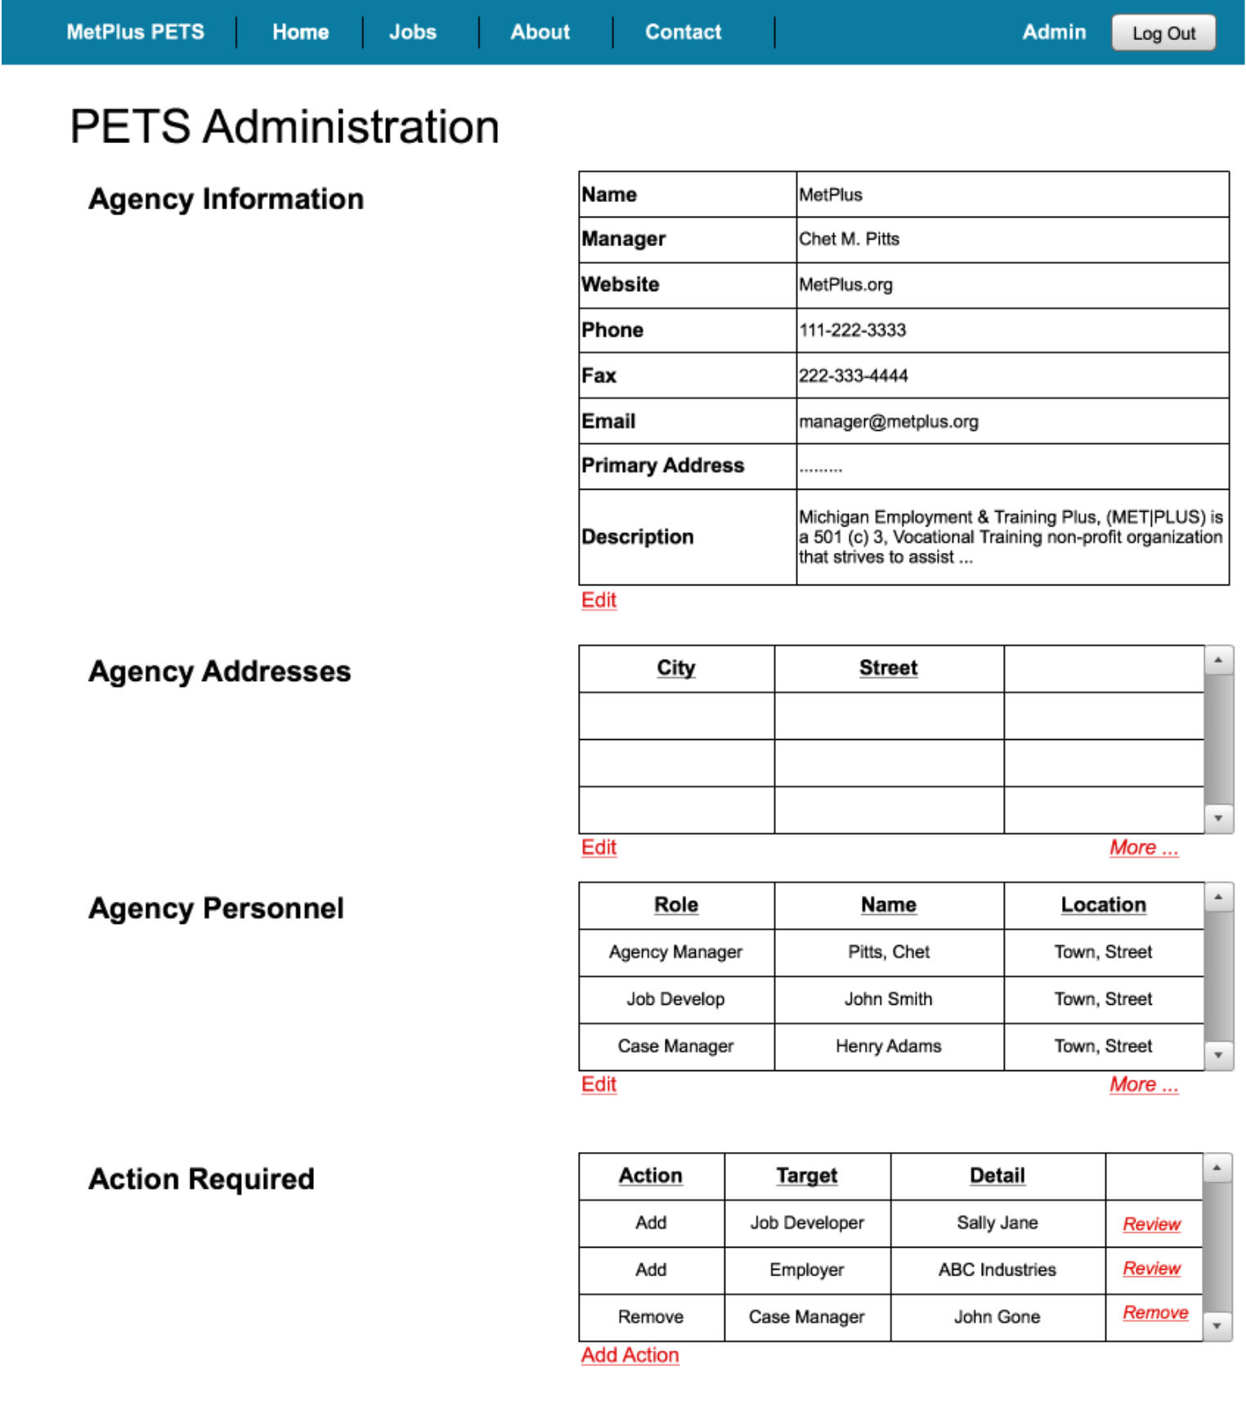

The "Review" button takes the user to a specific page for reviewing and acting upon the action item. (later, we can expand so that the admin can perform some of these actions while in this page - rev 2 of the UI).

The "Add Action" results is a dialog box where a new action can be created.

**Category Edit Page**

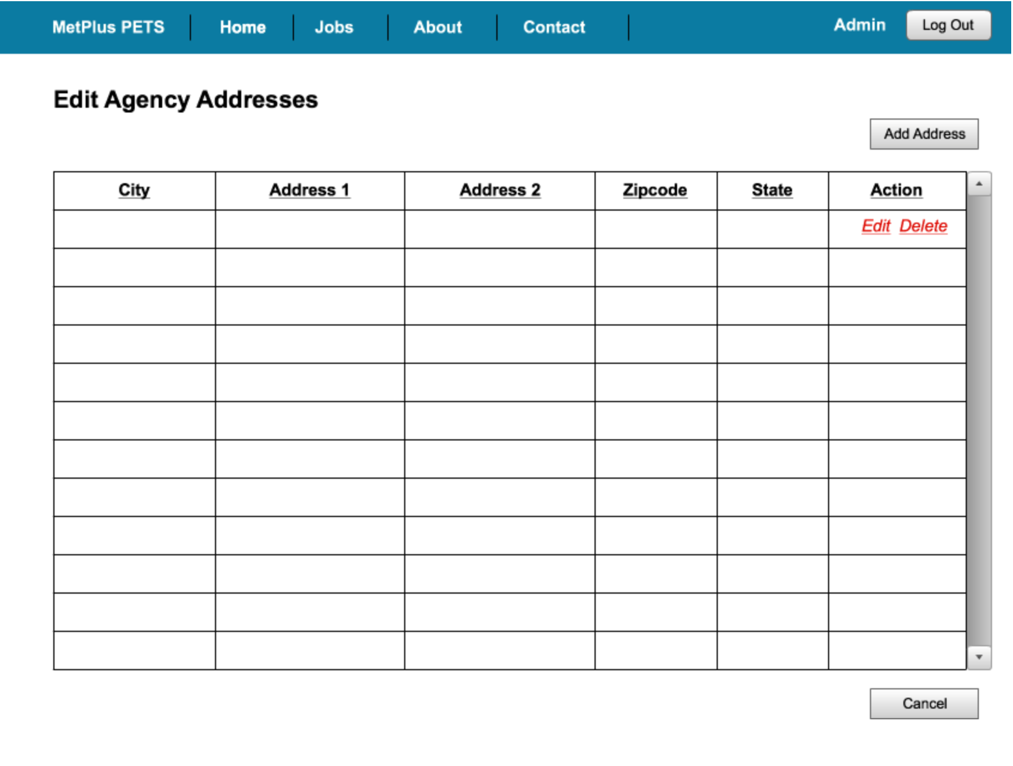

This example table would have address data for all defined addresses ("fake" data not shown above).

Each existing action item can be edited (in pop-up) or deleted (with confirmation box) via the "Action" column links.

**Action Page**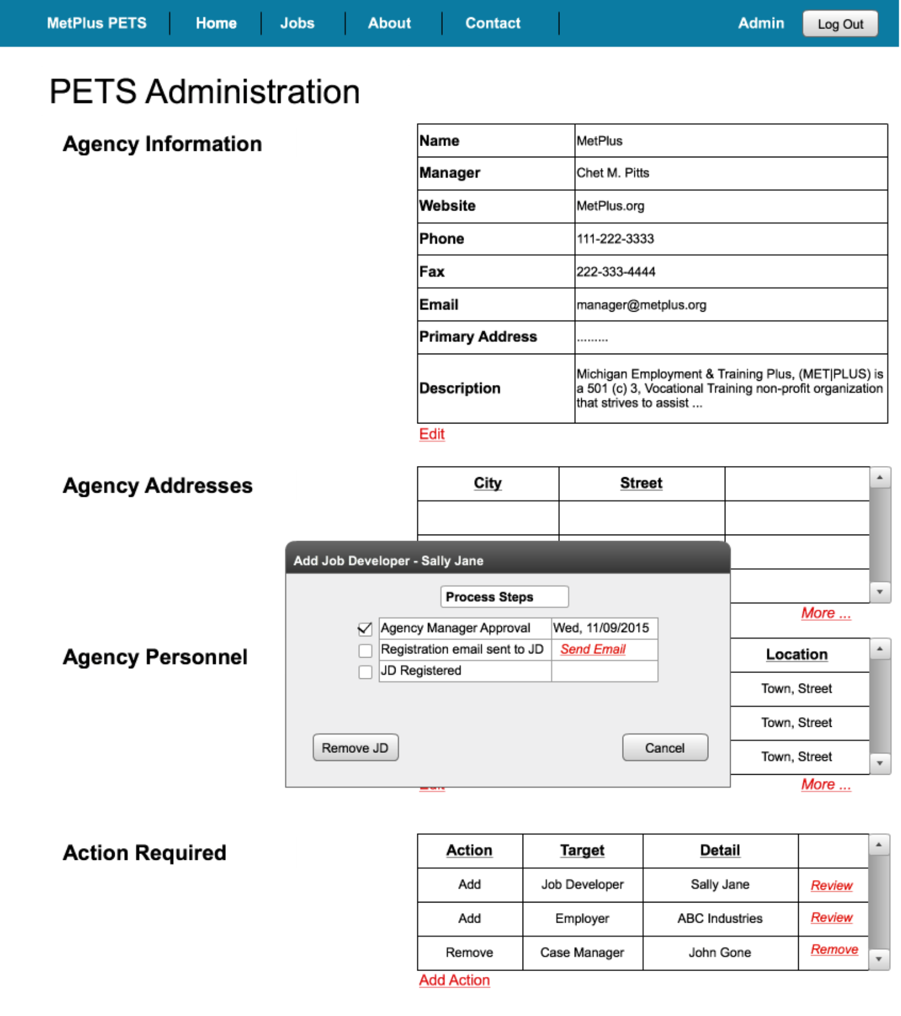

The agency admin can create a new action via the "Add Action" button. If the process for that action requires Agency Manager approval, it is routed to the AM as the first step.

Each action can be reviewed as shown in the pop-up. Here, we see that the first step for adding a job developer is complete (agency manager approval). The next step is to send an email to the JD with a link to the page in which the JD can register in PETS. This 2nd step is activated by the agency admin via the "Send Email" link.