AxPlugins
Overview

AxPlugins is an sample ASP.NET Core 8 Web API project designed to provide plugin-based extensibility and secure API endpoints using JWT authentication. The project includes basic status endpoints and is configured for easy integration and extension. This uses the AxExtend.DLL to extend Axpert/ARMs functionality on handling database access, Redis caching, and RabbitMQ and session access and other integration points

Features
- .NET 8 target for modern performance and features.
- JWT Authentication for secure API access. Use same as of ARM API auth.
- CORS Policy allowing any origin, method, and header.
- Swagger/OpenAPI enabled for API documentation (development only).

Referring to AxExtend and ARMCommon DLLs:
Once you have the AxExtend published folder locally:
- Right-click on your project in the Solution Explorer.
- Select Add > COM Reference...
- In the Reference Manager, click Browse and navigate to the location of AxExtend.dll and ARMCommon.dll. (Note: ARMCommon.dll reference is needed as AxExtend.dll internally refers to ARMCommon.dll)
- Select the DLLs and click Add.
- Click OK to confirm.

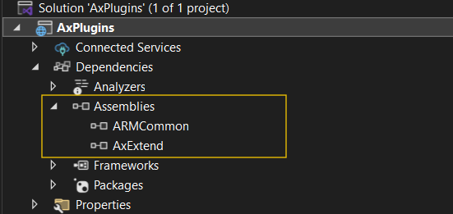
2. Registering Services
Registered the required services in your Startup.cs or Program.cs (for .NET 8):

services.AddScoped<IAxExtend, AxExtend>();

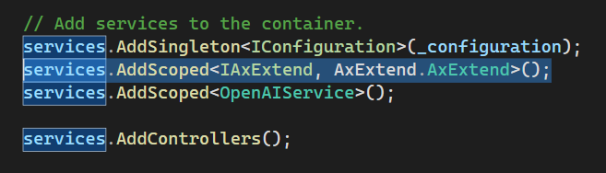

Sample APIs:
This project has sample APIs to connect to Axpert application DBs, Redis cache, RabbitMQ. Check the sample controllers.

How to add new APIs:
Edit this project and build your APIs and use methods from AxExtend DLL.
For more info refer AxExtend.DLL document.

Appsettings.ini placement:
Appsettings.ini file should be placed in the parent folder of the application release folder

Recommended Hosting:
Host the Axplugins site as microservice application under current ARM microservices list.

