**Form & Periodic Notifications**

**Form Notifications:**

Form Notifications are primarily triggered when specific actions are performed on a form, such as creating, deleting, modifying and cancelling a record. Depending on the configuration, notifications can be sent through various channels, including email, mobile notifications, and other integrated communication platforms. These notifications are designed to handle the notification process within the Axpert system.

**NOTE: Form Notifications are available under the Forms section in Config Studio**  
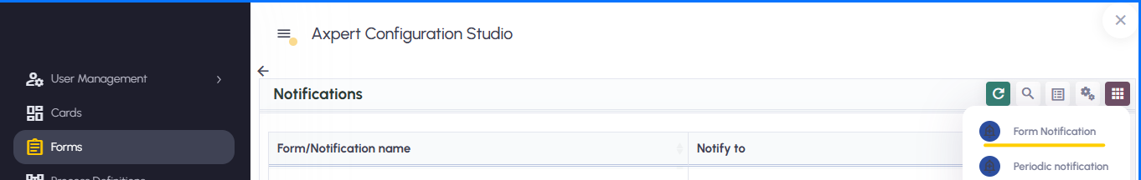 **Form Notification:  
  
Notify on data change in form** – The user can select the required form from the dropdown list, which displays all forms available within the schema

**Condition -** An optional validation expression based on form fields. The notification will be triggered only if this condition evaluates to *true*.

**Active** - When enabled, the notification will be triggered based on the defined condition  
  
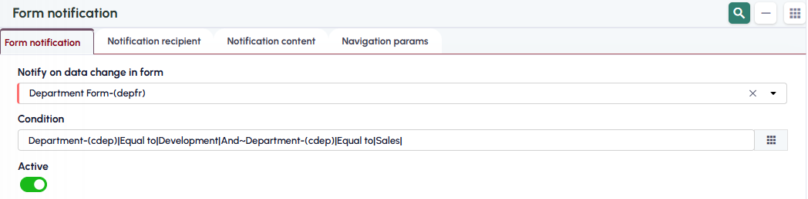

**Notification recipient:  
Overview:**  
Notifications are triggered and sent to the users specified in the *Selected Users Active List*

**Notify to –** This is a multi-select dropdown that allows users to choose one or more recipient types. The available options include:

* **Creator** – Sends the notification to the form initiator.
* **Reporting Manager** – Sends the notification to the initiator’s reporting manager.
* **Skip Manager** – Sends the notification to the reporting manager of the initiator’s reporting manager.
* **From Form Field** – Sends the notification to the user specified in a selected form field.
* **User Roles** – Sends the notification to users belonging to the selected roles.
* **User Names** – Sends the notification to the selected individual users.

**Note: WhatsApp and SMS notification options are not yet implemented**

**Email Required -** Enable the *Email Required* checkbox if the notification should also be sent via email.  
Once this option is enabled, the Email Recipient and Email Body DC fields will automatically become visible for configuration.

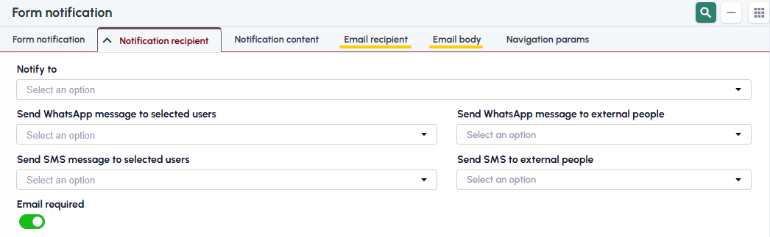

**Notification Content:**

**Overview:**

Notifications are triggered to the users in the active list when specific actions are performed on the form — such as **New**, **Edit**, **Cancel**, or **Delete**. The content defined in this section determines the subject and message included in each notification

**Print forms to be attached with notification for new/edited data –** If the selected form includes a Fast Report, users can choose the required report to be attached automatically to the notification for new or edited data

**Notification Subject for New Data –** Enter the desired subject line for notifications triggered when a new record is created.

**Notification Message for New Data –** Enter the message content for notifications triggered on record creation.

**Notification Subject for Edit –** Enter the subject line for notifications triggered when an existing record is edited.

**Notification Message for Edit –** Enter the message content for notifications triggered on record edit.

**Notification Subject for Cancel –** Enter the subject line for notifications triggered when a record is cancelled.

**Notification Message for Cancel –** Enter the message content for notifications triggered on record cancellation.

**Notification Subject for Delete –** Enter the subject line for notifications triggered when a record is deleted.

**Notification Message for Delete –** Enter the message content for notifications triggered on record deletion.

***Note: Form notifications will be triggered to active list for the specified action only if the corresponding subject and message fields are defined.***

**Email recipient:**

Selected users in the Email to, Email CC & Email BCC fields will get Form Notification via EMAIL.

**Email Body:**

**Overview:**

Email notifications are sent to designated users **via email** when specific actions are performed on a form — such as **New**, **Edit**, **Cancel**, or **Delete**.

**Email attachments**- When the **Email Attachments** option is selected, the email notifications are triggered along with the specified attachments

To include attachments in an email notification:

* The **file path with the file name** must be provided as the attachment input through a form field.
* Form Notifications **do not directly process files** from attachment fields.
* If multiple files need to be attached, their paths should be **separated by semicolons (;)**.

Essentially, any field containing a **file path with a file name** can be designated as the **attachment field** in Form Notifications.  
The user must ensure that the field value is **properly formatted** as per the required file path structure.

***Refer to the image below for an example configuration:***

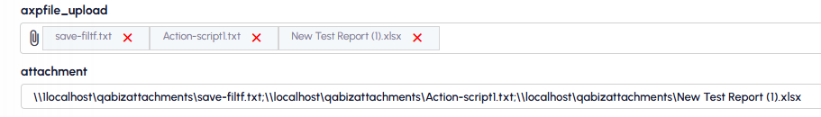  
**Email Subject for New Data –** Enter the desired subject line for email notifications triggered when a new record is created.

**Email Message for New Data –** Enter the message content for email notifications triggered on record creation.

**Email Subject for Edit –** Enter the subject line for email notifications triggered when an existing record is edited.

**Email Message for Edit –** Enter the message content for email notifications triggered on record edit.

**Email Subject for Cancel –** Enter the subject line for email notifications triggered when a record is cancelled.

**Email Message for Cancel –** Enter the message content for email notifications triggered on record cancellation.

**Email Subject for Delete –** Enter the subject line for email notifications triggered when a record is deleted.

**Email Message for Delete –** Enter the message content for email notifications triggered on record deletion.

**Navigation Params:**

**Overview:**

The **Navigation Parameters** section is used to open or load a **Form** or **IView** based on the defined parameters. When a user clicks on a triggered **SignalR** or **Active List Notification**, the system redirects to the corresponding Form or IView as per the defined configuration.

**Field Details**

* **Navigate To:** Displays a list of all available **Forms** and **IViews** that can be selected for navigation.
* **Open/Load:** A dropdown field with two options — **Open** or **Load** — to define how the selected Form or IView should be displayed.
* **Navigation Params:** Specifies the conditions under which the relevant record will be loaded. If the defined condition is met, the system automatically loads the corresponding record in the selected Form or IView.

***NOTE: Data Intellisense can be used by typing a colon (:). This will list all fields from DC1 of the selected form, along with available application parameters.***

**Periodic Notifications:**

These are notifications that are sent to users at specified time intervals like Daily, Weekly, Monthly, Quarterly and Yearly.

**Periodic Notification:**

**Name –** User can enter desired Name

**Start from date** – User can select the desired Date

**Start from time** – User can set the desired time

**Period** – Notification can be sent on Daily, Weekly, Monthly, Quarterly, Yearly basis based on the selection

**SendTime** - User can choose the desired time. Based on the Period, notification will get triggered on the selected SendTime

**SendDay** - If weekly is selected in Period, User can select the Day as well

**SendOn** - If Monthly or Quaterly is selected, First day, Last day, Frist day of last week can be selected.

**Is Active** - Check box.

**DataSource** - An SQL result that is defined through the custom data source option in RUNTIME.

**Message Title** - With this message title notification will be triggered.

**Message Content** - With this message content notification will be triggered.

**Attachment - Report/Fast print –** User can choose the required **Report/Fast print** to be attached automatically to the notification.

**Attachment - Data source -** User can choose the required Data source or multiple ADS to be attached automatically to the notification.

**From user -** Used for loading global variables while processing periodic notifications. Selected users mailid will be used as From Mail

**Notify to:** Notifications can be triggered to a specific user or users having the selected user role

**Condition and Navigation Params:**

**Overview:**

The **Navigation Parameters** section is used to open or load a **Form** or **IView** based on the defined parameters. When a user clicks on a triggered **SignalR** or **Active List Notification**, the system redirects to the corresponding Form or IView as per the defined configuration.

**Field Details**

* **Navigate To:** Displays a list of all available **Forms** and **IViews** that can be selected for navigation.
* **Open/Load:** A dropdown field with two options — **Open** or **Load** — to define how the selected Form or IView should be displayed.
* **Navigation Params:** Specifies the conditions under which the relevant record will be loaded. If the defined condition is met, the system automatically loads the corresponding record in the selected Form or IView.
* **Condition:** Based on the values defined in the application parameters, navigation will occur from the active list.