**Schema Configuration Guide**

Post IIS Setup for Axpert Web, AxpertStudio, ARM, AgileConnect, follow the steps below to configure schema-level settings:

**1. Create AgileConnect Connection for the Schema**

a. Sign in to AgileConnect.

b. Navigate to the **App** section and click **Create App** to configure a new AgileConnect connection

for the required schema.

**Note:** In the *Axpert DB Details* section, ensure the **Axpert Scripts URL** is correctly set to the **ARM Scripts URL**.

**2. Register Schema in axapps.xml (ARMScripts)**

a. Go to the ARMScripts folder.

b. Add the required schema entry in the axapps.xml file.

**3. Configure ARM and File Upload/Download Settings in config.aspx**

a. Open the config.aspx page  
 *Example:* [*https://localhost/AxpertWeb/aspx/config.aspx*](https://localhost/AxpertWeb/aspx/config.aspx)

b. Configure the appropriate **ARM** connection for the schema.

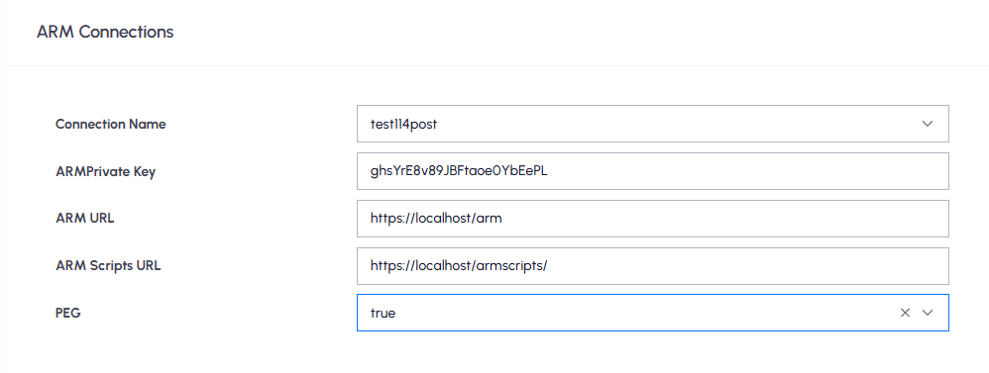

**Note:** ***A trailing slash is required at the end of the ARM Scripts URL.***

c. Set the correct **File Upload/Download** paths for the schema.

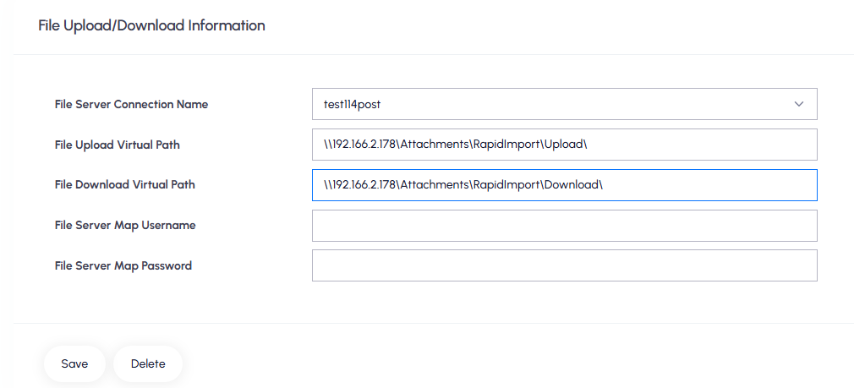

**4. Define Application Variables and Constants**

**Below is a list of key variables and their purposes:**

|  |  |  |
| --- | --- | --- |
| **AxVars and Constants** | **Purpose** | **Sample Path** |
| **AxpDbDirPath** | Specifies a local/shared path accessible by Oracle DB, SQL*Loader, and related processes like Rapid Save,Import Data, SubmitData API, and AxLanguages. | \\SERVER_IP\datafile1 |
| [**AxRapidSaveURL**](javascript:void(0)) | This URL points to the ASBRapidSaveRest API, which is used for handling data import operations. | **Example:**  https://localhost/armscripts/ASBRapidSaveRest.dll/datasnap/rest/TASBRapidSaveRest/RapidSave |
| **AxScriptsAPIURL** | URL of the **ASBScriptsREST** API for handling reminders, escalations, and notifications. Ensure this URL is correctly configured during environment promotion or deployment. | **Example:** https://localhost/armscripts/ASBScriptRest.dll/datasnap/rest/TASBScriptRest/scriptsapi |
| **AxRMQAPIURL** | This variable holds the URL of the ARM PushToQueue API, which is used to send messages to the RabbitMQ (RMQ) server. It is utilized in various processes such as:   * Form/PEG/Periodic Notifications * Cached Saving * Auto Print * Queue Listing * Import Data | **Example:**  http://localhost/arm/api/v1/ARMPushToQueue  (Note: This should point to the location where the ARM API’s are hosted.) |
| **AxSignalRapiURL** | This variable stores the URL of the ARM SignalR API, which is used to trigger SignalR notifications during the following operations:   * Excel Export * Cached Saving * Import Process * Form/PEG/Periodic Notifications | **Example:**  https://localhost/arms/api/v1/SendSignalR |
| **AxMailFrom** | This variable specifies the email address used as the "From" address when sending email notifications from forms. It is used to trigger form-related notifications and will appear as the sender's email ID in recipients' inboxes. | **Example:**  hcm.support@agile-labs.com |
| **axpegemailactionurl** | This variable holds the URL of the ARMMailTaskAction API. It is used to embed PEG action buttons within email notifications.  **Usage Instructions:**   * To include PEG action buttons in the email body, insert the (attachpegactions) tag in the notification definition. * The tag will render the corresponding HTML PEG action div inside the email content. * Ensure the axpegemailactionurl variable is created and correctly set to the ARMMailTaskAction URL. | **Example:**  https://localhost/arm/api/v1/ARMMailTaskAction |
| **AxFCMSendMsgURL** | This variable must be configured with the ARM API URL responsible for sending FCM (Firebase Cloud Messaging) notifications to the mobile app.  **Note:** By default, notifications are also pushed to the mobile app. Currently, there is no option to disable this behaviour, so configuring this URL is mandatory. | **Example:**  https://localhost/armapi/v1/SendFCMNotification |
| **AxPEGMailFrom** | his variable stores the email address that will be used as the "From" address for all PEG-related email notifications, including reminders, escalations, and general notifications. | **Example:**  hcm.support@agile-labs.com |
| **AxpImagePath** | This variable defines the local or shared network path used for storing file attachments. | **Example:** \\192.168.2.66\FileAttachments  **Note:** If the **AxpImageServer** variable is defined, then **AxpImagePath** should contain only the folder name (e.g., File Attachments) instead of the full path. |

**NOTE:** ***The above list can be defined as variables or configured as application-level constants***

**5. API Plugins**

**1. Text_Field_Intelligence:** This Plugin is used for Data Intellisense in Notifications, Fastprints

URL: [**https://localhost/armscripts/ASBMenuRest.dll/datasnap/rest/TASBMenuRest/GetSqldata**](https://localhost/armscripts/ASBMenuRest.dll/datasnap/rest/TASBMenuRest/GetSqldata)

**Sample Request String:**

{"_parameters":[{"getsqldata":{"axpapp":"{appschema}","sqlname":"Text_Field_Intelligence","isdropdown":"F","trace":"false"},"{appschema}":{

"type": "db",

"structurl": "",

"db": "{DB Type}",

"driver": "dbx",

"version": "",

"dbcon": "DBServer IPAddress",

"dbuser": "{appschema}\\{DBName}",

"pwd": "",

"dataurl": ""

},"sqlparams":{"txttransid":""}}]}

**Example:**

{"_parameters":[{"getsqldata":{"axpapp":"postgres114","sqlname":"Text_Field_Intelligence","isdropdown":"F","trace":"false"},"postgres114":{

"type": "db",

"structurl": "",

"db": "Postgre",

"driver": "dbx",

"version": "",

"dbcon": "192.166.2.178",

"dbuser": " postgres114\\axpertdb",

"pwd": "",

"dataurl": ""

},"sqlparams":{"txttransid":""}}]}

**2. Fast_Print_Master:** Used for FastPrint master-level data.

**URL:** <https://agileqa.agilecloud.biz/qaaxpert11.4basescripts/ASBMenuRest.dll/datasnap/rest/TASBMenuRest/GetSqldata>

**Sample Request String:**

{"_parameters":[{"getsqldata":{"axpapp":"{appschema}","sqlname":"Fast_Print_Master","isdropdown":"F","trace":"false"},"{appschema}":{

"type": "db",

"structurl": "",

"db": "{Db Type}",

"driver": "dbx",

"version": "",

"dbcon": "DB IPAddress",

"dbuser": "{appschema}\\{DBName}",

"pwd": "",

"dataurl": ""

},"sqlparams":{"master_data_source":"","masterdsrctmp":"","ftransid":""}}]}

**Example:**

{"_parameters":[{"getsqldata":{"axpapp":" postgres114","sqlname":"Fast_Print_Master","isdropdown":"F","trace":"false"}," postgres114":{

"type": "db",

"structurl": "",

"db": "Postgre",

"driver": "dbx",

"version": "",

"dbcon": "192.166.2.178",

"dbuser": "postgres114\\axpertdb",

"pwd": "",

"dataurl": ""

},"sqlparams":{"master_data_source":"","masterdsrctmp":"","ftransid":""}}]}

**3. Fast_Print_Detail:** Used for FastPrint detail-level data.

**URL:** <https://agileqa.agilecloud.biz/qaaxpert11.4basescripts/ASBMenuRest.dll/datasnap/rest/TASBMenuRest/GetSqldata>

**Sample Request String**

{"_parameters":[{"getsqldata":{"axpapp":"defschema","sqlname":"Fast_Print_Detail","isdropdown":"F","trace":"false"},"defschema":{

"type": "db",

"structurl": "",

"db": "Postgre",

"driver": "dbx",

"version": "",

"dbcon": "172.16.0.135",

"dbuser": "defschema\\goldendump11",

"pwd": "",

"dataurl": ""

},"sqlparams":{"dtlsrccnd":"","dtldsrctmp":"","griddcno":"","ftransid":""}}]}

**Example**

{"_parameters":[{"getsqldata":{"axpapp":"defschema","sqlname":"Fast_Print_Detail","isdropdown":"F","trace":"false"},"defschema":{

"type": "db",

"structurl": "",

"db": "Postgre",

"driver": "dbx",

"version": "",

"dbcon": "172.16.0.135",

"dbuser": "defschema\\goldendump11",

"pwd": "",

"dataurl": ""

},"sqlparams":{"dtlsrccnd":"","dtldsrctmp":"","griddcno":"","ftransid":""}}]}