**Schema Configuration Guide**

Post IIS Setup for Axpert Web, AxpertStudio, ARM, AgileConnect, follow the steps below to configure schema-level settings in AxpertAdmin.aspx Page:

***EG:***[*https://localhost/axpertweb/aspx/AxpertAdmin.aspx*](https://localhost/axpertweb/aspx/AxpertAdmin.aspx)

***NOTE:*** *From Axpert Web 11.4.0.0_Release26, Config.aspx has been renamed as 'AxpertAdmin.aspx' page.* *Agile connect avoided during ARM API's execution. All Required setup which was there in Agile Connect has been moved to 'AxpertAdmin.aspx' page. And all separate setup '.ini' files are removed and introduced single '.ini' file as 'AppSettings.ini'*

**a. Setting up Database Connections:**

Create database connections by selecting the database, entering the client connection name, username, and password. Then, test the connection and apply the changes

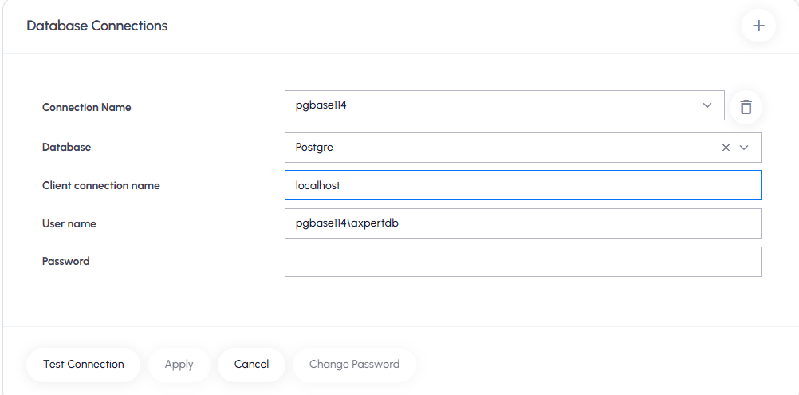

**b. Licensed Domain:**

Select the connection name, enter the licensed domain URL, and save the configuration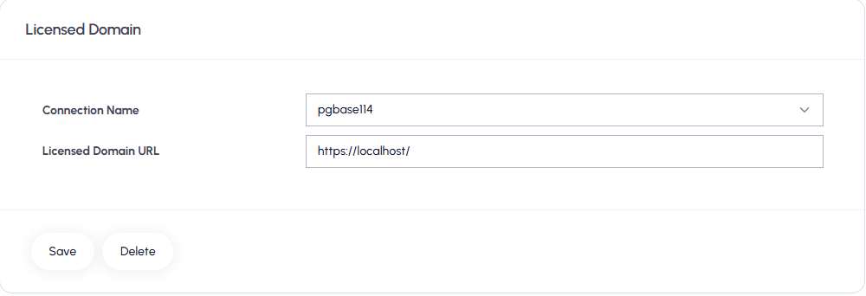

**c. Axpert Web Redis Connections:**

Select the connection name, enter the host name, port, and password (if applicable), then test the connection and apply the changes.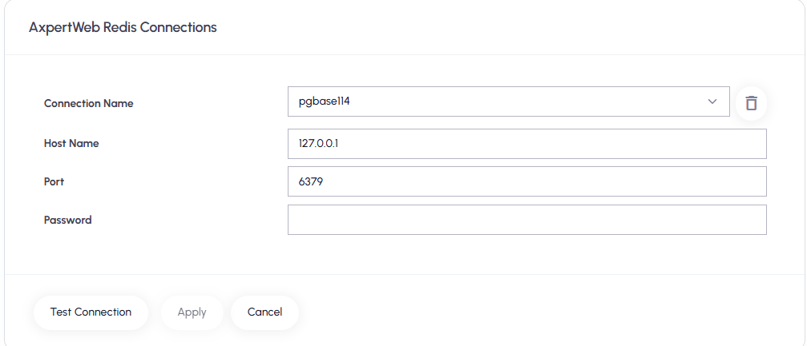

**d. Axpert Studio:**

Select the connection name, enter the Redis host name, port, password (if applicable), Studio URL, Studio script path, and Studio script URL path. Then, test the connection and apply the changes

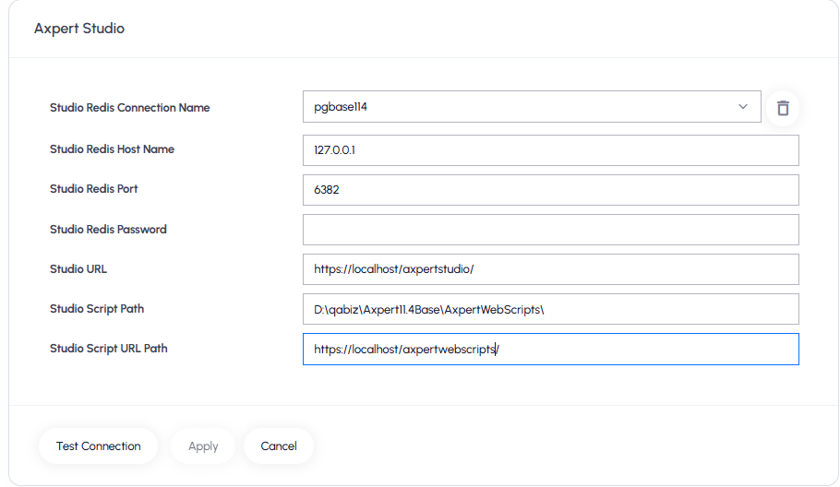

**e. ARM Connections:**

Select the connection name, enter the ARM private key, ARM URL, and ARM scripts URL, choose PEG, and save the configuration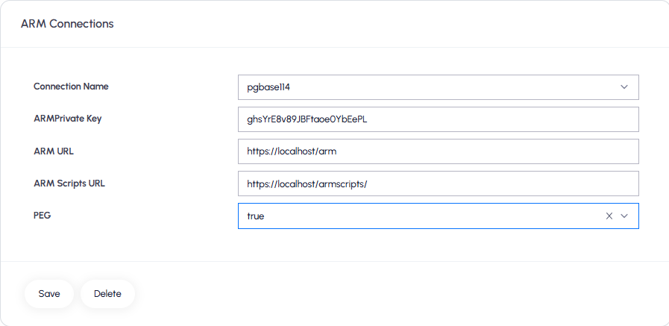

**Note:** ***A trailing slash is required at the end of the ARM Scripts URL.***

**f. File Upload/Download Information:**

Select Connection Name and Set the proper **File Upload/Download** Virtual paths and save it

***NOTE: Upload and Download folders should be created in the desired path***

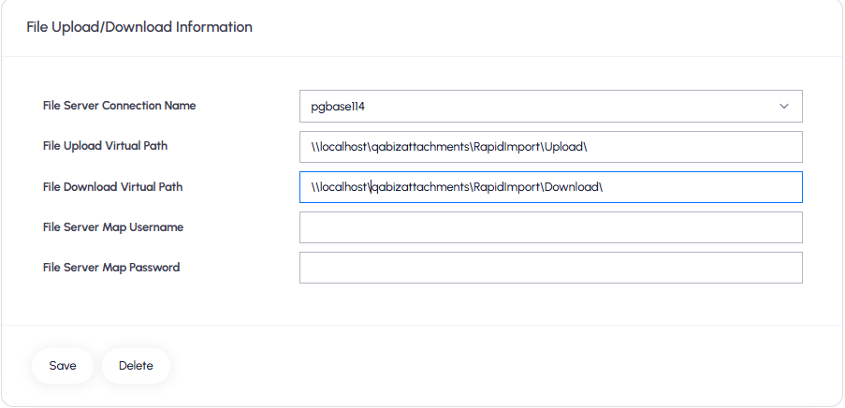

***NOTE****: Once configurations are saved on the AxpertAdmin page for a schema, they are stored in the AppSettings.ini file located in the AxpertWebScripts folder. Users must manually copy the updated AppSettings.ini file from AxpertWebScripts to the Axpert Studio and ARM folders.*

*\* Recycling the ARM, Studio, and Scripts pools is required whenever there is a change in the AppSettings.ini file*

**Define Application Variables and Constants in RUNTIME:**

**Below are key variables and their purposes:**

|  |  |  |
| --- | --- | --- |
| **AxVars and Constants** | **Purpose** | **Sample Path** |
| **AxpDbDirPath** | Specifies a local/shared path accessible by Oracle DB, SQL*Loader, and related processes like Rapid Save,Import Data, SubmitData API, and AxLanguages. | \\SERVER_IP\datafile1 |
| [**AxRapidSaveURL**](javascript:void(0)) | This URL points to the ASBRapidSaveRest API, which is used for handling data import operations. | **Example:**  https://localhost/armscripts/ASBRapidSaveRest.dll/datasnap/rest/TASBRapidSaveRest/RapidSave |
| **AxScriptsAPIURL** | URL of the **ASBScriptsREST** API for handling reminders, escalations, and notifications. Ensure this URL is correctly configured during environment promotion or deployment. | **Example:** https://localhost/armscripts/ASBScriptRest.dll/datasnap/rest/TASBScriptRest/scriptsapi |
| **AxRMQAPIURL** | This variable holds the URL of the ARM PushToQueue API, which is used to send messages to the RabbitMQ (RMQ) server. It is utilized in various processes such as:   * Form/PEG/Periodic Notifications * Cached Saving * Auto Print * Queue Listing * Import Data | **Example:**  http://localhost/arm/api/v1/ARMPushToQueue  (Note: This should point to the location where the ARM API’s are hosted.) |
| **AxSignalRapiURL** | This variable stores the URL of the ARM SignalR API, which is used to trigger SignalR notifications during the following operations:   * Excel Export * Cached Saving * Import Process * Form/PEG/Periodic Notifications | **Example:**  https://localhost/arms/api/v1/SendSignalR |
| **AxMailFrom** | This variable specifies the email address used as the "From" address when sending email notifications from forms. It is used to trigger form-related notifications and will appear as the sender's email ID in recipients' inboxes. | **Example:**  hcm.support@agile-labs.com |
| **axpegemailactionurl** | This variable holds the URL of the ARMMailTaskAction API. It is used to embed PEG action buttons within email notifications.  **Usage Instructions:**   * To include PEG action buttons in the email body, insert the (attachpegactions) tag in the notification definition. * The tag will render the corresponding HTML PEG action div inside the email content. * Ensure the axpegemailactionurl variable is created and correctly set to the ARMMailTaskAction URL. | **Example:**  https://localhost/arm/api/v1/ARMMailTaskAction |
| **AxFCMSendMsgURL** | This variable must be configured with the ARM API URL responsible for sending FCM (Firebase Cloud Messaging) notifications to the mobile app.  **Note:** By default, notifications are also pushed to the mobile app. Currently, there is no option to disable this behaviour, so configuring this URL is mandatory. | **Example:**  https://localhost/armapi/v1/SendFCMNotification |
| **AxPEGMailFrom** | his variable stores the email address that will be used as the "From" address for all PEG-related email notifications, including reminders, escalations, and general notifications. | **Example:**  hcm.support@agile-labs.com |
| **AxpImagePath** | This variable defines the local or shared network path used for storing file attachments. | **Example:** \\192.168.2.66\FileAttachments  **Note:** If the **AxpImageServer** variable is defined, then **AxpImagePath** should contain only the folder name (e.g., File Attachments) instead of the full path. |

**NOTE:** ***The above list can be defined as variables or configured as application-level constants***

**5. API Plugins**

**1. Text_Field_Intelligence:** This Plugin is used for Data Intellisense in Notifications, Fastprints

URL: [**https://localhost/armscripts/ASBMenuRest.dll/datasnap/rest/TASBMenuRest/GetSqldata**](https://localhost/armscripts/ASBMenuRest.dll/datasnap/rest/TASBMenuRest/GetSqldata)

**Sample Request String:**

{"_parameters":[{"getsqldata":{"axpapp":"{appschema}","sqlname":"Text_Field_Intelligence","isdropdown":"F","trace":"false"},"{appschema}":{

"type": "db",

"structurl": "",

"db": "{DB Type}",

"driver": "dbx",

"version": "",

"dbcon": "DBServer IPAddress",

"dbuser": "{appschema}\\{DBName}",

"pwd": "",

"dataurl": ""

},"sqlparams":{"txttransid":""}}]}

**Example:**

{"_parameters":[{"getsqldata":{"axpapp":"postgres114","sqlname":"Text_Field_Intelligence","isdropdown":"F","trace":"false"},"postgres114":{

"type": "db",

"structurl": "",

"db": "Postgre",

"driver": "dbx",

"version": "",

"dbcon": "192.166.2.178",

"dbuser": " postgres114\\axpertdb",

"pwd": "",

"dataurl": ""

},"sqlparams":{"txttransid":""}}]}

**2. Fast_Print_Master:** Used for FastPrint master-level data.

**URL:** <https://agileqa.agilecloud.biz/qaaxpert11.4basescripts/ASBMenuRest.dll/datasnap/rest/TASBMenuRest/GetSqldata>

**Sample Request String:**

{"_parameters":[{"getsqldata":{"axpapp":"{appschema}","sqlname":"Fast_Print_Master","isdropdown":"F","trace":"false"},"{appschema}":{

"type": "db",

"structurl": "",

"db": "{Db Type}",

"driver": "dbx",

"version": "",

"dbcon": "DB IPAddress",

"dbuser": "{appschema}\\{DBName}",

"pwd": "",

"dataurl": ""

},"sqlparams":{"master_data_source":"","masterdsrctmp":"","ftransid":""}}]}

**Example:**

{"_parameters":[{"getsqldata":{"axpapp":" postgres114","sqlname":"Fast_Print_Master","isdropdown":"F","trace":"false"}," postgres114":{

"type": "db",

"structurl": "",

"db": "Postgre",

"driver": "dbx",

"version": "",

"dbcon": "192.166.2.178",

"dbuser": "postgres114\\axpertdb",

"pwd": "",

"dataurl": ""

},"sqlparams":{"master_data_source":"","masterdsrctmp":"","ftransid":""}}]}

**3. Fast_Print_Detail:** Used for FastPrint detail-level data.

**URL:** <https://agileqa.agilecloud.biz/qaaxpert11.4basescripts/ASBMenuRest.dll/datasnap/rest/TASBMenuRest/GetSqldata>

**Sample Request String**

{"_parameters":[{"getsqldata":{"axpapp":"defschema","sqlname":"Fast_Print_Detail","isdropdown":"F","trace":"false"},"defschema":{

"type": "db",

"structurl": "",

"db": "Postgre",

"driver": "dbx",

"version": "",

"dbcon": "172.16.0.135",

"dbuser": "defschema\\goldendump11",

"pwd": "",

"dataurl": ""

},"sqlparams":{"dtlsrccnd":"","dtldsrctmp":"","griddcno":"","ftransid":""}}]}

**Example**

{"_parameters":[{"getsqldata":{"axpapp":"defschema","sqlname":"Fast_Print_Detail","isdropdown":"F","trace":"false"},"defschema":{

"type": "db",

"structurl": "",

"db": "Postgre",

"driver": "dbx",

"version": "",

"dbcon": "172.16.0.135",

"dbuser": "defschema\\goldendump11",

"pwd": "",

"dataurl": ""

},"sqlparams":{"dtlsrccnd":"","dtldsrctmp":"","griddcno":"","ftransid":""}}]}