Thomas Ouellet Fredericks (tof@t-o-f.info) & Alexandre Castonguay (acastonguay@artengine.ca)

Wiki: http://agitpov.net

Top View

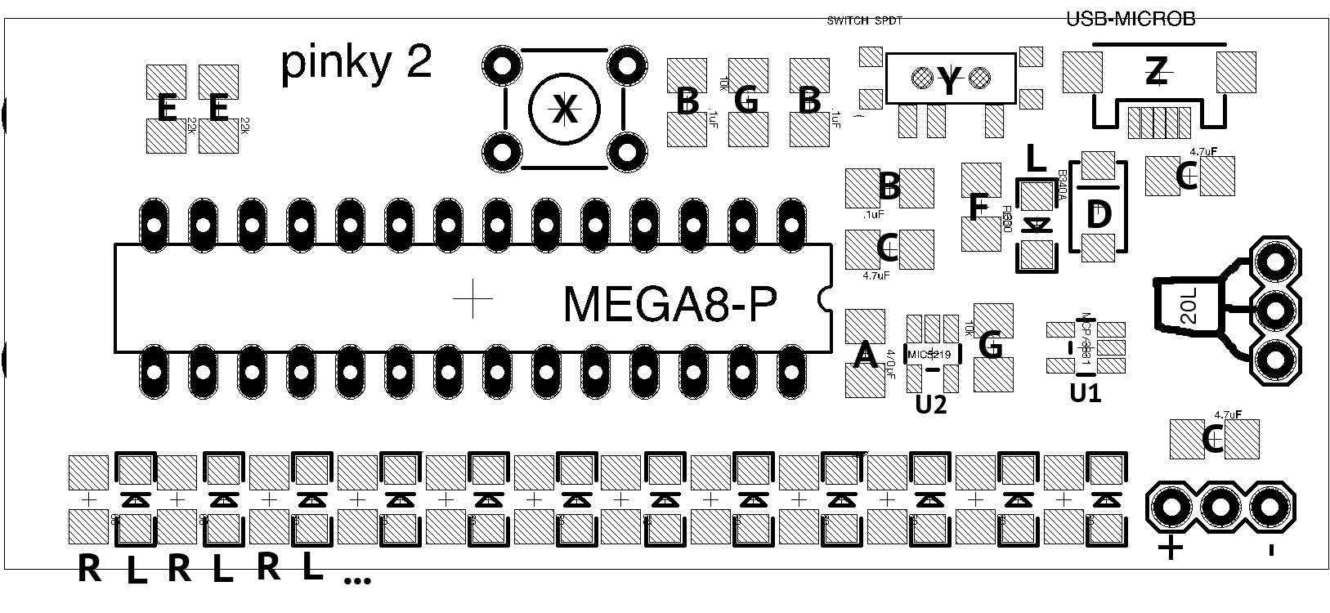

Step 1 : fasten stencil

Step 2 : apply paste

Step 3 : remove stencil

Step 4 : place components R

* R : 51 ohm resistor (maked 510)

Step 5 : place components L (directionnal)

* L : LED (the green pads of the LED must towards the center of the board)

Step 6 : place components A, B, C, D (directionnal), E, F, and G in any order

* A : 470pF capacitor (a single capacitor)
* B : .1uF capacitor (three in the same package marked with orange marker)
* C : 4.7uF capacitor (three in the same transparent package)
* D : B340A diode (the line on the diode must match the line on the board)
* E : 56k ohm resistor  (marked 563)
* F : 330 resistor (marked 331)
* G : 10K resistor (marked 103)

Step 7 : place components U1 and U2 (they are different and directionnal)

* U1 : MCP73831 charger
* U2 : MIC5219 regulator (marked with graphite)

Step 8 : bring your pcb to the hot plate

Step 9 : ask for assistance in placing component Z and on using the hot plate

...

Step 10 : place and solder components X, Y, and 20L

Step 11 : flip the board and solder the pins of components X, Y, and 20L

Bottom View

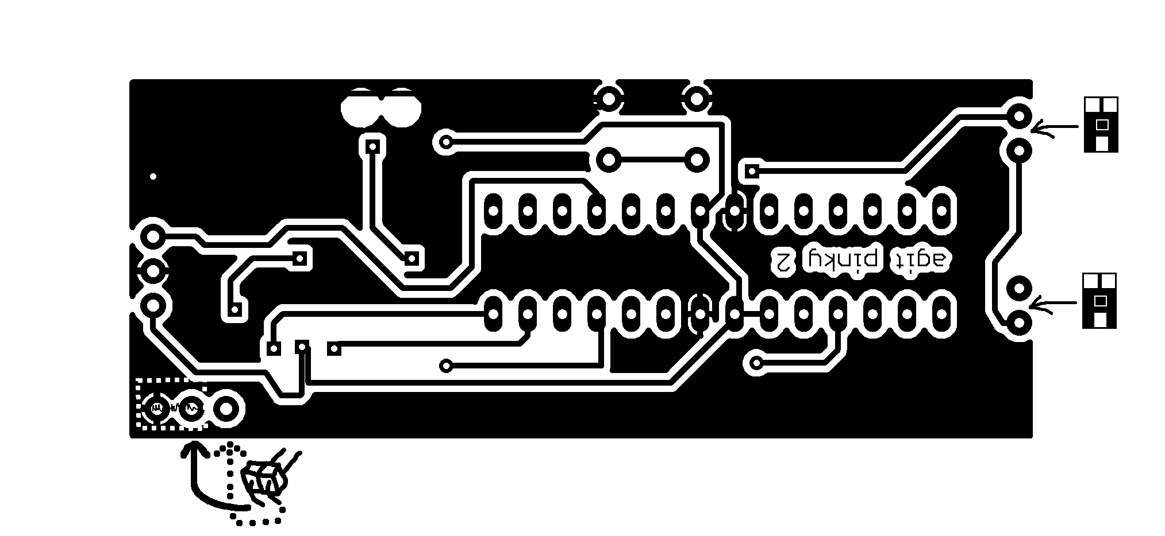

Step 12 : place the headers (lower left of Bottom View, long pins towards the center of the board) and solder on the top side

Step 13 : make a bridge between the indicated pads (lower left of Bottom View) on the top or bottom

Step 14 : place the ambient light sensors (far right of Bottom View) using the special Agit P.O.V. technique