Задание 0.

CREATE TABLE students (

id SERIAL PRIMARY KEY,

name TEXT NOT NULL,

total_score INTEGER DEFAULT 0,

scholarship INTEGER DEFAULT 0

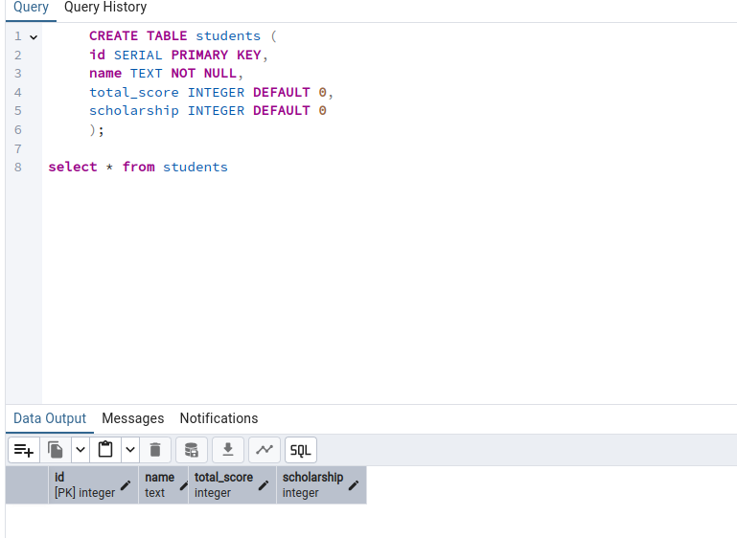 );

CREATE TABLE activity_scores (

student_id INTEGER NOT NULL,

activity_type TEXT NOT NULL,

score INTEGER NOT NULL,

FOREIGN KEY (student_id)

REFERENCES students(id)

ON DELETE CASCADE

);

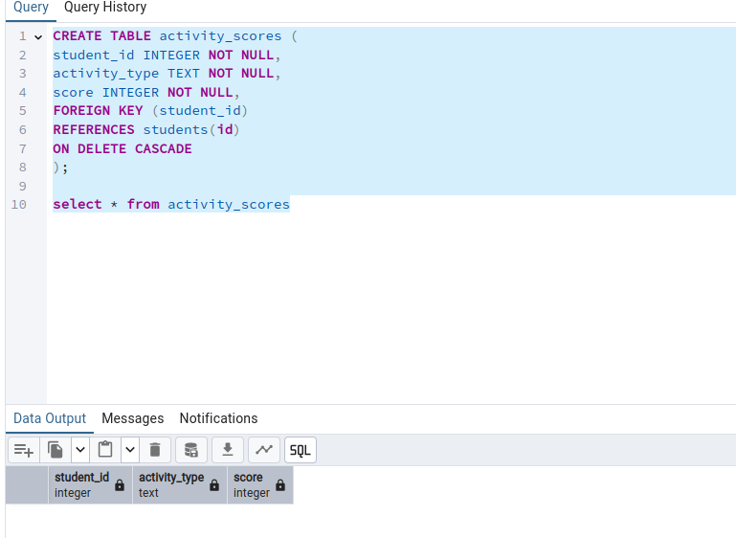

Задание 1.

1)

INSERT INTO students (name)

VALUES

('Андрей Аршавин'),

('Александр Кержаков'),

('Игорь Акинфеев');

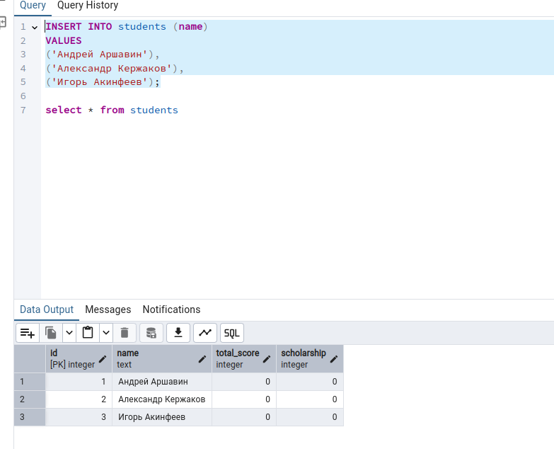

2) INSERT INTO activity_scores (student_id, activity_type, score) VALUES

(1, 'Домашняя работа', 10),

(1, 'Экзамен', 25),

(1, 'Курсовая', 30),

(2, 'Экзамен', 8),

(2, 'Диплом', 28),

(3, 'Домашняя работа', 9),

(3, 'Экзамен', 22);

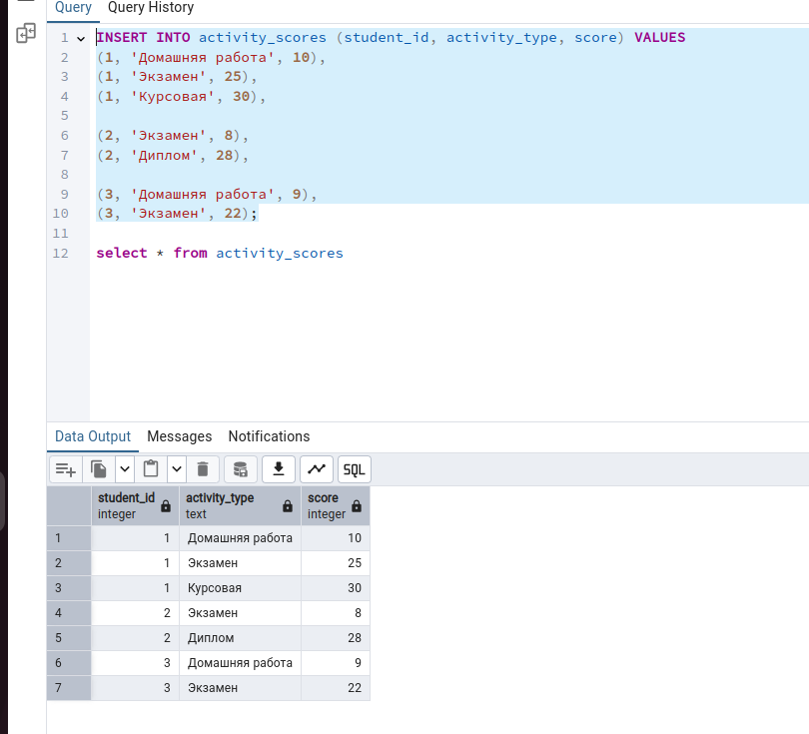

3)

UPDATE students

SET total_score = sub.total

FROM (

SELECT student_id, SUM(score) AS total

FROM activity_scores

GROUP BY student_id

) AS sub

WHERE students.id = sub.student_id;

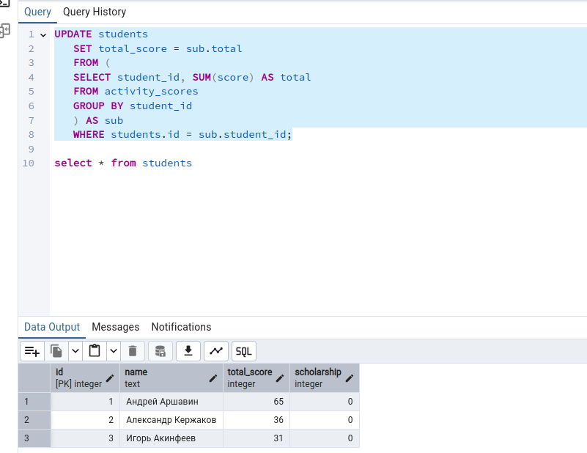

Задание 2.

UPDATE students

SET scholarship =

CASE

WHEN total_score >= 90 THEN 1000

WHEN total_score BETWEEN 80 AND 89 THEN 500

ELSE 0

END;

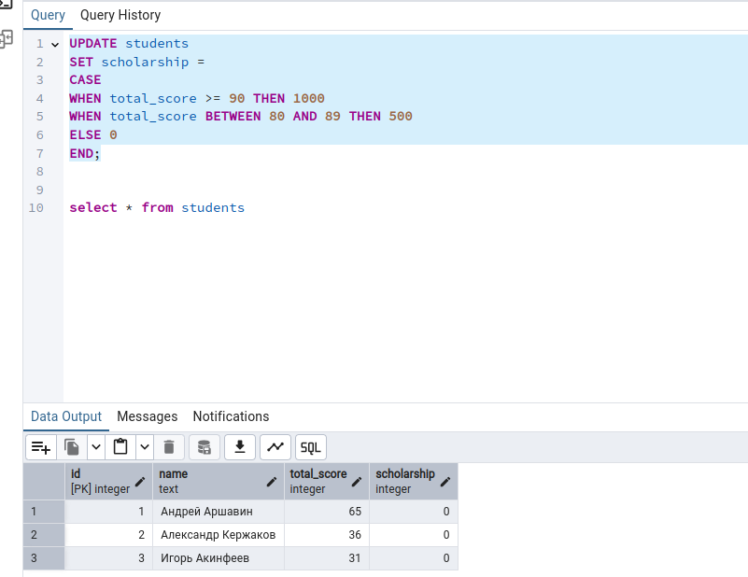

Задание 3.

Запрос на добавление:

INSERT INTO activity_scores (student_id, activity_type, score) VALUES

(1, 'Стажировка', 40),

(2, 'Стажировка', 50),

(3, 'Стажировка', 35);

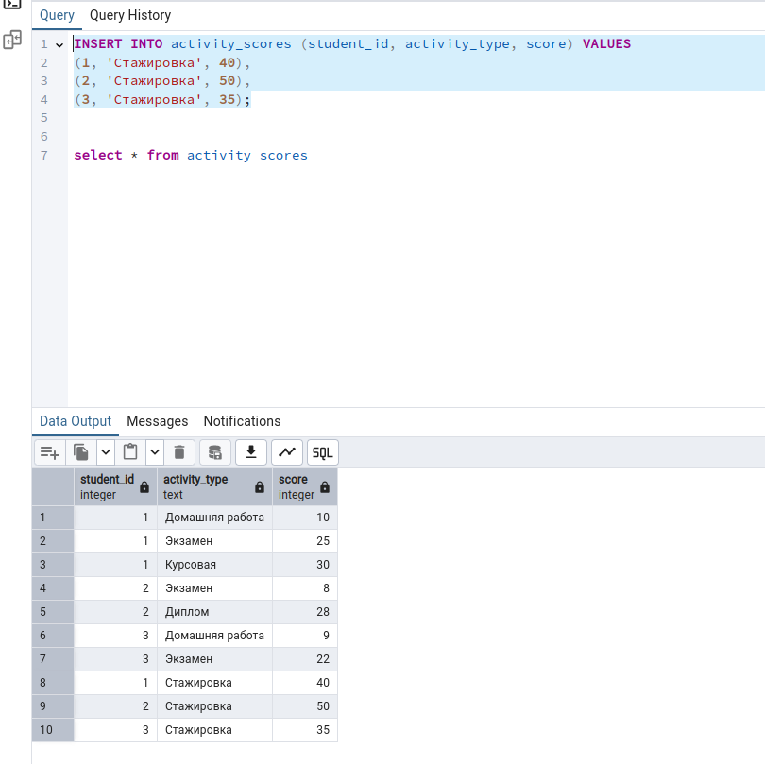

Результат:

