A)
select name, telegram_contact from public.student where city = 'Москва' or city = 'Казань'
order by name desc

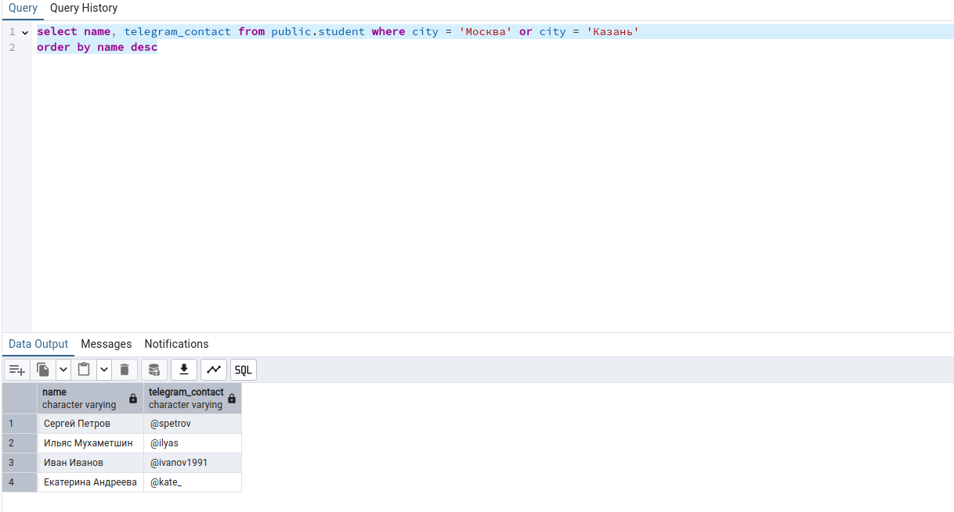
B)
select CONCAT('университет: ', name ,'; количество студентов: ', size) as "полная информация" from college
order by "полная информация"

C)
SELECT name, size FROM public.college where id in (10,30,50)
ORDER BY size desc, name

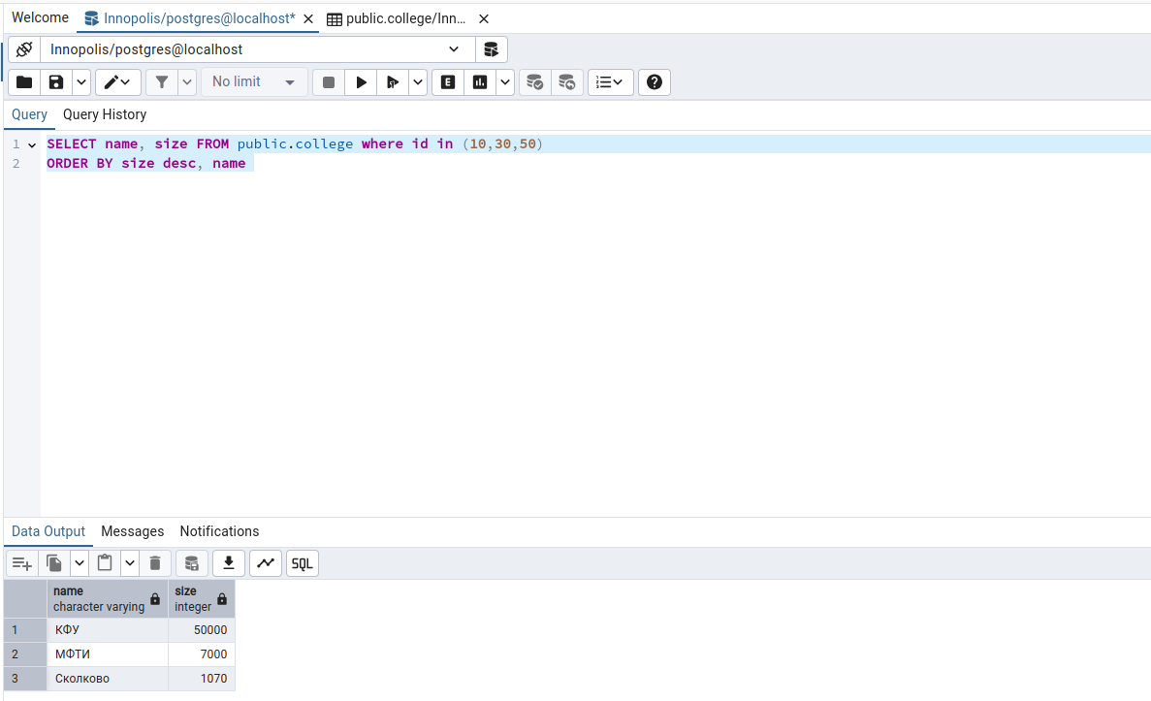
D)
SELECT name, size FROM public.college where id not in (10,30,50)
ORDER BY size desc, name

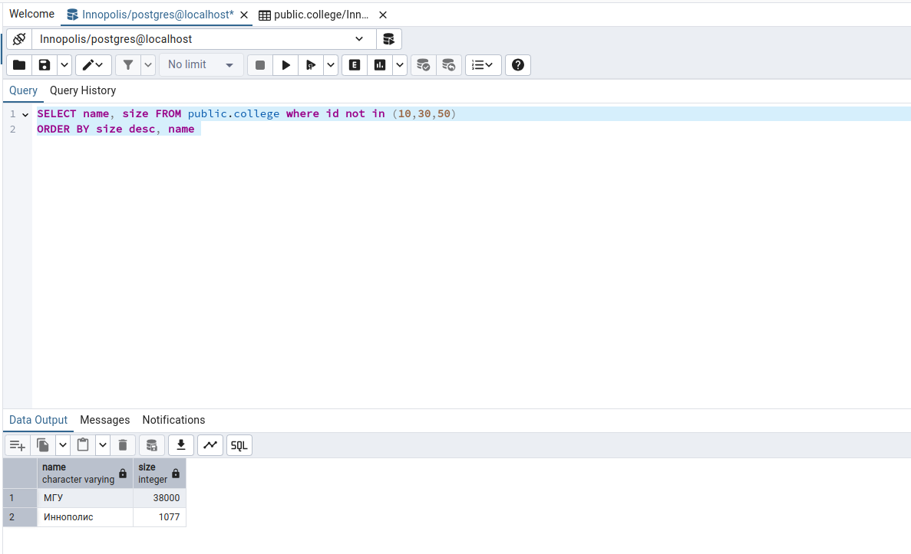

E)
SELECT name, amount_of_students FROM public.course where amount_of_students between 27 and 310
ORDER BY name desc, amount_of_students desc
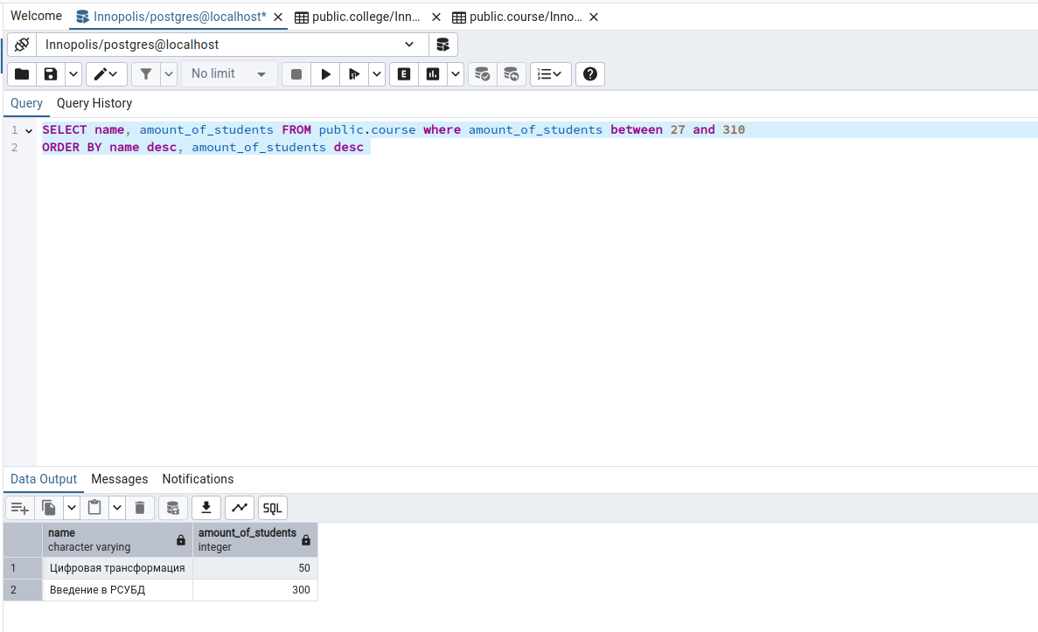

F) select name from student
union all select name from course
order by name desc


G)
select name, 'университет' AS object_type FROM college
union all select name, 'курс' from course
order by name desc
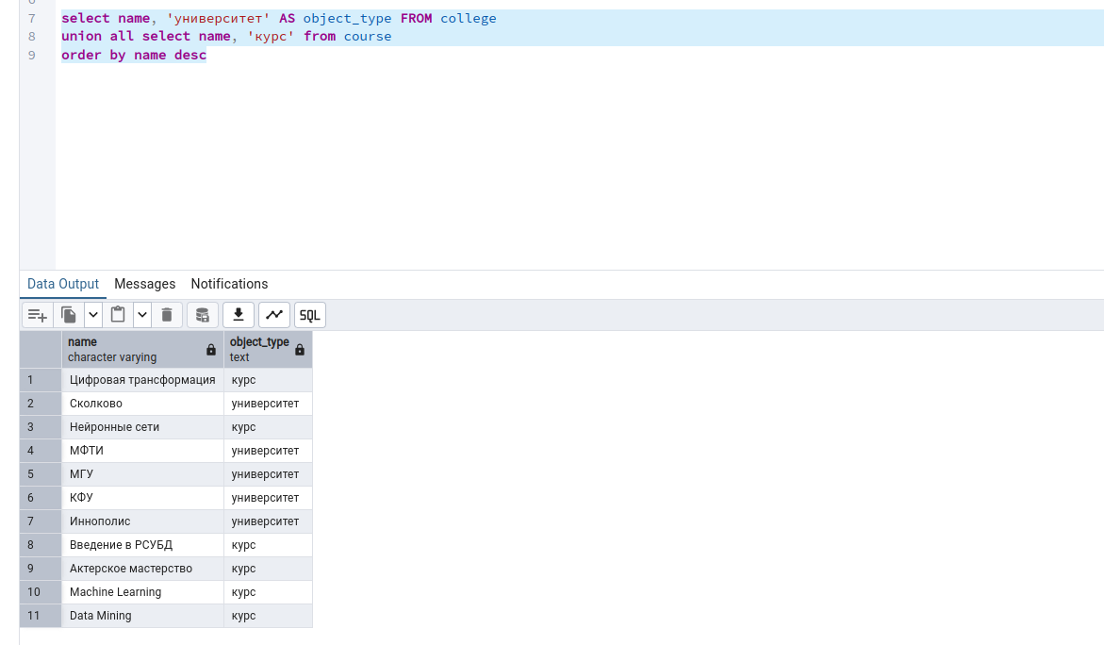
H)
SELECT name, amount_of_students FROM public.course
ORDER BY CASE WHEN(
amount_of_students = 300)
THEN 0
ELSE 1
END, amount_of_students asc limit 3

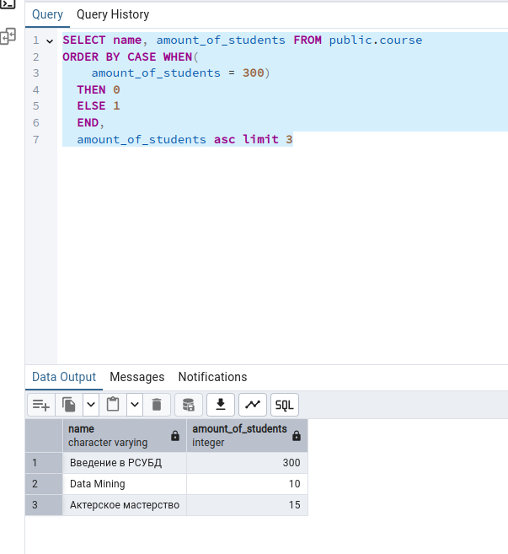

I) insert into public.course(id, name, is_online, amount_of_students, college_id)
values(60, 'Machine Learning', false, 17, 20)

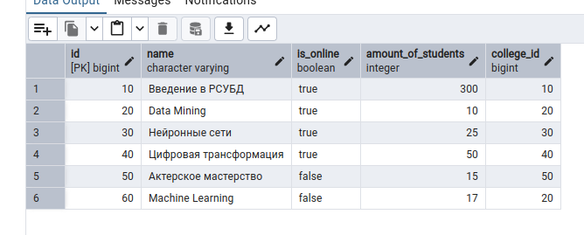
J)
(SELECT id FROM course
WHERE id NOT IN (SELECT id FROM student_on_course)
) UNION
( SELECT id FROM student_on_course
WHERE id NOT IN (SELECT id FROM course)
) ORDER BY id;
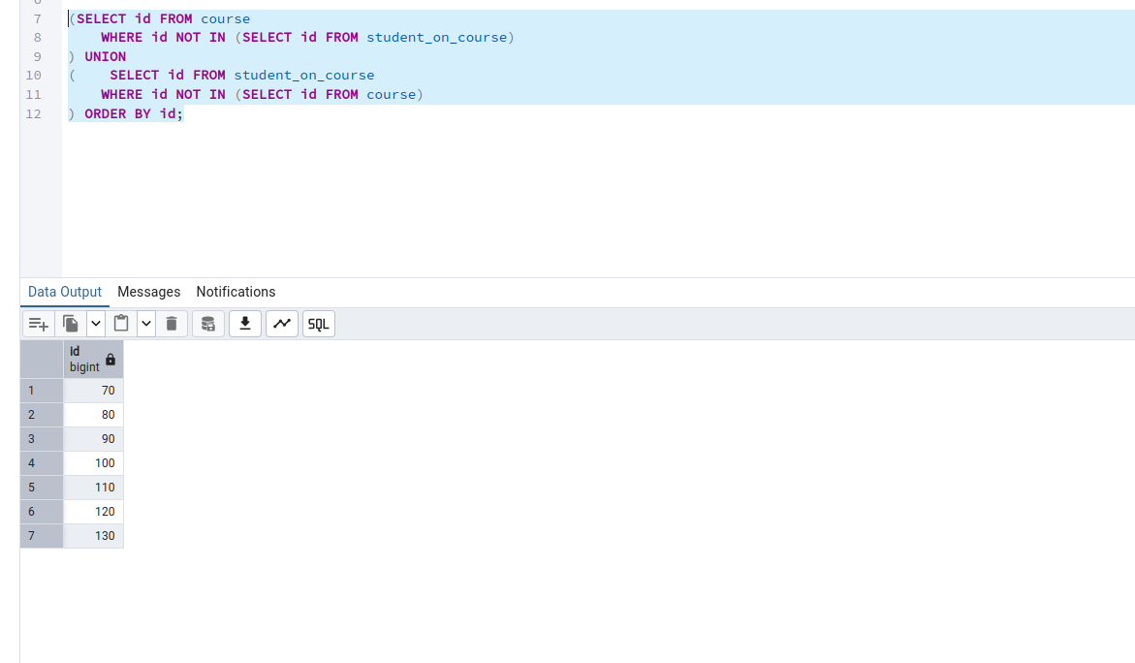

K) SELECT s.name as student_name, c.name as course_name, col.name as student_college, soc.student_rating as student_rating FROM student s
join student_on_course soc on soc.student_id = s.id and soc.student_rating > 50
join course c on soc.course_id = c.id
join college col on col.id = c.college_id and col.size > 5000
order by student_name, course_name
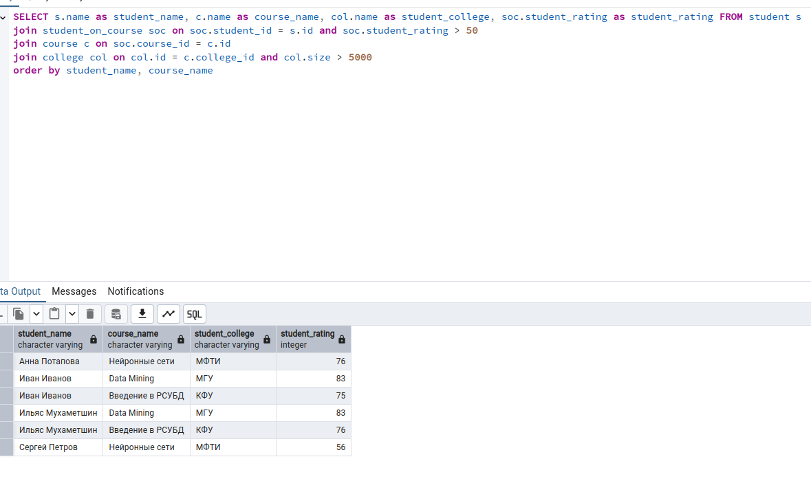

L) SELECT
LEAST(s1.name, s2.name) AS student_1,
GREATEST(s1.name, s2.name) AS student_2,s1.city
FROM student s1 JOIN
student s2 ON s1.city = s2.city AND s1.id < s2.id

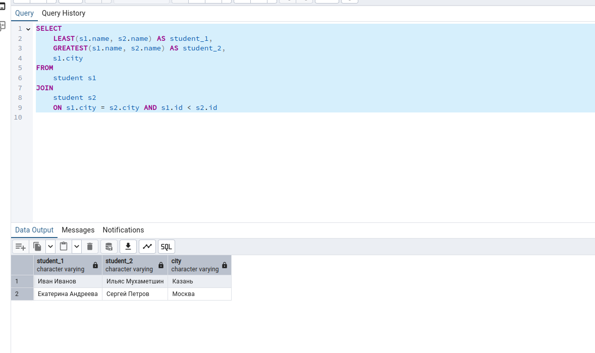

m) SELECT
CASE
WHEN soc.student_rating < 30 THEN 'неудовлетворительно'
WHEN soc.student_rating >= 30 AND soc.student_rating < 60 THEN 'удовлетворительно'
WHEN soc.student_rating >= 60 AND soc.student_rating < 85 THEN 'хорошо'
ELSE 'отлично'
END AS "оценка",
COUNT(*) AS "количество студентов"
FROM
student_on_course soc
JOIN
course c ON soc.course_id = c.id and c.amount_of_students > 0
GROUP BY "оценка"
ORDER BY "оценка";

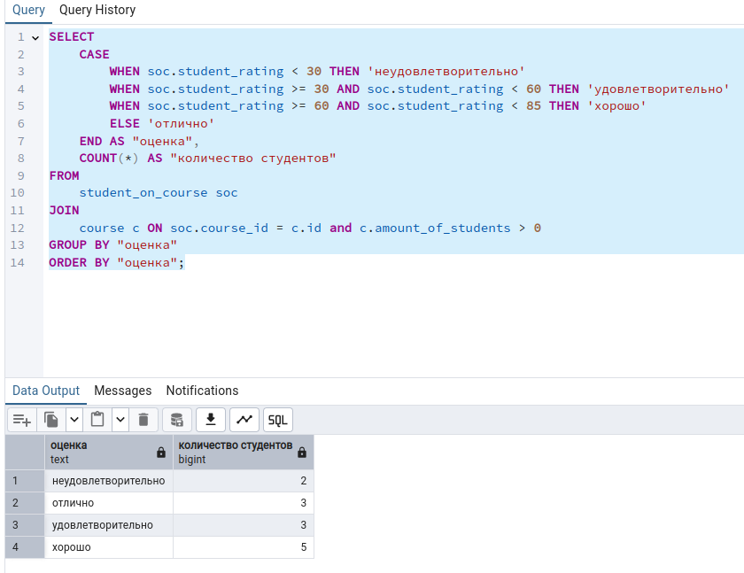

N) SELECT
c.name as "курс",
CASE
WHEN soc.student_rating < 30 THEN 'неудовлетворительно'
WHEN soc.student_rating >= 30 AND soc.student_rating < 60 THEN 'удовлетворительно'
WHEN soc.student_rating >= 60 AND soc.student_rating < 85 THEN 'хорошо'
ELSE 'отлично'
END AS "оценка",
COUNT(*) AS "количество студентов"
FROM
student_on_course soc
JOIN
course c ON soc.course_id = c.id and c.amount_of_students > 0
GROUP BY "курс", "оценка"
ORDER BY "курс", "оценка";
