From folder to finished report: a three-day walkthrough
  - Consumer Decision-Making Analysis in R
The Science Repository — workshop edition
2026-05-28
Table of contents

1. Why this document exists
This is the one orchestration file for the workshop. It walks you through the analysis end-to-end and shows how the folder structure you built on Day 1 removes duplication on Days 2 and 3.
The rule for this document: nothing is redefined here. Variable names, cleaning logic, models, plots — they all live in the R/ folder. This walkthrough just source()s them and tells the story.
That is the whole point. Change a model in R/functions/analysis.R and the website, the PDF, the manuscript, and the Shiny app all update the next time you render. No copy-paste.

1.1 How to render
One command, three folders:
quarto render
Output | Lands in
00_walkthrough.html (and the rest of the site) | docs/ → GitHub Pages
walkthrough.pdf | manuscript/output/
walkthrough.docx | manuscript/output/
The HTML/PDF/DOCX split is one source file, three formats. A post-render script (scripts/post_render.R) moves the PDF and DOCX out of docs/ and into manuscript/output/ so the site folder stays HTML-only.
PDF requires a LaTeX engine. One-time setup:
install.packages("tinytex")
tinytex::install_tinytex()
To render only a subset of formats (e.g., if tinytex isn’t installed):
quarto render reports/00_walkthrough.qmd --to html
quarto render reports/00_walkthrough.qmd --to html,docx

2. Day 1 — The scaffold
What you built yesterday is a project, not a folder. The difference:
folder_overview <- tibble::tribble(
~Folder, ~Purpose,
"R/", "Code: numbered scripts + reusable functions.",
"data/mock/", "Synthetic, committed, LLM-safe data.",
"data/raw/", "Real data. Gitignored.",
"data/processed/", "Output of cleaning. Reproducible, gitignored.",
"reports/", "Quarto sources (this file).",
"docs/", "Rendered website. GitHub Pages target.",
"manuscript/", "LaTeX paper.",
"shiny/", "Interactive app.",
"references/", "One .bib file used by both Quarto and LaTeX.",
"figures/", "Plots saved by scripts, shared by every output."
)
knitr::kable(folder_overview)
Table 1: What every folder in this project does.
Folder | Purpose
R/ | Code: numbered scripts + reusable functions.
data/mock/ | Synthetic, committed, LLM-safe data.
data/raw/ | Real data. Gitignored.
data/processed/ | Output of cleaning. Reproducible, gitignored.
reports/ | Quarto sources (this file).
docs/ | Rendered website. GitHub Pages target.
manuscript/ | LaTeX paper.
shiny/ | Interactive app.
references/ | One .bib file used by both Quarto and LaTeX.
figures/ | Plots saved by scripts, shared by every output.

You also wrote a smart .gitignore so real data can never be committed by accident, and an .Renviron.example with one switch:
DATA_MODE=mock # default — read from data/mock/
DATA_MODE=real # only when you mean it — read from data/raw/
Everything that follows in this document reads through data_path(). Flip DATA_MODE and the entire analysis re-runs on a different dataset, with no edits to any script.

3. Day 2 — From raw to results

3.1 Load the raw data
raw <- load_raw_consumer_data("consumer_data_raw.csv")
dplyr::glimpse(raw)
Rows: 300
Columns: 26
$ ParticipantID <chr> "P001", "P002", "P003", "P004", "P005", "P006",…
$ Condition <chr> "scarcity_frame", "combined_frame", "social_pro…
$ Age <dbl> 36, 63, 41, 51, 38, 46, 46, 43, 40, 27, 58, 58,…
$ Gender <chr> "female", "M", "Female", "non-binary", "W", "ma…
$ IncomeGroup <chr> "low", "low", "medium", "medium", "medium", "me…
$ ProductCategory <chr> "food", "clothing", "services", "electronics", …
$ ps_1 <dbl> 5, 2, 5, 5, 2, 4, 6, 4, 4, 3, 3, 4, 6, 2, 2, 5,…
$ ps_2 <dbl> 7, 4, 5, 4, 3, 5, 6, 5, 5, 1, 3, 2, 6, 4, 2, 2,…
$ ps_3 <dbl> 7, 3, 3, 4, 3, 4, 5, 3, 4, 2, 5, 3, 4, 5, 3, 5,…
$ sc_1 <dbl> 3, 4, 6, 3, 4, 4, 4, 4, 4, 5, 5, 4, 6, 4, 4, 4,…
$ sc_2 <dbl> 3, 4, 6, 2, 4, 4, 3, 4, 6, 4, 5, 4, 7, 4, 5, 3,…
$ sc_3 <dbl> 3, 4, 5, 5, 4, 4, 4, 5, 4, 5, 5, 4, 6, 5, 6, 4,…
$ bt_1 <dbl> 6, 4, 2, 4, NA, 3, 6, 4, 4, 3, 3, 6, 7, 2, 4, 6…
$ bt_2 <dbl> 6, 4, 1, 3, 5, 3, 6, 4, 5, 1, 4, 4, 5, 4, 3, 5,…
$ bt_3_r <dbl> 2, 2, 5, 6, 1, 4, 3, 3, 5, 5, 5, 3, 1, 5, 5, 4,…
$ pv_1 <dbl> 4, 5, 3, 3, 4, 3, 4, 3, 4, 3, 4, 3, 5, 3, 4, 5,…
$ pv_2 <dbl> 5, 3, 5, 4, 4, 2, 3, 4, 4, 5, 4, 5, 6, 3, 5, 4,…
$ pv_3 <dbl> 5, 4, 2, 3, 3, 3, 3, 4, 5, 3, 5, 3, 6, 4, 5, 4,…
$ perceived_quality <dbl> 6, 3, 3, 4, 4, 3, 5, 4, 4, 3, 4, 4, 5, 2, 4, 4,…
$ perceived_social_norm <dbl> 4, 5, 5, 4, 5, 5, 6, 4, 3, 4, 5, 4, 6, 2, 5, 5,…
$ pi_1 <dbl> 3, 4, 4, 2, NA, 5, 4, 3, 3, 3, 2, 5, 4, 5, 5, 5…
$ pi_2 <dbl> 2, 4, 4, 2, 3, 4, 4, 4, 2, 4, 4, 3, 4, 3, 4, 5,…
$ pi_3 <dbl> 5, 3, 4, 4, 3, 5, 4, 3, 3, 3, 3, 5, 5, 5, 6, 5,…
$ willingness_to_pay <dbl> 35.31, 39.74, 39.68, 44.55, 23.99, 48.11, 41.49…
$ choice <dbl> 0, 0, 0, 0, 0, 0, 0, 1, 0, 0, 0, 0, 0, 0, 1, 1,…
$ number_products_bought <dbl> 2, 4, 3, 1, 3, 2, 0, 2, 0, 4, 1, 2, 4, 1, 2, 3,…
The CSV is full of realistic mess: mixed-case column names, trailing whitespace, -99 missing codes, inconsistent gender labels, a reverse-scored item, scattered NAs. See data/mock/codebook.md for the full inventory.

3.2 Clean it
The cleaning logic lives in R/functions/data_loading.R so the cleaning script, this walkthrough, and the Shiny app all share one implementation:
clean <- clean_consumer_data(raw)
dplyr::glimpse(dplyr::select(clean, participant_id, condition, gender,
income_group, purchase_intention,
perceived_value, price_sensitivity))
Rows: 300
Columns: 7
$ participant_id <chr> "P001", "P002", "P003", "P004", "P005", "P006", "P0…
$ condition <fct> scarcity_frame, combined_frame, social_proof_frame,…
$ gender <fct> woman, man, woman, non_binary, woman, man, man, wom…
$ income_group <ord> low, low, medium, medium, medium, medium, medium, h…
$ purchase_intention <dbl> 3.333333, 3.666667, 4.000000, 2.666667, 3.000000, 4…
$ perceived_value <dbl> 4.666667, 4.000000, 3.333333, 3.333333, 3.666667, 2…
$ price_sensitivity <dbl> 6.333333, 3.000000, 4.333333, 4.333333, 2.666667, 4…
What clean_consumer_data() does (see source for the details): standardises column names with janitor::clean_names(), trims whitespace, recodes gender, turns -99 into NA, reverses bt_3_r, and averages each item set into a scale score.

3.3 Descriptives
desc <- descriptives_by_condition(clean)
knitr::kable(desc, digits = 2)
Table 2: Outcomes by experimental condition.
condition | n | mean_pi | sd_pi | mean_pv | sd_pv | mean_wtp | prop_choice_yes
control | 50 | 4.03 | 1.13 | 4.09 | 1.07 | 40.12 | 0.40
scarcity_frame | 75 | 4.20 | 1.01 | 4.12 | 1.07 | 43.05 | 0.35
sustainability_frame | 67 | 4.35 | 1.06 | 4.51 | 1.04 | 43.83 | 0.52
social_proof_frame | 53 | 4.28 | 1.19 | 4.25 | 0.93 | 44.35 | 0.40
combined_frame | 55 | 4.60 | 0.96 | 4.88 | 1.04 | 48.55 | 0.47

3.4 Visual first, model second
plot_pi_by_condition(clean)
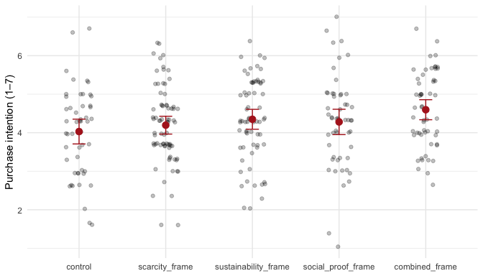
Figure 1: Purchase intention by condition. Red points are condition means; bars are 95% CIs.
combined_frame shows a clear bump over control. The scatter below suggests why: the conditions also raise perceived_value, and perceived value strongly predicts purchase intention.
plot_mediation_scatter(clean)
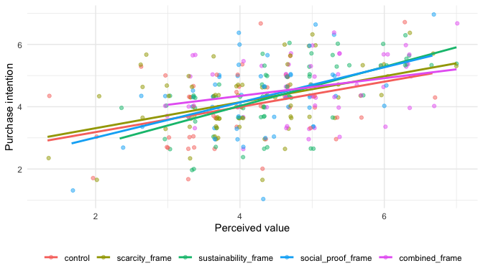
Figure 2: Perceived value (mediator) versus purchase intention (outcome), by condition.

3.5 Main effect: condition predicts purchase intention
fit_main <- fit_main_model(clean)
knitr::kable(broom::tidy(fit_main, conf.int = TRUE), digits = 3)
term | estimate | std.error | statistic | p.value | conf.low | conf.high
(Intercept) | 4.085 | 0.254 | 16.111 | 0.000 | 3.586 | 4.584
conditionscarcity_frame | 0.140 | 0.204 | 0.685 | 0.494 | -0.262 | 0.541
conditionsustainability_frame | 0.311 | 0.206 | 1.508 | 0.133 | -0.095 | 0.716
conditionsocial_proof_frame | 0.240 | 0.218 | 1.102 | 0.271 | -0.189 | 0.669
conditioncombined_frame | 0.582 | 0.218 | 2.675 | 0.008 | 0.154 | 1.010
age | -0.001 | 0.006 | -0.180 | 0.858 | -0.012 | 0.010
genderman | -0.032 | 0.137 | -0.233 | 0.816 | -0.301 | 0.237
gendernon_binary | -0.465 | 0.342 | -1.361 | 0.175 | -1.137 | 0.208
genderprefer_not_to_say | 0.124 | 0.297 | 0.418 | 0.676 | -0.460 | 0.709
income_group.L | -0.175 | 0.130 | -1.353 | 0.177 | -0.431 | 0.080
income_group.Q | 0.021 | 0.104 | 0.201 | 0.841 | -0.184 | 0.226

3.6 Mediation: condition → perceived value → purchase intention
Three regressions tell the conceptual mediation story (Baron and Kenny 1986; Hayes 2017):
med <- fit_mediation_models(clean)
dplyr::bind_rows(
total = broom::tidy(med$total, conf.int = TRUE),
mediator = broom::tidy(med$a, conf.int = TRUE),
outcome_w_m = broom::tidy(med$b, conf.int = TRUE),
.id = "model"
) |>
dplyr::filter(grepl("condition|perceived_value", term)) |>
knitr::kable(digits = 3)
model | term | estimate | std.error | statistic | p.value | conf.low | conf.high
total | conditionscarcity_frame | 0.140 | 0.204 | 0.685 | 0.494 | -0.262 | 0.541
total | conditionsustainability_frame | 0.311 | 0.206 | 1.508 | 0.133 | -0.095 | 0.716
total | conditionsocial_proof_frame | 0.240 | 0.218 | 1.102 | 0.271 | -0.189 | 0.669
total | conditioncombined_frame | 0.582 | 0.218 | 2.675 | 0.008 | 0.154 | 1.010
mediator | conditionscarcity_frame | 0.045 | 0.196 | 0.227 | 0.820 | -0.342 | 0.431
mediator | conditionsustainability_frame | 0.483 | 0.199 | 2.433 | 0.016 | 0.092 | 0.874
mediator | conditionsocial_proof_frame | 0.196 | 0.210 | 0.934 | 0.351 | -0.217 | 0.609
mediator | conditioncombined_frame | 0.849 | 0.210 | 4.050 | 0.000 | 0.436 | 1.262
outcome_w_m | conditionscarcity_frame | 0.119 | 0.183 | 0.650 | 0.516 | -0.242 | 0.480
outcome_w_m | conditionsustainability_frame | 0.090 | 0.187 | 0.483 | 0.630 | -0.278 | 0.459
outcome_w_m | conditionsocial_proof_frame | 0.151 | 0.196 | 0.767 | 0.443 | -0.236 | 0.537
outcome_w_m | conditioncombined_frame | 0.195 | 0.201 | 0.968 | 0.334 | -0.202 | 0.591
outcome_w_m | perceived_value | 0.456 | 0.056 | 8.154 | 0.000 | 0.346 | 0.566
The pattern to read for in the table: the condition coefficients in outcome_w_m are smaller than in total, and perceived_value is a significant predictor — that’s a mediation signature.

3.7 Moderation: price sensitivity weakens the effect
fit_mod <- fit_moderation_model(clean)
knitr::kable(
broom::tidy(fit_mod, conf.int = TRUE) |>
dplyr::filter(grepl("condition|price", term)),
digits = 3
)
term | estimate | std.error | statistic | p.value | conf.low | conf.high
conditionscarcity_frame | 0.090 | 0.197 | 0.455 | 0.649 | -0.298 | 0.477
conditionsustainability_frame | 0.270 | 0.199 | 1.353 | 0.177 | -0.123 | 0.662
conditionsocial_proof_frame | 0.091 | 0.212 | 0.431 | 0.667 | -0.326 | 0.509
conditioncombined_frame | 0.475 | 0.210 | 2.257 | 0.025 | 0.061 | 0.889
price_sensitivity_c | -0.488 | 0.120 | -4.076 | 0.000 | -0.723 | -0.252
conditionscarcity_frame:price_sensitivity_c | 0.291 | 0.155 | 1.885 | 0.060 | -0.013 | 0.596
conditionsustainability_frame:price_sensitivity_c | 0.276 | 0.165 | 1.676 | 0.095 | -0.048 | 0.600
conditionsocial_proof_frame:price_sensitivity_c | 0.242 | 0.164 | 1.472 | 0.142 | -0.082 | 0.565
conditioncombined_frame:price_sensitivity_c | 0.354 | 0.170 | 2.076 | 0.039 | 0.018 | 0.689
plot_moderation(clean)
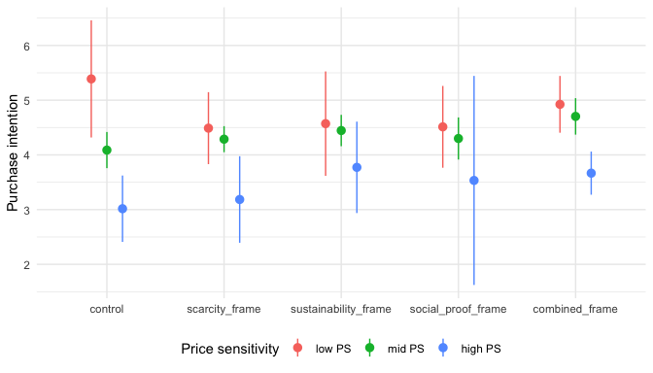
Figure 3: Condition × price sensitivity. The combined-frame boost shrinks for high-price-sensitive consumers.

4. Day 3 — Where does this go?
You’re reading the Day 3 output right now. The same .qmd you’re looking at becomes:
- An HTML website in docs/, served by GitHub Pages.
- A PDF ready to paste figures from into the LaTeX manuscript.
- A Word document for collaborators who don’t use git.

4.1 The connectedness — what got reused, not copied
Every piece of this document came from somewhere else in the repo:
Element on this page | Where it lives | Used by who else
Variable names (outcome_var, …) | R/01_setup.R | Every R script + Shiny app
clean_consumer_data() | R/functions/data_loading.R | 02_data_processing.R, Shiny app
fit_main_model(), fit_mediation_models() | R/functions/analysis.R | 03_analysis.R, manuscript
plot_pi_by_condition() etc. | R/functions/plotting.R | 03_analysis.R (figures saved to figures/)
Citations [@baron1986] | references/references.bib | This file + the LaTeX manuscript
Mock data | data/mock/ | This file + Shiny app + LLM on Day 3
If you renamed purchase_intention to intent_to_buy, you would change it in R/01_setup.R and R/functions/data_loading.R — two files — and every figure, table, PDF, website page, and the Shiny app would follow.

4.2 What happens when you point this at real data
Set DATA_MODE=real in your .Renviron. Re-render. Same code, same analysis, real numbers.
echo 'DATA_MODE=real' >> .Renviron
quarto render reports/00_walkthrough.qmd
The mock workflow is the rehearsal. The real workflow is one env var away.

4.3 On Day 3 you also brought in the LLM
If you opened this repo with the LLM-mode workspace (the-science-repository.llm.code-workspace), your assistant can see this file and data/mock/ but not data/raw/ or data/processed/. That’s not a vibe; it’s enforced by:
- The workspace file’s files.exclude (editor-level hiding).
- .claude/settings.json’s permissions.deny (tool-level blocking).
So you can ask Claude to “improve the moderation plot” and it can do the job against synthetic data without ever touching the real one.

5. Where to take this next
- Add a new analysis: write a function in R/functions/, call it from R/03_analysis.R and from a new section here. Don’t copy code.
- Add a new outcome: extend descriptives_by_condition() and re-render. All tables update.
- Write the paper: open manuscript/main.tex. It uses the same figures/ and references/references.bib.

6. References
Baron, Reuben M., and David A. Kenny. 1986. “The Moderator-Mediator Variable Distinction in Social Psychological Research: Conceptual, Strategic, and Statistical Considerations.” Journal of Personality and Social Psychology 51 (6): 1173–82. https://doi.org/10.1037/0022-3514.51.6.1173.
Hayes, Andrew F. 2017. Introduction to Mediation, Moderation, and Conditional Process Analysis: A Regression-Based Approach. 2nd ed. New York, NY: Guilford Press.

