一、登陆接口、api权限测试

1.登陆成功(B0000)
http://localhost:8080/spg/app/login?username=chencheng1604&password=123456

2.用户名不存在(B0001)
http://localhost:8080/spg/app/login?username=郑33书鹏&password=123456

3.密码错误(B0002)
http://localhost:8080/spg/app/login?username=10008001&password=123456789

4.接口没有权限(B1111)
http://localhost:8080/spg/app/auth

5.接口调用成功(B0000)
http://localhost:8080/spg/app/auth?token=用你们调用登陆接口返回的token

6.系统异常(B9999)
后台代码执行异常

- 分页查询类别的接口说明

http://localhost:8080/spg/app/User/page?filter_EQS_status=A&page=1&rows=20
1.输入参数：
page： 当前页码，默认为1
rows：每页行数，默认为20
过滤条件格式：filter_[查询规则|参数类型]_参数名称=参数值

2.查询规则：{EQ，全文匹配}、{LIKE，模糊匹配}、{LT，小于}、{GT，大于}、{LE，小于等于}、{GE，大于等于}
参数类型：S(String.class), I(Integer.class), L(Long.class), N(Double.class), D(Date.class), B(Boolean.class)

- 返回结果：
total：记录总条数
rows：结果集

- 短信验证码接口
1.发送成功(B0000)
http://localhost:8080/spg/app/varificationcode?phone=18761651893&username=10008001&token=67642E3EE5AB3D2E13E6FF35651DCF94

2.接口没有访问权限(B1111)
http://localhost:8080/spg/app/varificationcode?phone=18761651893&username=10008001&code=941350

- 系统异常(B9999)
后台代码执行异常

四、手机绑定接口
1.绑定成功(B0000)
http://localhost:8080/spg/app/bind?phone=18761651893&username=10008001&token=67642E3EE5AB3D2E13E6FF35651DCF94&code=759301

2.接口没有访问权限(B1111)
http://localhost:8080/spg/app/bind?phone=18761651893&username=10008001&token=faddsadasdassddsdasadas

- 时段内短信发送次数用尽,稍后再试(B1002)
注意：短信验证码，使用同一个签名，对同一个手机号码发送短信验证码，允许每分钟1条，累计每小时7条。 短信通知，使用同一签名、同一模板，对同一手机号发送短信通知，允许每天50条（自然日）。

- 系统异常(B9999)
后台代码执行异常

- 短信验证码缓存错误(B1004)
redis故障

- 短信验证码不正确(B1005)
http://localhost:8080/spg/app/bind?phone=18761651893&username=10008001&token=67642E3EE5AB3D2E13E6FF35651DCF94&code=01aaa

五、考勤模块接口
- 根据日期查询班次信息
http://localhost:8080/spg/app/attendance/bcinfo?username=EHZ02102&date=2017-04-17
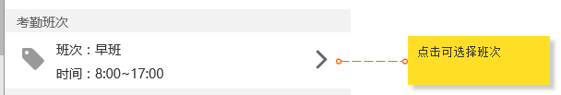

- 打卡(POST)
http://localhost:8080/spg/app/attendance/punch
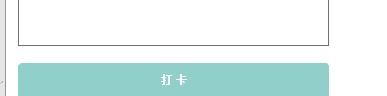
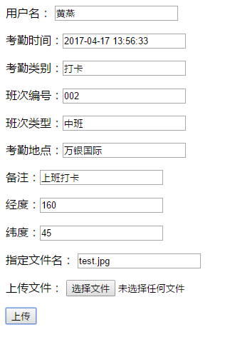

- 考勤排班-->门店查询
http://localhost:8080/spg/app/attendance/storeinfo?username=EHZ02102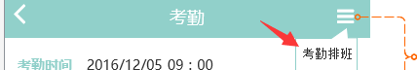

- 按日期查询某个店员的考勤记录
http://localhost:8080/spg/app/attendance/attinfo/self?username=EHZ02102&date=2017-04-17
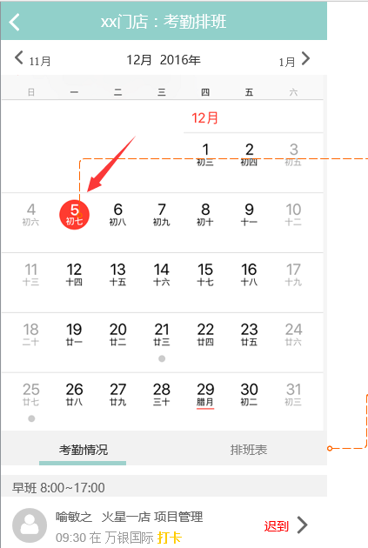

- 按日期查询所有店员的考勤记录（负责排班的角色能看到所有店员的考勤信息）
http://localhost:8080/spg/app/attendance/attinfo?username=EHZ02102&date=2017-04-17

- （PC端用）获取集团门店的地市信息
http://localhost:8080/spg/admin/attendance/cityinfo

- （PC端用）批量添加班次信息
http://localhost:8080/spg/admin/attendance/addSchedulings?jsonpCallback=XXX

- （PC端用）班次信息分页查询
不加限制条件
http://localhost:8080/spg/admin/attendance/pqSchedulings?page=1&rows=20
加限制条件
http://localhost:8080/spg/admin/attendance/pqSchedulings?filter_EQS_city=杭州市&page=1&rows=20

- 根据id查询某个店员某个班次的考勤信息
http://localhost:8080/spg/app/attendance/attinfo/single?kqid=402847105b807e4b015b807eccce0000

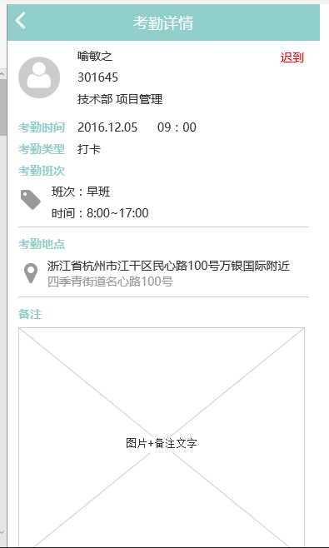

六、商学院接口
1、我的课程
http://localhost:8080/spg/app/training/mycourses?username=chencheng1604
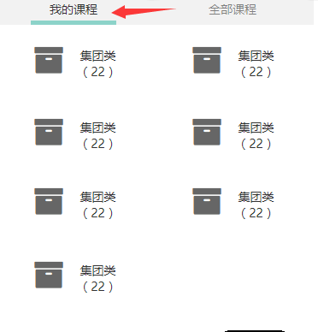
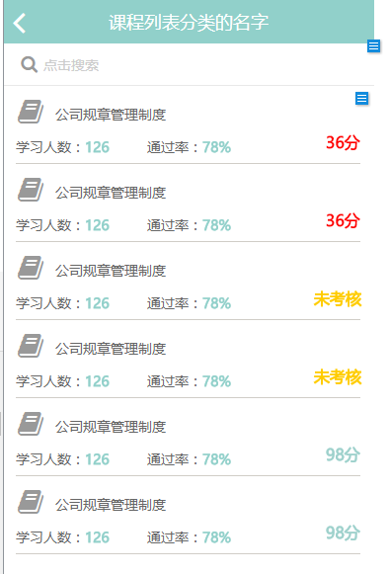
PS: 一级分类下课程的数目你们直接取各一级分类下list的size，每个一级分类下的课程信息直接从该接口返回的结果集中获取即可。

- 我的课程通过情况
http://localhost:8080/spg/app/training/myresults?username=chencheng1604
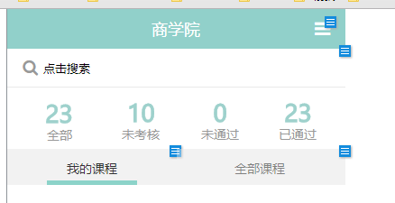
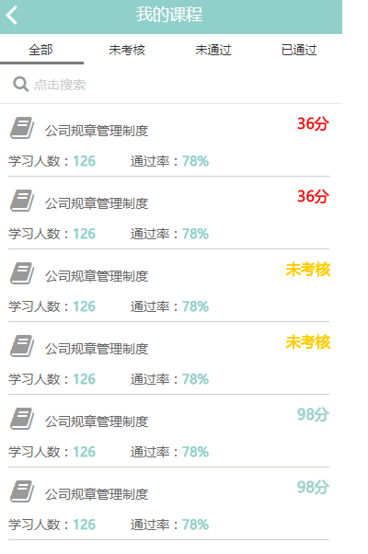

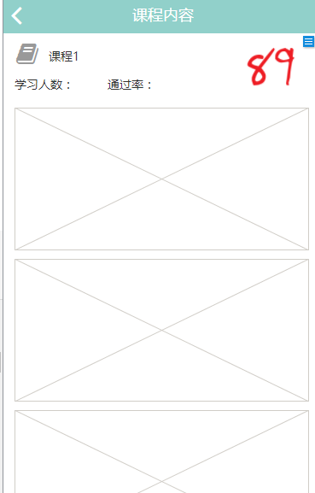

- 答题
http://localhost:8080/spg/app/training/myscore?username=chencheng1604&courseid=4&answer= 1-A,2-B,3-C,4-D
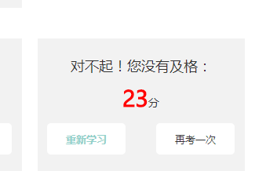

- 全部课程
http://localhost:8080/spg/app/training/allcourses?username=chencheng1604
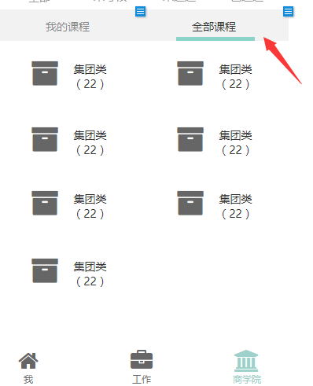
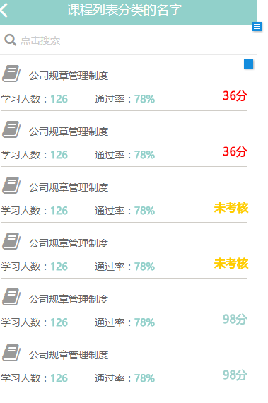

- 考核跟进--店铺员工信息
http://localhost:8080/spg/app/training/clerksinfo?username=chencheng1604
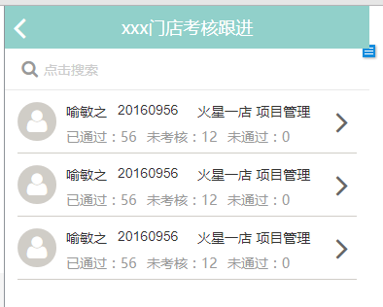

PS:考核详情调用 http://localhost:8080/spg/app/training/myresults?username=chencheng1604
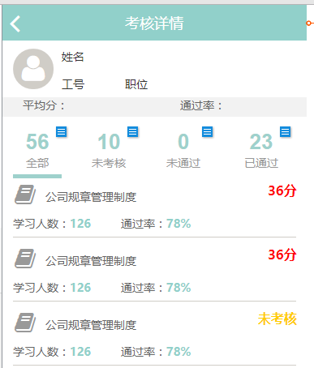

6.考核--查看试题
http://localhost:8080/spg/app/training/papers?courseid=4
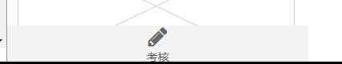
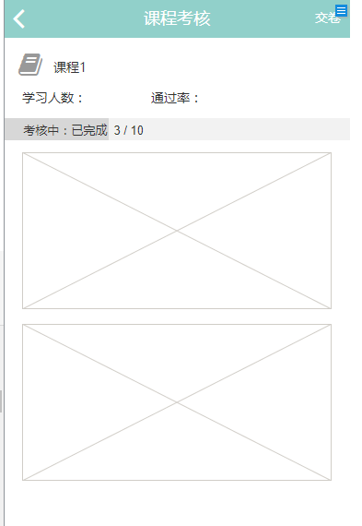

- 会议模块
PC端接口列表;
- 获取与会人员信息
http://localhost:8080/spg/admin/working/queryEmployees
- 发布会议
http://localhost:8080/spg/admin/working/publishmeeting
根据id查询会议
http://localhost:8080/spg/admin/working/getmeeting?mid=1
查询所有会议
http://localhost:8080/spg/admin/working/allmeeting
日程安排
http://localhost:8080/spg/admin/working/schedule
6.删除会议信息
http://localhost:8080/spg/admin/working/delmeeting
更新会议信息
http://localhost:8080/spg/admin/working/updmeeting

l20.55.85.65:8088
192.168.199.145:8080

移动端:
- 根据用户获取会议信息
http://localhost:8080/spg/app/working/queryMeetings?username=FGD05103
查询日程详情
http://localhost:8080/spg/app/working/getStaffing?meetingid=1&jobnum=FGD05103&programid=1
- 查询会务信息
http://localhost:8080/spg/app/working/conferencestaff?meetingid=1

