Level 9 Homework
Groups C&D: Monte Carlo Pricing Methods
- b) & c)
- For Batch 1, minimum absolute error (0.0022) is reached when NT = 100, NSIM = 500000.
- For Batch 2, minimum absolute error (0.00058) is reached when NT = 1000, NSIM = 500000.
- For Batch 4, an accuracy to two places behind the decimal point is reached when NT = 1000, NSIM = 200000.
[Accuracy Analysis]
- Accuracy of Monte Carlo Method is generally unpredictable under absolute error measure.
- Increasing NSIM generally improves accuracy, as MC error converges at a rate proportional to$\frac{1}{ √NSIM}$ .
- Increasing NT refines the discretization of the time interval. Theoretically, a finer discretization improves the pathwise approximation of the continuous-time model and hence the accuracy. However, in practice, especially when NT < 1000, the marginal improvement in accuracy is often negligible, while the computational cost increases linearly.
- While increasing NT and NSIM can both improve accuracy, they affect different types of error:
- NSIM reduces statistical error (variance)
- NT reduces discretization error (bias).
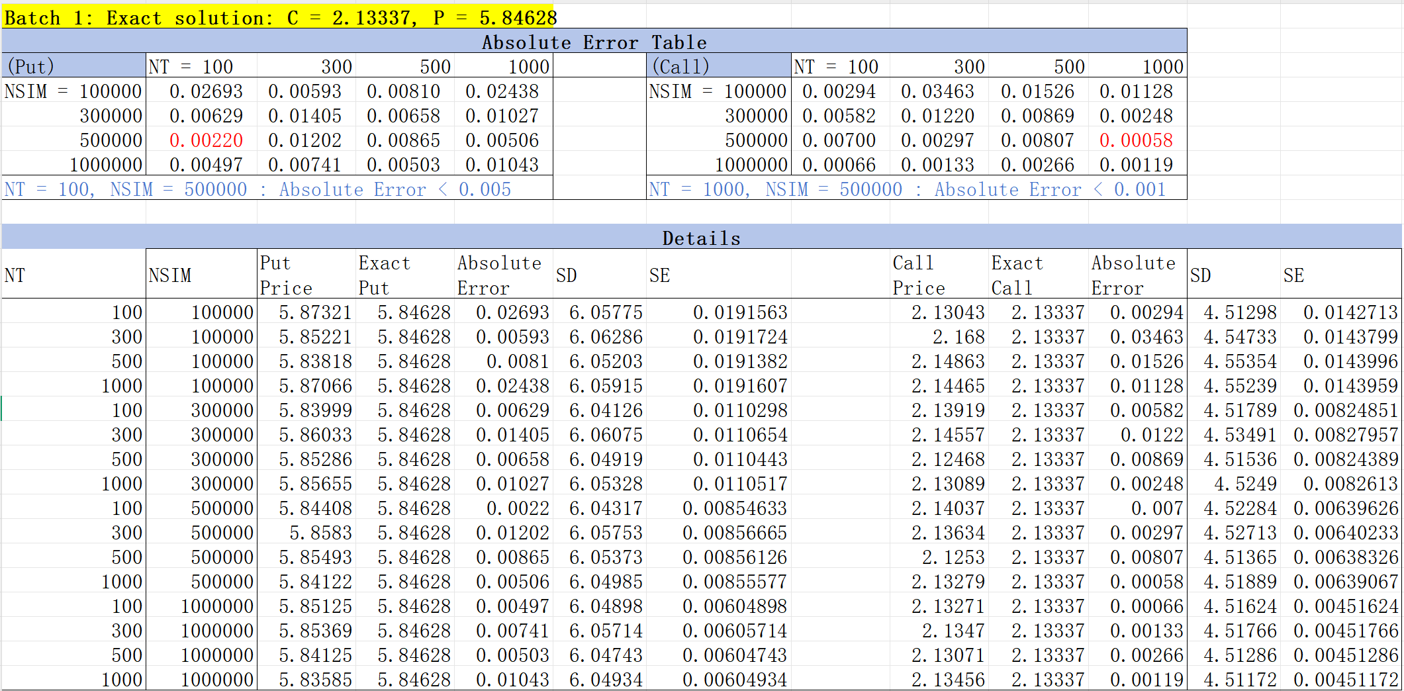
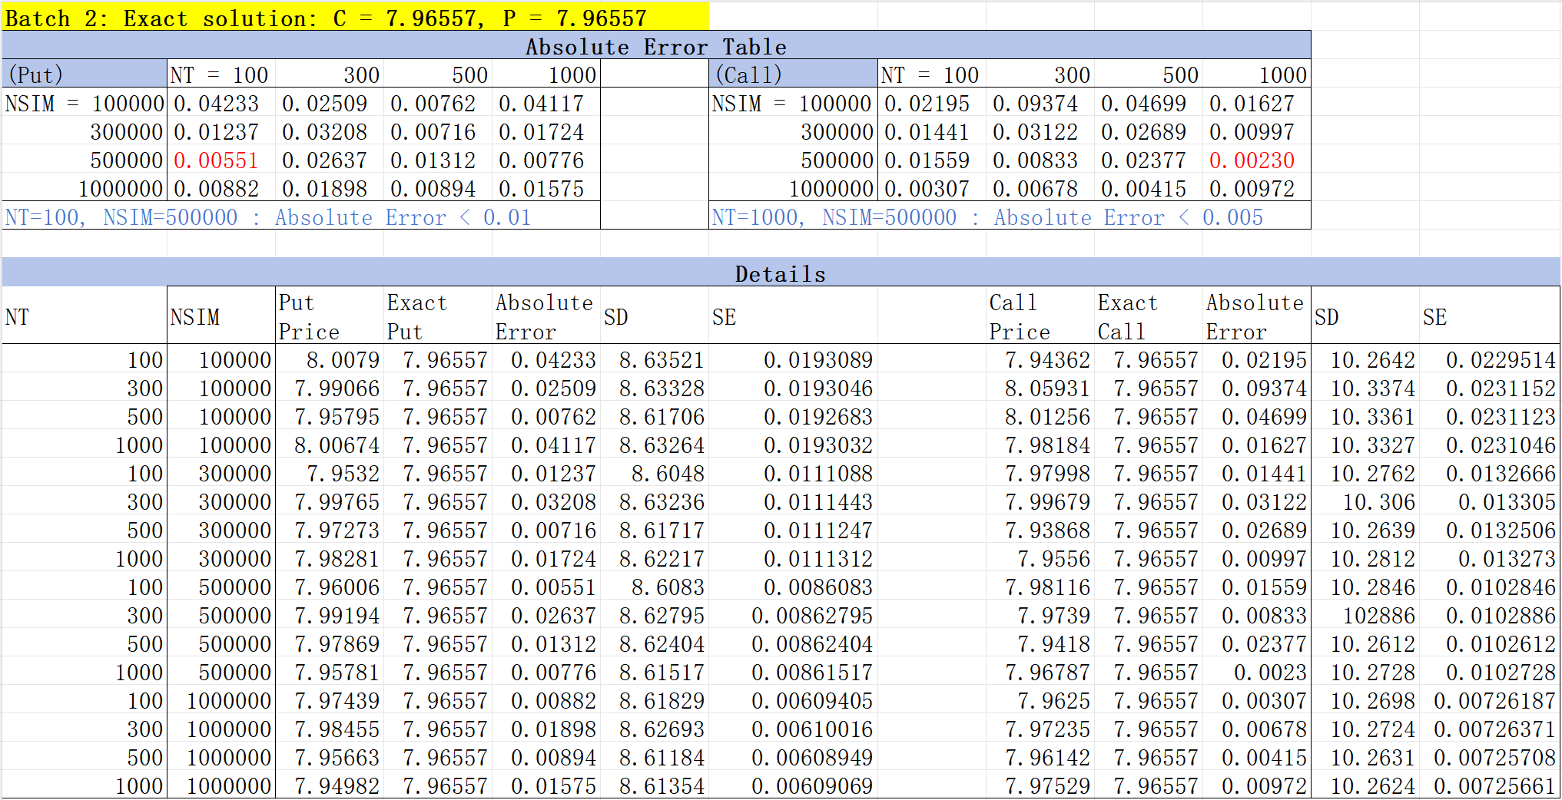
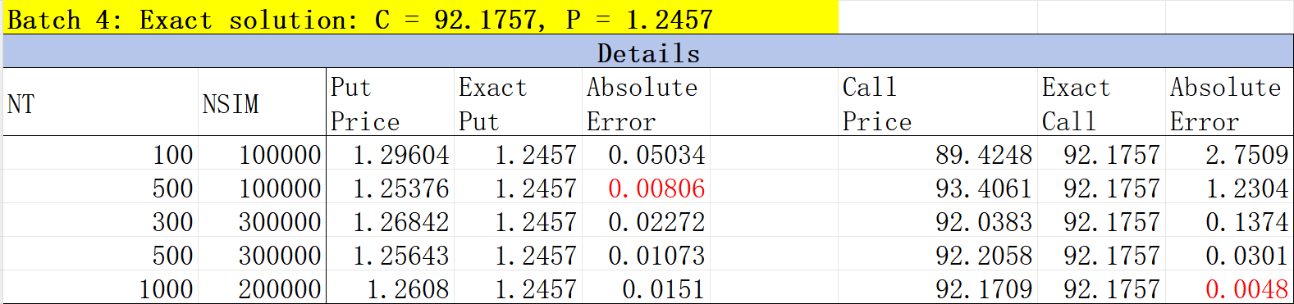

- b)
[Accuracy and Efficiency Analysis]
- Standard Deviation (SD):
SD in a Monte Carlo simulation reflects the spread of the sampled payoffs. It is inherent to the payoff distribution and does not strongly depend on NSIM or NT. However, it can be indirectly affected by other model parameters such as:
- Time to maturity (T): longer maturities typically result in higher paths’ variability, hence larger SD, yet they also reduce the discounting factor $e^{−rT}$, slightly lowering SD;
- Risk-free rate (r): higher rates tend to reduce present value dispersion, slightly lowering SD.

- Standard Error (SE):
As the formula suggests, SE = $\frac{SD}{√NSIM}$. Therefore, SE decreases as NSIM increases, improving the reliability (confidence) of the estimate. NT has negligible impact on SE unless it substantially alters SD through better path fidelity.

- Observed patterns:
- When comparing MC results to exact solutions (e.g., Black-Scholes), we observe that MC tends to perform better (i.e., smaller absolute error) when the true option price is small — possibly because smaller prices are less sensitive to volatility in the payoff.
- In empirical tests (e.g., Batch1 and Batch2), increasing NT beyond a moderate level (e.g., 1000) does not significantly enhance accuracy, while increasing NSIM can gradually reduces SE.
- This suggests a practical strategy: fix NT at a reasonable level (e.g., 100–1000), and focus computational resources on increasing NSIM (e.g., ≥ 100,000) to achieve a balance between accuracy and efficiency.




