**Extra files for subduction zone benchmark (van Keken et al., PEPI, 2008)**

1c: isoviscous benchmark 1c with Neumann b.c. for velocity

2a: same for benchmark with eta(T) - diffusion creep

2b: same for benchmark with eta(T,edot) - dislocation creep

Files:

**uvp.vtu**: velocity and pressure on computational mesh for a ‘typical’ sepran mesh (35169 nodal points with strong refinement near coupling point). Note that due to an early design ‘issue’ the subduction is to the left instead of to the right as specified in the benchmark. Plots below & VTU have this reversal of direction. The velocity and pressure are in non-dimensional form. To translate (u,v) to cm/yr multiply by 5/2.18. To convert pressure to MPa multiply by 727.2.

**temp.vtu**: temperature in degrees Celsius on same mirrored mesh.

**wedge_bc.dat:** boundary conditions at wedge inflow/outflow mapped onto benchmark geometry. For 1c the file contains (x,y,u,v,ub,vb,V) where (ub,vb) is the Batchelor velocity. For 2a and 2b it contains just (x,y,u,v,V). V is speed.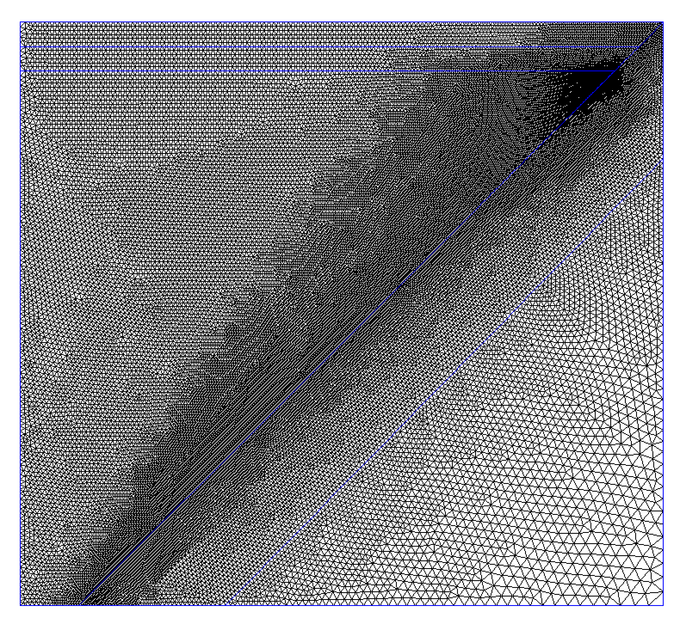

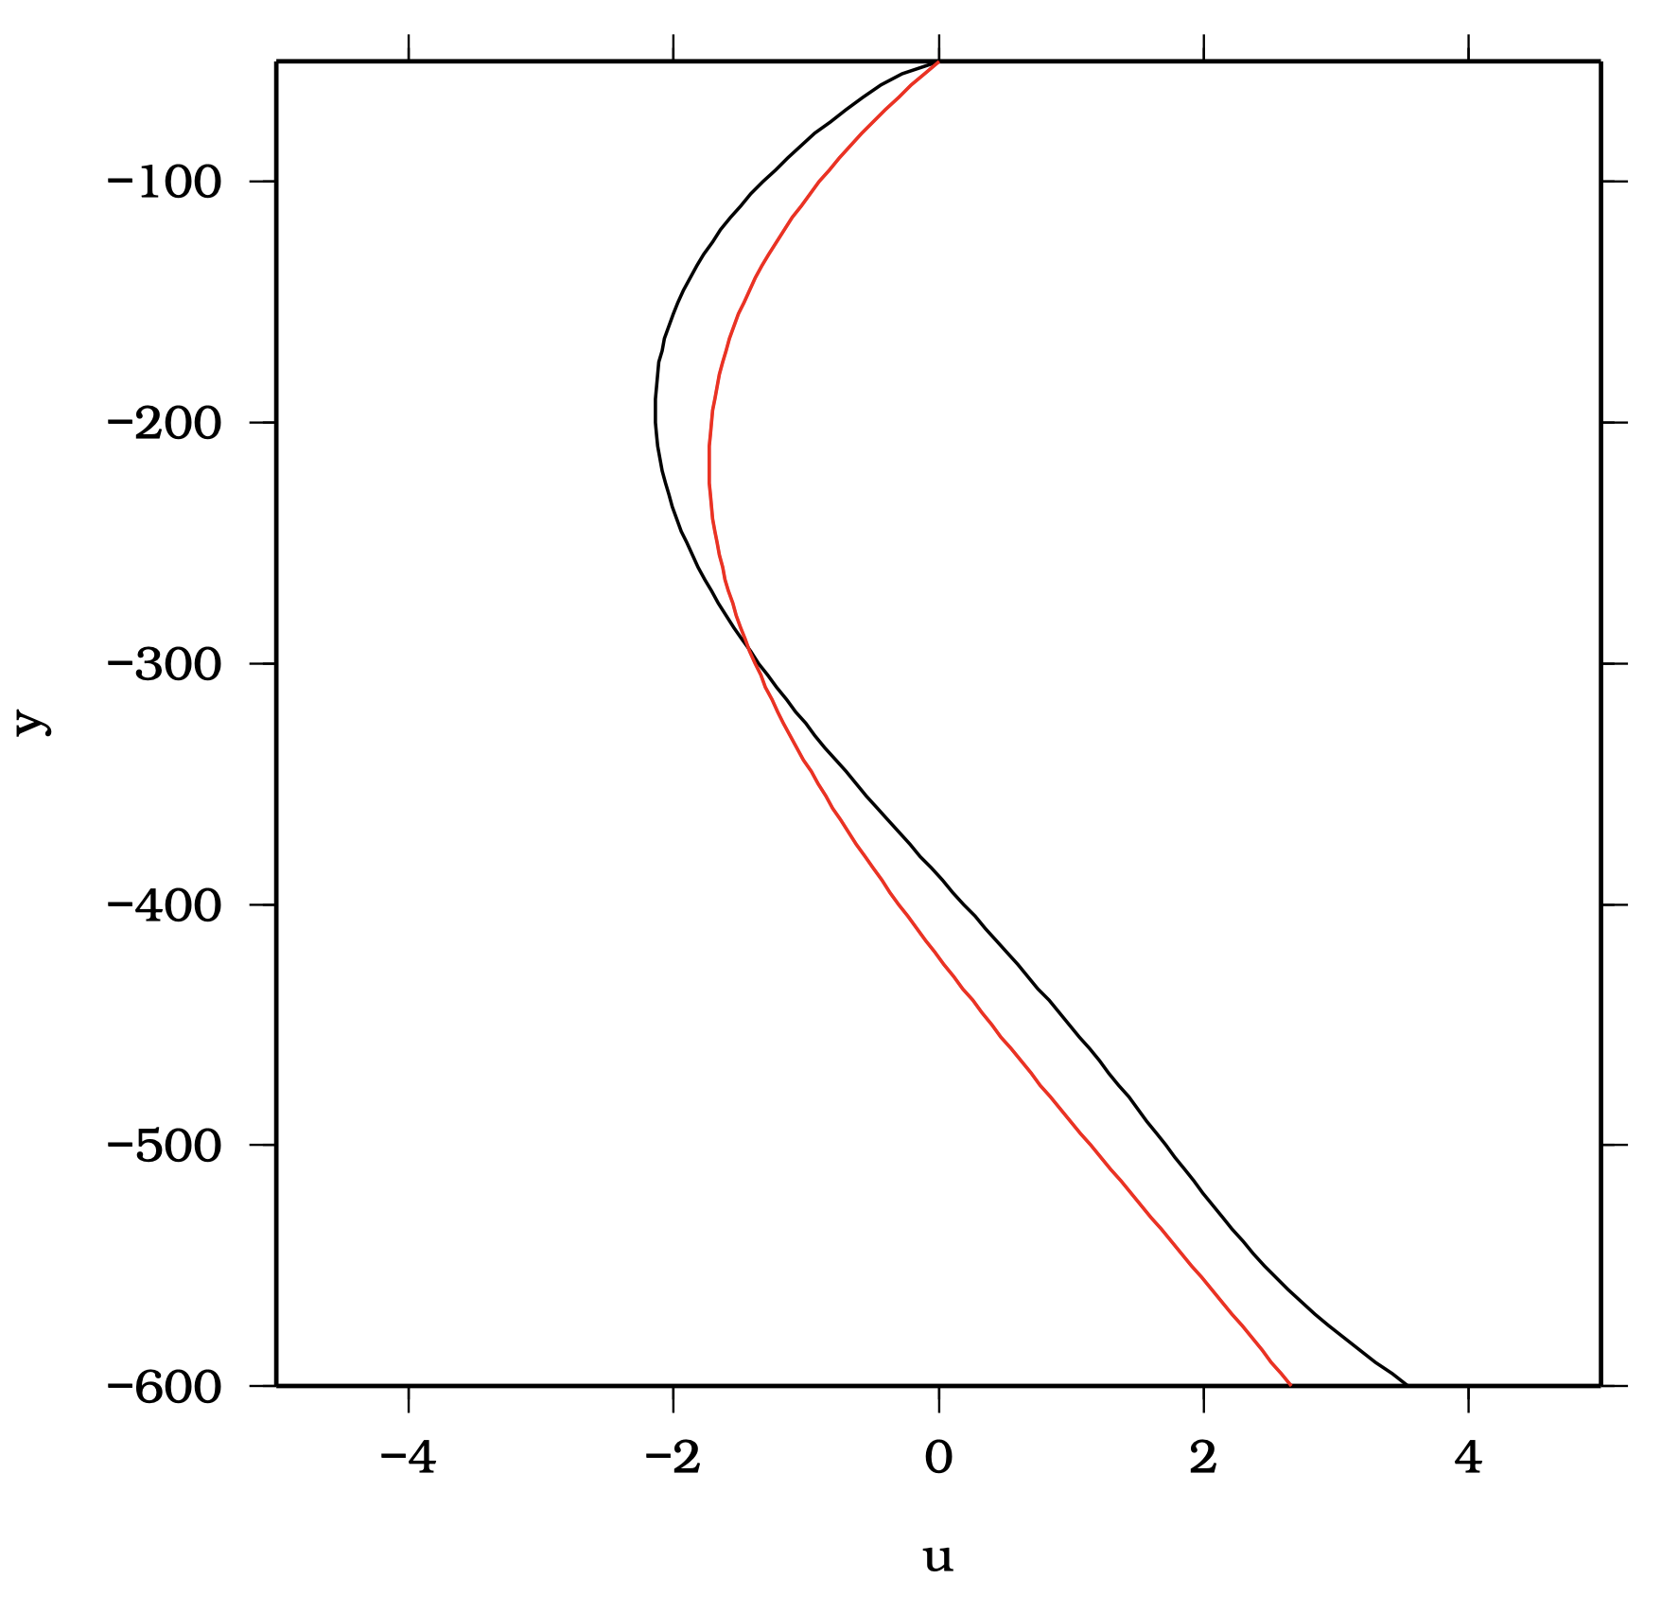

Benchmark 1c horizontal velocity at in/outflow boundary (red=Batchelor solution, black=sepran solution)

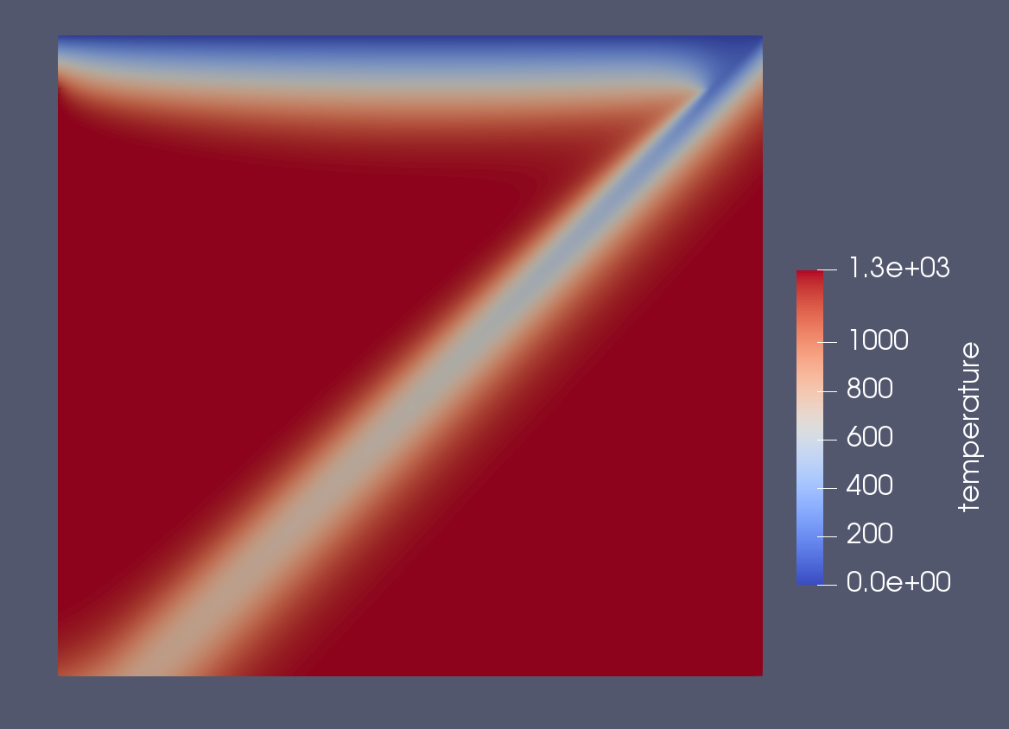

benchmark 1c temperature

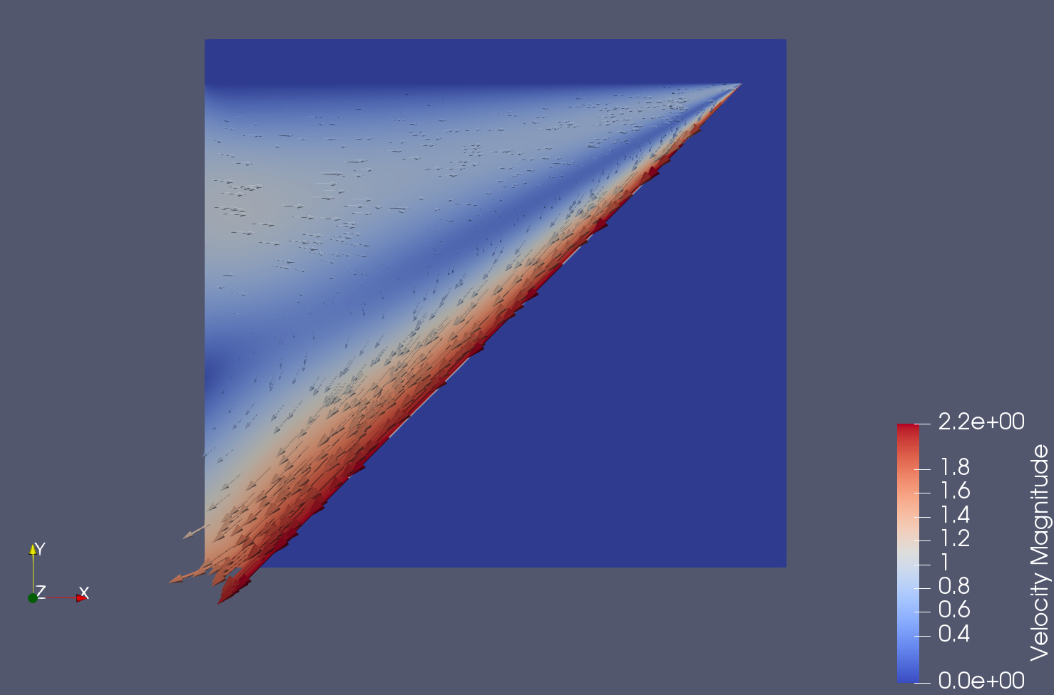

Benchmark 1c wedge velocity (non-dimensional)

Temperature at (60,-60):

1c: 387.44

2a: 579.79

2b: 582.71