**Function Tests**

**Adding Books**

POST <http://localhost:8080/book/add>

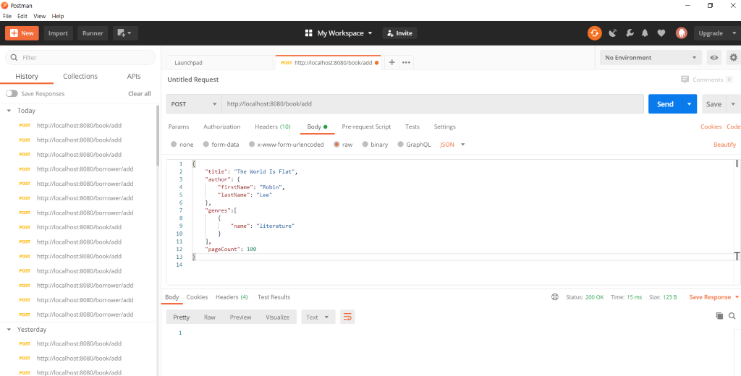

{

"title": "The World Is Flat",

"author": {

"firstName": "Robin",

"lastName": "Lee"

},

"genres":[

{

"name": "literature"

}

],

"pageCount": 100

}

{

"title": "Ordinary People",

"author": {

"firstName": "Danny",

"lastName": "Smith"

},

"genres":[

{

"name": "script"

}

],

"pageCount": 180

}

{

"title": "Peppa Pig",

"author": {

"firstName": "Ashley",

"lastName": "Davis"

},

"genres":[

{

"name": "Carton"

},

{

"name": "Kids Literature"

}

],

"pageCount": 180

}

**Adding Borrowers**

POST <http://localhost:8080/borrower/add>

{

"firstName": "Charles",

"lastName": "Robert",

"borrowingLimit": 3

}

{

"firstName": "Luis",

"lastName": "Houston",

"borrowingLimit": 5

}

{

"firstName": "Michelle",

"lastName": "Vilton",

"borrowingLimit": 3

}

**Verify in H2 Console**

<http://localhost:8080/h2-console/l>

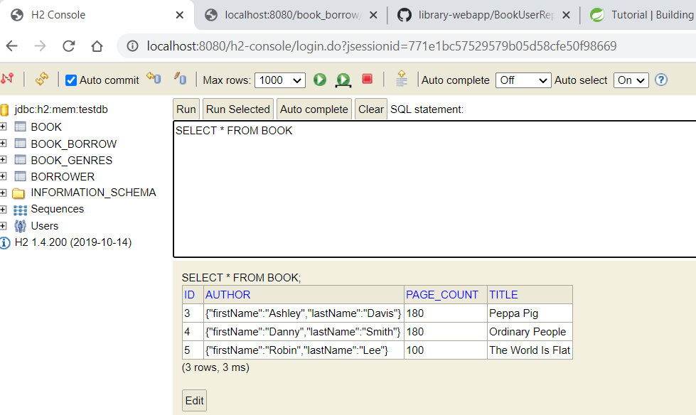

**Verify in Browser**

<http://localhost:8080/borrower/all>

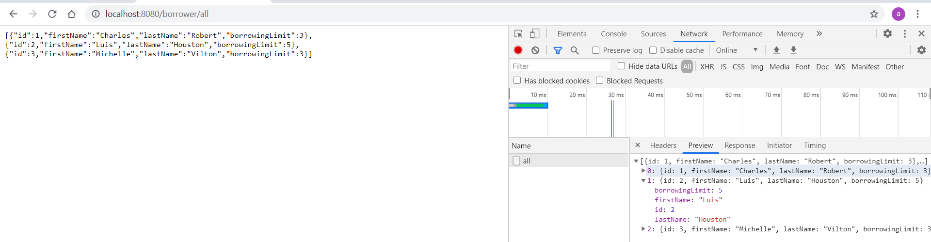

http://localhost:8080/borrower/id=3

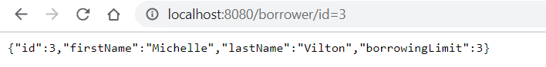

<http://localhost:8080/borrower/first_name=Charles&&last_name=Robert>

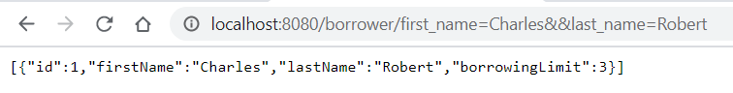

<http://localhost:8080/book/all>

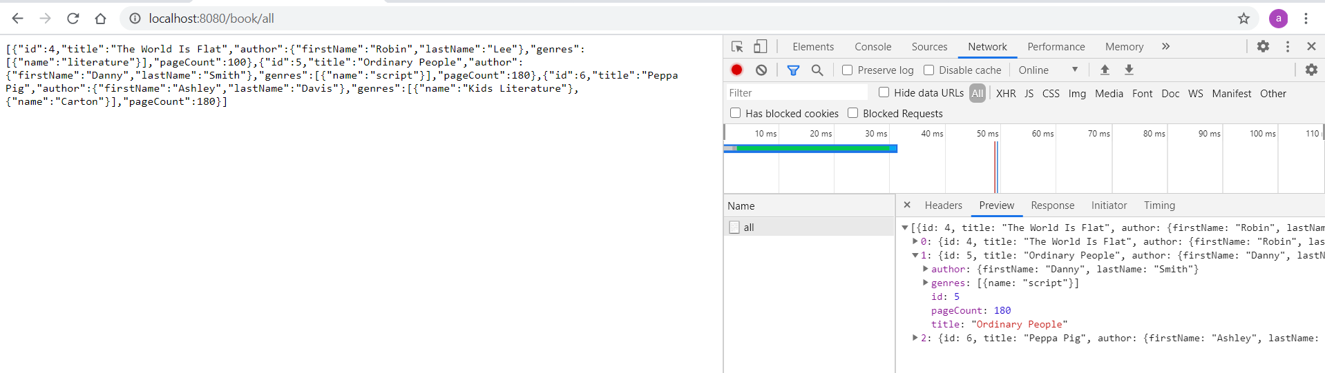

<http://localhost:8080/book/title=Peppa%20Pig>

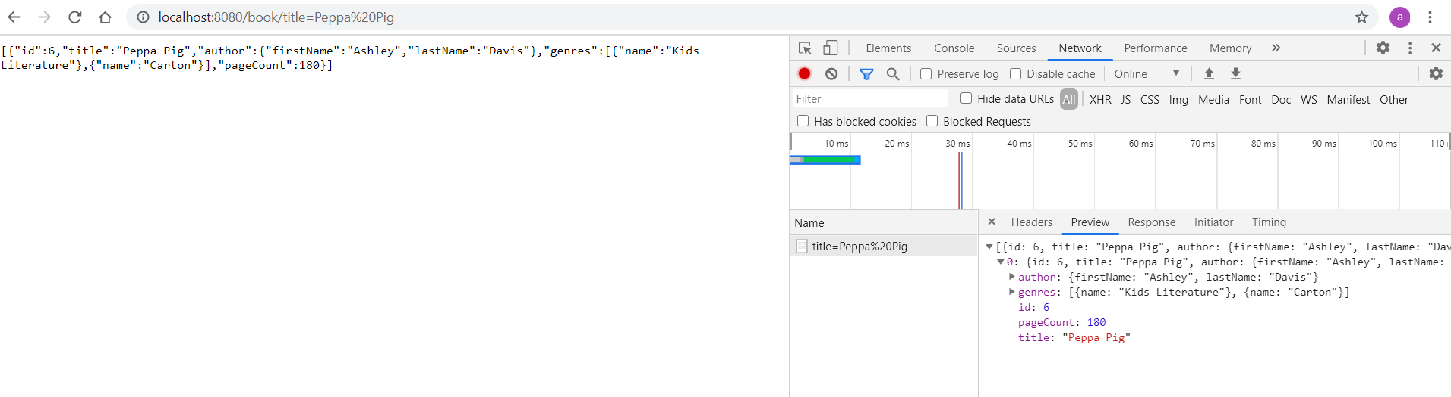

**Borrow a Book**

POST http://localhost:8080/book_borrow/add

{

"bookId": 1,

"borrowerId": 2

}

<http://localhost:8080/book_borrow/all>

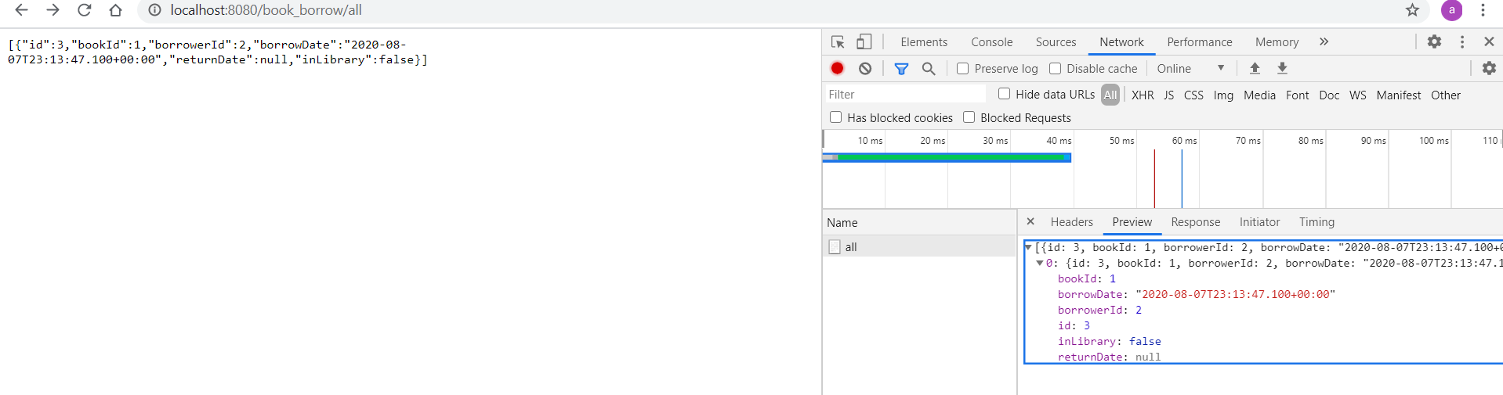

**Return a Book**

PUT http://localhost:8080/book_borrow/return

{

"bookId": 1,

"borrowerId": 2

}

