


A Mini-project Work Report on

“Virtual Stress Relief Game”
Submitted in the partial fulfillment for the award of

BACHELOR OF ENGINEERING
in

COMPUTER SCIENCE AND ENGINEERING

By

ABHISHEK S USN: 1BY22CS006
AGNIBHO CHOUDHURY USN: 1BY22CS013
DAMRUKESH D USN: 1BY22CS054
DHRUV C SHETTY USN: 1BY22CS064

Under the guidance of

Prof. Chaitanya V
Asst Professor

2025-2026

DEPARTMENT OF COMPUTER SCIENCE & ENGINEERING

CERTIFICATE

This is to certify that the mini-Project CCA work for Building Enterprise Applications (BCS703B) entitled “VIRTUAL STRESS RELIEF GAME” is a bonafide work carried out by 1BY22CS006,1BY22CS013,1BY22CS054,1BY22CS064 in partial fulfillment for the award of Bachelor of Engineering Degree in Computer Science and Engineering of the Visvesvaraya Technological University, Belagavi during the year 2024-25. It is certified that all corrections/suggestions indicated for Internal Assessment have been incorporated in this report. The mini-project report has been approved as it satisfies the academic requirements with respect to mini-project work for the B.E Degree.

Signature of the Guide Signature of the HOD
(Prof. Chaitanya V) (Dr. Sathish Kumar T)

ABSTRACT

Stress and anxiety have become common issues among individuals of all ages, especially students and working professionals. Many people struggle to find simple and accessible ways to relax, track their emotions, or engage in mindful activities. Without regular stress-relief habits, emotional imbalance can build up over time, affecting focus, productivity, and overall mental well-being. To address this growing problem, this project develops a web-based Virtual Stress Relief Game that helps users relax, assess their stress levels, and engage in mood-lifting activities through an interactive digital platform..

In this system, users can sign up or log in to access a personalized dashboard containing multiple wellness tools. The relaxation module provides guided breathing exercises where an animated circle shows inhale, hold, and exhale patterns based on the timer set by the user, supported by calming background music. Along with this, a simple focus-improving mini-game with a glowing dot enhances attention and awareness. The platform also includes a stress self-assessment section where users answer ten questions, and the system computes an internal score to determine the user’s current stress level.

To make stress relief enjoyable, the application offers three gamified activities—Emoji Memory Match, Bubble Pop, and Catch the Clouds—each designed to be light, engaging, and comforting. Background music and high-score tracking enhance the gaming experience. A mood journal feature allows users to record their daily emotions along with reasons, view previous entries with timestamps, and monitor overall mood distribution through a pie chart. The platform also provides a curated list of tips from reliable sources to help users adopt healthy stress-free habits.

Overall, this project uses interactive design, mood tracking, and gamification to create an engaging environment where users can relax, assess their emotional state, and gradually build healthier coping mechanisms. By combining simple games, guided relaxation, and self-reflection tools, the Virtual Stress Relief Game supports users in managing stress in a fun, accessible, and effective way.

ACKNOWLEDGEMENT

We are happy to write a mini-project report after completing it successfully. This mini-project would not have been possible without the guidance, assistance and suggestions of many individuals. We would like to express our deep sense of gratitude to each and every one who has helped us to make this mini- project a success.

We heartily thank Dr. Sanjay H A, Principal, BMS Institute of Technology & Management, for his constant encouragement and inspiration in taking up this mini-project.
We heartily thank Dr. Sathish Kumar T, Head of the Department, Computer Science and Engineering, BMS Institute of Technology& Management for constant encouragement and inspiration in taking up this mini-project.
We gratefully thank our mini-project guide, Prof. Chaitanya V, Asst. Professor, Dept. of Computer Science and Engineering, for their encouragement and advice throughout the course of the mini-project work in CCA(BCS703B-Building Enterprise Application).
Special thanks to all the staff members of the Computer Science and Engineering Department for their help and kind co-operation.
Lastly, we thank our parents and friends for their encouragement and support given to us in order to finish this mini-project work.
By,

ABHISHEK S

AGNIBHO CHOUDHURY

DAMRUKESH D

DHRUV C SHETTY



Declaration

We, hereby declare that the Mini-Project CCA work for Building Enterprise Applications (BCS703B) titled “VIRTUAL STRESS RELIEF GAME” is a record of original mini-project work undertaken for partial fulfilment of Bachelor of Engineering in Computer Science and Engineering of the Visvesvaraya Technological University, Belagavi during the year 2025-26. We have completed this mini-project work under the guidance of Prof. Chaitanya. V, Asst. Professor.
I also declare that this mini-project report has not been submitted for the award of any degree, diploma, associate ship, fellowship or other titles anywhere else.

STUDENT  PHOTO |  |  |  | 
USN | 1BY22CS006 | 1BY22CS013 | 1BY22CS054 | 1BY22CS064
NAME | ABHISHEK S | AGNIBHO  CHOUDHURY | DAMRUKESH D | DHRUV C  SHETTY
SIGNATURE

MARKS

TABLE OF CONTENTS

CHAPTER 1 – INTRODUCTION 01–02
CHAPTER 2 – LITERATURE REVIEW 03-04
CHAPTER 3 – REQUIREMENT ANALYSIS 05–09
CHAPTER 4 – METHODOLOGY / DESIGN 10-12
CHAPTER 5 – RESULTS AND DISCUSSION 13-16
CHAPTER 6 – CONCLUSIONS AND FUTURE WORK 17
REFERENCES / BIBLIOGRAPHY 18
CHAPTER-1

INTRODUCTION

Background

Currently, there is no unified, easy-to-use platform that combines relaxation techniques, stress self-assessment, mini stress-relief games, and mood tracking in a single web application. Users find it difficult to understand their stress levels, maintain emotional journals, or engage in calming activities without switching between multiple apps or tools. Many platforms lack interactive features like guided breathing animations, real-time focus training, or mood visualization. Additionally, users do not receive simple mood insights or accessible tips to improve their mental well-being. This project addresses these challenges by creating an integrated virtual stress relief platform that offers relaxation, emotional assessment, mini-games, and mood journaling in one place.

Problem Statement

There is no easy-to-use digital system where Anganwadi workers can register, track, and monitor pregnant women and young children in one place. Monthly health data such as weight, blood pressure, hemoglobin levels, vaccinations, and child growth measurements are often scattered or unrecorded. Important dates—like TT vaccinations for pregnant women and immunization schedules for babies—are not tracked automatically. This leads to delays and missed health services. There is also no AI-based tool to analyze these records and alert workers about possible risks such as anemia, malnutrition, or abnormal growth patterns. Parents also lack access to simple, multilingual health guidance. This project addresses all these issues with a single integrated digital solution.

Objectives

This project aims to:
- Provide a web-based platform where users can log in, access tools, and manage their stress-relief activities in a structured manner.
- Include guided breathing exercises with customizable timers and background music for relaxation and mindfulness.
- Offer a simple focus-enhancing mini-game and additional stress-free games like emoji memory match, bubble pop, and catch the clouds.
- Conduct stress self-assessment using a 10-question evaluation and compute scores to show the user’s stress level.
- Mood journalling and mental well being tips included

Scope

The main features include:
- Login/Signup for Anganwadi workers and parents
- Separate digital profiles for pregnant women and children
- Monthly data entry and record storage
- AI-based health analysis
- Automated reminders for vaccines, visits, and TT doses
- Educational content in multiple languages
- Simple and user-friendly interface
The project does not include medical diagnosis, emergency treatment, hospital integration, or advanced medical testing. It focuses on data tracking, digital monitoring, AI suggestions, and awareness support.

CHAPTER-2

LITERATURE REVIEW

Digital mental wellness tools have expanded rapidly, offering features like meditation, breathing exercises, mood tracking, and casual games, but most existing apps are either complex, paid, or lack engaging elements that encourage regular use. Many provide relaxation techniques or journaling tools, yet these functions are often scattered across different platforms without meaningful integration. Current apps may rely on long audio sessions, offer limited or purely manual mood tracking, or focus solely on entertainment without emotional support. Stress assessment tools typically give generic feedback and are rarely tied to personalized insights or dashboards. Due to this fragmentation—where breathing exercises, emotional assessments, journaling, and stress-relief games exist separately—users struggle to maintain consistent wellness habits. Hence, there is a need for a simple, unified, web-based platform that brings together quick relaxation techniques, interactive games, stress assessments, mood journaling, and practical mental wellness tips in one cohesive system.

Comparison Table – Existing Systems vs. Gaps vs. What Our System Covers

Feature / Requirement | Existing Systems | Identified Gaps | Our Proposed System Solves?
Guided breathing exercises | Present in some apps | Often long, complex, or audio-only | Simple animated breathing + user timer
Stress self-assessment | Available in a few tools | Limited questions, basic output | 10-Q assessment with clear scoring
Stress-free mini-games | Found separately in casual gaming sites | Not linked to relaxation or wellness | 3 integrated games with music + scores
Focus training mini-games | Rare | No attention-improving quick games | Built-in glowing-dot focus exercise
Mood journaling | Available in some apps | No visual mood analysis | Mood entries + pie chart distribution
Personalized dashboard | Present in premium apps | Most features scattered across apps | Single dashboard with all modules
Background music for relaxation | Limited | Few customization options | 4 selectable background tracks
Mental wellness tips | Common but generic | No integration with user activities | Curated stress-relief tips included

.

CHAPTER-3

REQUIRMENT ANALYSIS

Requirement analysis explains what the system needs in order to work properly. It includes what users need, what the system must do, and what conditions it must meet. This chapter helps in understanding the complete expectations before building the application.

User Requirements

Users Need:

Ability to create an account (signup/login).

Access to a personal dashboard after logging in.

To start guided breathing exercises with customizable timers and background music.

To use a simple focus mini-game integrated with the breathing section.

To play stress-free mini-games such as Emoji Memory Match, Bubble Pop, and Catch the Clouds.

To complete a 10-question stress self-assessment and receive a stress score.

To maintain a mood journal and record mood entries with date and time.

To view previous journal entries and overall mood distribution using a pie chart.

To read or view practical tips for stress reduction.

A clean , simple , and easy-to use interface.

Functional Requirements

These describe what the system must do.

FR1: User Authentication

Users must be able to sign up and log in securely.

FR2: Dashboard Access

After login, users must be able to access all modules through the dashboard.

FR3: Guided Breathing Exercise

Users must set a timer for inhale–hold–exhale intervals.

FR4: Focus Mini-Game

A glowing dot must appear at random positions inside a square.

FR5 Stress Self-Assessment

System must display a 10-question questionnaire.

Based on the user’s responses, an internal scoring algorithm must compute the stress level.

FR6: Mini Stress-Relief Games

Users must be able to play:

Emoji Memory Match

Bubble Pop

Catch the Clouds

System must track and store high scores.

FR7: Mood Journal

Users must view stress-relief tips collected from verified sources.

FR8 Tips Section

Users must view stress-relief tips collected from verified sources.’

Users must be able to save or bookmark useful tips for quick access later.

FR9: Logout

Users must be able to securely log out.

Non-Functional Requirements

These describe how the system should behave.

NFR1: Usability

Interface must be clean, simple, and easy to navigate.

NFR2: Reliability

System should save all user data accurately without errors.

NFR3: Performance

All game screens and dashboards must load quickly.

Animations should run smoothly.

NFR4: Security

User credentials and journal data must be stored securely.

Only the authenticated user should access their own data.

NFR5: Availability

System should remain accessible as long as internet connection is available.

NFR6: Scalability

Must support many users and large amounts of journal entries and game scores.

NFR7: Maintainability

System should allow easy updates for new games, tips, or UI changes.

Software Requirements

Web application (HTML, CSS, JavaScript framework like React)

Backend server (Node.js / Express or any suitable backend stack)

Database (MariaDB)

Chart library for mood analysis (Chart.js or Recharts)

Audio playback libraries for background music

User Roles and Permissions

User Role | Permissions
User | Access breathing exercises, mini-games, stress assessment, mood journal, view mood charts, read tips.
Admin (Optional) | Manage tips content, monitor system usage, update game assets.
Guest User (Optional Future Enhancement) | Can access a preview of relaxation techniques (limited-duration breathing exercise).

Constraints

Internet connectivity is required for full functionality.

Users may vary in digital familiarity; UI must be beginner-friendly.

Game animations must run smoothly across devices.

Data must be stored using secure formats and standard timestamp conventions.

This chapter identified what users want, what the system must do, and the technical and non-technical conditions it must satisfy. These requirements form the base for designing and building the system in the next chapter.

CHAPTER-4

METHODOLOGY/DESIGN

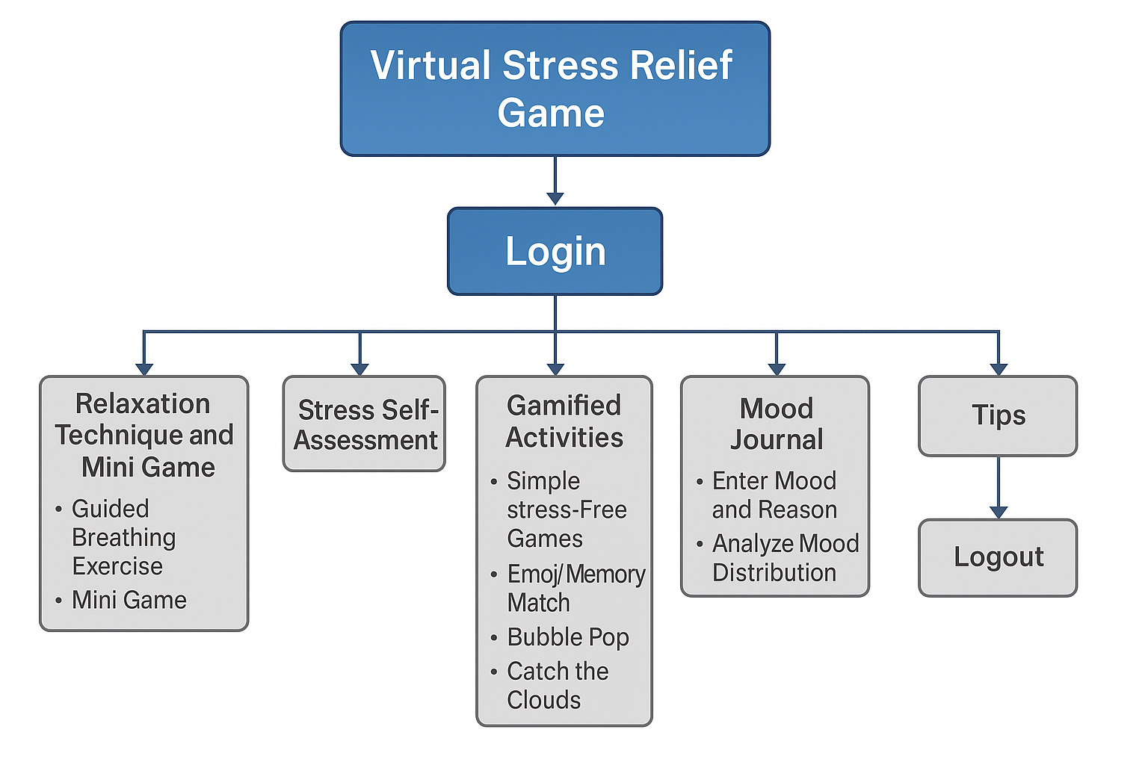

Test cases:

The following test cases were used in developing the applications:

TC01 – Login with Valid Credentials
Feature: Login
Preconditions: User already registered
Test Steps:
- Open login page
- Enter valid username and password
- Click Login
Expected Result: User is redirected to dashboard successfully

TC02 – Login with Invalid Credentials
Feature: Login
Preconditions: None
Test Steps:
- Open login page
- Enter incorrect username or password
- Click Login
Expected Result: Error message “Invalid username or password” is displayed

TC03 – User Registration
Feature: Registration
Preconditions: None
Test Steps:
- Open registration page
- Enter valid details
- Submit form
Expected Result: Account is created and redirected to login page

TC04 – Breathing Exercise Animation
Feature: Relaxation Technique
Preconditions: User logged in
Test Steps:
- Go to Relaxation Technique section
- Set timer
- Start exercise
Expected Result: Breathing animation follows inhale–hold–exhale timing correctly

TC05 – Mini Focus Game (Glowing Dot)
Feature: Mini Game
Preconditions: User logged in
Test Steps:
- Start mini game
- Click glowing dot when it appears
- Repeat until timer ends
Expected Result: Dot appears in random positions; score increases correctly

TC06 – Stress Assessment Score
Feature: Stress Self-Assessment
Preconditions: User logged in
Test Steps:
- Navigate to Stress Assessment
- Answer 10 questions
- Submit
Expected Result: Stress level is calculated and displayed accurately

TC07 – Emoji Memory Match Game
Feature: Games Section
Preconditions: User logged in
Test Steps:
- Open Gamified Activities
- Select Emoji Memory Match
- Complete the game
Expected Result: Game runs smoothly; high score is saved and displayed

TC08 – Background Music During Games
Feature: Games Section
Preconditions: User logged in
Test Steps:
- Start any game
- Choose background music
- Play game
Expected Result: Background music plays continuously throughout gameplay

TC09 – Mood Journal Entry
Feature: Mood Journal
Preconditions: User logged in
Test Steps:
- Open Mood Journal
- Enter mood and reason
- Save entry
Expected Result: Entry saved with correct mood, reason, date, and time

TC10 – Logout Function
Feature: Logout
Preconditions: User logged in
Test Steps:
- Click Logout in dashboard
Expected Result: User returns to login page; session ends

CHAPTER-5

RESULT AND DISCUSSION

- The project successfully developed a fully functional web-based Virtual Stress Relief Game that helps users relax, assess their stress levels, play calming mini-games, and maintain a mood journal. The main results are:
- Guided Breathing Exercise: Users can start a breathing session with an animated inhale–hold–exhale circle and choose from four background music tracks.
- Focus Mini-Game: The glowing-dot activity works smoothly, appearing at random positions and calculating the user’s score based on reaction time, helping improve attention and awareness.
- Stress Self-Assessment: The system displays 10 questions and computes a stress level score, giving users clarity about their emotional state.
- Mini Stress-Relief Games: Three simple and interactive games—Emoji Memory Match, Bubble Pop, and Catch the Clouds—were successfully implemented with background music and high-score tracking.
- Mood Journal: Users can record mood entries with date, time, and reasons. All entries are stored securely and displayed with a pie chart showing mood distribution.
- Tips Section: Users can view practical tips and guidance collected from reliable sources to support stress-free habits.

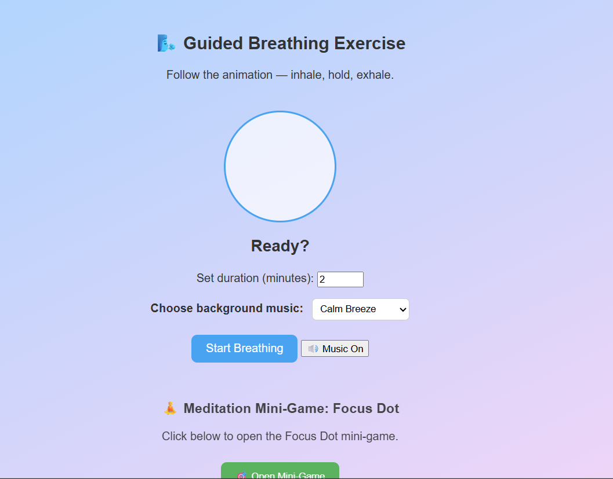
Fig1:Guided breathing exercise with mini game

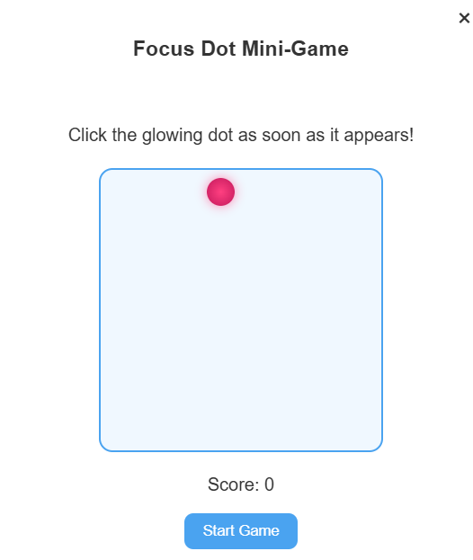

Fig2: Mini game for improving focus

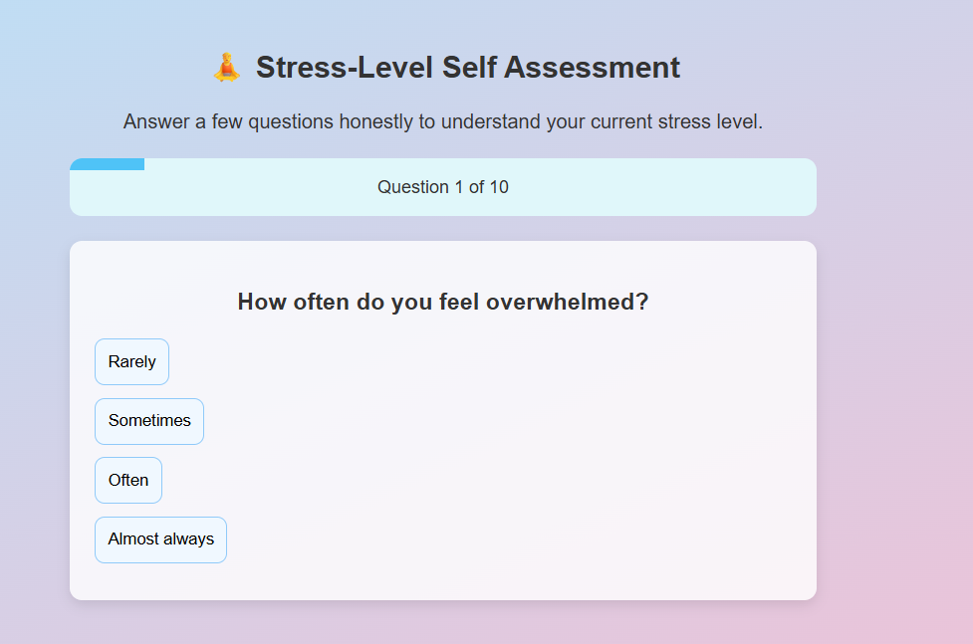

Fig3: Stress-self Assessment for measuring stress
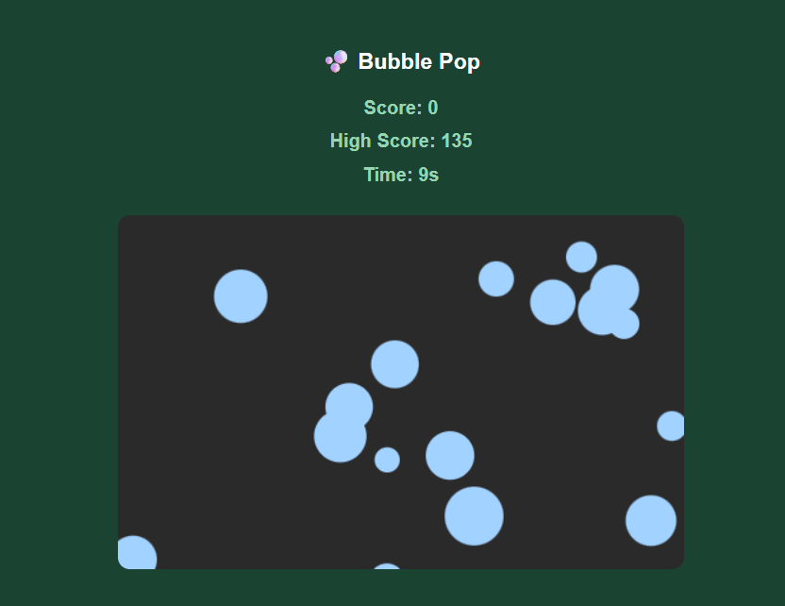
Fig4: Simple games to release stress

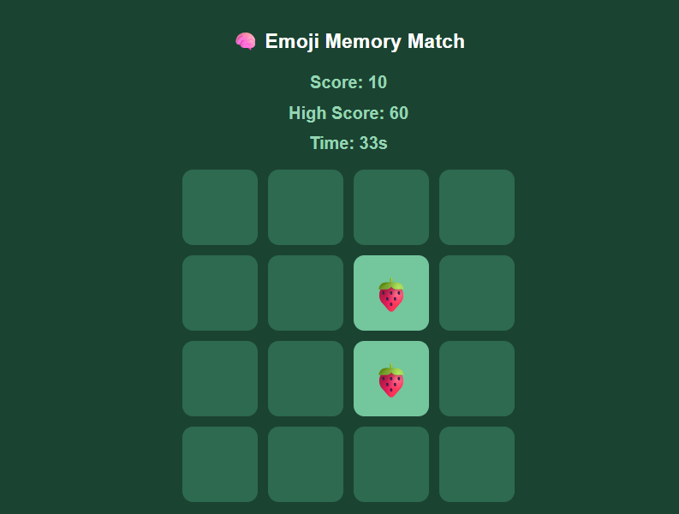
Fig5:Simple games to release stress 2

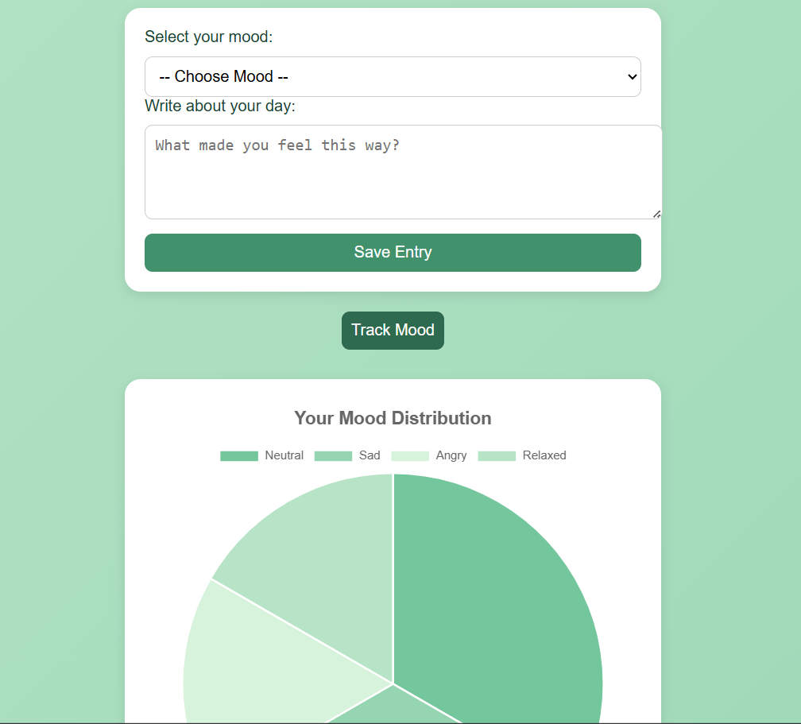
Fig6: Mood journalling
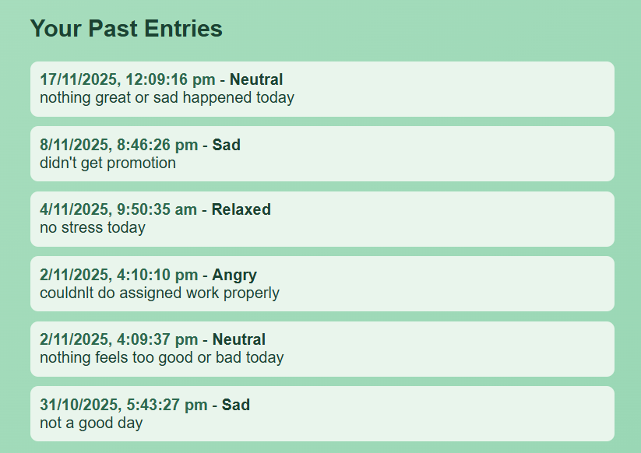
Fig7: Mood tracking

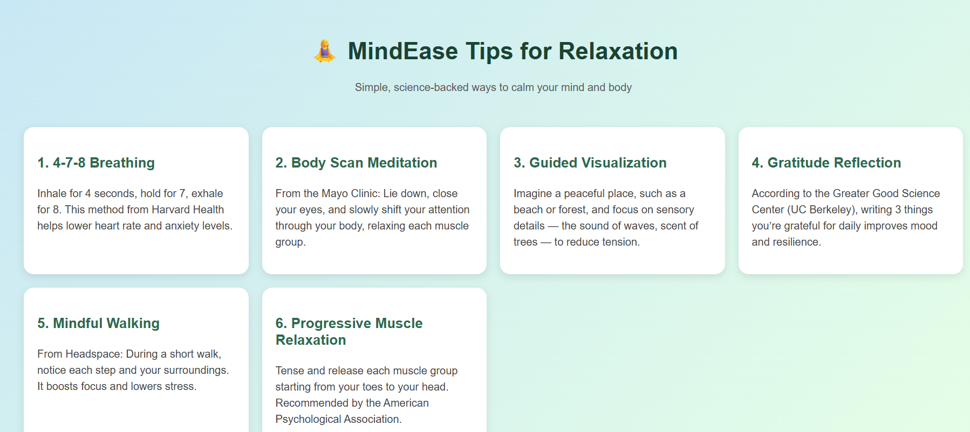
Fig8: Tips to reduce stress

Overall, the system meets its objectives by offering a simple, practical platform for mental wellness. It unifies essential stress-relief tools in one app, making it easier for users to build healthier habits

CHAPTER-6

CONCLUSIONS AND FUTURE WORK

This project successfully developed a user-friendly Stress Relief and Wellness Application designed to help individuals manage stress, improve emotional well-being, and build healthy daily habits. The system provides a simple and accessible platform where users can perform stress assessments, track their daily mood, play relaxation-based mini-games, follow guided breathing exercises, and access helpful wellness tips.

The application allows users to create accounts, log in, and maintain personalized profiles. Features such as notifications, streak tracking, and a clean interface encourage consistent engagement and help users make stress-management a part of their daily routine. Overall, the system fulfills its objectives by offering a practical, easy-to-use solution for supporting mental wellness. It replaces the need for multiple separate apps by combining essential stress-relief tools into one platform, making it more convenient for users to adopt healthier habits and build emotional awareness.

Although the system works effectively, there is scope for improvement and expansion. Future enhancements may include:
- Allow users to access breathing exercises, games, and mood tracking even without internet connectivity.
- Add graphical dashboards showing long-term mood patterns, common stress triggers, streak history, and progress reports.
- Introduce new relaxation-focused games, puzzles, and mindfulness activities to increase user engagement.
- Provide personalized wellness tips or activity suggestions based on the user’s mood history and stress patterns.
- Connect with smartwatches or fitness bands to track heart rate, sleep quality, and steps for better wellness insights.

REFERENCES/BIBLIOGRAPHY

- Mayo Clinic. (2021). Stress management: Techniques for managing stress. Retrieved from https://www.mayoclinic.org
- American Psychological Association. (2022). Understanding stress and its effects. Retrieved from https://www.apa.org
- Mindful.org. (2020). Breathing exercises to help you relax. Retrieved from https://www.mindful.org
- Healthline. (2021). Benefits of journaling for mental wellness. Retrieved from https://www.healthline.com
- Williams, J., & Chen, S. (2021). The impact of casual gaming on stress reduction: A review study. Journal of Digital Health Research, 14(3), 210–225.
- Kumar, R., & Elliott, P. (2020). Effectiveness of breathing exercises in lowering stress among young adults. International Journal of Behavioral Wellbeing, 9(2), 55–63.
- Martin, D., & Keller, A. (2022). Mood tracking tools and their influence on emotional awareness. Journal of Mental Health Technology, 7(1), 44–59.

