BMS INSTITUTE OF TECHNOLOGY AND MANAGEMENT
Autonomous Institute under VTU, Belagavi, Karnataka - 590 018 Yelahanka, Bengaluru, Karnataka - 560 119


Smart lighting systems and design
“Dialux simulation and calculation”

BACHELOR OF ENGINEERING
in
COMPUTER SCIENCE AND ENGINEERING
by

NAME: Agnibho Choudhury | USN: 1BY22CS013

Under the Guidance of Dr. Prashanth NA

DEPARTMENT OF COMPUTER SCIENCE AND ENGINEERING
Avalahalli, Yelahanka, Bengaluru, Karnataka -560119

Content Sheet

- Introduction
- Simulation Overview
- Output Screenshot
- Summary of results
- Observation and Calculations

Introduction

This report presents the lighting analysis and simulation results of a three-room layout conducted using DIALux software. The main objective of the simulation is to evaluate the illuminance levels (in lux) and uniformity across the working planes in each room to ensure proper lighting conditions for comfortable and efficient indoor use.
The simulation was carried out to verify whether the selected luminaires and their placements meet the recommended lighting standards for indoor environments. Through this analysis, factors such as average illuminance, uniformity ratio, glare control, and power consumption were studied to assess the overall lighting performance.
This study also aims to provide a practical understanding of lighting design principles and their application in real-world scenarios. It helps in analyzing how different luminaire types, mounting heights, and room reflectances affect the overall brightness and energy efficiency of the space. The findings from this simulation can be used to suggest improvements for achieving better visual comfort, energy efficiency, and optimal lighting distribution within the rooms.

Simulation overview

The simulation layout consists of three rooms—Room 1, Room 2, and Room 3. Each room is equipped with a specific number of luminaires distributed uniformly across the ceiling. The working plane height for measurement is set at 0.8 meters above the floor, representing the typical desk or work surface height.

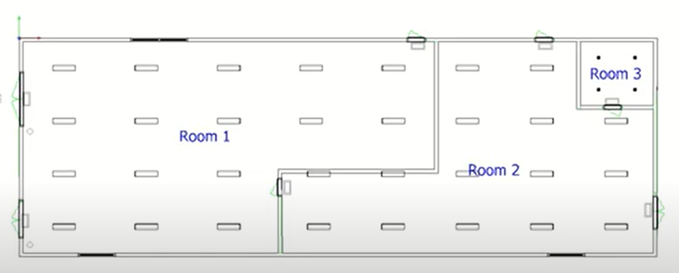

Layout showing Room 1, Room 2, and Room 3 with luminaire positions.
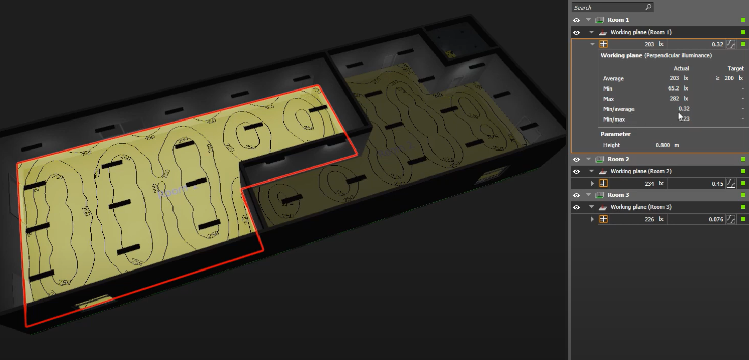

Room 1
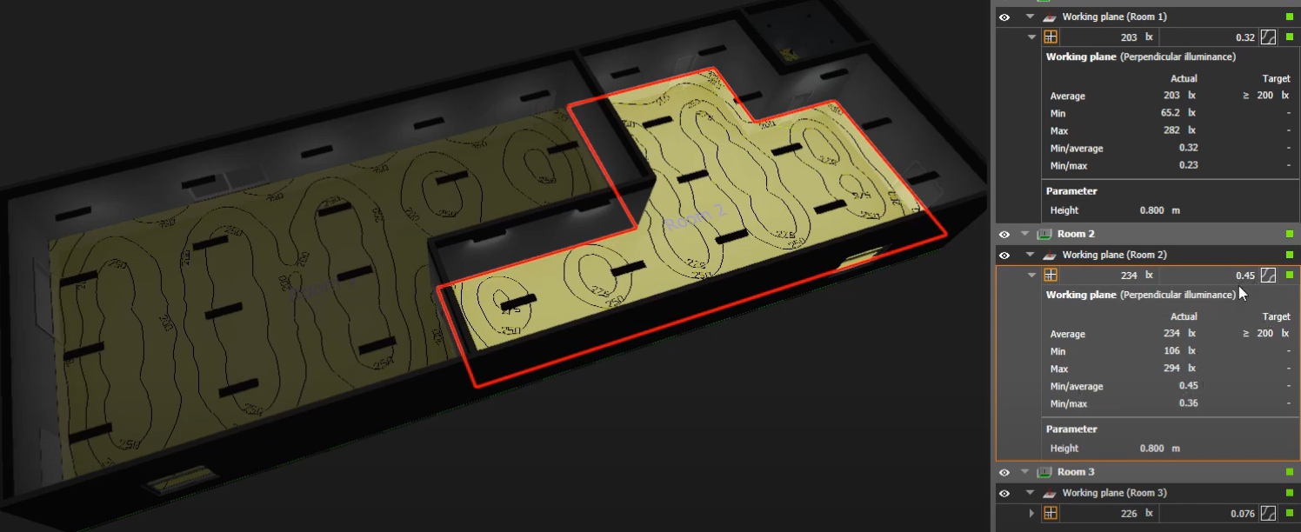

Room 2

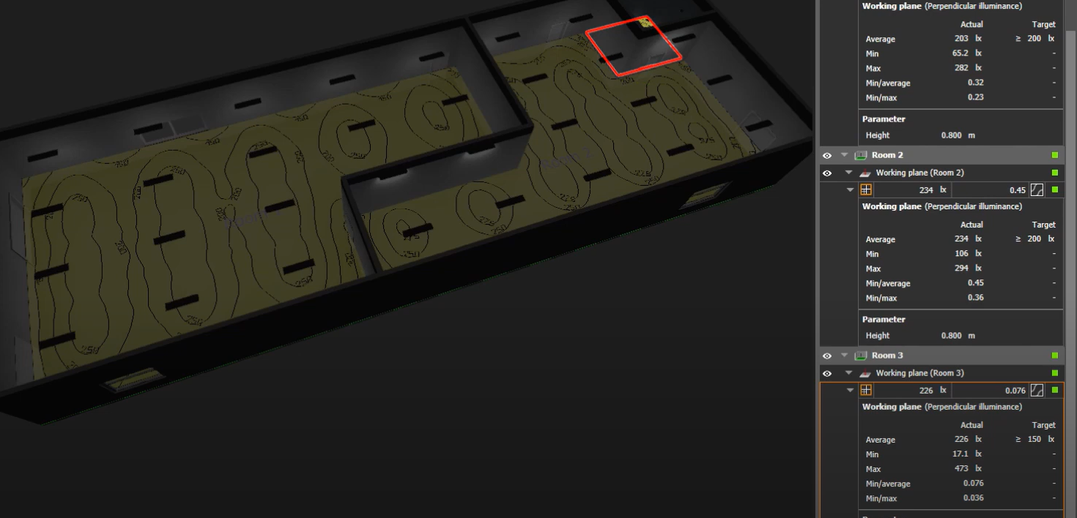
Room 3

Analysis of Output
The simulation results for each room are analyzed below based on the DIALux-generated illuminance maps and statistical output tables.
The key parameters considered are:
- Average Illuminance (E_avg)
- Minimum Illuminance (E_min)
- Maximum Illuminance (E_max)
- Uniformity ratios (E_min/E_avg and E_min/E_max)

Room 1
Results:
- Average Illuminance: 203 lx
- Minimum Illuminance: 65.2 lx
- Maximum Illuminance: 282 lx
- Uniformity (E_min/E_avg): 0.32
- Uniformity (E_min/E_max): 0.23
Analysis:
Room 1 meets the target average illuminance requirement of 200 lx. However, the uniformity ratio suggests some variation in brightness distribution, likely due to luminaire spacing or wall reflectance. Areas near corners or walls may have lower illuminance values.
Room 2
Results:
- Average Illuminance: 234 lx
- Minimum Illuminance: 106 lx
- Maximum Illuminance: 294 lx
- Uniformity (E_min/E_avg): 0.45
- Uniformity (E_min/E_max): 0.36
Analysis:
Room 2 exceeds the target illuminance value of 200 lx, with improved uniformity compared to Room 1. The lighting distribution is more consistent, making it suitable for general office or working environments. The uniformity ratio indicates a well-balanced lighting system.

Room 3
Results:
- Average Illuminance: 226 lx
- Minimum Illuminance: 17.1 lx
- Maximum Illuminance: 473 lx
- Uniformity (E_min/E_avg): 0.076
- Uniformity (E_min/E_max): 0.036
Analysis:
Room 3 meets the target average illuminance of 150 lx, but it shows poor uniformity due to extreme differences between the minimum and maximum values. This suggests that luminaire positioning or reflection effects need optimization to achieve balanced lighting. Additional luminaires or different fixture placement could improve performance.

Summary of results

Room | Average (lx) | Min (lx) | Max (lx) | E_min/E_avg | E_min/E_max
Room 1 | 203 | 65.2 | 282 | 0.32 | 0.23
Room 2 | 234 | 106 | 294 | 0.45 | 0.36
Room 3 | 226 | 17.1 | 473 | 0.076 | 0.036

Observation and Conclusion

Based on the simulation results, all rooms achieve their respective target illuminance values.
- Room 2 demonstrates the best lighting uniformity and overall performance.
- Room 1 performs adequately but may need minor luminaire adjustments.
- Room 3 requires significant improvement in luminaire arrangement to minimize lighting variation.
Adjustments such as repositioning fixtures, using diffused lighting, or increasing wall reflectivity can enhance the uniformity.
Overall, the lighting design effectively meets the functional requirements for general indoor usage, with Room 2 serving as an optimal configuration reference.

