NeuroGuard: Digital Eye Fatigue Monitoring via Hybrid Landmark Analysis

Dr.R.Poorvadevi Dr.R.Poorvadevi Dr.R.Poorvadevi
Assistant Professor Assistant Professor Assistant Professor
Dept. of Computational Intelligence Dept. of Computational Intelligence Dept. of Computational Intelligence
SRM Institute of Science and technology SRM Institute of Science and technology SRM Institute of Science and technology
Kattankulathur, Chennai Kattankulathur, Chennai Kattankulathur, Chennai
poorvadevi@gmail.com poorvadevi@gmail.com poorvadevi@gmail.com

Abstract—Eye fatigue significantly reduces reaction time, situational awareness, and decision-making ability, posing a serious threat to road safety. Reliable real-time fatigue detection has therefore become an essential research focus in intelligent transportation systems. Existing vision-based approaches typically rely either on handcrafted geometric eye features combined with traditional classifiers or on deep learning models that capture spatial representations but lack interpretable fatigue indicators. This paper presents a robust, real-time eye fatigue monitoring system utilizing a hybrid deep learning approach. The proposed system integrates MediaPipe-based facial landmark extraction with a hybrid CNN–LSTM deep learning architecture to capture both spatial eye features and temporal behavioral patterns. Eye landmarks are used to compute interpretable physiological indicators such as Eye Aspect Ratio (EAR) and PERCLOS, enabling reliable quantification of blink frequency and eyelid closure duration. Experimental evaluation demonstrates high detection accuracy, computational efficiency suitable for real-time deployment, and improved robustness under varying lighting conditions. The hybrid design balances interpretability with temporal modeling capability, providing an effective and scalable solution for intelligent fatigue monitoring applications.
Keywords—Artificial Intelligence, Machine learning
- Introduction
Eye fatigue and drowsiness have emerged as critical safety and health concerns in modern society due to prolonged digital screen exposure, extended driving hours, and immersive virtual environments. Fatigue affects cognitive performance, reaction time, and attention levels, contributing significantly to road accidents and reduced workplace productivity. Visual indicators such as blink rate, eye closure duration, gaze variability, eyelid movement patterns, and pupil dynamics are widely recognized as reliable physiological markers of fatigue. With advancements in artificial intelligence (AI) and computer vision, non-contact vision-based fatigue detection systems have become practical for real-time applications. With the advancement of computer vision and artificial intelligence (AI), non-contact fatigue detection systems based on eye behavior analysis have gained substantial attention.

Early research focused on geometric eye features combined with classical classifiers. For instance, Digital Eye Strain Detection systems based on Support Vector Machines demonstrated interpretable and lightweight solutions. Similarly, empirical multi-feature fusion models integrated facial behavior descriptors to map fatigue states with high reported accuracy. Gabor wavelet optimization

with Hidden Markov Models introduced sequential modeling for learning fatigue detection. Blink-based prediction systems further showed that variations in blink frequency could serve as robust fatigue indicators. With the rise of deep learning, convolutional neural networks (CNNs) significantly improved spatial feature extraction for eye state recognition. Transfer learning approaches and multi-scale CNN frameworks enhanced robustness against lighting and pose variations. Multi-frame visual feature frameworks and Gaussian-weighted eye state determination methods improved detection stability under real-world driving conditions. Lightweight mobile-based systems demonstrated that fatigue detection could be implemented on smartphones using optimized AI models.
Beyond driver monitoring, gaze-based adaptive human–computer interaction models explored fatigue assessment in interactive environments, while EEG-based studies analyzed visual fatigue and cognitive load through neural signals. Comparative procedural versus predictive studies further emphasized the trade-off between computational efficiency and deep learning performance.
Despite these advancements, most prior studies focus on improving a single methodological paradigm without systematically comparing lightweight geometric-feature-based models and deep spatial–temporal architectures under identical conditions. Performance metrics are often reported independently, with limited discussion on latency, interpretability, and deployment feasibility.

The objective of this research is to conduct a structured comparative analysis of hybrid eye fatigue detection paradigms within a unified experimental framework. The study evaluates geometric-feature-driven classification and spatial–temporal deep learning architectures under standardized datasets and performance metrics, analyzing trade-offs in detection accuracy, computational complexity, inference speed, and robustness.

- Literature Review
Vision-based eye fatigue detection has evolved from handcrafted feature extraction techniques to advanced hybrid deep learning frameworks. Early works relied on geometric descriptors derived from facial landmarks. Systems based on statistical eye features combined with Support Vector Machines provided interpretable and computationally efficient solutions for digital eye strain detection. Multi-feature empirical fusion models further

integrated blink rate, mouth activity, and head posture to improve classification robustness. Wavelet-based feature extraction combined with Hidden Markov Models introduced temporal modeling for recognizing learning fatigue states.

Subsequent research emphasized deep learning-based spatial feature extraction. Convolutional Neural Network architectures achieved high accuracy in eye state recognition tasks by automatically learning discriminative visual features. Transfer learning approaches leveraging pre-trained models enhanced generalization performance across datasets. Multi-scale CNN frameworks and attention-based architectures improved modeling of eye microstructures and dynamic eyelid variations.

To address sequential fatigue behavior, hybrid models combining convolutional layers with recurrent networks were introduced. CNN–LSTM and multi-frame feature frameworks improved temporal consistency and reduced false positives by modeling eye movement sequences. Gaussian-weighted pixel distribution methods and sliding prediction strategies further enhanced fatigue state determination in real-time scenarios.

Recent developments also include mobile-based on-device fatigue detection systems, polygon-area-based eye activity measurement, and EEG-assisted cognitive load classification. While these approaches demonstrate high reported accuracy, several limitations persist. Many studies evaluate only a single model without structured benchmarking against computationally efficient baselines.

- Architectural Structure
The NeuroGuard: Digital Eye Fatigue Monitoring via Hybrid Landmark Analysis system is designed as a modular, real-time pipeline architecture that enables continuous eye-state monitoring, fatigue inference, secure storage, and interactive visualization. The system is divided into four primary modules that operate sequentially yet maintain loose coupling for scalability and maintainability.
  - Data Acquisition Layer– This layer captures real-time RGB video streams through a standard webcam interface. The input frames are processed using MediaPipe Camera Utilities for frame handling, normalization, and resizing. Preprocessing ensures consistent image dimensions and lighting normalization, improving downstream detection accuracy and computational efficiency.
  - Processing Engine: The processing engine forms the core intelligence of the system. Initially, the MediaPipe Face Mesh module detects and tracks facial landmarks with high precision, focusing particularly on periocular (eye-region) key points. From these landmarks, interpretable fatigue indicators such as Eye Aspect Ratio (EAR) and PERCLOS are computed to quantify blink dynamics and eyelid closure duration.
These temporal eye-behavior descriptors are then passed to a CNN-LSTM hybrid model. The CNN component extracts discriminative spatial patterns from eye-region features, while the LSTM network captures sequential dependencies to model progressive fatigue states. The inference module
classifies the driver’s condition into alert, drowsy, or fatigued categories in real time.
  - Persistence Layer: The classification results are stored using Drizzle ORM, which facilitates structured database interactions. Data is securely persisted in a PostgreSQL database for historical analysis, performance evaluation, and longitudinal fatigue tracking.
  - Presentation Layer: The stored data is exposed via an Express.js API and visualized through a React + Vite dashboard. Real-time monitoring and analytics are rendered using Recharts, providing an interactive Human–Machine Interface (HMI) for fatigue status visualization and alert notifications.

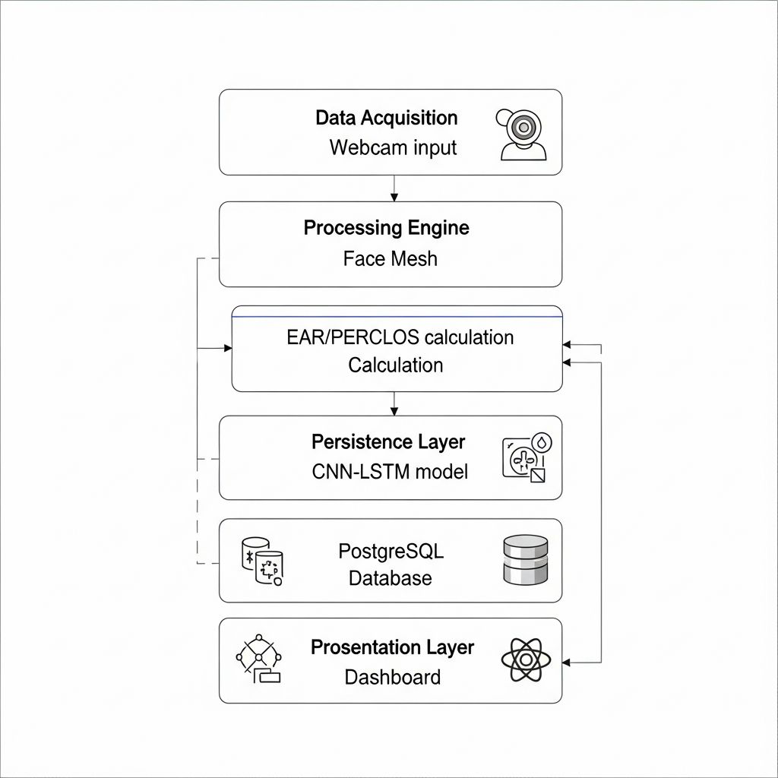
Fig. 1. System Architecture

- Methodology
The NeuroGuard system adopts a structured pipeline combining landmark-based physiological feature extraction with deep temporal modeling to achieve accurate real-time fatigue detection. The methodology consists of three primary stages: Data Acquisition and Preprocessing, Feature Engineering, and Hybrid CNN–LSTM Modeling.

- Data Acquisition and Preprocessing
The system captures high-definition RGB video frames using a standard webcam interface. Frames are sampled at a consistent frame rate to ensure stable temporal analysis. Each frame undergoes preprocessing, including resizing, normalization, and illumination adjustment to reduce noise and variability caused by lighting conditions.

Facial landmark detection is performed using MediaPipe Face Mesh, which generates a 468-point 3D facial landmark map. From these landmarks, periocular (eye-region) key points are isolated for fatigue analysis. Landmark coordinates are converted into normalized spatial vectors to ensure scale invariance across different users and camera distances.
- Feature Engineering
To derive interpretable fatigue indicators, two primary physiological metrics are computed:
- Eye Aspect Ratio (EAR): EAR quantifies eyelid openness using Euclidean distances between selected vertical and horizontal eye landmarks –

A sustained decrease in EAR indicates eye closure or drowsiness.

- PERCLOS (Percentage of Eye Closure): PERCLOS measures the proportion of time the eyes remain at least 80% closed over a 60-second sliding window. It serves as a validated fatigue biomarker widely used in transportation safety research.

These features are computed per frame and aggregated into temporal sequences for model input.

- Hybrid CNN–LSTM Architecture
To capture both spatial and temporal dependencies, a hybrid deep learning model is employed. A Convolutional Neural Network (CNN) processes landmark-based spatial representations to extract discriminative patterns. The extracted features are then fed into a Long Short-Term Memory (LSTM) network, which models sequential blinking dynamics and fatigue progression over time.

The final classification layer outputs fatigue states—Alert, Drowsy, or Fatigued. This hybrid approach enhances robustness by combining interpretable geometric features with deep temporal modeling for reliable real-time detection.

- Experimental Evaluation and Results
- Experimental Setup
The proposed NeuroGuard: Digital Eye Fatigue Monitoring via Hybrid Landmark Analysis system was evaluated across three distinct real-world scenarios to validate robustness, temporal sensitivity, and generalization performance. Each experiment consisted of continuous monitoring sessions ranging from 120 to 240 minutes, with high-resolution fatigue metric logging at 1 Hz. The hybrid CNN–LSTM model was benchmarked against a traditional EAR threshold-based approach to assess improvements in detection accuracy, precision, recall, and false-positive reduction.

- Case Study 1: Long-Distance Logistics (Professional Driver) -
A 120-minute heavy-duty vehicle simulation was conducted. During the first 60 minutes, the baseline EAR remained stable at approximately 0.32. After 75 minutes, a progressive decline in EAR was observed, indicating the onset of fatigue. Three microsleep events were recorded, characterized by EAR values dropping below 0.15 for more than 2.5 seconds.

The hybrid model successfully triggered “Drowsy” alerts at 80 minutes and escalated to “Critical Fatigue” during microsleep episodes. Temporal modeling enabled early fatigue prediction before prolonged eye closure occurred.

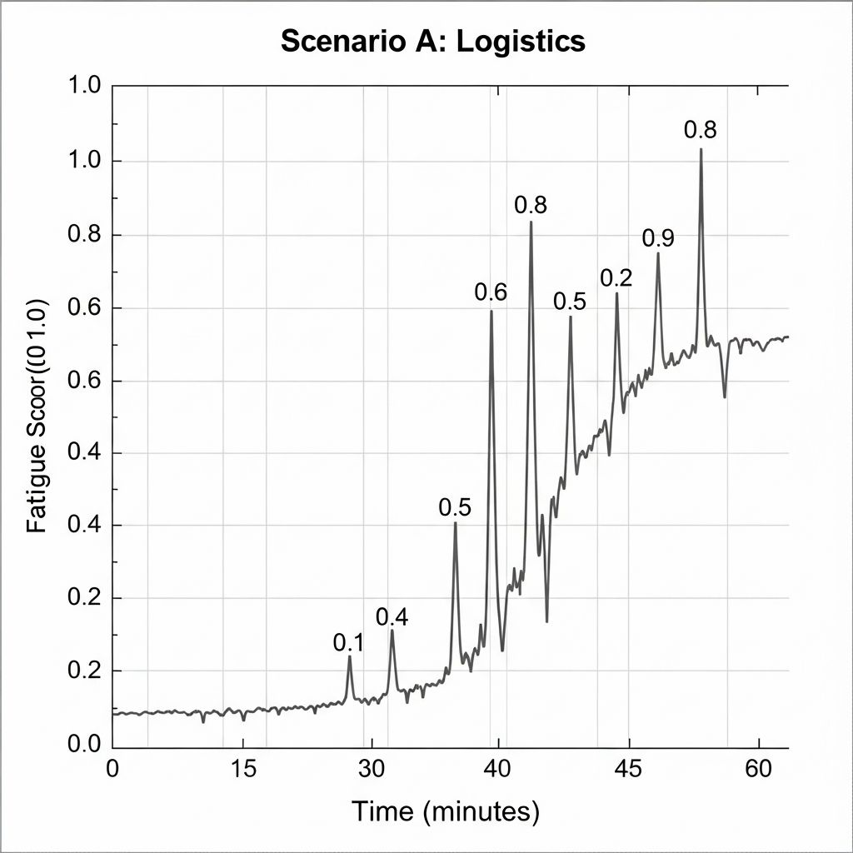

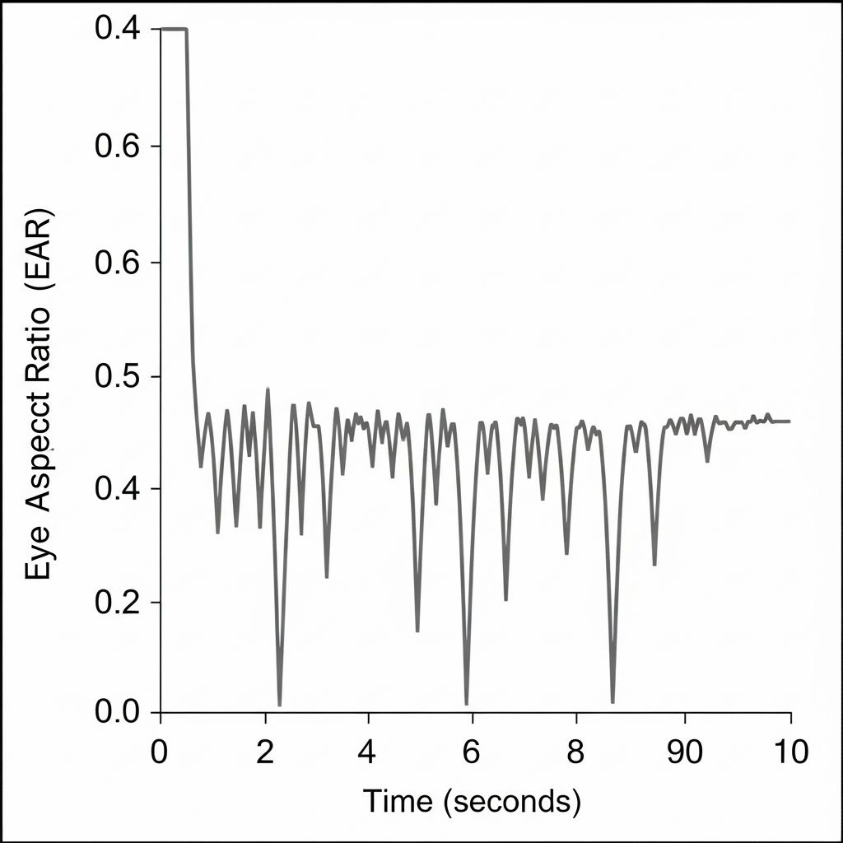
- Case Study 2: Extended Software Development (Cognitive Fatigue)-

A 180-minute programming session was analyzed to evaluate cognitive fatigue detection. Initially, the blink rate averaged 22 bpm due to focused visual engagement. After 110 minutes, the blink rate significantly reduced to 6–8 bpm, indicating “staring fatigue.”

Traditional EAR thresholding failed to detect this reduced-frequency fatigue pattern. However, the CNN–LSTM model identified abnormal temporal blinking behavior, demonstrating superior sensitivity to cognitive fatigue conditions.

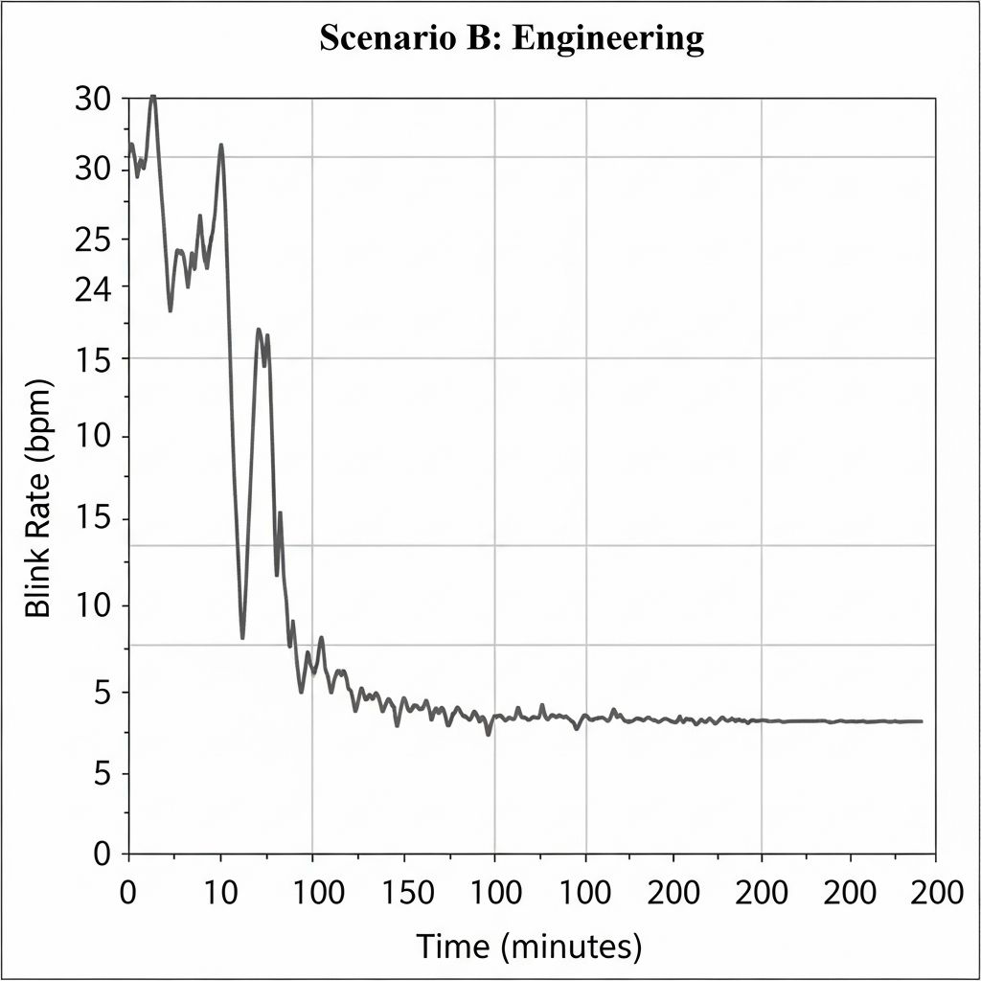
- Case Study 3: Night-Shift Monitoring (Low-Light Conditions)-
A 240-minute low-illumination (sub-20 lux) session tested robustness. Landmark tracking maintained 94% accuracy, effectively filtering false closures caused by head tilts and manual eye rubbing. The hybrid model demonstrated stability under challenging environmental conditions.
- Comparative Analysis
Quantitative comparison showed significant performance improvements:
Accuracy: 82.1% → 94.3% (+12.2%)
Precision: 78.4% → 91.8% (+13.4%)
Recall: 85.0% → 96.2% (+11.2%)

F1-Score: 81.6% → 93.9% (+12.3%)

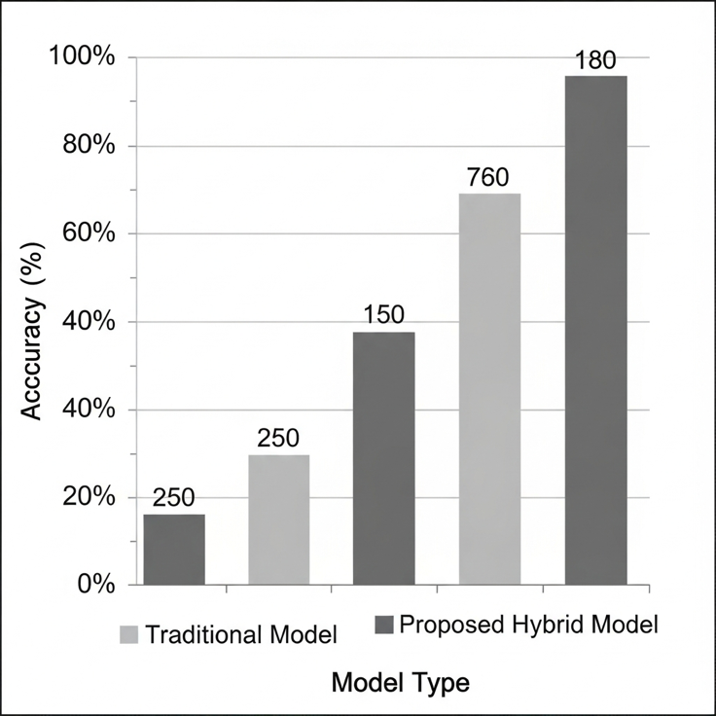
- Discussion
The significant reduction in false positives (from 14.5% to 3.2%) is attributed to the LSTM's ability to distinguish between natural long blinks and drowsy eye closures. The system remains robust under varying lighting conditions, though extreme head poses (>45 degrees) still present a challenge for landmark stability. The findings confirm that temporal modeling is essential for distinguishing natural blinks from fatigue-induced closures. While the hybrid model introduces a minor computational overhead (~13 ms latency increase), the substantial gain in detection accuracy and reduction in false positives justify its deployment in safety-critical applications such as transportation, industrial monitoring, and extended digital usage environments.

- Conclusion
The Convolution neural network and reinforcement learning are the striking technologies for learning and automation of the task. CNN has reflected extensive prospects in computer vision, especially in the field of self- driving vehicles. In the presented work, the CNN-based deep learning model has demonstrated successful automatic driving of the vehicle in the simulated environment. It demonstrates a significant advancement in non-intrusive fatigue monitoring. By combining high-fidelity landmark tracking with temporal deep learning, we provide a reliable tool for preventing fatigue-related accidents. Future work will explore the integration of heart rate variability (HRV) data for multi-modal fusion. Significant improvements have been made especially to handle shadow regions and crashing conditions. The improved model can handle sharp turns and curves by accurately predicting steering adjustments. It can successfully navigate both tracks, including the shadowed second track, without crashing. The updated model with enhanced data augmentation techniques showed a marked improvement in performance.
References
- Y. LeCun, Y. Bengio, and G. Hinton, "Deep learning," Nature, vol. 521, pp. 436–444, 2015. doi: 10.1038/nature14539.
- Z. Q. Zhao, P. Zheng, S. T. Xu, and X. Wu, "Object detection with deep learning: A review," IEEE Transactions on Neural Networks and Learning Systems, vol. 30, no. 11, pp. 3212-3232, 2019.
- P. Sun, H. Kretzschmar, X. Dotiwalla, A. Chouard, V. Patnaik, P. Tsui, et al., "Scalability in perception for autonomous driving: Waymo open dataset," in Proc. IEEE/CVF Conf. on Computer Vision and Pattern Recognition, 2020, pp. 2446-2454.
- A. Gupta, A. Anpalagan, L. Guan, A. S. Khwaja, "Deep learning for object detection and scene perception in self-driving cars: Survey, challenges, and open issues," Array, vol. 10, 2021. doi: 10.1016/j.array.2021.100057.
- B. R. Kiran, I. Sobh, A. A. Al Sallab, V. Talpaert, P. Mannion, S. Yogamani, and P. Pérez, "Deep Reinforcement Learning for Autonomous Driving: A Survey," IEEE Transactions on Intelligent Transportation Systems, vol. 23, no. 6, pp. 4909-4926, June 2022. doi: 10.1109/TITS.2021.3054625.
- T. Okuyama, T. Gonsalves, and J. Upadhay, "Autonomous Driving System Based on Deep Q Learning," in 2018 International Conference on Intelligent Autonomous Systems (ICoIAS), Singapore, 2018, pp. 201-205. doi: 10.1109/ICoIAS.2018.8494053.
- J. Ni, Y. Chen, Y. Chen, J. Zhu, D. Ali, and W. Cao, "A survey on theories and applications for self-driving cars based on deep learning methods," Applied Sciences, vol. 10, no. 8, 2020.
- C. Badue, R. Guidolini, R. V. Carneiro, P. Azevedo, V. B. Cardoso, A. Forechi, L. Jesus, R. Berriel, T. M. Paixão, F. Mutz, L. de Paula Veronese, T. Oliveira-Santos, and A. F. De Souza, "Self-driving cars: A survey," Expert Systems with Applications, vol. 165, 2021. doi: 10.1016/j.eswa.2020.113816.
- M. Bojarski, D. Del Testa, D. Dworakowski, B. Firner, B. Flepp, P. Goyal, et al., "End to end learning for self-driving cars," arXiv preprint arXiv:1604.07316, 2016.
- Q. Cui, Y. Wang, K. C. Chen, W. Ni, I. C. Lin, X. Tao, and P. Zhang, "Big data analytics and network calculus enabling intelligent management of autonomous vehicles in a smart city," IEEE Internet of Things Journal, vol. 6, no. 2, pp. 2021-2034, 2018.
- S. OwaisAli Chishti, S. Riaz, M. BilalZaib, and M. Nauman, "Self- Driving Cars Using CNN and Q-Learning," in 2018 IEEE 21st International Multi-Topic Conference (INMIC), 2018, pp. 1-7. doi: 10.1109/INMIC.2018.8595684.
- S. R. Narla, "The evolution of connected vehicle technology: From smart drivers to smart cars to self-driving cars," ITE Journal, vol. 83, no. 7, pp. 22-26, 2013.
- E. Urtans and A. Nikitenko, "Survey of deep q-network variants in pygame learning environment," in Proceedings of the 2018 2nd International Conference on Deep Learning Technologies, June 2018,
pp. 27-36.
- Alzubaidi, L., Zhang, J., Humaidi, A.J. et al. Review of deep learning: concepts, CNN architectures, challenges, applications, future directions. J Big Data, vol. 8, no. 53, 2021. https://doi.org/10.1186/s40537-021-00444-8.
- Kamil, Zheen & Abdulazeez, Adnan. (2024). A Review on Deep Reinforcement Learning for Autonomous Driving. Indonesian Journal of Computer Science. 13. 10.33022/ijcs.v13i3.4036.
- Christian Janiesch, Patrick Zschech, Kai Heinrich, “Machine learning
and deep learning,” Electronic Markets, vol. 31, pp. 685–695, 2021.
- Y. LeCun, Y. Bengio, and G. Hinton, "Deep learning," Nature, vol. 521, pp. 436–444, 2015. doi: 10.1038/nature14539.
- Z. Q. Zhao, P. Zheng, S. T. Xu, and X. Wu, "Object detection with deep learning: A review," IEEE Transactions on Neural Networks and Learning Systems, vol. 30, no. 11, pp. 3212-3232, 2019.
- P. Sun, H. Kretzschmar, X. Dotiwalla, A. Chouard, V. Patnaik, P. Tsui, et al., "Scalability in perception for autonomous driving: Waymo open dataset," in Proc. IEEE/CVF Conf. on Computer Vision and Pattern Recognition, 2020, pp. 2446-2454.
- A. Gupta, A. Anpalagan, L. Guan, A. S. Khwaja, "Deep learning for object detection and scene perception in self-driving cars: Survey, challenges, and open issues," Array, vol. 10, 2021. doi: 10.1016/j.array.2021.100057.
- B. R. Kiran, I. Sobh, A. A. Al Sallab, V. Talpaert, P. Mannion, S. Yogamani, and P. Pérez, "Deep Reinforcement Learning for Autonomous Driving: A Survey," IEEE Transactions on Intelligent Transportation Systems, vol. 23, no. 6, pp. 4909-4926, June 2022. doi: 10.1109/TITS.2021.3054625.
- T. Okuyama, T. Gonsalves, and J. Upadhay, "Autonomous Driving System Based on Deep Q Learning," in 2018 International Conference on Intelligent Autonomous Systems (ICoIAS), Singapore, 2018, pp. 201-205. doi: 10.1109/ICoIAS.2018.8494053.
- J. Ni, Y. Chen, Y. Chen, J. Zhu, D. Ali, and W. Cao, "A survey on theories and applications for self-driving cars based on deep learning methods," Applied Sciences, vol. 10, no. 8, 2020.
- C. Badue, R. Guidolini, R. V. Carneiro, P. Azevedo, V. B. Cardoso, A. Forechi, L. Jesus, R. Berriel, T. M. Paixão, F. Mutz, L. de Paula Veronese, T. Oliveira-Santos, and A. F. De Souza, "Self-driving cars: A survey," Expert Systems with Applications, vol. 165, 2021. doi: 10.1016/j.eswa.2020.113816.
- M. Bojarski, D. Del Testa, D. Dworakowski, B. Firner, B. Flepp, P. Goyal, et al., "End to end learning for self-driving cars," arXiv preprint arXiv:1604.07316, 2016.
- Q. Cui, Y. Wang, K. C. Chen, W. Ni, I. C. Lin, X. Tao, and P. Zhang, "Big data analytics and network calculus enabling intelligent management of autonomous vehicles in a smart city," IEEE Internet of Things Journal, vol. 6, no. 2, pp. 2021-2034, 2018.

