**TWIT: AN APPLICATION FOR TRANSPORT SERVICES**

**PROJECT REPORT**

SUBMITTED IN PARTIAL FULFILLMENT OF THE REQUIREMENT FOR THE AWARD OF THE DEGREE OF:

**BCA**

(Bachelor of Computer Application)

SUBMITTED BY

**AGNIKIRAN MAITY**

Roll No. 2528

**RITESH MANNA**

Roll No.2556

**ARKA KOLYA**

Roll No.2554

**SUDIPTA BERA**

Roll No.2552

SUPERVISED BY

**MRS. ARUNITA DAS**

FACULTY MEMBER  
Dept. of BCA, Midnapore College (Autonomous)

May 2024



**MIDNAPORE COLLEGE (AUTONOMOUS)**

MIDNAPORE, PASCHIM MEDINIPUR-721101, WEST BENGAL, INDIA

**TWIT: AN APPLICATION FOR TRANSPORT SERVICES**

**PROJECT REPORT**

SUBMITTED IN PARTIAL FULFILLMENT OF THE REQUIREMENT FOR THE AWARD OF THE DEGREE OF:

**BCA**

(Bachelor of Computer Application)

SUBMITTED BY

**AGNIKIRAN MAITY**

Roll No. 2528

**RITESH MANNA**

Roll No.2556

**ARKA KOLYA**

Roll No.2554

**SUDIPTA BERA**

Roll No.2552

SUPERVISED BY

**MRS. ARUNITA DAS**

FACULTY MEMBER  
Dept. of BCA, Midnapore College (Autonomous)

May 2024



**MIDNAPORE COLLEGE (AUTONOMOUS)**

MIDNAPORE, PASCHIM MEDINIPUR-721101, WEST BENGAL, INDI

**MIDNAPORE COLLEGE**

**(AUTONOMOUS)**

MIDNAPORE, PASCHIM MEDINIPUR

# CANDIDATE'S DECLARATION

We hereby certify that the work which is being presented in the thesis entitled “TWIT: AN APPLICATION FOR TRANSPORT SERVICES” by AGNIKIRAN MAITY, RITESH MANNA, ARKA KOLYA and SUDIPTA BERA in partial fulfillment of requirements for the award of degree of BCA submitted in the Department of BCA at MIDNAPORE COLLEGE affiliated to VIDYASAGAR university, is an authentic record of our work carried out during a period from September 2023 to March 2024 under the supervision of MRS. ARUNITA DAS. The matter presented in this project report has not been submitted by our in any other University / Institute for the award of BCA Degree.

___________________

Signature of the Students

This is to certify that the above statement made by the candidate is correct to the best of my knowledge.

_____________________

Signature of the Supervisor

The BCA Examination of AGNIKIRAN MAITY, RITESH MANNA, ARKA KOLYA and SUDIPTA BERA has been held on ________________ and accepted.

___________________ _________________________

Signature of Supervisor Signature of External Examiner

___________________________ _____________________

Signature of H.O.D DEPT. OF BCA Signature of the Examiners.



**MIDNAPORE COLLEGE**

**(AUTONOMOUS)**

**PASCHIM MEDINIPUR, WEST BENGAL, INDIA**

# Date:

# CERTIFICATE

We hereby certify that the work which is being presented in the BCA Project Report entitled **“TWIT: AN APPLICATION FOR TRANSPORT SERVICES”,** in partial fulfilment of the requirements for the award of the **BCA** and submitted to the Department of **BCA** of **Midnapore College (Autonomous)** is an authentic record of our work carried out during a period from **September 2023 to March 2024** under the supervision of **Mrs**. **Arunita Das, FACULTY MEMBER Dept of BCA, Midnapore College (Autonomous)**.

The matter presented in this thesis has not been submitted by us for the award of any other degree elsewhere.

______________________________

Signature of Candidates with Roll No

This is to certify that the above statement made by the candidate is correct to the best of my knowledge.

___________________

#### Signature of Supervisor

#### Date:

# ACKNOWLEDGEMENT

We would like to place on record our deep sense of gratitude to MRS. ARUNITA DAS, FACULTY MEMBER, DEPT. OF BCA, MIDNAPORE COLLEGE (AUTONOMOUS), PASCHIM MEDINIPUR, WEST BENGAL, INDIA for her generous guidance, help and useful suggestions.

We express our sincere gratitude to DR. KRISHNA GOPAL DHAL, HOD OF DEPT. OF BCA, MIDNAPORE COLLEGE (AUTONOMOUS), PASCHIM MEDINIPUR, WEST BENGAL, INDIA, for his stimulating guidance, continuous encouragement and supervision throughout the course of present work.

We also wish to extend our thanks to all the respected teachers for attending our seminars and for their insightful comments and constructive suggestions to improve the quality of this research work.

We are extremely thankful to PROF. SATYARANJAN GHOSH, TEACHER-IN-CHARGE, MIDNAPORE COLLEGE (AUTONOMOUS), PASCHIM MEDINIPUR, WEST BENGAL, INDIA for providing our infrastructural facilities to work in, without which this work would not have been possible.

_________

Signatures

**CONTENTS**

|  |  |
| --- | --- |
|  | **Page No** |
| **Candidate’s Declaration** | **i** |
| **Certificate** | **ii** |
| **Acknowledgement** | **iii** |
| **Section 1: INTRODUCTION** | **1** |
| * 1. **Related work** | **2** |
| * 1. **Common features of existing works** | **2** |
| * 1. **Flaws of existing works** | **3** |
| **Section 2: Objective** | **5** |
| **Section 3: Motivation of work** | **6** |
| **Section 4: Purpose of work** | **7** |
| **Section 5: Software and Hardware Specification** | **8** |
| **Section 6: Work Flow Diagram** | **9** |
| **Section 7: Data Flow Diagram** | **10** |
| **Section 8: E-R Diagram** | **12** |
| **Section 9: Application Features** | **13** |
| **Section 10: Snapshots** | **14** |
| **Section 11:Conclusion** | **21** |
| **Section 12:Limitaions** | **22** |
| **Section 13: Future Work** | **23** |
| **REFERENCE** | **24** |
|  |  |

# INTRODUCTION

TWiT is an android-based application designed to revolutionize human transportation services in small towns that rely on e-rickshaws.

**Challenges Addressed:**

◻ Small towns face difficulties providing accessible and reliable transportation, especially during urgent situations.

◻ Rickshaw drivers experience extended idle periods without customers.

**Passenger Benefits:**

◻ TWiT offers a seamless solution for passengers to find transportation easily and efficiently.

◻ Passengers can locate nearby rickshaws via the app, reducing stress and uncertainty associated with waiting or finding a ride.

**Driver Benefits:**

◻ TWiT optimizes drivers' time and resources by connecting them with passengers in need of rides.

◻ Minimizes idle time and maximizes earning potential for rickshaw drivers.

◻ Provides access to a pool of potential customers, streamlining drivers' workflow and resource utilization.

**Community Impact:**

◻ TWiT contributes to a more connected and efficient transportation network in small towns.okk

◻ Enhances overall mobility and accessibility, fostering community development and prosperity.

**Summary:**

TWiT acts as a catalyst for change in small-town transportation.

- Addresses fundamental challenges faced by passengers and rickshaw drivers.

- Paves the way for a more efficient, accessible, and connected transportation network.

- Helps small towns overcome transportation barriers, unlocking opportunities for growth, development, and prosperity.

## RELATED WORKS

In India, some popular ride-hailing apps are Ola, Uber, Meru Cabs, Jugnoo, Rapido, and Savaari. These apps provide users with options to book taxis, auto-rickshaws, bike taxis, and outstation cabs.

## Common Features of existing apps:

• A rider creates an account.

• A rider orders a ride.

• A rider is matched with a driver.

• The driver picks up the rider.

• The driver takes the rider to the destination.

• The rider pays for the ride.

• The rider and driver rate each other and leave a review.

## Flaws of existing:

**OLA**

We all know about OLA cab service which provide human transportation for a long time. But there are some flaws on it like-

* OLA cab in transportation has the potential for higher costs compared to traditional modes of transportation.
* While OLA has expanded its services to many cities and towns, there may still be locations where OLA cabs are not readily available.
* Ola Cab primarily accepts payment through its own digital wallet, Ola Money, which may not be convenient for all users. Some users prefer to pay with cash.
* Some users have reported issues with the reliability of Ola Cab, such as drivers cancelling rides last minute or not showing up at all. This can be frustrating for users who rely on the app for transportation.

**UBER**

UBER cab service is one of the provider who provide human transportation for a long time. But there are some flaws on it like-

* Uber uses an automated system to increase prices based on supply and demand. For example, fares may double or triple on New Year 's Eve.
* Uber drivers may cancel rides, which can affect customers ' plans.
* Uber may be more expensive for short rides.
* Although Uber is available in many cities around the world, it is not available everywhere. Many rural communities do not have access to the various benefits Uber offers to riders in larger cities

**Rapido Bikes**

Rapido bike service is one of them. Here are the flaws of it:

* Rapido bike taxis can only take one passenger at a time. You’ll either have to ditch your friend or find another mode of transportation to accommodate both of you.
* When it’s raining outside or scorching hot, hopping onto a bike taxi isn’t the most appealing option. Let’s not even mention the discomfort of riding through bone-chilling cold temperatures.
* Rapido, along with its competitors like Ola and Uber, has faced its fair share of regulatory hurdles. Take Delhi, for example, where bike taxi services are banned due to the use of personal vehicles for commercial purposes. This goes against the Motor Vehicle Act of 1988, which is a bummer for those hoping to catch a quick bike taxi ride in the city. Unfortunately, legal complications like these can slow down the growth and adoption of bike taxis in certain regions.

# OBJECTIVES

* **Door-to-Door Services:** TWiT offers a unique advantage by providing door-to-door services in tier-2, tier-3, or urban cities where other ride-hailing services like Uber or Ola may not be as reliable or functional. This service ensures that customers can be picked up and dropped off at their exact locations, enhancing convenience and accessibility, especially in areas with limited transportation options.
* **Reduced Costs:** Implementing TWiT can significantly reduce costs for businesses compared to traditional taxi dispatch systems. By eliminating the need for call centers and manual booking processes, businesses can streamline their operations and achieve greater efficiency. These cost savings can contribute to increased profitability and sustainability for businesses utilizing the TWiT platform.
* **Economic Development:** A good transportation system can make it easier for businesses to move people, which can boost the local economy. It can also make a small city more attractive to potential residents and businesses.
* **Payment System:** TWiT offers flexibility in payment options, allowing users to pay in cash upon reaching their destination. This feature caters to users who prefer cash transactions or may not have access to digital payment methods. By accommodating various payment preferences, TWiT ensures that all users can easily utilize its services, enhancing accessibility and convenience for a diverse range of customers**.**

# MOTIVATION OF WORK

* **Market Expansion:** Developing the app will upscale small transport services, providing a structured platform for TOTO rickshaw drivers to reach more customers, thereby increasing their business potential and overall market reach.
* **First-Mover Advantage:** With no competitors in the niche market of TOTO rickshaw services, the app can establish a strong brand presence and customer loyalty, making it a dominant player in the market from the outset.
* **Economic Boost for Small Towns:** The app can stimulate local economies by improving transportation efficiency, making it easier for people to travel for work, shopping, and other activities, thus benefiting local businesses and communities.
* **Opportunities for Partnerships:** The app's development opens doors for collaborations with local businesses, such as shops and restaurants, offering integrated services like deliveries or special promotions, enhancing the overall value proposition for users.

# PURPOSE OF WORK

The purpose of developing the TWiT (Travel With Toto) app for small-town transportation services includes:

* **Enhancing Accessibility:** Provide a reliable and efficient transportation solution for residents and visitors in small towns, ensuring they can easily find and book TOTO rickshaws when needed.
* **Supporting Local Economy:** Boost the income of TOTO rickshaw drivers by increasing their customer base and ride frequency, contributing to the economic growth of small towns.
* **Improving User Experience:** Offer a user-friendly interface that simplifies the process of booking rides, tracking drivers, and making payments, enhancing overall customer satisfaction.
* **Solving Transportation Challenges:** Address common issues faced by both drivers and customers, such as the difficulty in finding rides promptly and meeting urgent travel needs, ensuring a smoother transportation experience.
* **Facilitating Partnerships:** Create opportunities for collaboration with local businesses and services, integrating additional features like delivery services or special offers, thus adding value to the community and fostering local partnerships.

# SOFTWARE AND HARDWARE SPECIFICATION

**Hardware:**

* **CPU:**

Processor-AMD RYZEN 5 5000 series

Speed-3.5GHz to 4.2 GHz

Cores-Six cores and 12 threads

* **RAM:**

RAM- 8GB

* **GPU:**

AMD RADEON graphics card

* **Storage:**

512 GB SSD

* **Operating System(OS):**

Windows 11(64bit)

**Software:**

* Visual Studio Code(IDE for Development)
* Android Studio
* Fire Base(for database)
* Openstreetmap API

# WORK FLOW DIAGRAM

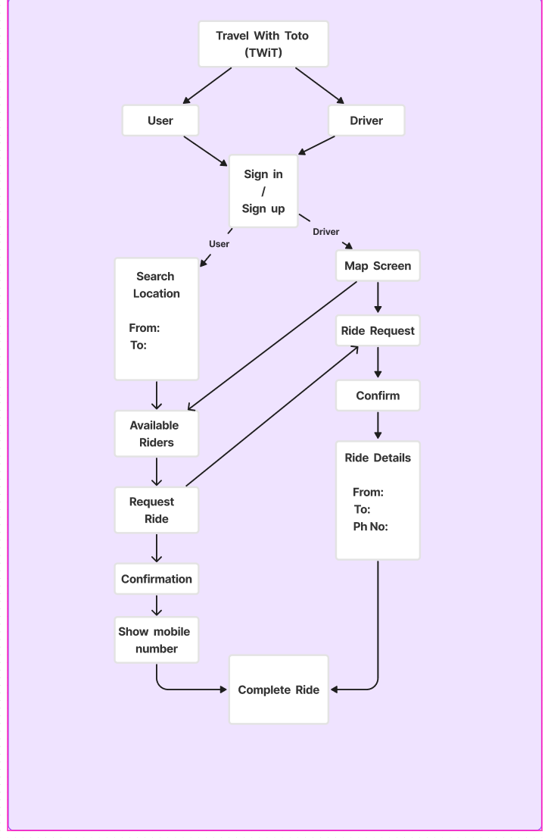

Figure : Work flow Diagram

# DATA FLOW DIAGRAM

**DFD LEVEL 0:**

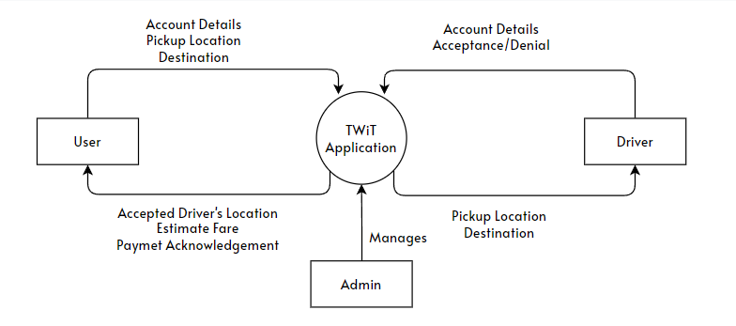

Figure: DFD LEVEL 0

**DFD LEVEL 1:**

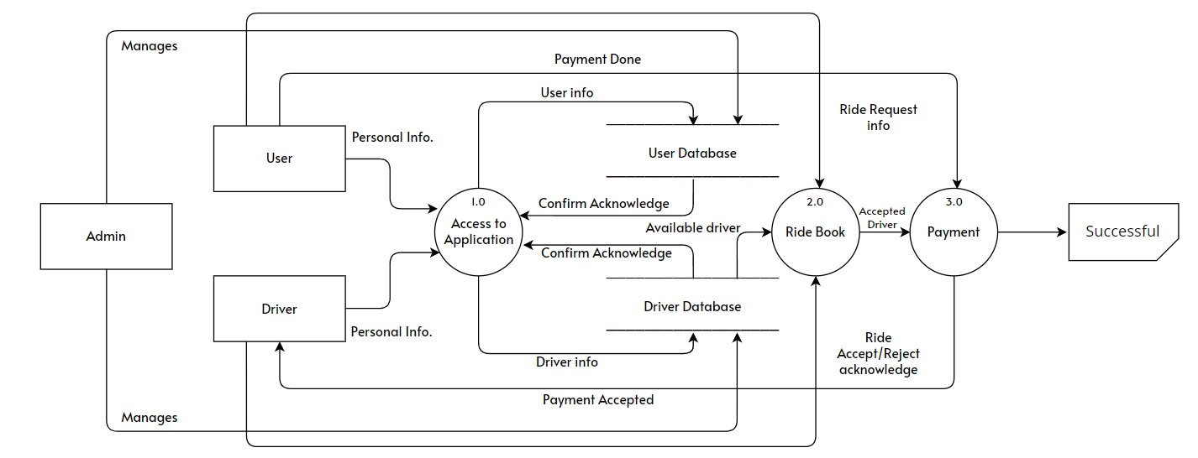

Figure: DFD LEVEL 1

**DFD LEVEL 2:**

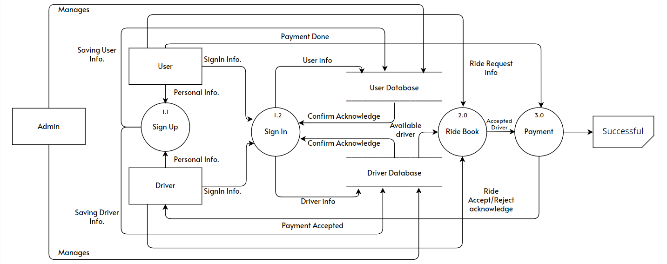

Figure : DFD LEVEL 2

# E-R DIAGRAM

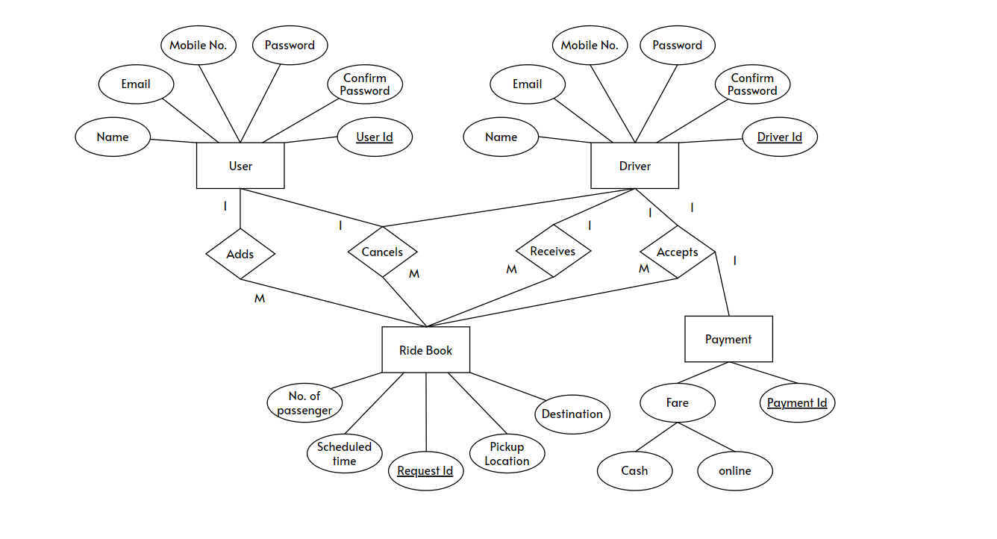

Figure: ER Diagram

# APPLICATION FEATURES

**Registration:**

Registration can be done using email address, phone number, name, contact details.

**Login:**

Log in can be done using their registered phone number along with a password.

**Set Pick-Up and Drop-Off Locations**:

Users can select pick-up and drop-off points directly on an interactive map.

**Ride Scheduling:**

User can schedule their ride too.

**Notification on Driver Side:**

When a passenger choose the driver, driver will get notified.

**Accept and Manage Rides:**

Now driver can accept the ride.

**Ride History**:

Ride history will be always visible on the driver side.

# SNAPSHOTS

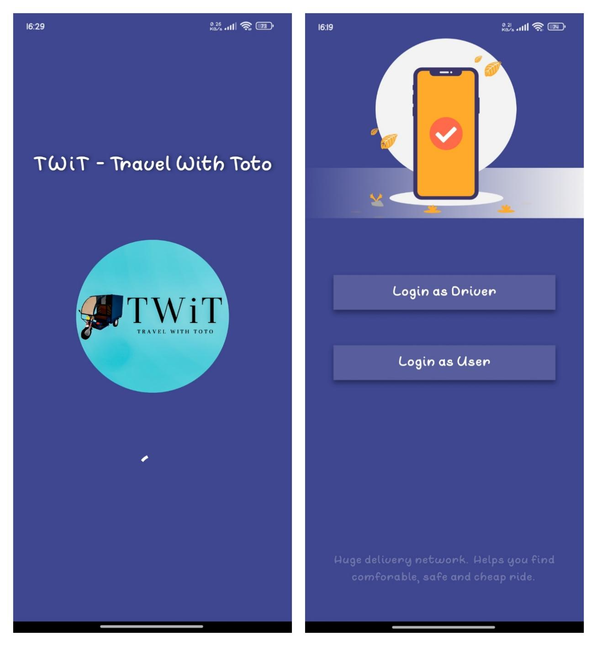

Figure 1: Splash Screen Figure 2: Splash Screen 2

Figure 1: It is the splash screen. It appears when the application is starting.

Figure 2: Here is the option where the application user select them as a driver or user.

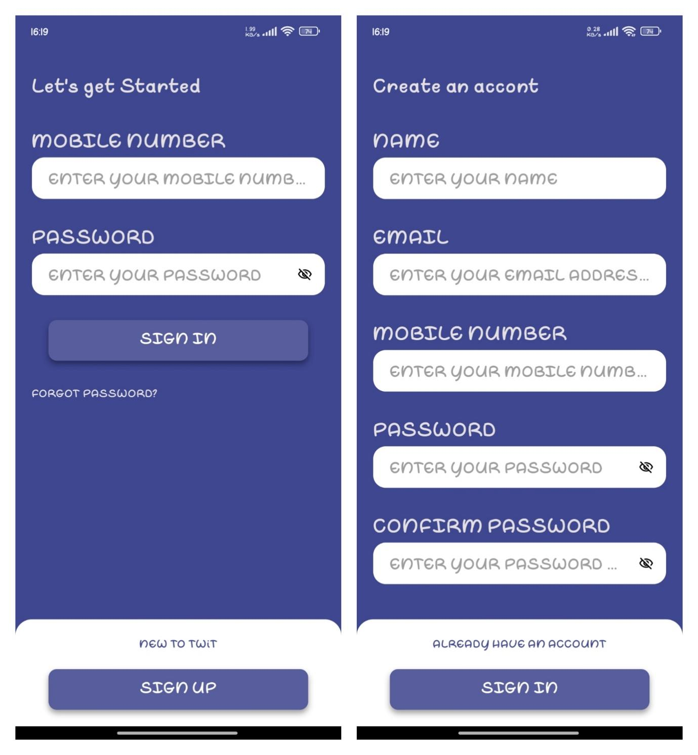

Figure 3: Sign in Figure 4: Sign up

Figure 3: Here is the sign in area, by putting credentials you can go forward.

Figure 4: If you are a new user of this app, you have to go through this signup page

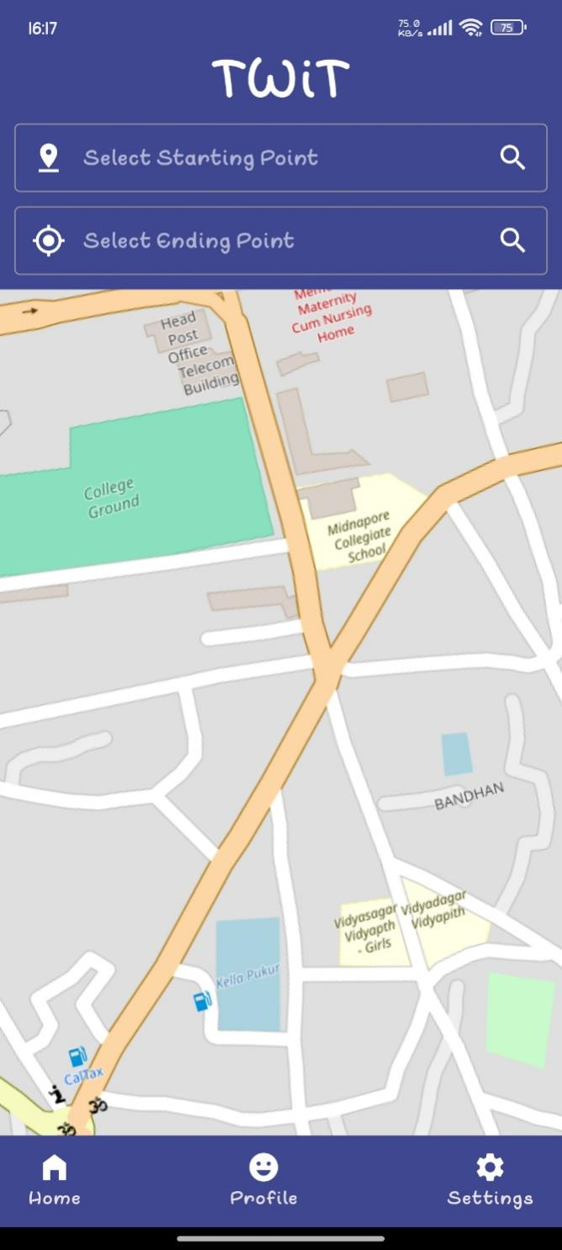

Figure 5: Home Screen (USER)

Figure 5: It is the home screen for the user. From here you can select your location and destination. You can visit profile screen or from the settings you can go and log out.

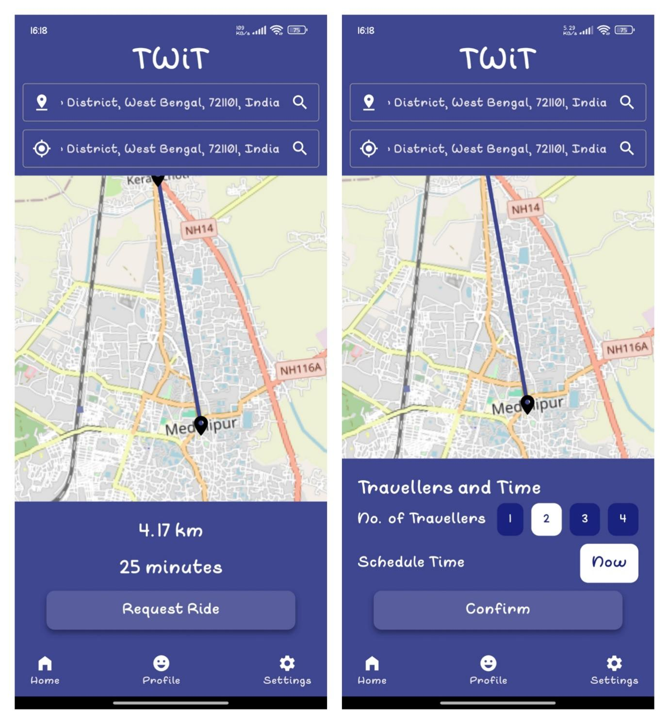

Figure 6 Figure 7

Figure 6: It shows the destination and distance

Figure 7: Here you can select your seat and confirm it

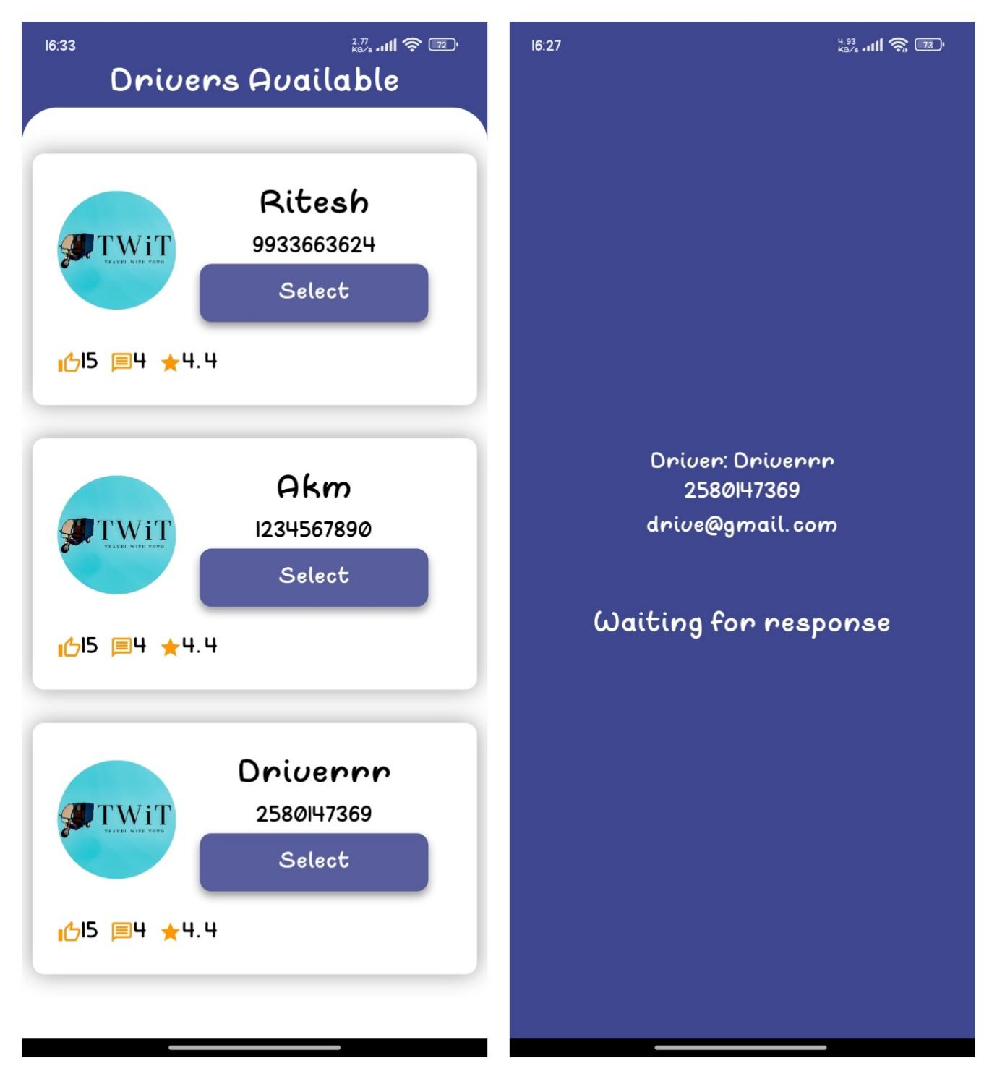

Figure 8 Figure 9

Figure 8: All available drivers are there, you can select a driver from there.

Figure 9: After selecting driver, this screen appears.

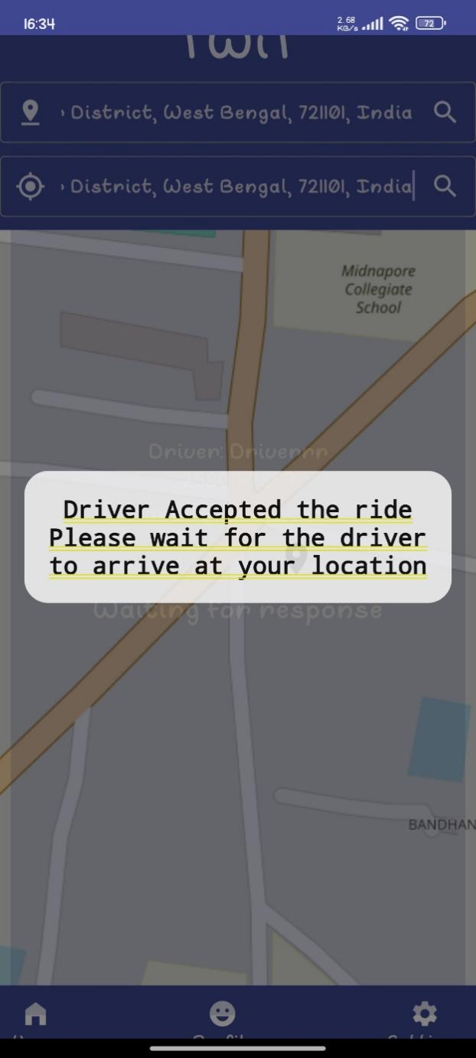

Figure 10

Figure 10: This pop up will be visible when the driver accept your booking

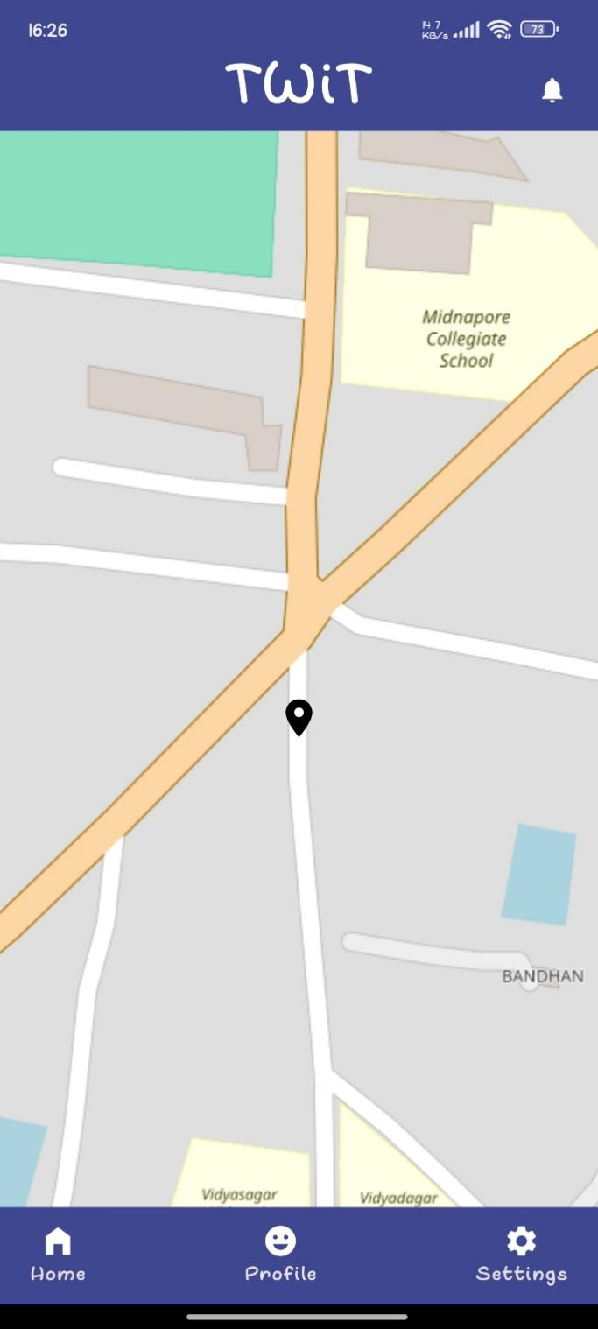 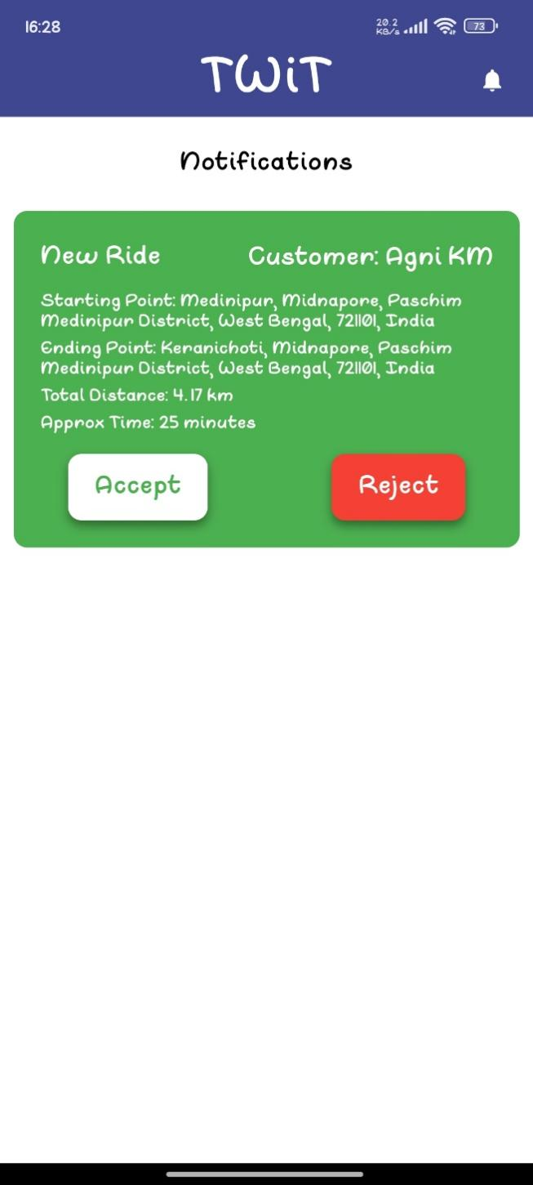

*Figure 11: Driver’s Home screen* *Figure 12*

Figure 11: After login driver will redirected to this screen, where he/she can saw his/her own location.

Figure 12: Driver’s notification screen show the request. From here driver can select or reject the booking.

# CONCLUSION

In conclusion, TWiT (Travel With Toto) has the potential to revolutionize human transportation services in small towns dependent on TOTO rickshaws. By providing door-to-door services, reducing costs associated with traditional taxi dispatch systems, enhancing user experience through a user-friendly interface, and offering a flexible payment system, TWiT addresses critical challenges faced by both passengers and drivers in these areas.

However, the successful implementation of TWiT is contingent upon overcoming various challenges, including infrastructure limitations, driver and user adoption, competition, regulatory hurdles, safety concerns, payment infrastructure, and market penetration.

Despite these challenges, TWiT's future scope is promising. It can expand to new markets, integrate with public transport, diversify its services, integrate advanced technologies, enhance safety features, promote environmental sustainability, engage with local communities, and even consider international expansion.

Overall, TWiT has the potential to not only improve accessibility, efficiency, and customer satisfaction in small-town transportation but also to serve as a model for addressing transportation challenges in similar regions worldwide. With strategic planning, innovation, and community engagement, TWiT can pave the way for a more connected, efficient, and sustainable transportation network in small towns.

# LIMITATIONS

**Limited Coverage Area**: The TWiT app may initially have limited coverage in small towns, as it relies on the availability of TOTO rickshaws and may not be accessible in all areas.

**Dependency on Internet Connectivity:** The app's functionality depends on internet connectivity, which may be unreliable or unavailable in some areas, affecting its usability.

**Technological Constraints:** TOTO rickshaw drivers and users in small towns may not be familiar with or have access to smartphones or the technology required to use the TWiT app, limiting its adoption.

**Seasonal Variations:** Demand for transportation services in small towns may vary seasonally, with fluctuations in tourist traffic or agricultural activities, impacting the app's usage and effectiveness.

**Competition from Informal Transport:** Informal transport options, such as cycle rickshaws or local buses, may continue to be preferred by some residents, limiting the market potential for the TWiT app.

**Financial Constraints**: TOTO rickshaw drivers and users in small towns may have limited financial resources, making it difficult for them to afford smartphones or data plans required to use the app.

**Cultural and Social Factors:** Cultural preferences or social norms in some small towns may favor traditional modes of transportation, posing a barrier to the widespread adoption of the TWiT app.

# FUTURE WORK

**Expansion to New Markets**: After establishing a strong presence in small towns, TWiT could expand its services to other similar regions or even larger cities that face similar transportation challenges.

**Integration with Public Transport:** TWiT could explore partnerships with public transport authorities to integrate its services with existing public transport networks, offering seamless multimodal transportation solutions.

**Diversification of Services:** TWiT could diversify its services beyond rickshaws to include other modes of transportation, such as e-bikes or electric scooters, to cater to a wider range of transportation needs.

**Integration of Advanced Technologies:** TWiT could integrate advanced technologies such as AI and machine learning to optimize ride allocation, predict demand, and enhance overall user experience.

**Seat Allotment:** Implement a dynamic seat reservation system that allows users to select and book specific seats in a TOTO rickshaw based on real-time availability.

**Payment Options:** Integrate multiple payment methods, including digital payments on application and cash, to provide users with flexible and convenient payment options for their rides.

**Community Engagement:** TWiT could engage with local communities to understand their specific transportation needs better and tailor its services to meet those needs effectively.

# REFERENCES

* **Case study of ola -** https://www.protocloudtechnologies.com/ola-business-case-study/
* **case study of uber -**   
  https://www.addevice.io/blog/how-to-make-an-app-like-uber
* **case study of rapido -**https://techweblabs.com/rapido-business-model/
* **For Map Access-**https://www.openstreetmap.org/#map=4/21.84/82.79
* **FOR ERROR SOLUTIONS-**  
  [www.stackoverflow.com](http://www.stackoverflow.com)
* **FOR PACKAGES-**[www.flutter.dev](http://www.flutter.dev)