AgriSmart: AI-Powered Crop Recommendation System
Project Documentation
Data-driven crop recommendations using soil and environmental conditions
1. Project Overview
1.1 Introduction
AgriSmart is a professional machine-learning web application that recommends the most suitable crop to grow based on soil nutrient levels and environmental conditions. The system trains and compares five classification algorithms on the Kaggle Crop Recommendation Dataset and exposes both a Streamlit dashboard and a Flask REST API — all from a single Python file (app.py).
1.2 Problem Statement
Selecting the wrong crop for given soil and climate conditions leads to reduced crop yields, financial losses for farmers, and unnecessary environmental impact. Traditional crop selection often relies on inherited knowledge, which may not account for changing climate patterns or regional soil variations. AgriSmart provides data-driven, ML-powered recommendations to support informed planting decisions.
1.3 Objectives
• Build a complete end-to-end machine learning pipeline from raw data to live predictions.
• Train and compare five classification models to identify the best-performing algorithm.
• Deliver a professional Streamlit dashboard with interactive EDA, model metrics, and live prediction.
• Expose a Flask REST API that shares the same trained model and preprocessing pipeline.
• Contain the entire application in a single Python file (app.py) for portability.
2. Dataset
2.1 Dataset Source
The dataset used in this project is the Crop Recommendation Dataset available on Kaggle, published by Atharva Ingle. It can be downloaded from: https://www.kaggle.com/datasets/atharvaingle/crop-recommendation-dataset
2.2 Dataset Description
The dataset contains 2,200 records of agricultural observations across 22 different crops. Each record captures seven soil and environmental measurements alongside the recommended crop label. The dataset is clean, well-balanced (100 records per crop), and contains no missing values.
2.3 Target Variable
The target variable is label, which contains the name of the recommended crop. There are 22 unique crop classes: apple, banana, blackgram, chickpea, coconut, coffee, cotton, grapes, jute, kidneybeans, lentil, maize, mango, mothbeans, mungbean, muskmelon, orange, papaya, pigeonpeas, pomegranate, rice, and watermelon.
Feature | Unit | Description
N | kg/ha | Nitrogen content in soil
P | kg/ha | Phosphorus content in soil
K | kg/ha | Potassium content in soil
temperature | °C | Average ambient temperature
humidity | % | Relative humidity
ph | 0–14 | Soil pH value
rainfall | mm | Annual rainfall
label | — | Target: recommended crop name (22 classes)
3. Application Architecture
3.1 Single-File Architecture
The entire AgriSmart application is contained in a single Python file: app.py. This design choice ensures maximum portability and simplicity for deployment. The file is logically organized into 18 numbered sections covering imports, configuration, data loading, preprocessing, model training, evaluation, caching, all UI render functions, the Flask API, and the entry point.
3.2 Logical Code Sections
- Section 1: Imports — All third-party library imports
- Section 2: Configuration — Constants (dataset path, columns, random state)
- Section 3: Dataset Loading — load_data() with @st.cache_data
- Section 4: Data Preprocessing — preprocess_data() — clean, encode, scale, split
- Section 5: Model Training — train_models() with @st.cache_resource
- Section 6: Model Evaluation — evaluate_models() returning metrics DataFrame
- Section 7: Best Model Selection — get_best_model() by highest F1 Score
- Section 8: Prediction Helper — make_prediction() scaling + inference
- Sections 9–15: Streamlit UI helpers and all six page render functions
- Section 16: Flask API — create_api() with four REST endpoints
- Section 17: Streamlit Main App — run_streamlit() — layout, sidebar, routing
- Section 18: Entry Point — main() with --api flag for standalone API mode
3.3 Frontend + Backend Integration
When launched with streamlit run app.py, the application starts the Streamlit frontend as the primary process. Simultaneously, a Flask REST API is started in a background daemon thread on port 5000. Both the Streamlit UI and the Flask API use the same trained model, scaler, and label encoder objects — there is no duplication of training logic.
An alternative standalone API mode is available: python app.py --api starts only the Flask server without Streamlit, which is useful for headless or server deployments.
4. Machine Learning Pipeline
4.1 Data Cleaning
The preprocessing pipeline performs the following steps in order:
- 1. Load CSV file and validate that all required columns are present.
- 2. Remove duplicate rows using pandas drop_duplicates().
- 3. Drop rows with any missing values in the required columns.
- 4. Encode the target labels using sklearn.preprocessing.LabelEncoder.
- 5. Perform a stratified 80/20 train/test split (random_state=42).
- 6. Scale all seven input features using StandardScaler (fit on train, transform both sets).
4.2 Models Trained
Five classification models are trained and compared:
- Logistic Regression: max_iter=1000, multi_class=auto, random_state=42
- Decision Tree Classifier: random_state=42 (no depth limit, full tree)
- Random Forest Classifier: n_estimators=100, random_state=42, n_jobs=-1
- K-Nearest Neighbors: n_neighbors=5 (default Euclidean distance)
- Support Vector Machine: kernel=rbf, probability=True, random_state=42
4.3 Model Evaluation & Selection
All five models are evaluated on the hold-out test set using weighted Accuracy, Precision, Recall, and F1 Score. The model with the highest weighted F1 Score on the test set is automatically selected for deployment. On the standard Crop Recommendation Dataset, Random Forest and SVM typically achieve near-perfect scores (>99% F1), while Logistic Regression achieves around 96–97%.
The selection rule is implemented in get_best_model() and is fully automatic — no metric is hard-coded.
4.4 Caching Strategy
Streamlit's caching decorators are used to prevent redundant computation on widget interactions. load_data() and preprocess_data() use @st.cache_data (serialisable data objects). train_models() uses @st.cache_resource (ML model objects that should not be serialised). This means models are trained only once per application session, regardless of how many times the user interacts with the UI.
5. Application Pages
5.1 Overview Page
The Overview page serves as the application landing page. It displays five KPI metric cards at the top: Total Records, Number of Crops, Number of Features, Training Accuracy, and Testing Accuracy. All values are calculated dynamically from the loaded dataset and trained model — none are hard-coded.
Below the KPI cards, the page shows a project description, the ML workflow in an expandable section, a two-column layout listing all 22 supported crops, dataset summary statistics, and a bar chart showing the number of records per crop class.
5.2 Crop Recommendation Page
This is the primary application page. It presents a Streamlit form with numeric inputs for all seven features: N, P, K, temperature, humidity, ph, and rainfall. Default values are set to the dataset mean for each feature. Input ranges are derived from the dataset min/max values.
When the user clicks Recommend Crop, the application validates the inputs, passes them through the StandardScaler fitted on the training data, runs inference with the best model, and displays the result in a styled green card showing the crop name and confidence percentage. A horizontal bar chart shows the top 5 crop probabilities. An expandable Why this recommendation? section provides a plain-language explanation of the key input factors.
5.3 Exploratory Data Analysis Page
The EDA page is organized into three tabs: Distributions, Correlations, and Crop Comparisons. A crop selector dropdown at the top allows the user to filter all Distribution charts to a single crop or view all crops together.
Distributions tab: histograms for all seven features using a 2x4 subplot grid (when all crops are selected), plus a crop distribution bar chart. Correlations tab: a feature correlation heatmap and an N-P-K grouped bar chart by crop. Crop Comparisons tab: average metric bar chart and box plot for the user-selected metric (rainfall, temperature, ph, or humidity) grouped by crop.
5.4 Model Performance Page
This page displays the complete model evaluation results. It opens with a blue info banner identifying the deployed model. Below it, a styled metrics table shows Train Accuracy, Test Accuracy, Precision, Recall, and F1 Score for all five models with a green gradient highlighting the best scores.
A grouped bar chart provides a visual side-by-side comparison across all four test metrics. The confusion matrix for the selected model is rendered as a heatmap. A full classification report is available in an expandable section. At the bottom, a Random Forest feature importance horizontal bar chart shows which input features contribute most to the model's predictions.
5.5 Dataset Explorer Page
The Dataset Explorer allows the user to browse the full dataset interactively. A crop selector filters by class. An expandable Numeric Range Filters section provides sliders for each of the seven feature columns. The filtered dataframe is displayed in a scrollable table. A Download filtered dataset as CSV button allows the user to export the currently visible subset. A summary statistics table and a data quality report (null counts, dtypes, unique values) are available in expandable sections.
5.6 About Project Page
The About page contains full project documentation rendered directly in the Streamlit interface, including problem statement, dataset source and feature table, technologies used, evaluation metrics, project workflow diagram, limitations, and future improvements. A clear disclaimer is displayed at the bottom.
6. REST API Reference
The Flask API runs on http://localhost:5000. All four endpoints are described below.
GET /api/health
Returns a JSON object confirming the service is operational. No request body required. Example response: {"status": "ok", "service": "AgriSmart Crop Recommendation API"}
GET /api/dataset
Returns a summary of the loaded dataset including row count, column count, number of crop classes, list of feature column names, target column name, and sorted list of all crop names.
GET /api/model-info
Returns information about the deployed model: selected model name, list of all available models, full evaluation metrics for all models (as a list of records), feature names, and target name.
POST /api/predict
Accepts a JSON body with keys N, P, K, temperature, humidity, ph, and rainfall. Returns the predicted crop name, a dictionary of class probabilities for all 22 crops (if the model supports predict_proba), and the input values echoed back. Returns HTTP 400 if any field is missing or invalid, and HTTP 500 if inference fails.
7. Setup and Running Instructions
7.1 Prerequisites
- Python 3.9 or higher
- pip package manager
- Crop_recommendation.csv downloaded from Kaggle and placed in the project directory
7.2 Installation
- Step 1: Create a virtual environment — python -m venv venv
- Step 2: Activate it — Windows: venv\Scripts\activate | macOS/Linux: source venv/bin/activate
- Step 3: Install dependencies — pip install -r requirements.txt
7.3 Running the Application
- Streamlit Dashboard (default): streamlit run app.py — Opens at http://localhost:8501. The Flask API starts automatically in the background on port 5000.
- Flask API only (standalone): python app.py --api — Starts only the REST server at http://localhost:5000.
8. Technologies Used
- Streamlit (>=1.32.0) — Web dashboard framework
- Flask (>=3.0.0) — REST API framework
- scikit-learn (>=1.3.0) — Machine learning models and preprocessing
- pandas (>=2.0.0) — Data manipulation and analysis
- numpy (>=1.24.0) — Numerical computing
- Plotly (>=5.18.0) — Interactive charts and visualisations
- Matplotlib (>=3.7.0) — Supporting visualisation library
- Seaborn (>=0.12.0) — Statistical visualisation library
- joblib (>=1.3.0) — Model serialisation utility
9. Limitations and Disclaimer
9.1 Limitations
- Model performance reflects the training dataset's geographic and temporal scope, which may not represent all agricultural regions.
- Soil and climate conditions vary significantly by region, altitude, and season in ways not captured in the dataset.
- Confidence scores are probabilistic estimates, not agronomic guarantees.
- The system does not account for crop market prices, irrigation infrastructure, or crop rotation practices.
- The dataset contains only 22 crop classes; many regional crops are not represented.
9.2 Future Improvements
- Incorporate geospatial data (GPS coordinates, regional agricultural databases).
- Add seasonal and temporal features to capture climate variation.
- Deploy with a dedicated FastAPI backend and PostgreSQL database.
- Implement a continuous model retraining pipeline with newly collected field data.
- Add multi-language support for regional farmers.
- Integrate soil microbiome and satellite imagery as additional input features.
10. Application Screenshots
The following screenshots were generated directly from the trained models and the Crop Recommendation dataset. They illustrate the key pages, charts, and components of the AgriSmart application.
10.1 Overview Page — KPI Cards
The Overview page opens with five KPI metric cards showing Total Records, Crop Types, Features, and the Train/Test Accuracy of the currently selected model. All values are calculated dynamically from the dataset and trained model — none are hard-coded.
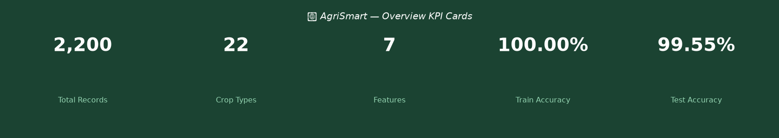
Figure 1 – Overview Page KPI Cards
10.4 Feature Correlation Heatmap
The correlation heatmap shows pairwise linear correlations between all seven input features. Most features are weakly correlated, indicating they carry largely independent information for the model.
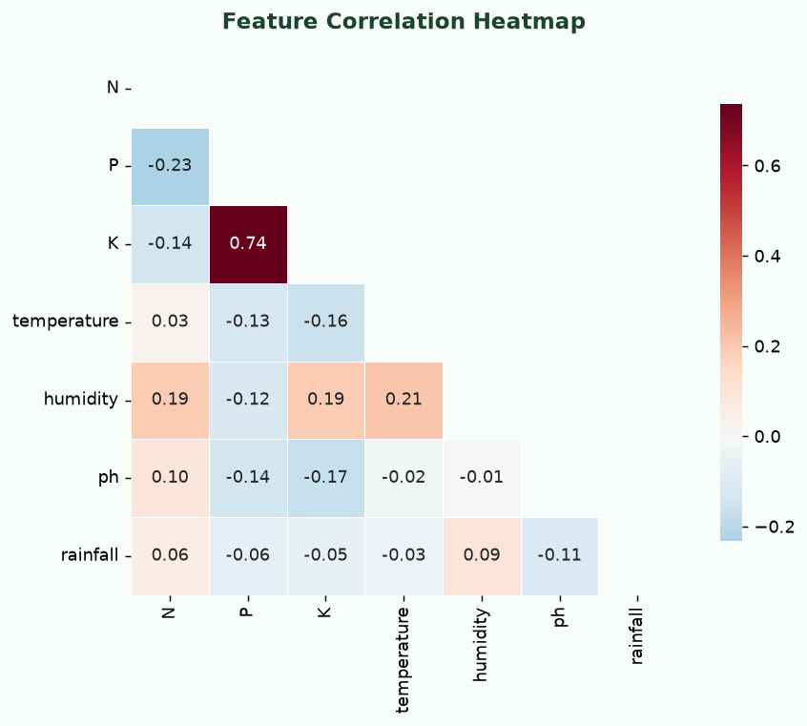
Figure 4 – Feature Correlation Heatmap
10.5 N-P-K Comparison by Crop
The grouped bar chart compares average Nitrogen, Phosphorus, and Potassium levels across all 22 crop classes, highlighting how different crops have distinct soil nutrient requirements.
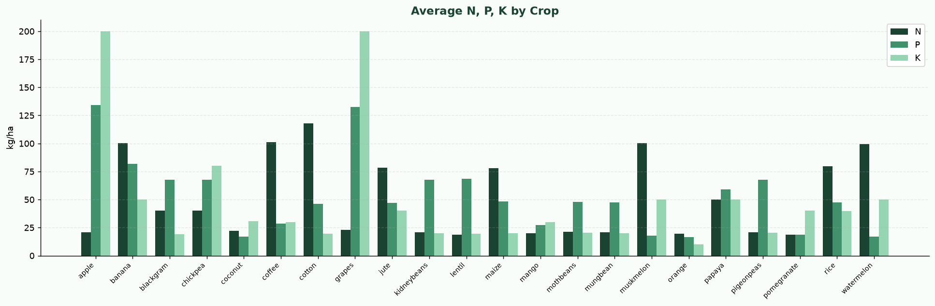
Figure 5 – Average N, P, K by Crop
10.6 Average Rainfall by Crop
Annual rainfall requirements vary significantly across crop classes. Crops above the dataset mean rainfall are highlighted in dark green.
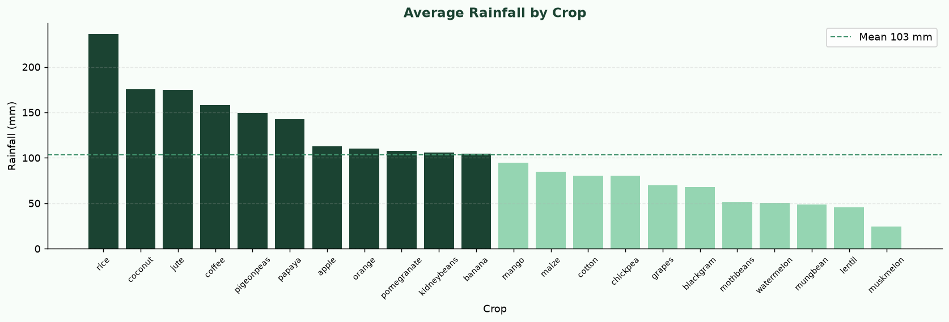
Figure 6 – Average Rainfall by Crop
10.7 Sidebar Navigation and Model Selector
The sidebar contains page navigation, dataset statistics, and the Select Model dropdown. Changing the active model updates all pages instantly — KPI cards, predictions, confusion matrix, classification report, and feature importance.
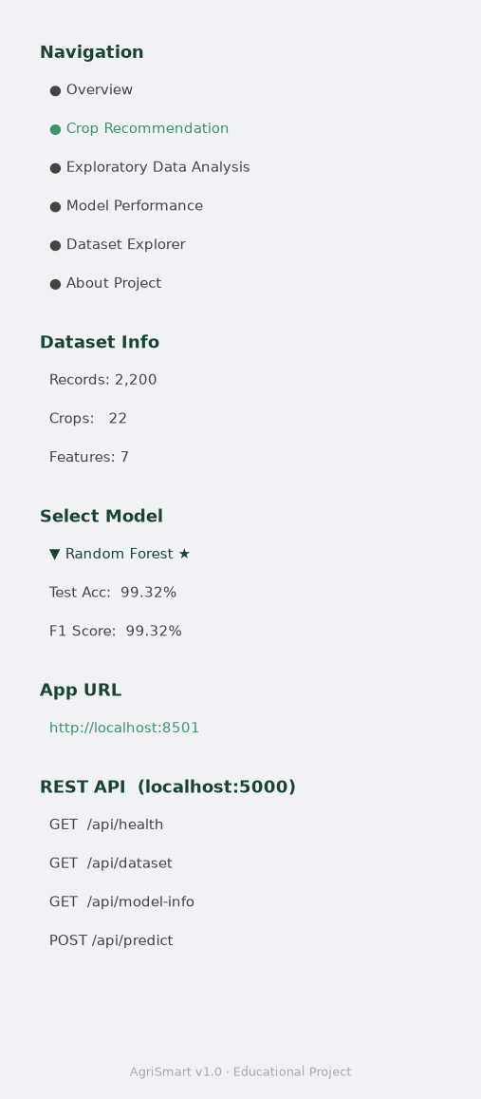
Figure 7 – Sidebar Navigation and Model Selector
10.12 Confusion Matrix
The confusion matrix for the best-performing model (Random Forest by default) shows predicted vs. actual crop labels across all 22 classes. Darker cells indicate higher counts. The near-diagonal pattern demonstrates high classification accuracy.
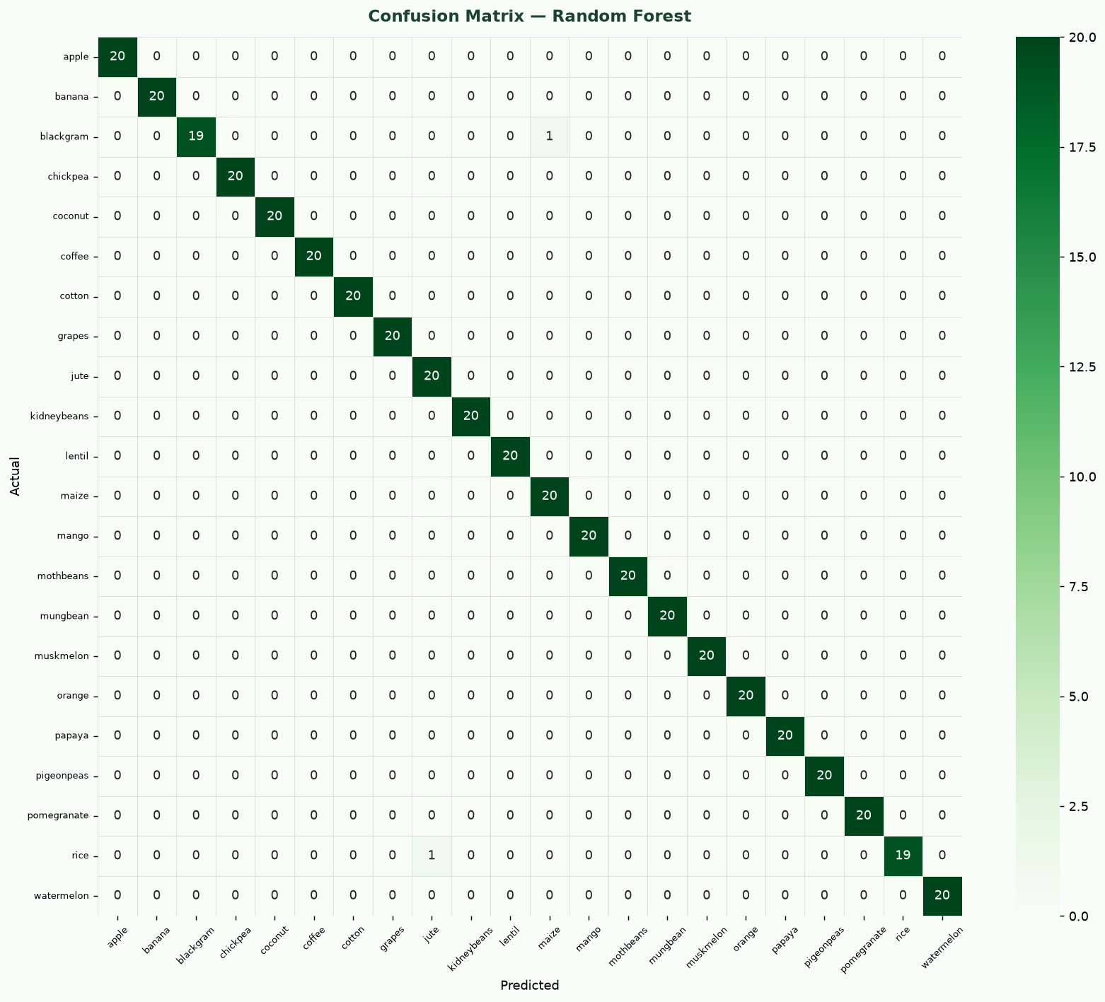
Figure 12 – Confusion Matrix (Best Model — Random Forest)
10.13 Feature Importance
Feature importance scores from the Random Forest model indicate which input variables contribute most to crop predictions. Rainfall, humidity, and potassium are consistently the top predictors. For models without native feature importances (Logistic Regression, KNN, SVM), the Random Forest importances are displayed as a reference.
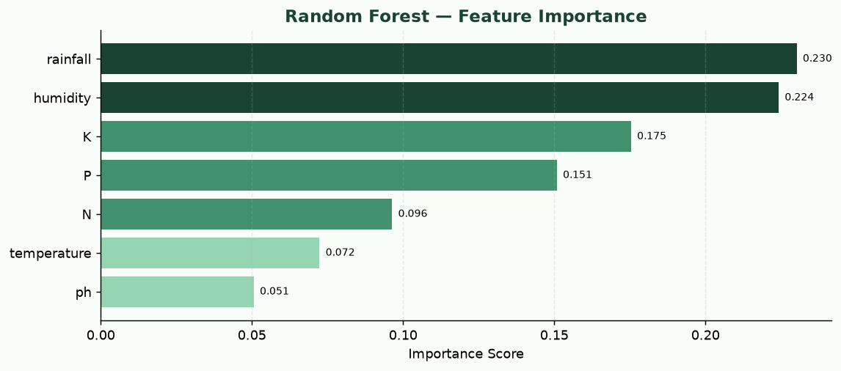
Figure 13 – Random Forest Feature Importance
10.2 Crop Distribution
The dataset is perfectly balanced with 100 records per crop class across all 22 categories.
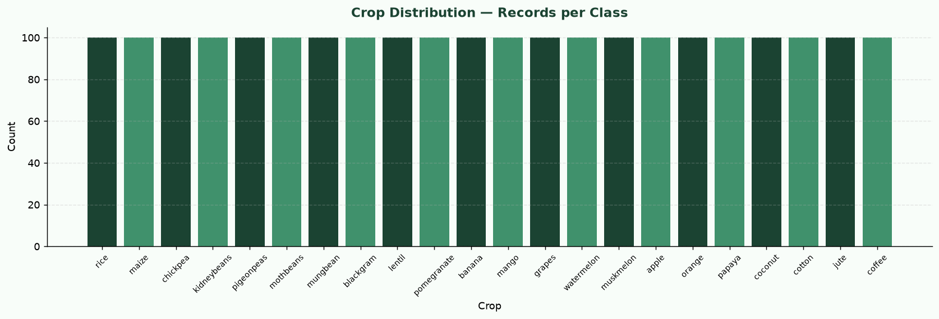
Figure 2 – Crop Distribution Bar Chart
10.3 Feature Distributions
Histogram distributions for all seven input features across the full dataset.
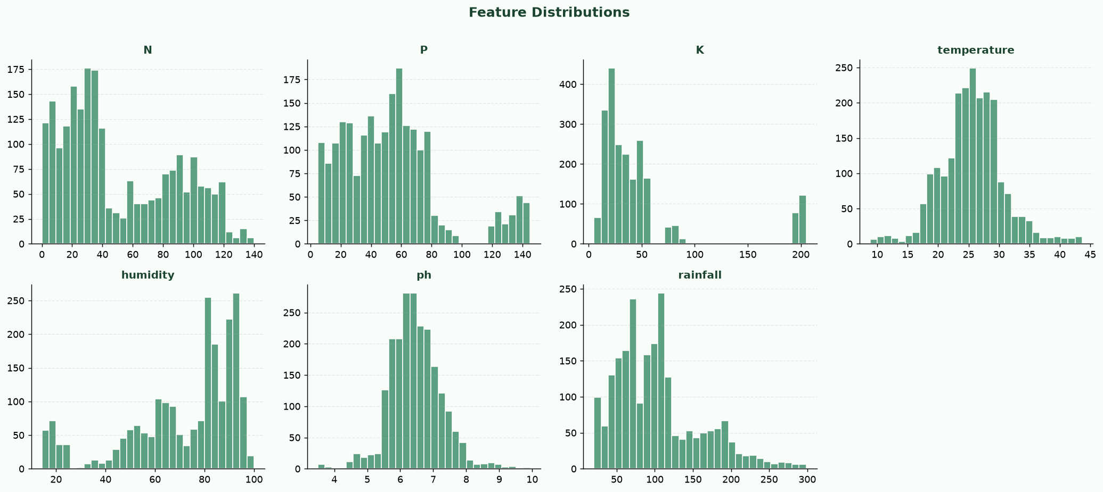
Figure 3 – Feature Distributions (all 7 input features)
10.10 Model Evaluation Metrics Table
All five models ranked by F1 Score. The top-ranked row is highlighted in green.
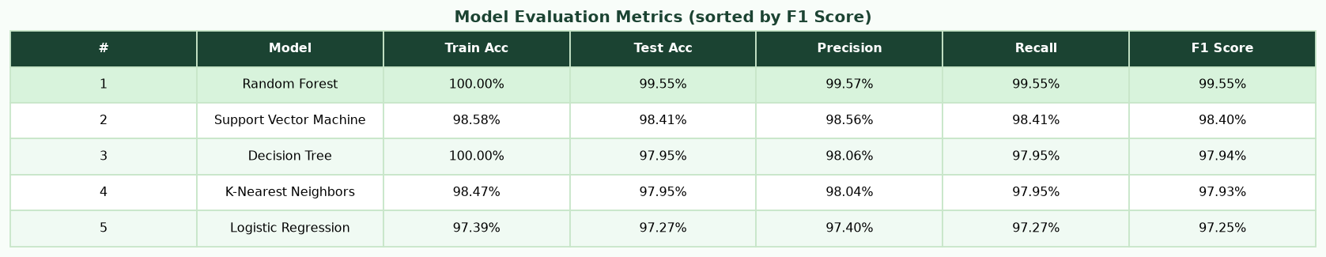
Figure 10 – Model Evaluation Metrics Table
10.11 Model Performance Comparison Chart
Side-by-side bar chart comparing Test Accuracy, Precision, Recall, and F1 Score across all five models. The best model's group is shaded.
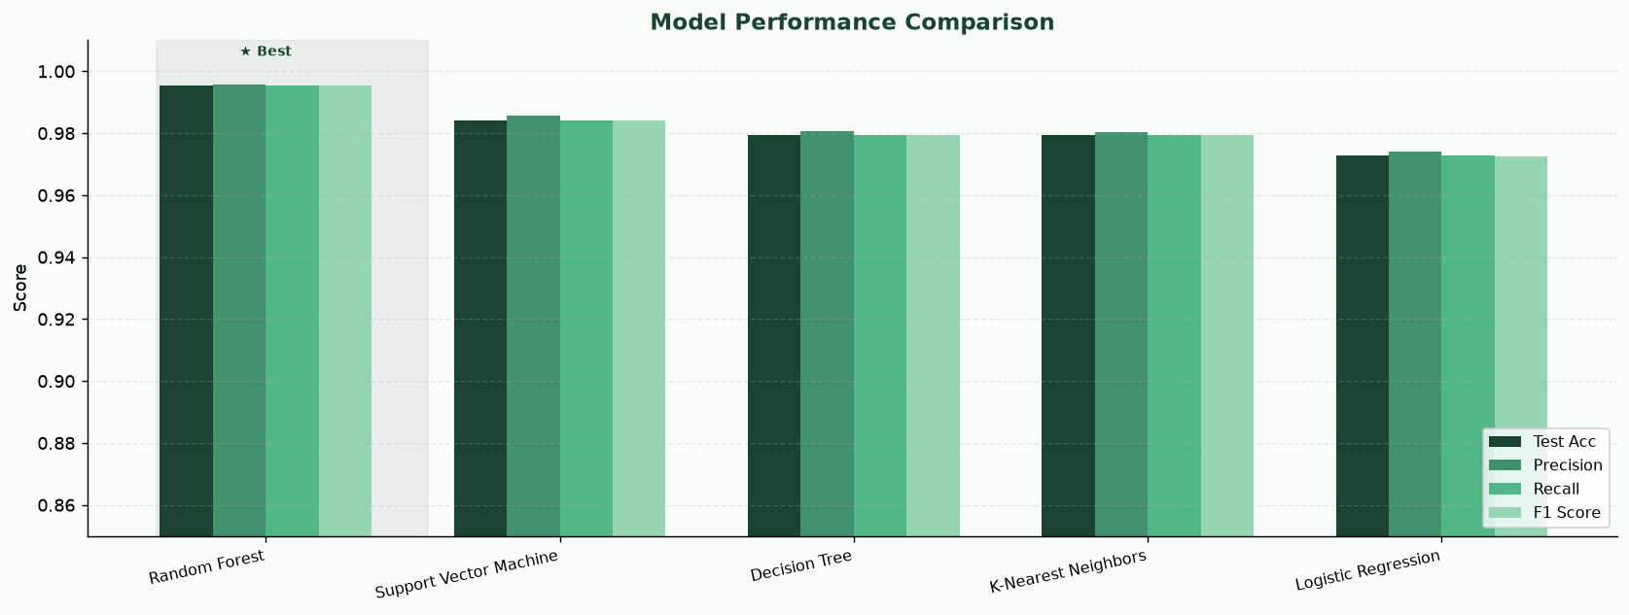
Figure 11 – Model Performance Comparison Chart

