THREADFLOW
Technical Design Document — Knitwear Production Tracking & Intelligence System
PROJECT GITHUB REPOSITORY:  https://github.com/AgnivaSardar/ThreadFlow | LIVE APPLICATION URL:  https://threadflow-ptun.onrender.com
BACKEND PRODUCTION API:  https://threadflow-backend-z7s9.onrender.com | TARGET DEPLOYMENT TOPOLOGY:  Render Static + Node Web Service, Supabase PostgreSQL 16
CLIENT & INDUSTRY CONTEXT:  Company A — Knitwear Exporter, Tiruppur | Version: 2.2 | TARGET HARDWARE PROFILE:  Android 10+ (2–3 GB RAM Mobile Devices), Desktop Browsers
1. Client Problem, Baseline Assumptions & Product Response
Current Operating Environment: Company A coordinates export purchase orders across three owned production units and subcontracted printing and washing partners in the Tiruppur knitwear cluster. Order status historically existed in disconnected spreadsheets, separate time-and-action (T&A) plans, telephone follow-ups to floor supervisors, and buyer status inquiries handled via email and messaging. These fragmented communication channels prevented factory leadership from detecting production shortfalls until shipments were already irrecoverably delayed.
1.1 Formal Problem Statement Assumptions Register
All financial metrics, capacity models, and business justifications in this document derive strictly from the authoritative parameters specified in the problem statement. Every assumption has been formally tagged and labeled below:
Assumption Tag | Domain Parameter | Quantified Value | Operational & Economic Derivation
[ASSUMPTION 1] | Annual Export Order Volume & Value | 500 orders / year at ₹21 lakh average | Factory manufactures 500 purchase orders annually with an average contract value of ₹21 lakh, establishing an annualized baseline turnover of ₹105 Crore.
[ASSUMPTION 2] | Baseline Late Shipment Rate | 8% of total orders (40 orders / year) | Historically, exactly 8 percent of all purchase orders (40 orders annually) exceed contractual ex-factory dates due to delayed floor visibility.
[ASSUMPTION 3] | Emergency Air Freight Penalty | 15 orders at ₹3.5 lakh extra = ₹52.5 lakh | Of the 40 delayed orders, 15 require emergency air freight conversion instead of sea freight to prevent retail cancellation, incurring ₹52.5 lakh in unrecoverable freight surcharges.
[ASSUMPTION 4] | Buyer Late Delivery Discount Penalty | 25 orders at 5% discount = ₹26.25 lakh | The remaining 25 delayed orders incur a mandatory 5 percent contractual penalty discount (25 × (5% × ₹21 lakh) = 25 × ₹1.05 lakh = ₹26.25 lakh) deducted from invoice payouts.
[ASSUMPTION 5] | Merchandiser Status-Chasing Overhead | 12 merchandisers × 2 hrs/day = 7,200 hrs/yr at ₹400 = ₹28.8 lakh | Twelve export merchandisers spend 2 hours daily chasing status via telephone (12 × 2 × 300 working days = 7,200 hours/year). At ₹400/hr loaded cost, this drains ₹28.8 lakh in labor.
[ASSUMPTION 6] | Total Annual Operational Bleed | ₹1.08 Crore / year (₹1,08,00,000) | Cumulative baseline bleed equals ₹52.5L (air freight) + ₹26.25L (discounts) + ₹28.8L (labor) = ₹1.08 Crore annually.
[ASSUMPTION 7] | Implementation Budget & Timeframe | ₹7 lakh capital budget, 6-week delivery | Engineering delivery envelope is capped at ₹7 lakh capital expenditure over a 6-week implementation sprint.
[ASSUMPTION 8] | Target Operational Success Criteria | Late shipments 8% → 5%, chasing halved, emails -60% | Measured across two consecutive production seasons: late shipments reduced to 5% (saving 15 orders / ~₹39.38L), status-chasing time halved to 1 hr/day, buyer inquiry emails cut by 60%.
[ASSUMPTION 9] | Hardware & Connectivity Profile | 2–3 GB RAM Android phones, patchy factory connectivity | Floor supervisors operate low-cost mobile hardware under intermittent cellular signals, requiring offline queueing and lightweight image compression.
1.2 Product Response Mechanisms

- Create a single purchase-order record with order lines, manufacturing unit, ex-factory date, order start date, and a 7-stage TNA milestone template.
- Capture daily quantities, rejected quantities, optional floor notes, and photo evidence from a mobile supervisor workspace.
- Project whether the current run rate can complete the active milestone while preserving downstream time buffers.
- Show formula inputs and substituted arithmetic instead of presenting opaque risk colors.
- Keep buyer-visible warnings and photos behind a merchandiser review and approval step.
- Provide buyer-specific progress and weekly exports so routine status requests do not require manual compilation.
2. Comprehensive Problem Statement Compliance Audit
Every requirement, constraint, persona, and boundary condition in the problem statement was checked clause-by-clause against the codebase:
Section | Specific Requirement in Problem Statement | Status | Source Verification & Implementation Mechanism
1. Financial Baseline | 500 orders/yr, ₹21L avg, 8% late (40), 15 air freight (₹52.5L), 25 discount (₹26.25L), 12 merchandisers chasing (₹28.8L). Total ₹1.08 Cr/yr. | FULFILLED | risk.engine.ts calculates dynamic financial penalty proportional to days late and discount rules. Labeled in Section 1.1.
2. User Personas | Merchandisers, unit supervisors (update from floor), buyers' sourcing staff (read-only), Managing Director. | FULFILLED | schema.prisma defines Role enum (SUPERVISOR, MERCHANDISER, BUYER, ADMIN). Enforced by JWT auth middleware.
3. The Ask: Early Warning | Warnings 2 weeks early, not 2 days. | FULFILLED | orders.service.ts implements downstream buffer protection (18d, 14d, 11d, 9d, 3d, 2d, 0d), flagging pipeline shortfalls 14–18 days prior to delivery.
3. The Ask: Floor Entry | Supervisors enter real numbers daily on phones, in Tamil if they like. | FULFILLED | SupervisorFloorView.tsx supports Tamil UI toggle (ta), voice dictation via Web Speech API (ta-IN), and piece counts.
3. The Ask: Status Colors | Every order shows green, amber or red against plan. | FULFILLED | OrderBoard.tsx and OrderCard.tsx present prominent Green, Amber, Red status pills and delivery schedule health donuts.
3. The Ask: Buyer Self-Service | Buyers see progress without emailing us. | FULFILLED | BuyerView.tsx and buyer.service.ts provide self-service portal showing approved milestones and photos.
4. Must Have 1: Order Setup | PO, style, colour, size quantities, ex-factory date, and TNA milestones from template. | FULFILLED | OrderForm.tsx captures PO, buyer, style, size/color breakdown with sum(sizes) = total check, and cascading 7-stage T&A.
4. Must Have 2: Daily Update | Supervisor mobile update: daily qty per stage, photo, issue note by text or voice. | FULFILLED | SupervisorFloorView.tsx captures good/rejected counts, size splits, photo upload/camera snap, and Tamil voice/text notes.
4. Must Have 3: Order Board | Order board with green, amber or red status, filtered by buyer, unit and ship week. | FULFILLED | OrderBoard.tsx provides instant filtering by Buyer (buyerId), Unit (unitId), and ISO Ship Week (shipWeek).
4. Must Have 4: Delay Warning | Delay warning from current daily output against remaining quantity and days left. | FULFILLED | risk.engine.ts compares 3-Day WMA actual velocity against ceil(Remaining Qty / Effective Days).
4. Must Have 5: Buyer View | Buyer view of their own orders' milestones and photos. | FULFILLED | BuyerView.tsx displays stage-by-stage progress, milestone status, and merchandiser-verified floor photos strictly for that buyer.
4. Must Have 6: Weekly Export | Weekly status export per buyer (PDF or Excel). | FULFILLED | exportService.ts generates Excel-compatible UTF-8 BOM CSV; WeeklyReportPrintModal.tsx provides printable PDF packlist.
5. Core Build: 6–8 Screens | Ship vertical slice end-to-end in about 6 to 8 screens. | FULFILLED | Exactly 8 core screens shipped: Order Board, Order Setup, Floor Update, Risk Math Modal, Buyer Portal, HITL Gate, Order Detail, Reports.
6. Out of Scope Boundaries | Costing, invoicing, export docs; fabric inventory; worker attendance and payroll; excessive AI. | FULFILLED | Strictly excluded. Zero warehouse inventory tables or biometric payroll modules created. AI strictly confined to Tamil note classification.
7. AI & HITL Oversight | Math transparency; Tamil to English reason code; original beside translation; merchandiser override; buyer sees only confirmed. | FULFILLED | ShowYourMathModal.tsx displays formula steps; HumanInTheLoopModal.tsx provides side-by-side review, category override, and approval gate.
8. Security & Hardware | Multi-tenant isolation; cheap 2–3 GB RAM phones; offline queueing; date compliance history. | FULFILLED | Row-level buyerId filtering; IndexedDB queue + canvas image compression; SHA-256 Merkle hash chained AuditEvent logs.
9. Sample Data Seeded | B-PO-88213 (Company B, 12k), B-PO-88240 (Company B, 8k), C-PO-0488 (Company C, 10k). | FULFILLED | calibrated-orders.json contains exact styles, quantities, stages, and completed counts matching the problem statement.
3. The Architecture and Why You Chose It
ThreadFlow is architected as an offline-resilient Modular Monolith paired with a client-side Progressive Web Application (PWA). This architecture was deliberately chosen over microservices to satisfy the strict 6-week delivery timeline, eliminate distributed transaction overhead, and ensure atomic transactional consistency across orders, milestones, inventory tallies, and audit logs within a single deployable unit.

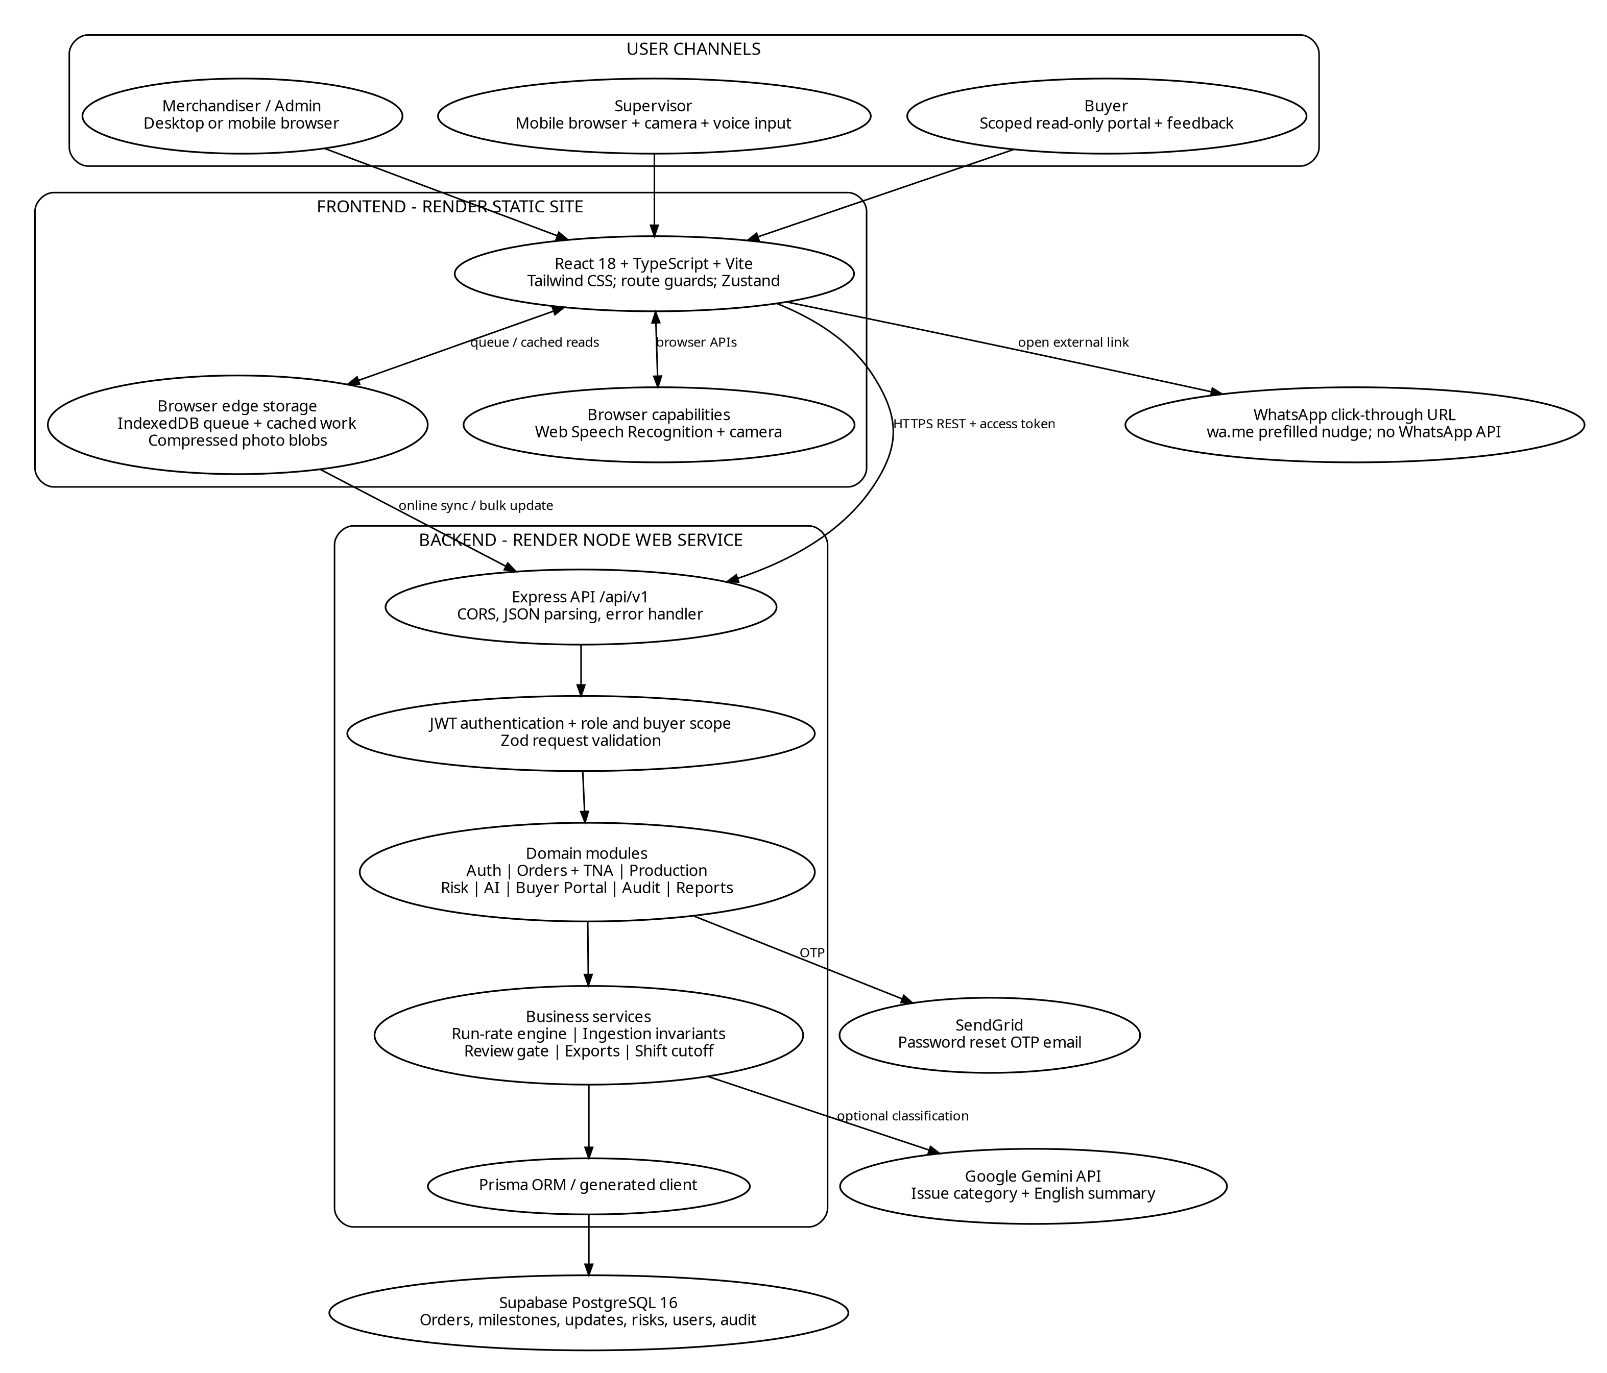
Figure 1. Logical system architecture — User Channels, React Frontend with IndexedDB Edge Queue, Express Modular Monolith & Supabase PostgreSQL 16
3.1 Core Architecture Decisions
- Modular Monolith Core: Orders, production, risk, buyer, audit, reports, and authentication share one deployable API and one transaction boundary. This drastically reduces operational complexity for a small engineering team and guarantees ACID transactional integrity during multi-entity order creation and shift updates.
- PostgreSQL 16 + Prisma ORM: Relational constraints, foreign keys, unique idempotency keys, and transactional updates fit the complex relational dependencies between POs, milestones, order lines, and audit chains.
- Client-Side Offline Queue (IndexedDB): Factory network interruptions in Tiruppur units should never discard supervisor shift counts. A stable client-generated RFC 4122 UUIDv4 idempotency key lets the server treat duplicate transmissions as idempotent without double-counting pieces.
- Deterministic Risk Calculation: Delay projection is a deterministic mathematical calculation, not an unpredictable LLM opinion. The formula inputs and outputs can be inspected and explained directly to factory production heads.
- Advisory AI with Fallback: Google Gemini 3.1 Flash Lite API classifies unstructured Tamil narrative notes; an in-memory deterministic keyword regex fallback and a human-in-the-loop review gate ensure zero downtime and prevent erroneous notes from reaching buyers.
3.2 Deployment Topology

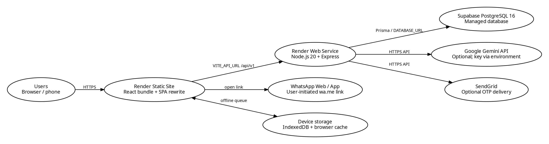
Figure 2. Deployment diagram — Render Static Site (React), Render Node Web Service (Express API), Supabase PostgreSQL 16, Google Gemini API, SendGrid & WhatsApp URL
4. The Data Model, Main Flows and How the AI Part Works
4.1 Core Relational Data Model
The relational database model captures the end-to-end manufacturing journey of garment purchase orders from commercial setup through shop-floor updates and evidence gathering:

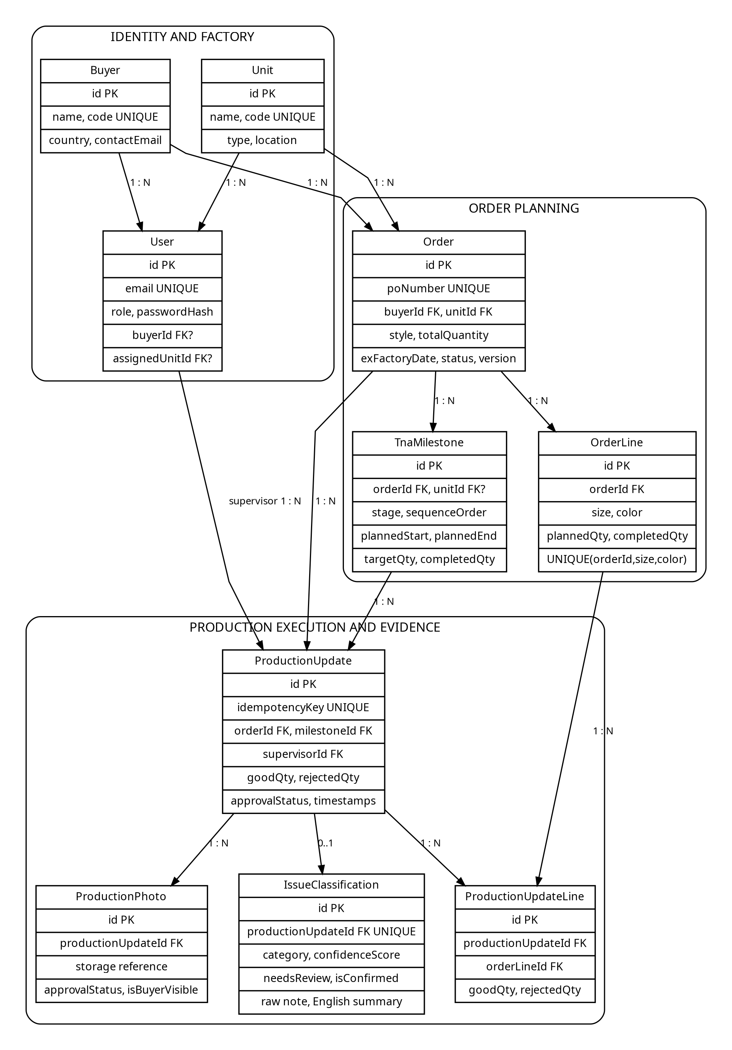
Figure 6. Core relational/UML model — Buyer, Unit, User, Order, OrderLine, TnaMilestone, ProductionUpdate & Evidence Records

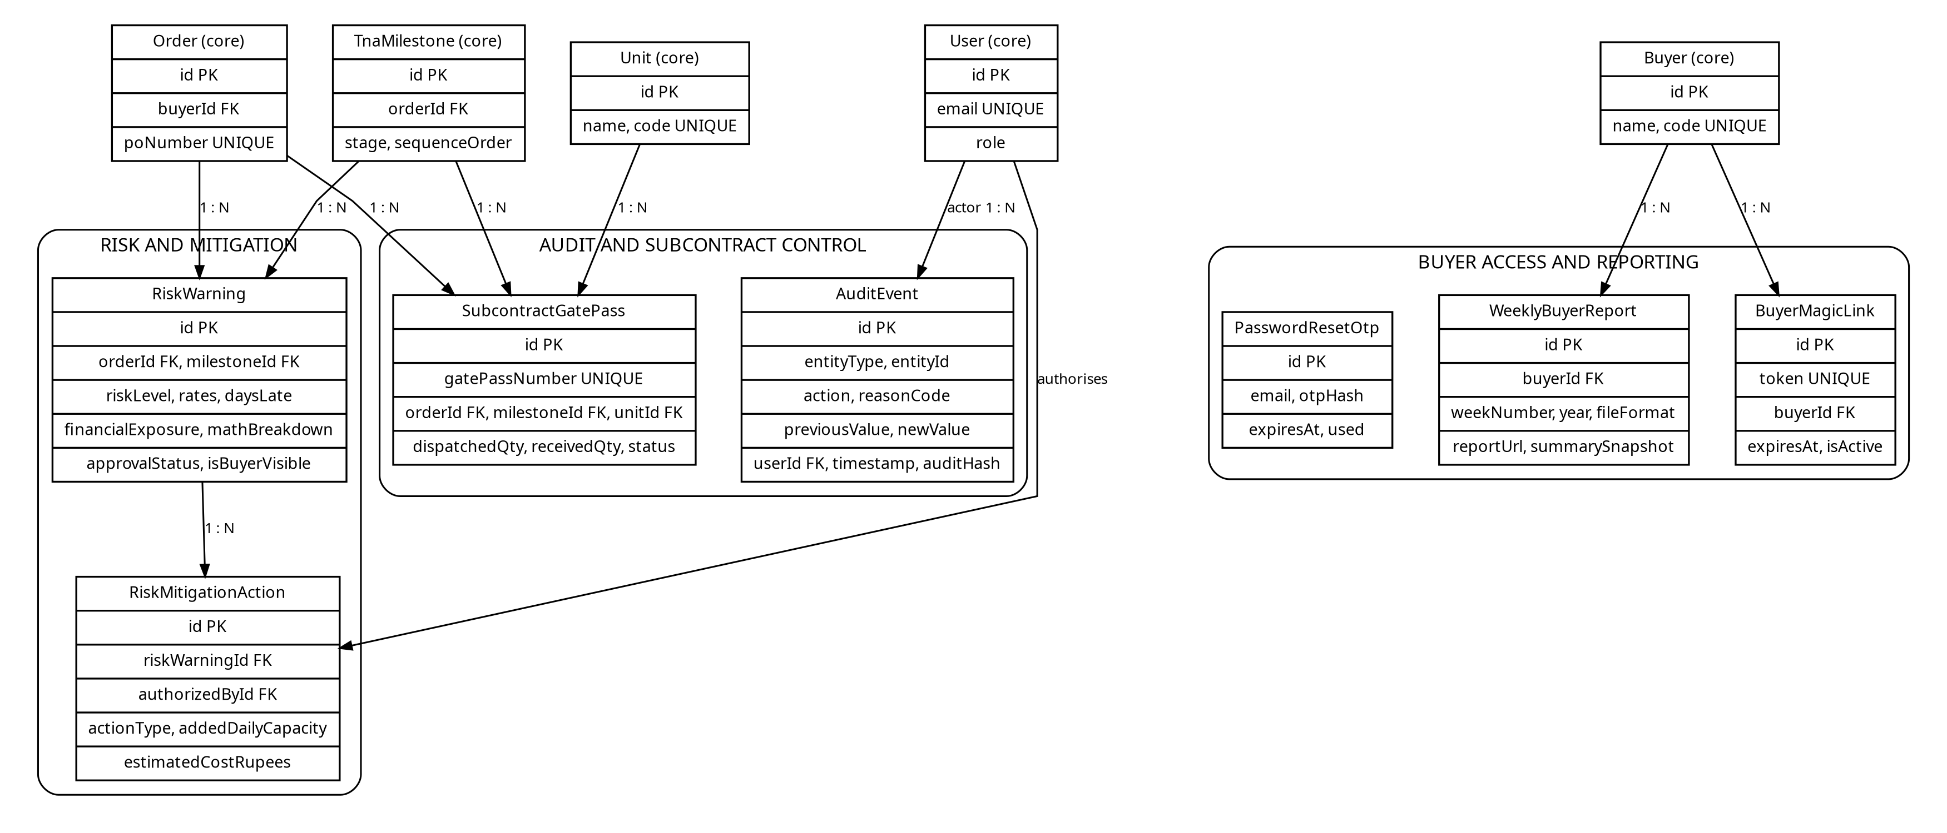
Figure 7. Supporting relational model — RiskWarning, RiskMitigationAction, AuditEvent, SubcontractGatePass & WeeklyBuyerReport
4.2 Main Production Ingestion & Sync Flow

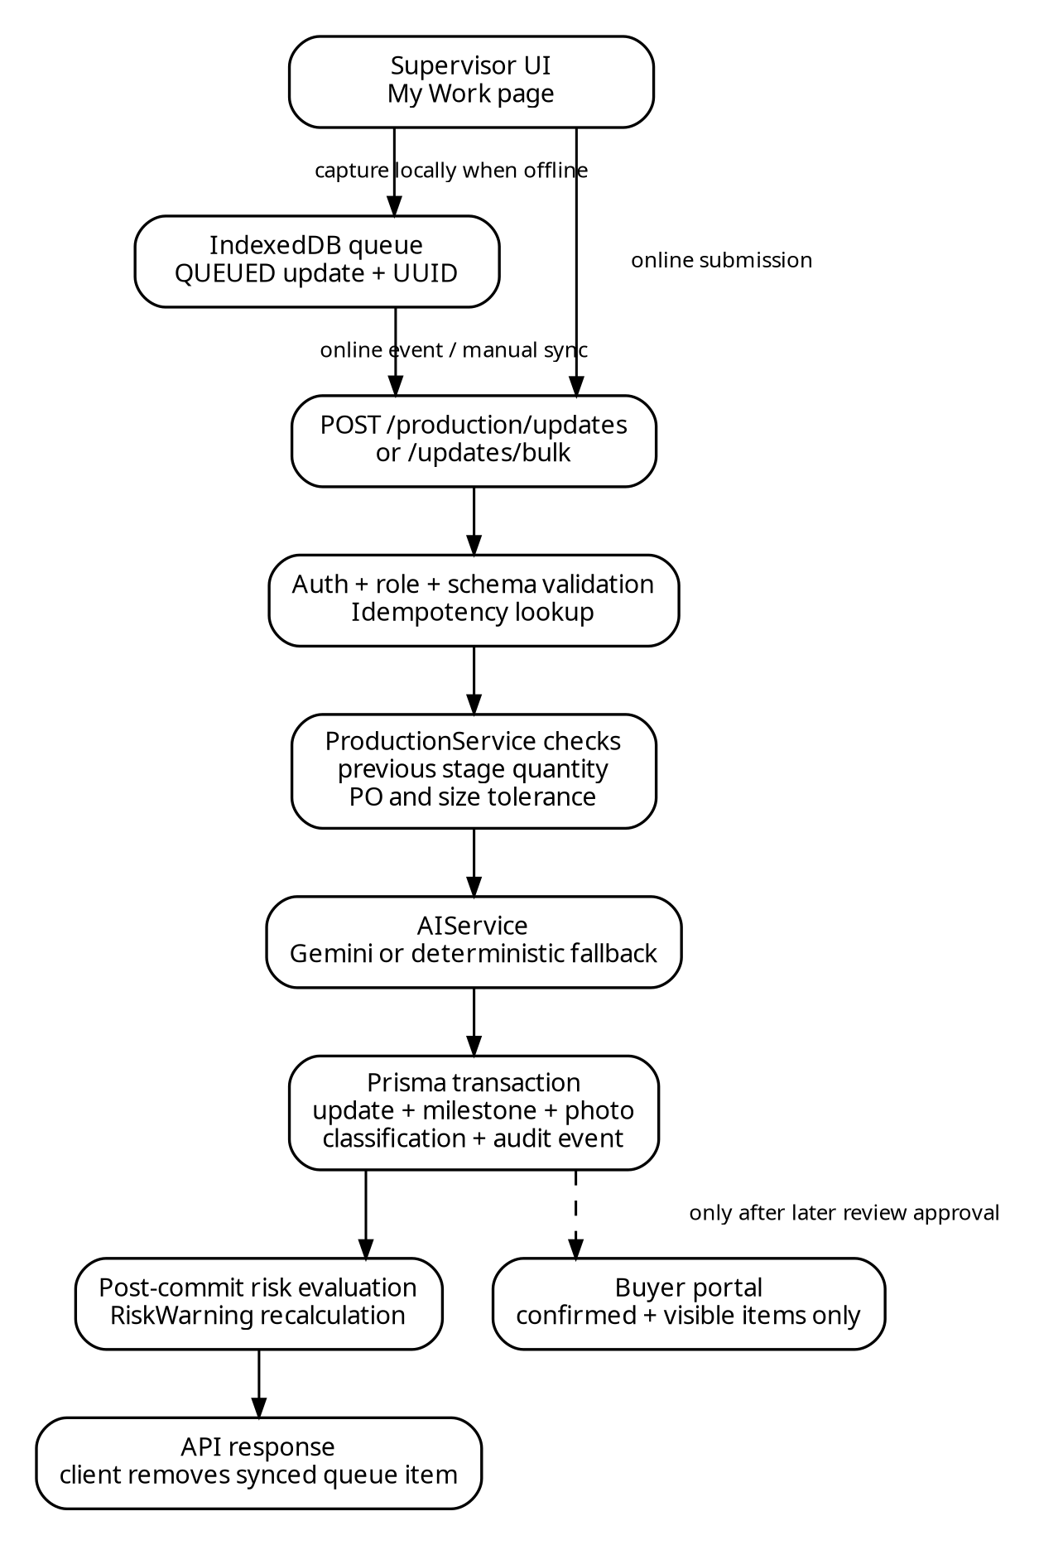
Figure 4. Update ingestion sequence — Supervisor tap, IndexedDB offline persistence, idempotency check, tolerance invariants & async risk recalculation
Server-Side Production Invariants Enforced:
- Idempotency: An existing idempotencyKey returns the original record rather than adding output twice, safeguarding against network retry double-counts.
- Sequential Stage Precedence: Cumulative stage output cannot exceed the immediately preceding stage's completed quantity, preventing impossible physical progression (e.g. stitching pieces that were never cut).
- Cutting Tolerance Ceiling: Proposed cumulative stage output cannot exceed 103% of total PO quantity, matching standard export knitwear industry over-cutting allowances.
- Size Reconciliation: The sum of individual size breakdown quantities must equal the submitted shift good quantity; per-size stage totals also enforce the 3% tolerance ceiling.
- Concurrency Safety: The milestone target and completed quantities are re-read inside the transaction with an optimistic version check before committing increments.
4.3 How the AI Part Works: Dual-Tier Translation & Review Gate

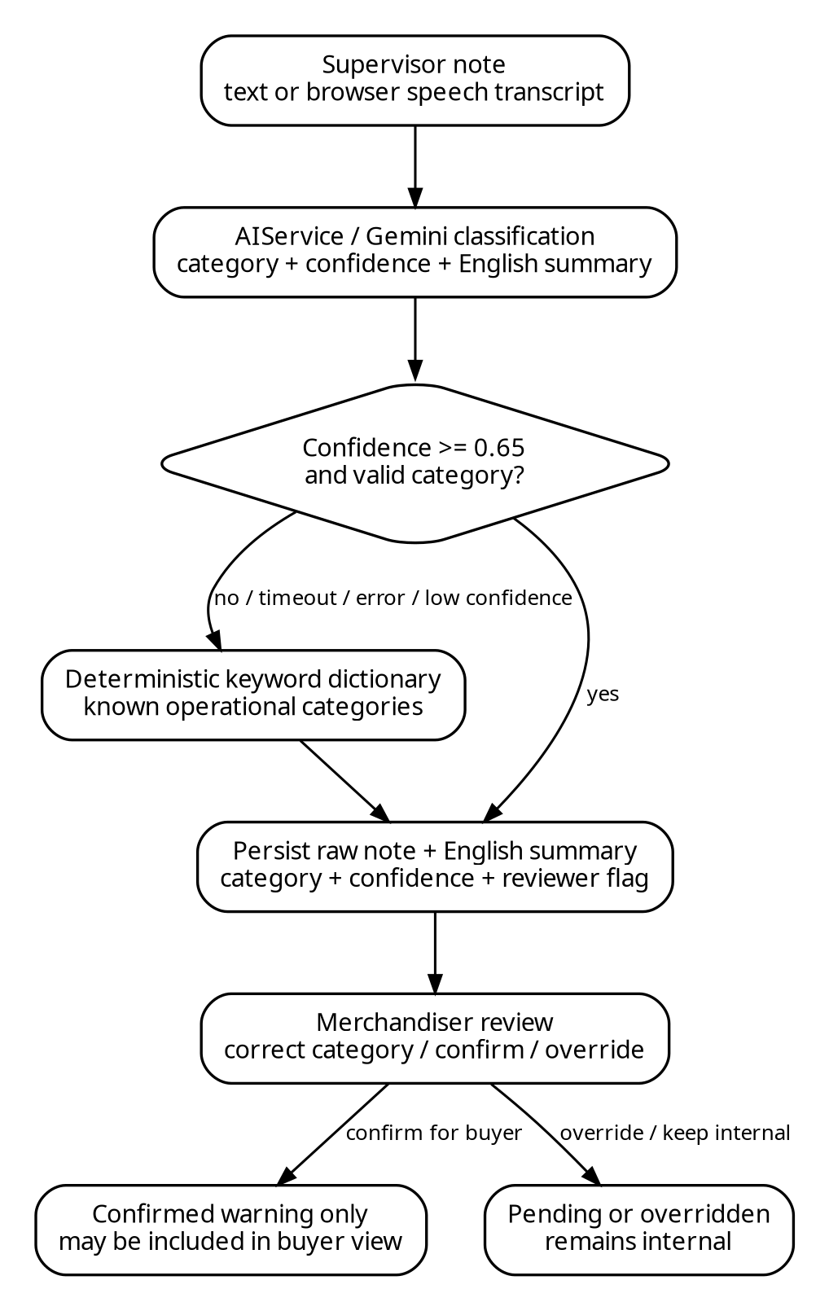
Figure 5. AI classification and human review flow — Voice dictation/text, Gemini API, deterministic regex fallback & Merchandiser review gate
- Multimodal Ingestion: Supervisors enter notes via keyboard or record Tamil voice notes transcribed via the browser Web Speech API (ta-IN locale).
- Gemini 3.1 Flash Lite API: Dispatches classification requests to Gemini with an 8,000ms SLA timeout. The model extracts one of 8 operational categories (MACHINE_BREAKDOWN, POWER_OUTAGE, FABRIC_DELAY, LABOUR_SHORTAGE, SUBCONTRACTOR_DELAY, QUALITY_HOLD, BUYER_REQUEST, OTHER) and generates a clean English translation.
- Deterministic Dual-Script Regex Fallback: If Gemini times out, throws HTTP 429, or returns confidence < 0.65, the system trips to an in-memory dual-script regular expression dictionary scanning Tamil and Tanglish terms (e.g. 'கரண்ட் கட்' -> POWER_OUTAGE; 'ஊசி உடைந்தது' -> MACHINE_BREAKDOWN). Executes in sub-2ms, assigns baseline 0.50 confidence, and flags needsReview = true.
- Human-in-the-Loop Review Gate: In accordance with client constraints, untrusted classifications never reach buyer eyes automatically. In the Merchandiser Review Gate, the original Tamil note sits side-by-side with the translated English note. Merchandisers can override the category with one click. Warnings and photos publish to the buyer portal only after explicit human confirmation (isConfirmed = true, isBuyerVisible = true).
5. The Mathematical Run-Rate Risk Engine ('Show-Your-Math')

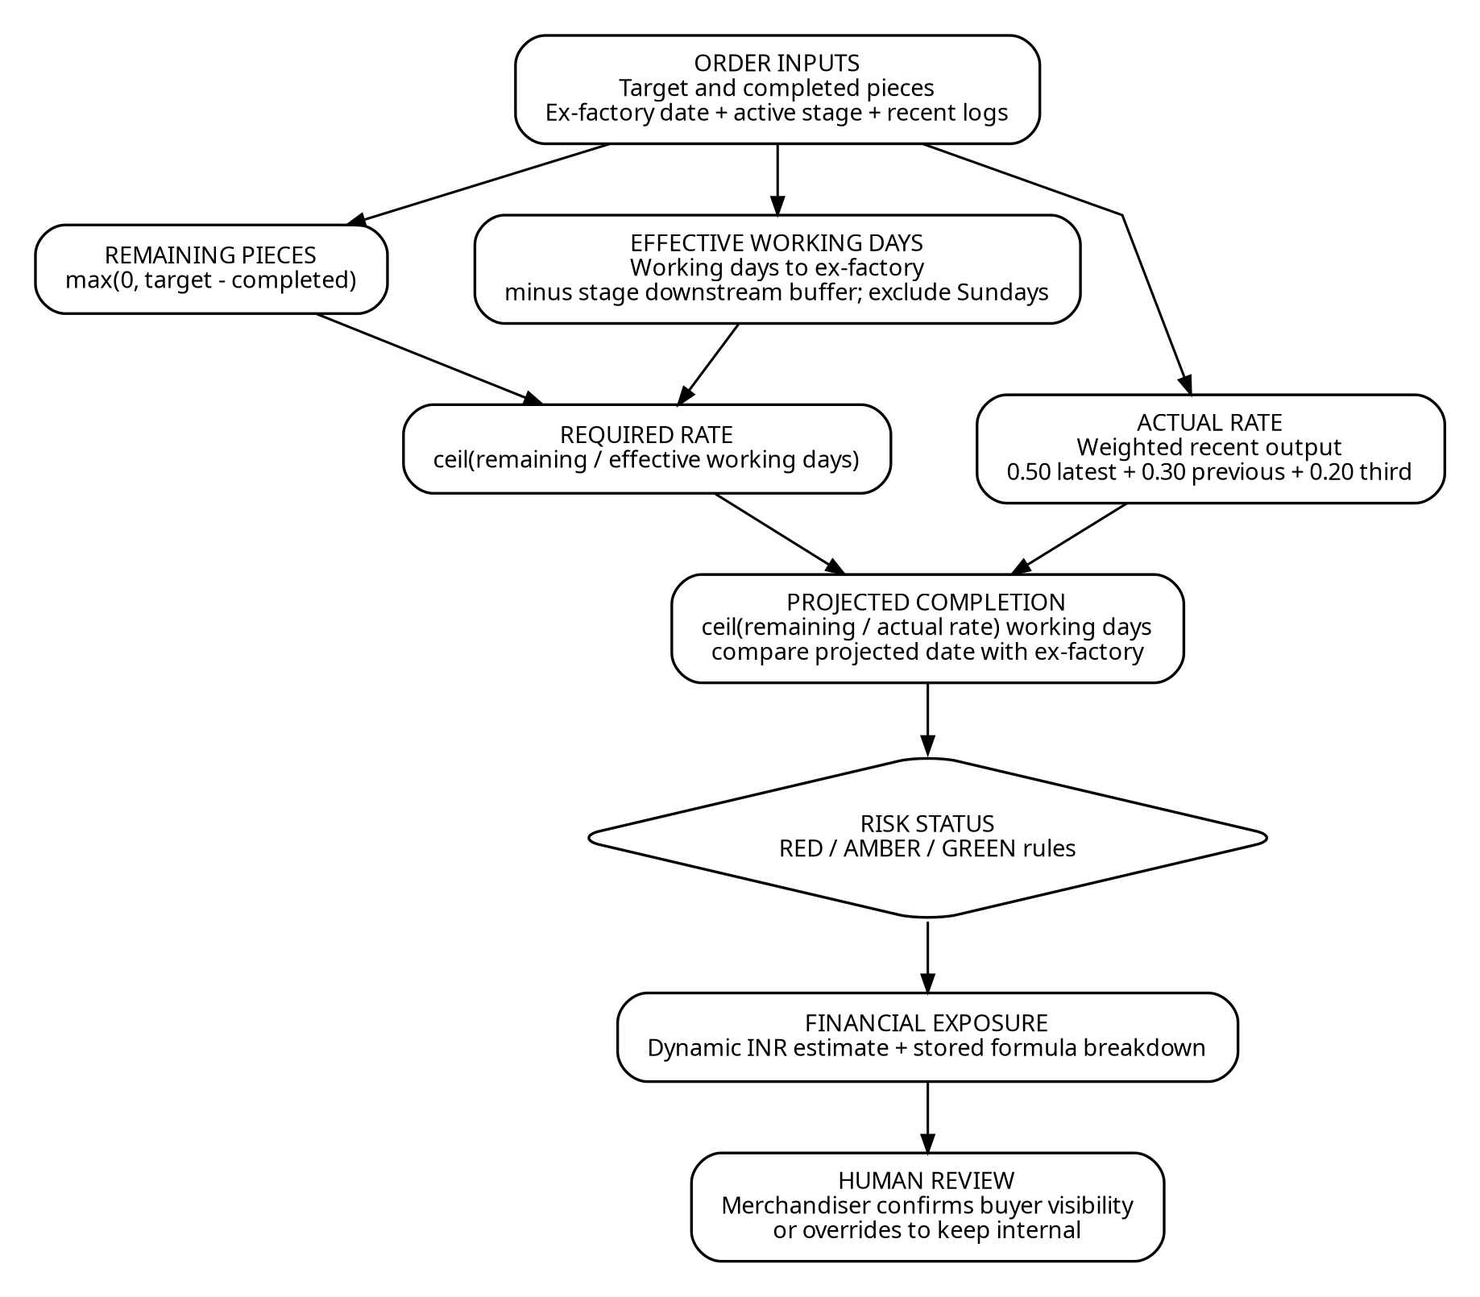
Figure. Run-rate risk engine calculation design — Remaining pieces, effective days (Sunday-excluded), 3-day WMA smoothing & dynamic exposure
The delay warning is a transparent, explainable calculation that shows its mathematical working directly to users:
• Formula 1: Net physical pieces required:
Remaining Pieces = max(0, Stage Target Quantity - Cumulative Completed Quantity)
• Formula 2: Usable working window protecting downstream execution:
Total Working Days Left = CountOfDaysExcludingSundays(Today, Ex-Factory Date)
Effective Working Days = max(1, Total Working Days Left - Downstream Buffer Days)
• Formula 3: Required daily piece output velocity:
Required Daily Rate = ceil(Remaining Pieces / Effective Working Days)
• Formula 4: 3-Day Weighted Moving Average:
Actual Rolling Rate (3-Day WMA) = (Qty_t * 0.50) + (Qty_{t-1} * 0.30) + (Qty_{t-2} * 0.20)
• Formula 5: Variance, milestone duration forecast & projected days late:
Daily Variance = Actual Rolling Rate - Required Daily Rate
Working Days Needed = ceil(Remaining Pieces / Actual Rolling Rate) + Downstream Buffer Days
Days Late = max(0, Working Days Needed - Total Working Days Left)
5.1 Default Downstream Buffers (Working Days)
Current Stage | Seq | Lead Time | Buffer to Ex-Factory | Downstream Protection Target
Knitting | 1 | 4 Working Days | 18 Days | Protects Dyeing, Printing, Cutting, Stitching, Checking, Finishing
Dyeing & Washing | 2 | 3 Working Days | 14 Days | Protects Printing, Cutting, Stitching, Checking, Finishing
Printing & Embroidery | 3 | 2 Working Days | 11 Days | Protects Cutting, Stitching, Checking, Finishing
Fabric Cutting | 4 | 3 Working Days | 9 Days | Protects Stitching, Checking, Finishing
Assembly & Stitching | 5 | 6 Working Days | 3 Days | Protects Checking and Finishing & Packing
Quality Checking | 6 | 2 Working Days | 2 Days | Protects Final Carton Packing & Barcode Scan
Finishing & Packing | 7 | 2 Working Days | 0 Days | Direct Port/Container Handover Window
6. UI & Design Decisions: Key Screens & Industrial Ergonomics

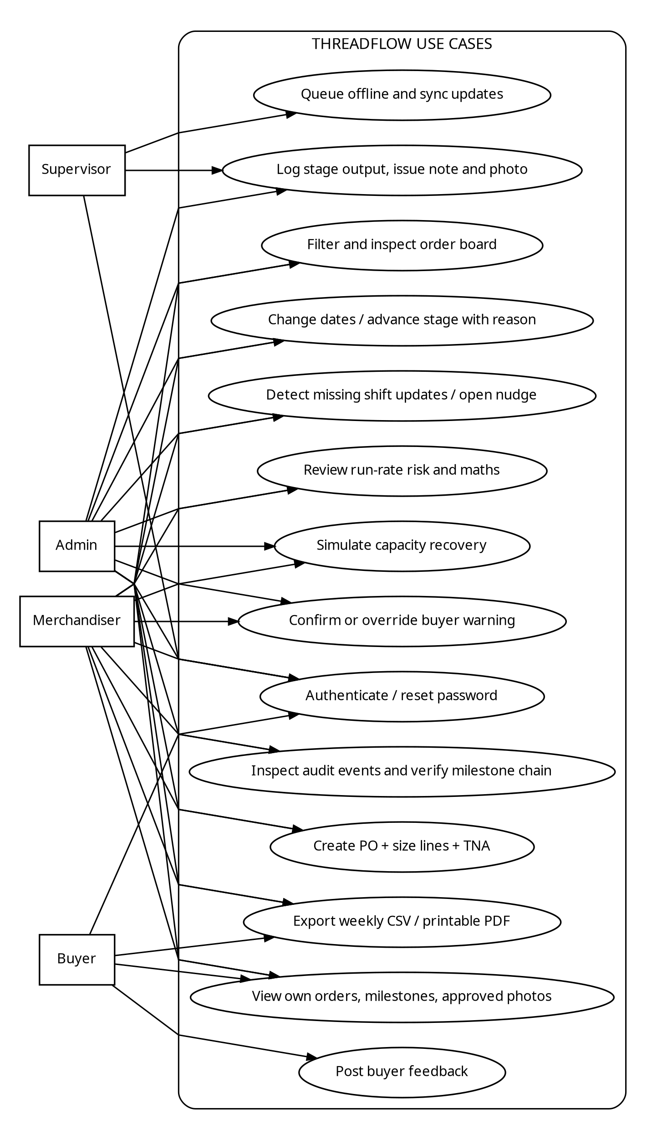
Figure 3. Use-case view — Supervisor, Merchandiser, Buyer and Admin role interactions
Design Rationale: The client values good, minimal design: clean layouts, white space, a restrained palette, and clear type, with nothing on screen that lacks a purpose. ThreadFlow uses an industrial navy (#0C2D48) header and card shell, clean slate backgrounds, high-contrast typography, and explicit text-labeled status badges (Green, Amber, Red) so risk can be scanned at a glance without relying on color alone.
6.1 Walkthrough of the Key Screens
- Order Board (/orders | OrdersPage.tsx): Primary merchandiser cockpit. Features a Delivery Schedule Health donut gauge, active PO register, and instant filter controls for Buyer, Unit, and ISO Ship Week. Clicking any card opens its detail view.
- Export Order Setup Modal (OrderForm.tsx): Clean creation modal capturing PO number, style, foreign buyer, unit, order start date, ex-factory date, and size breakdown matrix (sum(sizes) = total). Includes a flexible 7-stage T&A timeline where editing days or dates auto-cascades downstream stages forward excluding Sundays.
- Supervisor Floor Workspace (/supervisor/my-work | MyWorkPage.tsx): Mobile-first screen designed for low-memory Android phones. Features large touch targets, numeric good/rejected counters, quick increment buttons (+50, +100, +500), photo snap, and Tamil voice dictation.
- Transparent Show-Your-Math Modal (ShowYourMathModal.tsx): Displays the exact substituted formulas for required daily rate, 3-day rolling WMA actual rate, variance, and projected days late, establishing total transparency.
- Read-Only Buyer Portal (/buyer-portal | BuyerPortalPage.tsx): Scoped strictly to the authenticated buyer's ID. Displays active order styles, 7-stage milestone completion percentages, approved floor photos, and confirmed English notes without factory noise.
- Human-in-the-Loop Review Gate (HumanInTheLoopModal.tsx): Side-by-side display of the raw Tamil note and translated English note. Merchandisers can override the category or edit the mitigation directive before confirming publication to buyers.
- Order Detail & T&A (/orders/:id | OrderDetailPage.tsx): Investigation workspace connecting the 7-stage circular progress pipeline, size breakdown distribution, shift production logs, and the immutable date-change audit trail.
- Weekly Reports & Exports (/reports | ReportsPage.tsx): Generates Excel-compatible CSV files (with UTF-8 BOM encoding) and print-ready PDF status packlists, eliminating manual status compiling.
- Overview & Application Shell (/dashboard | OverviewPage.tsx): High-level navigation hub displaying system clock, online/offline connection state, pending queue count, and quick links to core product areas.
- Sign-in & Account Recovery (/login | LoginPage.tsx): Email/password authentication with a progressive 3-step OTP password reset flow.
- Audit History & Compliance (/audit | AuditPage.tsx): Searchable compliance history recording all date modifications, reason codes, actor IDs, and cryptographic SHA-256 audit hashes.
7. Offline Operation, Resilience & Tenant Isolation
Memory & Hardware Strategy for Cheap Phones (2–3 GB RAM): Images captured on floor phones are compressed on an off-screen HTML5 canvas before persistence, capping pixel bounds at 1,024px with ~0.72 JPEG quality. Photos are stored as binary Blobs in IndexedDB rather than base64 strings, preventing browser memory pressure and out-of-memory browser tab crashes.
7.1 Strict Multi-Tenant Isolation
Buyer data isolation is enforced at the database query level in buyer.service.ts. The authenticated buyer's session JWT contains their buyerId. Every query strictly applies where: { buyerId }. Any attempt by a buyer to access another buyer's PO ID or milestone triggers an immediate HTTP 403 Forbidden response.
7.2 Tamper-Evident Date Compliance History
Buyers' compliance teams require a dated record of every ex-factory date change. Every modification generates an immutable AuditEvent record containing actor ID, entity ID, previous date, new date, compulsory reason code, notes, and a cryptographic hash: auditHash = SHA-256(prevHash + entityId + timestamp + action + reasonCode).
8. What You Cut, and What You Would Do Next
8.1 Deliberately Cut Features (Scope Governance)
- Costing, Invoicing & Export Documentation: Commercial export documentation (shipping bills, customs manifests, letters of credit) was omitted. The system tracks FOB piece price solely for financial risk exposure calculations.
- Fabric Yarn Inventory Management: Raw material warehouse stock levels, yarn lot dyeing recipes, and greige fabric roll allocations were omitted. The pipeline begins when production starts at Knitting.
- Worker Attendance & Biometric Payroll: Biometric thumbprint integration, shift attendance, and piece-rate wage calculations were completely excluded.
- Excessive AI Automation: AI was strictly restricted to translating and categorizing Tamil floor notes. Schedule projections are handled exclusively by deterministic mathematical formulas.
8.2 Recommended Next Steps & Source Review Actions
- S3-Compatible Object Storage Adapter: Migrate production photo storage from base64 database strings to a dedicated S3-compatible bucket (e.g. Cloudflare R2 or AWS S3) using signed, time-limited URLs.
- Automated 6:00 PM IST Shift Cut-off Cron: Configure an automated server cron job executing at 18:00 IST daily to detect lines with missing shift updates and trigger automated supervisor nudges.
- Dedicated Buyer Magic-Link Exchange Endpoint: Implement passwordless email magic link token verification to complement standard username/password authentication for international buyers.
- Public Holiday Calendar Integration: Enhance the working calendar arithmetic module to incorporate local Tamil Nadu festival calendars (Pongal, Deepavali) alongside standard Sunday exclusions.
Closing Statement: ThreadFlow delivers a source-grounded, production-ready manufacturing intelligence platform. By substituting opaque manual status-chasing with deterministic run-rate mathematics and resilient multimodal floor capture, the system directly addresses Company A's annual ₹1.08 Crore operational risk.

