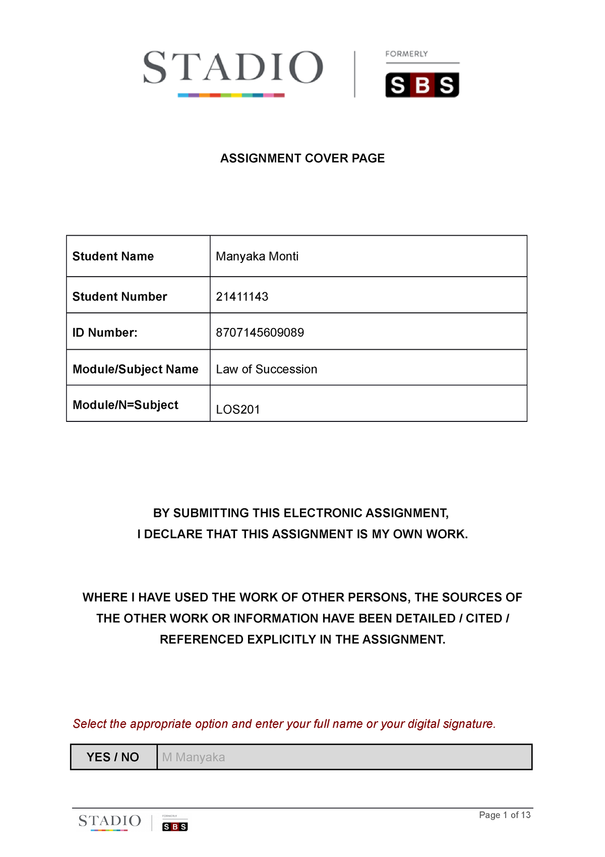
AMT Rathotse
Agobokwe Rathotse
MADA372

Mobile Application Development A

0507070225085
24301464

Table Of Content

Task A: Project Documentation ………………………………………………….… 2

Task B: Mobile Application Strategy…………………………………………..…. 3

Task C: Systems Thinking and App Requirements ……………………….… 7

Task D: App Features and Functionalities ………………………………….… 11

Task E: DevOps & Continuous Integration PLANNING …………………. 13

Screenshots ..…………………………………………………….……..…………………. 16

Task A: Project Documentation

Project Title:
- Textbook Store Mobile Application

Project Logo:

- A stack of books leaning of a shelf with an arch.

Project Role:
Student Name: Agobokwe Rathotse
Module: MADA372
Project: MADA372_SS1
Role:
- Mobile Application Designer
- UI / UX Designer
- App Concept Developer

Task B: Mobile Application Strategy

1. Project Scope:
  - Overview
The Textbook Store App is a mobile application designed to help undergraduate students easily find and access prescribed textbooks for their courses. Students will be able to explore various textbooks and view key book details on an easy-to-use platform provided by the program. The app's primary goal is to increase textbook accessibility by giving students a practical mobile option.
  - What the App will do:
The application will allow users to:
- Browse a list of available textbooks.
- Search for textbooks by title or course name.
- View textbook details such as title, author, edition, and price.
- View textbook descriptions and images.
- Navigate easily between different screens using a mobile-friendly interface.
The app will focus on providing a simple and efficient user experience for students looking for academic textbooks.
  - Who the App is for:
Undergraduate students who need quick and simple access to required textbooks are the application's primary users.
Students who wish to sell their old textbooks to other students at their school are examples of secondary users.
  - Included MVP Features:
The Minimum Viable Product (MVP) will include the following features:
- Home screen displaying available textbooks.
- Textbook browsing functionality
- Search feature to find textbooks quickly.
- Textbook detail screen showing book information.
- Simple and intuitive user interface
- Static textbook data for demonstration purposes
These features will demonstrate the core functionality of the mobile application.
  - Excluded MVP Features:
The following features will not be included in this version of the application:
- Database integration
- Backend server functionality
- User authentication or login system
- Online payments
- Shopping cart functionality
- Real-time communication between buyers and sellers
These features may be considered for future versions of the application as the system evolves.

2. Problem Statement:
Many students find it difficult to locate the textbooks they require for their classes. Textbooks are frequently costly and challenging to find, particularly for students who rely on various online or physical bookstores for their book searches.
Additionally, current textbook systems may be difficult to use, sluggish, or not mobile-friendly. As a result, of concentrating on their academics, students could spend too much time looking for textbooks.
The goal of the Textbook Store App is to offer a straightforward mobile solution that enables students to swiftly peruse and read textbook content in one handy location.

3. SMART Goals:
  - Specific
Develop a mobile application that allows students to easily browse and search for textbooks required for their courses.
  - Measurable
The application will include at least:
- Five textbook listings
- Three main screens (Home, Search, Book Details)
  - Achievable
The application will be developed using Android Studio, using a simple layout and static data without a database or backend system.
  - Relevant
The app supports students by making textbook discovery easier and faster using mobile technology.
  - Time-Bound
The mobile application prototype will be completed within the project submission timeline for MADA372 SS1.

4. Target Audience:
  - Primary Users
- University students
- College students
- Students searching for academic textbooks.
  - Secondary Users
- Lecturers recommending textbooks.
- Campus bookstores
- Academic institutions
  - Device and Connectivity Considerations
The application will be designed for Android smartphones, which are commonly used by students.
The app will also:
- Use simple layouts to ensure satisfactory performance on low spec devices.
- Require minimal internet connectivity since textbook data will be stored locally for the prototype.

5. Competitive Analysis:
Competitor | Strengths | Weaknesses
Amazon Books | Wide selection of textbooks | Expensive and overwhelming choices
Google Books | Easy search and previews | Not focused specifically on student textbooks
Chegg | Textbook rentals and study help | Subscription costs
VitalSource | Digital textbooks available | Limited free options
Campus Bookstores | Trusted by universities | Limited stock and higher prices

Task C: Systems Thinking and App Requirements

1. Functional Requirements
The functional requirements describe what the system must do.
- The system must allow users to register an account through a registration screen (UI only).
- The system must display a list of available textbooks that users can browse.
- The system must allow users to search for textbooks using keywords such as book title or subject.
- The system must allow users to view detailed information about each textbook including title, author, edition, and price.
- The system must allow users to send an inquiry message to the seller regarding a specific textbook.
- The system must provide simple navigation between the main screens such as registration, book listing, and search results.

2. System Architecture Rationale
The application will use a Model–View–ViewModel (MVVM) architecture pattern. This architecture separates the user interface from the business logic, making the application easier to maintain and evaluate.
The View layer consists of Android Activities or Fragments that display the user interface and handle user interactions. The ViewModel layer manages the application’s state and provides data to the UI without directly exposing the data source. This helps maintain a clear separation between the UI and the application logic.
State management is supported through the ViewModel, which stores and manages the app's data during configuration changes such as screen rotation.
The architecture also supports testing readiness because the ViewModel can be evaluated independently from the user interface.
A database is not required for the MVP, because the application will use in-memory data structures (such as arrays or lists) to store textbook information during runtime.

3. Main App Components
  - Registration Screen (UI Only)
The registration screen will allow users to enter basic information such as name, email address, and password. This screen will demonstrate the user interface only and will not include backend authentication.
  - Book Listing Interface
This component will display a list of available textbooks. Each item will show key information such as the book title, author, and price. Users can scroll through the list to view available textbooks.
  - Search Functionality
The search feature will allow users to quickly find textbooks by entering keywords such as book title or subject. The system will filter the available book list and display matching results.
  - Inquiry Mechanism
The inquiry mechanism allows users to send a message or inquiry to the seller regarding a textbook. This feature will simulate interaction without requiring a backend messaging system.
  - Navigation Flow
Navigation allows users to move between different screens of the application, such as registration, book listing, and search results. This will be implemented using Android navigation components or activity navigation.
  - In-Memory Data Handling
Textbook data will be stored temporarily in in-memory data structures such as lists or arrays. This means the data exists only while the application is running.
  - Error Handling
The application will display basic error messages if users attempt to perform invalid actions, such as searching with empty input or submitting incomplete forms.
  - UI Responsiveness
The application will be designed with responsive layouts to ensure that the interface adapts well to different Android screen sizes and device orientations.

4. App Architecture Diagram
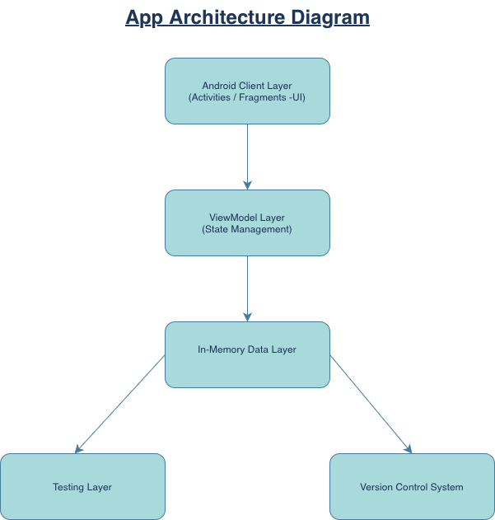

5. Minimum Viable Product (MVP)
  - Included Features
The following features will be included in the Minimum Viable Product:
- Registration screen (UI only)
- Book listing interface
- Search functionality for textbooks.
- Inquiry interaction to contact the seller.
- Basic navigation between screens
  - Excluded Features
The following features will not be included in the MVP:
- Online payment functionality
- Persistent database storage
- Authentication server for user accounts
- Cloud services or external API integration
- Real-time messaging between users
These features may be considered in future versions of the application once the core functionality has been validated.

Task D: App Features and Functionalities

1. Essential App Features
  - 1. User Registration Interface
The application will provide a registration screen where users can enter basic information such as their name, email address, and password. This feature focuses on the user interface only and demonstrates how a user would register in the system.
  - 2. Book Listing Display
The app will display a list of available textbooks on the main screen. Each listing will include the book title, author, and price, allowing users to instantly view available textbooks.
  - 3. Book Search Functionality
Users will be able to search for textbooks by entering keywords such as book title, author, or subject. The system will filter the list of books and display matching results.
  - 4. Book Detail View
When a user selects a textbook from the list, the application will display detailed information about the book. This may include the title, author, edition, price, and a brief description.
  - 5. Inquiry Interaction
The app will allow users to send an inquiry message to the seller regarding a specific textbook. This feature simulates communication between buyers and sellers within the app.
  - 6. Navigation Between Screens
The application will include a clear navigation structure that allows users to move easily between different screens such as registration, book listings, search results, and book details.
  - 7. Temporary Data Handling
The application will use in-memory data structures such as lists or arrays to temporarily store textbook information while the application is running. This eliminates the need for a database in the MVP version.
  - 8. Error Handling
The system will display error messages when users enter invalid or incomplete information, such as submitting an empty search field or leaving required registration fields blank.
  - 9. Responsive User Interface
The user interface will be designed to adapt to different Android device screen sizes. This ensures that the application remains usable and visually consistent across various smartphones.
  - 10. User-Friendly Interface Design
The app will prioritize simplicity and ease of use by using clear buttons, readable text, and organized layouts to improve the overall user experience.

Task E: DevOps & Continuous Integration PLANNING

1. DevOps in Mobile Context
DevOps in mobile application development refers to the integration of development and operations practices to improve collaboration, efficiency, and software quality. In Android development, DevOps principles encourage continuous development, testing, and improvement of the application.
For the Textbook Store App, DevOps practices help ensure that the application is developed in an organized way, with regular testing and version tracking. This approach allows developers to detect issues early, maintain code quality, and deliver updates efficiently throughout the development process.

2. Version Control Strategy
The project will use Git as the version control system to manage and track changes to the application’s source code.
A simple branching strategy will be followed:
- Main branch – contains the stable version of the application.
- Development branch – used for ongoing feature development and testing before merging into the main branch.
Developers will follow commit discipline, meaning they will create clear and descriptive commit messages whenever changes are made to the project. This helps track modifications and makes collaboration easier.

3. Continuous Integration Workflow
Continuous Integration (CI) ensures that code changes are regularly integrated and evaluated during development.
The workflow includes:
- Build Process: The application will be built using Android Studio to ensure the code compiles successfully.
- Automated Testing: Unit tests can be run to verify that individual components of the application work correctly.
- Code Review Cycle: Before changes are merged into the main branch, the code can be reviewed to ensure it meets coding standards and functions correctly.
This process helps maintain application quality and reduces development errors.

4. Testing Strategy
The testing strategy for the application includes both automated and manual testing.
Unit Testing Readiness:
The MVVM architecture allows individual components such as the ViewModel to be evaluated independently using unit tests.
Manual UI Testing:
The application’s user interface will be evaluated manually to ensure that screens display correctly, navigation works properly, and user interactions function as expected.
Bug Tracking Approach:
Any bugs or issues identified during testing will be documented and fixed before the application is updated or released.

5. Iterative Release Strategy
The development process will follow an iterative release strategy, where the application is improved gradually over time.
MVP Release:
The first release will be the Minimum Viable Product (MVP), which includes the core features such as book listings, search functionality, registration interface, and inquiry interaction.
Feedback Collection:
Feedback from users or testers will be collected to identify usability issues and areas for improvement.
Incremental Improvements:
Future versions of the application will introduce new features such as database integration, authentication systems, and additional user functionality based on feedback and development progress.

Screenshots

