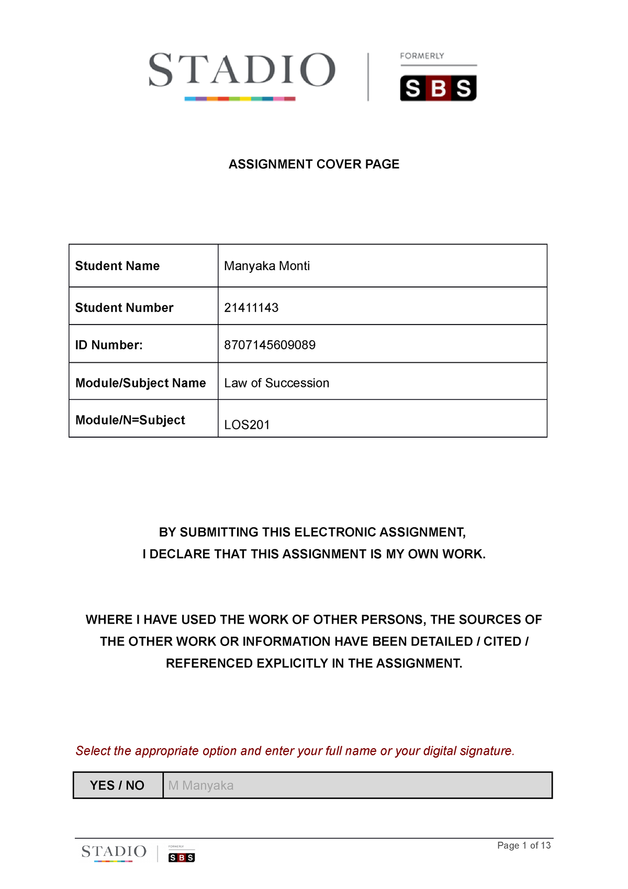
AMT Rathotse
Mobile Application Development A
MADA372
MA
0507070225085

Agobokwe Rathotse

24301464
Agobokwe Rathotse

Table of Contents

Section One: Project Documentation
1.1.1 Project Du

Task 1.1: Project Documentation & Design Alignment

Project Overview:
Project Title: Textbook Store Mobile Application
Project Application: Student – Student Marketplace for Campus Textbooks
Project Members: Agobokwe Rathotse
Project Logo: A stack of books leaning of a shelf with an arch.

Platform: Android (Kotlin + XML)
Minimum SDK: API 24 (Android 7.0 Nougat)
Target SDK: API 34 (Android 14)
Development Environment: Android Studio Ladybug | 2024.2.1
  - Introduction
The Textbook Store App is an Android mobile application developed using Kotlin and XML within Android Studio. The application was designed to assist students in higher education institutions by providing a platform where second-hand textbooks can be browsed, viewed, and enquired about.
The project was developed over four phases:
- SS1 – Strategic Planning
- SS2 – UI/UX Design and Wireframing
- SS3 – Application Development
- SS4 – Final Functional Implementation and Documentation
The final solution provides a simple, user-friendly platform that addresses the challenge of expensive academic textbooks by supporting affordable peer-to-peer textbook exchanges.
  - 2. PROJECT SCOPE AND GOALS
Project Title
Textbook Store App
Project Purpose
The purpose of the application is to provide students with an accessible platform for locating affordable second-hand academic textbooks.
Target Audience
The primary target audience includes:
- University students
- College students
- Academic institutions
- Students seeking affordable educational resources.
Project Goals
The application aims to:
- Provide affordable textbook access.
- Improve student textbook discovery.
- Simplify communication between buyers and sellers.
- Deliver an intuitive mobile experience.
- Support educational accessibility.

  - 3. PROJECT PLANNING AND DESIGN
The project was planned during SS1 and designed during SS2 before implementation in SS3 and refinement in SS4.
Wireframe Planning
The application consists of:
Home Screen
Purpose:
- Welcome users.
- Display navigation options.
- Highlight featured textbooks.
Listings Screen
Purpose:
- Display available textbooks.
- Support searching and filtering.
Detail Screen
Purpose:
- Present detailed textbook information
Contact Screen
Purpose:
- Allow students to enquire about textbooks.
  - 4. SYSTEM ARCHITECTURE
The application follows a layered Android architecture.
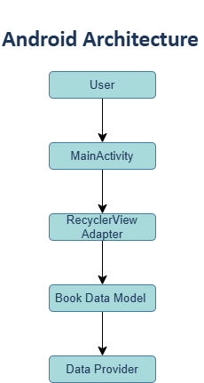
Architecture Components
Presentation Layer
Consists of:
- MainActivity
- DetailActivity
- HomeFragment
- ListingsFragment
- InboxFragment
- ProfileFragment
Business Logic Layer
Consists of:
- Adapters
- Search functionality
- Navigation logic
- Validation logic
Data Layer
Consists of:
- Book data model
- In-memory textbook collections
  - 5. FLOW DIAGRAMS
User Navigation Flow
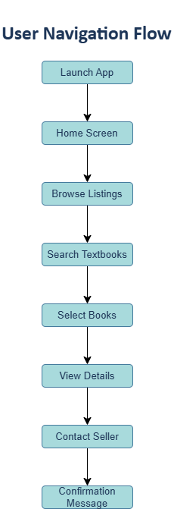

  - 6. PROJECT APPLICATION OVERVIEW
App Purpose and Target Audience
The Textbook Store App serves as a student peer-to-peer marketplace that enables students to locate and enquire about affordable second-hand textbooks.
The target users include students attending higher education institutions who require cost-effective access to academic materials.

Core Features
The application implements the following features:
Textbook Browsing
Students can browse available textbook listings.
Search Functionality
Users can search for textbooks using keywords.
Book Detail Viewing
Detailed textbook information is displayed.
Seller Interaction
Students can contact sellers regarding listings.
Navigation
Bottom navigation allows movement between sections.

Technical Architecture
The project uses:
- Kotlin programming language
- XML layouts
- RecyclerView
- View Binding
- Data Binding
- Fragment Navigation
This architecture separates presentation logic from data structures and improves maintainability.

User Journey
Typical user journey:
- Launch application.
- Browse textbooks.
- Search for textbooks.
- Select a textbook.
- View detailed information.
- Contact seller
- Receive confirmation.

Value Proposition
The application helps students reduce educational costs by providing access to affordable second-hand textbooks while maintaining a simple mobile user experience.

  - 7. KOTLIN IMPLEMENTATION
Textbook Data Model
The Book data class contains:
- Title
- Author
- Edition
- Price
- Description
- Seller Information
- Course Code
Example:
data class Book (
val id: String,
val title: String,
val author: String,
val edition: String,
val price: Int,
val description: String
)

Listing Management
RecyclerView is used to dynamically display textbook listings.
Benefits include:
- Efficient rendering
- Scalability
- Improved user experience

User Interaction Logic
Implemented interactions include:
- Selecting books
- Viewing details
- Contacting sellers
- Navigation between screens

Navigation Control
Navigation is implemented using:
- Activities
- Fragments
- Bottom Navigation

Search and Filtering
Search functionality filters textbooks by:
- Title
- Author
- Course code

Input Validation
Validation includes:
- Empty field detection
- Invalid email detection
- Message validation
Error messages are displayed using:
- EditText errors
- Toast notifications

  - 8. XML USER INTERFACE IMPLEMENTATION
Main Listing Interface
RecyclerView displays:
- Book image
- Title
- Author
- Price

Book Detail Screen
Displays:
- Textbook image
- Title
- Author
- Edition
- Price
- Description

Interaction Screen
Provides:
- Name input
- Email input
- Message input
- Send enquiry button.

Navigation Layout
Navigation components include:
- Bottom Navigation View
- Fragment container
- Toolbar elements

Visual Consistency
The interface maintains:
- Consistent colours
- Consistent typography
- Proper spacing
- Hierarchical layout structure

  - 9. DATA BINDING IMPLEMENTATION
Data Binding was enabled to connect UI elements directly to data models.
Benefits include:
- Reduced boilerplate code
- Improved maintainability
- Dynamic UI updates

View-Model Connection
UI components are bound directly to textbook data.

Dynamic Updates
RecyclerView updates automatically when data changes.

RecyclerView Binding
Book information is bound efficiently using RecyclerView adapters.

Input Validation Binding
Validation logic provides immediate user feedback.

  - 10. PROJECT CODE QUALITY
Code Organisation
The project follows a structured package layout:
activities
adapters
fragments
models
utils

Error Handling
The application handles:
- Empty searches
- Invalid user input
- Missing data

Performance
RecyclerView improves performance by reusing views and minimising memory usage.

  - 11. DESIGN ALIGNMENT AND AFRICAN AESTHETICS
The application incorporates African-inspired design principles.
Elements include:
- Earth-tone colour palette
- Gold accent colours
- Student-focused imagery
- Clean typography
- Accessible design
The final implementation aligns with the SS2 wireframes and branding strategy.

  - 12. GITHUB HOSTING
Repository Structure:
README.md
Source Code
Documentation
Screenshots
APK
Repository includes:
- Complete Android project
- Documentation
- Screenshots
- Commit history.

  - 13. CONCLUSION
The Textbook Store App successfully satisfies the objectives established during SS1, SS2, SS3, and SS4.
The application provides students with a user-friendly platform for discovering affordable second-hand textbooks while demonstrating Android development skills including Kotlin programming, XML design, RecyclerView implementation, search functionality, navigation, validation, and data binding.
The final solution aligns with the project strategy, design requirements, and assessment rubric.

16. REFERENCES
- Android Developers. (2026). Android developer documentation. Available at: Android Developers Documentation [Accessed March 2026].
- JetBrains. (2026). Kotlin documentation. Available at: Kotlin Documentation [Accessed March 2026].
- STADIO Higher Education Library. (2026). Mobile application development resources and academic journals. Available through the institutional library database.

