**Event Mention Detection scoring**

Date: August 8, 2014

**Overall workflow**

We show an overall workflow of evaluation for event mention detection in Figure 1.

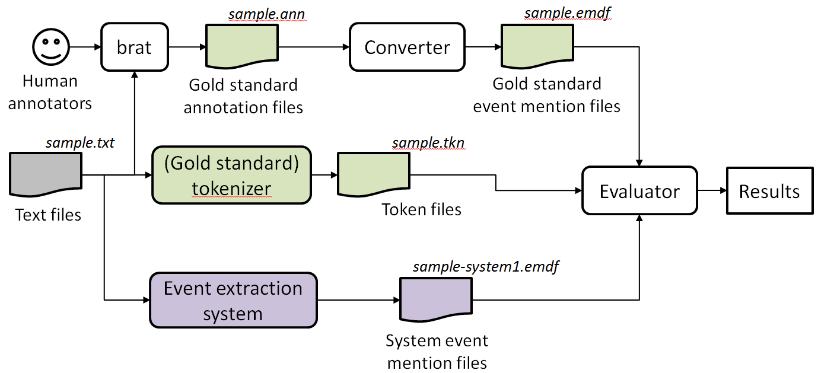

Figure 1: An overall workflow of event mention evaluation.

For each text file, human annotators use the brat rapid annotation tool to create a gold standard annotation file. We convert a brat annotation file to our evaluation file format. We assume event extraction systems output system event mentions in the same file format. The evaluator (scorer) then reads the output of event mention detection systems and compares them to the gold standard.

**Input:**

1. Gold standard annotation for documents, in format (one line per mention)

2. System output annotation for documents, in format (one line per mention)

3. Tokenization files associated with each document

**Output:**

1. System output annotation for the same text, with score for each mention appended to each line

2. System’s overall performance report as described in “Scoring” section

**System and gold standard annotation file format:**

1. Event mention annotations of all documents are written into one single file.
2. First line of each document is a header.
   1. Header := #BeginOfDocument<s><doc ID>
3. Last line of each document is a footer
   1. Footer := #EndOfDocument
4. Different event mentions should include the same token

**Definition of event mention format:**

event-mention := <system ID><TAB><doc ID><TAB><token ID list><TAB> <mention><TAB><event-type><TAB><realis status><TAB><score1><TAB> <score2><TAB><score3>

**Explanation of above-mentioned notations:**

<engine ID> := the name of the system

<text ID> := the ID of the text

<token ID list> := List of token Id in ascending order, separated by comma (,)

<mention> := the actual character string of the mention

<event-type> := the ACE hierarchy type

<realis-status> := the REALIS label

<score1> := any score (confidence, etc.) the system wants to assign (ignored)

<score2> := score assigned in the evaluation

<score3> := additional possible score assigned by human

<s> := represent a space character

<TAB> := represent a tab character

**Scoring:**

Let mappingScores = {}

#compute overlap scores pairwisely

FOR each system mention S := {S_mid, S_tokens}

Let S_mid := mention id of S

Let S_tokens := token indices associated with S

Let S_tokens := S_tokens – {token indices of invisible words} #See NOTE 1

FOR each gold mention G:= {G_mid, G_tokens}

Let G_mid := mention id of G

Let G_tokens := token indices associated with G

Let G_tokens := G_tokens – {token indices of invisible words}

Let overlap := OVERLAP(S_tokens, G_tokens)

IF overlap > 0

mappingScores := mappingScores + (G, S, overlap)

END IF

END FOR

END FOR

#Find mapping based on overlap scores

Sort mappingScores based on overlap

Mapping = {}

WHILE mappingScores != {}:

(G, S, overlap) = mappingScores.pop()

IF G has not been mapped and S has not been mapped THEN Mapping := Mapping + {G,S, overlap}

END WHILE

#Append score to compare

FOR each gold mention G:= {G_mid, G_tokens}:

Score := Mapping[G].overlap

append Score to the end of the line of G_mid in Gold Standard, in position <score2>

END FOR

#Compute overall performance

TP = 0

FN = 0

FOR EACH Gold Mention G

IF G contains in Mapping

TP := TP + Mapping[G].overlap

ELSE

FN := FN + 1

END IF

END FOR

#Performance based on precision, recall:

Precision := TP / (TP+FP)

Recall := TP / #GoldStandardMentions

**Subroutine OVERLAP(G,S):**

IF G == S, THEN score := 1.0

IF G∧S == {}, THEN score := 0.0

ELSE

IF |G| > |S|, THEN score := (|S∧G|)/|G|

IF |G| < |S|, THEN score := (|S∧G|)/|S|

RETURN score

End Subroutine

**Subroutine OVERLAP2(G,S): #NOTE2**

IF G == S, THEN score := 1.0

IF G∧S == {}, THEN score := 0.0

ELSE

precision_m := (|S∧G|)/|S|

recall_m := (|S∧G|)/|G|

score := 2*precision_m*recall_m / (precision_m + recall_m)

RETURN score

End Subroutine

Note 1: Invisible words are ignored in scoring. They include: determiners {the, a, an}, pronouns {I, you, he, she, we, they, his, her, my, your, mine, yours, our, ours}, relative pronouns {who, what, where, when}, …?

“it” and “that” are removed from the list because they can be resolved as nominal event mentions sometime.

Note 2: Overlap2 is an alternative routine to calculate overlap. It actually provides an upper bound of the score computed by Overlap.

Examples:

Rule 1: do not accept prepositions but include particles

* "[look] up a chimney" vs "[look up] a dictionary"
* "[climb] up the ladder"
* [take responsibility for]
* sing [all the way] to school
* [go] to school

Rule 2: consider the maximum extent of an event mention, but don't worry about determiners (they are invisible)

* [takes a shower] ==> it is okay for annotators to include "a" in their annotation; we can ignore "a" in evaluation
* [make a quick decision] ==> it is okay for annotators to annotate the whole phrase; we can ignore "a" and include "quick" in evaluation