1. Check if your processor supports Intel/AMD virtualization technology. Enable Intel virtualization technology in BIOS if possible.

The picture below shows the vitalization technology is active.

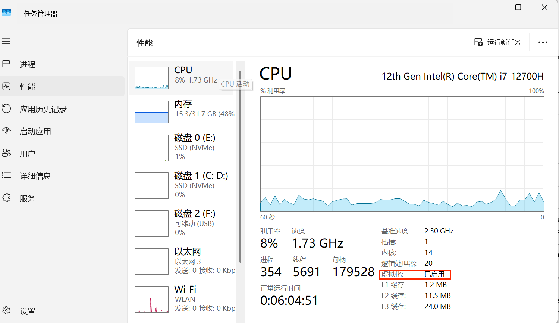

2. The cloud is almost everywhere in our lives now. What do you think are the fundamental reasons behind its success? Name three pros and three cons of cloud.

**Answer:**

Cloud computing has become a vital part of modern life because it offers flexibility, scalability, and cost efficiency that traditional computing cannot match. The fundamental reason behind its success is the on-demand service model, which allows users to access powerful computing infrastructure without investing in hardware. It also allows users and organizations to scale services quickly according to changing needs and to collaborate seamlessly through internet-based platforms.

**Pros:**

* Cost Efficiency: Cloud services reduce capital expenses by shifting to a pay-as-you-go model. For example, startups can launch global applications using AWS without buying physical servers.
* Scalability and Flexibility: Resources can be scaled up or down automatically to match changing demand, as seen with streaming platforms like Netflix during peak hours.
* Accessibility and Collaboration: Data and applications are available anytime and anywhere with an internet connection. For example, Google Workspace or Microsoft 365 allow employees to work together in real time from any device or location.

**Cons:**

* Security and Privacy Risks: Data breaches or unauthorized access at a cloud provider can expose sensitive information.
* Downtime and Internet Dependence: Service outages can interrupt access and productivity., like occasional AWS or Azure outages.
* Limited Control and Compliance Issues: Users depend on the provider’s security measures and data storage policies, which may complicate compliance with regulations like GDPR.

3. What is the primary function of a hypervisor in virtualization?

**Answer:**

The primary function of a hypervisor in virtualization is to create and manage virtual machines (VMs) by allocating and controlling the underlying physical hardware resources to each VM such as CPU, memory, storage, and network.

A hypervisor acts as a layer between the physical hardware and the virtual machines, allowing multiple operating systems to run independently on the same physical server. It ensures isolation so that each VM operates as if it were a separate computer, without interfering with others.

There are two main types of hypervisors:

* Type 1 (bare-metal) hypervisors, such as VMware ESXi or Microsoft Hyper-V, run directly on hardware for better performance.
* Type 2 (hosted) hypervisors, such as VirtualBox or VMware Workstation, run on top of an existing operating system.

4. What is a virtual machine (VM)?

**Answer:**

A virtual machine (VM) is a software-based environment that behaves like a physical computer. It runs its own operating system and applications while sharing the underlying hardware resources of a host system. Virtual machines are created and managed by a hypervisor, which allocates CPU, memory, storage, and network resources to each VM. This allows multiple VMs to operate independently on a single physical server, each functioning as if it were a separate device.

Virtual machines provide several advantages, including better resource utilization, easier testing and deployment, and improved system security through isolation. Because each VM is separated from others, errors or malware in one environment do not affect the rest of the system. VMs are also portable, meaning they can be moved or copied between hosts with minimal effort. Overall, virtual machines offer flexibility, scalability, and efficiency, making them a core component of modern data centers and cloud computing environments.

5. What are the benefits of using virtual machines?

**Answer:**

Virtual machines (VMs) offer several significant benefits that make them essential in modern computing and enterprise environments. One major advantage is resource efficiency. By running multiple VMs on a single physical server, organizations can maximize hardware utilization and reduce costs related to equipment and maintenance. Each VM operates independently, allowing different operating systems and applications to coexist securely on the same hardware.

Another benefit is flexibility and portability. Virtual machines can be easily created, cloned, or migrated between servers without hardware compatibility issues, making them ideal for testing, software development, and disaster recovery. They also enable isolation, meaning a crash or infection in one VM does not affect others, improving overall system stability and security.

Additionally, VMs simplify backup and recovery, since entire virtual environments can be saved as files and quickly restored. These advantages make virtualization a key technology for efficient, scalable, and resilient IT infrastructure.

6. List five use cases of virtual machines.

1. Server Consolidation and Resource Optimization:

Virtual machines allow multiple servers to run on a single physical machine, reducing hardware costs and energy consumption. For example, a company can run web, database, and email servers as separate VMs on one host instead of maintaining three separate servers. This improves resource utilization and simplifies maintenance.

1. Software Testing and Development

Developers often use VMs to test applications in different operating systems or environments without affecting their main system. For instance, a developer can run Windows, Linux, and macOS VMs on one computer to test cross-platform compatibility.

1. Disaster Recovery and Backup

Because VMs are stored as image files, they can be easily backed up and restored on another host after a system failure. Many organizations use VMs to quickly recover operations after hardware damage or cyberattacks.

1. Running Legacy Applications

Some businesses still depend on older software that only works on outdated operating systems. A VM can emulate these environments, allowing legacy applications to run safely on modern hardware.

1. Cybersecurity and Training Environments

Security professionals and students use VMs to create isolated lab environments for practicing ethical hacking, malware analysis, or system configuration. Any damage or infection stays within the VM, protecting the host system.

7. In virtualization, what is the guest operating system?

a) The main operating system running on the physical machine

b) The operating system installed on a virtual machine

c) The operating system running on a remote server

d) The operating system running on a mobile device

**Answer: (b)**

Because in virtualization, the guest operating system is the OS that runs inside a virtual machine (VM). It operates as if it were running on physical hardware, but in reality, it runs on virtualized hardware provided by the hypervisor. The physical machine’s OS, if one exists, is called the host operating system, while the guest OS runs independently in its own isolated environment. For example, if a computer running Windows 11 uses VMware to create a virtual machine running Ubuntu Linux, then Windows 11 is the host OS, and Ubuntu is the guest OS.

8. What does virtual machine isolation mean?

a) Virtual machines can communicate directly with the physical hardware.

b) Virtual machines share the same resources and cannot be isolated.

c) Virtual machines run independently and are isolated from each other and the host system.

d) Virtual machines can only be accessed locally.

**Answer: (c)**

Virtual machine isolation means that each VM operates in its own independent environment, separate from other VMs and the host system. Actions or failures in one VM like crashes, malware infections or configuration errors do not affect other VMs or the host. This isolation enhances security, stability, and fault tolerance within virtualized environments.

9. What is the benefit of virtual machine portability?

a) It allows virtual machines to communicate with each other easily.

b) It ensures faster boot times for virtual machines.

c) It allows virtual machines to be moved between different physical machines with compatible hypervisors.

d) It reduces the need for hardware virtualization.

**Answer: (c)**

Virtual machine portability means that a VM, along with its operating system and applications, can be easily transferred to another physical machine as long as both systems support compatible virtualization platforms. This makes it easier to perform tasks like load balancing, disaster recovery, or system upgrades without reinstalling software. The portability feature enhances flexibility and efficiency in managing virtualized data centers and cloud environments.

10. What is the purpose of cloning a virtual machine?

**Answer:**

The purpose of cloning a virtual machine is to create an exact copy of an existing virtual machine, including its operating system, configuration settings, installed applications, and data. Cloning is often used to quickly deploy multiple identical systems without repeating the installation and setup process. For example, in a testing or development environment, administrators can clone a VM to create a safe environment for experiments without affecting the original system. It is also useful for backup, system recovery, or scaling when several servers with the same configuration are needed.

There are typically two types of cloning: a full clone, which operates independently of the original VM, and a linked clone, which shares virtual disks with the original to save storage space. Overall, cloning helps save time, ensures consistency, and simplifies system management in virtualized environments.