- Install and unzip istio-1.28.1 from the official website
- Move to the Istio package directory
cd istio-1.28-1
- Add the istioctl client to my path
$env:PATH = "$PWD\bin;$env:PATH"
- Install Istio using the demo profile, without any gateways
istioctl install -f samples/bookinfo/demo-profile-no-gateways.yaml -y
- Install Istio using the demo profile, without any gateways
kubectl label namespace default istio-injection=enabled
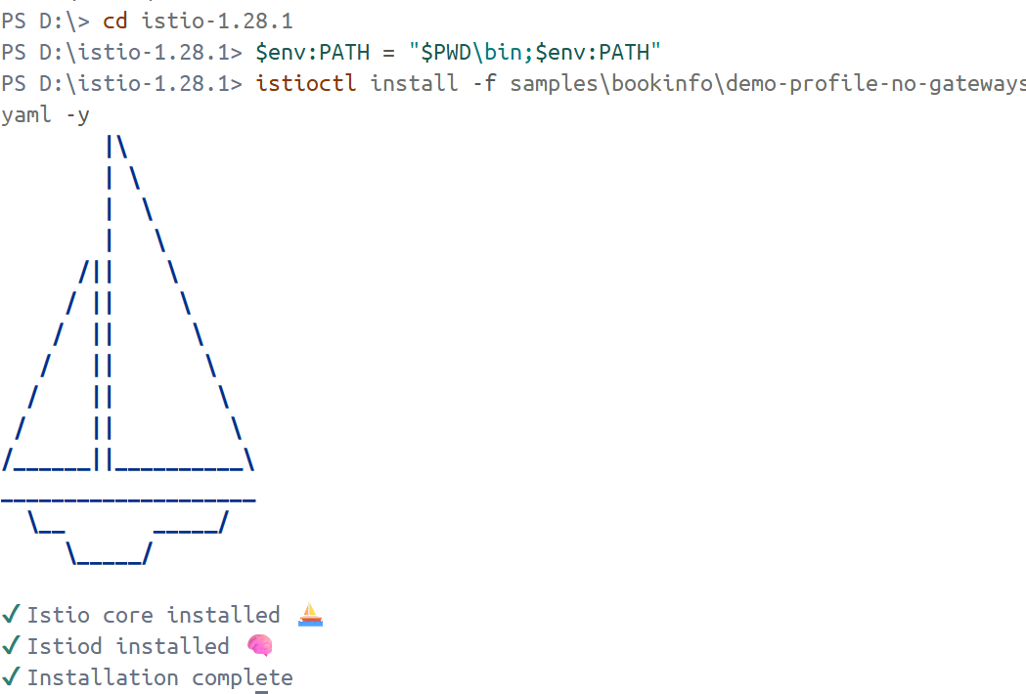
- Install the Gateway API CRDs
kubectl kustomize "github.com/kubernetes-sigs/gateway-api/config/crd?ref=v1.4.0" | kubectl apply -f -
Problem that I met:
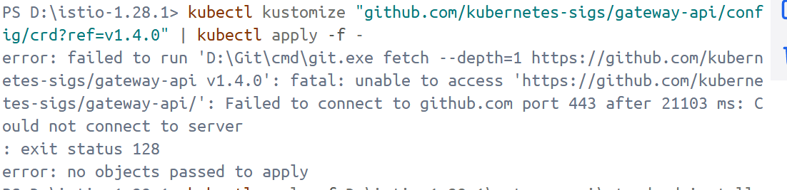
Solution：pull manually

kubectl apply --server-side -f D:\istio-1.28.1\gateway-api\standard-install.yaml
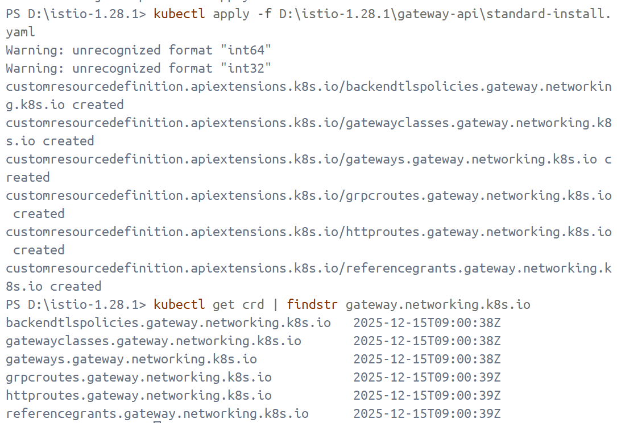
- Deploy the Bookinfo sample application
kubectl apply -f samples/bookinfo/platform/kube/bookinfo.yaml
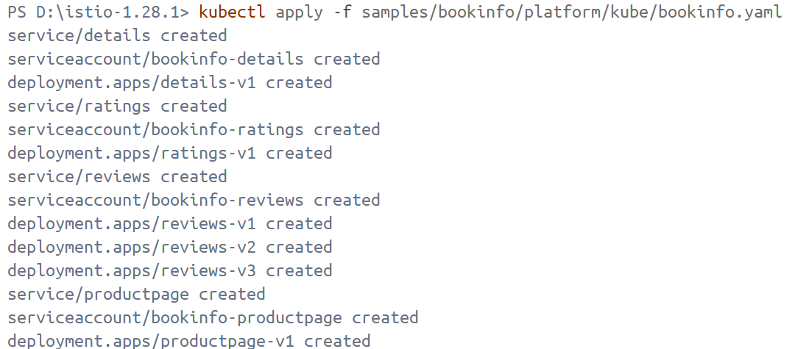
- Check if each pod becomes ready
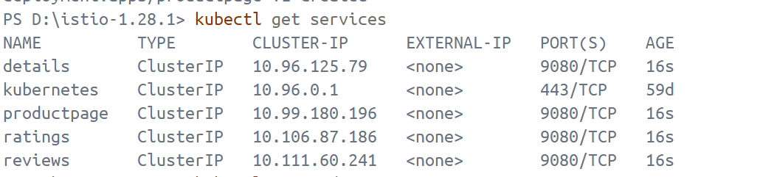
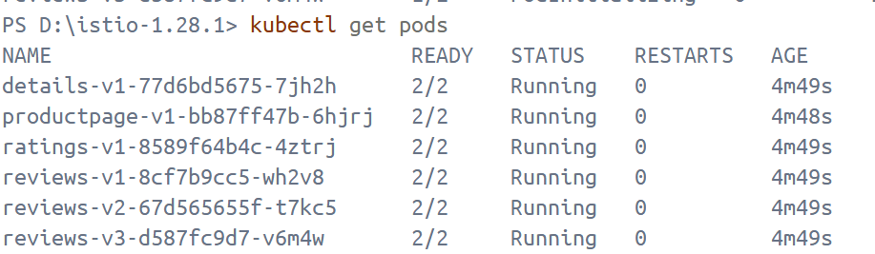
Note that the pods show READY 2/2, confirming they have their application container and the Istio sidecar container.
- Note that the pods show READY 2/2, confirming they have their application container and the Istio sidecar container.
$RATINGS_POD = kubectl get pod -l app=ratings -o jsonpath=”{.items[0].metadata.name}”
kubectl exec $RATINGS_POD -c ratings -- `
curl -sS productpage:9080/productpage |
Select-String "<title>.*</title>" |
ForEach-Object { $_.Matches[0].Value }
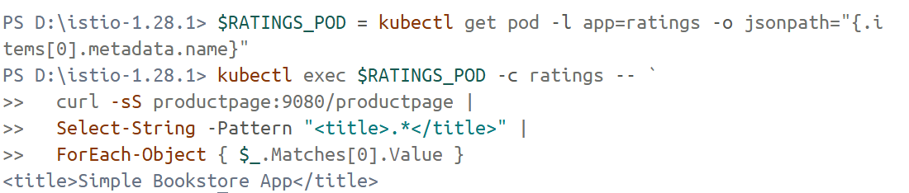
- Create a Kubernetes Gateway for the Bookinfo application
kubectl apply -f samples/bookinfo/gateway-api/bookinfo-gateway.yaml
- Change the service type to ClusterIP by annotating the gateway
kubectl annotate gateway bookinfo-gateway networking.istio.io/service-type=ClusterIP --namespace=default
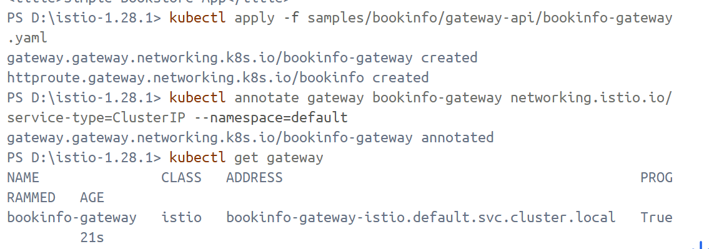
- kubectl port-forward svc/bookinfo-gateway-istio 8080:80
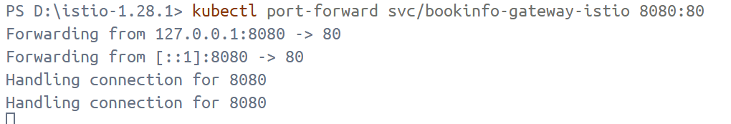
- access to the Bookinfo productpage
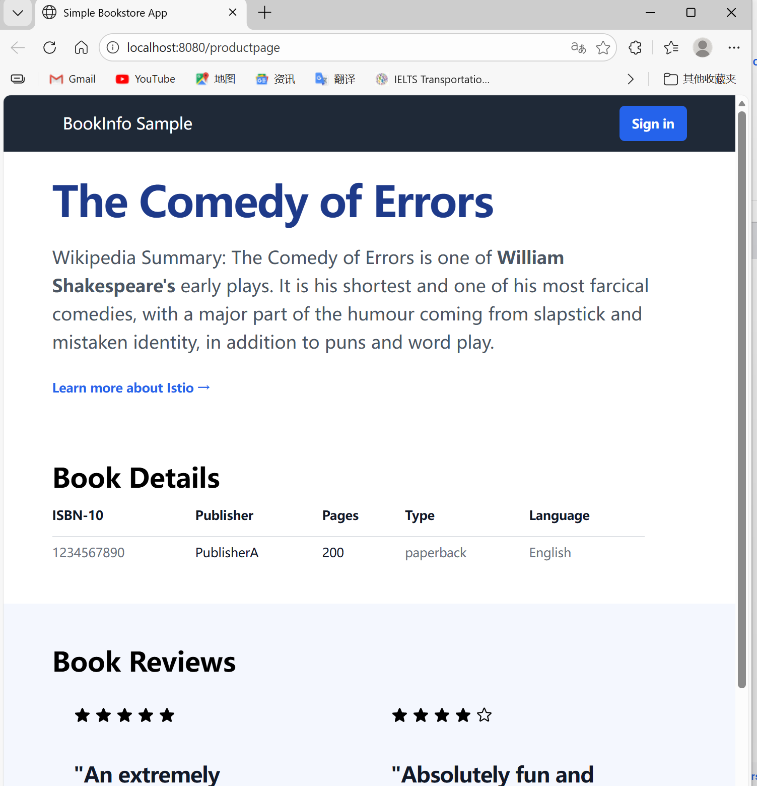
- Install Kiali and the other addons
kubectl apply -f samples/addons/kiali.yaml
kubectl rollout status deployment/kiali -n istio-system
- Access the Kiali dashboard
istioctl dashboard kiali
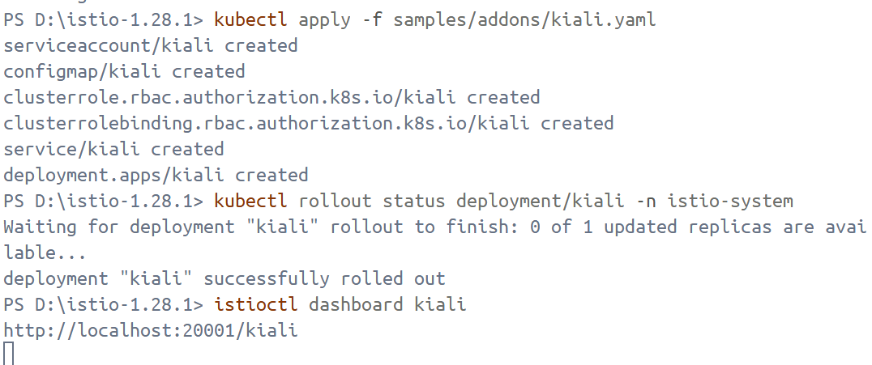
- In the left navigation menu, select Graph and in the Namespace drop down, select default. Then send 100 requests to the productpage service
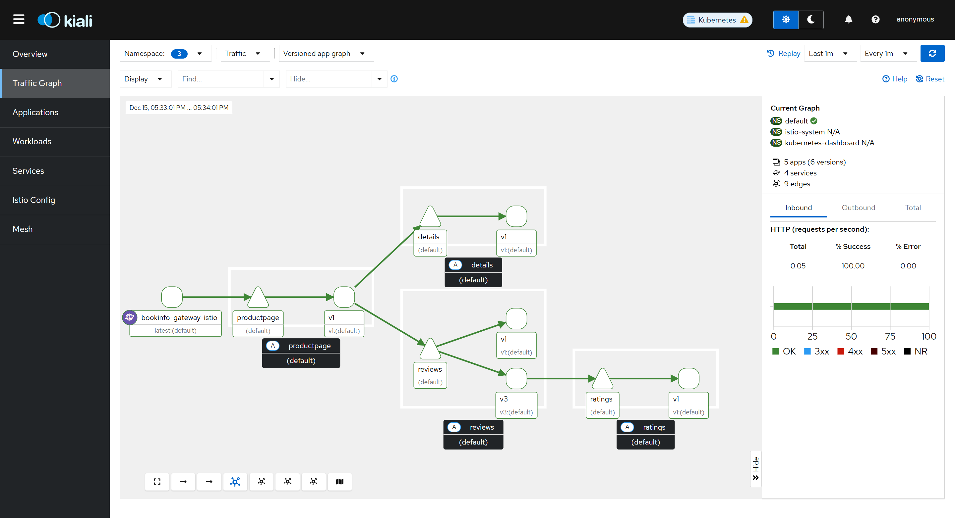
- Delete the Bookinfo sample application and its configuration
kubectl delete -f samples/addons
istioctl uninstall -y –purge
kubectl delete namespace istio-system
kubectl label namespace default istio-injection-
