KServe Quickstart

Prerequisites
Tools
- kubectl - The Kubernetes command-line tool
- helm - for installing KServe and other Kubernetes operators
- curl - for the quickstart script and for testing API endpoints (installed by default on most systems)
- verify kubectl installation
kubectl version –client
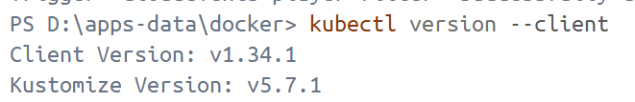
- verify helm installation
.\ helm version
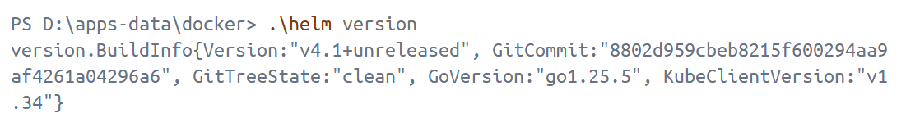
- verify curl installation
curl.exe --version
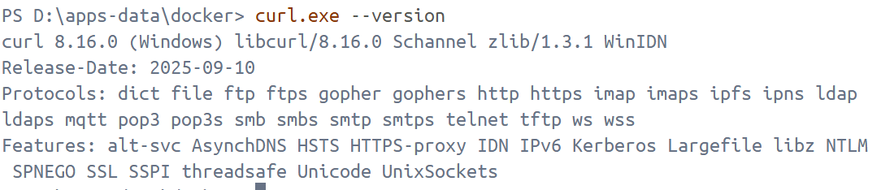

Install Kserve with Kubernetes deployment installation
minikube start --driver=docker --memory=10240 --cpus=8 --base-image=registry.k8s.io/kicbase/stable:v0.0.48 --kubernetes-version=v1.34.0
Note: The first attempt at istio-system kept crashing with CrashLoopBackOff, and all three replicas failed simultaneously. The reason was likely insufficient initial memory allocation. Therefore, this time we increased the CPU to 8 and memory to 10240MB.
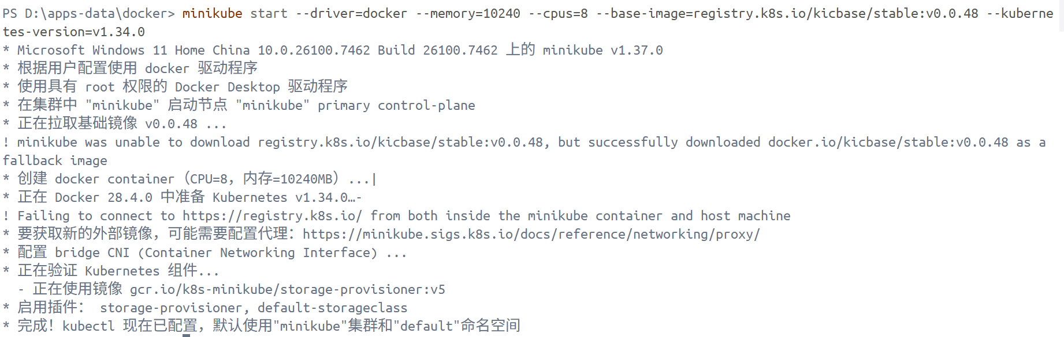
kubectl apply -f .\yaml\serving-crds.yaml
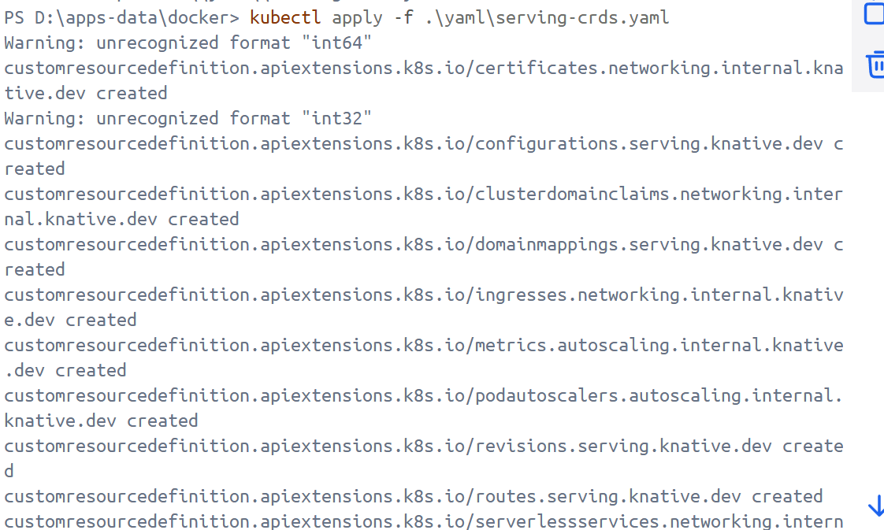
kubectl apply -f .\yaml\serving-core.yaml
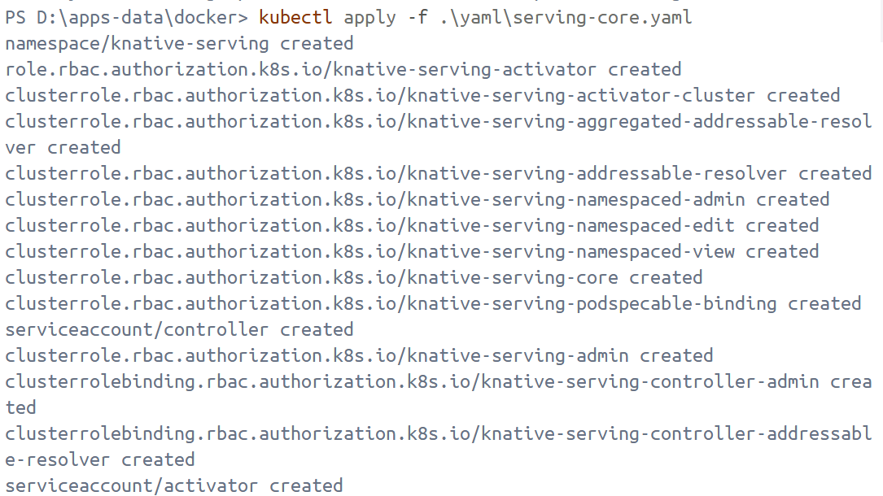
kubectl apply -f .\yaml\istio.yaml
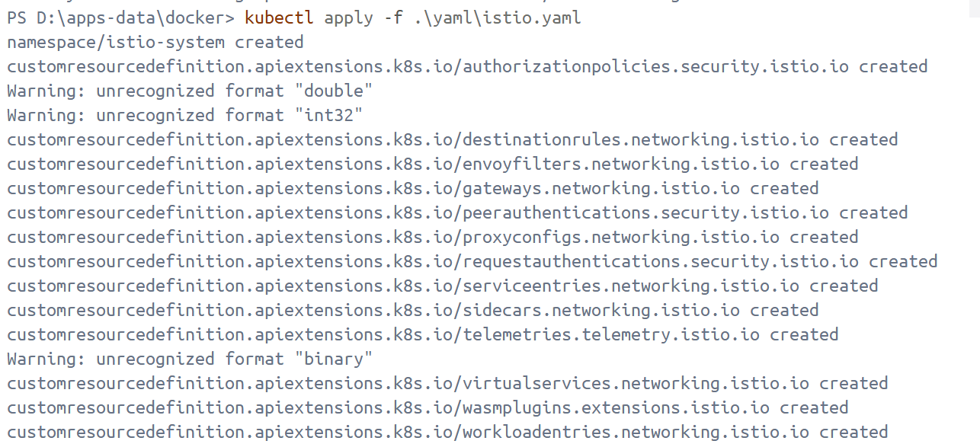
kubectl apply -f .\yaml\net-istio.yaml
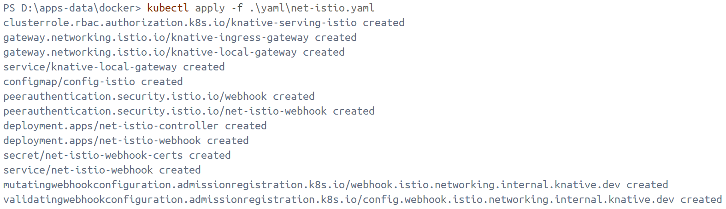
kubectl --namespace istio-system get service istio-ingressgateway
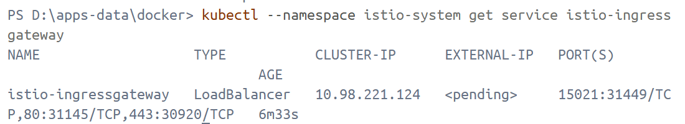
Cert Manager is required to provision webhook certs for production-grade installation.
kubectl apply -f .\yaml\cert-manager.yaml
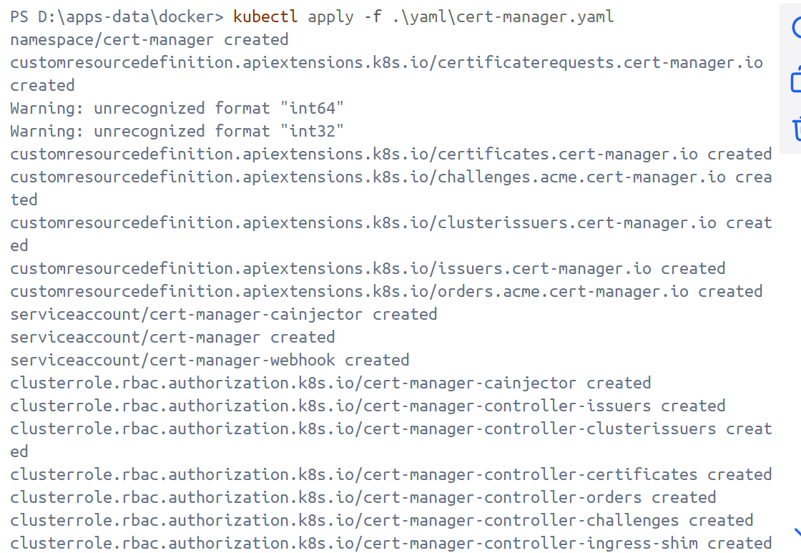
kubectl get pods -A
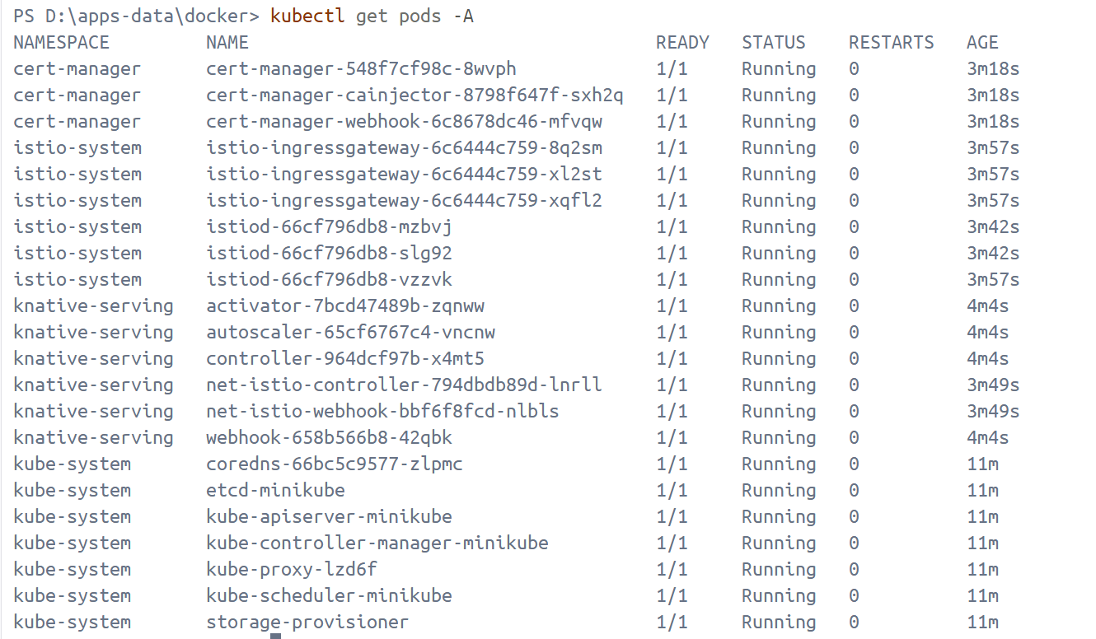
Install KServe CRDs
.\helm install kserve-crd oci://ghcr.io/kserve/charts/kserve-crd --version v0.15.2 --namespace kserve --create-namespace --wait
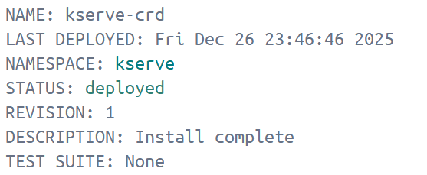
Install Kserve resources
.\helm install kserve oci://ghcr.io/kserve/charts/kserve --version v0.15.2 --namespace kserve --create-namespace --wait --set-string kserve.controller.deploymentMode="Serverless"
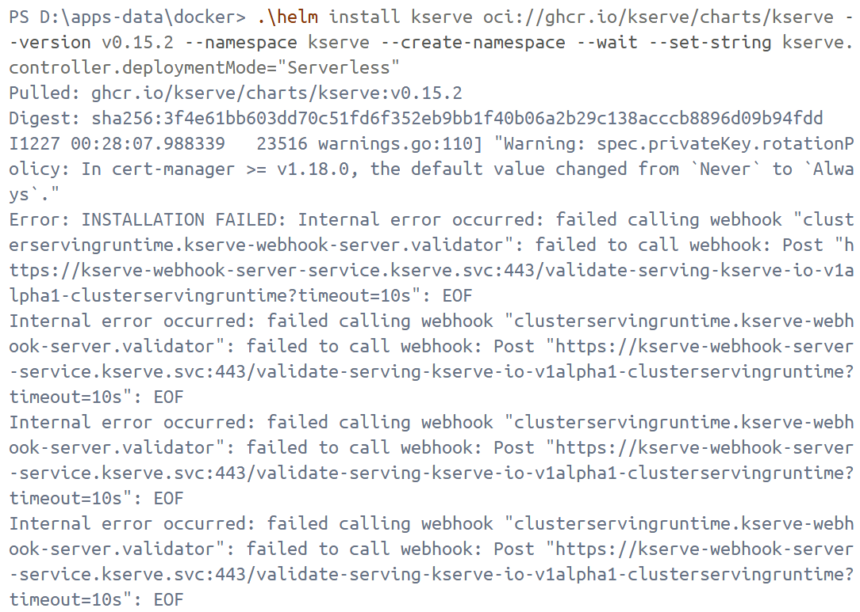
Because I tried so many times, I didn't take screenshots of the experiment. I only roughly recorded the commands that ran successfully, and it's likely that not all commands are included. This is only for reference.
- Clean up
.\helm uninstall kserve -n kserve
.\helm uninstall kserve-crd -n kserve
kubectl delete ns kserve --ignore-not-found
# wait namespace disappear
kubectl get ns kserve
- Install CRD
.\helm upgrade --install kserve-crd oci://ghcr.io/kserve/charts/kserve-crd `
--version v0.15.2 `
--namespace kserve `
--create-namespace `
--wait
- Verify that the CRD already exists.
kubectl get crd | findstr /I "kserve.io"
kubectl get crd | findstr /I "clusterservingruntimes"
kubectl get crd | findstr /I "inferenceservices"
- Download kserve chart（I've tried two methods here.）
- Download online and then install using the local package offline
.\helm pull oci://ghcr.io/kserve/charts/kserve --version v0.15.2
.\helm upgrade --install kserve .\kserve-v0.15.2.tgz `
--namespace kserve --create-namespace `
--set-string kserve.controller.deploymentMode=RawDeployment `
--wait
- Rendering template
.\helm template kserve oci://ghcr.io/kserve/charts/kserve `
--version v0.15.2 `
--namespace kserve `
--set kserve.controller.deploymentMode=RawDeployment `
> .\kserve-rendered.yaml
Note: Applying the rendered YAML using `kubectl apply` only constitutes a "manual installation." Helm may fail to install subsequently due to ownership conflicts.
- Verify webhook endpoints is normal
kubectl get pods -n kserve
kubectl get svc -n kserve kserve-webhook-server-service -o wide
kubectl get endpoints -n kserve kserve-webhook-server-service -o wide

kubectl get pods -n kserve
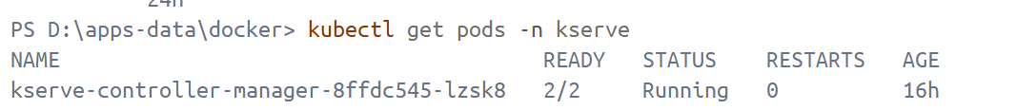
kubectl get crd | Select-String kserve
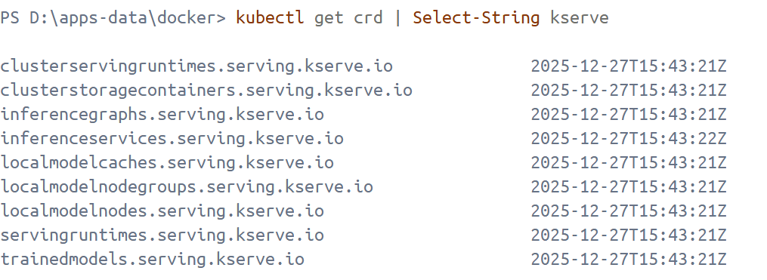
kubectl get services -n kserve
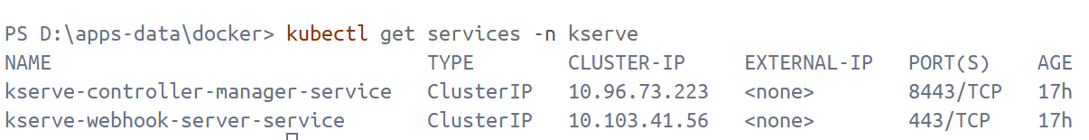

Deploy a predictive model
Create InferenceService（sklearn iris）
Create iris-isvc.yaml and apply it
@"
apiVersion: serving.kserve.io/v1beta1
kind: InferenceService
metadata:
name: sklearn-iris
namespace: default
spec:
predictor:
model:
modelFormat:
name: sklearn
storageUri: gs://kfserving-examples/models/sklearn/1.0/model
"@ | kubectl apply -f -
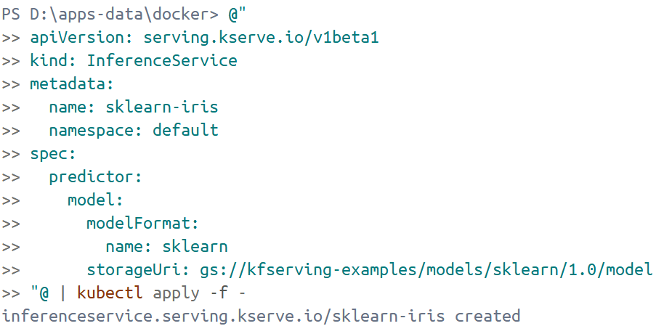
Check InferenceService status
kubectl get inferenceservice sklearn-iris
Execute the following command to determine if the Kubernetes cluster is running in an environment that supports external load balancers
kubectl get svc istio-ingressgateway -n istio-system
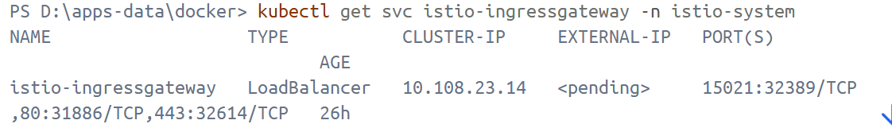
Port Forward
Find the Service name of istio ingressgateway (usually istio-ingressgateway).
$INGRESS_GATEWAY_SERVICE = kubectl get svc -n istio-system -l app=istio-ingressgateway `
-o jsonpath="{.items[0].metadata.name}"
Do Port Forward
kubectl port-forward -n istio-system "svc/$INGRESS_GATEWAY_SERVICE" 8080:80
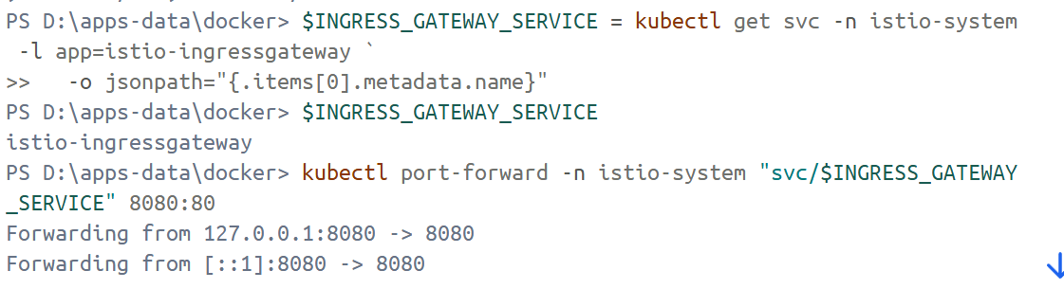
kubectl get inferenceservice sklearn-iris -o jsonpath='{.status.url}'
Open another terminal, and enter the following to perform inference
$SERVICE_URL = kubectl get inferenceservice sklearn-iris -o jsonpath="{.status.url}"
$SERVICE_HOSTNAME = ([Uri]$SERVICE_URL).Host
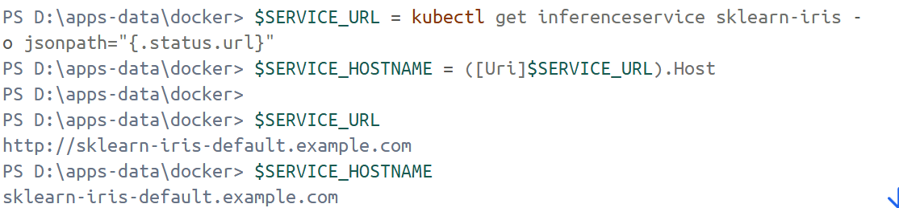
curl.exe -v `
-H "Host: $SERVICE_HOSTNAME" `
-H "Content-Type: application/json" `
"http://${INGRESS_HOST}:${INGRESS_PORT}/v1/models/sklearn-iris:predict" `
--data-binary "@.\iris-input.json"
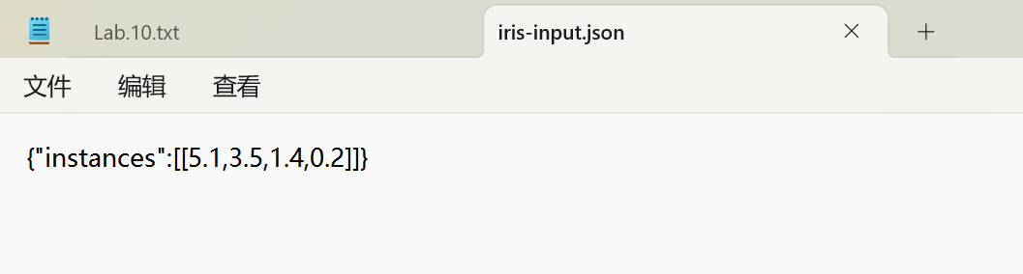
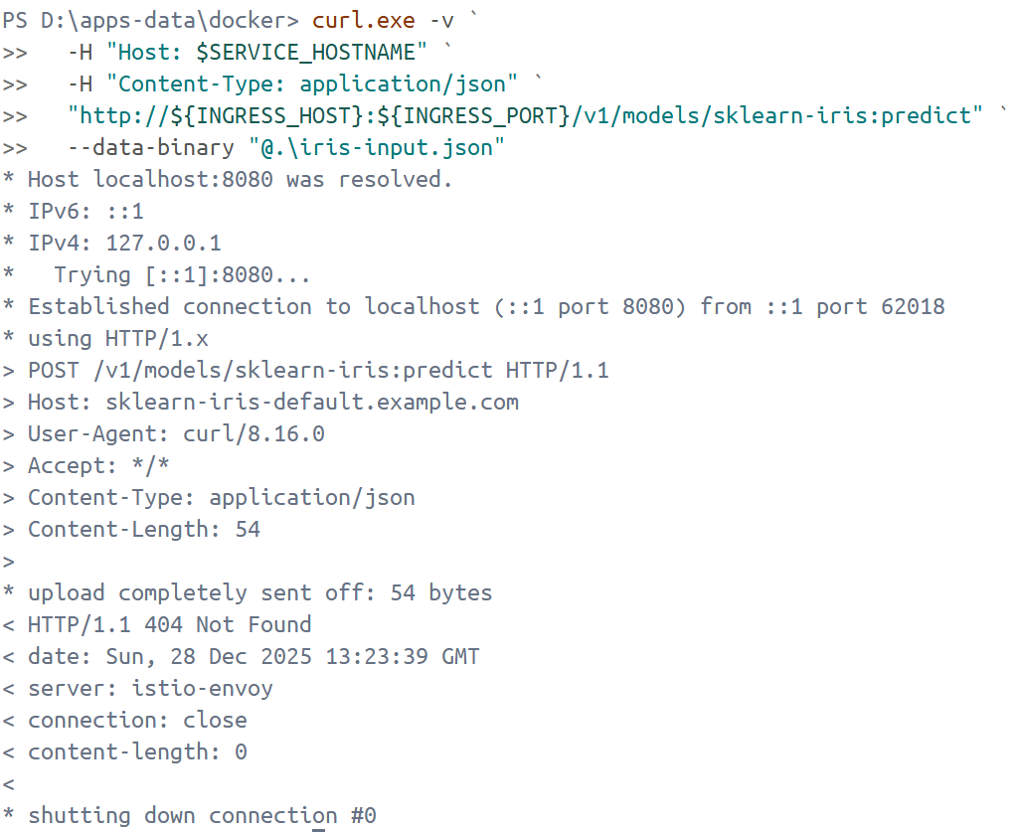

kubectl port-forward -n istio-system svc/knative-local-gateway 8080:80
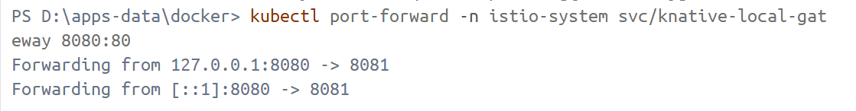
curl.exe -v `
-H "Host: $SERVICE_HOSTNAME" `
-H "Content-Type: application/json" `
--data-raw '{"instances":[[5.1,3.5,1.4,0.2]]}' `
http://localhost:8080/v1/models/sklearn-iris:predict
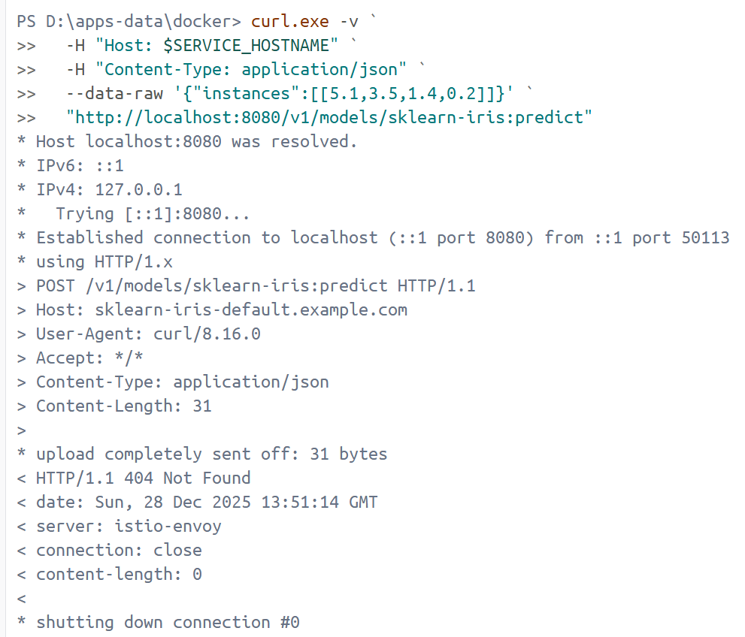

Port Forward to Predictor Service
kubectl -n default port-forward svc/sklearn-iris-predictor 18080:80
