Content
Installing Knative Serving using YAML files 2
Install the Knative Serving component 2
Install a networking layer 3
Verify the installation 4
Configure DNS 4
Install optional Serving extensions 7
Installing Knative Eventing using YAML files 8
Kafka start 8
Install a default Channel (messaging) layer 10
Install a Broker layer 11
Install optional Eventing extensions: Kafka Sink 11
Knative Functions 12
Install Knative functions 12
Create a function 12
Build a function 12
Knative Serving 14
Autoscaling 14
Traffic splitting 15
Knative Eventing 18
Using a Knative Service as a source 20
Sending an event using the CloudEvents Player interface 22
Send events using the command line 22
Using Triggers and sinks 23

Installing Knative Serving using YAML files

Install the Knative Serving component
- Install the required custom resources
kubectl apply -f https://github.com/knative/serving/releases/download/knative-v1.20.0/serving-crds.yaml
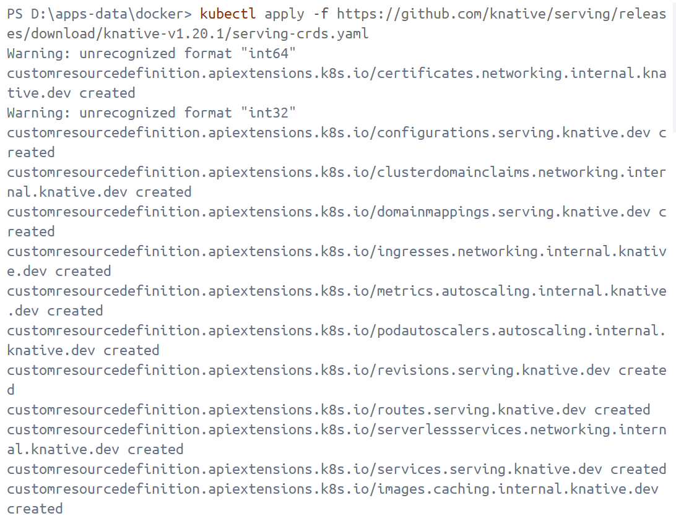
- Install the core components of Knative Serving
kubectl apply -f https://github.com/knative/serving/releases/download/knative-v1.20.0/serving-core.yaml
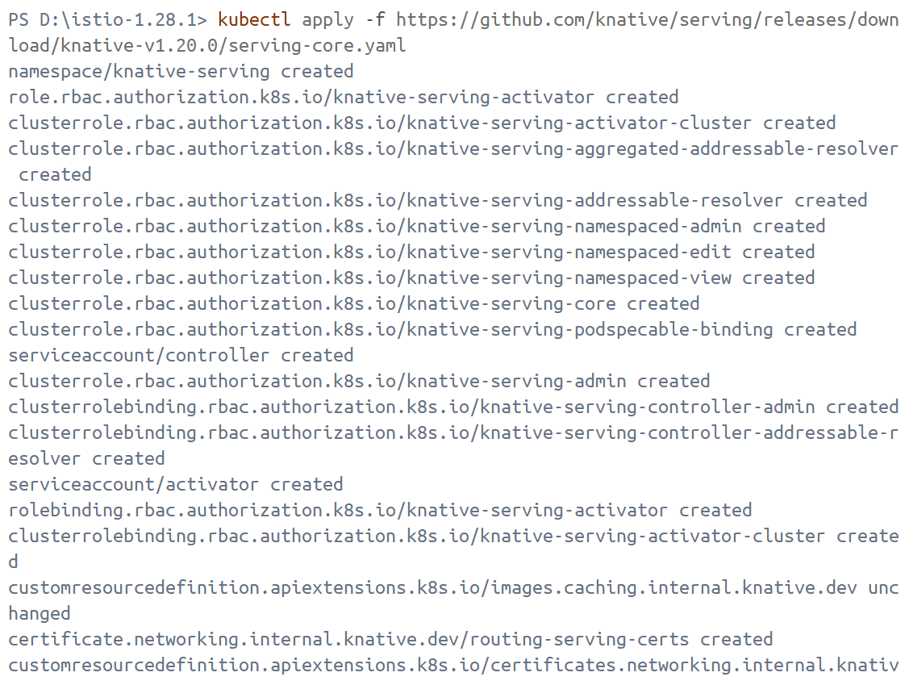

Install a networking layer
- Install the Knative Kourier controller
kubectl apply -f https://github.com/knative-extensions/net-kourier/releases/download/knative-v1.20.0/kourier.yaml
Problems that I met:
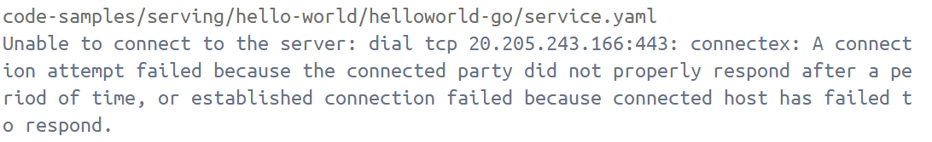
Solutions: Download the file locally https://github.com/knative-extensions/net-kourier/releases/download/knative-v1.20.0/kourier.yaml.
Then run the command kubectl apply -f kourier.yaml
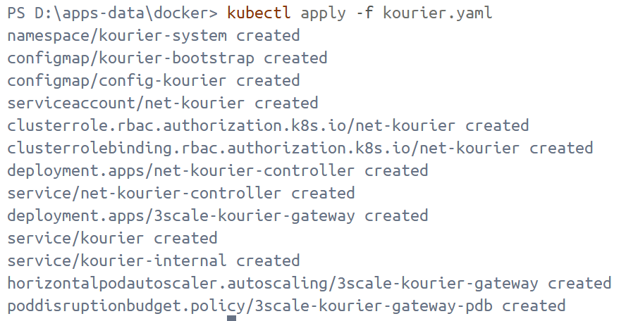
- Configure Knative Serving to use Kourier by default
@"
apiVersion: v1
kind: ConfigMap
metadata:
name: config-network
namespace: knative-serving
data:
ingress-class: kourier.ingress.networking.knative.dev
"@ | kubectl apply -f –
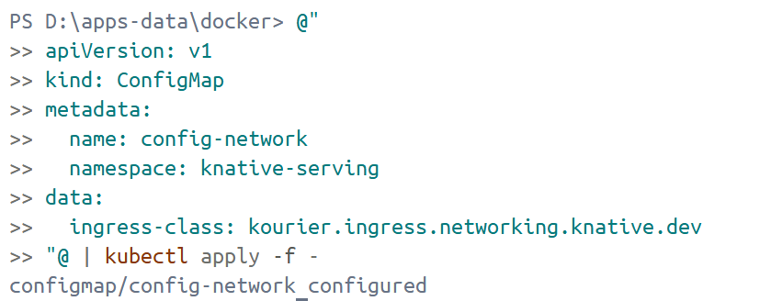
- Fetch the External IP address or CNAME
kubectl --namespace kourier-system get service kourier

Verify the installation
kubectl get pods -n knative-serving
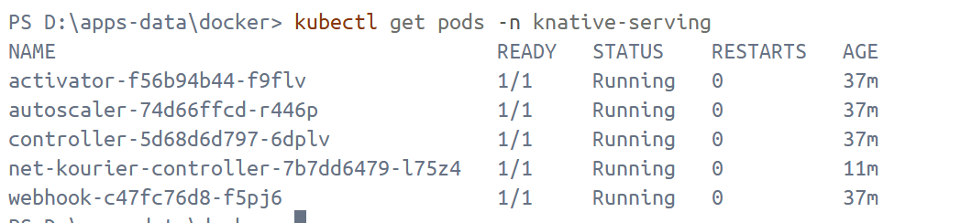

Configure DNS
No DNS
- Knative provides a Kubernetes Job called default-domain that configures Knative Serving to use sslip.io as the default DNS suffix
kubectl apply -f https://github.com/knative/serving/releases/download/knative-v1.20.0/serving-default-domain.yaml
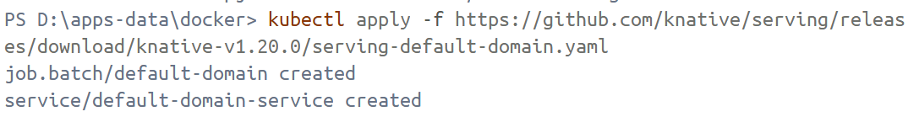
- Configure Knative to use a domain reachable from outside the cluster
@"
apiVersion: v1
kind: ConfigMap
metadata:
name: config-domain
namespace: knative-serving
data:
example.com: ""
"@ | kubectl apply -f -
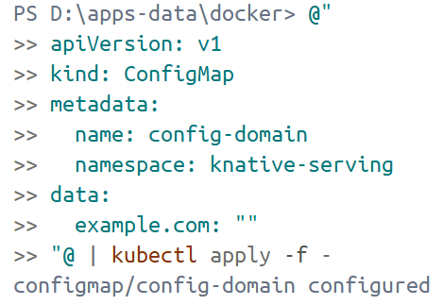
@"
apiVersion: serving.knative.dev/v1
kind: Service
metadata:
name: helloworld-go
namespace: default
spec:
template:
spec:
containers:
- image: gcr.io/knative-samples/helloworld-go
env:
- name: TARGET
value: "Go Sample v1"
"@ | kubectl apply -f -
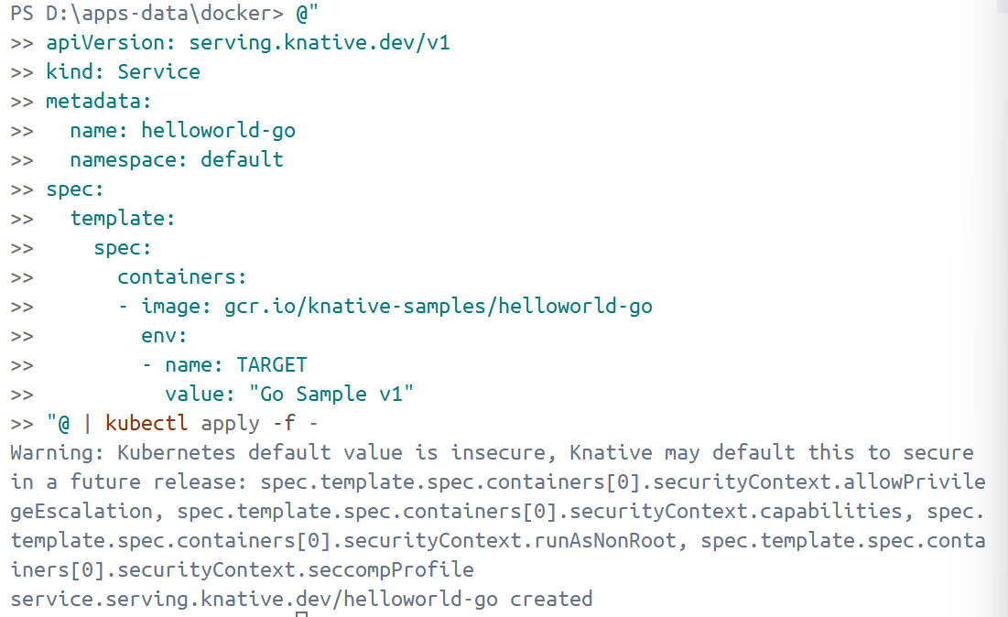
- Get the URL of the application
kubectl get ksvc
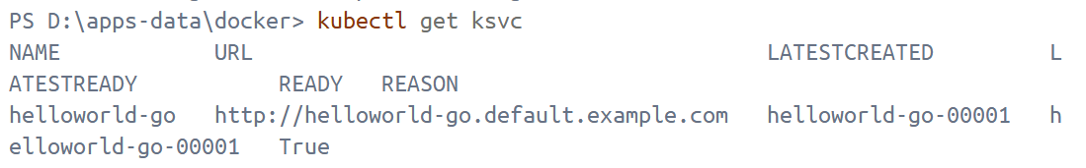
- Instruct curl to connect to the External IP or CNAME defined by the networking layer
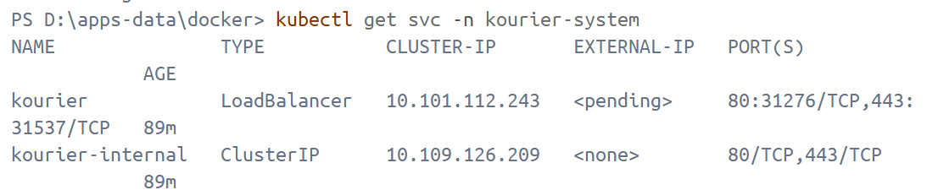
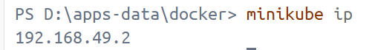
According to the above two figures, it can get http://192.168.49.2:31276
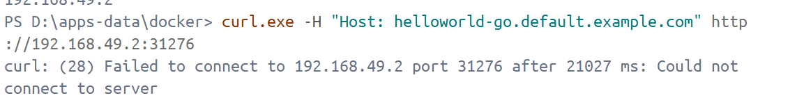
Cause: The IP address 192.168.49.2 returned by minikube may not be reachable on the Windows host machine (especially with Docker driver/Hyper-V network isolation), so accessing 192.168.49.2:31276 will time out. Knative/Kourier is not broken; the problem is that the network entry point is not working.
Under the Docker driver:
- The minikube IP address is an internal/virtual network address within the cluster
- The Windows host machine may not be able to directly route to that network segment
- The NodePort port will also be inaccessible.
port-forward / minikube service --url essentially creates a "bridging entry point" on the host machine, bypassing network isolation
Solutions: port-forwardto the host
Open a new PowerShell window and keep it running.
kubectl -n kourier-system port-forward svc/kourier 8080:80
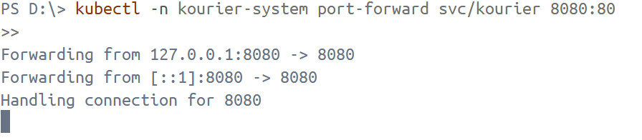Another window:
curl.exe -H "Host: helloworld-go.default.example.com" http://127.0.0.1:8080
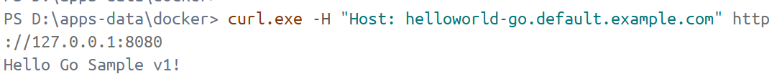

Install optional Serving extensions
Install the components needed to support HPA-class autoscaling
kubectl apply -f serving-hpa.yaml
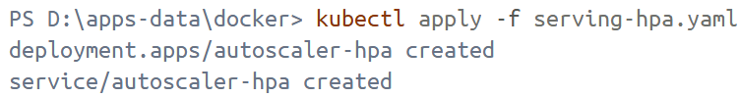

Installing Knative Eventing using YAML files
- Install the required custom resource definitions (CRDs)
kubectl apply -f eventing-crds.yaml
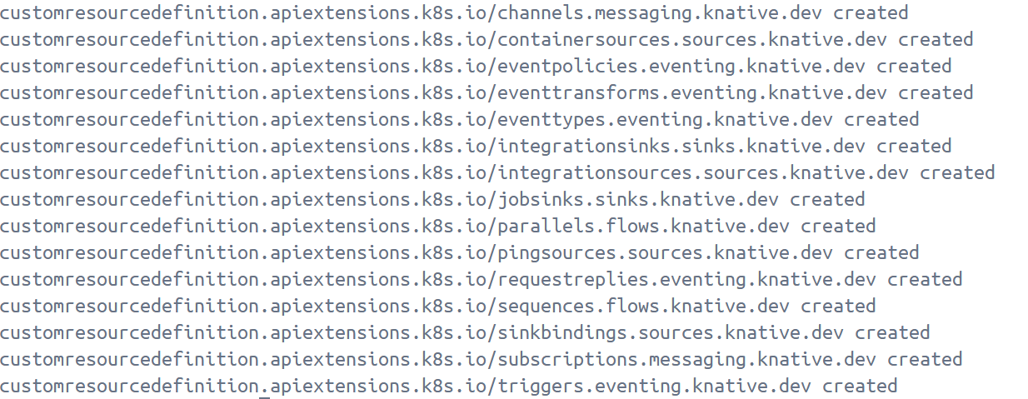
- Install the core components of Eventing
kubectl apply -f eventing-core.yaml
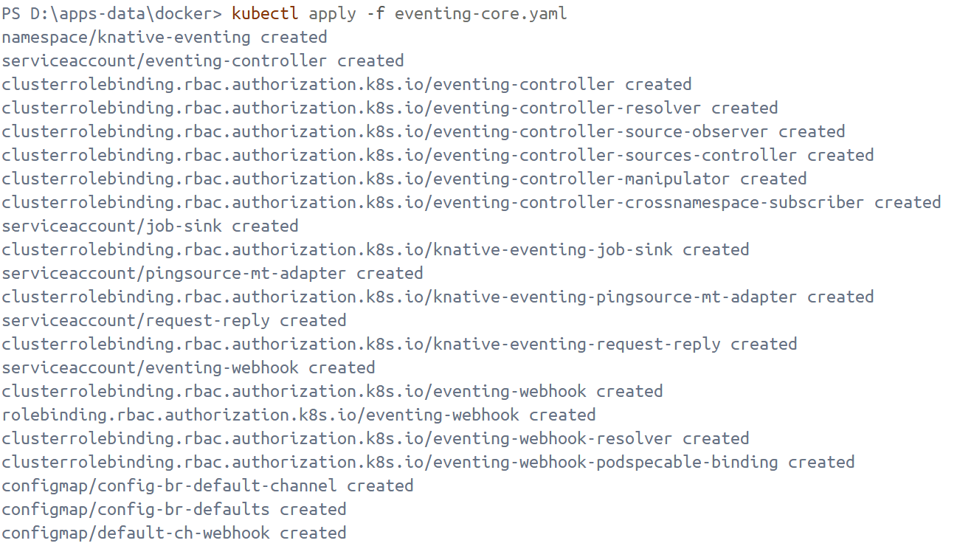
- Verify the installation
kubectl get pods -n knative-eventing
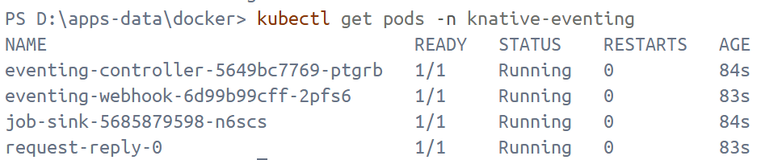

Kafka start
Deployed according to https://strimzi.io/quickstarts/
Deploy Strimzi using installation files
kubectl create namespace kafka
kubectl create -f 'https://strimzi.io/install/latest?namespace=kafka' -n kafka
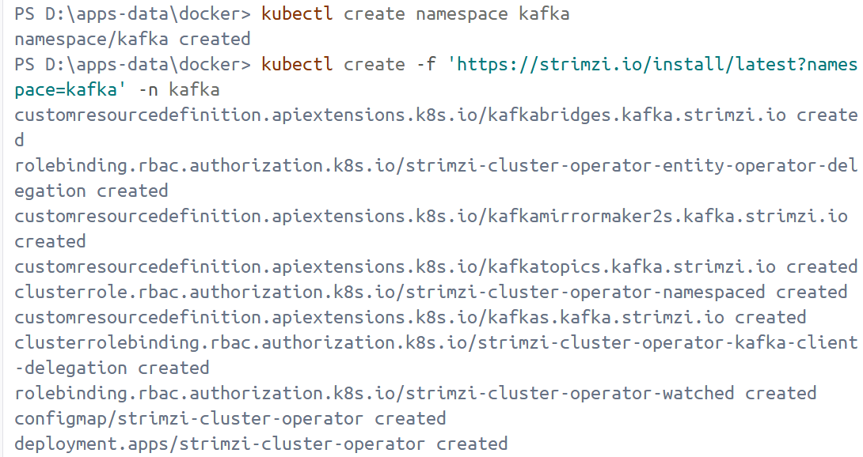
kubectl get pod -n kafka –watch
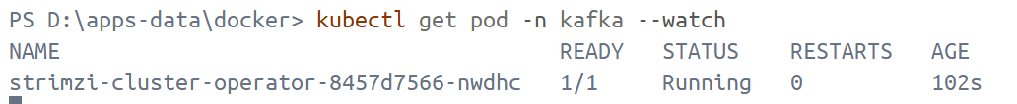
Create a new Kafka custom resource to get a single node Apache Kafka cluster
kubectl apply -f https://strimzi.io/examples/latest/kafka/kafka-single-node.yaml -n kafka
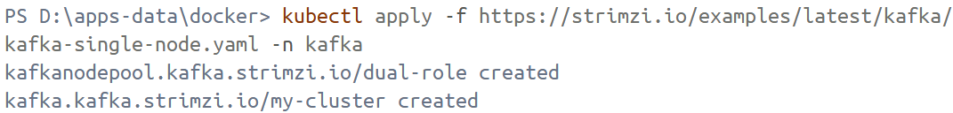
Wait while Kubernetes starts the required pods, services, and so on
kubectl wait kafka/my-cluster --for=condition=Ready --timeout=300s -n kafka
With the cluster running, run a simple producer to send messages to a Kafka topic
kubectl -n kafka run kafka-producer -ti --image=quay.io/strimzi/kafka:0.49.1-kafka-4.1.1 --rm=true --restart=Never -- bin/kafka-console-producer.sh --bootstrap-server my-cluster-kafka-bootstrap:9092 --topic my-topic
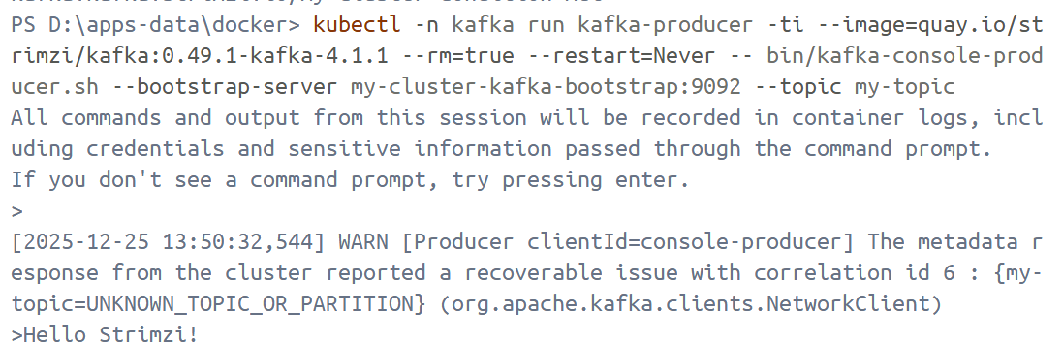
And to receive them in a different terminal
kubectl -n kafka run kafka-consumer -ti --image=quay.io/strimzi/kafka:0.49.1-kafka-4.1.1 --rm=true --restart=Never -- bin/kafka-console-consumer.sh --bootstrap-server my-cluster-kafka-bootstrap:9092 --topic my-topic --from-beginning
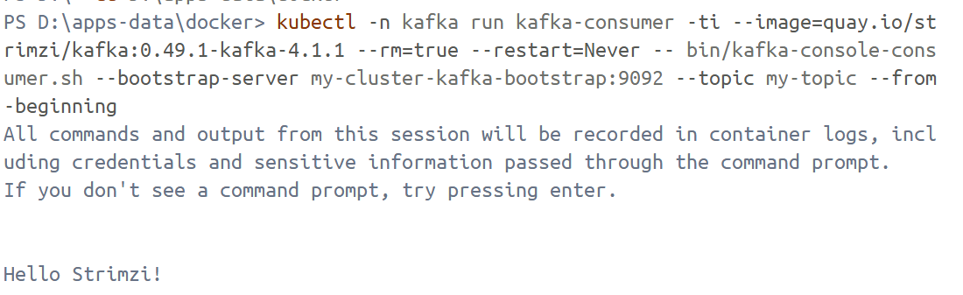

Install a default Channel (messaging) layer
- Install the Kafka controller
kubectl apply -f eventing-kafka-controller.yaml
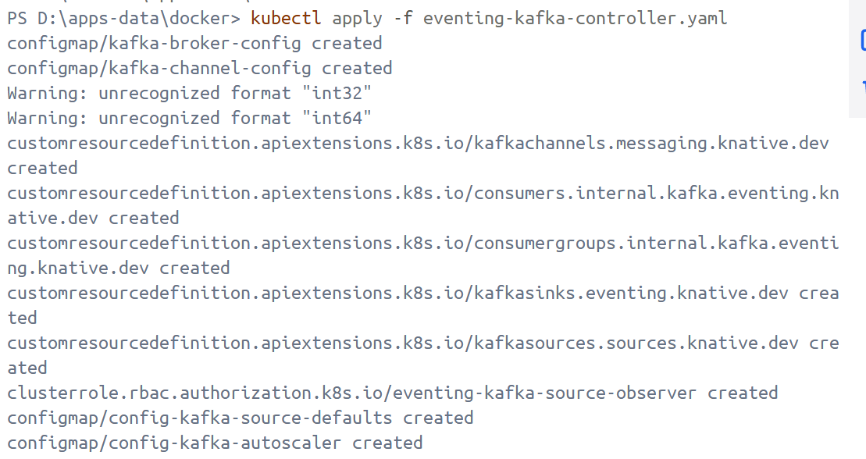
- Install the KafkaChannel data plane
kubectl apply -f eventing-kafka-channel.yaml
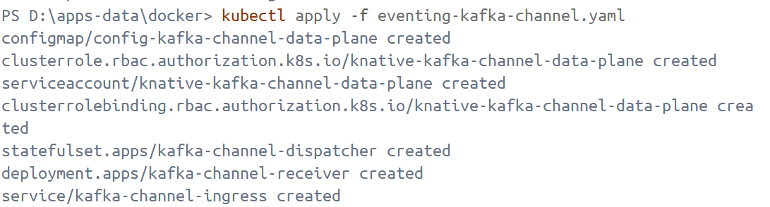
- Upgrade from the previous version
kubectl apply -f eventing-kafka-post-install.yaml
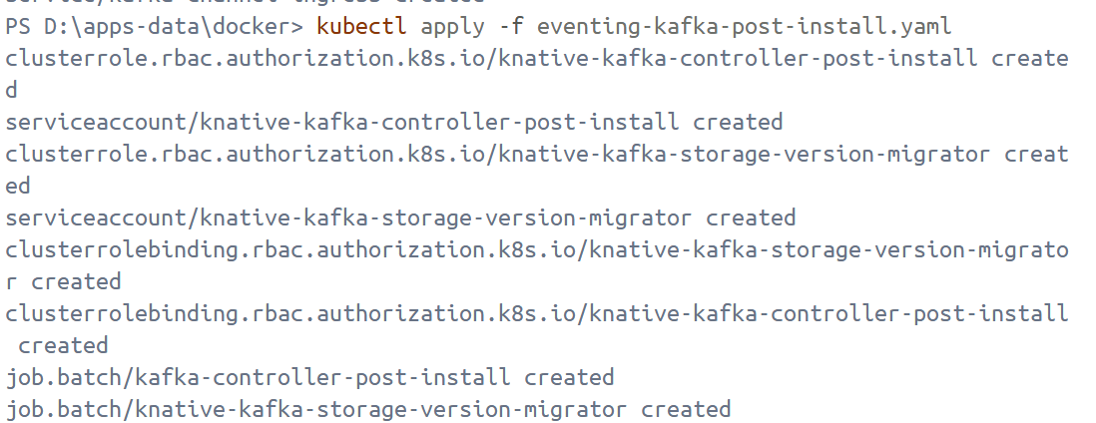

Install a Broker layer
kubectl apply -f eventing-kafka-broker.yaml
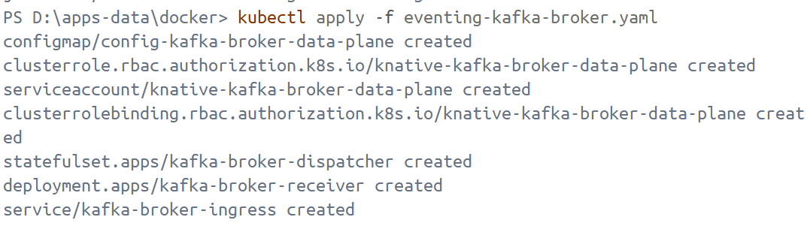

Install optional Eventing extensions: Kafka Sink
kubectl apply -f eventing-kafka-sink.yaml
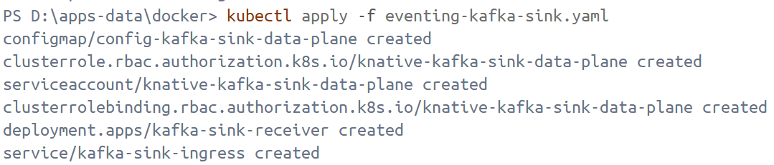

Knative Functions

Install Knative functions
docker run --rm -it ghcr.io/knative/func/func create -l node -t http myfunc
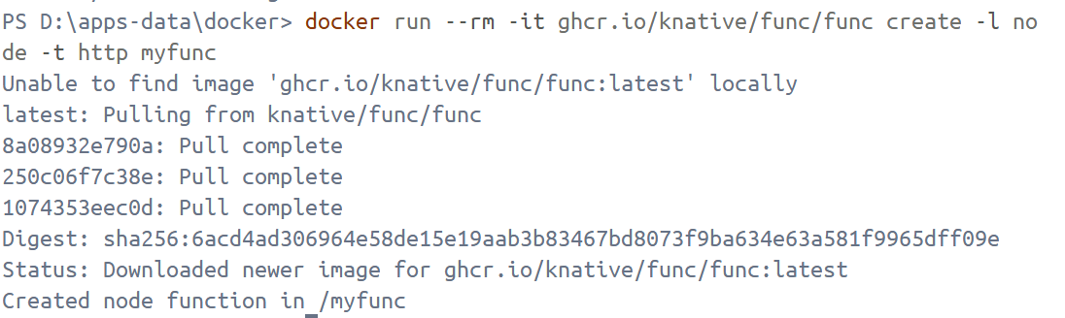
Download knative func from https://github.com/knative/func/releases/tag/knative-v1.20.1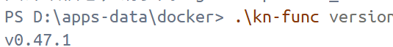

Create a function
.\kn-func create -l go hello

Build a function
Start the local image repository registry (5001→5000).
docker run -d -p 5001:5000 --name registry registry:2
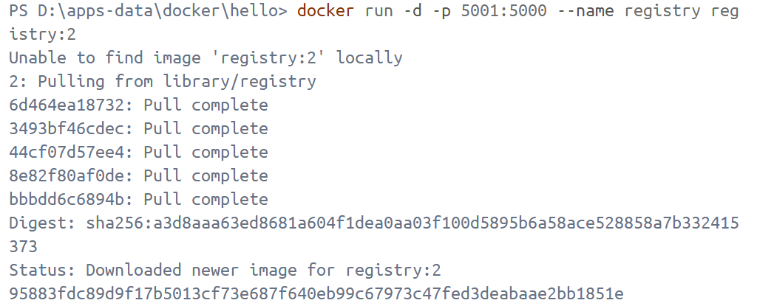
..\kn-func run --build --registry localhost:5001
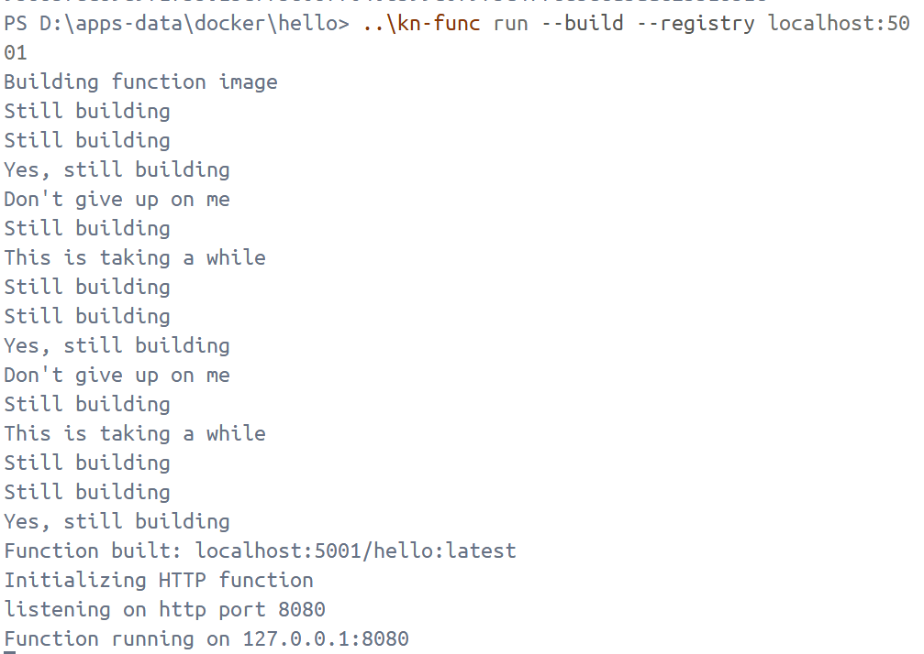
Verify that my function has been successfully run by using the invoke command and observing the output
..\kn-func invoke
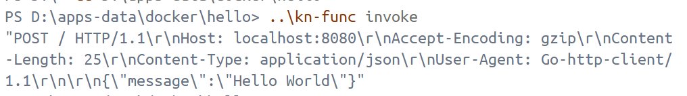
The output of this command below the previous image is:
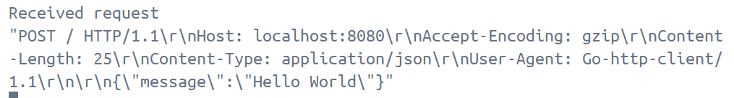
Build a function
..\kn func build
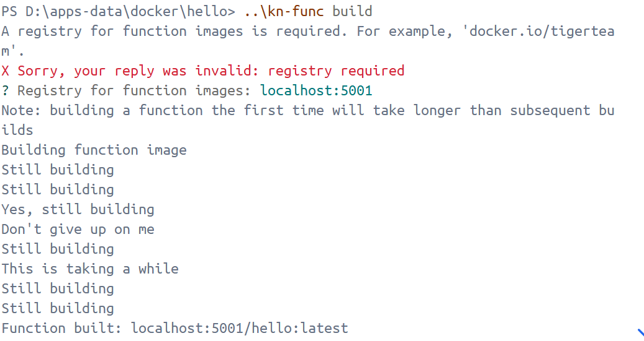

Knative Serving
hello.yaml
apiVersion: serving.knative.dev/v1
kind: Service
metadata:
name: hello
spec:
template:
spec:
containers:
- image: ghcr.io/knative/helloworld-go:latest
ports:
- containerPort: 8080
env:
- name: TARGET
value: "World"
Deploy the Knative Service
kubectl apply -f hello.yaml
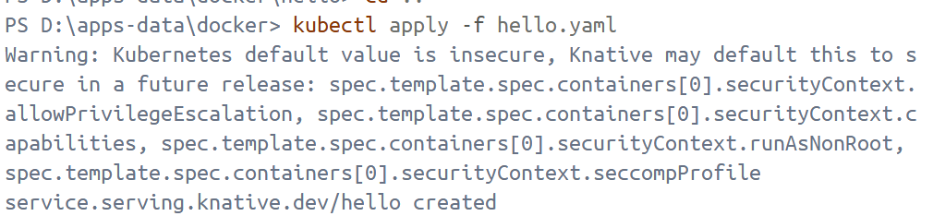
Because kn wasn't downloaded, I used kubectl to perform autoscaling. During the process, I encountered the error "GET / HTTP/1.1\r\nHost: hello.default.example.com\r\nAccept: */*\r\nUser-Agent: curl/8.16.0\r\n\r\n". This was because port-forward wasn't enabled at the time. So, I created a new PowerShell window and entered `kubectl -n kourier-system port-forward svc/kourier 18080:80`.
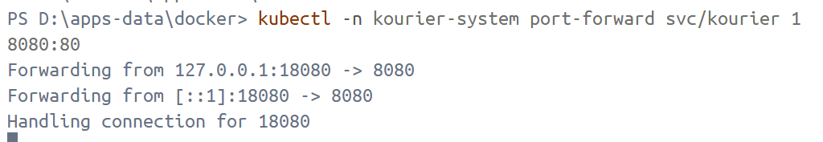

Autoscaling
View a list of Knative Services
kubectl get ksvc
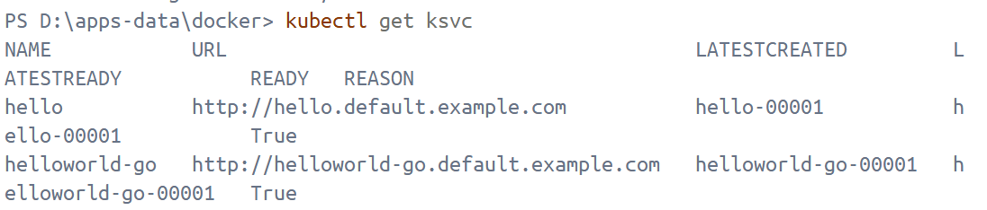
Access my Knative Service by opening the previous URL in my browser
$URL = kubectl get ksvc hello -o jsonpath="{.status.url}"
echo "Accessing URL $URL"
curl.exe -H "Host: hello.default.example.com" http://127.0.0.1:18080
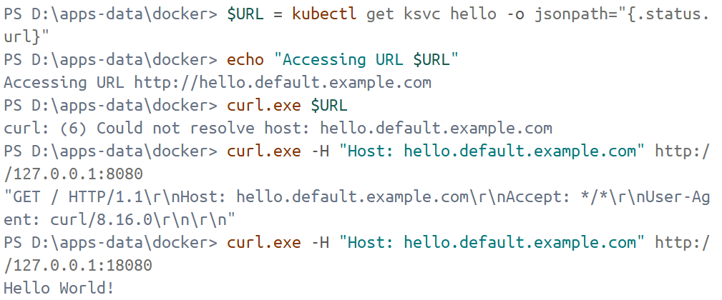
Watch the pods and see how they scale to zero after traffic stops going to the URL
kubectl get pod -l serving.knative.dev/service=hello -w
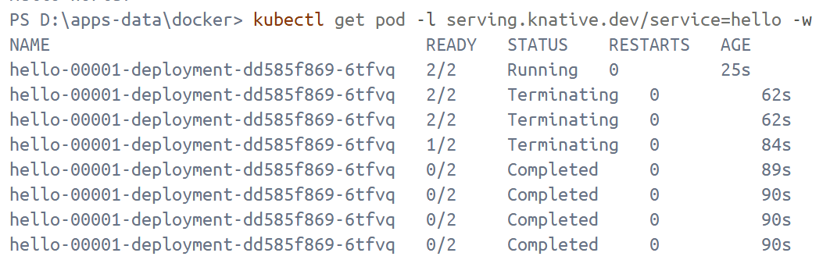

Traffic splitting
hello.yaml
apiVersion: serving.knative.dev/v1
kind: Service
metadata:
name: hello
spec:
template:
spec:
containers:
- image: ghcr.io/knative/helloworld-go:latest
ports:
- containerPort: 8080
env:
- name: TARGET
value: "Knative"
Deploy the updated version of my Knative Service
kubectl apply -f .\yaml\hello.yaml
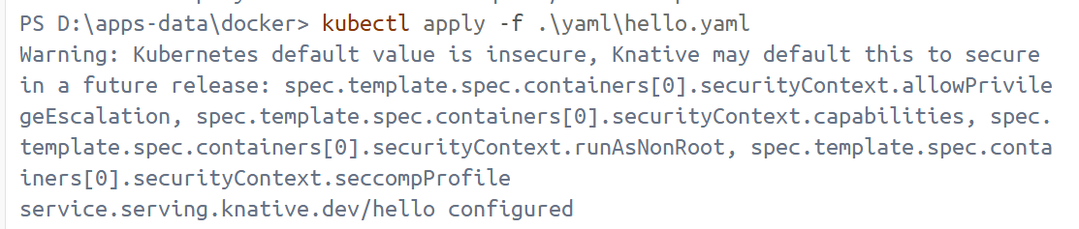
Access the Knative Service on the browser
$URL = kubectl get ksvc hello -o jsonpath="{.status.url}"
echo "Accessing URL $URL"
curl.exe -H "Host: hello.default.example.com" http://127.0.0.1:18080
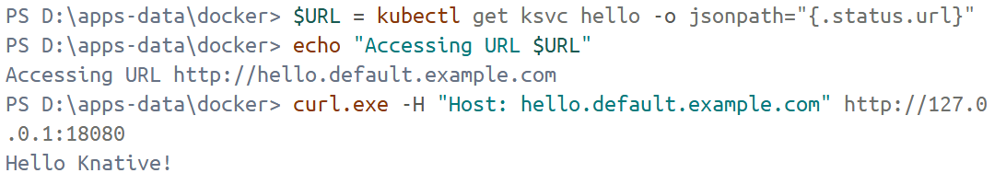
View a list of Revisions
kubectl get revisions
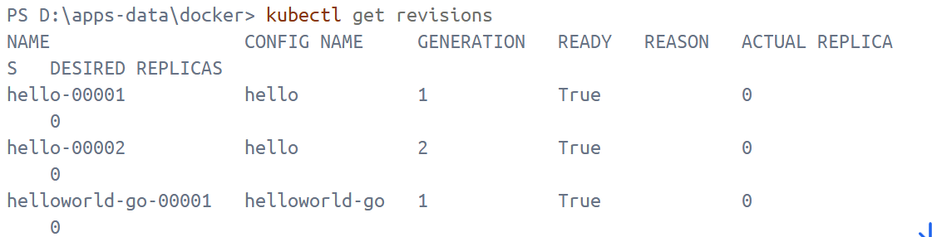
Add to the bottom of the existing hello.yaml
apiVersion: serving.knative.dev/v1
kind: Service
metadata:
name: hello
spec:
template:
spec:
containers:
- image: ghcr.io/knative/helloworld-go:latest
ports:
- containerPort: 8080
env:
- name: TARGET
value: "Knative"
traffic:
- latestRevision: true
percent: 50
- latestRevision: false
percent: 50
revisionName: hello-00001
Apply the YAML
kubectl apply -f .\yaml\hello.yaml
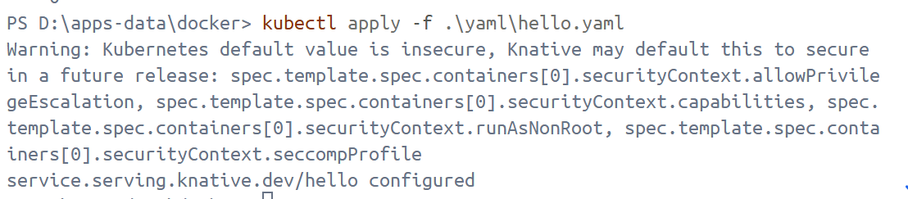
Verify the traffic split and list the Revisions
.\kn revisions list
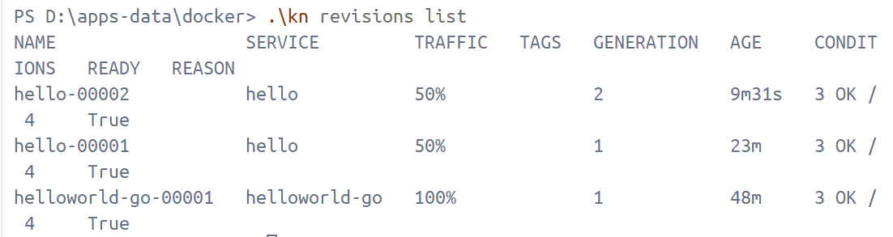
Access the Service URL from the terminal multiple times to see the traffic being split between the Revisions
curl.exe -H “Host: hello.default.example.com” http://127.0.0.1:18080
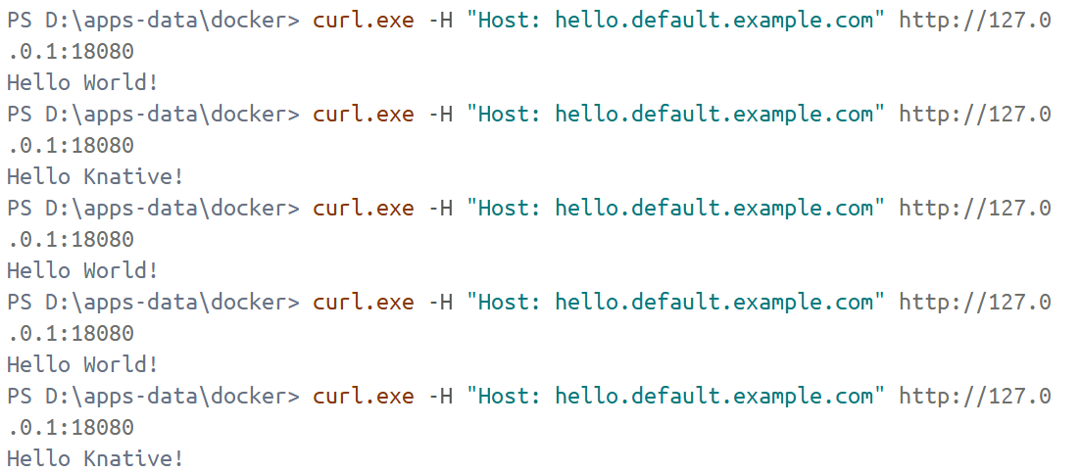

Knative Eventing
Download from https://github.com/knative/eventing/releases/download/knative-v1.20.0/in-memory-channel.yaml
And apply it.
kubectl apply -f in-memory-channel.yaml
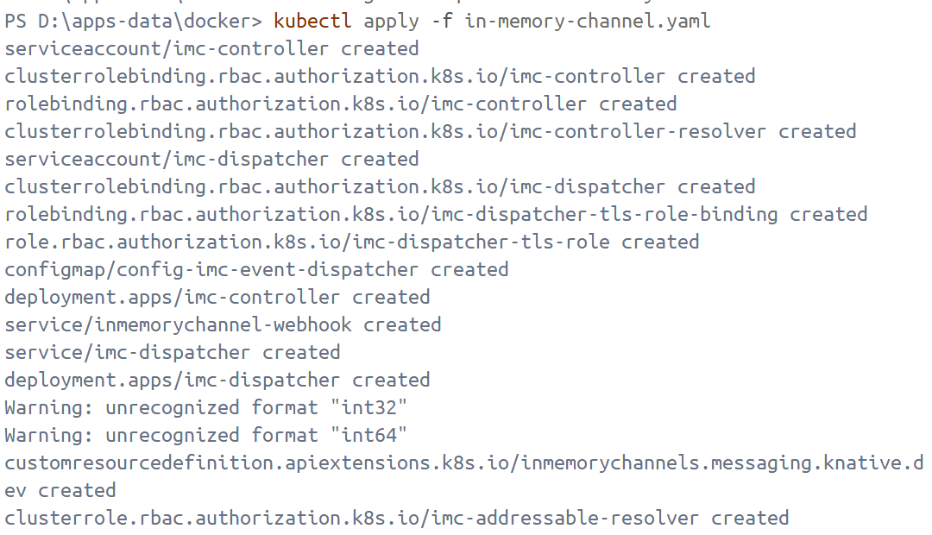
.\kn broker create example-broker -n default
.\kn broker list -n default
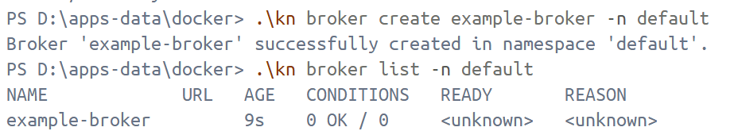
At this point, it shows that there are no URLs under the broker, and Ready=unknown. Check using the following command.
kubectl get pods -n knative-eventing | findstr broker
kubectl describe broker example-broker -n default
The Broker specified is MTChannelBasedBroker, which also points to config-br-default-channel. However, there are no MT Broker controller/data plane components running in the cluster (knative-eventing only contains kafka-broker-receiver, not mt-broker-controller/broker-ingress/broker-filter). Therefore, it will never generate status/conditions and will always show <unknown>. Therefore, the mt-channel-broker component needs to be installed.
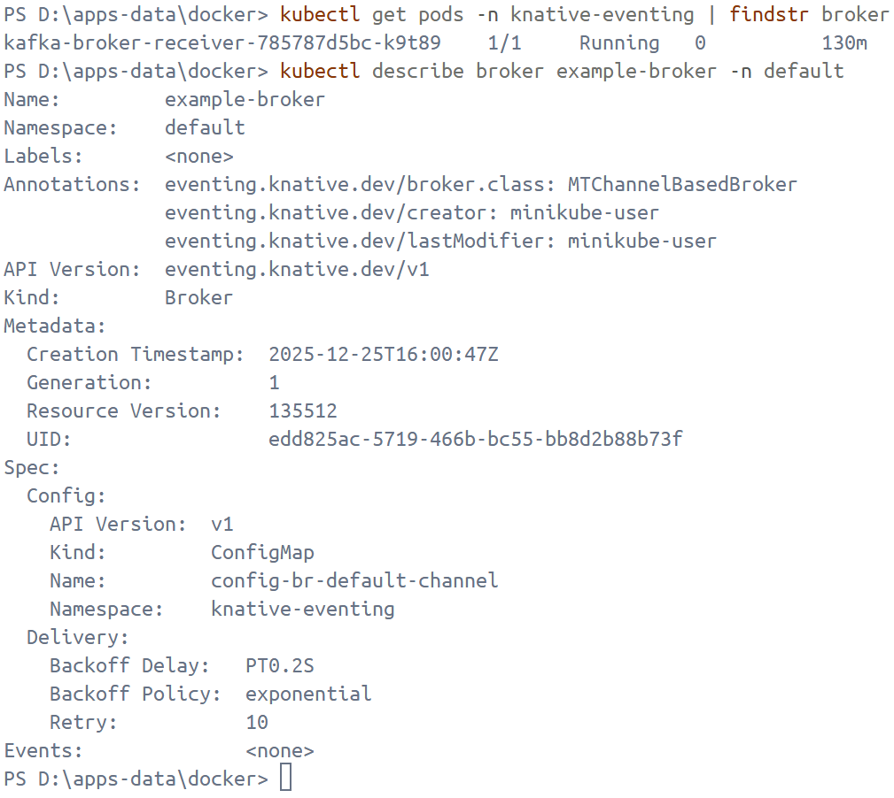
Download mt-channel-broker.yaml from https://github.com/knative/eventing/releases/download/knative-v1.20.0/mt-channel-broker.yaml and then apply it.
kubectl apply -f D:\apps-data\docker\mt-channel-broker.yaml
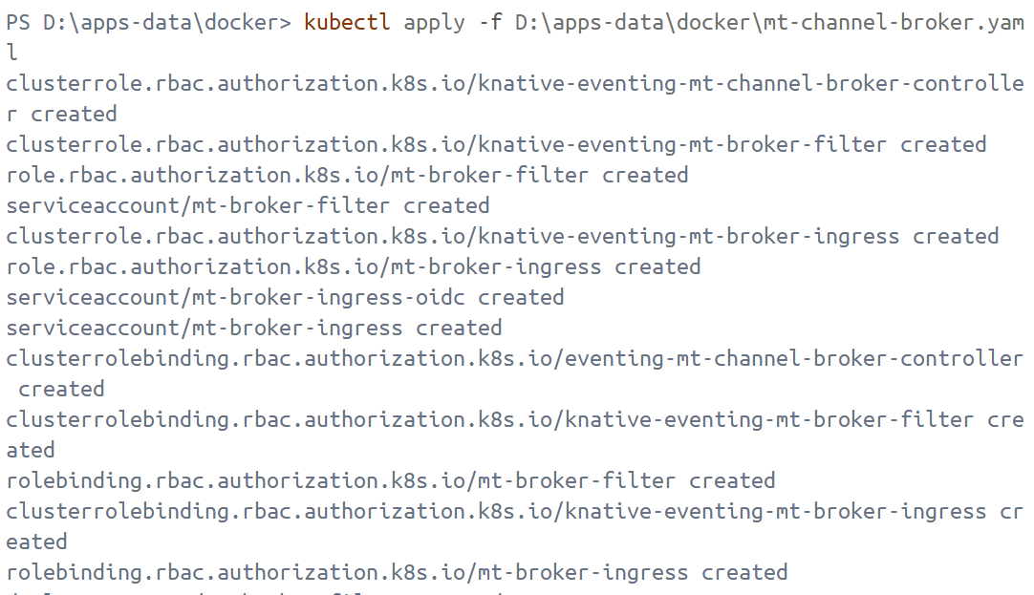
kubectl get pods -n knative-eventing | findstr -i "broker mt-broker ingress filter"
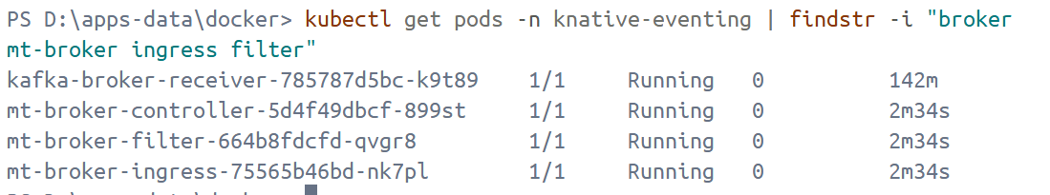
kubectl wait broker/example-broker -n default --for=condition=Ready=True --timeout=180s
.\kn broker list -n default
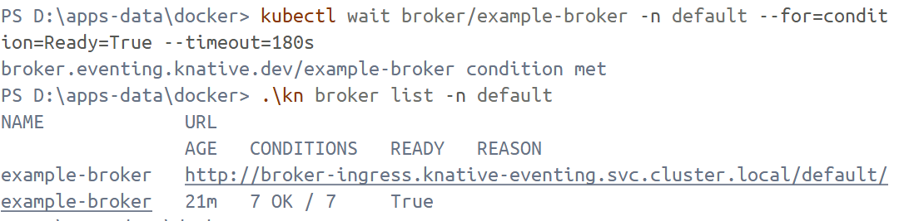

Using a Knative Service as a source
cloudevents-player.yaml
apiVersion: serving.knative.dev/v1
kind: Service
metadata:
name: cloudevents-player
spec:
template:
metadata:
annotations:
autoscaling.knative.dev/min-scale: "1"
spec:
containers:
- image: quay.io/ruben/cloudevents-player:latest
Apply the YAML file
kubectl apply -f .\yaml\cloudevents-player.yaml
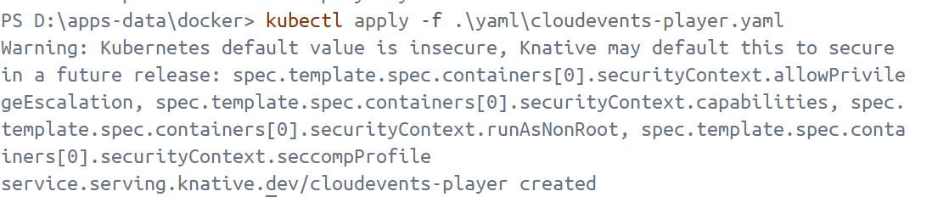
Open the following directory with administrator privileges: C:\Windows\System32\drivers\etc\hosts. Add the following line to the end: 127.0.0.1 cloudevents-player.default.example.com. Then open your browser and enter http://cloudevents-player.default.example.com:18080/
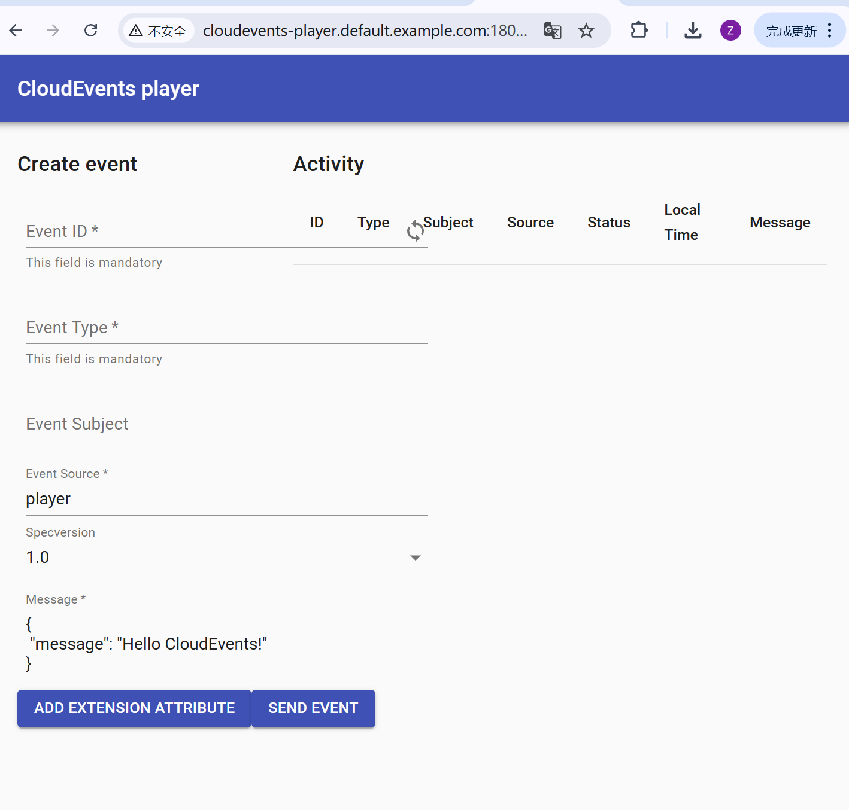These fields mean:
Field | Description
Event ID | A unique ID. Click the loop icon to generate a new one.
Event Type | An event type.
Event Source | An event source.
Specversion | Demarcates which CloudEvents spec you're using (should always be 1.0).
Message | The data section of the CloudEvent, a payload which is carrying the data you care to be delivered.

Sending an event using the CloudEvents Player interface
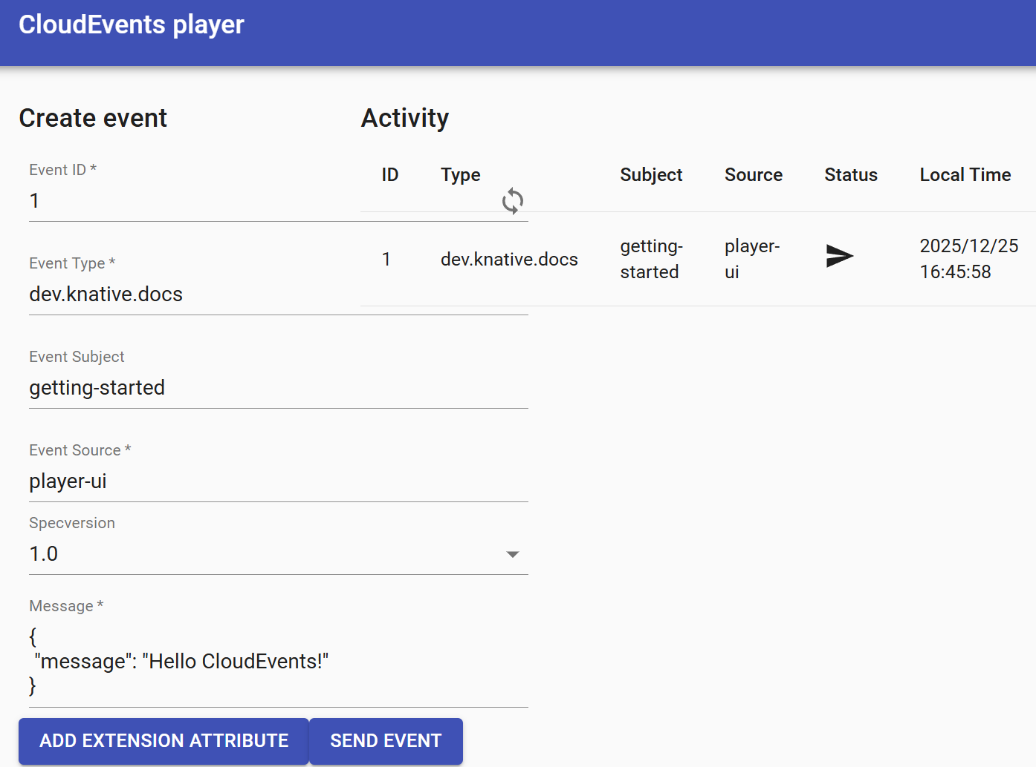
Clicking the icon like envelop shows you the CloudEvent as the Broker sees it.
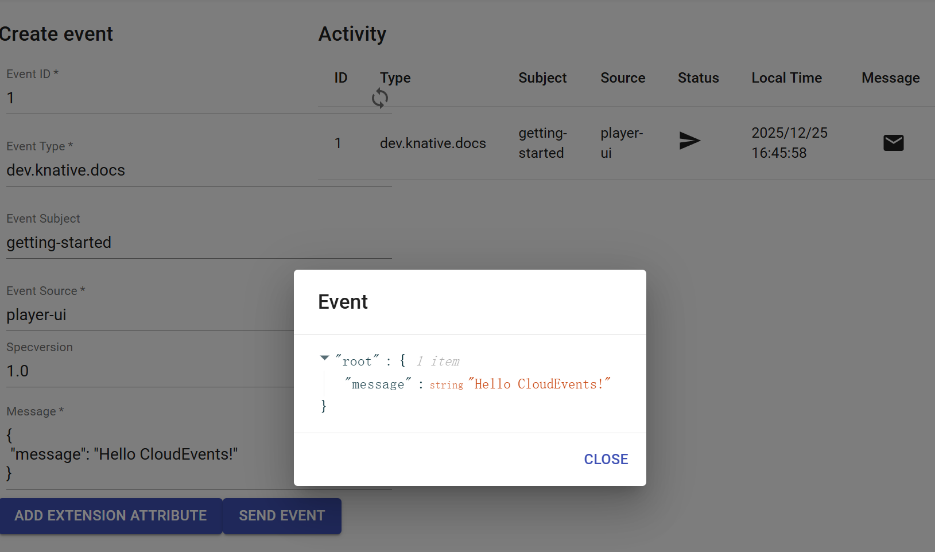

Send events using the command line
curl.exe -X POST http://127.0.0.1:18080/ `
-H "Host: cloudevents-player.default.example.com" `
-H "Ce-Id: 123456789" `
-H "Ce-Specversion: 1.0" `
-H "Ce-Type: some-type" `
-H "Ce-Source: command-line" `
-H "Content-Type: application/json" `
-d "{""msg"":"" Hello CloudEvents! ""}"
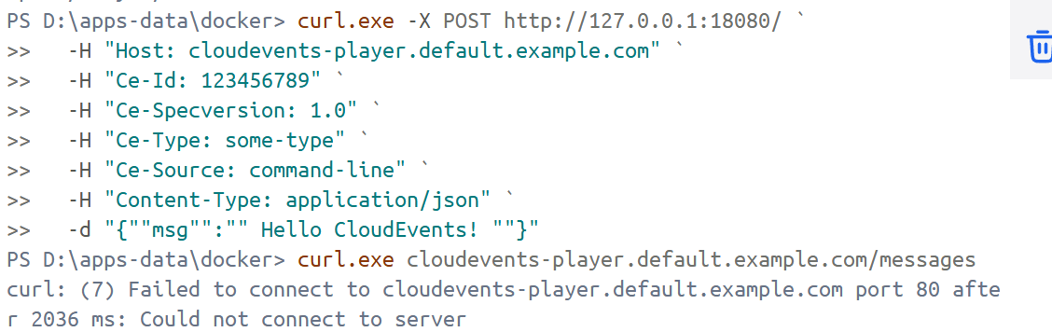
Entering `kubectl logs -n default cloudevents-player-00002-deployment-cd76b487-tg8gl --tail=200` to view the logs of cloudevents-player reveals:
This usually happens when the data actually looks like this: {msg:Hello} (the field name isn't in quotes), or the data is stored as a string or incorrectly escaped, resulting in it not being standard JSON.
My use of -d "{""msg"":""Hello CloudEvents!""}" looks correct in PowerShell, but when actually passed, it might produce unexpected content (especially due to different quotes/escaping).
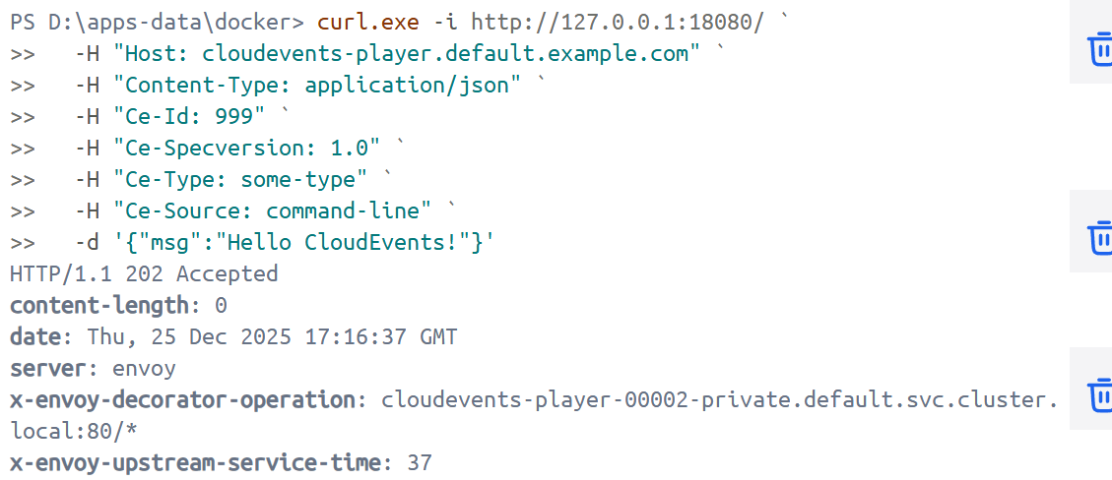

Using Triggers and sinks
ce-trigger.yaml
apiVersion: eventing.knative.dev/v1
kind: Trigger
metadata:
name: cloudevents-trigger
annotations:
knative-eventing-injection: enabled
spec:
broker: example-broker
subscriber:
ref:
apiVersion: serving.knative.dev/v1
kind: Service
name: cloudevents-player
Create the Trigger
kubectl apply -f ce-trigger.yaml
Delete the existing Trigger
kn trigger delete cloudevents-trigger
Add a Trigger that listens for a certain CloudEvent Type
kn trigger create cloudevents-player-filter --sink cloudevents-player --broker example-broker --filter type=some-type
