Installation with Docker
- Create a docker-compose.yml
The file sequentially lists the network gitea, the gitea service gitea-server, and the database service gitea-mysql-server.
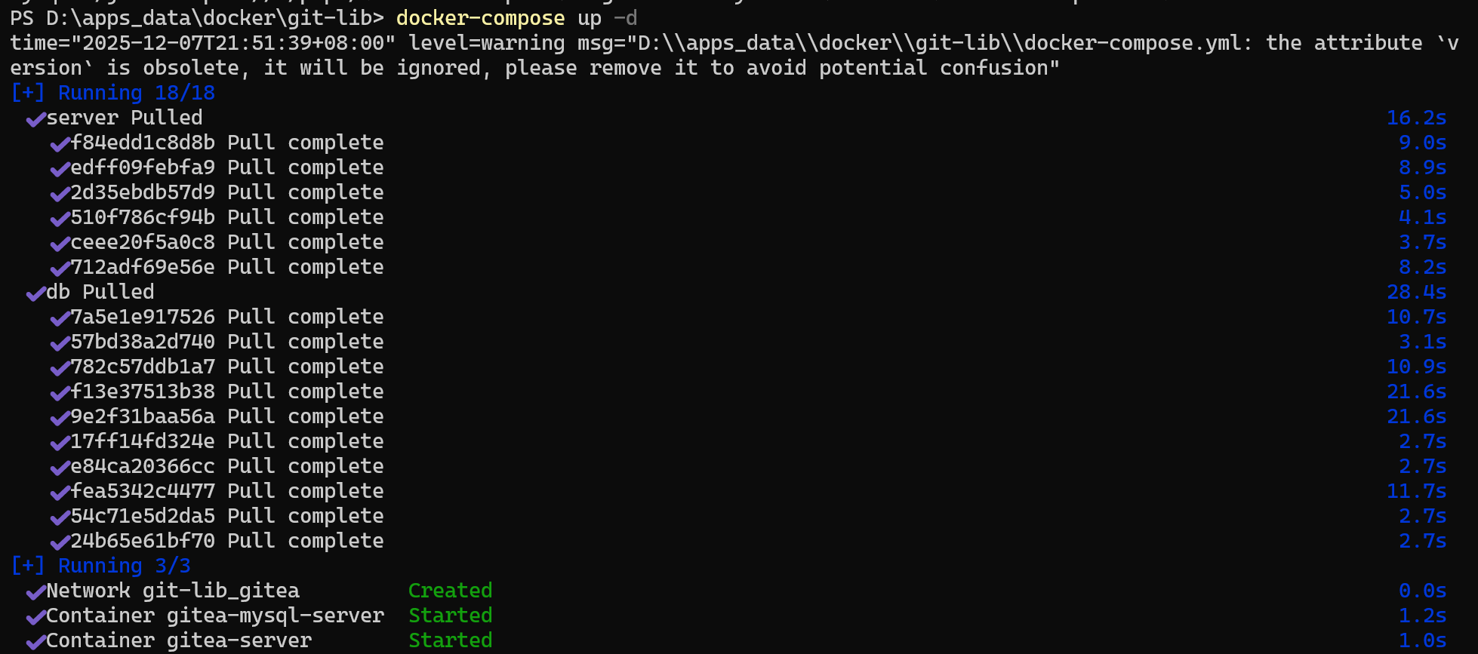
- Start up
Open PowerShell and enter the directory that docker-compose.yml belongs to. Enter the following command: docker-compose up -d.
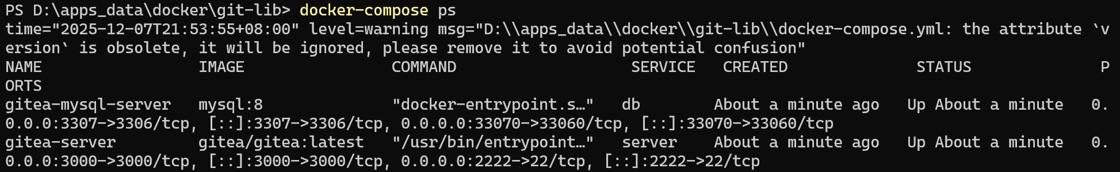
Note: the gitea and mysql:8 mirrors are pulled to your local machine in advance. If they are not pulled in advance, the information you see will show the additional pulling process.
- Access
Once the above service starts successfully, you can access Gitea. By default, you can access it using localhost:3000 or your local IP address:3000.
- Database setting: Gitea supports various database types including MySQL, PostgreSQL, MSSQL, and SQLite3. This practice uses MySQL, so MySQL is selected. Other configuration values ​​should remain consistent with the database configuration in `docer-compose.yml`.
Note: The database host configuration `db:3306` means that when gitea-server accesses data, it will directly access the data via network port 3306, without needing to access it through port 3307 exposed by the database service.
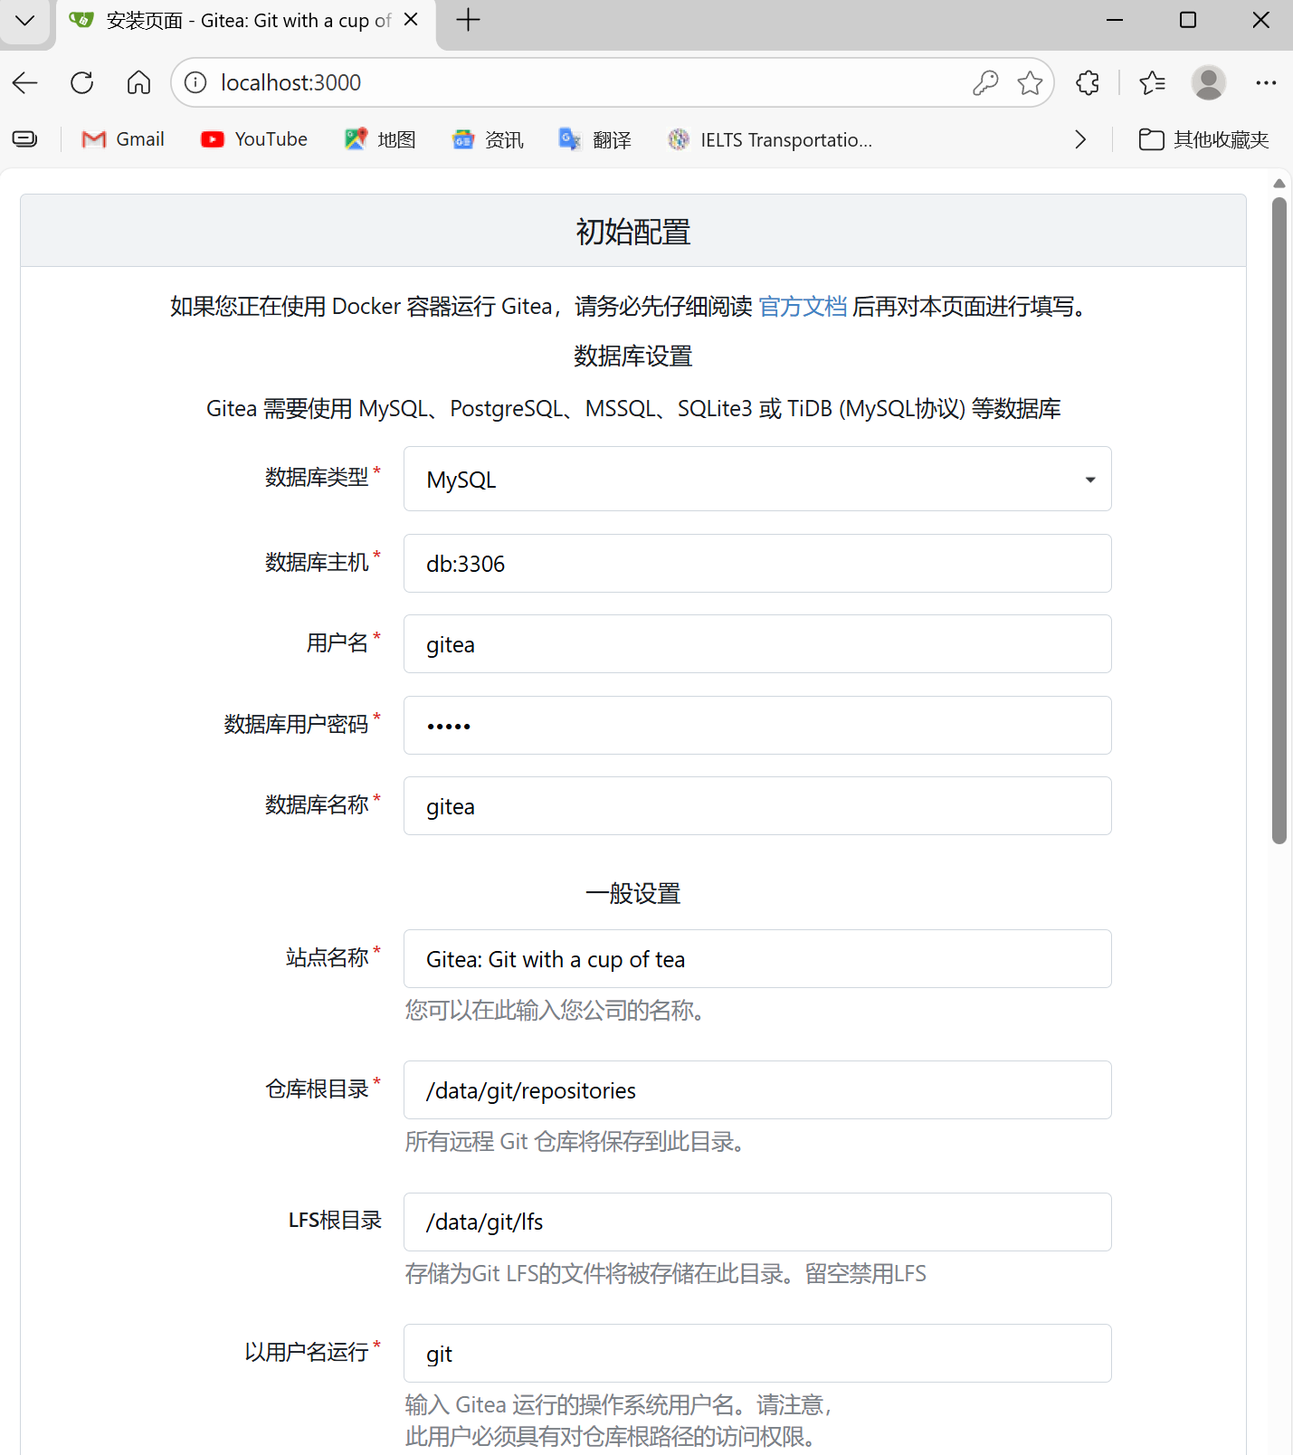
- General Settings
General settings are used to configure information related to the Gitea server container. The configurable items are shown below.
- Does Gitea support LFS? Prove it.
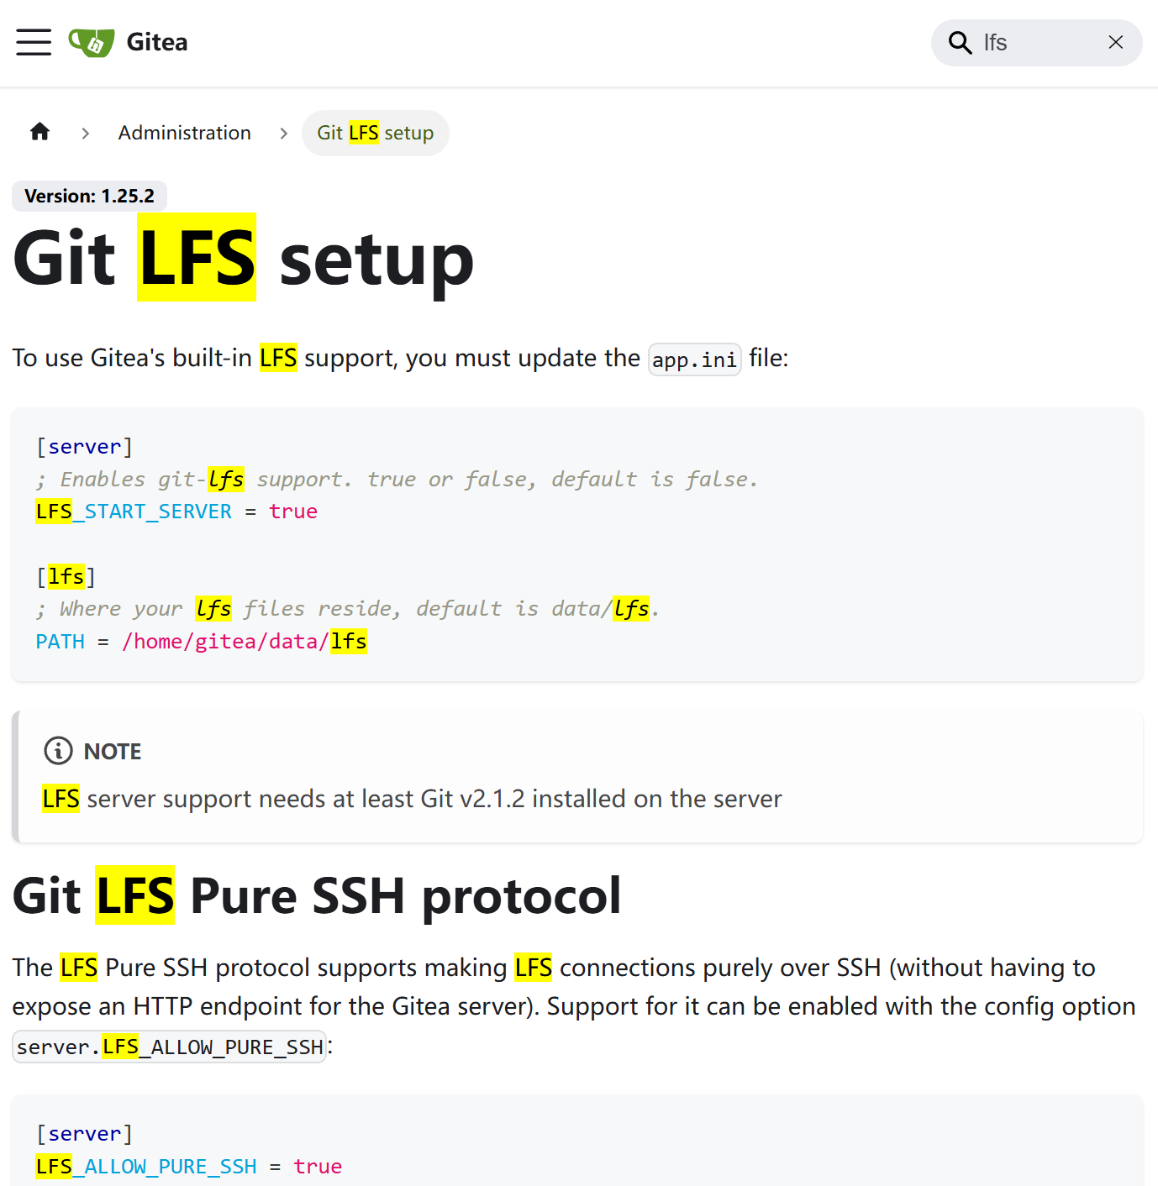

- Create a repo with a large file (1G+)
Here Git is needed. I installed it according to https://blog.csdn.net/weixin_73435127/article/details/155746513.
Create a repo named as large-file-test
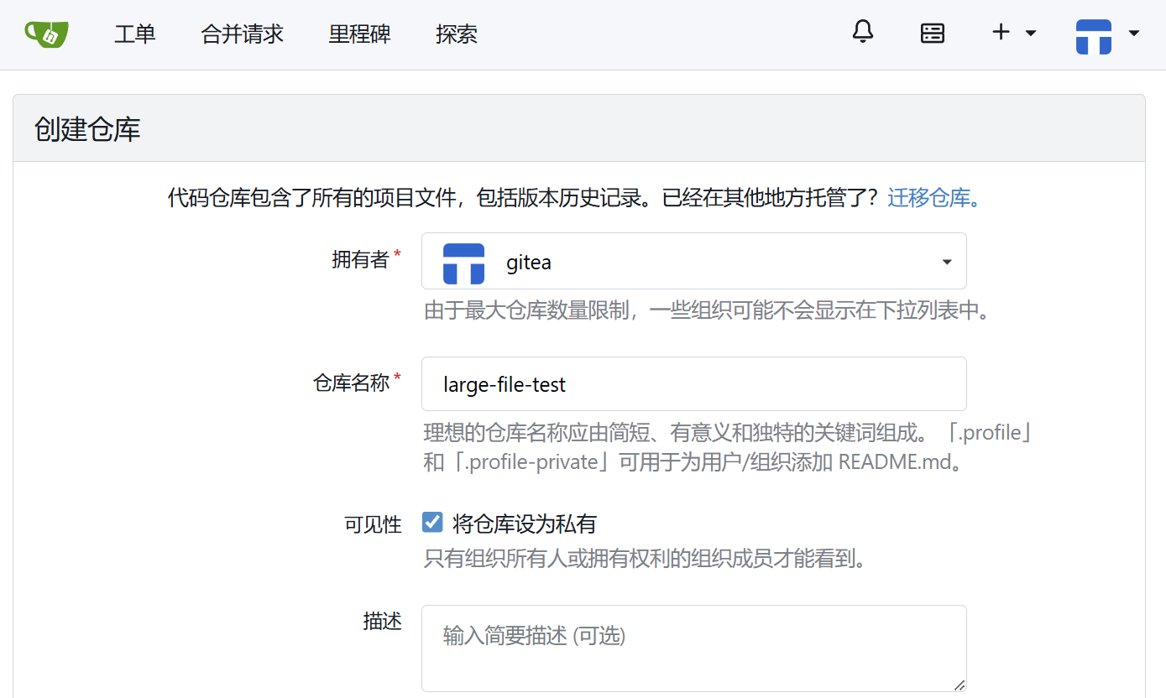
In a local Gitea environment, a 1GB file was successfully created, committed, and pushed using Git LFS. Git only manages pointers, while LFS is responsible for storing and transferring the actual large file.
Command:
git clone http://localhost:3000/gitea/large-file-test.git
cd large-file-test
git lfs track "*.dat"
git add .gitattributes
fsutil file createnew bigfile.dat 1073741824
git add bigfile.dat
git commit -m "Add 1GB large test file"
git push
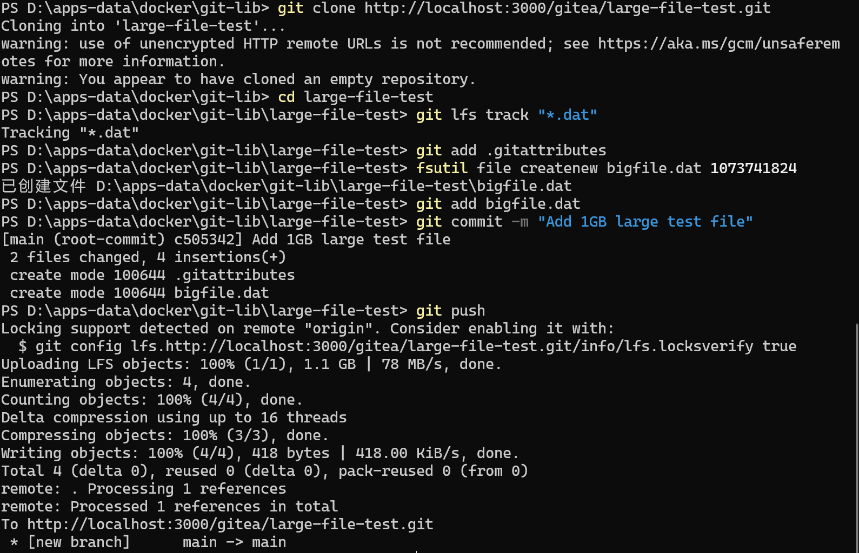
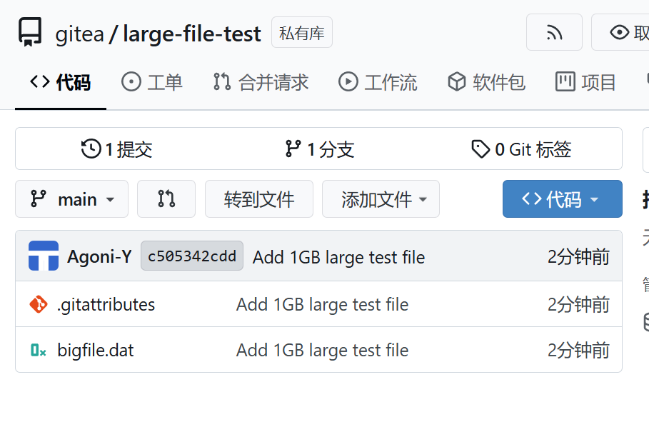
- Backup all data to an external harddrive/USB stick and restore it from another computer.
Copy D:\apps_data\docker\git-lib\ to a USB drive, then paste it to another computer (using the same directory in this case) and save it as D:\apps_data\docker\git-lib\. Open the directory in cmd and execute D:\apps_data\docker\git-lib\. Then gitea will restore the user, restore all repos, restore LFS files, etc.

Install Gitea without Docker
First, download gitea-1.23.6-windows-4.0-amd64.exe from https://dl.gitea.com/gitea/1.23.6/ and save it to D:\gitea. Then, open CMD in that directory and type the web command gitea-1.23.6-windows-4.0-amd64.exe to launch Gitea. The following setting is similar with the above one. However, the database is chosen as SQLite3 because MySQL is very complicated.
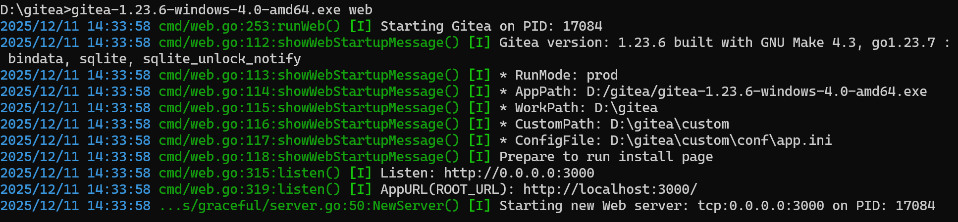
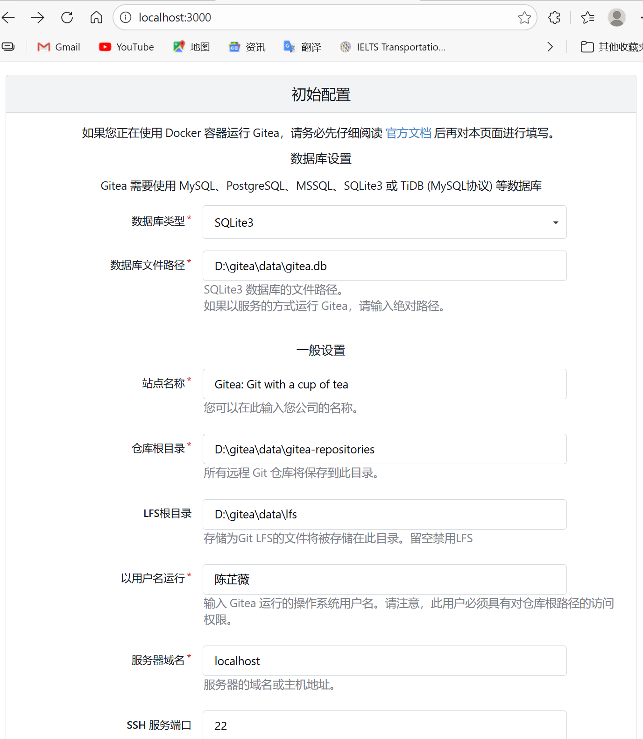
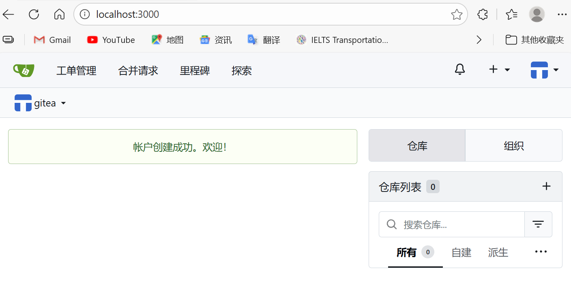

Summary
Port conflicts are likely to occur when installing without Docker.
