Content
What is a container? 2
what-is-an-image 4
What is Docker Compose? 5
Publishing and exposing ports 6
Use the Docker CLI 7
Use the Docker CLI 7
Overriding container defaults 8
Persisting container data 11
Sharing local files with containers 14
Multi-container applications 16

What is a container?
- run a container using the CLI
Command: docker run -d -p 8080:80 docker/welcome-to-docker
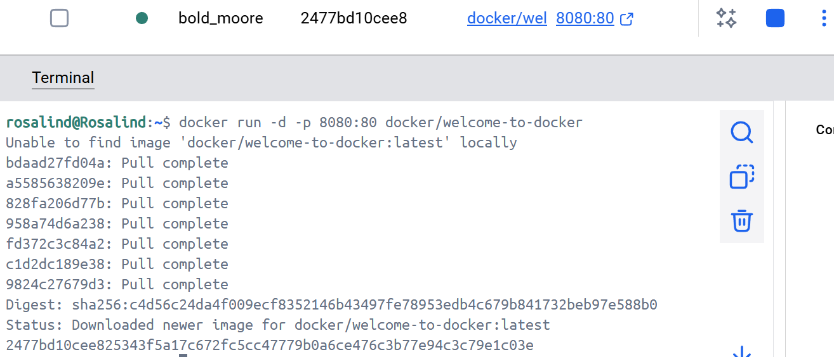
- View the running containers
Command: docker ps
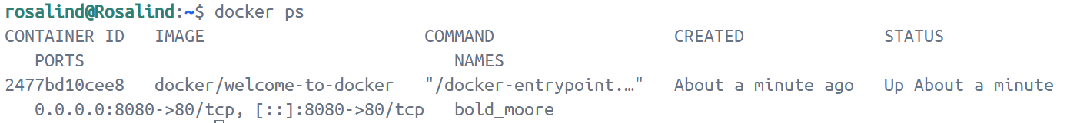
- Access the frontend from http://localhost:8080
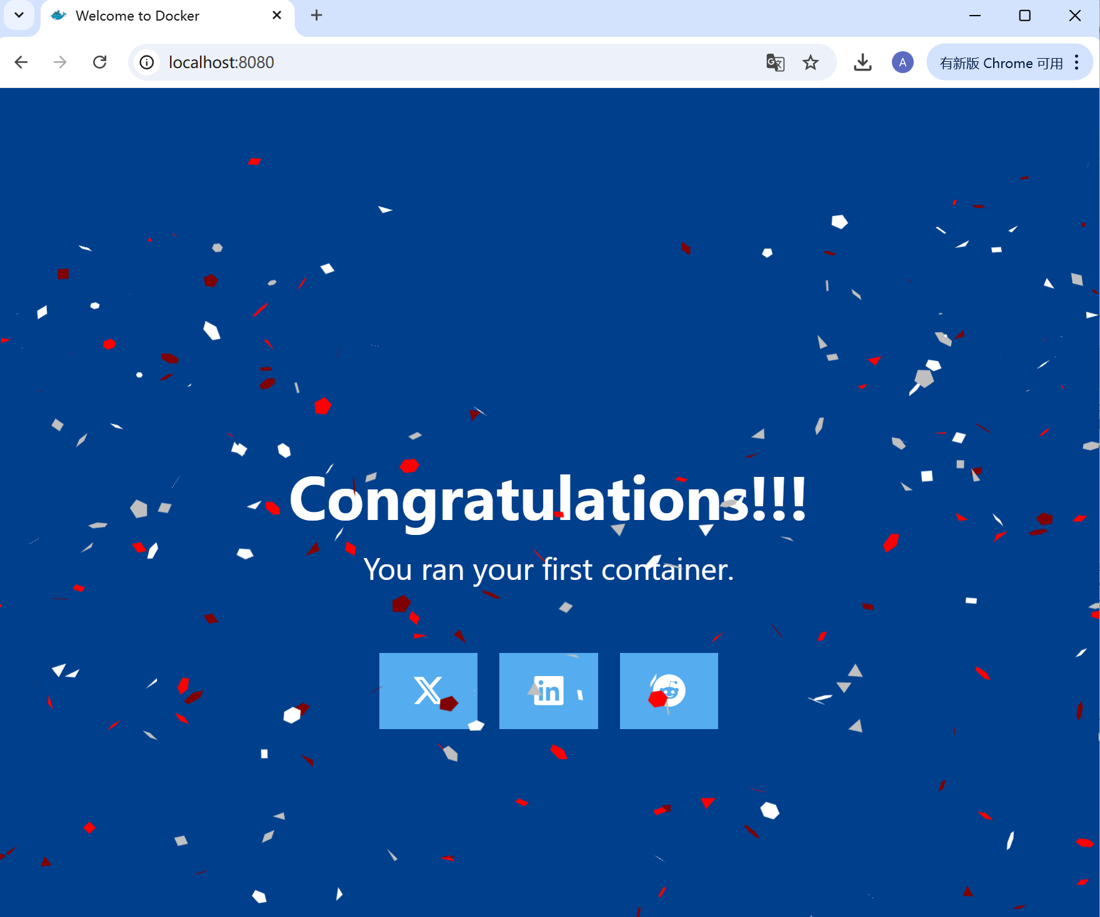
- Stop the container
First, run docker ps to get the ID of the container. Here Container ID is 2477bd10cee825343f5a17c672fc5cc47779b0a6ce476c3b77e94c3c79e1c03e.
Then Provide the container ID to the docker stop command
docker stop 2477bd10cee825343f5a17c672fc5cc47779b0a6ce476c3b77e94c3c79e1c03e
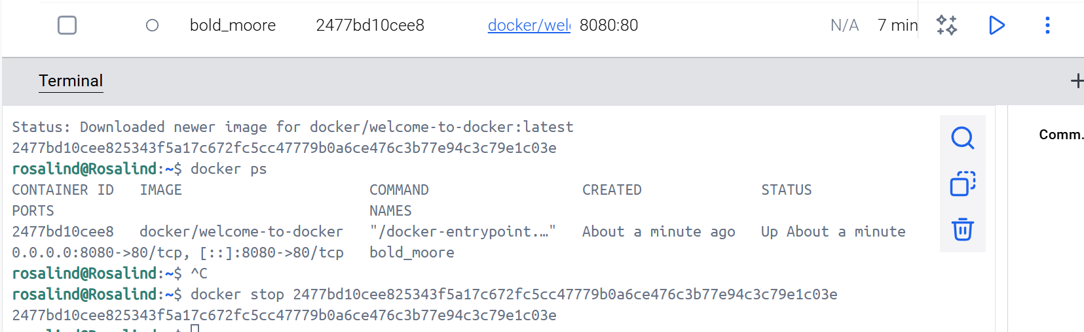

what-is-an-image
- search for images using the docker search command
docker search docker/welcome-to-docker
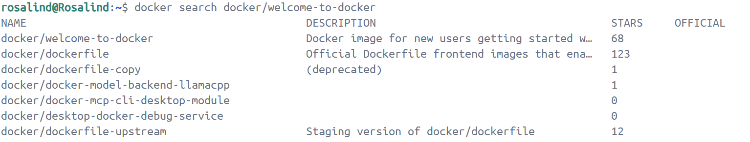
Here it shows the available images relatedt docker/welcome-to-docker on Docker Hub.
- Pull the image using the docker pull command.
docker pull docker/welcome-to-docker
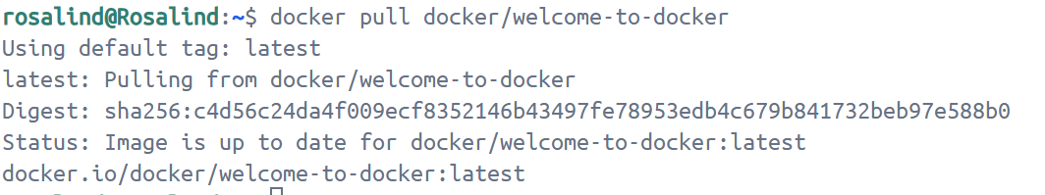
- List the downloaded images
docker image ls
The command shows a list of Docker images currently available on your system. The docker/welcome-to-docker has a total size of approximately 22.2MB, which represented here reflects the uncompressed size of the image, not the download size of the layers.
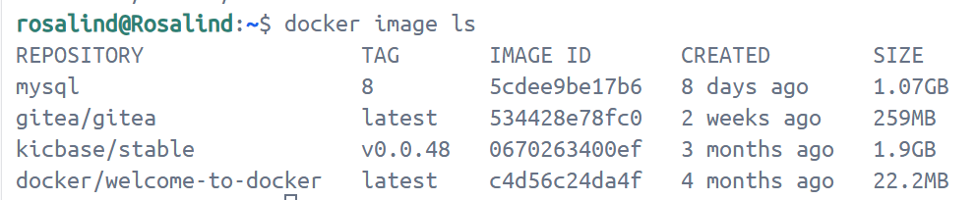
- List the image's layers
docker image history docker/welcome-to-docker
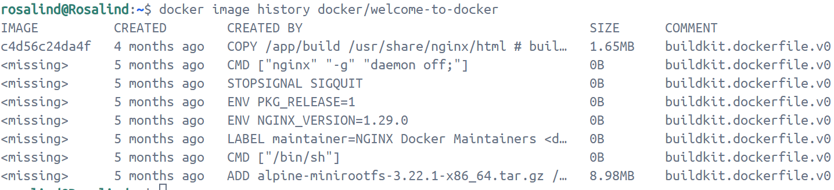

What is Docker Compose?
git clone https://github.com/dockersamples/todo-list-app
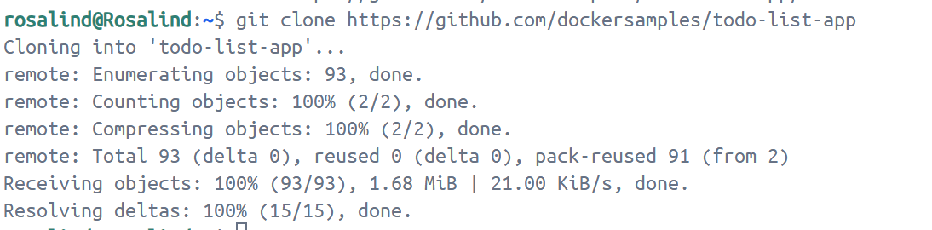
cd todo-list-app
docker compose up -d --build
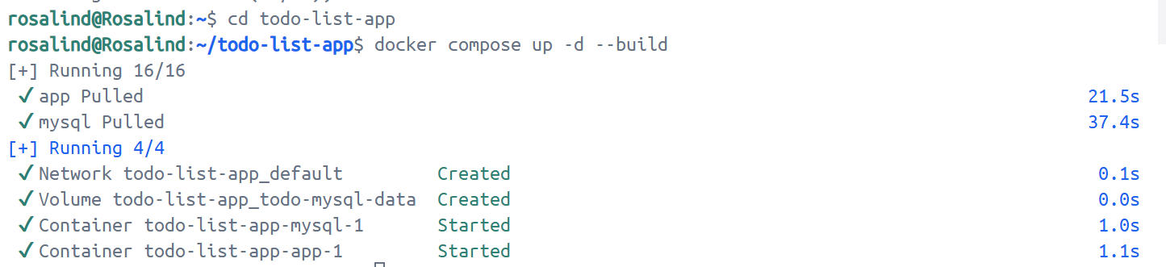
From this screenshot, it shows:
- Two container images were downloaded from Docker Hub - node and MySQL
- A network was created for the application
- A volume was created to persist the database files between container restarts
- Two containers were started with all of their necessary config
Open http://localhost:3000 in the browser.
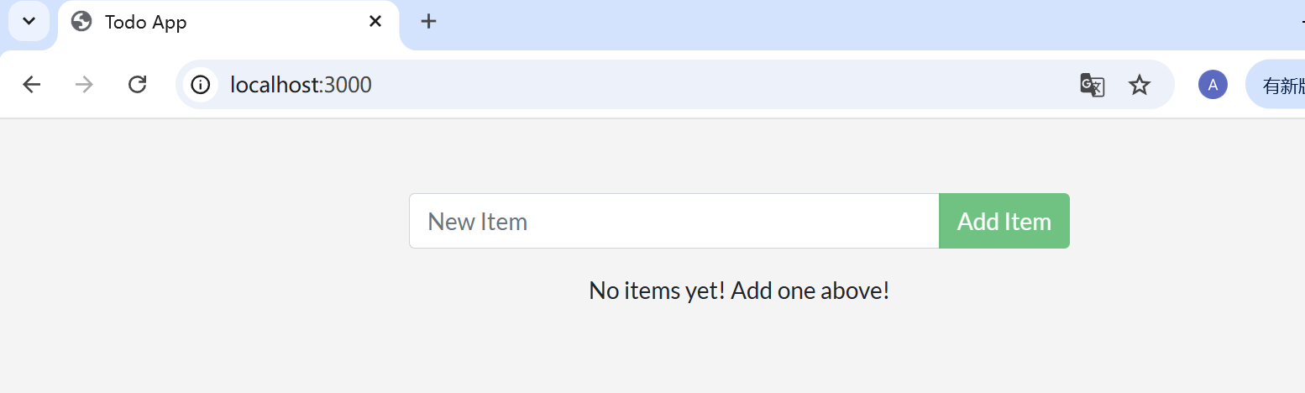
Look at the Docker Desktop GUI, we can see that the containers and dive deeper into their configuration.

Tear down the application when we are done.
Enter the command docker compose down in CLI to remove everything.
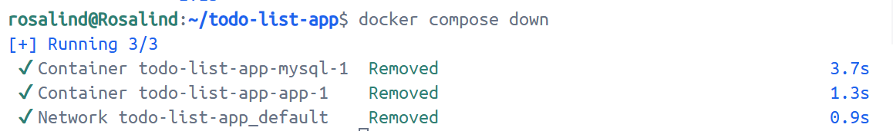

Publishing and exposing ports
- Publish the container's port 80 to host port 8080
docker run -d -p 8080:80 nginx
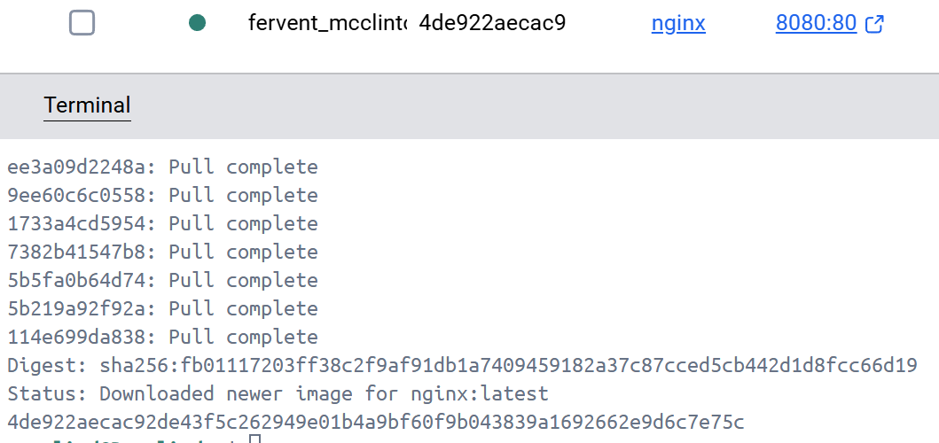
- publish the container’s port 80 onto an ephemeral port on the host:
docker run -p 80 nginx
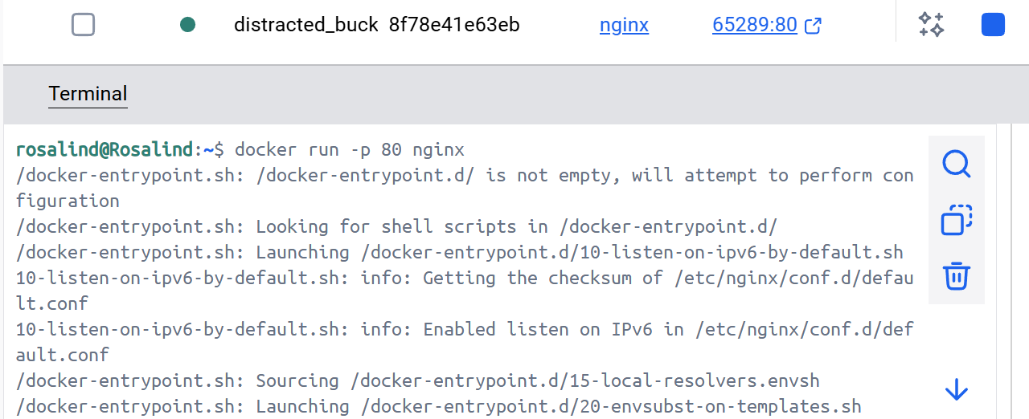
Then use docker ps to show the chosen port once the container is running
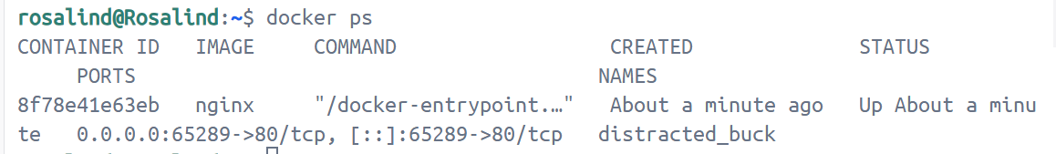
- publish all exposed ports to ephemeral ports with the -P or --publish-all flag
docker run -P nginx
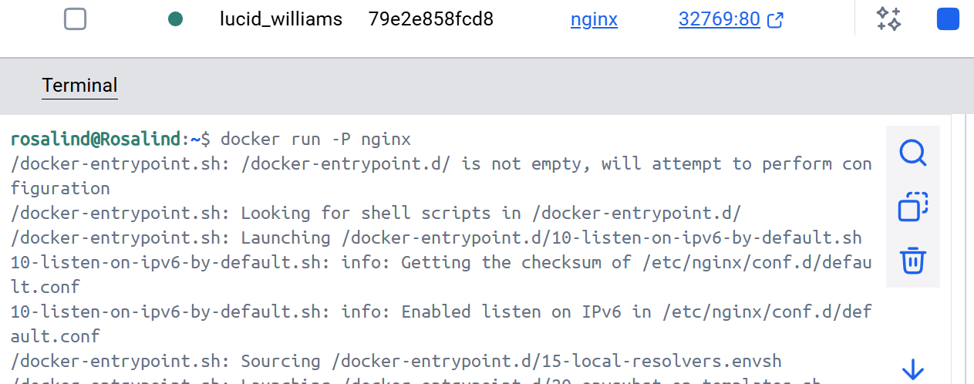

Use the Docker CLI
Start a new container: docker run -d -p 8080:80 docker/welcome-to-docker
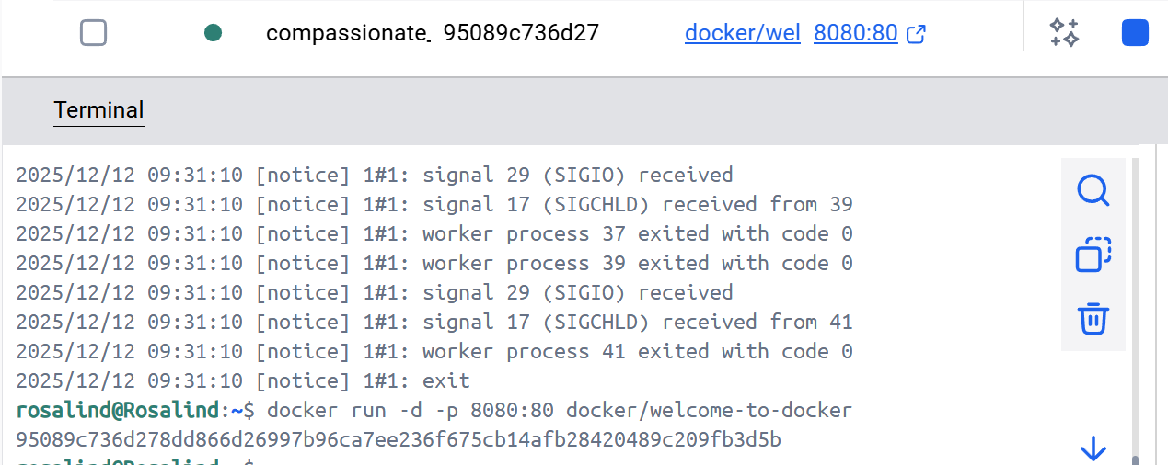
Open the website by either selecting the link in the Port(s) column of the container like http://localhost:8080.


Use the Docker CLI
Create a compose.yaml file with the dollowing contents:
services:
app:
image: docker/welcome-to-docker
ports:
- 8080:80
Then enter the docker run command to run a container,
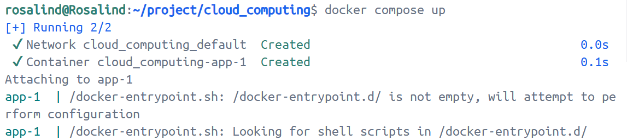
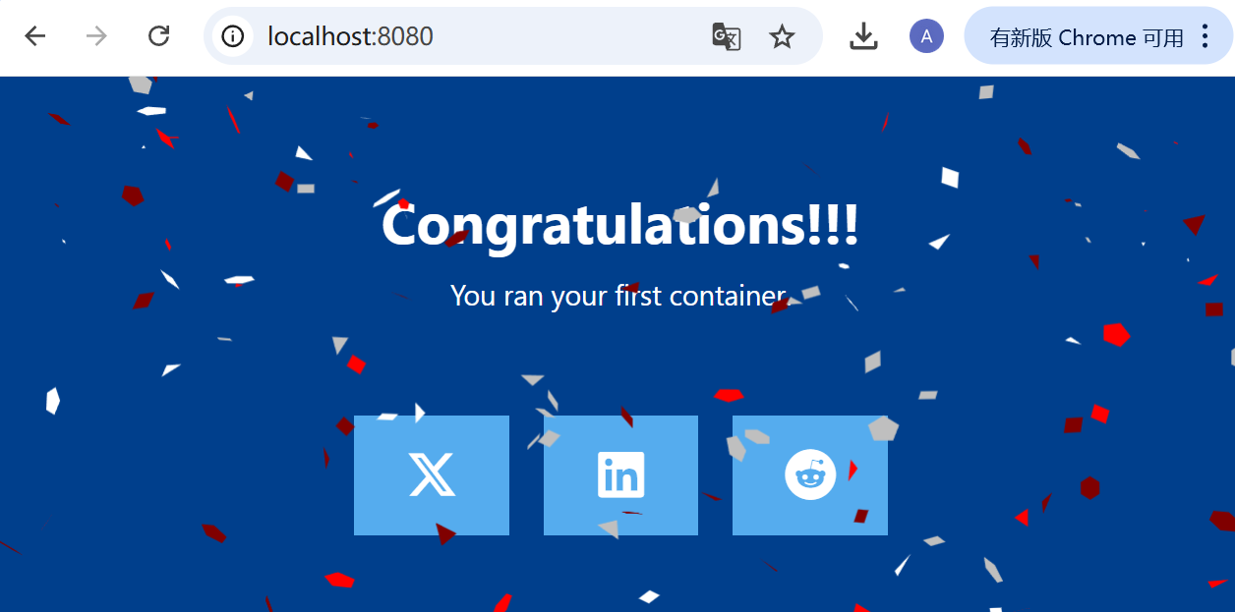

Overriding container defaults
- Sets an environment variable foo inside the container with the value bar.
docker run -e foo=bar postgres env
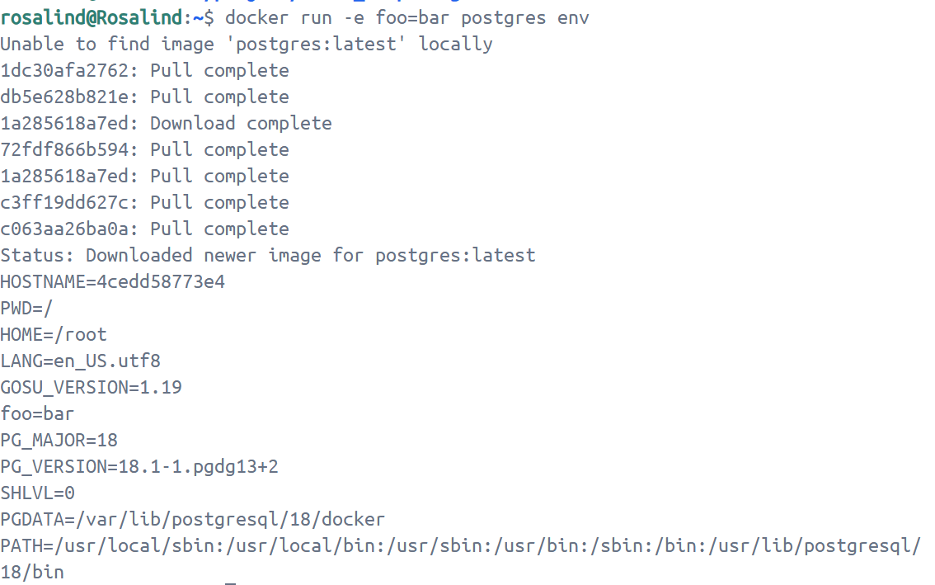
- Use the --memory and --cpus flags with the docker run command to restrict how much CPU and memory a container can use.
docker run -e POSTGRES_PASSWORD=secret --memory="512m" --cpus="0.5" postgres
Here the command limits container memory usage to 512 MB and defines the CPU quota of 0.5 for half a core.
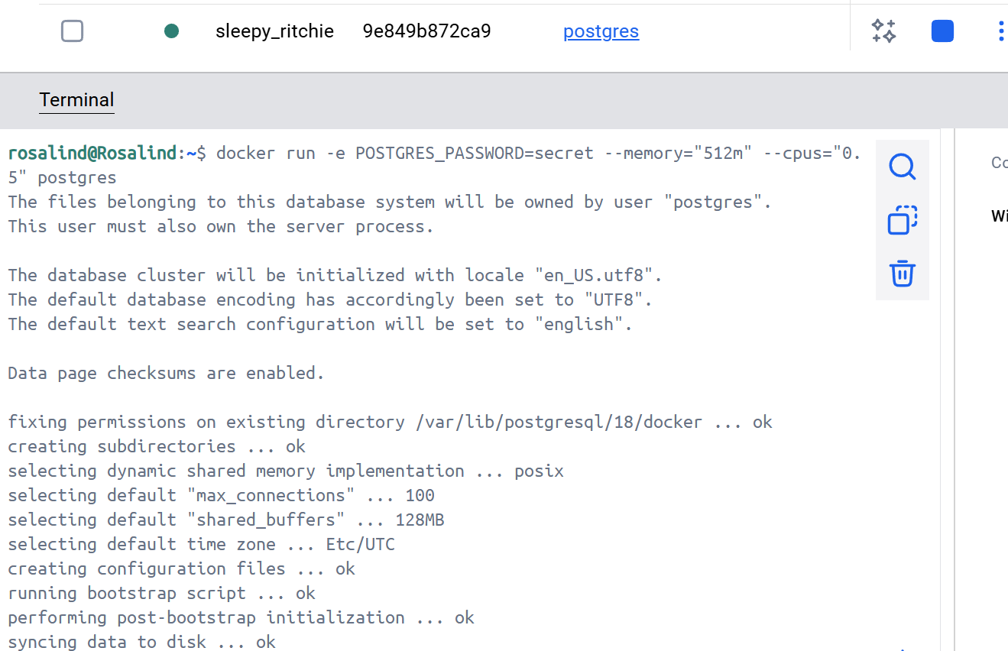
- Use the docker stats command to monitor the real-time resource usage of running containers. This helps to understand whether the allocated resources are sufficient or need adjustment.
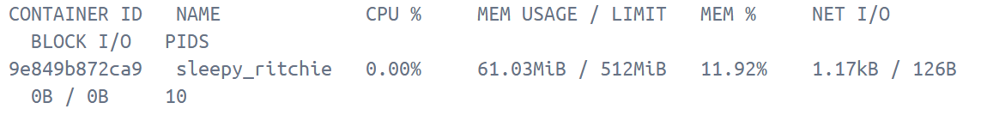
- Start the Postgres database in the background, listening on the standard container port 5432 and mapped to port 5432 on the host machine.
docker run -d -e POSTGRES_PASSWORD=secret -p 5432:5432 postgres
- Start another Postgres container in the background, listening on the standard postgres port 5432 in the container, but mapped to port 5433 on the host machine.
docker run -d -e POSTGRES_PASSWORD=secret -p 5433:5432 postgres
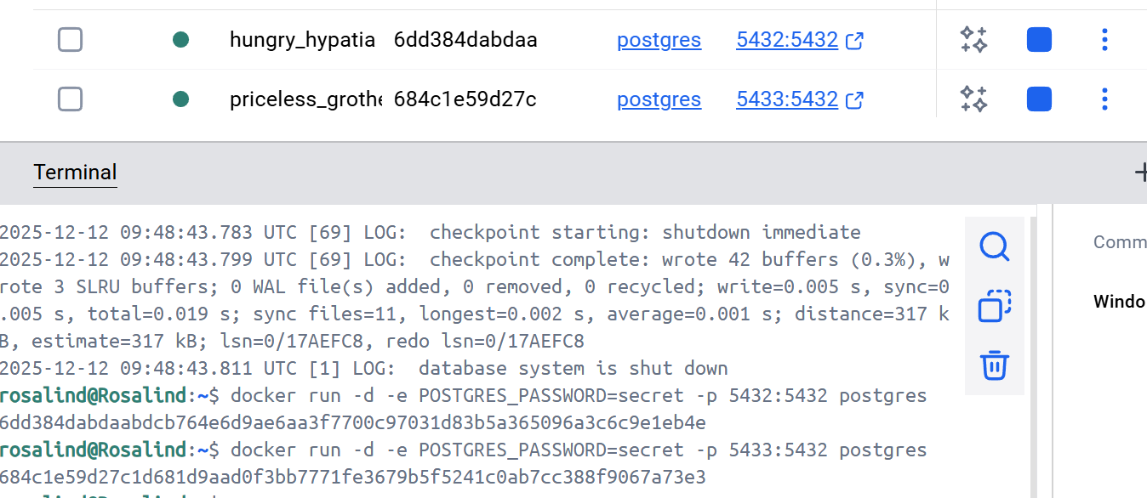
- Create a new custom network
docker network create mynetwork
- Verify the network by listing all networks, including the newly created "mynetwork".
docker network ls
- Connect Postgres to the custom network
docker run -d -e POSTGRES_PASSWORD=secret -p 5434:5432 --network mynetwork postgres
This will start Postgres container in the background, mapped to the host port 5434 and attached to the mynetwork network.
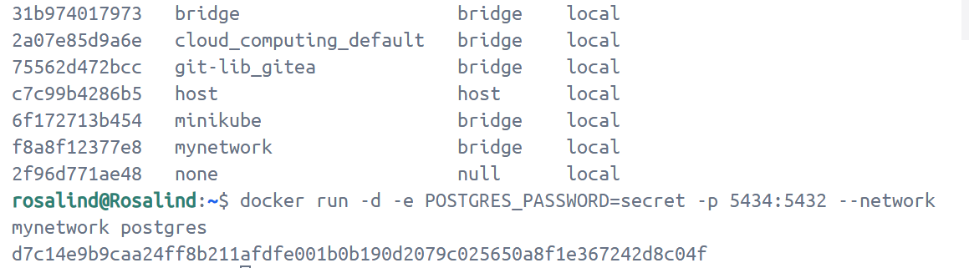
- Run a container whose CPU and memory are restricted by flags --memory and --cpus
docker run -d -e POSTGRES_PASSWORD=secret --memory="512m" --cpus=".5" postgres
The --cpus flag specifies the CPU quota for the container. Here, it's set to half a CPU core (0.5) whereas the --memory flag specifies the memory limit for the container. In this case, it's set to 512 MB.
- Use Docker compose to override the default commands (CMD) or entry points (ENTRYPOINT) defined in a Docker image
services:
postgres:
image: postgres:18
entrypoint: ["docker-entrypoint.sh", "postgres"]
command: ["-h", "localhost", "-p", "5432"]
environment:
POSTGRES_PASSWORD: secret
The Compose file defines a service named postgres that uses the official Postgres image, sets an entrypoint script, and starts the container with password authentication.
- Bring up the service by running docker compose up -d
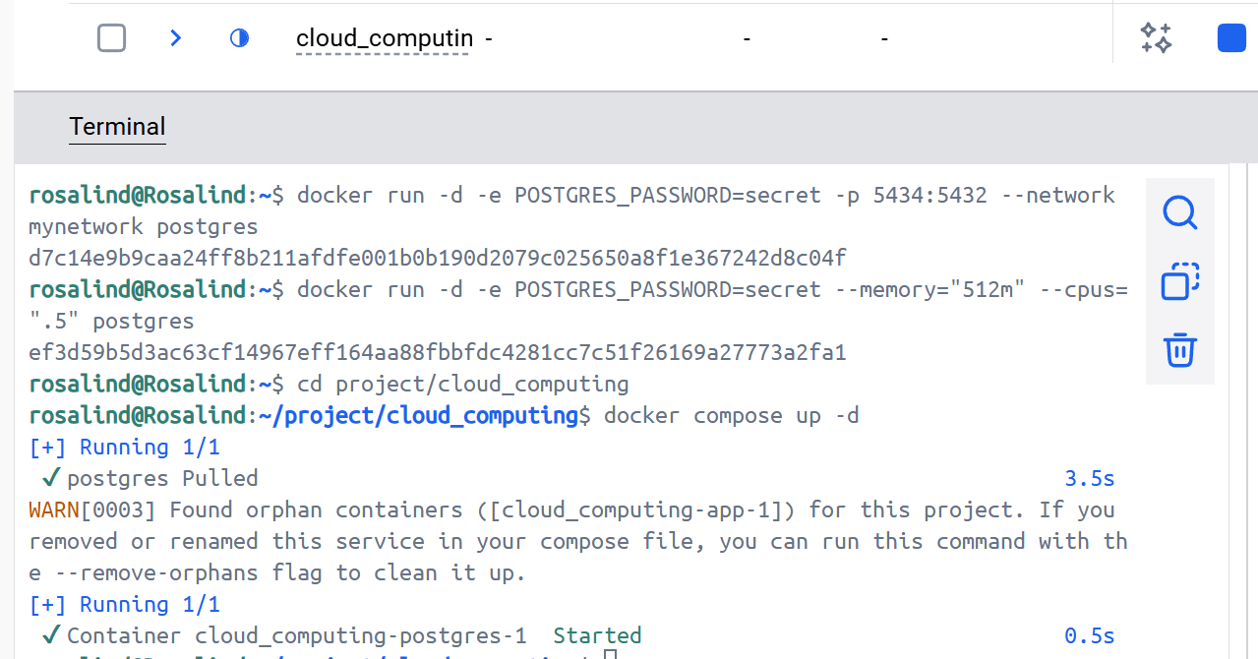
- Open the Docker Desktop Dashboard, select the Postgres container and select Exec to enter into the container shell.
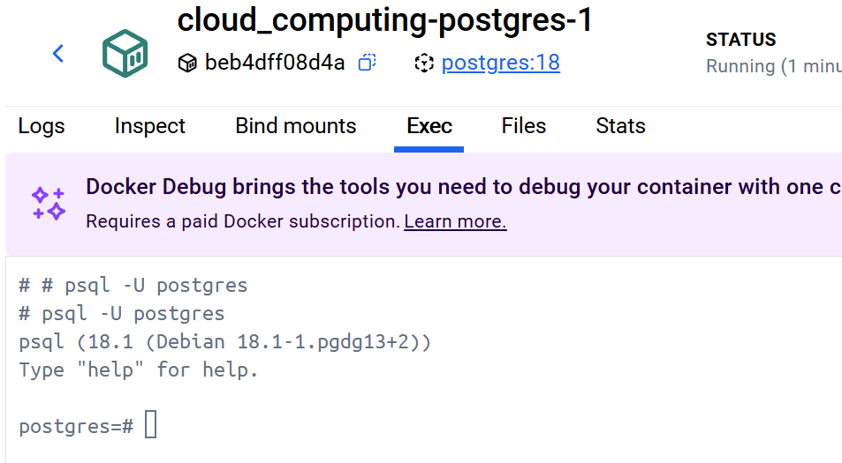
- Override defaults directly using docker run -e POSTGRES_PASSWORD=secret postgres docker-entrypoint.sh -h localhost -p 5432
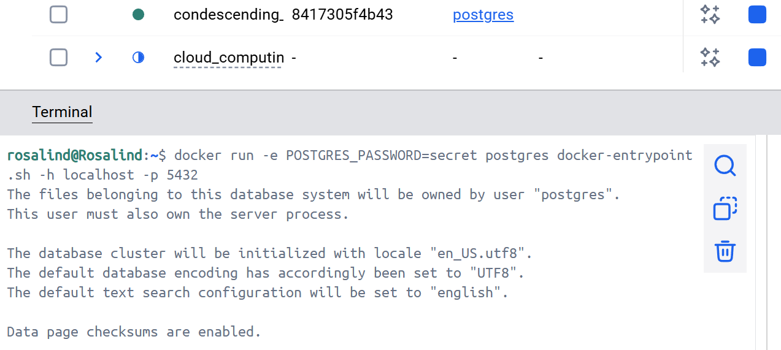

Persisting container data
- Create a volume named as log-data
docker volume create log-data
- When starting a container with the following command, the volume will be mounted (or attached) into the container at /logs
docker run -d -p 80:80 -v log-data:/logs docker/welcome-to-docker
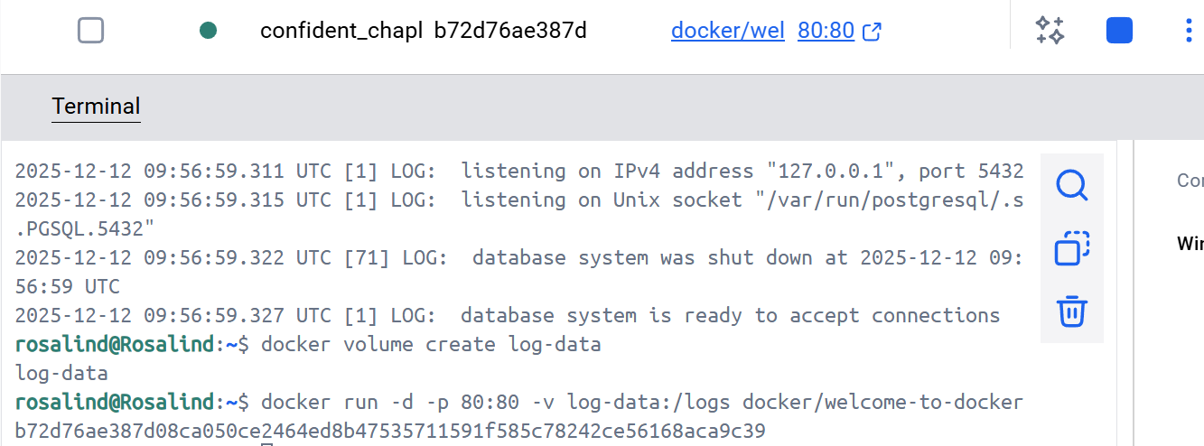
- list all volumes: list all volumes
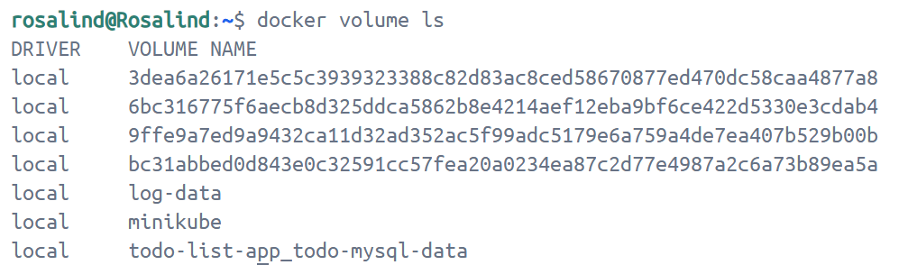
- docker volume rm <volume-name-or-id>: remove a volume (only works when the volume is not attached to any containers)
- docker volume prune: remove all unused (unattached) volumes
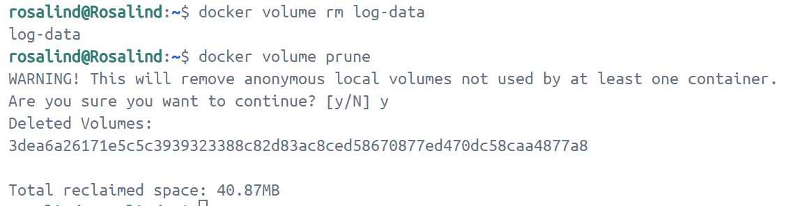
- Start a container using the Postgres image.
docker run --name=db -e POSTGRES_PASSWORD=secret -d -v postgres_data:/var/lib/postgresql postgres:18
This will start the database in the background, configure it with a password, and attach a volume to the directory PostgreSQL will persist the database files.
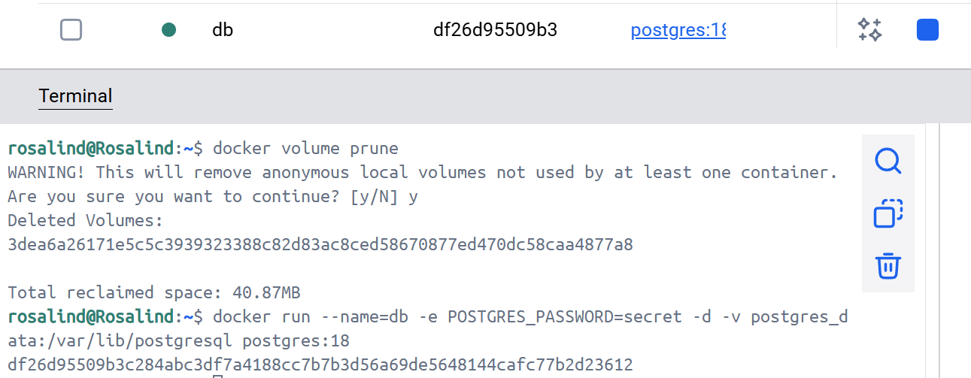
- Connect to the database
docker exec -ti db psql -U postgres
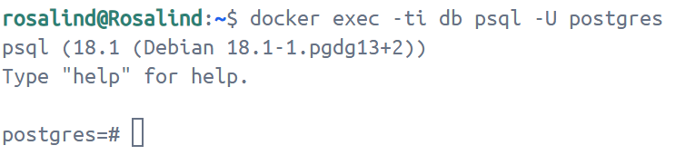
- In the PostgreSQL command line, run the following to create a database table and insert two records:
CREATE TABLE tasks (
id SERIAL PRIMARY KEY,
description VARCHAR(100)
);
INSERT INTO tasks (description) VALUES ('Finish work'), ('Have fun');
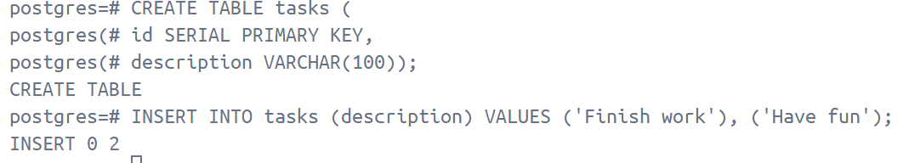
- Verify the data is in the database by running the following in the PostgreSQL command line
SELECT * FROM tasks;
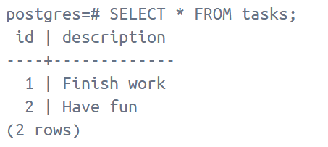
- \q: exit out of the PostgreSQL shell
- Stop and remove the database container. Note: even though the container has been deleted, the data is persisted in the postgres_data volume.
docker stop db
docker rm db
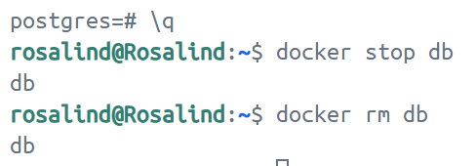
- Start a new container, attaching the same volume with the persisted data
docker run --name=new-db -d -v postgres_data:/var/lib/postgresql postgres:18
- Verify the database still has the records
docker exec -ti new-db psql -U postgres -c "SELECT * FROM tasks"
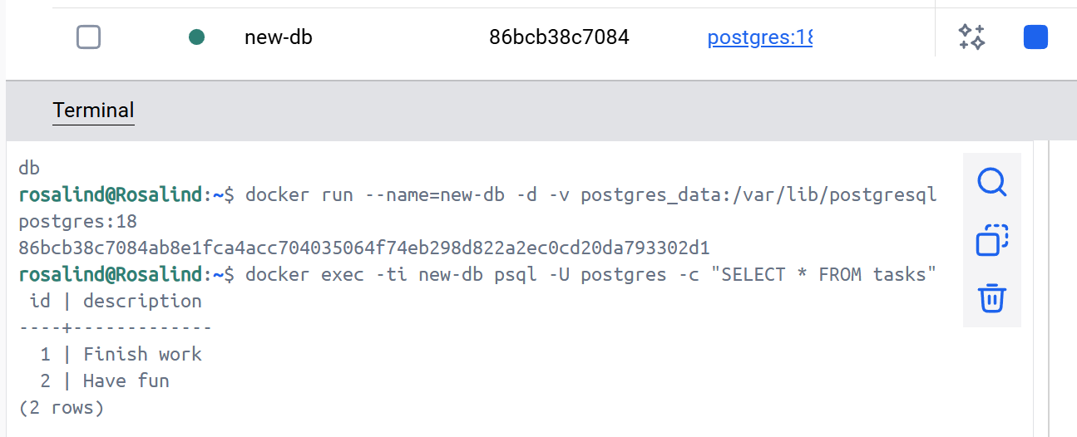
- View volume contents by the Docker Desktop Dashboard
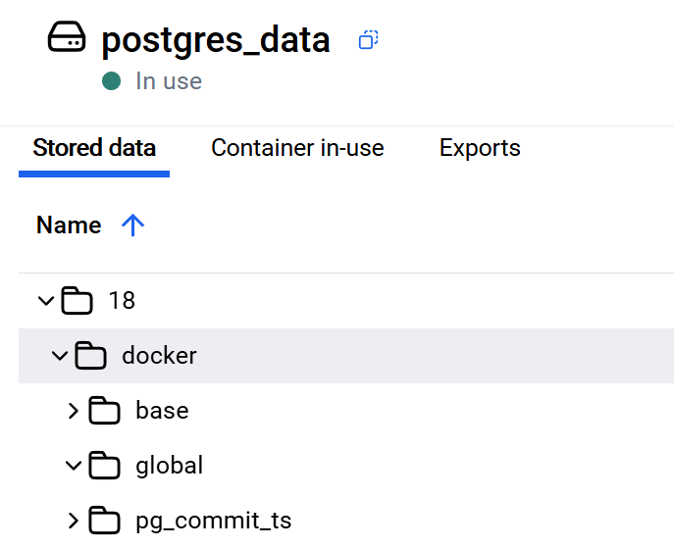
- Remove volumes:
  - docker rm -f new-db: -f means that it stop the container first and then remove it
  - docker volume rm postgres_data
  - docker volume prune: remove all unused volumes
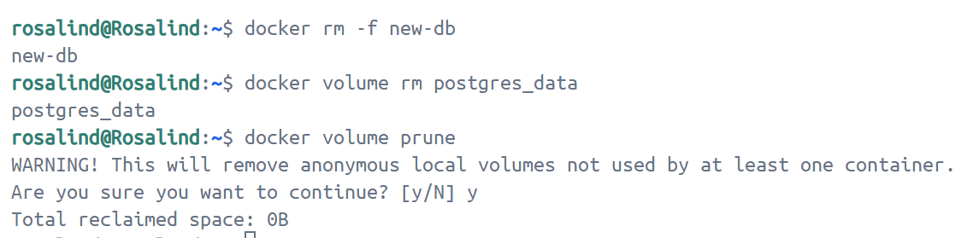

Sharing local files with containers
- Start a container using the httpd image
docker run -d -p 8080:80 --name my_site httpd:2.4
This will start the httpd service in the background, and publish the webpage to port 8080 on the host.
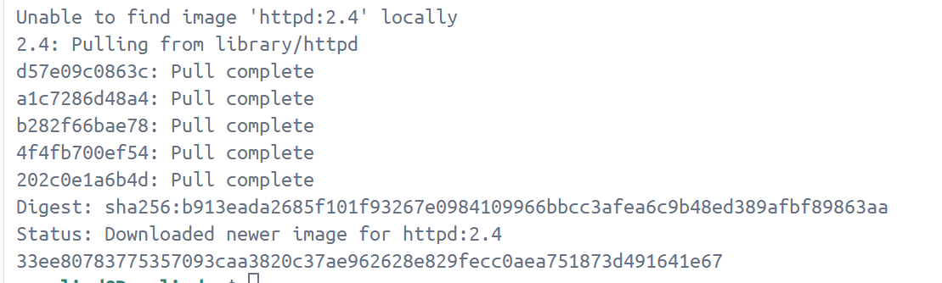
- Open http://localhost:8080 or use the curl command to verify if it's working fine or not

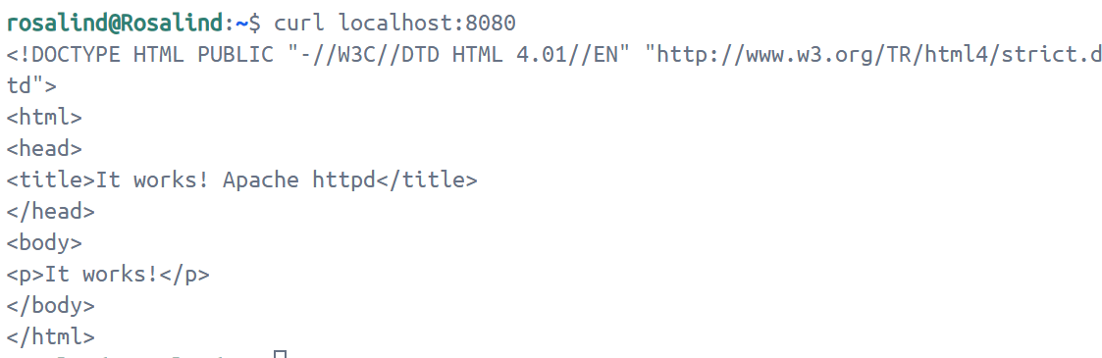
- Create a directory and create index.html in it.
<!DOCTYPE html>
<html lang="en">
<head>
<meta charset="UTF-8">
<title> My Website with a Whale & Docker!</title>
</head>
<body>
<h1>Whalecome!!</h1>
<p>Look! There's a friendly whale greeting you!</p>
<pre id="docker-art">
## .
## ## ## ==
## ## ## ## ## ===
/"""""""""""""""""\___/ ===
{ / ===-
\______ O __/
\ \ __/
\____\_______/

Hello from Docker!
</pre>
</body>
</html>
Then run the command docker run -d --name my_site -p 8080:80 -v .:/usr/local/apache2/htdocs/ httpd:2.4.
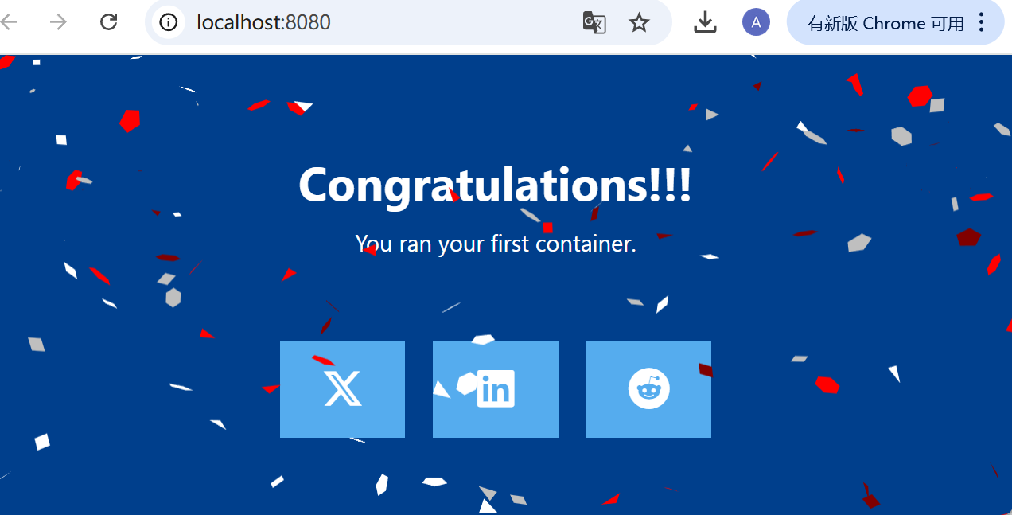
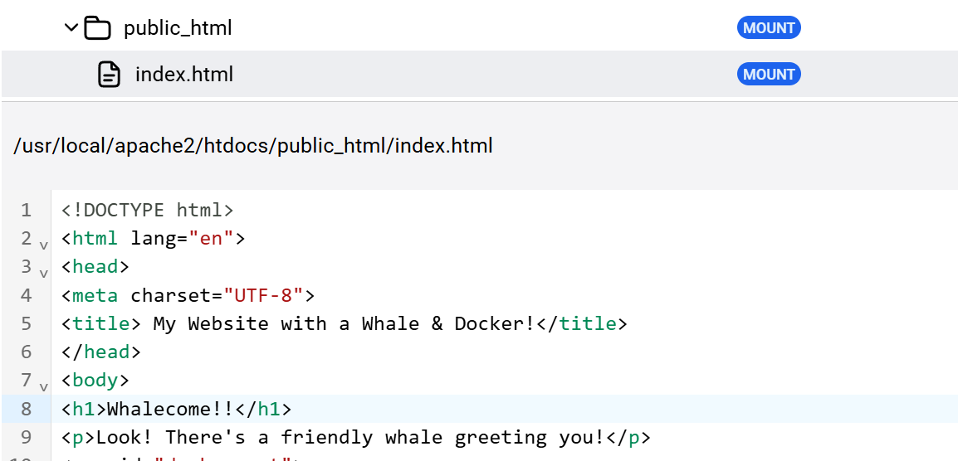
Then delete it, and create a new HTML file on the main computer. You'll find the file reappears under the Files tab under Containers on the Docker Desktop Dashboard.

Multi-container applications
- git clone https://github.com/dockersamples/nginx-node-redis
- cd nginx-node-redis
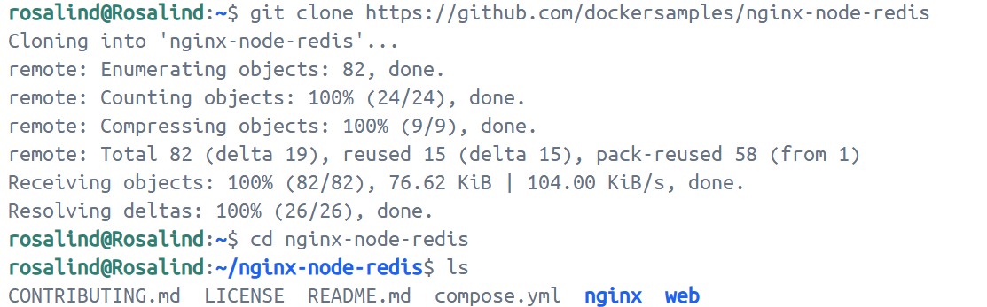
- docker build -t nginx .
Encountering a network connection problem that won't download
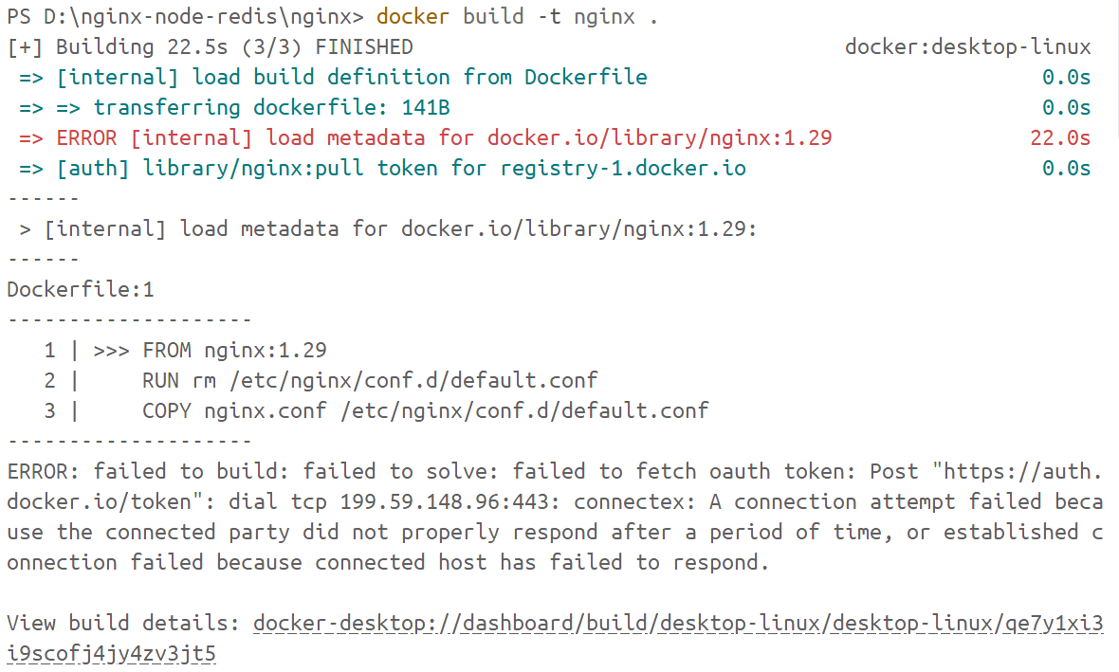
So I used a mirror website, based on https://mirrors.ustc.edu.cn/help/dockerhub.html
- navigate into the nginx directory to build the image
docker build -t nginx .
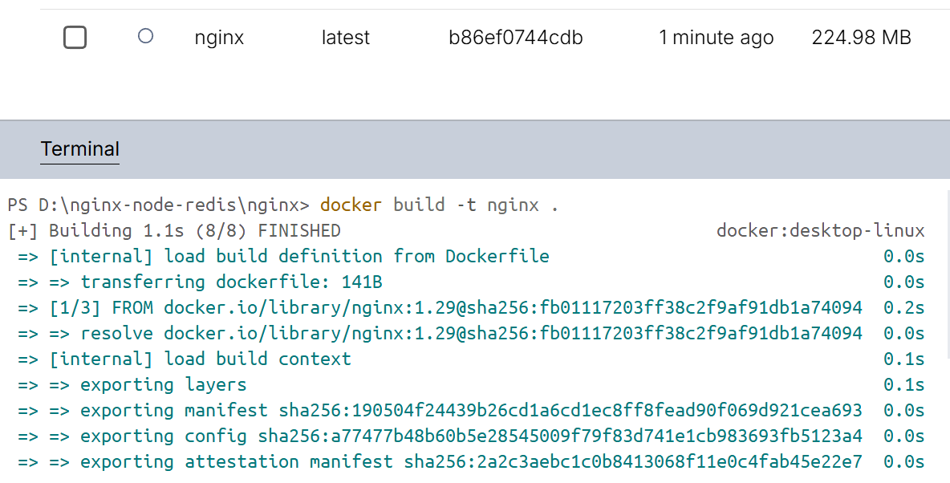
Similarly, first navigate to the web folder and enter `docker pull node:21`.
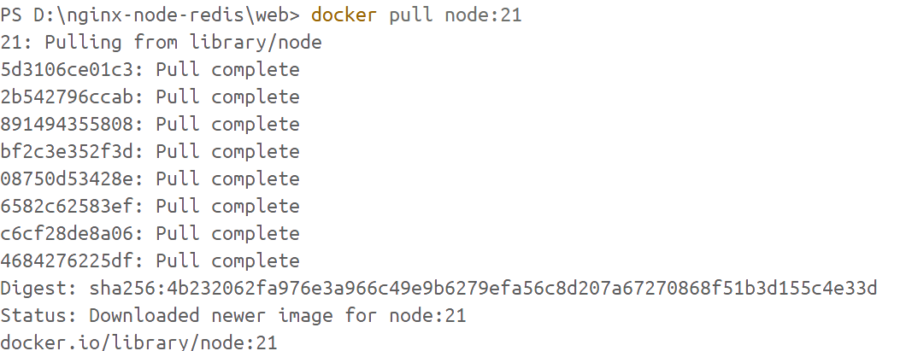
- Then Navigate into the web directory and run the following command to build the first web image:
docker build -t web .
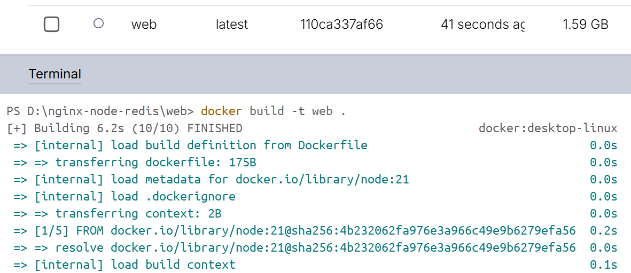
- create a network for them all to communicate through.
docker network create sample-app
- Start the Redis container, which will attach it to the previously created network and create a network alias (useful for DNS lookups)
docker run -d --name redis --network sample-app --network-alias redis redis
- Start the first web container
docker run -d --name web1 -h web1 --network sample-app --network-alias web1 web
- Start the second web container
docker run -d --name web2 -h web2 --network sample-app --network-alias web2 web
- Start the Nginx container
docker run -d --name nginx --network sample-app -p 80:80 nginx
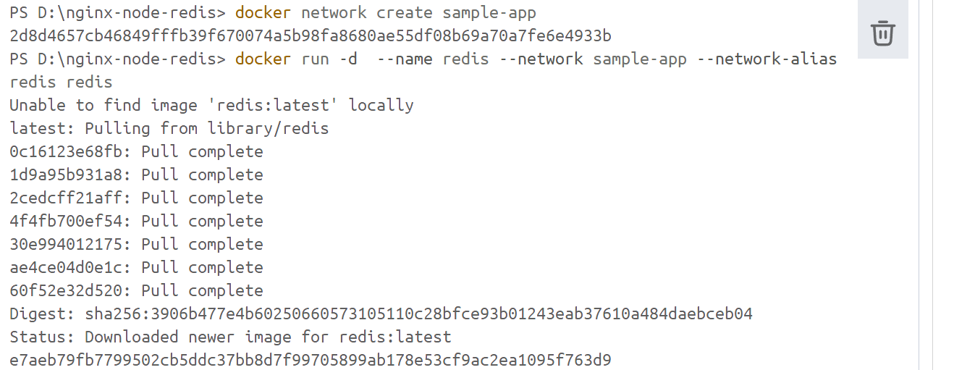
- Verify the containers
docker ps
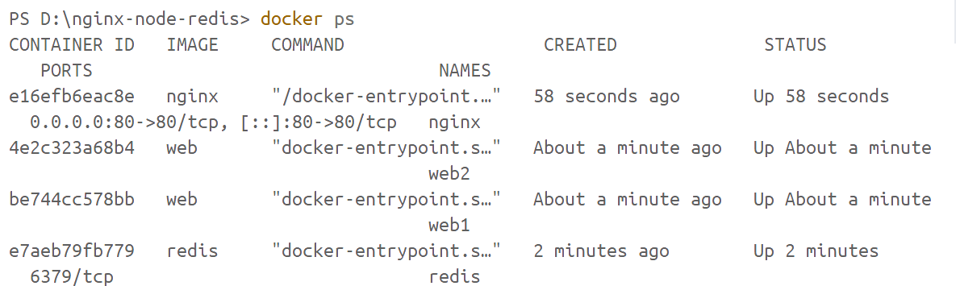
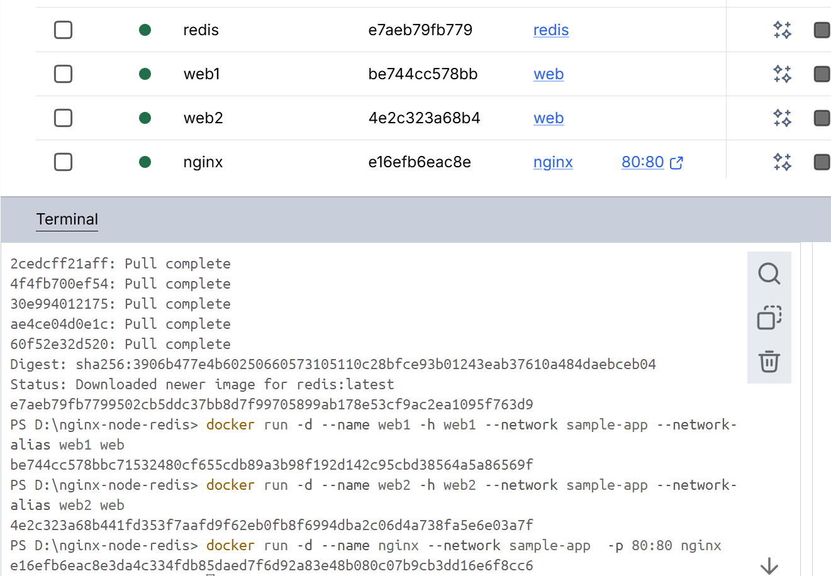

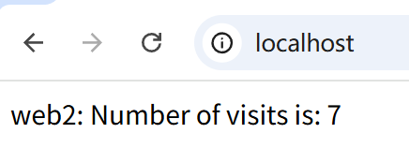
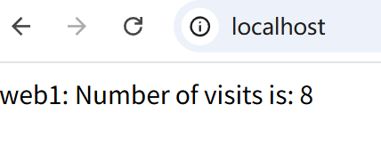

Then refresh the page several times to see the host that’s handling the request and the total number of requests. The output shows consecutive increments for both the web1 and web2 containers and the actual counter value stored in Redis is updated only after the response is sent back to the client.
- compose.yaml

services:
redis:
image: redis
ports:
- '6379:6379'
web1:
restart: on-failure
build: ./web
hostname: web1
ports:
- '81:5000'
web2:
restart: on-failure
build: ./web
hostname: web2
ports:
- '82:5000'
nginx:
build: ./nginx
ports:
- '80:80'
depends_on:
- web1
- web2
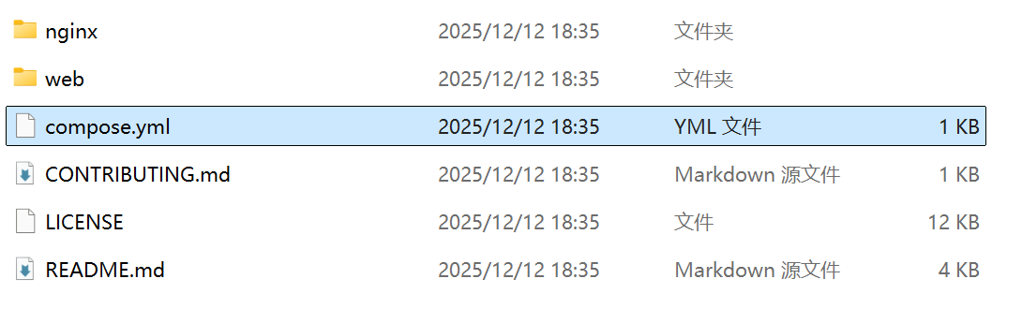
- docker compose up -d --build
