Process
- Install Nebula in WSL2
Command: sudo snap nebula
- A Nebula certificate authority
It create files named ca.key and ca.cert in the current directory. The ca.key file is the key used to sign the certificates for individual nebula nodes/hosts.
Command: ./nebula-cert ca -name “chenzhiwei”
- Generate Nebula host keys and certificates from that certificate authority
Command: ./nebula-cert sign -name "lighthouse1" -ip "192.168.100.1/24"
./nebula-cert sign -name "MBP15" -ip "192.168.100.15/24"
./nebula-cert sign -name "mini" -ip "192.168.100.10/24"
This assumes I have three nodes, named lighthouse1, MBP15 and mini, followed with the chosen IP addresses and the associated subnet.
- Run nebula on each host
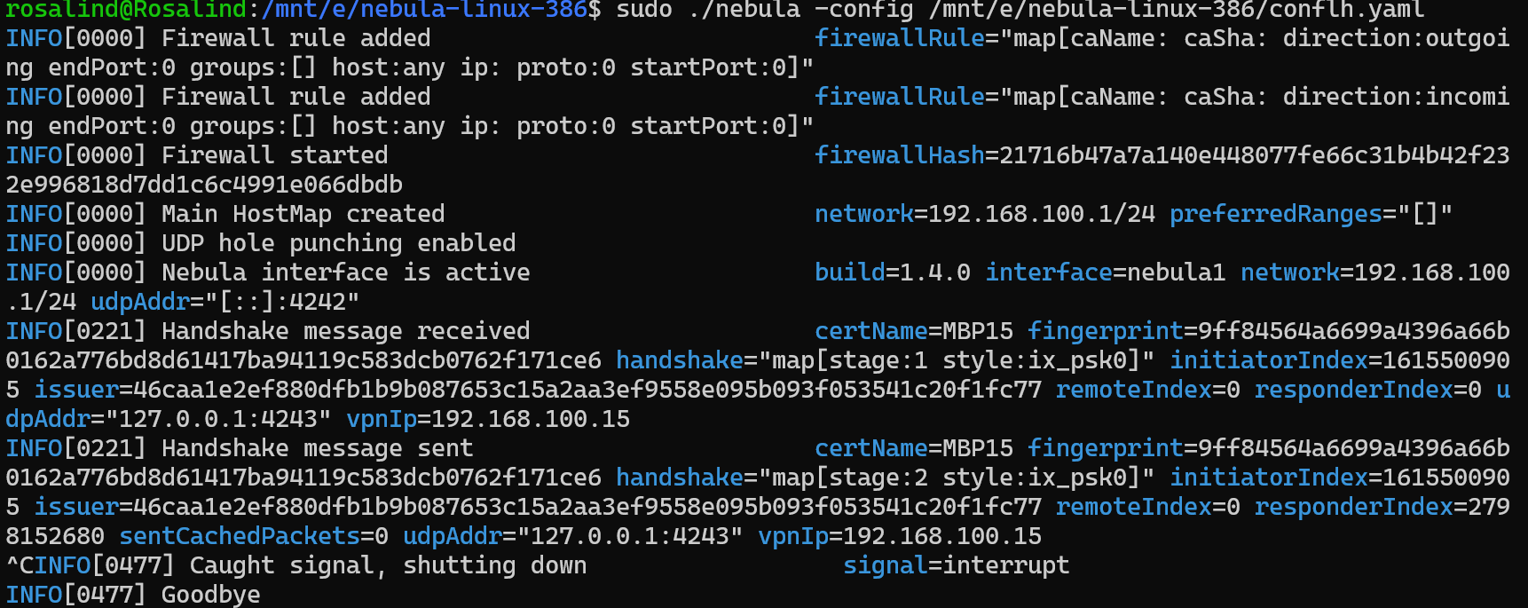
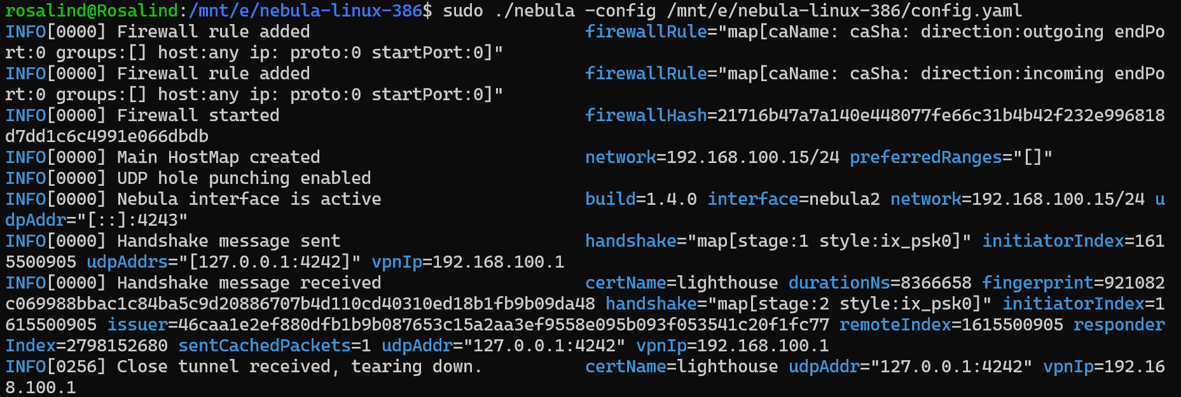
- Ping from one host to another one
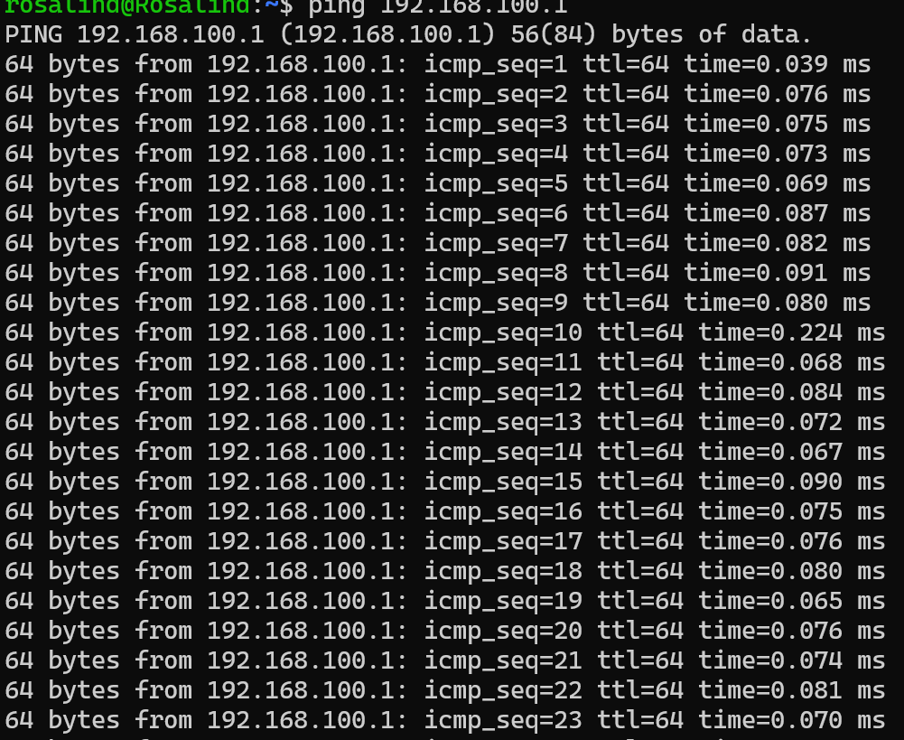

Problems that I met
- This image indicates that my Lab.2.lighthouse.config.yaml file has syntax errors in its YAML format, especially issues with the colon, indentation, or quotation marks near line 8.
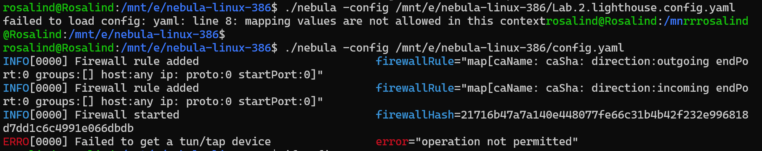
Solution:
The modified conflh.yaml

pki:
ca: /mnt/e/nebula-linux-386/ca.crt
cert: /mnt/e/nebula-linux-386/lighthouse.crt
key: /mnt/e/nebula-linux-386/lighthouse.key

lighthouse:
am_lighthouse: true
interval: 60

listen:
host: "[::]"
port: 4242

punchy:
punch: true

cipher: chachapoly

tun:
disabled: false
dev: nebula1
drop_local_broadcast: false
drop_multicast: false
tx_queue: 500
mtu: 1300

logging:
level: info
format: text

firewall:
conntrack:
tcp_timeout: 12m
udp_timeout: 3m
default_timeout: 10m
max_connections: 100000

outbound:
- port: any
proto: any
host: any

inbound:
- port: any
proto: any
host: any
- This indicates that Nebula failed to create the virtual network interface (TUN/TAP) during startup. TUN/TAP is a virtual network interface at the operating system kernel level; ordinary users do not have permission to create it.
Therefore, start Nebula with sudo instead.
- Lighthouse has already started successfully and is listening on port 4242 normally. I am currently running two Nebula instances (Lighthouse + Node) on the same machine, both of which are trying to create a network interface with the same name, nebula1, causing a resource conflict.
Solution:
Change the dev in
“
tun:
disabled: false
dev: nebula1
“
to nebula2
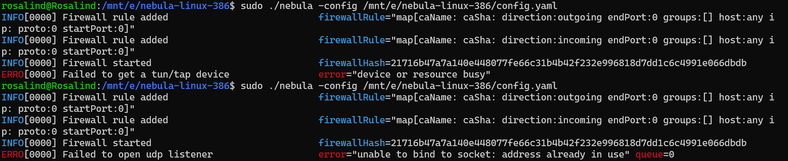
- Each Nebula node needs to bind to a UDP port for communication (4242 by default). A Lighthouse instance is already running on the same machine, occupying UDP port 4242. Therefore, when a second instance (config.yaml) also tries to listen on the same port, a conflict occurs. This is because a UDP port cannot be bound to by two programs simultaneously on the same IP address.
Solution: change the listening port of config to 4243.
- My node (192.168.100.15) wants to contact Lighthouse (192.168.100.1), but I don't know its real IP/port because static_host_map is not configured.
Solution: The static_host_map was modified to use 127.0.0.1 because it runs on the same host.
