W4-LinAlg-Neural Network

|  |  |
| --- | --- |
| Group 24 Members: |  |
|  | Liu Liu |
|  | Xiaoyang Sun |
|  | Agoston Szabo |

We used a single layer network structure, consisting of a randomly initialized 25x3 matrix NN1 (also called a filter), a sigmoid function and a softmax function. The input is a character represented as 5x5 matrix, that is first flattened to a 1x25 matrix and then multiplied with NN1, giving a 1x3 array. A sigmoid function is then applied to the results for introducing nonlinearity and then the softmax function normalizes these values using the standard exponential function. The error is calculated using the output and the true labels for the characters, which is used for updating the matrix NN1. This is repeated for a set amount of times, called epochs. However, to speed up processing all nine character matrices (3 variations of each letter) are concatenated into a 9x25 matrix to speed up processing. (matrix multiplication is considerably faster than looping over each character after one and other).

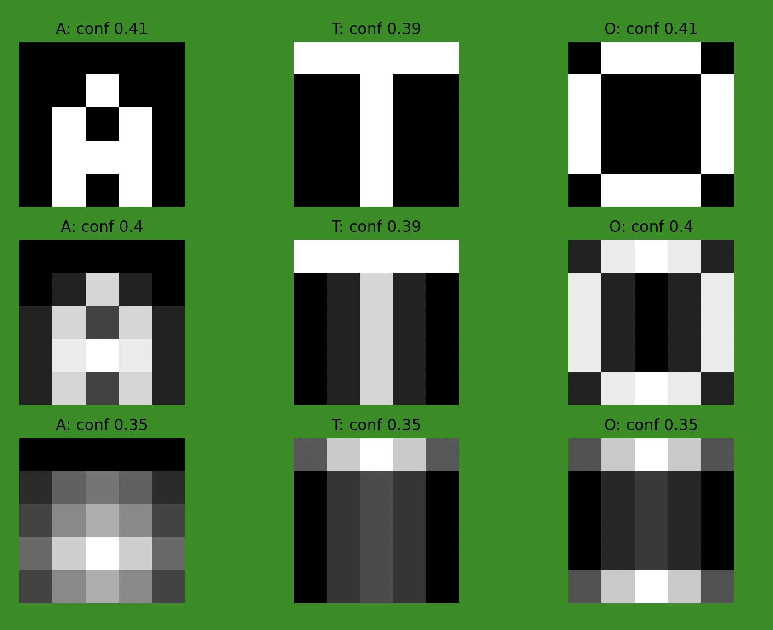

Fig. 1: Character matrices, predictions and confidence numbers

The algorithm is able to identify all of the 9 letters, as shown in Fig. 1, but the confidence of the predictions is fairly low, that is the sign for that recognising more letters using this technique is not possible. In order to identify all 26 letters of the alphabet a more complicated network structure is necessary, either using more layers or multiple matrices in 1 layer.

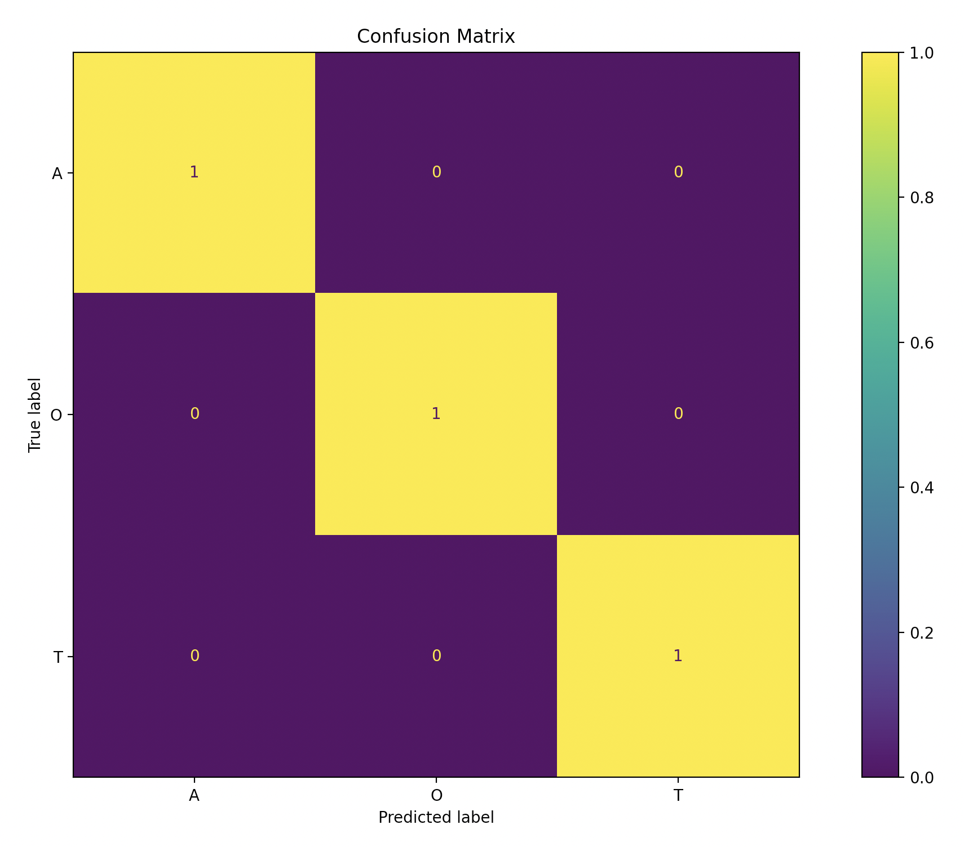

Fig. 2: Confusion Matrix

The weak spot of the algorithm is the number of layers (only one), the number of filters and the size of the filters. A more complex model is computationally more expensive but it would have the ability to recognize all 26 letters of the alphabet. The algorithm in its current state always outputs a prediction, which can be seen as a weak point. A way to improve this would be to define a certain confidence only over that the algorithm outputs a predictions. However, the confidence number can be used as a measure for the the probability of a correct or incorrect prediction.

Because of the random initialised filter inputs only consisting of ones and zeros lead to different results and it is not possible to predict it beforehand.

*matrix resulting in equal values for all 3 characters*

Preprocessing the matrices could lead to better results using methods such as upscaling, data augmentation or normalizing the input.