Simulated maize trial
10 November 2026
Contents

Summary
117 participants registered and 75 gave valid answers for ‘Overall Preference’, the main trait of this report.
8 items were tested. Each participant tested 3 of them.
Taking all answers together, the items with the best performance for ‘Overall Preference’ were Hybrid 03, Hybrid 06 and Hybrid 08.
1 of the items tested outperformed the check Hybrid 04 with statistical confidence (p < 0.05) for the main trait, namely Hybrid 03.
2 trait(s) were left out because they had too few valid answers, namely Flood tolerance [Vegetative] and Flood tolerance [Reproductive].
In their open answers, 84 participants talked most about early maturity and cob size. The most praised was early maturity, 71 % of its 45 mentions were positive. The main complaint was fall armyworm damage, 77 % of its 44 mentions were negative.
“ready before the rains stopped with Hybrid 01”
Results by group of participants are in the section ‘Differences between groups’.

Introduction
This report presents results from the Simulated maize trial trial implemented using the tricot approach (triadic comparison of technology options), a participatory and data-driven method for testing agricultural technologies directly in their use environments (1, 2). Tricot is a citizen science approach that actively engages farmers and other users as co-researchers, enabling the generation of robust experimental evidence at scale while preserving the diversity of real-world farming conditions.
Instead of relying on a small number of tightly controlled researcher-managed trials, tricot distributes experimentation across many farms. Each participant evaluates only three randomly assigned options (for example, crop varieties, fertilizer types, or management practices) under their usual conditions. These small, simple trials are easy to implement, require minimal training, and can be conducted without continuous supervision. When aggregated across many participants and locations, the resulting data provide powerful insights into relative performance, farmer preferences, and context-specific suitability.
A key strength of the tricot approach is its focus on external validity. By allowing farmers to test technologies using their own practices, soils, and climatic conditions, the results better reflect how technologies perform in real-life settings. Farmer-reported rankings are combined with environmental, management, and socio-economic data, allowing analyses that capture genotype-by-environment interactions, preference heterogeneity, and trade-offs that are often missed in conventional trials.
Tricot is supported by a streamlined digital workflow through the ClimMob platform (3), which facilitates trial design, randomization, data collection, monitoring, and reporting. Statistical analysis is based on the Plackett-Luce model for ranking data (4, 5), enabling valid inference from incomplete and overlapping comparisons without loss of information. Together, these methodological and digital components make tricot a scalable, cost-effective, and scientifically rigorous approach for on-farm testing, product evaluation, and decision support.
This report builds on these principles to synthesize results from the current trial cycle and to provide actionable insights for researchers, development practitioners, breeders, and other stakeholders.

What you should expect from this report
This report gives a transparent and reproducible overview of the tricot trial, from experimental design to interpretation of results. It includes the following parts.
- Trial monitoring and data quality. Participation at each data collection moment, the answers that could be used and who collected the data.
- Analytical approach. The statistical methods, mainly the Plackett-Luce model, and how environmental, management or socio-economic variables are included.
- Results and interpretation. The relative performance of the tested options, its uncertainty and patterns across environments or groups of participants.
- Measured traits. When the trial measured traits such as yield, the means of each option adjusted for the farm and the heritability.
- Evidence for variety release. A summary of each option against the check that can support a release application.
This report is produced automatically, so it cannot capture every factor that influences the performance of a technology in its target environment. For an in-depth analysis, to combine data from several projects or to prepare a peer-reviewed publication with your tricot data, send a request to the ClimMob team climmob@mrbotcr.com.

Trial monitoring and data quality
This section helps you follow the trial while it runs. It shows how many participants answered at each data collection moment, which answers can be used in the analysis and who collected the data. Use it to plan visits and reminders before the next data collection moment.
117 participants registered. Of these, 82 (70.1%) answered the last data collection moment, ‘Agronomic performance’. Figure 1 shows the answers received at each moment. The table behind it is in the appendix.
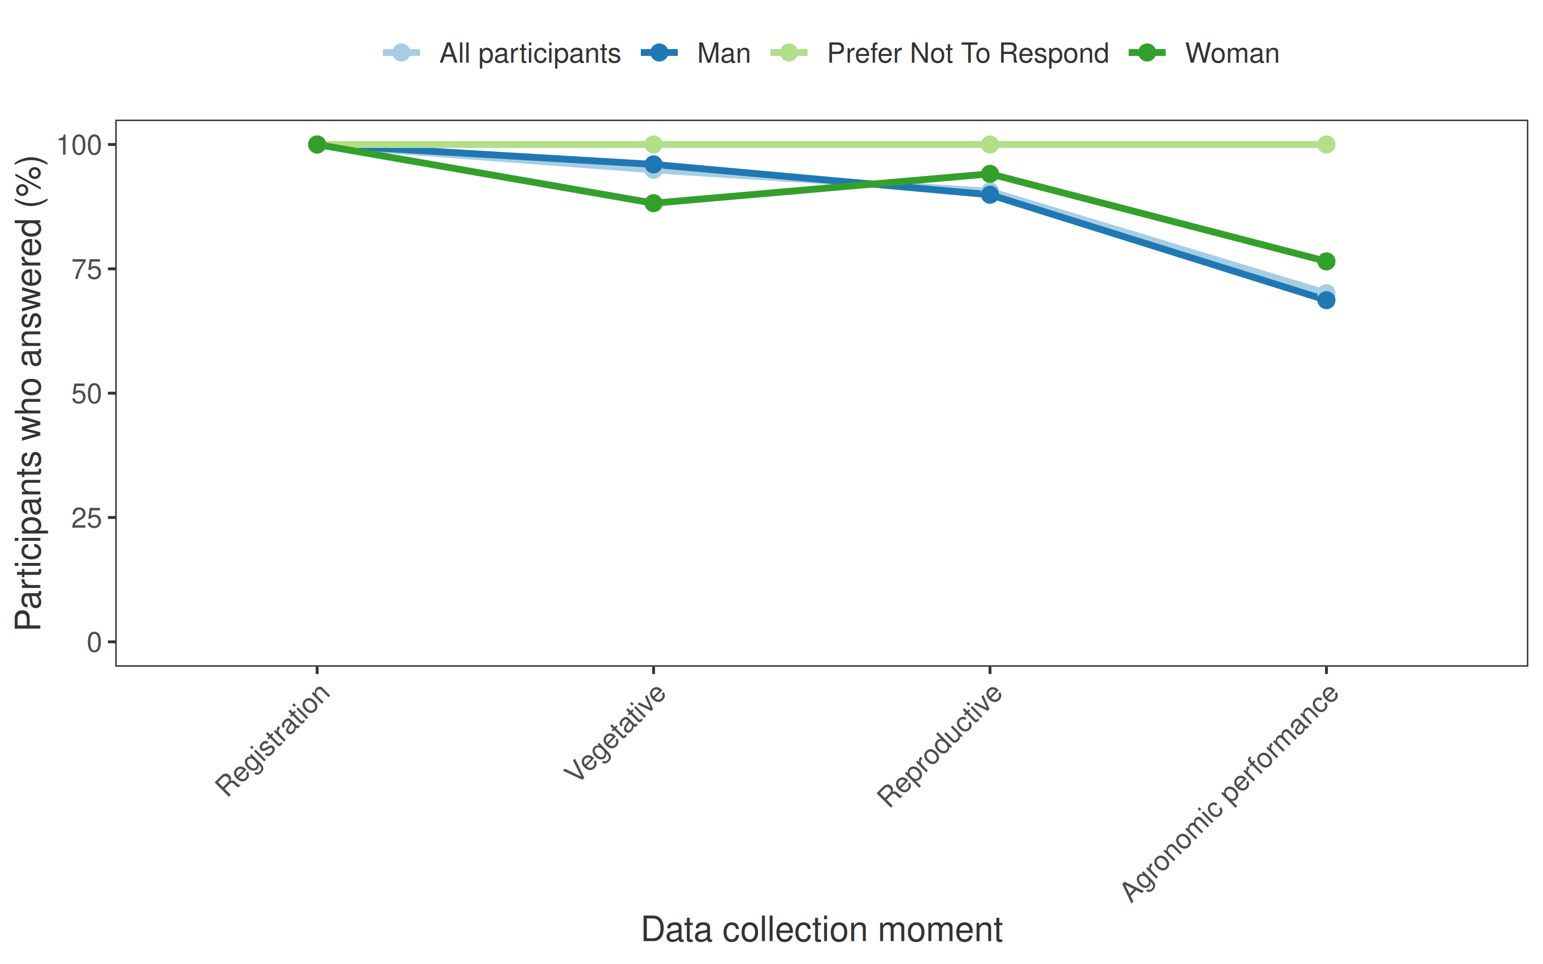
Figure 1. Percentage of registered participants who answered each data collection moment.
Table 1 shows the answers received for each trait. Only valid answers enter the analysis. An answer is not valid when the trait was not observed, when the options were tied, when the same option was given as best and worst, or when the answer was not one of the options. A trait is analysed when it has more than five valid answers and every item was tested at least twice.
Table 1. Answers received for each trait, by type.
Trait | Data collection moment | Valid | Not answered | Not observed | Tie | Same best and worst | Invalid
Germination | Vegetative | 101 | 10 | 5 | 4 | 1 | 0
Diseases resistance | Vegetative | 61 | 10 | 48 | 0 | 2 | 0
Drought tolerance | Vegetative | 62 | 10 | 49 | 0 | 0 | 0
Flood tolerance | Vegetative | 5 | 10 | 106 | 0 | 0 | 0
Fall armyworm resistance | Vegetative | 82 | 10 | 26 | 2 | 1 | 0
Diseases resistance | Reproductive | 55 | 15 | 51 | 0 | 0 | 0
Drought tolerance | Reproductive | 46 | 15 | 58 | 1 | 1 | 0
Flood tolerance | Reproductive | 9 | 15 | 96 | 1 | 0 | 0
Fall armyworm resistance | Reproductive | 81 | 15 | 24 | 1 | 0 | 0
Maturity | Agronomic performance | 78 | 39 | 1 | 2 | 1 | 0
Yield | Agronomic performance | 79 | 39 | 1 | 2 | 0 | 0
Grain size | Agronomic performance | 77 | 39 | 2 | 1 | 2 | 0
Grain colour | Agronomic performance | 78 | 39 | 2 | 2 | 0 | 0
Taste | Agronomic performance | 77 | 39 | 3 | 1 | 1 | 0
Marketability | Agronomic performance | 72 | 39 | 5 | 3 | 2 | 0
Overall preference | Agronomic performance | 75 | 39 | 3 | 2 | 2 | 0
These traits were left out of the analysis because they had too few valid answers, namely Flood tolerance [Vegetative] and Flood tolerance [Reproductive].
The number of forms submitted by each person who collected data is listed in the appendix.

Location of the trial plots
Figure 2 shows where the trial plots were located.
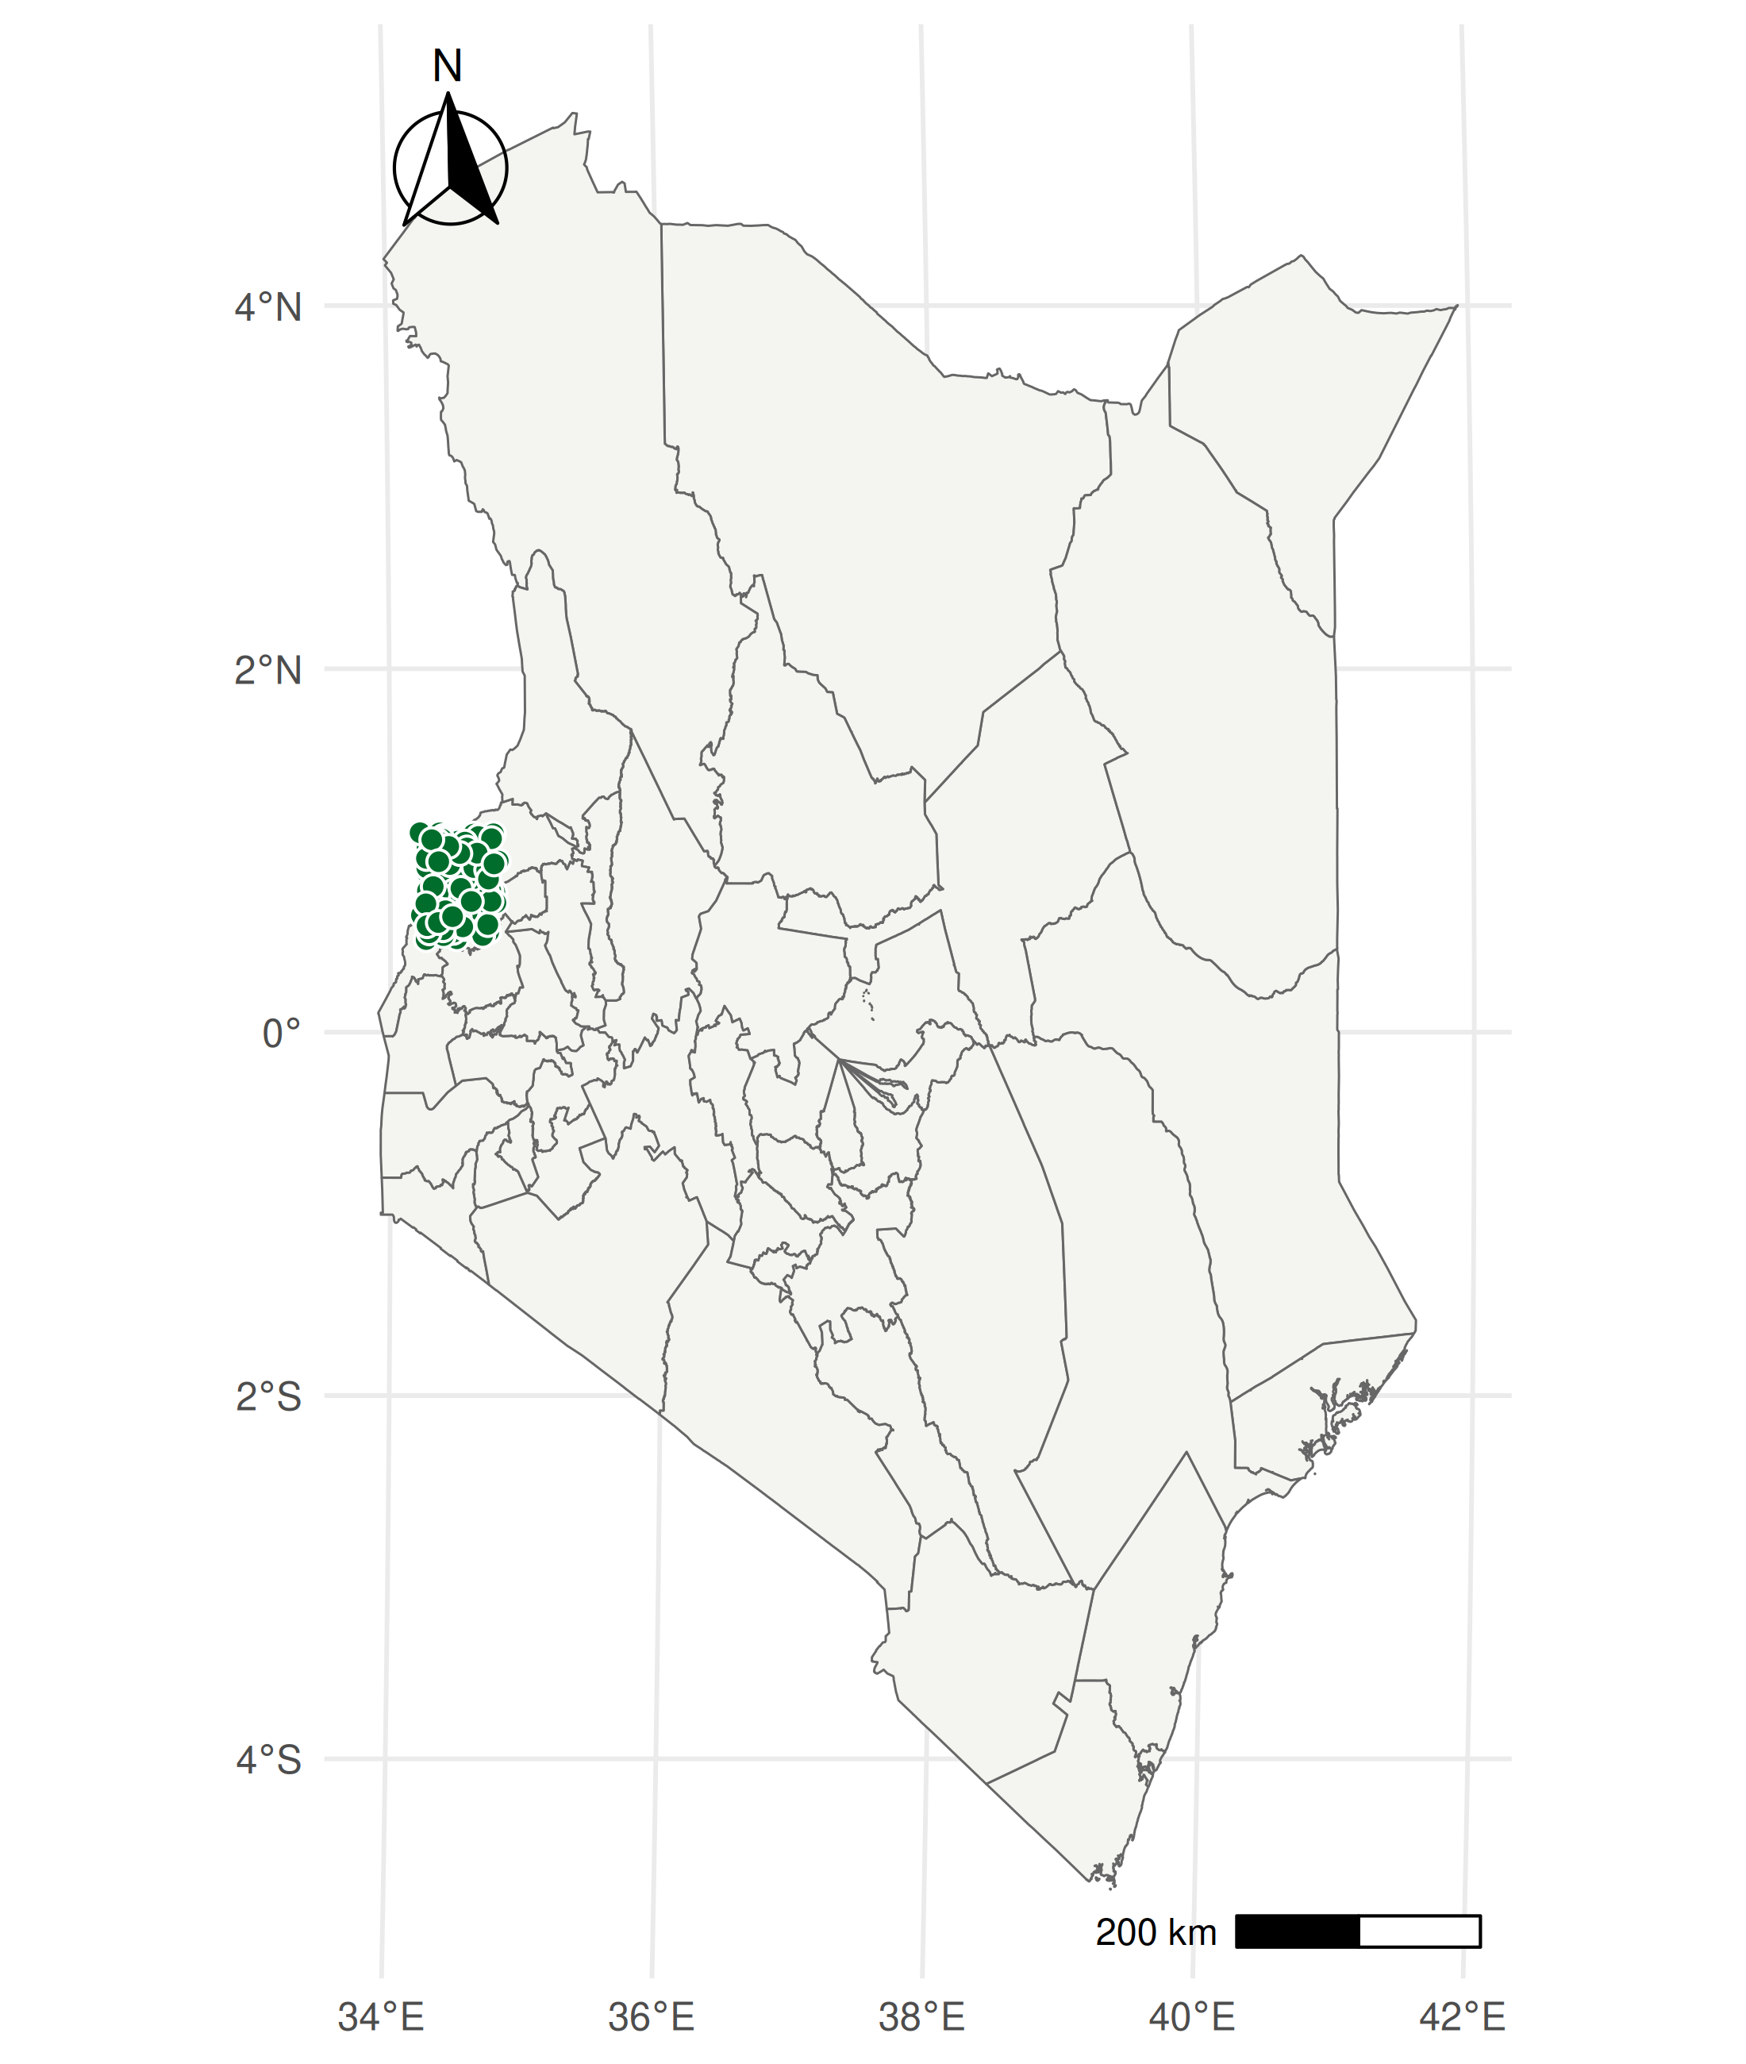
Figure 2. Location of the trial plots. Administrative boundaries are from the Database of Global Administrative Areas (GADM).

Who answered the latest data collection
Figure 3 shows the trial plots by whether the participants answered the latest data collection, «Agronomic performance». 82 of the 121 participants with GPS coordinates answered. Use the map to plan visits and reminders.
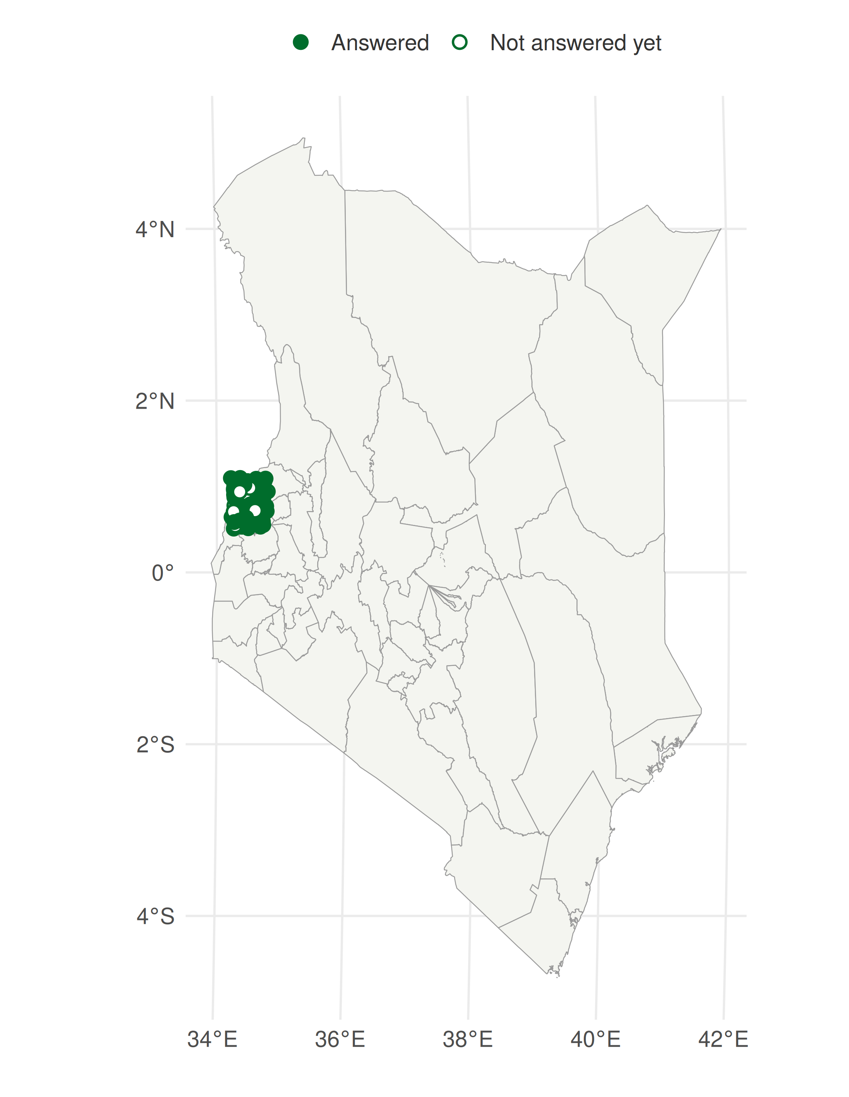
Figure 3. Trial plots by answer at «Agronomic performance». Filled points answered, open points have not answered yet.

Climate during the season
Figure 4 and Figure 5 show temperature and rainfall indices at the trial plots in the map, for 85 days from the planting day (from 2022-09-03 to 2022-12-08). The window follows the data collection moments set for this project. Data come from NASA POWER through the R package nasapower (6) and the indices were computed with the R package climatrends (7). The same indices are tested as covariates in the Plackett-Luce trees.
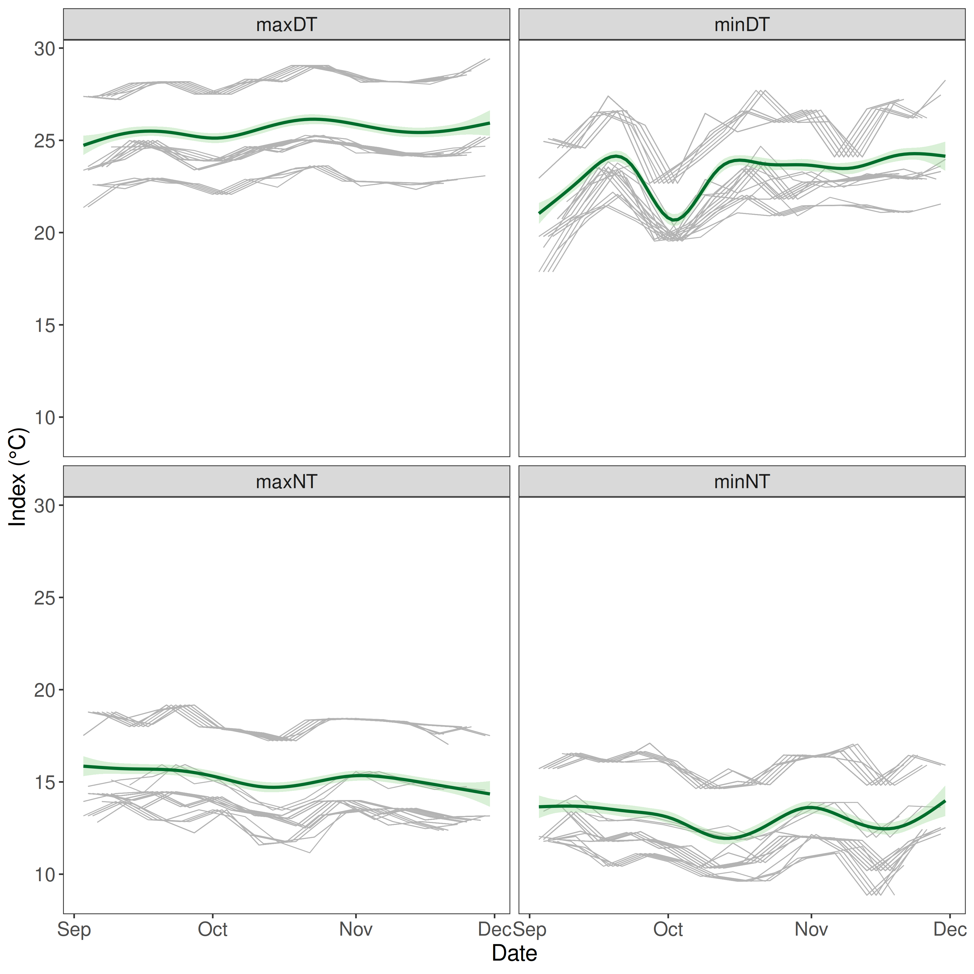
Figure 4. Weekly temperature indices from 2022-09-03 to 2022-12-08. Maximum day temperature (maxDT), minimum day temperature (minDT), maximum night temperature (maxNT) and minimum night temperature (minNT).
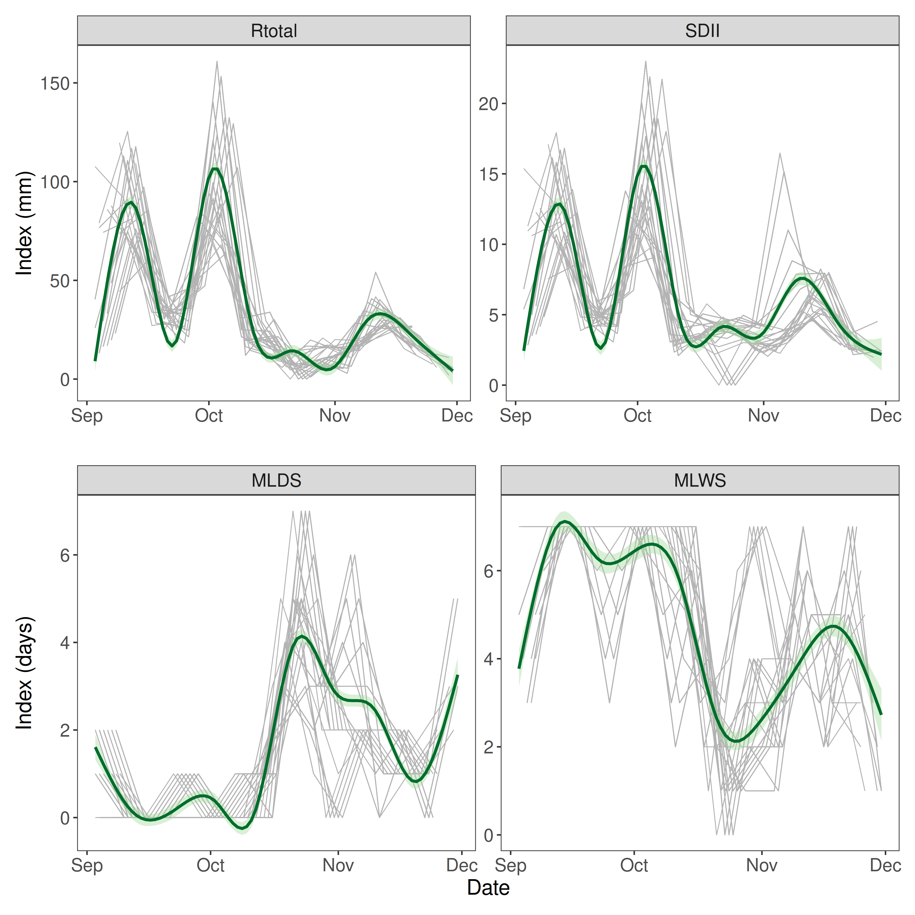
Figure 5. Weekly rainfall indices from 2022-09-03 to 2022-12-08. Total rainfall (Rtotal), daily intensity on wet days (SDII), longest dry spell with rain below 1 mm (MLDS) and longest wet spell with rain of 1 mm or more (MLWS).

How many answers are needed?
Each answer makes the results more reliable. To show how much, the trial was simulated with the preferences estimated for «Overall Preference» taken as the truth. Each simulated participant tests 3 items drawn at random, and the model is refitted 50 times for each number of participants. Figure 6 shows how well the simulated trials recover the order of the items (Kendall tau) and how often they find the same best item. With the 75 answers available now, the chance of finding the best item is 90 %.
If all 117 registered participants answered, the chance would be 94 %.
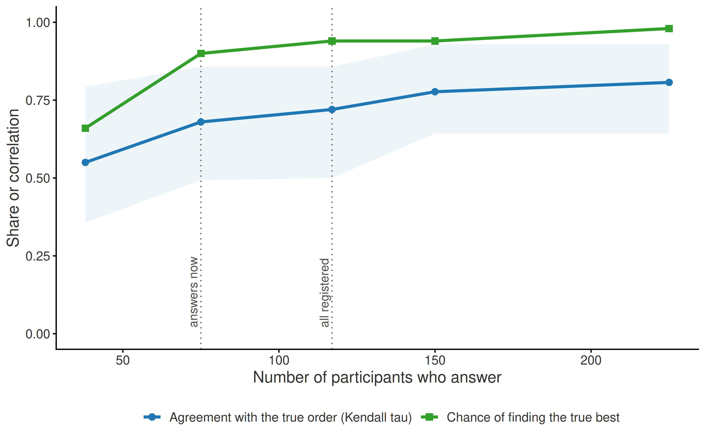
Figure 6. Expected accuracy of the ranking for «Overall Preference» by the number of participants who answer. The band shows the 10th to 90th percentiles of Kendall tau.

Methods
ClimMob applies the Plackett-Luce (PL) model, independently proposed by Luce (1959) (5) and Plackett (1975) (4), to analyse ranking data. It is implemented in R by the package ‘PlackettLuce’ (8). The PL model estimates the probability that one technology outperforms the others following Luce’s Choice Axiom (5), which states that the probability that one item outperforms another is independent of the presence or absence of any other item in the set.
$$P(i≻j)=\frac{p_{i}}{p_{i}+p_{j}}$$
Here $p_{i}$ is a positive score for item $i$, and $i≻j$ reads as ‘$i$ is preferred over $j$’. The PL model estimates these scores, called worth, which give the probability that each item outperforms all other items in the set. We report log-worth centred on the check Hybrid 04 and Hybrid 05. Each tricot ranking of three technologies $(i≻j≻k)$ has the following probability under the PL model.
$$P(i≻j≻k)=P(i≻\{j,k\})⋅P(j≻k)$$
Covariates, if any, are linked to the rankings with model-based recursive partitioning (9), which builds Plackett-Luce trees. The trees find groups of participants for which the performance of the technologies differs. When coordinates and dates are available, rainfall and temperature indices from NASA POWER are added as covariates (6, 7). Covariates are chosen by forward selection, adding at each step the covariate that most improves the model according to the Akaike Information Criterion (AIC) (10). The AIC adds the degrees of freedom ($ν$) to the maximised log-likelihood ($L$).
$$AIC=−2L+2ν$$
Based on this approach, the following model was applied to the data.
G ~ Age + Education
Not all covariates in this model appear in the tree, since the tree is limited to a few nodes. The covariates shown are the most important for this data set. This report uses ‘Overall Preference’ as the reference trait for the analysis.
The correlation between ‘Overall Preference’ and the other traits is estimated with the Kendall tau coefficient (11), an equivalent of the Pearson correlation for ranking data. It ranges from -1 to 1, where 1 means full agreement and -1 full disagreement. It can show what drives the choices of participants and help to prioritise traits in the next stage of testing.
This report is generated in R (12) with the packages ‘knitr’ (13) and ‘rmarkdown’ (14). Data handling and analysis use ‘ClimMobTools’ (15), ‘gosset’ (16), ‘PlackettLuce’ (8), ‘partykit’ (17), ‘psychotools’ (18), ‘qvcalc’ (19), ‘lme4’ (20), ‘gtools’ (21) and ‘jsonlite’ (22). Charts use ‘ggplot2’ (23), ‘ggparty’ (24), ‘igraph’ (25), ‘multcompView’ (26) and ‘patchwork’ (27). The tricot approach is introduced by van Etten et al. (2019) (2). To cite ClimMob, use van Etten et al. (2020) (28). The workflow that produced this report is described by de Sousa et al. (2022) (29).

Trial design
121 participants took part in this trial. Each assessed 3 different items and ranked them for 14 trait(s). The traits analysed and the number of valid answers for each are listed in the appendix.
Figure 7 shows the experimental design as a network. Two items are connected when they were tested together in at least one package of 3. The network uses the rankings of ‘Overall Preference’.
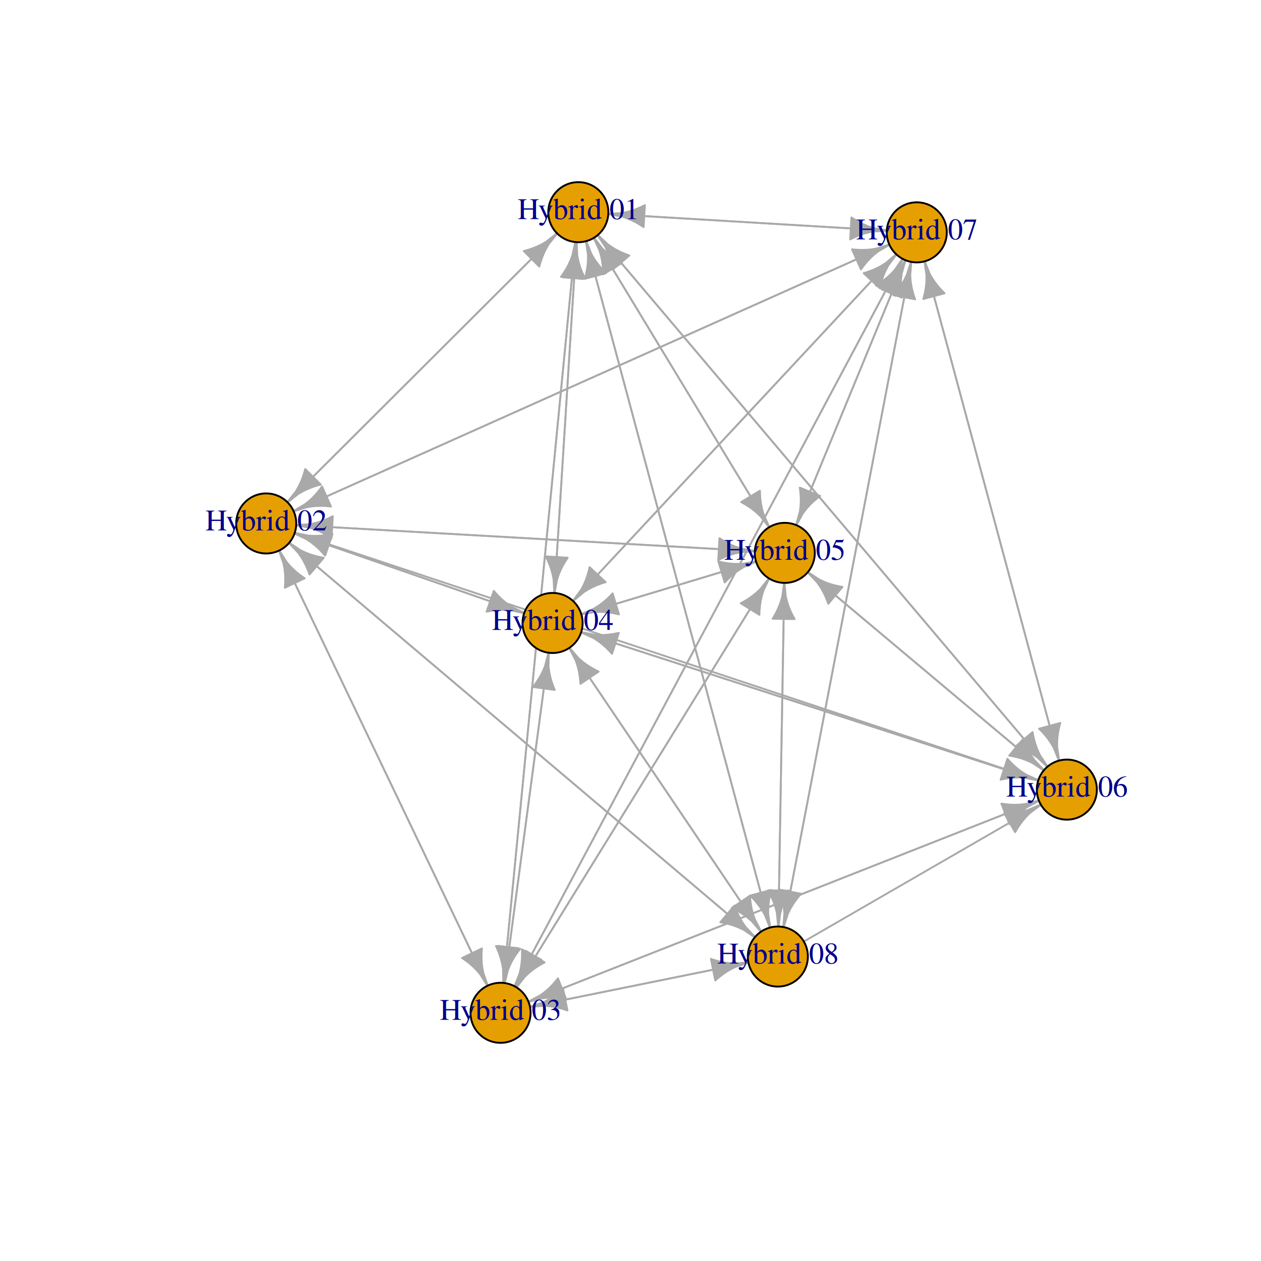
Figure 7. Network of the items tested in this trial. Arrows show direct wins and losses between pairs of items that were tested together.
Table 2 lists the 8 items tested, with the number and percentage of participants who tested each. Names longer than 12 characters are abbreviated in the charts.
Table 2. Frequency of the items tested.
Item | Abbreviation | Frequency | Relative frequency
Hybrid 01 | Hybrid 01 | 45 | 37.2%
Hybrid 02 | Hybrid 02 | 38 | 31.4%
Hybrid 03 | Hybrid 03 | 40 | 33.1%
Hybrid 04 | Hybrid 04 | 49 | 40.5%
Hybrid 05 | Hybrid 05 | 59 | 48.8%
Hybrid 06 | Hybrid 06 | 40 | 33.1%
Hybrid 07 | Hybrid 07 | 40 | 33.1%
Hybrid 08 | Hybrid 08 | 52 | 43%

Performance of the items
Table 3 tests, for each trait, whether at least one item performs differently from the others (likelihood ratio test against a model where all have the same worth). A p-value below 0.05 means that the differences in performance are unlikely to be due to chance.
Table 3. Test of differences between items, by trait.
Trait | logLik | DF | Statistic | p-value
Germination [Vegetative] | -166.916 | 296 | 28.104 | < 0.001 | ***
Diseases resistance [Vegetative] | -89.658 | 176 | 39.278 | < 0.001 | ***
Drought tolerance [Vegetative] | -99.911 | 179 | 22.356 | 0.0022 | **
Fall armyworm resistance [Vegetative] | -138.628 | 239 | 16.592 | 0.0202 | *
Diseases resistance [Reproductive] | -94.560 | 158 | 7.974 | 0.335
Drought tolerance [Reproductive] | -73.060 | 131 | 18.722 | 0.0091 | **
Fall armyworm resistance [Reproductive] | -136.195 | 236 | 17.876 | 0.0125 | *
Maturity [Agronomic performance] | -129.845 | 227 | 19.824 | 0.006 | **
Yield [Agronomic performance] | -129.411 | 230 | 24.276 | 0.001 | ***
Grain size [Agronomic performance] | -127.166 | 224 | 21.598 | 0.003 | **
Grain colour [Agronomic performance] | -127.196 | 227 | 25.122 | < 0.001 | ***
Taste [Agronomic performance] | -124.991 | 224 | 25.948 | < 0.001 | ***
Marketability [Agronomic performance] | -122.166 | 209 | 13.682 | 0.0571 | .
Overall preference [Agronomic performance] | -125.972 | 218 | 16.820 | 0.0186 | *
Table 4 gives the favourability of each item for the main trait and, when it was ranked, yield. ‘Top’ and ‘Bottom’ are the probabilities (%) that the item was ranked first or last in the sets where it was tested, and the favourability score is their difference. Positive values mean that the item was more often a winner than a loser. The same table for every trait is in the appendix. Breeding teams use it in variety release applications.
Table 4. Favourability of the items for the main trait and yield.
Trait | Option | N | Top (%) | Bottom (%) | Favourability
Yield [Agronomic Performance] | Hybrid 03 | 56 | 50.0 | 16.1 | 33.9
 | Hybrid 06 | 52 | 49.7 | 15.9 | 33.7
 | Hybrid 08 | 66 | 37.1 | 26.5 | 10.6
 | Hybrid 02 | 40 | 36.5 | 28.5 | 8.1
 | Hybrid 05 | 76 | 29.6 | 35.4 | -5.8
 | Hybrid 01 | 62 | 28.6 | 34.8 | -6.1
 | Hybrid 04 | 70 | 26.3 | 41.1 | -14.8
 | Hybrid 07 | 52 | 12.4 | 66.6 | -54.2
Overall preference [Agronomic Performance] | Hybrid 03 | 54 | 57.3 | 11.3 | 46.0
 | Hybrid 06 | 42 | 44.6 | 20.1 | 24.5
 | Hybrid 08 | 62 | 36.6 | 27.7 | 8.8
 | Hybrid 02 | 42 | 33.8 | 30.5 | 3.3
 | Hybrid 05 | 70 | 28.6 | 37.5 | -8.9
 | Hybrid 01 | 58 | 26.5 | 39.2 | -12.7
 | Hybrid 07 | 54 | 23.0 | 46.0 | -23.0
 | Hybrid 04 | 68 | 23.1 | 46.5 | -23.5
Figure 8 shows the Kendall tau between ‘Overall Preference’ and the other traits. The strongest correlation was with ‘Drought tolerance [Vegetative]’ (tau = 0.14) and the weakest with ‘Fall armyworm resistance [Vegetative]’ (tau = -0.05). A table with the significance tests is in the Appendix.
The bars show 95 % intervals from 200 bootstrap resamples of participants. An interval that does not cross zero indicates a clear association.
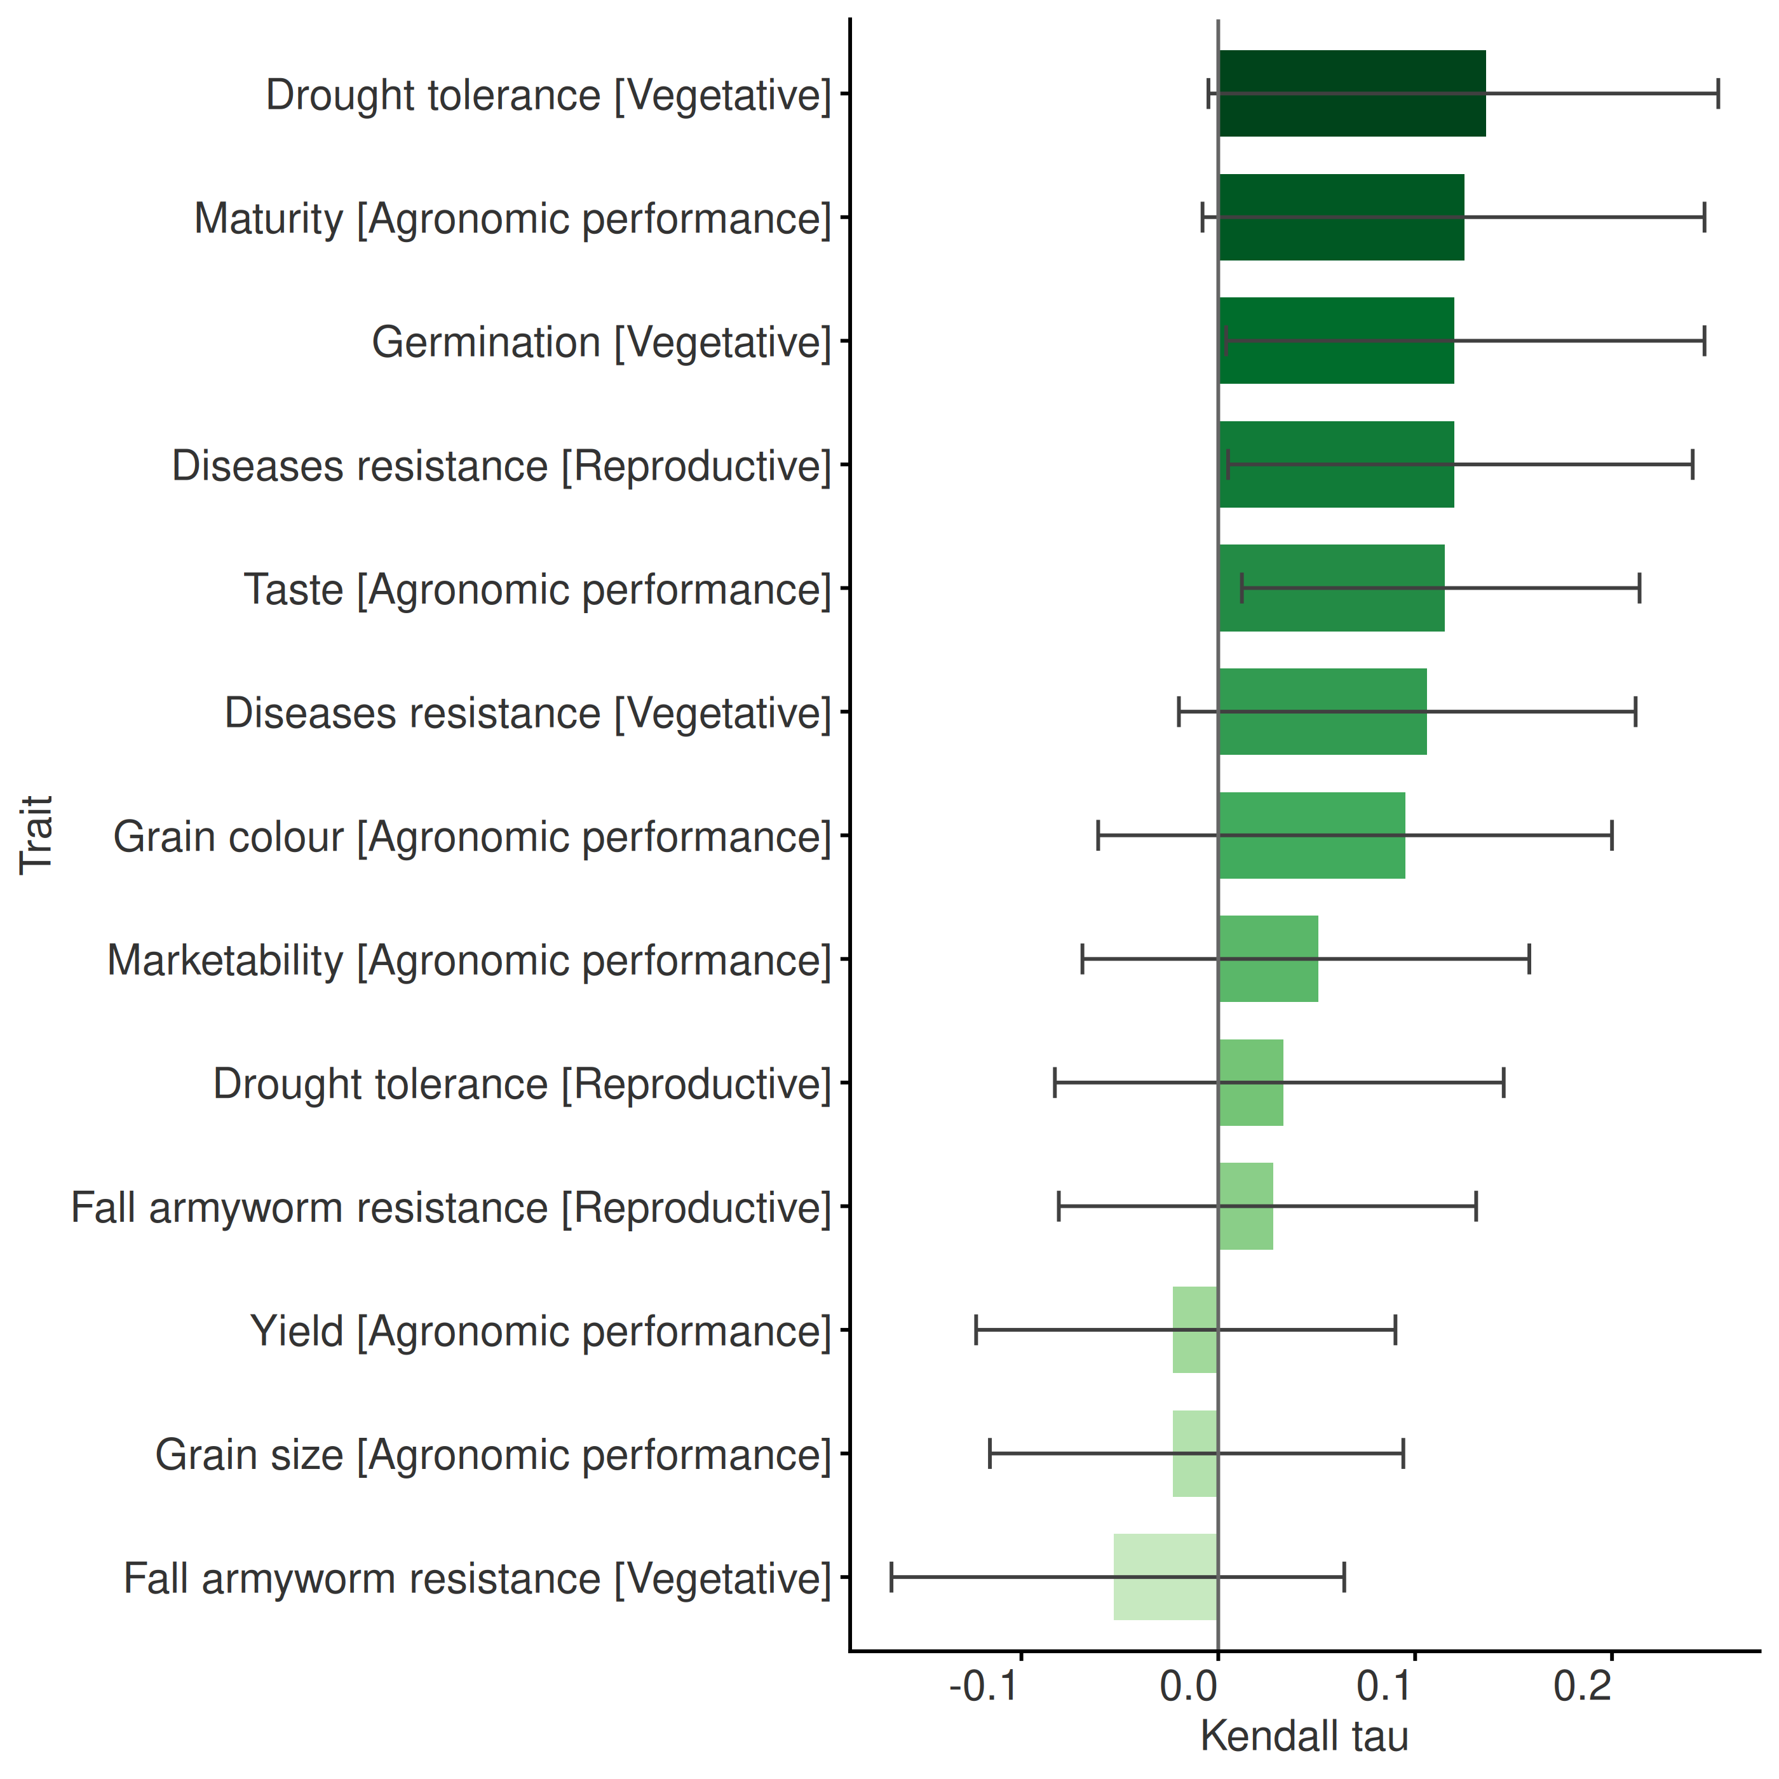
Figure 8. Kendall correlation between ‘Overall Preference’ and the other traits.
Figure 9 shows the log-worth of each item for every trait, relative to the check Hybrid 04 and Hybrid 05. Positive values show items that performed better than the check for that trait, and negative values those that performed worse.
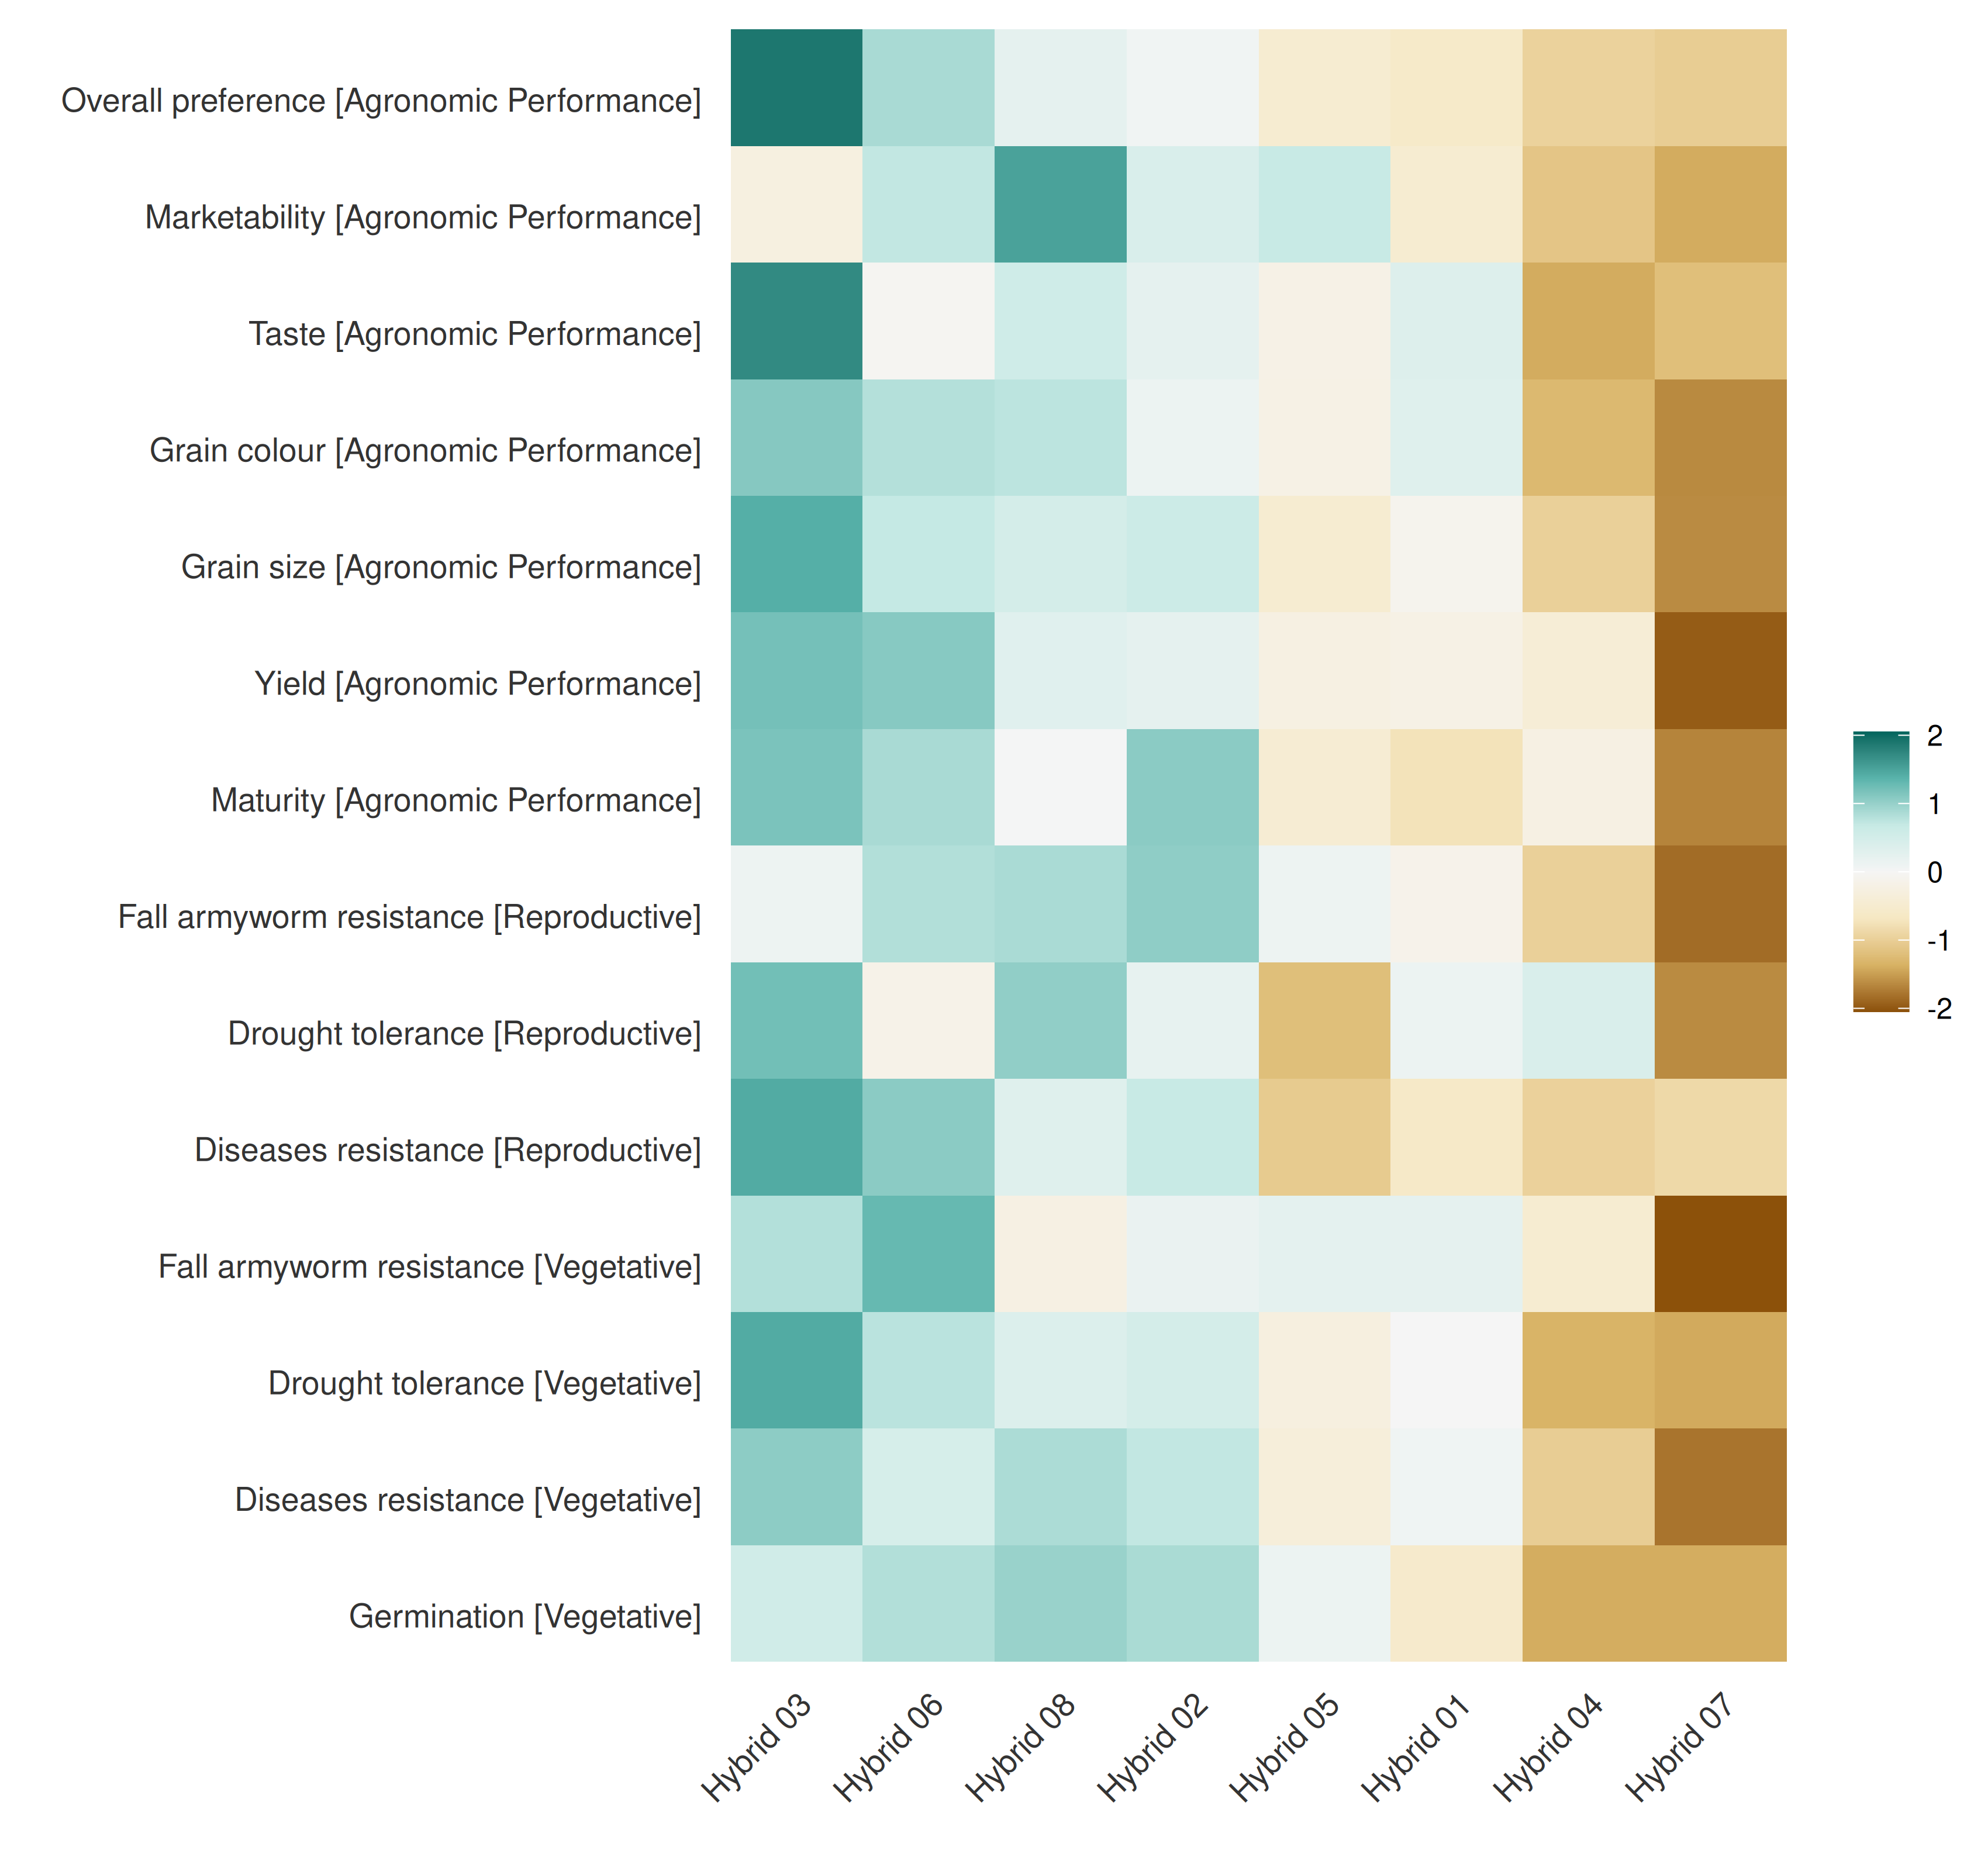
Figure 9. Item performance by trait, as log-worth relative to the check.
Figure 10 shows the reliability of each item, the probability that it outperforms the check Hybrid 04 (30). Values above 0 mean that the item is more likely to beat the check than to lose to it. Results for other checks are in the extra outputs.
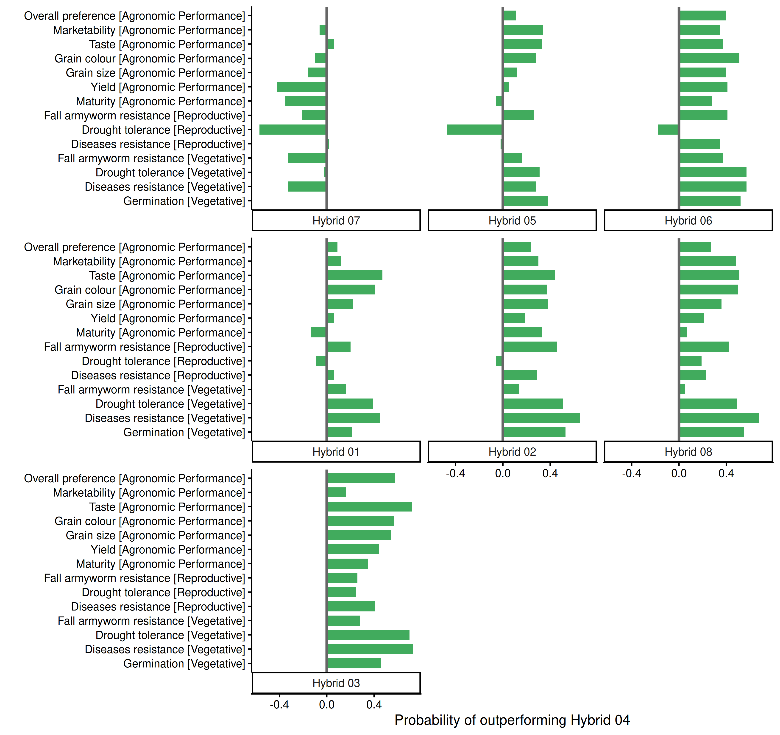
Figure 10. Reliability of the items against the check Hybrid 04.
Figure 11 shows the log-worth of each item for ‘Overall Preference’. items that share a letter are not significantly different (p = 0.05). Bars show 50% confidence intervals from quasi standard errors.
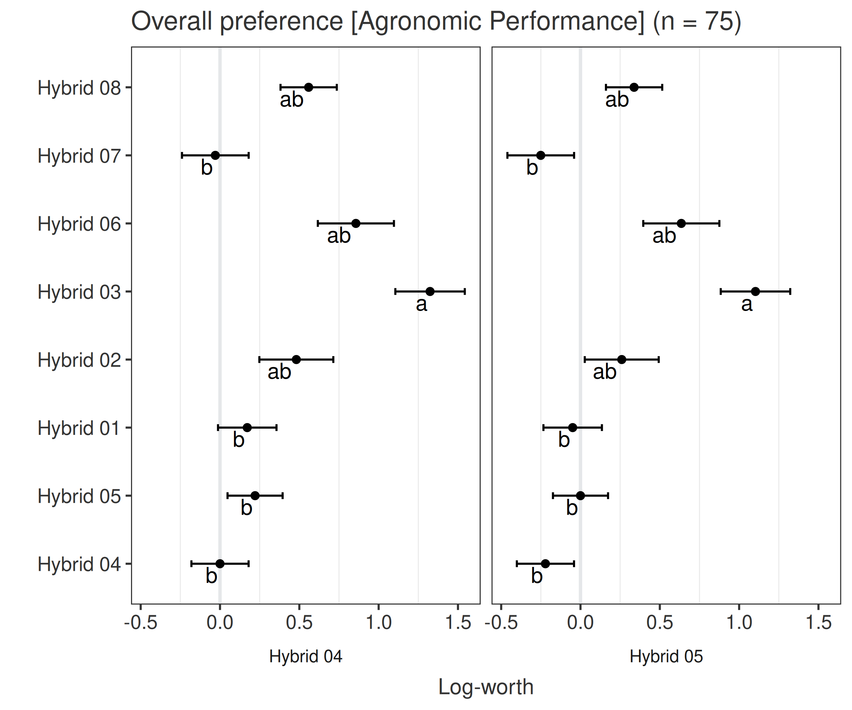
Figure 11. Log-worth of the items for ‘Overall Preference’.

Why they preferred it
The open answers read by Sikia Analytics say why participants ranked the Overall Preference as they did. Table 5 lists, for every option, the topics with mostly positive mentions and those with mostly negative mentions, with the number of mentions in brackets.
Hybrid 03, the item ranked first, was praised for storage weevils (5), drought tolerance (4). The complaints were about early maturity (13), lodging (4), fall armyworm damage (3).
Table 5. What participants said about each of the items, from the open answers read by Sikia Analytics. Options in the order of the ranking for Overall Preference.
Option | Praised for | Complaints about | Mentions
Hybrid 03 | storage weevils (5), drought tolerance (4) | early maturity (13), lodging (4), fall armyworm damage (3) | 37
Hybrid 06 | fall armyworm damage (9), cob size (5), lodging (3) | drought tolerance (3), storage weevils (2) | 42
Hybrid 02 | cob size (7), lodging (4) | early maturity (12), drought tolerance (6), fall armyworm damage (6) | 43
Hybrid 05 | early maturity (7), lodging (6), drought tolerance (3) | taste (8), fall armyworm damage (6), seed cost (6) | 43
Hybrid 01 | early maturity (11), drought tolerance (5), storage weevils (4) | lodging (7), taste (3) | 42
Hybrid 04 | fall armyworm damage (9), taste (9), seed cost (7) | cob size (6), storage weevils (2) | 47

Differences between groups
The results were requested by group of participants. A comparison between groups is only reliable when every group has enough answers, so each group needs at least 20 valid answers for ‘Overall Preference’ to be analysed. Table 6 shows the groups found in the data.
Table 6. Groups of participants and valid answers for the main trait.
Group | Valid answers | Share | Status
Man | 63 | 84% | analysed
Woman | 12 | 16% | too few answers
Only 12 participants in the group ‘Woman’ gave valid answers (16% of those with a group). This is too few for a separate result. The overall results therefore mostly reflect the other groups. To compare groups in future trials, aim for at least 20 participants in every group.
Fewer than two groups have enough answers, so the groups are not compared. The results in this report mostly reflect the views of the largest group, ‘Man’ (84% of the participants with a group).

Effect of covariates on the performance of the items
Table 7 presents the groups (nodes) found by the Plackett-Luce tree with the covariates kept by the forward selection.
Table 7. Groups (nodes) identified by the Plackett-Luce tree.
Node | N | Superior performance | Underperformance | Variable and threshold
2 | 28 | Hybrid 02, Hybrid 06, Hybrid 08 | Hybrid 05 | Age <= 38
4 | 20 | Hybrid 02, Hybrid 03, Hybrid 05 | Hybrid 04, Hybrid 07, Hybrid 06 | Age > 38 & Education = Illiterate, Primary School
5 | 27 | Hybrid 03, Hybrid 06, Hybrid 07 | Hybrid 02, Hybrid 08, Hybrid 04 | Age > 38 & Education = High School, Other, Secondary School, University Degree, Vocational Training
Figure 12 shows the Plackett-Luce tree.
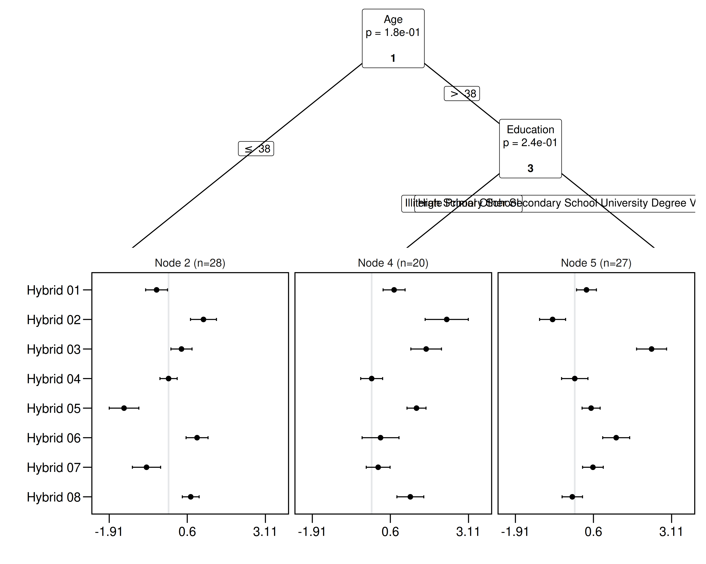
Figure 12. Plackett-Luce tree of the items. The horizontal axis of each panel is the log-worth. Error bars show quasi standard errors.
Table 8 gives the worth and regret of the items across the nodes of the tree (31, 32). Worst regret is the loss under the worst possible outcome. Choosing items with a low worst regret is a cautious way to manage risk across all the groups in the tree.
Table 8. Probability of winning (worth) and regret of each item. High worth and low regret indicate a good choice.
Option | Worth | Worst regret | Regret
Hybrid 03 | 0.280 | 0.056 | 0.024
Hybrid 06 | 0.140 | 0.107 | 0.107
Hybrid 02 | 0.221 | 0.149 | 0.111
Hybrid 08 | 0.110 | 0.144 | 0.136
Hybrid 05 | 0.078 | 0.134 | 0.141
Hybrid 01 | 0.063 | 0.137 | 0.155
Hybrid 07 | 0.053 | 0.132 | 0.159
Hybrid 04 | 0.055 | 0.142 | 0.167

Measured traits
This section analyses traits measured on each plot, such as yield. Zeros are treated as missing plots. Values outside 1.5 times the interquartile range are flagged as possible outliers, listed in the Appendix and left out of the model. The mean of each item is estimated with a linear mixed model with the farm of each participant as a random effect (20), so that differences between farms do not bias the comparison. Broad-sense heritability is estimated with the ad hoc method of Holland et al. (2003) (33).

Plant population - Vegetative
363 plots from 121 farms. 30 plots had no value (0 values were zero) and 1 values were flagged as possible outliers.
Table 9. Mean of each item adjusted for the farm, with 95% confidence interval and comparison with the check Hybrid 04. Items that share a letter are not significantly different (p = 0.05).
Option | N | Mean | Lower 95% | Upper 95% | % of check | p vs check | Group
Hybrid 01 | 38 | 51.05 | 49.11 | 52.99 | 104.85 | 0.074 | a
Hybrid 08 | 47 | 50.93 | 49.18 | 52.68 | 104.59 | 0.0728 | a
Hybrid 05 | 55 | 49.76 | 48.14 | 51.37 | 102.18 | 0.373 | ab
Hybrid 02 | 37 | 49.62 | 47.65 | 51.59 | 101.90 | 0.487 | ab
Hybrid 07 | 37 | 49.62 | 47.65 | 51.59 | 101.90 | 0.488 | ab
Hybrid 03 | 37 | 49.06 | 47.10 | 51.03 | 100.76 | 0.782 | ab
Hybrid 04 | 45 | 48.69 | 46.91 | 50.48 | 100.00 |  | ab
Hybrid 06 | 36 | 47.68 | 45.69 | 49.67 | 97.92 | 0.45 | b
Broad-sense heritability is 0.28. Values close to 1 mean that most of the variation between plots comes from differences between the items, values close to 0 that it comes from the environment and measurement error.
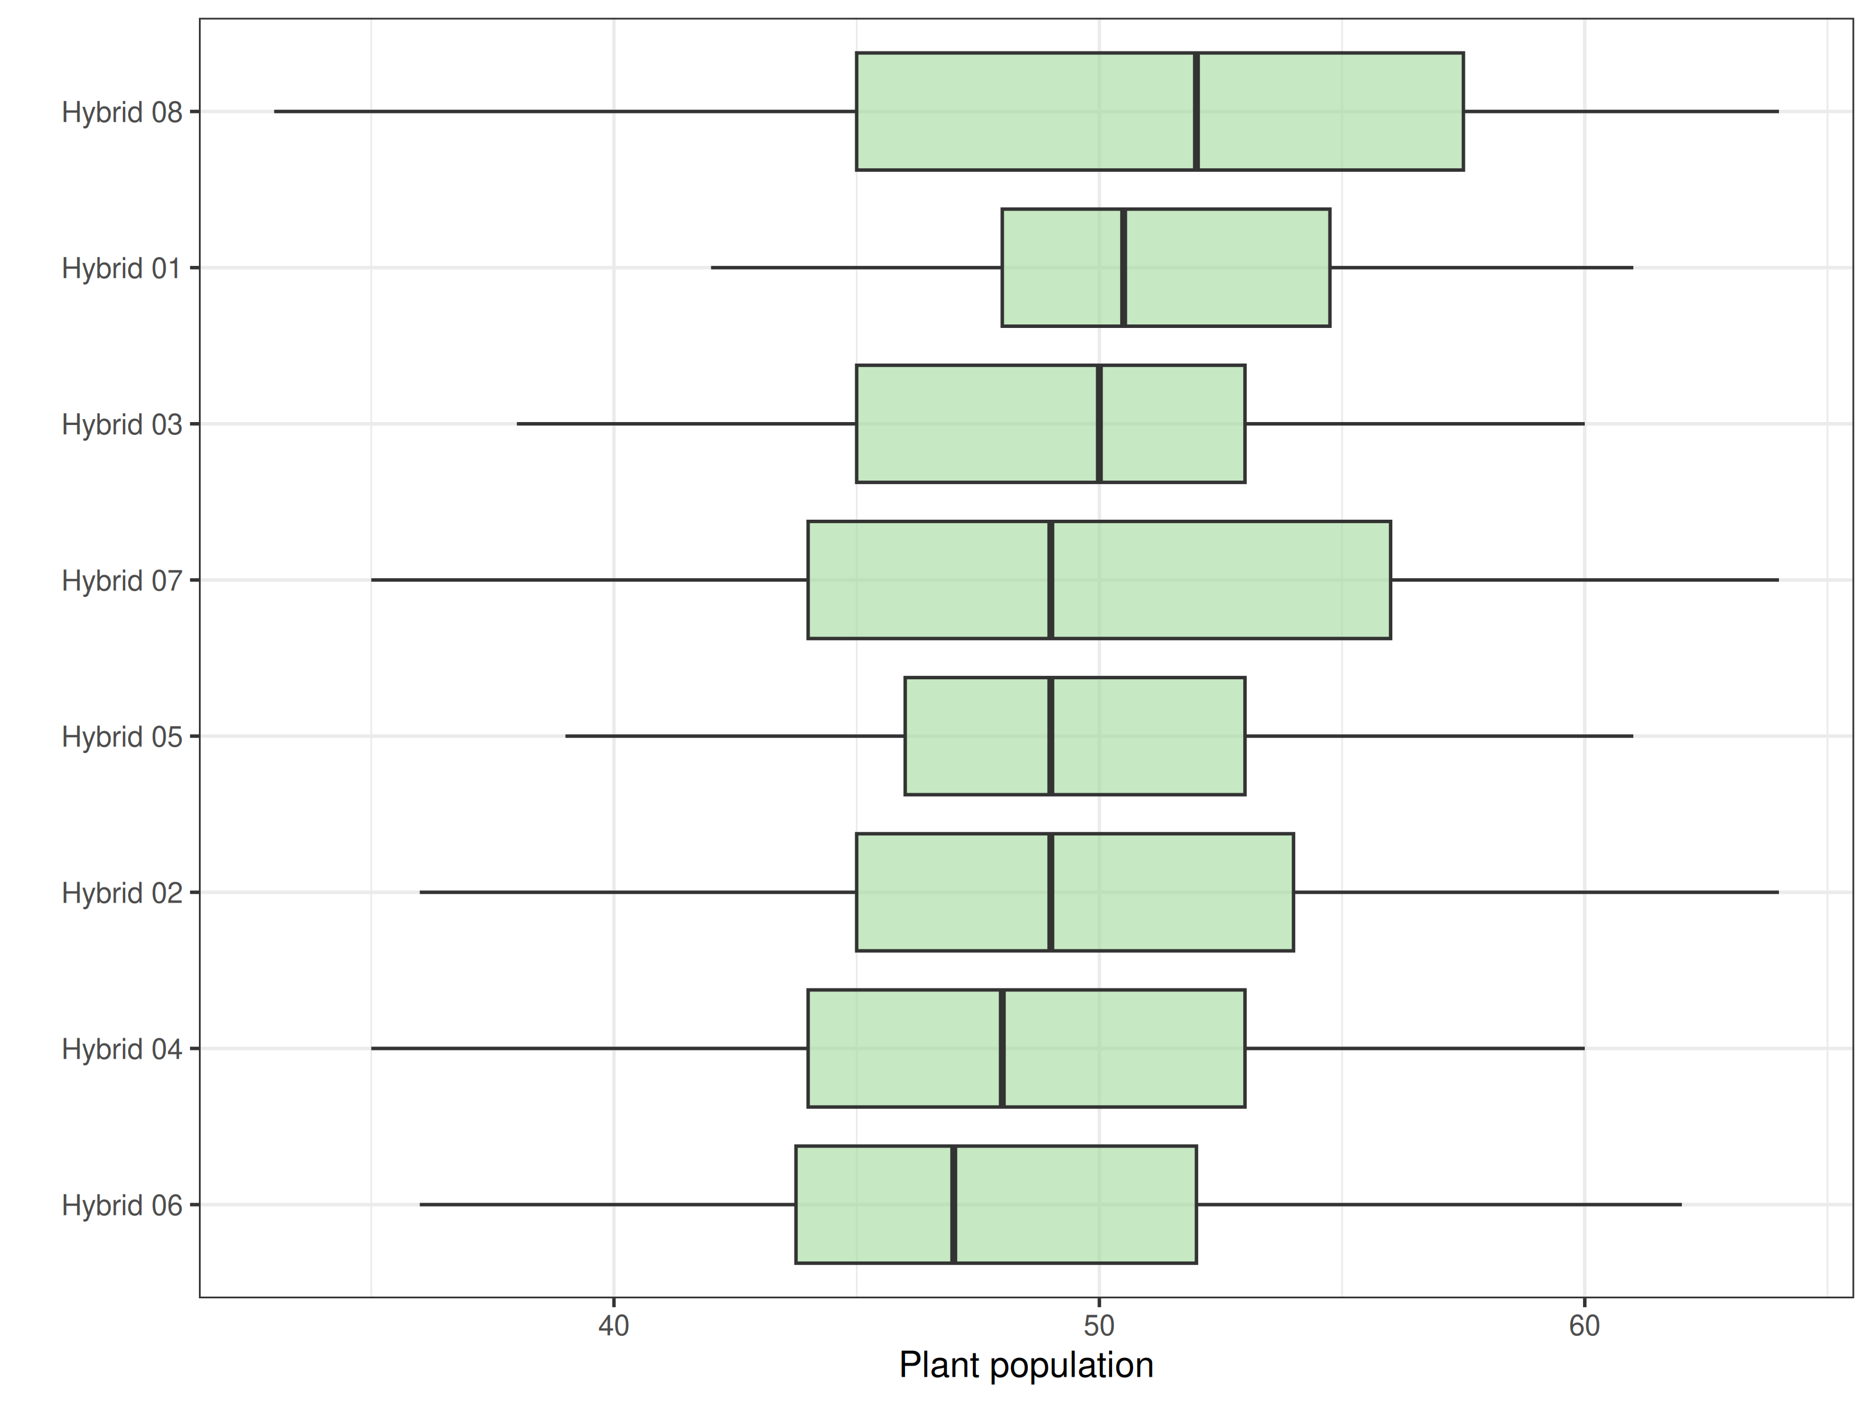
Figure 13. Distribution of Plant population - Vegetative by option, possible outliers removed.

Disease severity - Vegetative
363 plots from 121 farms. 35 plots had no value (5 values were zero) and 3 values were flagged as possible outliers.
Table 10. Mean of each item adjusted for the farm, with 95% confidence interval and comparison with the check Hybrid 04. Items that share a letter are not significantly different (p = 0.05).
Option | N | Mean | Lower 95% | Upper 95% | % of check | p vs check | Group
Hybrid 07 | 35 | 30.94 | 27.75 | 34.14 | 111.23 | 0.153 | b
Hybrid 04 | 44 | 27.82 | 24.97 | 30.67 | 100.00 |  | ab
Hybrid 01 | 38 | 25.42 | 22.35 | 28.49 | 91.38 | 0.262 | ac
Hybrid 05 | 55 | 23.22 | 20.67 | 25.77 | 83.46 | 0.0184 | cd
Hybrid 02 | 35 | 21.97 | 18.77 | 25.17 | 78.98 | 0.00747 | cde
Hybrid 06 | 37 | 19.95 | 16.84 | 23.06 | 71.70 | < 0.001 | def
Hybrid 08 | 47 | 19.45 | 16.69 | 22.21 | 69.91 | < 0.001 | ef
Hybrid 03 | 34 | 16.53 | 13.29 | 19.77 | 59.42 | < 0.001 | f
Broad-sense heritability is 0.89. Values close to 1 mean that most of the variation between plots comes from differences between the items, values close to 0 that it comes from the environment and measurement error.
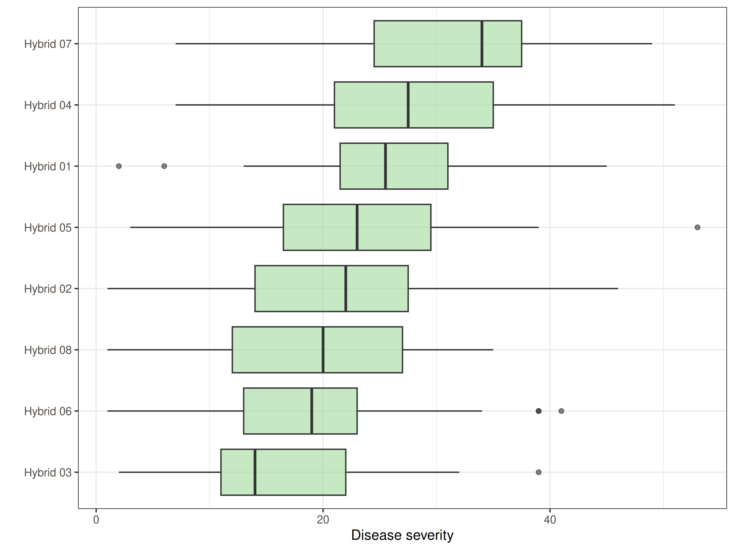
Figure 14. Distribution of Disease severity - Vegetative by option, possible outliers removed.

Plant population - Reproductive
363 plots from 121 farms. 45 plots had no value (0 values were zero) and 3 values were flagged as possible outliers.
Table 11. Mean of each item adjusted for the farm, with 95% confidence interval and comparison with the check Hybrid 04. Items that share a letter are not significantly different (p = 0.05).
Option | N | Mean | Lower 95% | Upper 95% | % of check | p vs check | Group
Hybrid 03 | 37 | 50.47 | 48.48 | 52.45 | 103.94 | 0.174 | a
Hybrid 01 | 39 | 50.25 | 48.32 | 52.19 | 103.50 | 0.221 | a
Hybrid 05 | 50 | 49.68 | 47.97 | 51.39 | 102.32 | 0.389 | a
Hybrid 08 | 45 | 49.40 | 47.60 | 51.20 | 101.74 | 0.529 | a
Hybrid 07 | 37 | 49.36 | 47.37 | 51.34 | 101.66 | 0.568 | a
Hybrid 06 | 35 | 48.75 | 46.71 | 50.78 | 100.40 | 0.893 | a
Hybrid 04 | 39 | 48.55 | 46.62 | 50.48 | 100.00 |  | a
Hybrid 02 | 33 | 47.59 | 45.49 | 49.69 | 98.02 | 0.508 | a
Broad-sense heritability is 0. Values close to 1 mean that most of the variation between plots comes from differences between the items, values close to 0 that it comes from the environment and measurement error.
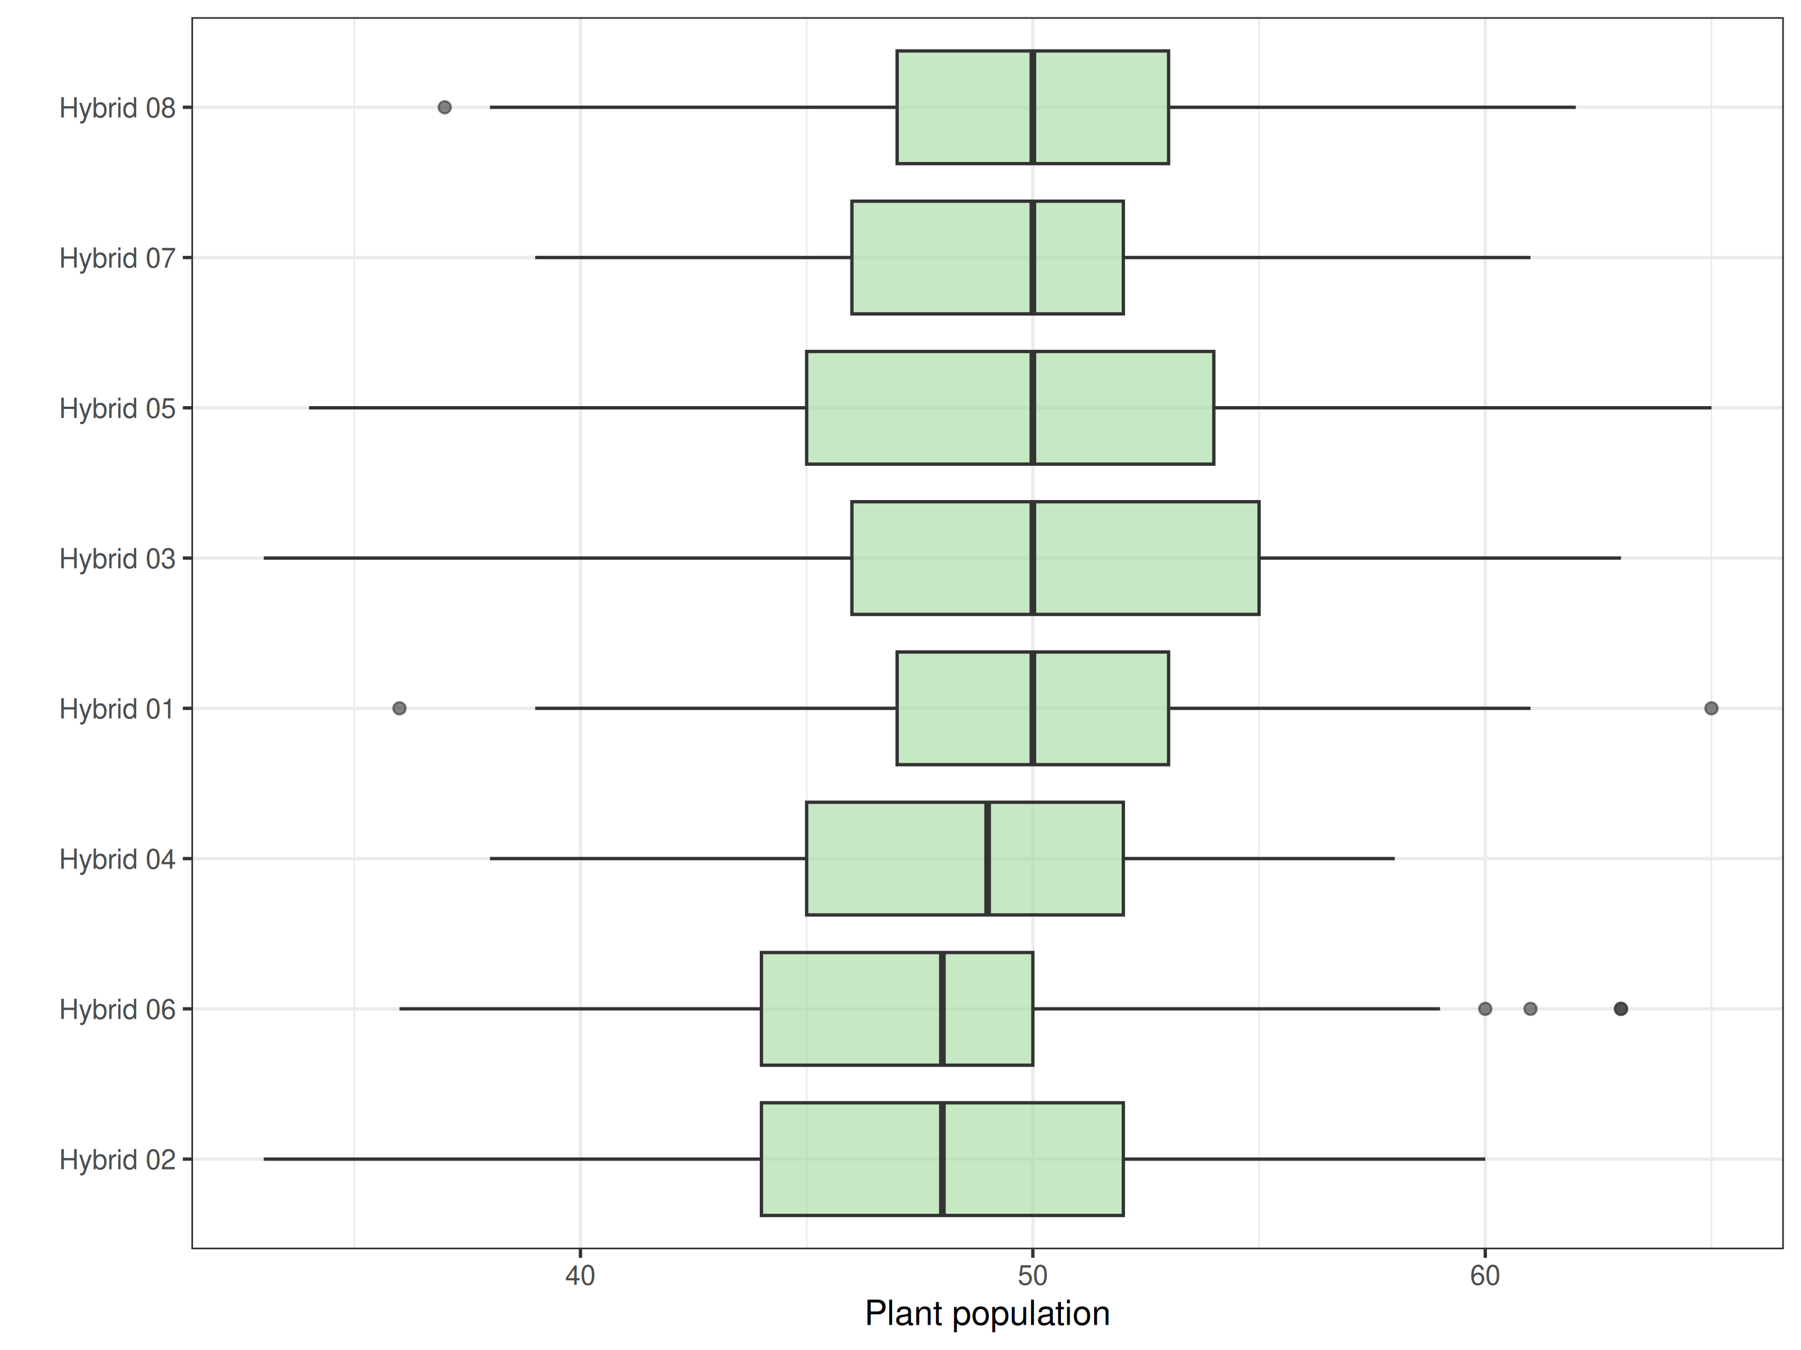
Figure 15. Distribution of Plant population - Reproductive by option, possible outliers removed.

Disease severity - Reproductive
363 plots from 121 farms. 50 plots had no value (5 values were zero) and 1 values were flagged as possible outliers.
Table 12. Mean of each item adjusted for the farm, with 95% confidence interval and comparison with the check Hybrid 04. Items that share a letter are not significantly different (p = 0.05).
Option | N | Mean | Lower 95% | Upper 95% | % of check | p vs check | Group
Hybrid 07 | 36 | 32.89 | 29.71 | 36.07 | 108.33 | 0.261 | a
Hybrid 04 | 39 | 30.36 | 27.30 | 33.42 | 100.00 |  | a
Hybrid 02 | 32 | 24.00 | 20.62 | 27.38 | 79.05 | 0.00621 | b
Hybrid 01 | 40 | 23.93 | 20.91 | 26.94 | 78.81 | 0.00334 | b
Hybrid 05 | 50 | 23.14 | 20.44 | 25.84 | 76.22 | < 0.001 | b
Hybrid 08 | 44 | 20.66 | 17.78 | 23.54 | 68.05 | < 0.001 | b
Hybrid 06 | 34 | 19.79 | 16.52 | 23.07 | 65.20 | < 0.001 | bc
Hybrid 03 | 37 | 16.32 | 13.18 | 19.46 | 53.77 | < 0.001 | c
Broad-sense heritability is 0.92. Values close to 1 mean that most of the variation between plots comes from differences between the items, values close to 0 that it comes from the environment and measurement error.
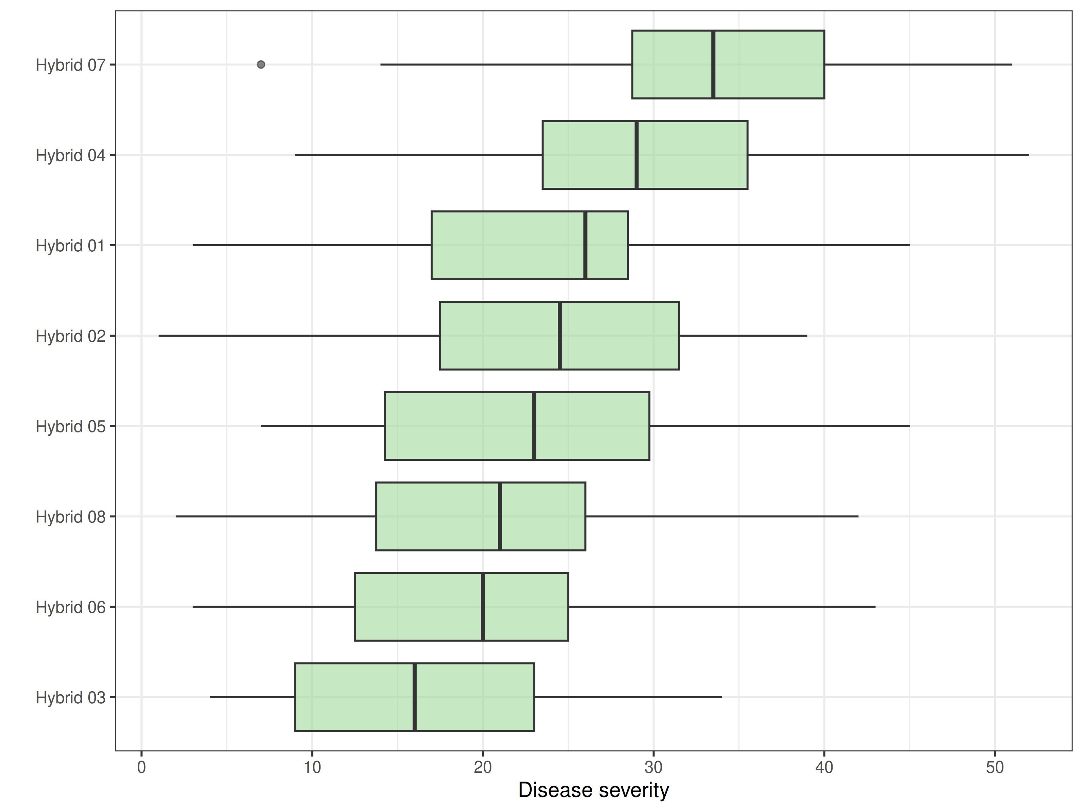
Figure 16. Distribution of Disease severity - Reproductive by option, possible outliers removed.

Number of cobs - Agronomic performance
363 plots from 121 farms. 117 plots had no value (0 values were zero) and 2 values were flagged as possible outliers.
Table 13. Mean of each item adjusted for the farm, with 95% confidence interval and comparison with the check Hybrid 04. Items that share a letter are not significantly different (p = 0.05).
Option | N | Mean | Lower 95% | Upper 95% | % of check | p vs check | Group
Hybrid 03 | 30 | 48.11 | 45.23 | 50.99 | 132.79 | < 0.001 | d
Hybrid 06 | 26 | 43.15 | 40.05 | 46.24 | 119.09 | < 0.001 | c
Hybrid 02 | 22 | 41.56 | 38.19 | 44.92 | 114.70 | 0.0146 | c
Hybrid 05 | 38 | 41.22 | 38.66 | 43.78 | 113.78 | 0.00773 | c
Hybrid 08 | 35 | 40.44 | 37.78 | 43.11 | 111.63 | 0.0279 | c
Hybrid 01 | 32 | 39.49 | 36.70 | 42.28 | 109.00 | 0.0964 | ac
Hybrid 04 | 35 | 36.23 | 33.56 | 38.90 | 100.00 |  | ab
Hybrid 07 | 26 | 33.90 | 30.81 | 37.00 | 93.58 | 0.263 | b
Broad-sense heritability is 0.88. Values close to 1 mean that most of the variation between plots comes from differences between the items, values close to 0 that it comes from the environment and measurement error.
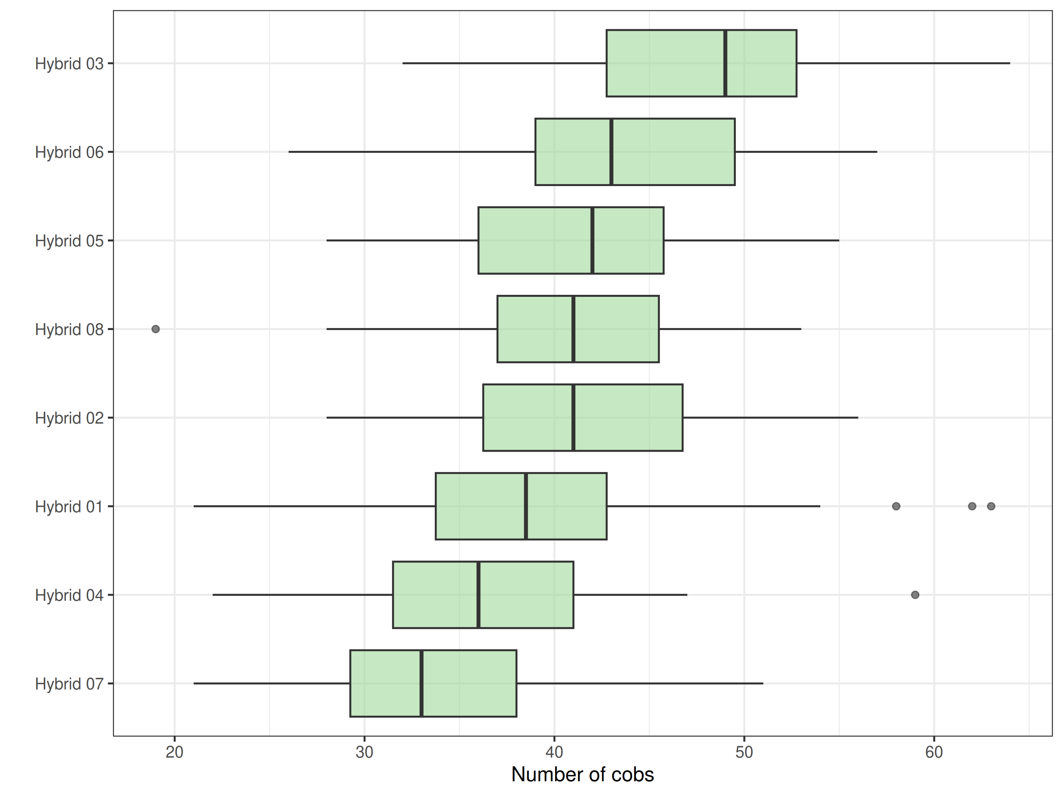
Figure 17. Distribution of Number of cobs - Agronomic performance by option, possible outliers removed.

Yield (quantitative) - Agronomic performance
363 plots from 121 farms. 145 plots had no value (28 values were zero) and 4 values were flagged as possible outliers.
Table 14. Mean of each item adjusted for the farm, with 95% confidence interval and comparison with the check Hybrid 04. Items that share a letter are not significantly different (p = 0.05).
Option | N | Mean | Lower 95% | Upper 95% | % of check | p vs check | Group
Hybrid 03 | 25 | 11.35 | 10.44 | 12.26 | 159.86 | < 0.001 | d
Hybrid 06 | 21 | 10.11 | 9.14 | 11.07 | 142.34 | < 0.001 | c
Hybrid 02 | 21 | 9.93 | 8.96 | 10.91 | 139.91 | < 0.001 | c
Hybrid 08 | 28 | 9.68 | 8.80 | 10.55 | 136.30 | < 0.001 | bc
Hybrid 05 | 34 | 9.19 | 8.36 | 10.02 | 129.40 | < 0.001 | bc
Hybrid 01 | 32 | 8.86 | 8.02 | 9.70 | 124.79 | < 0.001 | b
Hybrid 04 | 32 | 7.10 | 6.26 | 7.94 | 100.00 |  | a
Hybrid 07 | 21 | 6.42 | 5.46 | 7.38 | 90.45 | 0.173 | a
Broad-sense heritability is 0.96. Values close to 1 mean that most of the variation between plots comes from differences between the items, values close to 0 that it comes from the environment and measurement error.
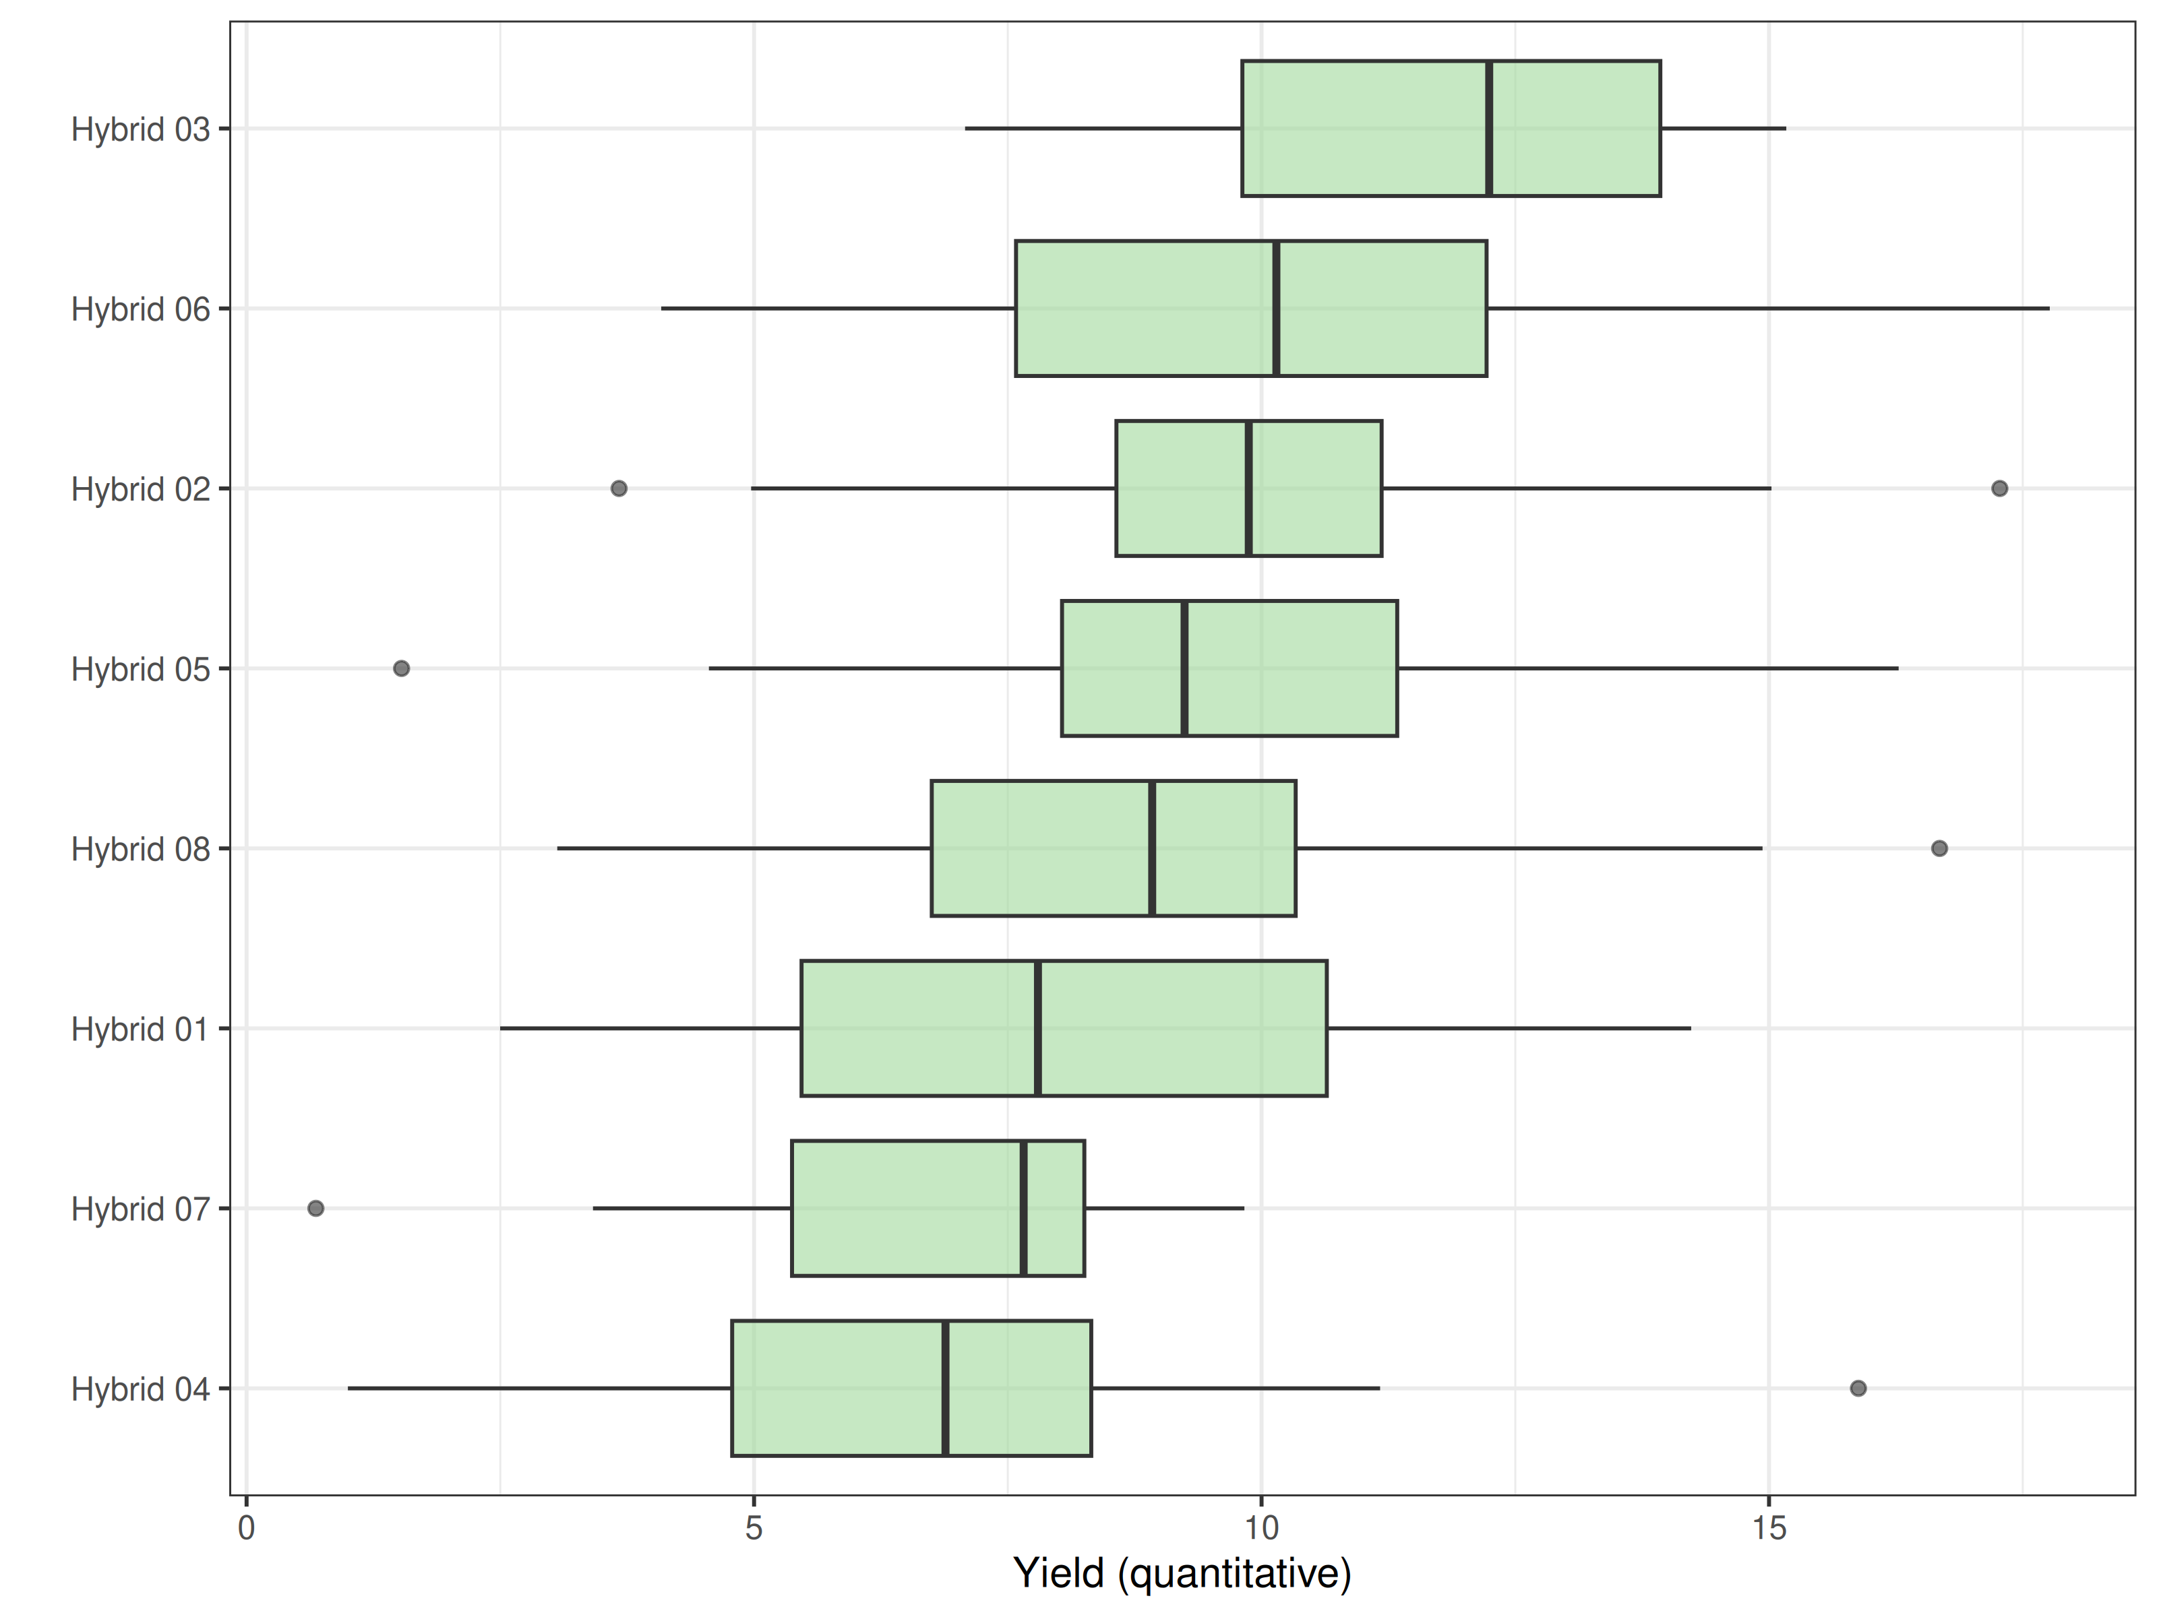
Figure 18. Distribution of Yield (quantitative) - Agronomic performance by option, possible outliers removed.

Evidence for variety release
Tables 15 and 16 bring together the evidence for each item against the check Hybrid 04, in a form that can support a variety release application. The probability of beating the check and its p-value come from the Plackett-Luce model for ‘Overall Preference’. The favourability score is described in the section on performance. The traits where each item was better or worse than the check are those with p < 0.05. When yield was measured, the mean and its percentage of the check come from the mixed model.
Table 15. Summary of each option against the check Hybrid 04.
Option | Times tested | Beats check | p-value | Favourability | Yield (mean) | Yield (% of check)
Hybrid 03 | 40 | 79% | 0.00164 | 46.0 | 11.3 | 159.9
Hybrid 06 | 40 | 70% | 0.0542 | 24.5 | 10.1 | 142.3
Hybrid 08 | 52 | 64% | 0.136 | 8.8 | 9.7 | 136.3
Hybrid 02 | 38 | 62% | 0.271 | 3.3 | 9.9 | 139.9
Hybrid 05 | 59 | 56% | 0.551 | -8.9 | 9.2 | 129.4
Hybrid 01 | 45 | 54% | 0.653 | -12.7 | 8.9 | 124.8
Hybrid 04 | 49 |  |  | -23.5 | 7.1 | 100.0
Hybrid 07 | 40 | 49% | 0.943 | -23.0 | 6.4 | 90.4

Table 16. Traits in which each option was better or worse than the check Hybrid 04 (p < 0.05).
Option | Better than check in | Worse than check in
Hybrid 03 | Germination; Diseases resistance; Drought tolerance; Yield; Grain size; Grain colour; Taste; Overall preference
Hybrid 06 | Germination; Diseases resistance; Drought tolerance; Fall armyworm resistance; Yield; Grain size; Grain colour
Hybrid 08 | Germination; Diseases resistance; Drought tolerance; Fall armyworm resistance; Grain colour; Taste; Marketability
Hybrid 02 | Germination; Diseases resistance; Drought tolerance; Fall armyworm resistance; Taste
Hybrid 05 | Germination
Hybrid 01 | Diseases resistance; Grain colour; Taste
Hybrid 04
Hybrid 07 |  | Drought tolerance
The full comparison, trait by trait and for every check, is in the files ‘variety-release-summary.csv’ and ‘variety-release-by-trait.csv’ in the extra outputs.

What participants said in their own words
Besides ranking the options, participants answered open questions in their own words, by text or voice. Sikia Analytics read 84 answers and found 254 mentions of 9 different topics, such as a trait, a pest or a quality, each with the feeling expressed about it. The labels and sentiments are reported as Sikia returned them, with their counts, so readers can weigh them.
Figure 19 shows the 9 most mentioned topics. Bars to the right count positive mentions, bars to the left negative ones, and grey bars neutral ones. The number at the end of each bar is the total.
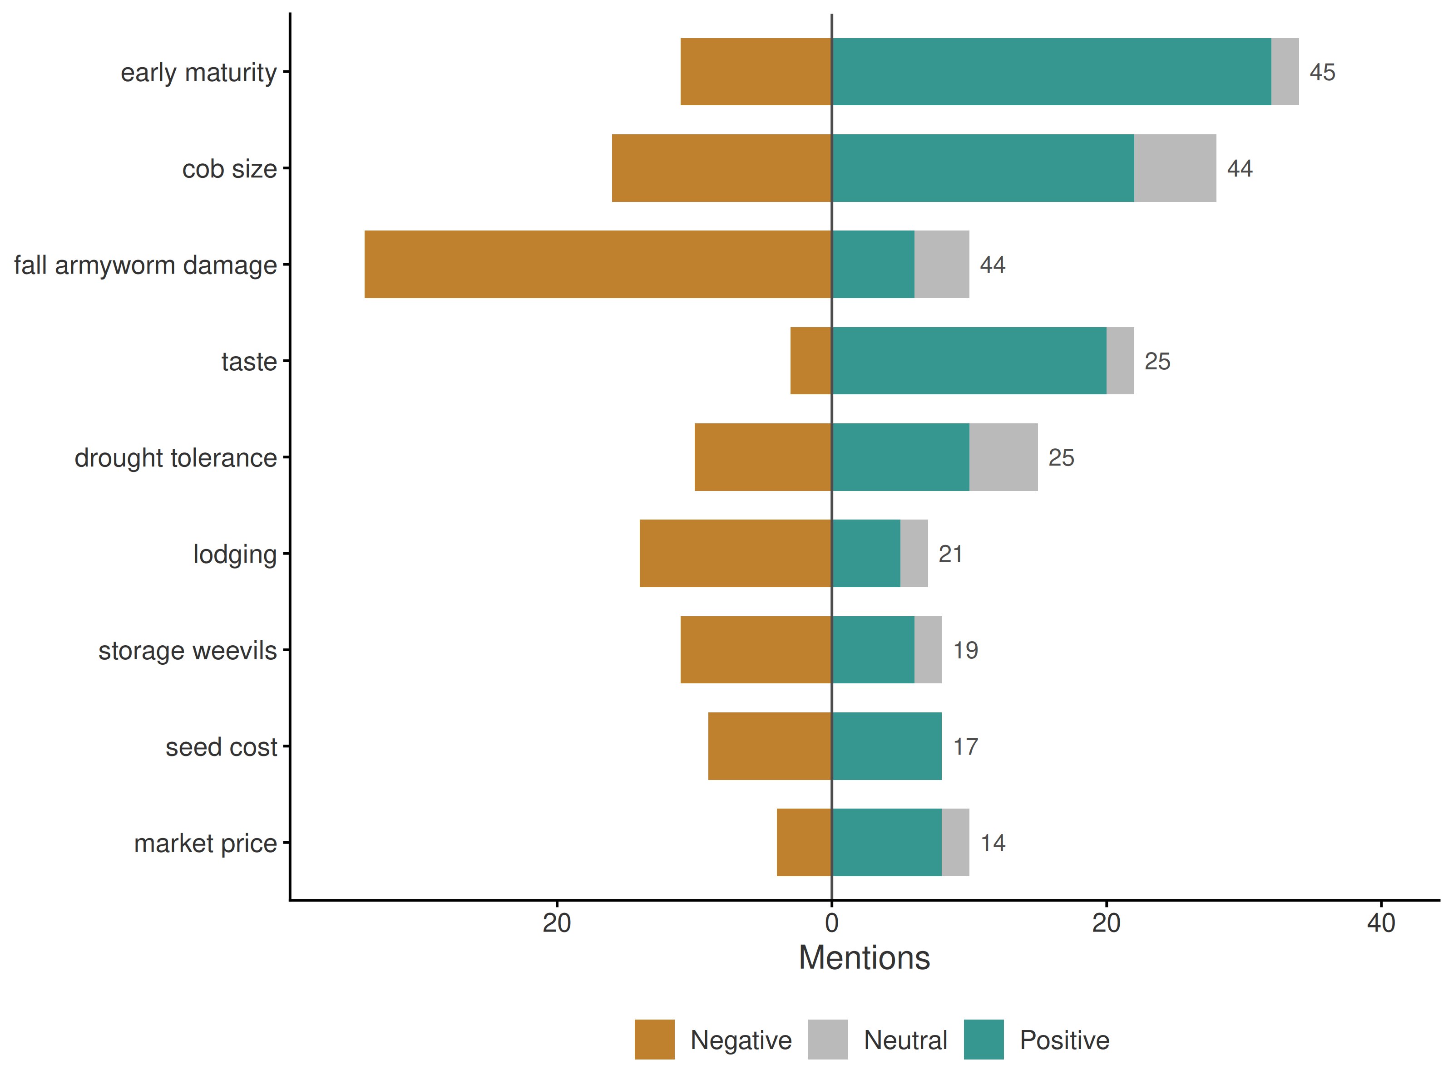
Figure 19. Topics mentioned by participants in their open answers, and the sentiment of each mention, as read by Sikia Analytics.
Sikia linked part of the mentions to the items they were about. Figure 20 shows, for each items and topic, the number of mentions and whether they were mostly positive (teal) or negative (brown).
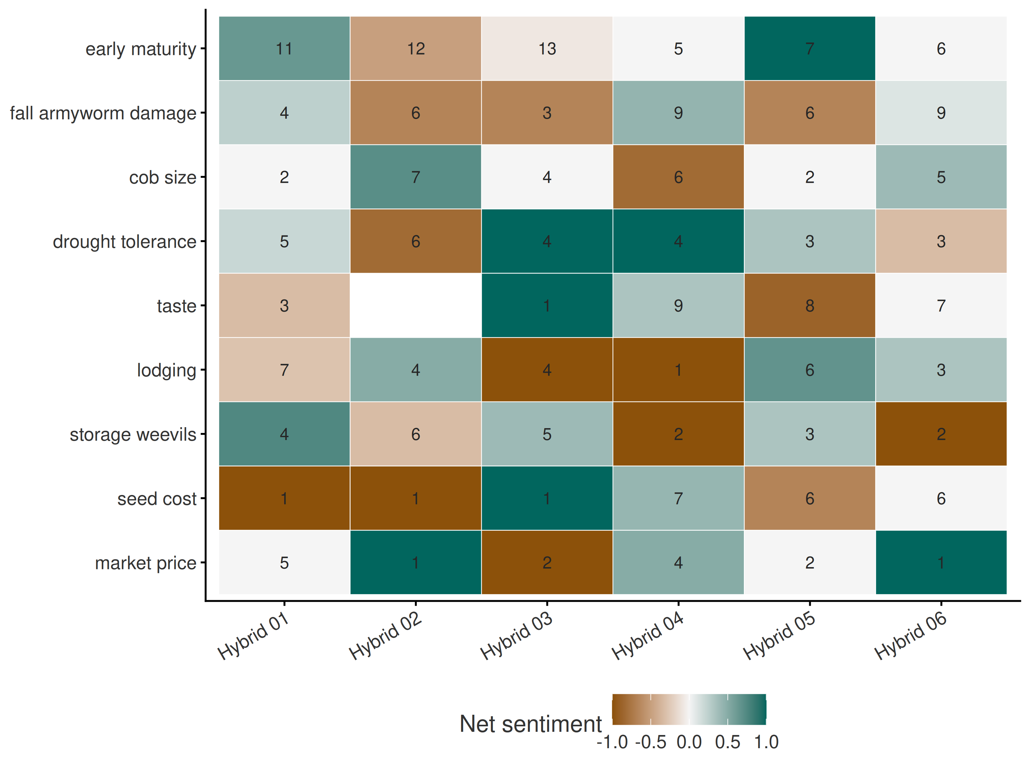
Figure 20. Mentions by Item and topic. Numbers are mentions, colour is the net sentiment, from all negative (brown) to all positive (teal).

In their words
One positive and one negative quote for the most mentioned topics, chosen by Sikia’s confidence in the reading. They are the words of individual participants, not a summary.
Table 17. Quotes from the open answers, by topic and sentiment.
Topic | Sentiment | Quote
early maturity | Positive | ready before the rains stopped with Hybrid 01
early maturity | Negative | still green when the others were dry with Hybrid 01
cob size | Positive | cobs filled to the tip with Hybrid 05
cob size | Negative | small cobs with Hybrid 01
fall armyworm damage | Positive | few worms on this one with Hybrid 01
fall armyworm damage | Negative | armyworm ate the leaves with Hybrid 01
taste | Positive | soft and tasty with Hybrid 02
taste | Negative | hard to chew with Hybrid 04
drought tolerance | Positive | survived the dry spell in February with Hybrid 02
drought tolerance | Negative | wilted when the rains failed with Hybrid 01

Topics across all answers
Sikia grouped similar mentions into 7 topics in 3 broader categories (Table 18). Topics show what participants kept returning to, including things the trial did not ask about.
Table 18. Topics found by Sikia across all open answers, with the number of mentions and representative phrases.
Category | Topic | Mentions | Representative phrases
Growing season | Early maturity and escape from drought | 70 | ready before the rains stopped · kept green with little rain · harvested earliest of the three
Pests in field and store | Fall armyworm and spraying | 44 | armyworm ate the leaves · had to spray twice
Harvest, food and money | Cob size and filling | 44 | big cobs with full rows · many empty tips
Harvest, food and money | Seed cost and market | 31 | sold at a good price · seed too expensive for next season
Harvest, food and money | Eating quality | 25 | sweet when roasted · children liked the ugali from it
Growing season | Standing in wind | 21 | stood well in the wind · fell over after the storm
Pests in field and store | Weevils in storage | 19 | stored for months without weevils · weevils came within weeks
Sikia’s reading of free text is automatic and can miss or misread an answer. Counts of mentions are not counts of participants, as one answer can carry several mentions. The results were produced by Sikia Analytics on 2026-10-20 and are shared through ClimMob. The mentions table is in extra-outputs/sikia-mentions.csv.

References
1. K. de Sousa, J. van Etten, R. Manners, E. Abidin, R. O. Abdulmalik, B. Abolore, K. Acheremu, S. Angudubo, A. Aguilar, E. Arnaud, A. Babu, M. Barrios, G. Benavente, O. Boukar, J. E. Cairns, E. Carey, H. Daudi, M. Dawud, G. Edughaen, J. Ellison, W. Esuma, S. G. Mohammed, J. van de Gevel, M. Gomez, J. van Heerwaarden, P. Iragaba, E. Kadege, T. M. Assefa, S. Kalemera, F. S. Kasubiri, R. Kawuki, Y. G. Kidane, M. Kilango, H. Kulembeka, A. Kwadwo, B. Madriz, E. Masumba, J. Mbiu, T. Mendes, A. Müller, M. Moyo, K. Mtunda, T. Muzhingi, D. Muungani, E. T. Mwenda, G. R. V. P. R. Nadigatla, A. R. Nanyonjo, S. N’Danikou, A. Nduwumuremyi, J. C. Nshimiyimana, E. Nuwamanya, H. Nyirahabimana, M. Occelli, O. Olaosebikan, P. O. Ongom, B. Ortiz-Crespo, R. Oteng-Fripong, A. Ozimati, D. Owoade, C. F. Quiros, J. C. Rosas, P. Rukundo, P. Rutsaert, M. Sibomana, N. Sharma, N. Shida, J. Steinke, R. Ssali, J. G. Suchini, B. Teeken, T. K. Tengey, H. A. Tufan, S. Tumwegamire, E. Tuyishime, J. Ulzen, M. L. Umar, S. Onwuka, T. U. Madu, R. C. Voss, M. Yeye, M. Zaman-Allah, The tricot approach: An agile framework for decentralized on-farm testing supported by citizen science. A retrospective. Agronomy for Sustainable Development 44 (2024).
2. J. van Etten, E. Beza, L. Calderer, K. Van Duijvendijk, C. Fadda, B. Fantahun, Y. G. Kidane, J. van de Gevel, A. Gupta, D. K. Mengistu, D. Kiambi, P. N. Mathur, L. Mercado, S. Mittra, M. J. Mollel, J. C. Rosas, J. Steinke, J. G. Suchini, K. S. Zimmerer, First experiences with a novel farmer citizen science approach: crowdsourcing participatory variety selection through on-farm triadic comparisons of technologies (tricot). Experimental Agriculture 55, 275–296 (2019).
3. C. Quirós, K. de Sousa, J. Steinke, B. Madriz, M.-A. Laporte, E. Arnaud, R. Manners, B. Ortiz-Crespo, A. Müller, J. van Etten, ClimMob: Software to support experimental citizen science in agriculture. Computers and Electronics in Agriculture 217, 108539 (2024).
4. R. L. Plackett, The Analysis of Permutations. Journal of the Royal Statistical Society. Series C (Applied Statistics) 24, 193–202 (1975).
5. R. D. Luce, Individual Choice Behavior (Courier Corporation, 1959).
6. A. H. Sparks, nasapower: A NASA POWER Global Meteorology, Surface Solar Energy and Climatology Data Client for R. Journal of Open Source Software 3, 1035 (2018).
7. K. de Sousa, J. van Etten, S. Ø. Solberg, Climatrends: Climate Variability Indices for Ecological Modelling (2020; https://CRAN.R-project.org/package=climatrends).
8. H. L. Turner, J. van Etten, D. Firth, I. Kosmidis, Modelling rankings in R: the PlackettLuce package. Computational Statistics, doi: 10.1007/s00180-020-00959-3 (2020).
9. A. Zeileis, T. Hothorn, K. Hornik, Model-based recursive partitioning. Journal of Computational and Graphical Statistics 17, 492–514 (2008).
10. Y. Sakamoto Ishiguro, M., Kitagawa, G., Akaike information criterion statistics (KTK Scientific Publishers ; D. Reidel ; Sold; distributed in the U.S.A.; Canada by Kluwer Academic Publishers, Tokyo; Dordrecht; Boston; Hingham, MA, 1986).
11. M. G. Kendall, A new measure of ranking correlation. Biometrika 30, 81–93 (1938).
12. R Core Team, R: A language and environment for statistical computing. version 3.6.2. (2019). https://r-project.org/.
13. Y. Xie, Dynamic Documents with R and knitr (Chapman; Hall/CRC, Boca Raton, Florida, ed. 2nd, 2015; https://yihui.org/knitr/).
14. Y. Xie, J. J. Allaire, G. Grolemund, R Markdown: The Definitive Guide (Chapman; Hall/CRC, Boca Raton, Florida, 2018; https://bookdown.org/yihui/rmarkdown).
15. K. de Sousa, J. van Etten, ClimMobTools: API Client for the ’ClimMob’ platform (2022). https://CRAN.R-project.org/package=ClimMobTools.
16. K. de Sousa, D. Brown, J. Steinke, J. van Etten, gosset: An R Package for Analysis and Synthesis of Ranking Data in Agricultural Experimentation. SSRN Electronic Journal, doi: 10.2139/ssrn.4236267 (2022).
17. A. Zeileis, T. Hothorn, K. Hornik, Model-Based Recursive Partitioning. Journal of Computational and Graphical Statistics 17, 492–514 (2008).
18. J. Kopf, C. Strobl, A. Zeileis, Anchor Selection Strategies for DIF Analysis: Review, Assessment, and New Approaches. Educational and Psychological Measurement 75, 22–56 (2015).
19. D. Firth, qvcalc: Quasi Variances for Factor Effects in Statistical Models (2020). https://CRAN.R-project.org/package=qvcalc.
20. D. Bates, M. Mächler, B. Bolker, S. Walker, Fitting linear mixed-effects models using lme4. Journal of Statistical Software 67, 1–48 (2015).
21. G. R. Warnes, B. Bolker, T. Lumley, gtools: Various R Programming Tools (2018). https://CRAN.R-project.org/package=gtools.
22. J. Ooms, The jsonlite Package: A Practical and Consistent Mapping Between JSON Data and R Objects. arXiv:1403.2805 [stat.CO] (2014).
23. H. Wickham, ggplot2: Elegant Graphics for Data Analysis (Springer-Verlag New York, 2016; https://ggplot2.tidyverse.org).
24. M. Borkovec, N. Madin, ggparty: ’ggplot’ Visualizations for the ’partykit’ Package (2019; https://CRAN.R-project.org/package=ggparty).
25. G. Csardi, T. Nepusz, The igraph software package for complex network research. InterJournal Complex Systems, 1695 (2006).
26. S. Graves, H.-P. Piepho, L. S. with help from Sundar Dorai-Raj, multcompView: Visualizations of Paired Comparisons (2019; https://CRAN.R-project.org/package=multcompView).
27. T. L. Pedersen, patchwork: The Composer of Plots (2019; https://CRAN.R-project.org/package=patchwork).
28. J. van Etten, R. Manners, J. Steinke, E. Matthus, K. de Sousa, The tricot approach: Guide for large-scale participatory experiments (Bioversity International; Bioversity International, Rome, Italy, 2020; https://hdl.handle.net/10568/109942).
29. K. de Sousa, A. Müller, B. Madriz, J. van Etten, Workflow for automated analysis and report of decentralized experiments with the tricot approach. doi: 10.5281/zenodo.4609907 (2022).
30. K. M. Eskridge, R. F. Mumm, Choosing plant cultivars based on the probability of outperforming a check. Theoretical and Applied Genetics 84-84, 494–500 (1992).
31. G. Loomes, R. Sugden, Regret theory: An alternative theory of rational choice under uncertainty. The Economic Journal 92, 805 (1982).
32. H. Bleichrodt, P. P. Wakker, Regret theory: A bold alternative to the alternatives. The Economic Journal 125, 493–532 (2015).
33. J. B. Holland, W. E. Nyquist, C. T. Cervantes-Martı́nez, “Estimating and interpreting heritability for plant breeding: An update” in Plant Breeding Reviews (John Wiley & Sons, 2003)vol. 22, pp. 9–112.

Appendix

Monitoring tables
Table 19. Number of participants who answered each data collection moment, percentage of those registered and number lost since the previous moment.
Group | Data collection moment | Day | N | % of registered | Lost since previous
All participants | Registration | 0 | 117 | 100.0
All participants | Vegetative | 30 | 111 | 94.9 | 6
All participants | Reproductive | 70 | 106 | 90.6 | 5
All participants | Agronomic performance | 85 | 82 | 70.1 | 24
Man | Registration | 0 | 99 | 100.0
Man | Vegetative | 30 | 95 | 96.0 | 4
Man | Reproductive | 70 | 89 | 89.9 | 6
Man | Agronomic performance | 85 | 68 | 68.7 | 21
Prefer Not To Respond | Registration | 0 | 1 | 100.0
Prefer Not To Respond | Vegetative | 30 | 1 | 100.0 | 0
Prefer Not To Respond | Reproductive | 70 | 1 | 100.0 | 0
Prefer Not To Respond | Agronomic performance | 85 | 1 | 100.0 | 0
Woman | Registration | 0 | 17 | 100.0
Woman | Vegetative | 30 | 15 | 88.2 | 2
Woman | Reproductive | 70 | 16 | 94.1 | -1
Woman | Agronomic performance | 85 | 13 | 76.5 | 3

Table 20. Forms submitted by data collector and data collection moment.
Data collection moment | Data collector | Forms
Registration | enumerator1 | 52
Registration | enumerator2 | 65
Vegetative | enumerator1 | 60
Vegetative | enumerator2 | 51
Reproductive | enumerator1 | 55
Reproductive | enumerator2 | 51
Agronomic performance | enumerator1 | 48
Agronomic performance | enumerator2 | 34

Traits analysed
Table 21. Traits analysed and number of valid answers.
Trait | Data collection moment | Question asked | Valid answers
Germination | Vegetative | Which option germinated more plants?, Which option germinated less plants? | 101
Diseases resistance | Vegetative | Which option is more resistant to diseases?, Which option is more susceptible to diseases? | 61
Drought tolerance | Vegetative | Which option is more tolerant to drought?, Which option is more susceptible to drought? | 62
Fall armyworm resistance | Vegetative | Which option is more resistant to fall armyworm?, Which option is more susceptible to fall armyworm? | 82
Diseases resistance | Reproductive | Which option is more resistant to diseases?, Which option is more susceptible to diseases? | 55
Drought tolerance | Reproductive | Which option is more tolerant to drought?, Which option is more susceptible to drought? | 46
Fall armyworm resistance | Reproductive | Which option is more resistant to fall armyworm?, Which option is more susceptible to fall armyworm? | 81
Maturity | Agronomic Performance | Which option has the earlier maturity?, Which option has the later maturity? | 78
Yield | Agronomic Performance | Which option has the higher grain yield?, Which option has the lower grain yield? | 79
Grain size | Agronomic Performance | Which option has the best grain/seed size for the target market?, Which option has the worst grain/seed size for the target market? | 77
Grain colour | Agronomic Performance | Which option has the best grain/seed colour for the target market?, Which option has the worst grain/seed colour for the target market? | 78
Taste | Agronomic Performance | Which option has the best taste?, Which option has the worst taste? | 77
Marketability | Agronomic Performance | Which option is easier to sell?, Which option is more difficult to sell? | 72
Overall preference | Agronomic Performance | Overall, which option was the best?, Overall, which option was the worst? | 75

Favourability by trait
Table 22. Favourability of the items, by trait.
Trait | Option | N | Top (%) | Bottom (%) | Favourability
Germination [Vegetative] | Hybrid 08 | 82 | 46.4 | 18.4 | 28.1
 | Hybrid 02 | 66 | 42.6 | 22.1 | 20.5
 | Hybrid 06 | 66 | 42.0 | 21.9 | 20.1
 | Hybrid 03 | 72 | 39.2 | 25.1 | 14.1
 | Hybrid 05 | 96 | 35.3 | 28.7 | 6.6
 | Hybrid 01 | 74 | 26.1 | 39.9 | -13.8
 | Hybrid 07 | 68 | 18.3 | 53.9 | -35.6
 | Hybrid 04 | 82 | 17.3 | 56.2 | -38.9
Diseases resistance [Vegetative] | Hybrid 03 | 36 | 57.4 | 11.0 | 46.4
 | Hybrid 08 | 44 | 53.8 | 12.9 | 41.0
 | Hybrid 02 | 42 | 45.7 | 19.8 | 25.8
 | Hybrid 06 | 40 | 40.6 | 22.4 | 18.2
 | Hybrid 01 | 48 | 33.6 | 25.5 | 8.0
 | Hybrid 05 | 56 | 25.9 | 33.6 | -7.7
 | Hybrid 04 | 60 | 13.9 | 57.7 | -43.8
 | Hybrid 07 | 40 | 8.2 | 73.4 | -65.2
Drought tolerance [Vegetative] | Hybrid 03 | 40 | 55.6 | 11.9 | 43.7
 | Hybrid 06 | 52 | 44.0 | 19.4 | 24.6
 | Hybrid 08 | 52 | 39.8 | 24.2 | 15.6
 | Hybrid 02 | 32 | 36.4 | 28.1 | 8.3
 | Hybrid 01 | 48 | 32.0 | 30.7 | 1.3
 | Hybrid 05 | 62 | 28.0 | 36.1 | -8.1
 | Hybrid 04 | 42 | 16.1 | 58.1 | -42.0
 | Hybrid 07 | 44 | 16.0 | 59.2 | -43.2
Fall armyworm resistance [Vegetative] | Hybrid 06 | 48 | 48.8 | 16.8 | 32.1
 | Hybrid 03 | 54 | 42.3 | 22.2 | 20.1
 | Hybrid 05 | 82 | 37.3 | 27.3 | 10.1
 | Hybrid 01 | 60 | 35.7 | 28.1 | 7.6
 | Hybrid 02 | 48 | 34.0 | 31.6 | 2.4
 | Hybrid 08 | 80 | 29.6 | 35.9 | -6.3
 | Hybrid 04 | 60 | 27.7 | 39.5 | -11.9
 | Hybrid 07 | 60 | 15.1 | 61.9 | -46.8
Diseases resistance [Reproductive] | Hybrid 03 | 36 | 48.2 | 17.5 | 30.7
 | Hybrid 06 | 24 | 45.6 | 19.9 | 25.7
 | Hybrid 02 | 32 | 38.0 | 26.2 | 11.8
 | Hybrid 08 | 58 | 37.8 | 27.1 | 10.7
 | Hybrid 01 | 46 | 27.9 | 39.4 | -11.5
 | Hybrid 07 | 40 | 26.9 | 40.9 | -14.0
 | Hybrid 04 | 46 | 25.9 | 42.2 | -16.2
 | Hybrid 05 | 48 | 25.3 | 43.6 | -18.3
Drought tolerance [Reproductive] | Hybrid 03 | 32 | 50.8 | 14.9 | 35.9
 | Hybrid 08 | 42 | 51.0 | 15.8 | 35.2
 | Hybrid 04 | 30 | 39.3 | 23.9 | 15.4
 | Hybrid 02 | 36 | 32.8 | 29.4 | 3.4
 | Hybrid 01 | 38 | 33.3 | 31.2 | 2.1
 | Hybrid 06 | 22 | 28.6 | 38.4 | -9.8
 | Hybrid 05 | 46 | 16.3 | 54.3 | -38.0
 | Hybrid 07 | 30 | 14.2 | 58.5 | -44.3
Fall armyworm resistance [Reproductive] | Hybrid 02 | 54 | 43.7 | 21.2 | 22.5
 | Hybrid 08 | 66 | 42.7 | 21.6 | 21.1
 | Hybrid 06 | 60 | 42.5 | 22.2 | 20.2
 | Hybrid 05 | 78 | 33.3 | 31.0 | 2.3
 | Hybrid 03 | 60 | 33.3 | 31.9 | 1.3
 | Hybrid 01 | 60 | 31.3 | 33.5 | -2.2
 | Hybrid 04 | 54 | 21.6 | 48.9 | -27.3
 | Hybrid 07 | 54 | 15.4 | 61.2 | -45.9
Maturity [Agronomic Performance] | Hybrid 03 | 56 | 48.5 | 17.2 | 31.3
 | Hybrid 02 | 44 | 47.6 | 17.6 | 30.1
 | Hybrid 06 | 48 | 47.1 | 18.6 | 28.5
 | Hybrid 08 | 66 | 33.5 | 30.6 | 2.9
 | Hybrid 04 | 64 | 29.6 | 35.7 | -6.1
 | Hybrid 05 | 72 | 27.9 | 38.8 | -10.9
 | Hybrid 01 | 64 | 23.7 | 43.4 | -19.6
 | Hybrid 07 | 54 | 16.6 | 57.4 | -40.8
Yield [Agronomic Performance] | Hybrid 03 | 56 | 50.0 | 16.1 | 33.9
 | Hybrid 06 | 52 | 49.7 | 15.9 | 33.7
 | Hybrid 08 | 66 | 37.1 | 26.5 | 10.6
 | Hybrid 02 | 40 | 36.5 | 28.5 | 8.1
 | Hybrid 05 | 76 | 29.6 | 35.4 | -5.8
 | Hybrid 01 | 62 | 28.6 | 34.8 | -6.1
 | Hybrid 04 | 70 | 26.3 | 41.1 | -14.8
 | Hybrid 07 | 52 | 12.4 | 66.6 | -54.2
Grain size [Agronomic Performance] | Hybrid 03 | 56 | 51.2 | 14.9 | 36.3
 | Hybrid 06 | 50 | 43.1 | 21.0 | 22.1
 | Hybrid 02 | 44 | 40.9 | 23.2 | 17.8
 | Hybrid 08 | 62 | 39.2 | 24.5 | 14.7
 | Hybrid 01 | 60 | 30.8 | 33.2 | -2.5
 | Hybrid 05 | 74 | 27.5 | 39.0 | -11.5
 | Hybrid 04 | 64 | 21.8 | 48.5 | -26.7
 | Hybrid 07 | 52 | 16.8 | 57.6 | -40.8
Grain colour [Agronomic Performance] | Hybrid 03 | 56 | 47.1 | 17.7 | 29.3
 | Hybrid 06 | 50 | 43.4 | 20.3 | 23.1
 | Hybrid 08 | 66 | 42.8 | 21.2 | 21.6
 | Hybrid 01 | 62 | 36.3 | 26.5 | 9.8
 | Hybrid 02 | 42 | 35.3 | 29.2 | 6.0
 | Hybrid 05 | 72 | 30.8 | 33.1 | -2.3
 | Hybrid 04 | 68 | 17.9 | 55.7 | -37.7
 | Hybrid 07 | 52 | 15.4 | 60.6 | -45.2
Taste [Agronomic Performance] | Hybrid 03 | 54 | 58.2 | 10.5 | 47.7
 | Hybrid 08 | 70 | 40.9 | 22.7 | 18.2
 | Hybrid 01 | 58 | 36.3 | 26.2 | 10.1
 | Hybrid 02 | 40 | 34.9 | 28.4 | 6.5
 | Hybrid 06 | 50 | 31.7 | 31.9 | -0.3
 | Hybrid 05 | 74 | 30.8 | 33.1 | -2.3
 | Hybrid 07 | 50 | 19.0 | 53.6 | -34.6
 | Hybrid 04 | 66 | 16.3 | 58.4 | -42.1
Marketability [Agronomic Performance] | Hybrid 08 | 60 | 48.6 | 17.0 | 31.6
 | Hybrid 06 | 44 | 40.3 | 23.7 | 16.7
 | Hybrid 05 | 64 | 40.0 | 24.4 | 15.6
 | Hybrid 02 | 42 | 37.4 | 27.5 | 9.8
 | Hybrid 03 | 54 | 29.8 | 36.6 | -6.8
 | Hybrid 01 | 54 | 28.5 | 37.0 | -8.5
 | Hybrid 04 | 62 | 22.1 | 47.9 | -25.8
 | Hybrid 07 | 52 | 20.4 | 51.4 | -31.1
Overall preference [Agronomic Performance] | Hybrid 03 | 54 | 57.3 | 11.3 | 46.0
 | Hybrid 06 | 42 | 44.6 | 20.1 | 24.5
 | Hybrid 08 | 62 | 36.6 | 27.7 | 8.8
 | Hybrid 02 | 42 | 33.8 | 30.5 | 3.3
 | Hybrid 05 | 70 | 28.6 | 37.5 | -8.9
 | Hybrid 01 | 58 | 26.5 | 39.2 | -12.7
 | Hybrid 07 | 54 | 23.0 | 46.0 | -23.0
 | Hybrid 04 | 68 | 23.1 | 46.5 | -23.5

Kendall correlation
Table 23. Kendall correlation between ‘Overall Preference’ and the other traits. A p-value below 0.05 indicates a significant correlation.
Trait | Kendall tau | Lower 95% | Upper 95% | Z value | Pr(>|z|)
Drought tolerance [Vegetative] | 0.136 | -0.005 | 0.254 | 0.847 | 1.98e-01
Maturity [Agronomic performance] | 0.125 | -0.008 | 0.247 | 0.848 | 1.98e-01
Germination [Vegetative] | 0.120 | 0.004 | 0.247 | 0.801 | 2.11e-01
Diseases resistance [Reproductive] | 0.120 | 0.005 | 0.241 | 0.743 | 2.29e-01
Taste [Agronomic performance] | 0.115 | 0.012 | 0.214 | 0.775 | 2.19e-01
Diseases resistance [Vegetative] | 0.106 | -0.020 | 0.212 | 0.651 | 2.57e-01
Grain colour [Agronomic performance] | 0.095 | -0.061 | 0.200 | 0.642 | 2.60e-01
Marketability [Agronomic performance] | 0.051 | -0.069 | 0.158 | 0.341 | 3.66e-01
Drought tolerance [Reproductive] | 0.033 | -0.083 | 0.145 | 0.202 | 4.20e-01
Fall armyworm resistance [Reproductive] | 0.028 | -0.081 | 0.131 | 0.179 | 4.29e-01
Yield [Agronomic performance] | -0.023 | -0.123 | 0.090 | -0.153 | 5.61e-01
Grain size [Agronomic performance] | -0.023 | -0.116 | 0.094 | -0.155 | 5.62e-01
Fall armyworm resistance [Vegetative] | -0.053 | -0.166 | 0.064 | -0.345 | 6.35e-01

Possible outliers in measured traits
Table 24. Possible outliers in the measured traits. If any of these values is a mistake, correct it in ClimMob and request a new report.
id | technology | trait | data_collection | value | enumerator
4 | Hybrid 05 | Plant population | Reproductive | 66.000 | enumerator1
4 | Hybrid 07 | Disease severity | Reproductive | 59.000 | enumerator1
7 | Hybrid 01 | Plant population | Reproductive | 28.000 | enumerator1
18 | Hybrid 07 | Number of cobs | Agronomic performance | 15.000 | enumerator2
34 | Hybrid 06 | Yield (quantitative) | Agronomic performance | 72.988 | enumerator2
35 | Hybrid 07 | Disease severity | Vegetative | 54.000 | enumerator1
36 | Hybrid 08 | Plant population | Reproductive | 67.000 | enumerator2
41 | Hybrid 06 | Plant population | Vegetative | 68.000 | enumerator1
50 | Hybrid 05 | Disease severity | Vegetative | 53.000 | enumerator2
57 | Hybrid 07 | Disease severity | Vegetative | 55.000 | enumerator1
62 | Hybrid 04 | Disease severity | Vegetative | 56.000 | enumerator1
72 | Hybrid 05 | Number of cobs | Agronomic performance | 13.000 | enumerator2
97 | Hybrid 08 | Yield (quantitative) | Agronomic performance | 137.143 | enumerator1

