Certificate of Participation in a ClimMob Experiment

Thank you Meimunatu Zakaria for your participation!

You collaborated together with 100 participants who contributed to this experiment. Each of the 100 participants evaluated 3 technologies out of 15 of the experiment. You ranked these technologies: PG17362-N1, SARI-Nan, SARI-Tiemeh.You and the other participants were asked to answer the questions: Overall, which option was the best?, Overall, which option was the worst?. Your response was:

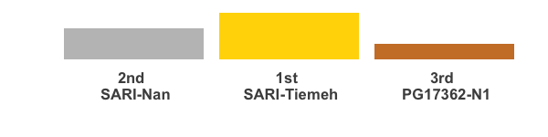

Adding up all the responses from the other participants we obtained the following ranking. The technologies in the top are the most often ranked as the best while the technologies in the botton are the most often ranked as worst.

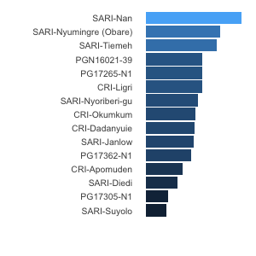

This is how you ranked the 3 technologies that you received based on the other 10 traits that you evaluated in this experiment:

|  |  |  |  |
| --- | --- | --- | --- |
| Trait | First | Middle | Last |
| Overall ranking | SARI-Tiemeh | SARI-Nan | PG17362-N1 |
| What is the vigour of the variety | SARI-Tiemeh | SARI-Nan | PG17362-N1 |
| What’s the virus status of the varieties? | Not replied |  |  |
| What is the response of varieties to other diseases or pests? | PG17362-N1 | SARI-Tiemeh | SARI-Nan |
| What is the response of varieties to drought? 1 | SARI-Nan | SARI-Tiemeh | PG17362-N1 |
| What is the yield of the varieties? | SARI-Nan | SARI-Tiemeh | PG17362-N1 |
| What are the sizes of the storage roots? | SARI-Tiemeh | SARI-Nan | PG17362-N1 |
| What is the response of varieties to drought? 2 | PG17362-N1 | SARI-Tiemeh | SARI-Nan |
| What is the yield of fresh vines of the varieties? | SARI-Nan | PG17362-N1 | SARI-Tiemeh |
| What is the weevil infestation level of the varieties? | SARI-Tiemeh | SARI-Nan | PG17362-N1 |
| What is the overall performance of the varieties? | SARI-Tiemeh | SARI-Nan | PG17362-N1 |