Genomic prediction associated with citizen science for early selection and improvement in durum wheat

Kauê de Sousa1,2, Jacob van Etten2, Svein Ø. Solberg1, Mario Enrico Pè3, Carlo Fadda4, Yosef Gebrehawaryat4, Jean-Luc Jannink5,6, Basazen Fantahun Lakew3, Dejene Mengistu7, Jesse Poland8, [… add others], Matteo Dell’Acqua3[*]  
1 Department of Agricultural Sciences, Inland Norway University of Applied Sciences, 2318 Hamar, Norway  
2 Bioversity International, Costa Rica Office, 30501 Turrialba, Costa Rica  
3 Institute of Life Sciences, Scuola Superiore Sant’Anna, 56124 Pisa, Italy  
4 Bioversity International, Ethiopia Office, 1000 Addis Ababa, Ethiopia  
5 College of Agriculture and Life Sciences, Cornell University, NY 14853 Ithaca, USA  
6 Agricultural Research Service, United States Department of Agriculture, NY 14853 Ithaca, USA  
7 Bioversity International, Nepal Office, 3055 Kathmandu, Nepal  
8 Department of Agronomy, Kansas State University, KS 66506 Manhattan, USA  
[*]Correspondence should be addressed to MDA (email: [m.dellacqua@santannapisa.it](mailto:m.dellacqua@santannapisa.it))

# Introduction

* wheat is the second largest ceral grain cultivated worldwide
* most of durum wheat’s genetic diversity is found in Ethiopia
* even though most farmers are exposed to a small set of Mediterranean modern varieties

# Part 1

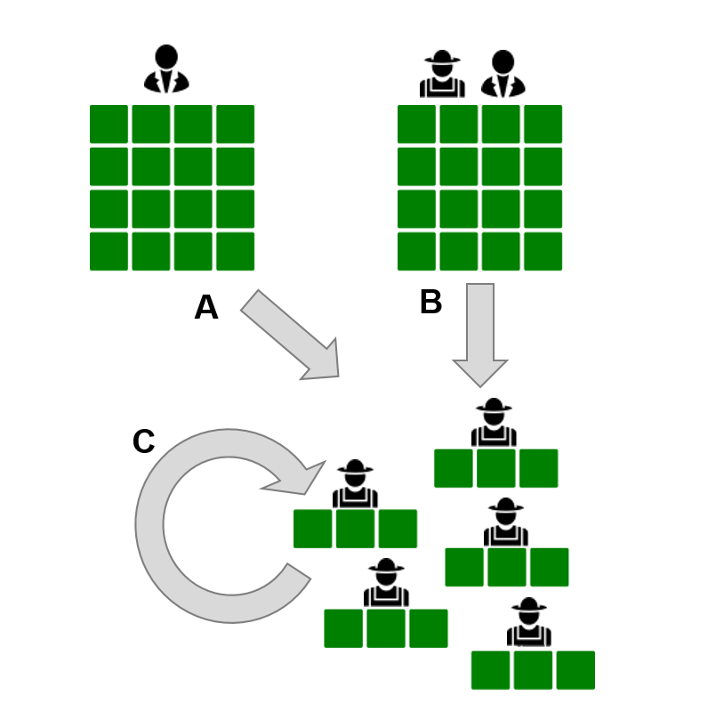

Fig. 1. Research method.

# Part 2

Farmer evaluation traits can predict metric traits fairly well, depending on their derivation. Overall, spike, and GY observed in first year have a similar performance in predicting GY in the second year (Fig. 2A). Farmers scores (both overall and spike) well predict TGW in 2013. There is a gender interaction, especially in overall, as arguably men and women have a different interpretation of the overall appreciation of varieties. When men and women criteria are contrasting, the prediction power decreases (see overall, overall.f and overall.m over GY in 2013). When they are aligned, the prediction power increases (see overall, overall.f and overall.m over DF in 2013; farmers are very worried about late maturation of varieties).

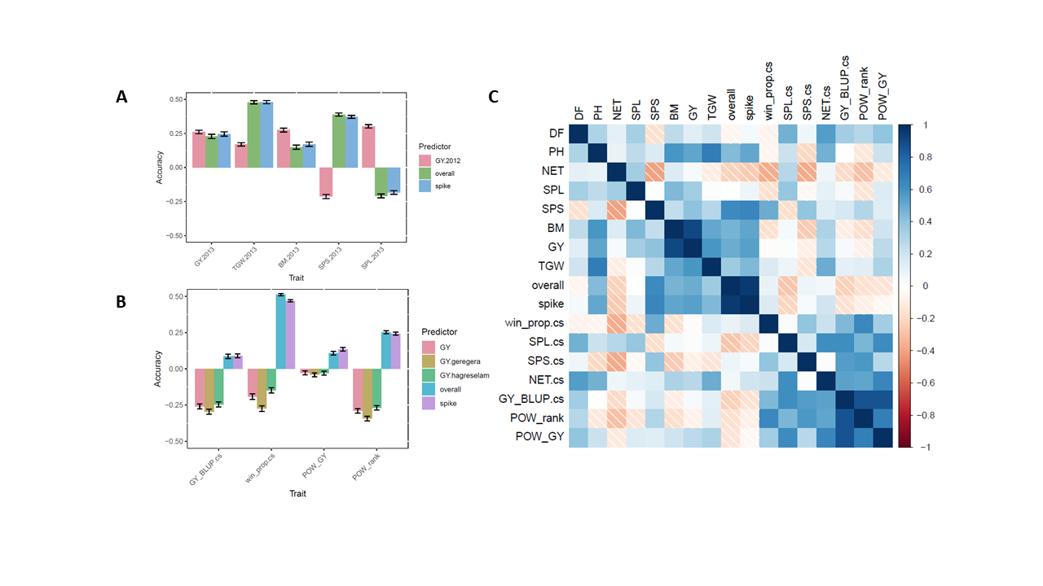

Fig. 2. R

# Part 3

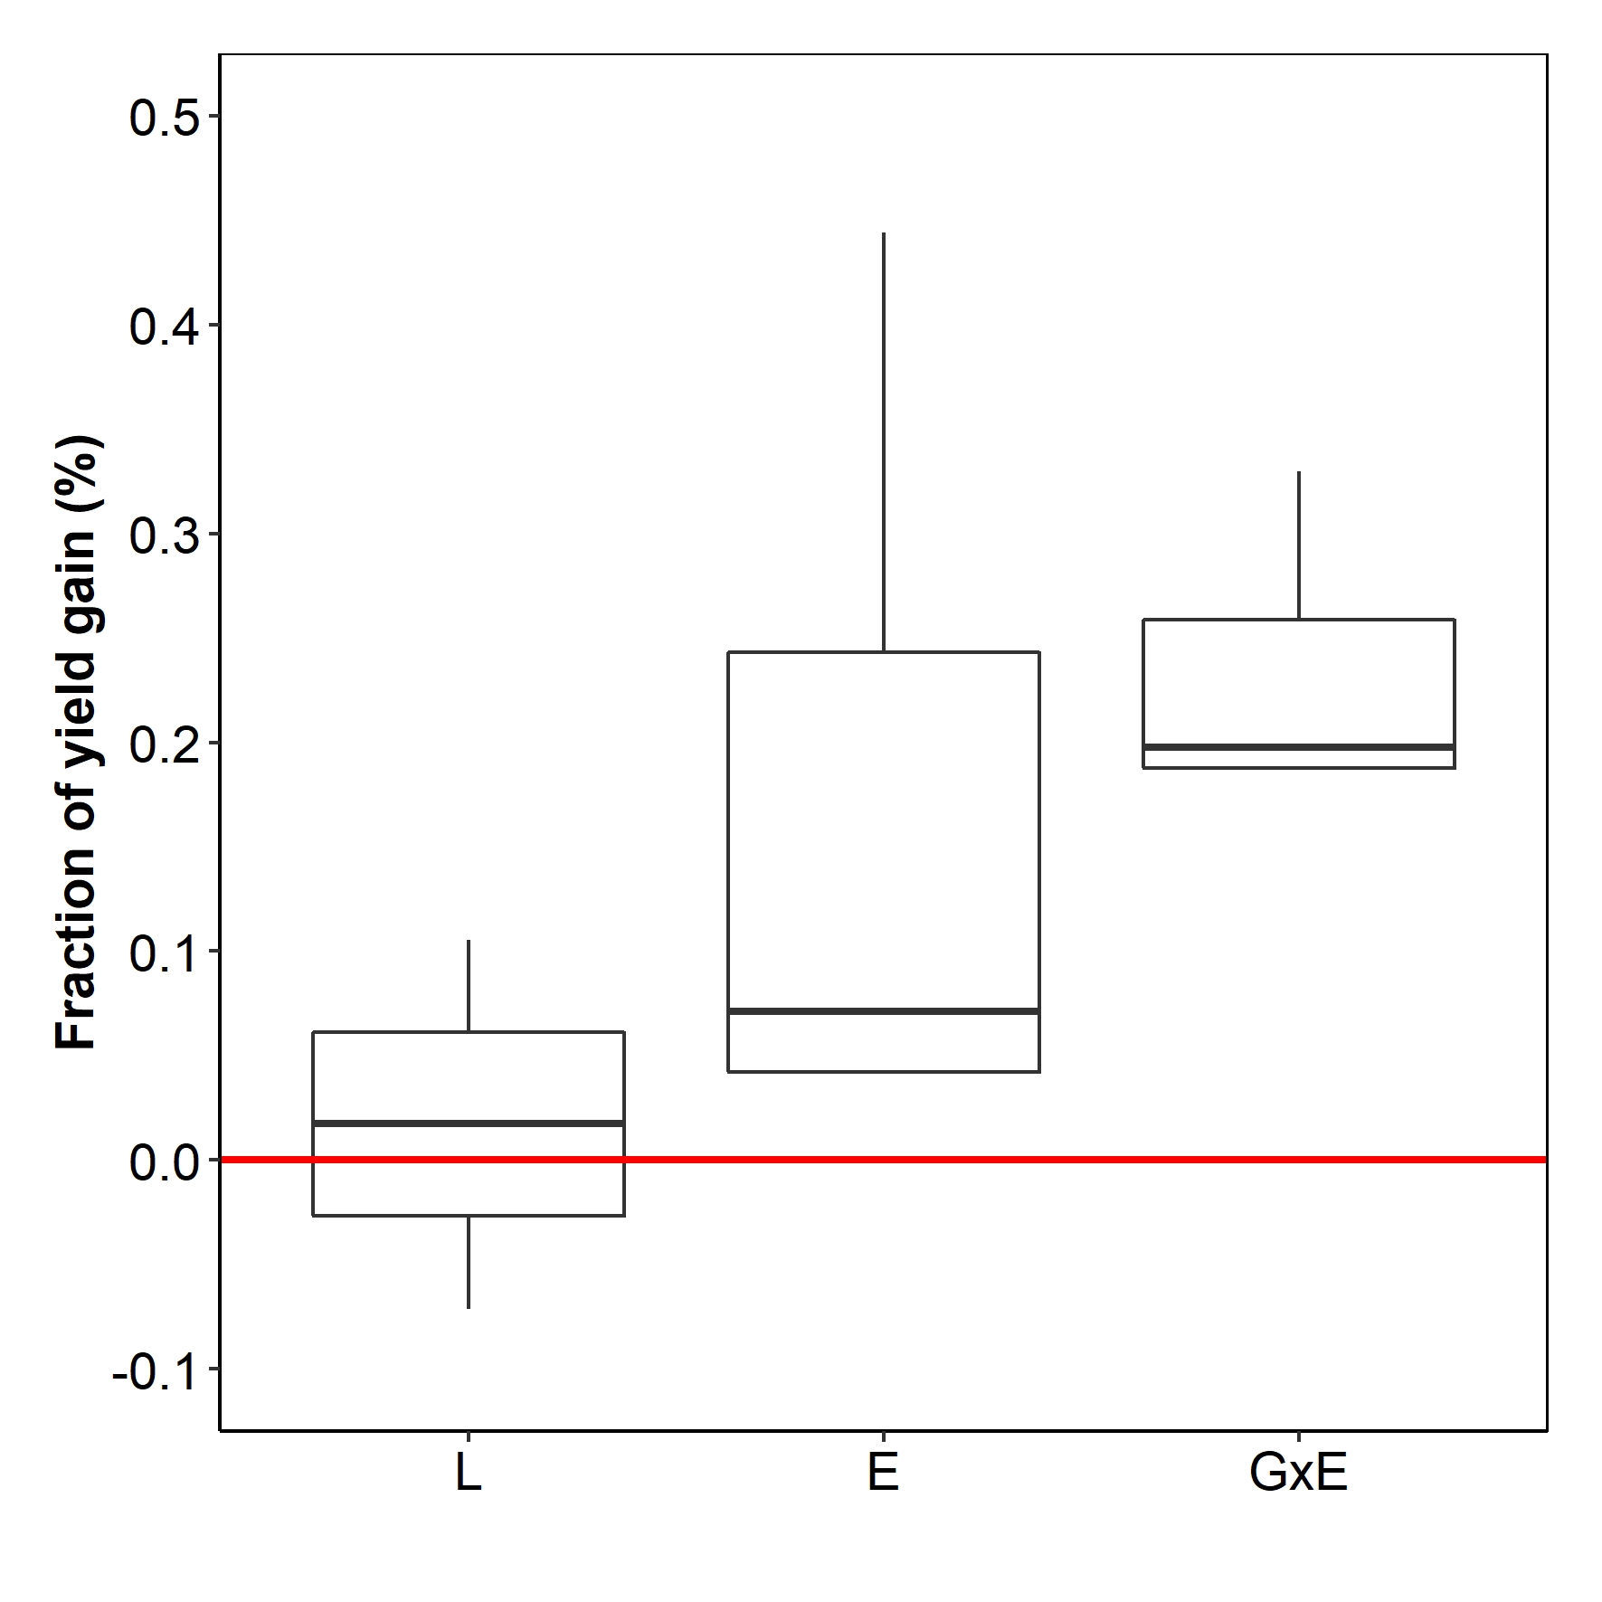

Fig. 3. Expected yield gain of adopting variety recommendations based on (L) location model, (E) environmental model and (GxE) genotype by environmental model.

# Methods

# References