Taratibu sanifu za utekelezaji wa majaribio shambani na ukusanyaji wa data kwa kutumia mbinu ya tricot: kiazi kitamu
Toleo: v2026-06-03
Zao: kiazi kitamu
Jina la kisayansi: Ipomoea batatas (L.) Lam.
Waandishi: Gonzaga Madroba (Researcher), Gervancio Covele (Researcher), Reuben Ssali (Researcher), Thiago Mendes (Researcher), Almendra Cremaschi (DataCurator), Marie-Angélique Laporte (DataManager), Kauê de Sousa (Editor)
Taasisi: International Potato Center, Bioversity International
Sifa zinazotathminiwa: Plant establishment, Virus symptoms, Vigor, Drought tolerance, Pests and Diseases, Yield, Commercial yield, Root size, Root shape, Root skin color, Weevil resistance, Millipede resistance, Marketability, Overall preference, Overall vs Local, Taste, Texture after cooking
Vipindi vya ukusanyaji wa data: Participant registration form, Vegetative - Establishment, Vegetative - Drought and heat tolerance, Harvest - Technician assessment, Harvest - Farmer assessment, Post-harvest - Food product evaluation, Socio-economic baseline
Hati hii pia inapatikana kwa: EN, PT, FR, ES
DOI: https://doi.org/10.5281/zenodo.20525269

Utangulizi
Hati hii inatoa muhtasari wa kina wa data zitakazokusanywa wakati wa jaribio la shambani la kiazi kitamu linalotekelezwa kwa kutumia mbinu ya tricot na kubuniwa kwenye jukwaa la ClimMob (https://climmob.net). Itifaki hii inaeleza hatua kuu za ukusanyaji wa data katika kipindi chote cha jaribio, ikijumuisha vigezo na sifa zitakazokusanywa katika kila hatua ya ukuaji wa zao. Wakulima hutathmini aina mbalimbali katika majaribio yao ya shambani na kutoa tathmini za kulinganisha kwa kupanga aina kulingana na utendaji wao wakati wa ukuaji na sifa za baada ya mavuno. Maelezo ya kina zaidi kuhusu hatua zinazohitajika kuandaa jaribio shirikishi la shambani kwa kutumia mbinu ya tricot yanapatikana katika https://learn.climmob.net.

Wigo
Yanayohusika: SOP hii inaeleza taratibu na viwango vya kutekeleza majaribio shirikishi ya shambani yaliyogatuliwa kwa kutumia mbinu ya tricot. Inajumuisha muundo wa tathmini, nyaraka, ufuatiliaji na usimamizi wa data za majaribio ya tricot. SOP hii inatoa mwongozo kuhusu usanidi wa dodoso za kidijitali, ukusanyaji wa data, viwango vya metadata na taratibu za msingi za uhakikisho wa ubora ili kusaidia uzalishaji wa data za FAIR. SOP hii imekusudiwa kusaidia utekelezaji wa majaribio ya tricot kwa njia iliyo sanifu huku ikiruhusu marekebisho kulingana na zao, mfumo wa uzalishaji, lugha na mazingira ya taasisi husika.
Visivyohusika: SOP hii haijumuishi mwongozo kuhusu uchaguzi wa jenotipu, uchaguzi wa washiriki, uchambuzi wa hali ya juu wa takwimu, michakato ya maamuzi katika uboreshaji wa mazao, taratibu za uchambuzi wa maabara, uzalishaji wa mbegu au taratibu za uthibitishaji wa mbegu. Taratibu maalum zinazohusiana na uchambuzi wa jenomu, utabiri wa hali ya hewa, kanuni za usafirishaji wa mbegu au tathmini za maabara zinapaswa kushughulikiwa katika SOP tofauti pale inapofaa.
Walengwa: SOP hii imekusudiwa kwa watafiti wa uboreshaji wa mazao, wataalamu wa kilimo, wahifadhi wa benki za jeni, mashirika yasiyo ya kiserikali, mashirika ya wakulima, wanafunzi na watafiti wanaohusika katika utekelezaji, uratibu na usimamizi wa majaribio ya tricot na majaribio shirikishi yaliyogatuliwa.

Ridhaa yenye ufahamu
Fomu ya ridhaa yenye ufahamu inatoa mfumo wa kawaida wa kuhakikisha kwamba washiriki wote wamepewa taarifa za kutosha kabla ya kushiriki katika jaribio na dodoso zinazohusiana nalo. Inaeleza madhumuni ya ukusanyaji wa data, aina za taarifa zitakazokusanywa na jinsi data hizo zitakavyoweza kutumika, ikiwa ni pamoja na matumizi ya utafiti na uchapishaji wa matokeo. Ushiriki ni wa hiari kabisa. Washiriki wanaweza kukataa kujibu swali lolote au kujiondoa katika utafiti wakati wowote bila madhara yoyote.
Ridhaa hukusanywa kabla ya ukusanyaji wa data ili kuhakikisha uwazi, maadili ya utafiti na heshima kwa haki za washiriki. Kutoa ridhaa yenye ufahamu ni sharti la kushiriki katika shughuli zote zinazofuata za jaribio na dodoso. Mfano wa fomu ya ridhaa yenye ufahamu umeambatishwa katika SOP hii.

Muundo wa jaribio
Maeneo yote ya majaribio hupewa alama za herufi (eneo dogo A, eneo dogo B na eneo dogo C). Maeneo haya madogo yanapaswa kupandwa katika tarehe moja na kufuata vipimo na mbinu sawa za usimamizi wa mazao. Maeneo hayo yanapaswa kuwa karibu ili kuhakikisha yanakabiliwa na mazingira na usimamizi unaofanana.
Iwapo kuna ardhi ya kutosha, wakulima wanahimizwa kuanzisha eneo dogo la ziada lenye aina yao ya kawaida au wanayoipendelea (“Local”), kwa kutumia tarehe ileile ya kupanda, vipimo vilevile na usimamizi unaofanana. Ingawa eneo la Local si sehemu ya msingi ya muundo wa tricot, linajumuishwa katika tathmini ya mwisho wa msimu ambapo washiriki huulizwa kama aina ya Local ilifanya vizuri zaidi au vibaya zaidi kuliko chaguo A, B na C.
Ukubwa wa eneo dogo unapaswa kufuata mapendekezo ya Timu ya Usimamizi wa Bidhaa (PMT) na kuwa unaofaa kwa zao na mfumo wa uzalishaji. Taarifa kuhusu vipimo vya eneo dogo zinapaswa kurekodiwa katika metadata za jaribio. Kwa kiazi kitamu, ukubwa unaopendekezwa wa eneo dogo ni Mistari 4 yenye urefu wa m 3, na nafasi ya m 1 kati ya mistari, unaohitaji x mimea kwa kila eneo dogo.
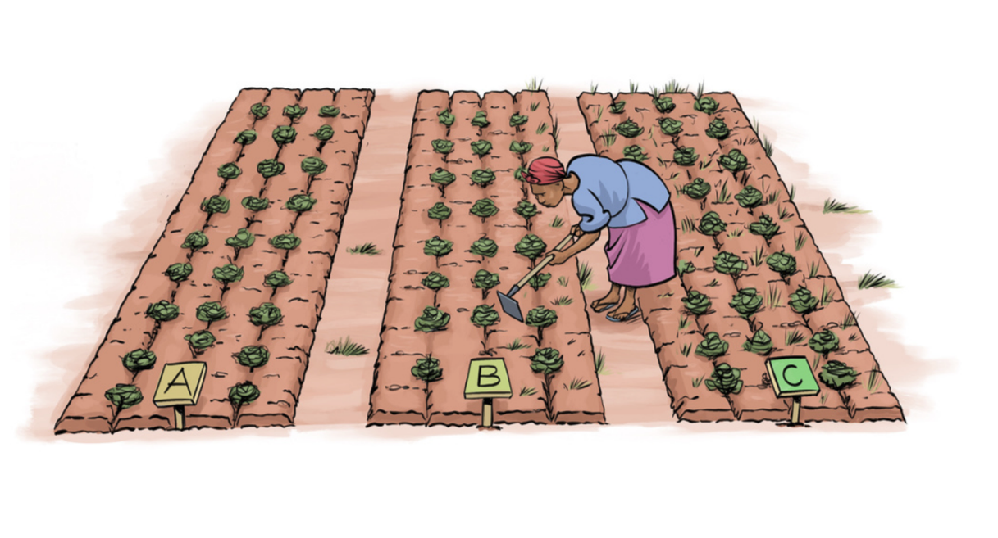

Vifaa na nyenzo
Ukusanyaji wa data katika majaribio ya tricot unaweza kufanyika kwa kutumia dodoso za kidijitali zinazosimamiwa na watendaji wa uwanjani au kwa kutumia kadi za uchunguzi zinazojazwa na washiriki. Kulingana na mbinu ya ukusanyaji wa data iliyochaguliwa, vifaa vifuatavyo vinaweza kuhitajika.
Ukusanyaji wa data kwa njia ya kidijitali (ODK): i) Simu janja au kompyuta kibao ya Android yenye uwezo wa kutosha wa betri; ii) Programu ya ODK Collect iliyosakinishwa na kusanidiwa; iii) Muunganisho wa intaneti kwa kupakua na kutuma fomu (pale unapopatikana); iv) Betri ya ziada au vifaa vya kuchaji kwa kazi za uwanjani; v) Orodha za washiriki na kumbukumbu za ugawaji wa majaribio.
Ukusanyaji wa data kwa kutumia kadi za uchunguzi: i) Kadi za uchunguzi zilizochapishwa; ii) Kalamu au penseli kwa washiriki; iii) Lebo za kutambua chaguo A, B na C; iv) Orodha za washiriki na kumbukumbu za ugawaji wa majaribio.
Uingizaji na uandaaji wa data: i) Kompyuta yenye muunganisho wa intaneti; ii) Upatikanaji wa jukwaa la ClimMob; iii) Fomu za Enketo kwa ajili ya uingizaji wa data moja kwa moja; au iv) Faili za Excel za ClimMob kwa ajili ya uingizaji wa data nje ya mtandao na upakiaji wa baadaye.
Timu za mradi zinapaswa kuchagua mbinu ya ukusanyaji wa data inayofaa zaidi kulingana na mazingira ya eneo husika, mapendeleo ya washiriki na rasilimali zilizopo.

Ufuatiliaji wa jaribio na ukusanyaji wa data
Washiriki hufuatilia maeneo yao ya majaribio waliyopewa katika kipindi chote cha jaribio na kurekodi uchunguzi wao katika vipindi vilivyopangwa vya ukusanyaji wa data (hatua za ukuaji wa zao). Data inaweza kukusanywa moja kwa moja na mafundi wa shambani kwa kutumia ODK kwenye vifaa vya Android au kurekodiwa na washiriki kwenye kadi za uchunguzi na baadaye kuingizwa katika ClimMob kwa kutumia fomu za Enketo au faili za Excel. SOP hii inaeleza vipindi vya uchunguzi vinavyolingana na hatua za ukuaji wa zao na vinapaswa kuelezwa kwa uwazi kwa washiriki wakati wa ugawaji wa kifurushi cha jaribio na katika kipindi chote cha utekelezaji wa jaribio.
Kadi za uchunguzi zinapaswa kuwa na maswali rahisi ya kulinganisha yanayowawezesha washiriki kutambua chaguo bora zaidi na chaguo dhaifu zaidi kwa kila kigezo cha tathmini. Washiriki wanapaswa kuhimizwa kuzingatia kigezo kimoja kwa wakati wanapofanya tathmini zao. Timu za mradi zinahimizwa kutoa msaada wa ufuatiliaji kupitia ziara za shambani, simu au njia nyingine za mawasiliano ili kuwakumbusha washiriki kuhusu uchunguzi unaofuata, kujibu maswali yao na kusaidia ukusanyaji wa data kwa wakati.
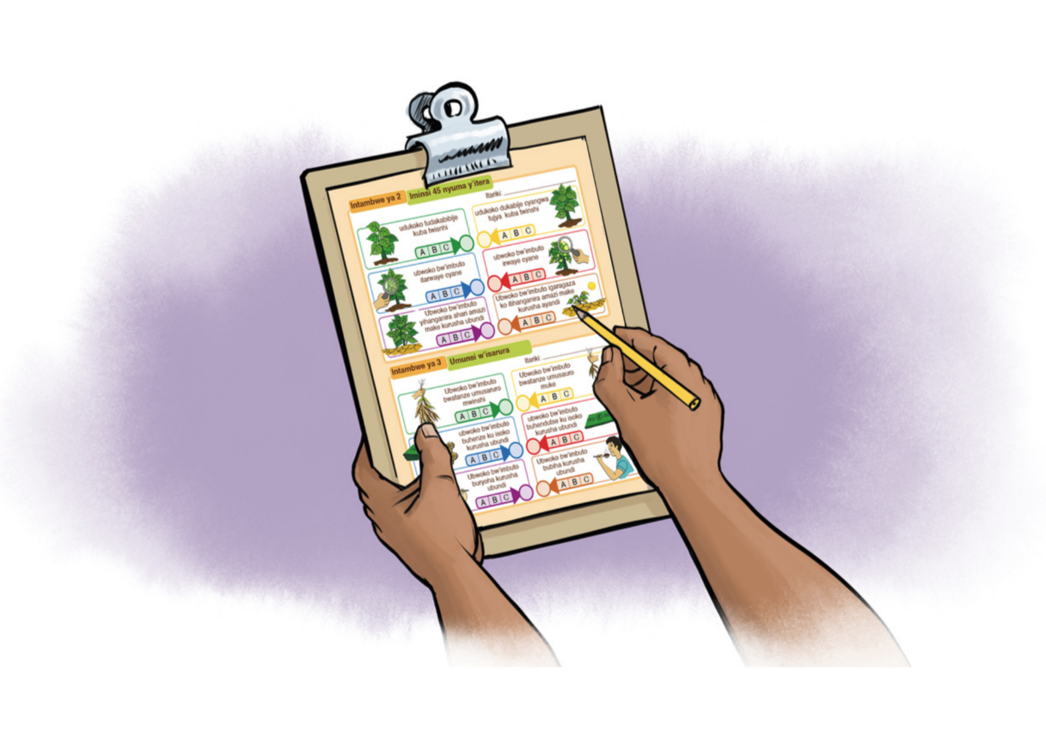

Usajili wa washiriki
Usajili wa washiriki hufanyika wakati wa ugawaji wa vifurushi vya majaribio na unapaswa kukamilishwa kwa washiriki wote kabla ya shughuli zozote za baadaye za ukusanyaji wa data kuanza. Vifurushi vya majaribio vinapaswa kusambazwa mapema vya kutosha kabla ya kupanda ili kuwapa washiriki muda wa kuandaa shamba na kuanzisha jaribio. Madhumuni ya usajili ni kumhusisha kila mshiriki na kifurushi cha kipekee cha jaribio na kukusanya taarifa za msingi zinazohitajika kwa usimamizi wa jaribio na ufuatiliaji wa washiriki.
Shughuli za usajili zinapaswa kuwa fupi na zenye ufanisi kadri inavyowezekana, kwa kuwa ugawaji wa vifurushi mara nyingi huwa shughuli yenye shughuli nyingi ambapo watendaji wa mradi wanahitaji kusambaza vifaa vya jaribio, kueleza taratibu za utekelezaji, kujibu maswali ya washiriki na kutoa maelekezo ya utekelezaji. Kukamilika kwa usajili ni sharti la kushiriki katika shughuli za baadaye za ukusanyaji wa data na uchambuzi. Wakati wa usajili, watendaji wa mradi wanapaswa kueleza malengo ya jaribio, taratibu za kuanzisha maeneo ya majaribio, ratiba ya uchunguzi na wajibu wa washiriki katika kipindi chote cha jaribio.

Utafiti wa msingi wa kijamii na kiuchumi
Utafiti wa msingi wa kijamii na kiuchumi hukusanya taarifa kuhusu sifa za washiriki, muundo wa kaya, shughuli za kilimo, mbinu za usimamizi wa mazao, mifumo ya mbegu, ushiriki katika masoko na upatikanaji wa huduma za kilimo. Madhumuni ya utafiti huu ni kutambua sababu za kijamii na kiuchumi zinazohusiana na usimamizi wa aina za mazao na mapendeleo ya wakulima, pamoja na kusaidia tafsiri ya matokeo ya majaribio katika makundi mbalimbali ya washiriki.
Kwa kuwa utafiti wa kijamii na kiuchumi ni mpana zaidi kuliko fomu ya usajili wa washiriki, hauhitaji kufanyika wakati wa ugawaji wa vifurushi vya majaribio. Utafiti unaweza kufanyika wakati wa ziara za ufuatiliaji au wakati mwingine wowote unaofaa katika kipindi cha jaribio. Timu za mradi zinaweza kuutekeleza kwa makundi tofauti ya washiriki katika kipindi chote cha jaribio kulingana na rasilimali zilizopo na vikwazo vya kiutendaji. Ingawa inapendekezwa kwamba washiriki wote washiriki katika utafiti huu, timu za mradi zinaweza kuamua kutumia sampuli inayowakilisha washiriki wote pale ambapo rasilimali ni chache. Kadri inavyowezekana, utafiti huu unapaswa kukamilishwa kabla ya uchambuzi wa mwisho wa data ili kuwezesha kuunganisha taarifa za kijamii na kiuchumi na uchunguzi pamoja na tathmini za washiriki.

Vipengele vya dodoso
Mfumo wa ukusanyaji wa data wa tricot unajumuisha vipengele mbalimbali vya dodoso vinavyotekelezwa katika kipindi chote cha jaribio. Vipengele hivi hukusanya taarifa zinazokamilishana zinazohitajika kwa usimamizi wa jaribio, ufuatiliaji wa washiriki, uelewa wa mazingira ya jaribio na tathmini ya utendaji wa teknolojia zinazojaribiwa. Ukusanyaji wa data huanza na usajili wa washiriki na ridhaa yenye ufahamu, kisha kufuatiwa na uchunguzi wa hatua mbalimbali za ukuaji wa zao. Kulingana na malengo ya mradi na rasilimali zilizopo, taarifa za ziada za kijamii na kiuchumi zinaweza kukusanywa kutoka kwa washiriki wote au kutoka kwa sampuli inayowakilisha washiriki.
Mwisho wa jaribio, washiriki hukamilisha tathmini za mwisho za teknolojia zilizojaribiwa, ikiwa ni pamoja na tathmini za baada ya mavuno. Sehemu zinazofuata zinatoa orodha kamili ya vigezo, maswali na vipindi vya ukusanyaji wa data vinavyohusiana na itifaki hii ya tricot. Dodoso hili linapatikana katika ClimMob kama kiolezo cha mradi kinachoitwa Sweetpotato OFVT Breeding.

Participant registration form
Jina la swali | Maelezo ya swali
Consent | Are you willingly to accept hosting a tricot trial and provide required information from the trial?
Participant name | Participant name
Point of delivery | Please register the GPS location where the seeds were delivered
ADM1 | Name of administrative zone level 1 (state, province, region, etc)
ADM2 | Name of administrative zone level 2 (city, county, town, local govern area, etc)
ADM3 | Name of administrative region level 3 (community, village etc)
Age | Please indicate your age
Gender | Please select your gender
Experience with the crop | Please indicate how many years you have growing the crop?
Telephone | Please indicate your telephone number

Vegetative - Establishment
Jina la swali | Maelezo ya swali
On time | Was your trial package delivered on time?
Planting date | Date of trial establishment
Trial GPS | The GPS location of the on-farm trial
Local variety | What is the name of the local variety planted in the trial as check?
Previous land use | What was the previous land use of the on-farm plot site?
Mode of land preparation | What equipment was used for land preparation?
Slope | What is the slope of the area you established your tricot trial?
Plant establishment | Which option had the first establishment?; Which option had the last establishment?
Virus symptoms | Which variety shows fewer virus symptoms?; Which variety shows more virus symptoms?

Vegetative - Drought and heat tolerance
Jina la swali | Maelezo ya swali
Vigor | Which option showed the best vigor?; Which option showed the worst vigor?
Drought tolerance | Which option is more tolerant to drought?; Which option is more susceptible to drought?
Pests and Diseases | Which option is more resistant to pests and diseases? ; Which option is more susceptible to pests and diseases?

Harvest - Technician assessment
Jina la swali | Maelezo ya swali
Total foliage yield | Total foliage yield (kg) of
Number of plants harvested | Total number of plants harvested in the plot
Number of plants with roots | Number of plants with roots in the plot
Marketable root count | Total number of commercial roots/tubers harvested in the plot
Non-marketable root | Total number of non-commercial roots/tubers harvested in the plot
Marketable yield quantitative | The total marketable yield in the plot
Non-marketable yield quantitat | The total non-marketable yield in the plot
Yield quantitative unit | What was the unit of measure for yield?

Harvest - Farmer assessment
Jina la swali | Maelezo ya swali
Yield | Which option has the higher yield?; Which option has the lower yield?
Commercial yield | Which variety produced more commercial yield per plant?; Which variety produced less commercial yield per plant?
Root size | Which variety has the biggest roots?; Which variety has the smallest roots?
Root shape | Which variety has the best shaped roots? ; Which variety has the worst shaped roots?
Root skin color | Which variety shows the best skin color?; Which variety shows the worst skin color?
Weevil resistance | Which variety is most resistant to weevil damage?; Which variety is least resistant to weevil damage?
Millipede resistance | Which variety is most resistant to milliped damage?; Which genotype is least resistant to milliped damage?
Marketability | Which option is easier to sell?; Which option is more difficult to sell?
Overall preference | Overall, which option was the best?; Overall, which option was the worst?
Best why | Why do you indicate this option as the best?
Worst why | Why you indicated this option as the worst?
Overall vs Local | Overall, is A, B, C better or worse than the one that you currently grow?

Post-harvest - Food product evaluation
Jina la swali | Maelezo ya swali
Cooking methods | Which cooking method do you commonly use to prepare it in your household?
Taste | Which option has the best taste?; Which option has the worst taste?
Texture after cooking | Which variety did you find to be the softest after cooking? ; Which variety did you find to be the roughest/ toughest after cooking?
Best attributes | What attributes make this variety best for you? (Tick all that apply)
Worst attributes | What attributes make this variety worst for you? (Tick all that apply)
Grow again | If seeds were available for all three options, which option(s) would you like to grow in the next season?

Socio-economic baseline
Jina la swali | Maelezo ya swali
Civil status | Please indicate your civil status
Occupation | What is the main occupation of the respondent?
Education | Please select your highest degree obtained
Reading | Is the respondent able to read in English?
Reading Local Language | Is the respondent able to read in the local language?
Household size | Number of persons living together and sharing meals for more than 6 months a year
Household below 18 | How many children under the age of 18 live in your household?
Main crop | What is the most important crop that you produce?
Other crops | What are the crops that you produce?
Experience with tricot | Have you contributed to a tricot trial before? If yes, how many times? Zero if first time.
Who controls seed exchange | Who in your household is mainly responsible for {your tricot crop} seed saving or seed exchange?
Varieties source | What is the source of {your tricot crop} seed?
Number of varieties | How many different varieties of {your tricot crop} does your household produce?
Variety name | What is the name of the variety(ies) that you commonly plant in your field?
Variety brand | Does the seed that you buy have a brand and a label? If yes, please indicate the name.
Ways of selling | How do you usually sell {your tricot crop}?
Who controls selling | Who in your household is mainly responsible for {your tricot crop} selling?
Distance to market | How far is the nearest market or place you sell your {your tricot crop} from your farm?
Sell share | What share of your {your tricot crop} harvest do you usually sell?
Income crop sell | What share of your total household income comes from selling {your tricot crop}?
Who controls production | Who in your household is mainly responsible for {your tricot crop} production?
Production last 12 months | Did you produced {your tricot crop} during the past 12 months?
Frequency of production | How many times per year you usually produce your {tricot crop}?
Reason no production | If no production during the past 12 months, why?
Production practices | Which of the following practices do you usually apply in {your tricot crop} production?
Storage | Do you store for a long time before consumption?
Type of storage | What type of storage method do you use?
Storage duration days | If Yes, what is the longest storage duration you usually keep the harvest?
Handling surplus | How do you handle the surplus of your harvest (more than you can eat immediately)?
Crop purchase | Besides producing in your farm, do you also purchase the crop you tested in your trial from the market?
Purchase criteria | If Yes, based on what criteria do you use choose to buy? (Tick all that apply)
Member of an organization | To what types of organization do you belong?
Public extension service | Are you in contact with government/public extension services in relation with {your tricot crop} production?
Private extension service | Are you in contact with private extension services in relation with {your tricot crop} production?

Rasilimali na SOP nyingine
Jedwali lifuatalo linatoa mwongozo wa ziada na SOP zinazoweza kusaidia kupanga, kutekeleza, kuandika na kuchambua majaribio ya tricot.
Rasilimali | Kiungo
Orodha ya ukaguzi ya utekelezaji wa jaribio la tricot | https://learn.climmob.net/preparation/checklist
Bajeti ya jaribio la tricot | https://learn.climmob.net/preparation/budgeting
Uchaguzi wa washiriki | https://learn.climmob.net/design/sampling-plots
Uchaguzi wa maeneo ya majaribio | https://learn.climmob.net/design/trial_size
Uchaguzi wa jenotipu | TBD
Uzalishaji wa mbegu | TBD
Kurekodi metadata za jaribio lako | https://learn.climmob.net/design/trial_documentation
Uchambuzi wa data | https://learn.climmob.net/analysis/intro-data-analysis
Ukadiriaji wa mavuno | TBD

