**PROJECT PROPOSAL OF DESIGN TASK**

**AUTOMATED GARAGE DOOR OPENING MECHANISM FOR AUTHENTICATED VEHICLES**

EMBEDDED SYSTEMS AND DESIGN - EC6020

**GROUP MEMBERS:**

2021 / E / 009 – PERERA A.Y.I.D.

2021 /E / 053 - SEWWANDI I.G.P.T.

2021 / E / 121 – AGRAPALA P.W.S.H.D.

2021 / E / 138 – LOKUVITHANA S.M.

1. **INTRODUCTION**

The objective of this project is to design and implement an secure automated garage door opening system using embedded systems and wireless communication technologies. The system will leverage microcontrollers equipped with Wi-Fi communication modules to authenticate the owner's vehicle and trigger the garage door opening mechanism upon approach. Then by using this Wi-Fi connections if an unknown vehicle is coming to the door, this gate will not open. This system aims to provide a convenient, advanced secure, and efficient solution for homeowners.

1. **PROBLEM STATEMENT**

Conventional garage door opening systems require manual operation or rely on simple remote controls that lack advanced security features. These limitations can be inconvenient, especially in adverse weather conditions or when the user is occupied. Furthermore, the risk of unauthorized access remains a significant concern. Our proposed solution aims to automate the garage door opening process while ensuring security and convenience through advanced authentication mechanisms

1. **SOLUTION**

* Microcontrollers: Handle wireless communication and authentication.
* Sonar Sensors (HC-SR04): Detect approaching vehicles.
* Motor Driver Module (H-Bridge): Control garage door operation.
* LED Indicators: Provide visual feedback on vehicle proximity and system status.
* Communication Protocol: A secure protocol based on Wi-Fi or Bluetooth for authentication and control.

1. **Novelty**

* The system enhances security by utilizing MAC address authentication.

(MAC stands for Media Access Control. It is a unique identifier assigned to network devices, such as Wi-Fi modules in vehicles, that helps in identifying and authenticating devices on a network.)

* Non-blocking programming techniques to ensure parallelism of distance measurement, door control, and connection maintenance.

A scalable and modular design that can be expanded with additional features like mobile app control

1. **High-Level Architecture**

**Technologies Chosen:**

* Microcontroller: NodeMCU is chosen due to its built-in Wi-Fi capabilities, cost-effectiveness, and ease of programming.
* Sonar Sensor: HC-SR04 ultrasonic sensor is selected for its accuracy and compatibility with the microcontroller.
* Motor Driver: H-Bridge provides efficient control of the garage door motor.
* Software Technology: C language for designing the control logic and system function, PlatformIO IDE extension with VS code for coding the ESP32 microcontroller, TCP/IP for secure communication and MAC address based authentication

**System Architecture:**

1. The vehicle (server board) sends a connection request to the garage (client board).
2. If the vehicle's MAC address matches the stored data, the connection is accepted.
3. The sonar sensor measures the vehicle's proximity.
4. The garage door opens if the vehicle is within the predefined range.
5. **Circuit design and protocols**

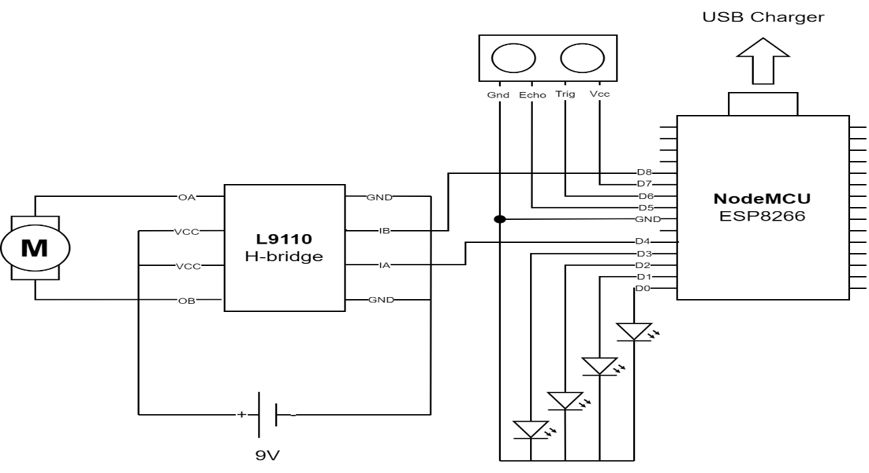

**Circuit Design:**

* The client board (garage unit) consists of the microcontroller, sonar sensor, and motor driver module.
* The server board (vehicle unit) includes a microcontroller for communication and authentication.

**Protocols Used:**

* **Wi-Fi (TCP/IP):** For secure communication and authentication.
* **Non-blocking delay programming:** To ensure seamless sensor readings and control operations

1. **Components and Cost Estimation:**

|  |  |  |
| --- | --- | --- |
| **Component** | **Quantity** | **Cost (Rs.)** |
| **NodeMCU** | **2** | **<6000** |
| **Sonar sensor** | **1** | **<600** |
| **H-bridge IC** | **1** | **<450** |
| **Breadboard** | **2** | **<1000** |
| **LEDs** | **4** | **80** |
| **Jump wire set** | **1** | **<200** |
| **Motor** | **1** | **<300** |
| **Total Estimated Cost** |  | **<8630** |

1. **Timeline**

WEEK 1: Research and Planning

WEEK 2: Initializing system setup

WEEK 3: Add MAC address authentication

WEEK 4: Integrating communication system

WEEK 5: Integrating software simulation

WEEK 6: Sensor and logic setup

WEEK 7: Motor control and testing

WEEK 8: System optimizing and debugging

WEEK 9: Final project development

WEEK 10:Final testing

1. **Conclusion**

The proposed automated garage door opening system offers an innovative solution to address the limitations of conventional systems by integrating advanced security features and wireless communication technologies. By utilizing NodeMCU microcontroller, sonar sensors, and an H-Bridge motor driver, the system ensures accurate vehicle detection and secure authentication through MAC address verification. The modular and scalable design provides a strong foundation for future enhancements, such as mobile app integration, further increasing its practicality and usability.