**“A WALK IN THE PARK”**

A

Major Project Report

*Submitted in partial fulfillment of the requirement for the award of*

*Degree of*

**BACHELOR OF ENGINEERING**

In

**COMPUTER SCIENCE**

Submitted to



**RAJIV GANDHI PRADYOGIKI VISHWAVIDHYALAYA,**

**BHOPAL (M.P.)**

Submitted by

**Rachit Agrawal**  (0225CS151043)

Under the Supervision of

**Prof. Rajendra Arakh**

Astt. Prof, CSE

GNCSGI, Jabalpur



**DEPARTMENT OF COMPUTER SCIENCE & ENGINEERING**

**GLOBAL INSTITUTE OF ENGINEERING, JABALPUR**

**Session 2015-2019**

**GLOBAL INSTITUTE OF ENGINEERING,**

**JABALPUR**



**DEPARTMENT OF COMPUTER SCIENCE & ENGINEERING**

**CERTIFICATE**

This is to certify that the Major Project report entitled **“A WALK IN THE PARK”** submitted by **Rachit Agrawal**  (0225CS151043) has been carried out under my guidance & supervision. The project report is approved for submission towards partial fulfillment of the requirement for the award of degree of **Bachelor of Engineering** in **Computer Science & Engineering** from “**Rajiv Gandhi Proudyogiki Vishwavidyalaya, Bhopal (M.P).**

Guided & Approved by:

Prof. Rajendra Arakh

Astt. Prof, CSE

GNCSGI, Jabalpur

**Prof. Sumit Nema Dr. Rajiv Khatri**

HOD, CSE Department Director GNCSGI,

GNCSGI, Jabalpur Jabalpur

**Session 2015-2019**

**GLOBAL INSTITUTE OF ENGINEERING,**

**JABALPUR**



**DEPARTMENT OF COMPUTER SCIENCE & ENGINEERING**

**CERTIFICATE**

This is to certify that the Major Project report entitled **“A WALK IN THE PARK”** submitted by **Rachit Agrawal**  (0225CS151043) has been carried out under my guidance & supervision. The project report is approved for submission towards partial fulfillment of the requirement for the award of degree of **Bachelor of Engineering** in **Computer Science & Engineering** from “**Rajiv Gandhi Proudyogiki Vishwavidyalaya, Bhopal (M.P).**

Guided & Approved by:

Prof. Rajendra Arakh

Astt. Prof, CSE

GNCSGI, Jabalpur

**Internal Examiner External Examiner**

**Date : Date :**

**GLOBAL INSTITUTE OF ENGINEERING, JABALPUR**



**DEPARTMENT OF COMPUTER SCIENCE & ENGINEERING**

**DECLARATION**

I, **Rachit Agrawal (0225CS151043),** students of Bachelor of Engineering, Computer Science Branch, Global Institute of Engineering, Jabalpur hereby declare that the work presented in this Minor project is outcome of our own work, is confide, correct to the best of my knowledge and this work has been carried out taking care of Engineering Ethics. The work presented does not infringe any patented work and has not been submitted to any University for the award of any degree or professional diploma.

**Rachit Agrawal (0225CS151043)**

**ACKNOWLEDGEMENT**

We sincerely express indebtedness to esteemed and revered guide Prof. Rajendra Arakh Astt. Prof, CSE GNCSGI, Jabalpur for his invaluable guidance, supervision and encouragement throughout the work. Without his kind patronage and guidance the project would not have taken shape.

We take this opportunity to express deep sense of gratitude to **“Prof. Sumit Nema”, Head of “Department of Computer Science & Engineering”**for his encouragement and kind approval. Also we thank him in providing the computer lab facility. We would like to express our sincere regards to him for advice and counseling from time to time.

We owe sincere thanks to all the lecturers in “Department of Computer Science & Engineering*”* for their advice and counseling time to time.

**Rachit Agrawal (0225CS151043)**

Table of Contents

1. Abstract
2. Objective of the Project
3. Problem Definition
4. Feasibility Study
5. Project Planning & Schedule
6. Hardware & Software Specification
7. Module Description
8. Database Table / Data File Structure
9. Diagrams *( Depending upon your project requirement)*
   1. Control Flow Diagram
   2. Data Flow Diagram
   3. Entity Relationship Diagram
10. Object Oriented Design ( for project using to OOP’s)
11. Input/ Output Forms Design
12. Future Scope and Further Enhancement of the Project
13. References

**ABSTRACT**

Our project mainly focuses on bringing the game industry and its benefits to the public since the generation today in our country is not so aware of it. The gaming industry in India has seen no development and we, for some reasons, are sure that if we succeed in generating awareness about it, it sure will boom with many opportunities.

Game design theories aim to assist game developers in creating and understanding games. Applied theory for game design supports creativity, speeds up the design process, and increases quality of games. This dissertation presents two theoretical frameworks for designing games and discusses how designers can use them to refine the game development process.

The computer and video game industry has grown from focused markets to mainstream. They took in about [US$](https://en.wikipedia.org/wiki/United_States_dollar)90.5 billion in the US in 2018 ([ESA](https://en.wikipedia.org/wiki/Entertainment_Software_Association) annual report).

Our game is an open world game consisting of missions that the player will have to succeed in order to complete the game.

**OBJECTIVE OF THE PROJECT**

We are going to develop an android-based application game which contains missions for which we have included various gaming controls with relatively compatible graphics and designing of each level. Our project is entitled as-“A Walk in the Park”

This entire project is about an open-world game called "A Walk in the Park". This game is based on android platform and requires a smart phone with good specifications. Through this game we aim to present a frame that helps people understand the significance of game development that it otherwise not so much into account.

This project focuses on delivering a game with good graphics and swift controls for the ease of its use by the user. It is developed using various different soft wares and engines that help in creating and enhancing the quality of the game. As an output we aim to come up with a game which does not only attract the public but also builds interest in them towards game development and designing.

**PROBLEM DEFINITION**

**1. THE PROBLEM FACED BY OUR PROJECT:**

**1. On designing level:**

Since our game is developed on the Unity Engine for game development, the assets provided by Unity asset store were not compatible on the android-platform. So we had to take in use various techniques to generate graphics and models that android could support. For this, we used techniques like Low Poly that helped us make models much less complex.

**2. On coding level:**

The movement of the free public in our game was not proper as we were not able to make them walk, and it seemed as if they’re skating in the air. Also, vehicles were not able to turn properly due the flaws in the path on which they had to travel.

**FEASIBILITY STUDY**

The idea of game development was initially quite intriguing when we first came across different games like GTA vice city, GTA San Andreas, Saints Row, Rust, Need for Speed etc. But all these games were made for a higher platform than Android itself. Games like Gangster Vegas, Spiderman, Gangster New Orleans etc. helped us build interest in the field of game development.

**PROJECT PLANNING AND SCHEDULE**

We got interested in this topic because of the games we used to play as a kid . So we have divided the development of the game in different modules , and to finish these modules in a decided time frame. The idea of game development was initially quite intriguing when we first came across different games like GTA vice city, GTA San Andreas, Saints Row, Rust, Need for Speed etc. But all these games were made for a higher platform than Android itself. Games like Gangster Vegas, Spiderman, Gangster New Orleans etc. helped us build interest in the field of game development.

The modules are as follows :-

1. MODEL DESIGNING

2. LEVEL DESIGNING

3. CODING

4. TESTING

**SCHEDULE**

|  |  |  |  |
| --- | --- | --- | --- |
| **Action** | **Days** | **From** | **To** |
| Requirement Gathering : | 20 Days | **5TH November, 2018** | **25th November, 2018** |
| Analysis : | 10 Days | **5th January, 2019** | **15th January, 2019** |
| Designing : | 15 Days | **16th January, 2019** | **1st February, 2019** |
| Implementation and coding : | 20 Days | **5th February, 2019** | **25th February, 2019** |
| Testing : | 6 Days | **5th march, 2019** | **11th march, 2019** |

**HARDWARE AND SOFTWARE SPECIFICATION**

**HARDWARE REQUIREMENTS-**

1. **16 GB RAM**
2. **4 GB GRAPHIC CARD**
3. **500GB HARD DISK**
4. **MINIMUM I5 PROCESSOR 4TH GENERATION**
5. **ANDROID MOBILE PHONE**

**SOFTWARE REQUIREMENTS-**

1. **3DS MAX**
2. **UNITY**
3. **JAVA TOOL KIT**
4. **ANDROID STUDIO**
5. **SDK TOOLS OF ANDROID**
6. **MONO DEVELOPER**

**MODULE DESCRIPTION**

The development team for this project consists of three members, namely - **Yash Purohit, Rachit Agrawal and Nandita Pathardikar** - who will work in different areas for the successful completion of the project. The total work which will be done on this project will not entirely be divided into different roles but is a product of collective team work by all the team members. The **Model Designing** will be done by **Nandita** and **Yash** which includes the implementation of graphics using low poly technique to ensure the working of the game on an android device.

The **Level Designing** will be done by **Nandita** and **Yash** which will include the generation and creation of the surroundings or the environment in which the game is set up. The terrain and the city development is the part of this phase of game designing.

The Codingwill be done collectively by **Rachit**. This phase defines the function of various controls and also manages the motion of vehicles, people and other similar things.

**DIAGRAMS**

**1. DATA FLOW DIAGRAM**

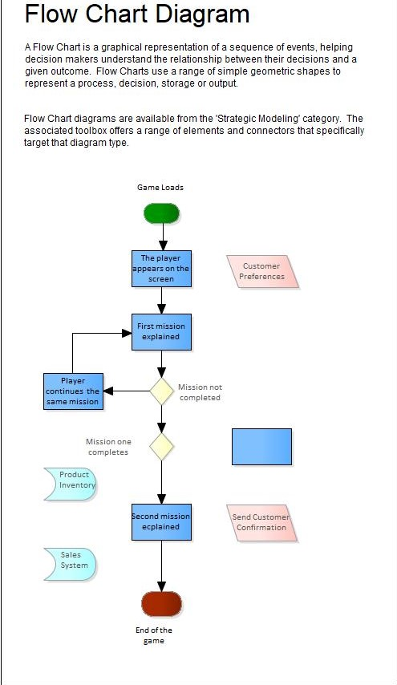

**2. ENTITY RELATION DIAGRAM**

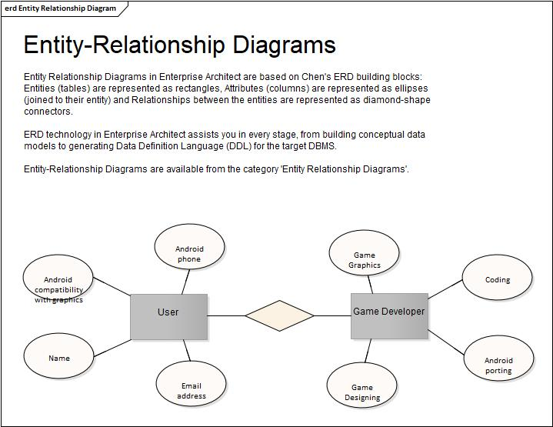

**3. USE CASE DIAGRAM**

**3.1 PLAYERS POINT OF VIEW**

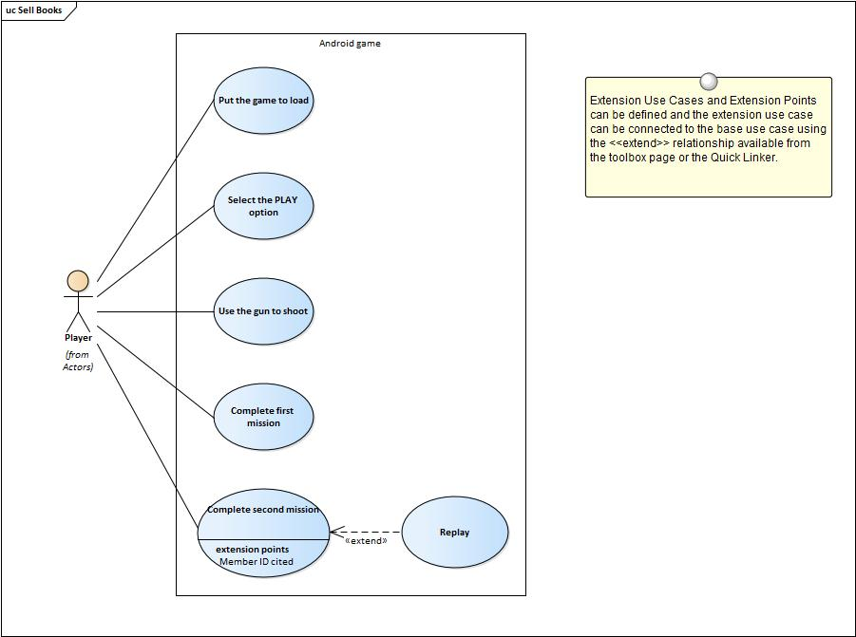

**3.2 GAME DEVELOPER POINT OF VIEW**

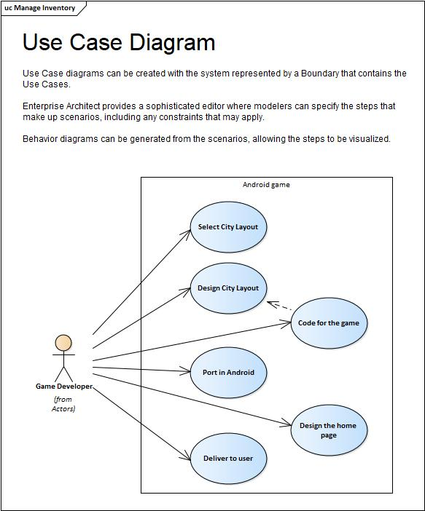

**4. ACTIVITY DIAGRAM**

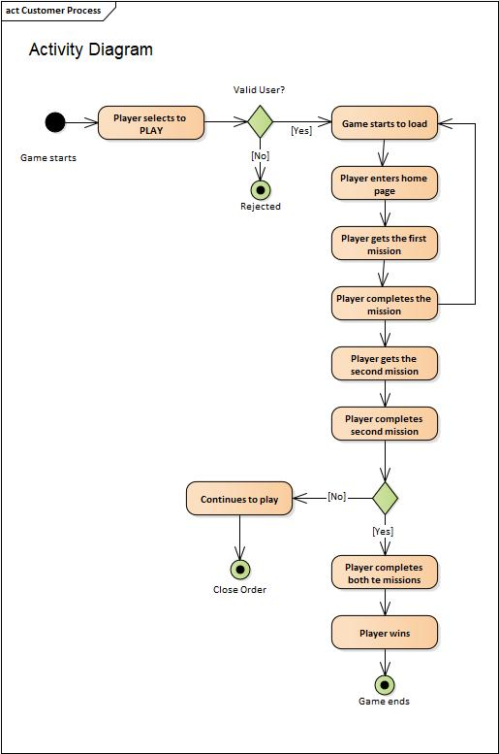

**5. COMPONENT DIAGRAM**

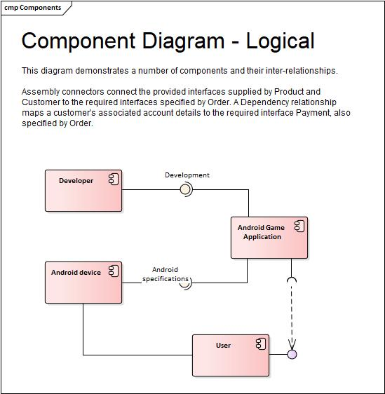

**6. TREE DIAGRAM**

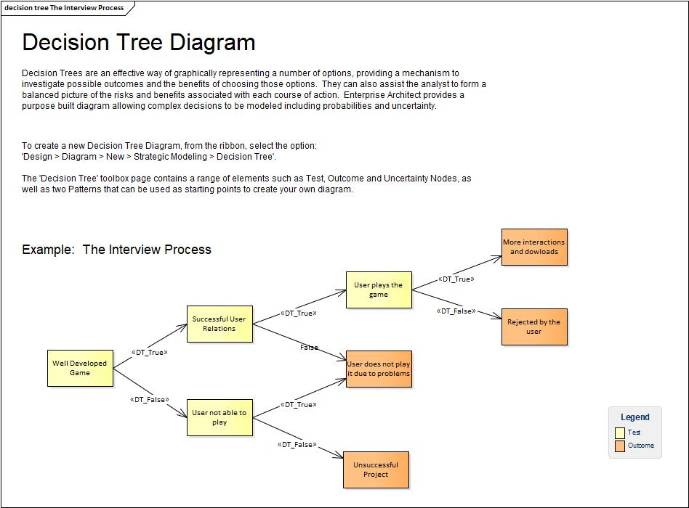

**7. MIND MAPPING**

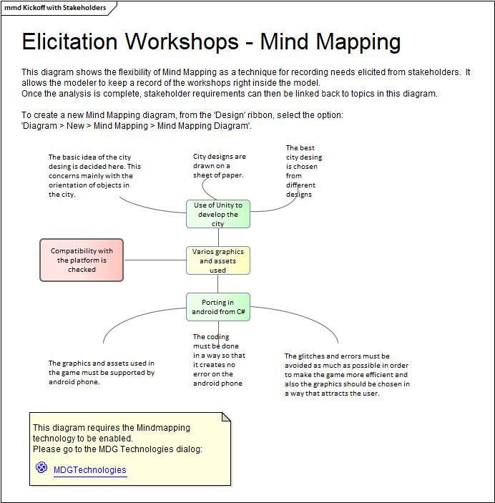

**FUTURE SCOPE OF THE PROJECT**

“A WALK IN THE PARK” can be developed further and can be released on various devices such as computers and mobile phones supporting different os such as ios and android

**CONCLUSION**

**A WALK IN THE PARK will be an android based game which was developed by using unity engine .The main focus of the game is to play an open world game and complete a couple of missions. To develop the game we took inspirations from various open world and simulation games such GTA liberty city , GTA vice city and EA sim city.To develop the assets or 3D models we used a software known as 3DS max. The coding of our game is done in mono developer software. The coding is done C# language. This game can be played anywhere is your android mobile phone. We wanted to understand more about game development and design and therefore we chose this field for our minor project.**

**REFERENCES**

**1.https://www.udemy.com/**

**2.** [**https://unity3d.com/**](https://unity3d.com/)

**3.https://en.wikipedia.org/wiki/Unity_(game_engine)**

**4.** [**https://www.monodevelop.com/**](https://www.monodevelop.com/)

**5.** [**https://developer.android.com/studio/**](https://developer.android.com/studio/)

**6.** **https://assetstore.unity.com/**