**PlacementRoadmap | YourPlacementBuddy**

**SHRI G.S. INSTITUTE OF TECHNOLOGY AND SCIENCE, INDORE**



**WEB ENGINEERING (IT38504)**

**MINOR PROJECT REPORT**

**(SESSION 2025)**

**Project Title:** Placement Roadmap

**Field of Project:** Web Development

**Field of Title:** Education (for Information Technology Branch Students)

**Group Members:**

1. **Name:** Adarsh Agrawal

**Enroll**: 0801IT221150

1. **Name**: Himanshu Shrivastava

**Enroll:** 0801IT221154

**Guide:** Assistant Professor Upendra Singh

**Co-Guide:** Assistant Professor Shraddha Verma

**INDEX**



**(Background of Project)**

**Why Placement Roadmap ?**

The first question which comes to mind is why placement roadmap? Was there even a need for such a thing, when there already are tons of solutions in the markets and so many guidance videos and all the materials and all websites ?

This project is a non-profit website made entirely for the growth of students, due to so much content over web it often overwhelm a new first year student in which direction he/she should proceed what he should do? Not all students are confident enough to ask their professors for guidance directly and even if they search for videos they would often get misguided to wrong resource and waste their time.Also multiple solution on internet consist of advertisements and related material to make students spend their money and trap them in wrong courses or choices leading to fatal mistakes and significantly dropping their chances of getting placed in good companies and for a secure future

We created this website with in mind, The Placement Roadmap Website is designed to help first-year college students systematically prepare for job placements. Many students struggle to find structured guidance on essential courses, competitive programming, hackathons, and personal progress tracking. Existing solutions, such as blog posts, fragmented YouTube tutorials, and paid AI roadmap services, do not offer a **customizable** roadmap experience for free. Most AI-powered roadmap editors generate general paths but restrict customization unless users pay for premium features. This project fills the gap by providing a **free and fully customizable roadmap editor**, ensuring that every student can tailor their journey without financial barriers. Helping them prepare in the minimal time available, It’s a hub of all the info spread across web helping them to search through and decide what to do and what not .

**(Summary of Project)**

**A Brief Overview Of the Project**

This is a website which provides a comprehensive and editable AI generated placemen, A community which is engaging and active , A collection of Resources needed for placement and many more….They are described below in detail:

* A **attractive frontpage** which lists features and easy navigation
* A **fully customizable AI-generated roadmap**, allowing users to modify their learning paths according to their interests and goals.
* A **performance tracker** that enables students to mark completed tasks and monitor their progress.
* A **hackathon and course repository**, keeping students updated on relevant opportunities.The hackathon list is fetch in real time using an external API.
* A **community chatting system** secured by their login credentials allowing them to interact with each other with no issue of having their personal info being revealed.
* **User profiles and account management**, allowing students to save and modify their customized plans
* A **list of resources needed for placement** along with SDE sheets, Videos and Roadmaps and QuestionBanks all in a single page so easy to navigate and look through.

**(Detailed Description of Project)**

**Technical Stack**

* **Frontend:** HTML, CSS, JavaScript
* **Backend:** Python (Django)
* **Database:** MySQL
* **API Used:** Devpost API and many more.
* **Authentication:** Secure login system with login with google functionality
* **AI Integration:** Generate Roadmaps with AI
* **Roadmap Editor:** Create and Save your Own roadmaps to your Liking
* **Chatroom:** A community chatroom to discuss and save your discussion for doubt clarification.Using Django Channels and WebSockets

**Architecture**

* **Frontend:** Handles UI and user Interaction
* **Backend:** Manages Database and API requests
* **Database:** Stores roadmap data and resources

**Working Principle**

* The website consists of multiple pages: Roadmap Editor, Hackathon&Competitions , Resources, To-Do Tracker, Roadmap Generator, User Login/SignUp , Community etc..,
* Users have to create Accounts to access performance tracker or Community.
* The interactive editor allows students to customize their roadmaps freely by adding, deleting, or modifying items.
* The performance tracker helps students monitor their completion rates and progress over time.
* A collection of real time Hackathons directly from Devpost using external API.
* A real-time chatroom enables collaborative discussions and idea exchange among students.
* The backend efficiently manages roadmap storage, user authentication, progress tracking etc..**.,**
* Acollection of resources consisting various famous SDE Sheets, Videos, Interview Preperation Resources, A structured YearWise Guide from first to fourth year of B.Tech directly from GFG.

**(Objective of Project)**

**Goals and Purpose of the Project**

The primary objective is to **democratize roadmap customization** for students, providing an **AI-powered yet fully editable roadmap experience for free**. Specifically, it aims to:

* **Provide Entirely Free and Affordable Service** by offering free customization, unlike existing paid AI roadmaps.
* Provide **personalized and editable resources and roadmaps** on courses, hackathons, and career paths.
* Gives **interactive roadmap editor** that lets students adjust their learning paths freely.
* Provides a **performance tracking system** to help students stay on course.
* Store and **archive different roadmaps** for future modifications and references.
* Enable a **real-time discussion platform** for peer-to-peer learning and clarification.
* A **systematic collection of various placement resources** like:
  + Popular SDE Sheets
  + Video Links for Studying Courses
  + Interview Preperation Material Links
  + All connected to database so dynamic update

**(UML DIAGRAMS)**

**Flow Chart**

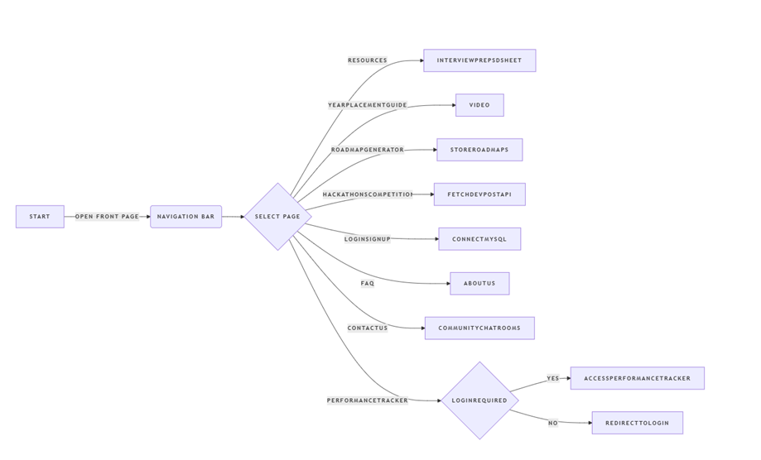

**Usecase Diagram**

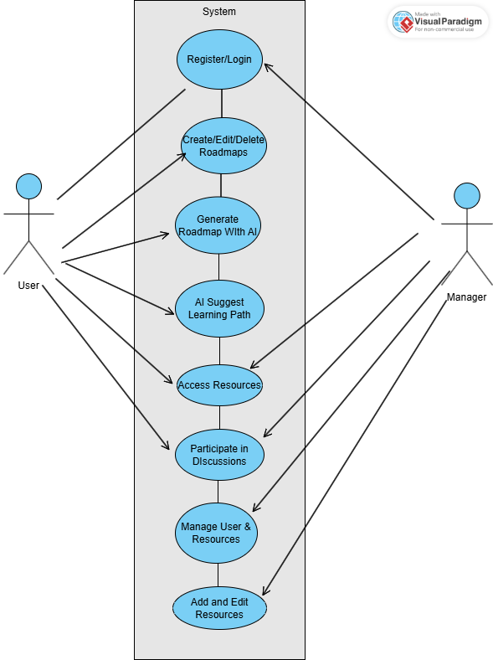

**Sequence Diagram**

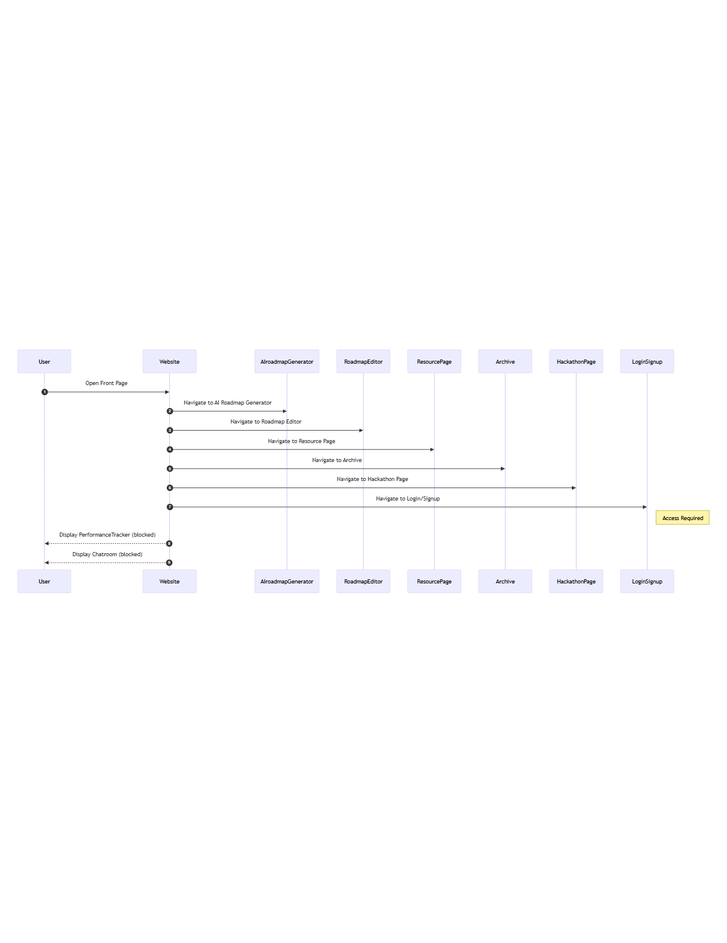

**Object Diagram**

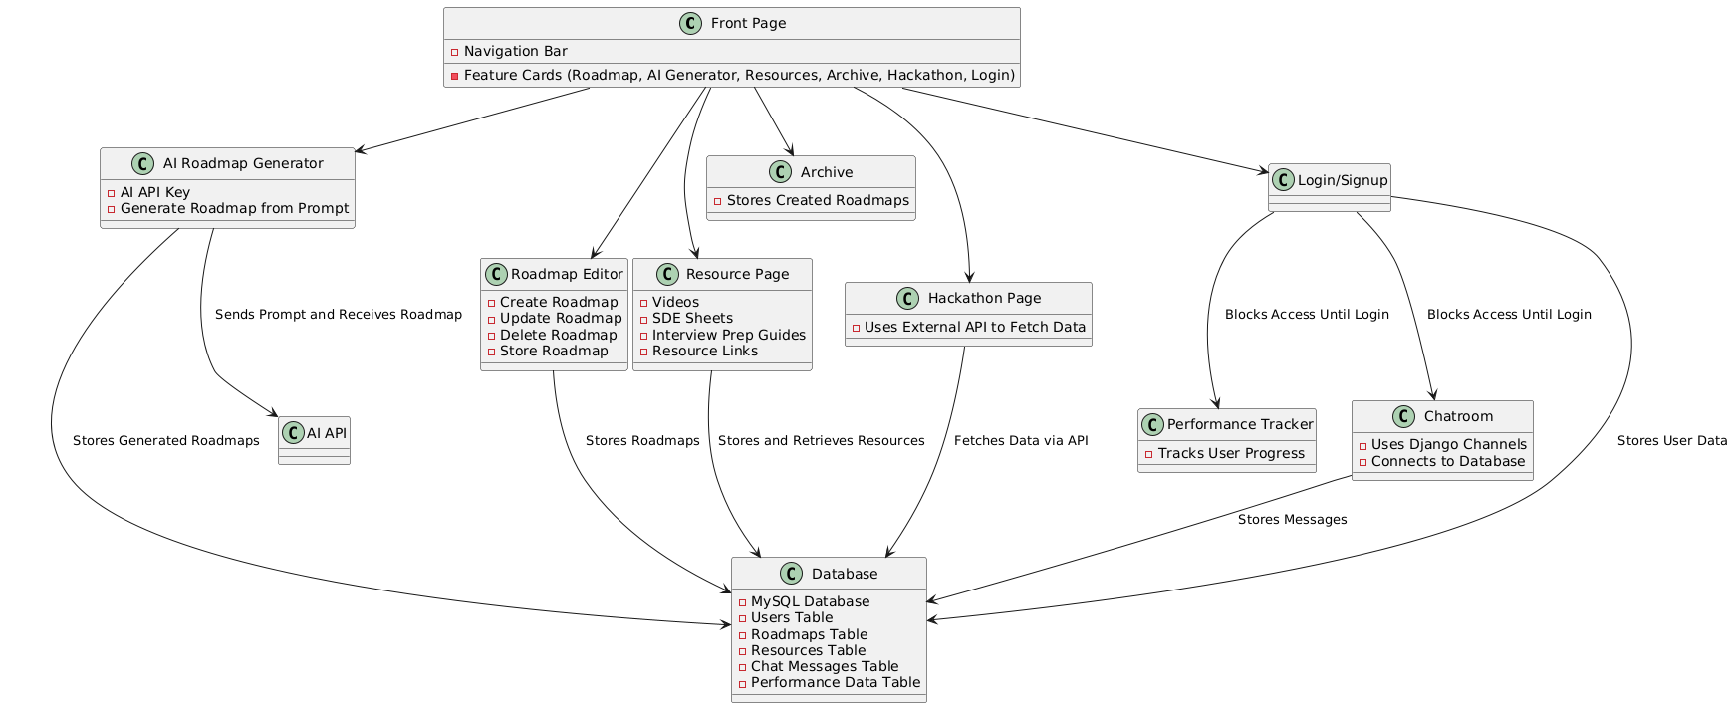

**Class Diagram**

