Use index.html from HW3 and give it styling similar to the Twitter page, without using the Twitter logo or trademark, similar to the following page

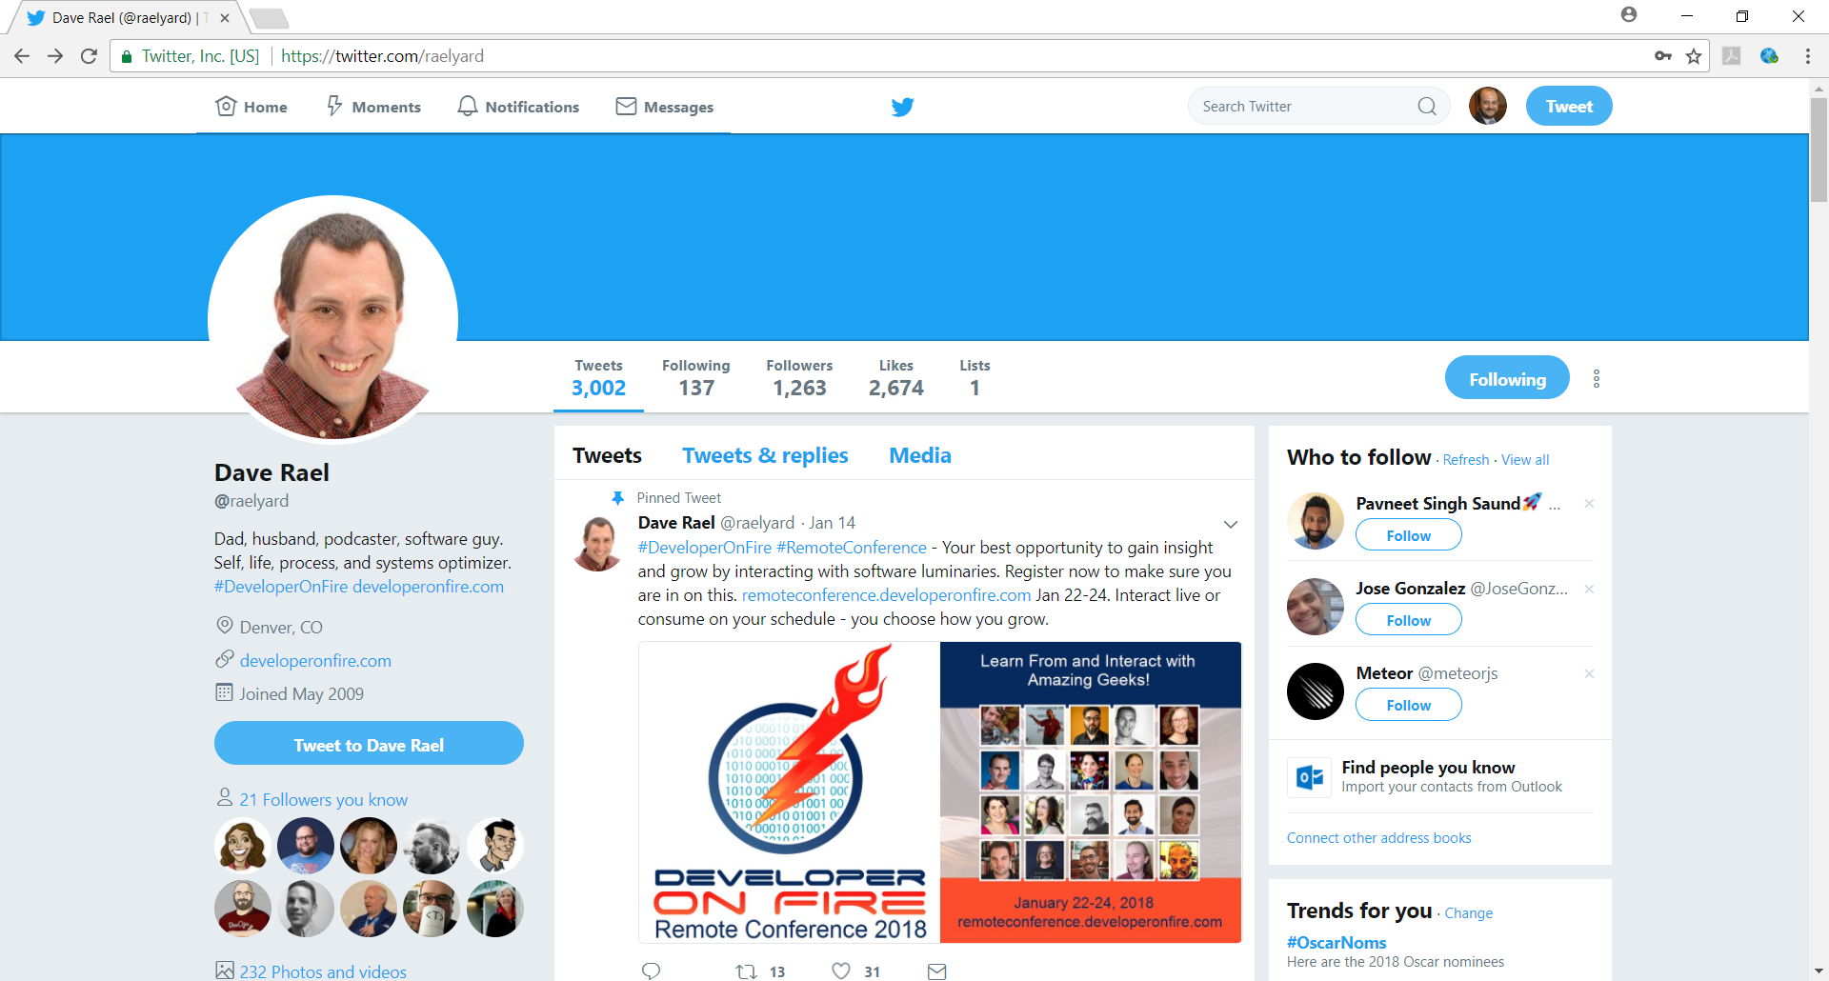

1. Have a color banner or picture at the top of the page
2. Enclose a picture in a circle
3. Have your links/menu at the top of the page
4. Select a non-white color for your background, but make it attractive and professional.
5. The body will be composed of 3 columns, each having a background color different than the color in the previous step
6. All boxes will have rounded corners, sufficient padding.
7. Have an opaque image hovering over a portion of the text.
8. Use your imagination to add additional styling to your page to better represent you.

Due: 9:00AM Thursday, January 25, 2018

Submission:

1. Create “HW5” repository in GitHub where all project files will be stored
2. Deploy the final solution to [*www.mydomain.com*/HW5](http://www.mydomain.com/HW5).
3. Email a publicly accessible link the web site to [samnasr@live.com](mailto:samnasr@live.com).