- Introduction
Archaeologists have long considered increased population sizes to be the cause for many shifts in hunter-gatherer social and technological strategies, yet few studies have been able to quantitatively evaluate the relationship between population size and technological change (e.g. Tryon & Faith, 2016Refs). Behavioral and ecological theories suggest that larger populations may put pressure on environmental resources, requiring hunter-gatherers to adopt social or technological strategies that help to mitigate resource stress. One such strategy operates under seasonal or aseasonal group aggregation and dispersal (Refs). The periods of dispersal allow hunter-gatherers to moderate resource use, and the aggregation allows groups to share technological knowledge, resources, and extend familial relations (Brewer & Dourish, 2008; DiNapoli & Morrison, 2017; Dyson-Hudson & Smith, 1978; Mackay et al., 2014; Marean, 2014; 2016; Wadley, 1989). Boyd and Richerson (1985; 2000) have argued that, during aggregation events, larger populations foster a greater probability of coming across technological innovations. In contrast, smaller, more dispersed populations may not be as efficient as communicating technological innovations, offering opportunities to lose some information, losing the frequency of technological innovations (Henrich 2004; 2006; c.f., Vaesen et al., 2016). However, rarely discussed is what lies between these two extremes, which is the case of organized aggregation and dispersal, creating temporary increase in population sizes, which needs to be positioned as an alternative explanation (e.g., Vaesen et al., 2016).
Many studies have employed the theories of Boyd and Richerson (1985; 2000) and Henrich (2004) to draw conclusions about prehistoric demographics, but rarely pull data from empirical sources (c.f., Genetics). Powell et al. (2009) apply these theoretical models to explain the emergence of ‘modern’ human behavior and the appearance of symbolic materials, standardized tool kits, and ‘complex’ technologies in Eurasia ~45 ka. In combination with genetic data (Refs), they see comparable population densities during the transition towards ‘modern’ human behaviors as is seen in African genetic populations. From this, they argue that demographics played a large role in the development of traits like symbolic behaviors and the development of ‘complex’ technologies. However, as Powell et al. (2009) emphasise, the scale of genetic data is much too broad to match up with shifts in archaeological assemblages (see also Jacobs & Roberts, 2008; Sealy, 2016). If we are to be able to evaluate the role of demographics on social and technological innovation, we must be able to all attributes onto the same scale, which is only possible via empirically derived evidence.

In response to this critique, Sealy (2016) attempts to link Richerson and Boyd’s (1985; 2000) and Henrich’s (2004) theories to technological toolkits across South Africa during the terminal Pleistocene through the Holocene. Here, Sealy (2016) separates the empirical data into broadly defined categories, namely Robberg, Oakhurst, Wilton, and post-Wilton (see Lombard et al., 2022). Each of these periods corresponds to distinct technological toolkits, geographic site distributions, and densities that Sealy (2016) uses to generate predictions for population sizes.
In particular, they note that the Robberg industry (~22-12 ka) is composed of unstandardized toolkits dominated by bladelets and few retouched tools found at only a handful of sites. Sealy (2016) argue this implies small population sizes during this period. After 12 ka they note that the Oakhurst industry dominates toolkits with abnormally large scrapers and the appearance of bone tools at an abundance of site locations along the South African coast (Refs) and interior regions (Bousman, 2005; others?), implying more densely packed populations than the Robberg. After 8 ka, Sealy (2016) notes the dominance of toolkits with abnormally small lithics including many standard tool types such as small scrapers (Refs) and backed segments (Refs), which span the Southern African coast (Refs) and are found as far north as Zimbabwe (Refs), but are notably absent from the central regions in South Africa (Refs). During this period, many scholars note the absence of interior-located sites (Refs; c.f., Newer refs), implying depopulated regions during this period. However, given the broad reach of this toolkit along coastal margins into Namibia (Refs) and Zimbabwe (e.g., Bisson, 1990; Fagan et al., 1966), Sealy (2016) argue this period reflects small, highly mobile populations. Lastly, after 4 ka, the post-Wilton technologies show more regional variation with a continual of small-based toolkits in the northwest (Refs) and a return of large lithic tools along the southern coast (Refs) and the interior regions (Refs). The increased site densities and regional variation leads Sealy (2016) to classify the post-Wilton as a period with high population density with the reoccupation of the central regions.
Though Sealy’s (2016) argument was a valiant attempt to solve the issue of matching population sizes to the empirical record, most behavioral theories, including Richerson and Boyd (1985; 2000) and Powell et al. (2009) position demographics as the main cause for social and technological innovation. However, Sealy (2016) juxtapositions these theories and uses technological innovation to predict prehistoric demographic patterns. Our concern with this argument is the weak explanatory power that technology has for predicting population size. Henceforth, to build off previous studies, it is crucial to find and deploy a proxy for population size that we can derive from empirically based data that scales to the archaeological assemblage. Our study claims that we can generate a proxy for population density via calibrated radiocarbon data, which allows us to capture site location, occupation period and duration, and temporal uncertainty. Since these data are also explicitly derived from the archaeological context, we can directly link these to lithic data.
There are several studies that use the occurrence and frequency of radiocarbon data to extrapolate periods of increased and decreased site use, which they often interpret as demographic or occupational shifts (Bamforth & Grund, 2012; Becerra-Valdivia et al., 2020; Carleton, 2019; 2021; Carleton & Groucutt, 2021; Chaput & Gajewski, 2016; Contreras & Meadows, 2014; Crema, 2022; Heaton et al., 2025; Timpson et al., 2014; Williams, 2012). However, until now most have focused on Eurasian archaeological periods given the enormous amount of genetic and radiocarbon data (see Banks et al., 2021; Crema and Kobayashi, 2020; Stewart et al., 2021). During this study, we use the largest collection of radiocarbon dates from southern Africa (Loftus et al., 2019) to model a proxy for population density that we term radiocarbon intensity. We then use generalized linear models to evaluate the relationship between the radiocarbon intensity and site occupation through time varying by technological industries. By doing this, we can directly test the hypotheses that Sealy (2016) puts forth regarding the occupation intensity of South African hunter-gatherer groups and whether there is evidence in support of a causal link between population density and technological change.
- Environmental trends in southern Africa during the terminal Pleistocene through the Holocene
  - Environment
Southern Africa is home to various environments ranging from arid to semi-tropical regions, including the fynbos biome, one of the most biodiverse biomes in the world. The fynbos biome lies along the winter rainfall zone (Quick et al., 2016) on the southern coast of Africa, south of the Cape Fold Mountains, and contains over 7,000 unique species (Bond & Goldblatt, 1984; Goldblatt, 1997; Ojeda et al., 2001). The fynbos biome is one of the most productive in the world (Refs of plant use) and contains several fire-resistant plants thought to be a direct adaptation to prehistoric landscape management (Refs). The biome transitions into the succulent Karoo, north of the Cape Fold mountains. At present, the Karoo biome is semi-arid, located within the central regions and makes up most of South Africa’s arid regions (Mucina et al., 2006). Namibia, along the west coast of southern Africa, is currently classified as a desert region, reflecting the aridity of the Karoo. As such, the Karoo and Namibia have the least amount of archaeological focus in southern Africa, which many have taken to mean only periodic or sporadic prehistoric settlement (Sealy, 2016; Other refs?). The Lesotho highlands in southern Africa’s northeast stands in stark contrast to the Karoo as a montane environment surrounded by grasslands on its east and savanna to its west (Fitchett et al., 2016; Mitchell et al., 1998). However, recent palaeoenvironmental proxies have shown the southern African climate and faunal composition to be much more diverse than is seen at present (Refs).
Over the past 21,000 years, broad climate trends show varying degrees of precipitation and temperatures, which vary within a few thousand kilometers at the smallest scale (Refs?). During the Last Glacial Maximum, there is evidence for increased precipitation during the winter months and decreased precipitation during summer months (Mills et al., (2012); Refs; Tyler refs). Pollen data also point to an increase during the coldest intervals from 24-15 ka (Scott et al., 2012). The western regions show markedly warmer and drier conditions from 15-11.5 ka while the Karoo shows the same trend but to a less of a degree (Scott et al., 2012). A dry trend across the Karoo biome is present after 11 ka until about 8 ka while the coastal region shows a synchronous increase in humidity (Scott et al., 2012). There are then marked dry periods in the Karoo region between 6 and 5 ka while the western coast shared a similar drying trend peaking at 5.6 ka. After which there were more rapid fluctuations between humid and drier climates across southern Africa until 2 ka (Scott et al. 2012). However, as Scott et al. (2012) and Chase et al. (refs) point out, local paleoclimatic data such as pollen and hyrax middens have shown extreme cases of localized climates during the last 20,000 years, forcing us to reconsider the accuracy of regional climate trends when linking these to hunter-gatherer settlement and technological patterns.
  - Demographic and technological trends in southern Africa during the terminal Pleistocene through the Holocene
Lombard et al. (2022) have developed a standard list and range of mutually exclusive time periods over the last 20,00 years in southern Africa based solely on radiocarbon data and the periods with the highest density of technological industries. These periods are given the same terminology as the industries, namely, Robberg, Oakhurst, Wilton, and Final Later Stone Age (LSA) (Table 1). Lombard et al. (2012; 2022) have rightly justified that each periods contains a degree of technological variation and do not strictly start and end during the period they propose. Table 1 further shows the degree to which some tool kits survive well past the end dates of the period. However, many of these periods correspond with broad shifts in site location, density, toolkit composition, and regional climate trends, making this period particularly useful for evaluating the role of demographic change on technological strategies.
The Robberg technology, not to be confused with the Robberg period (s.l. Lombard et al., 2022), is one example of a toolkit dominated by abnormally small bladelets and bladelet cores (Low, 2018; Mitchell, 1995; 2019; Porraz et al., 2020). These toolkits are normally composed of fine-grained raw materials like cryptocrystalline silicates or quartz and vary based on the distance required to source these resources (Low, 2018). Robberg-dominated contexts expand across broad ranges of southern Africa including coastal regions (Low, 2019; Porraz et al., 2020), the Cederberg mountains (Pargeter and Faith; Others), and the Lesotho Highlands (Low & Pargeter, 2020; Mitchell, 1995). Since this technology preserves such similar features across southern African for a long duration (~7,000 years), many take this to reflect a large social network but with small population density given the lack of technological innovation (Carter et al., 1988; Mackay et al., 2014; Stewart & Mitchell, 2018; Sealy, 2016; c.f., Low, 2019).
The Robberg transitions into the Oakhurst technology, which some note occurred up to 16 ka, well before the 12.7 ka beginning of the Oakhurst period (Low, 2019). Oakhurst technology reflects abnormally large stone tools including large scrapers, adzes, and few to no stone tools that resemble the small size of the Robber (Lombard et al., 2022; Schrier, 1962). Hunter-gatherers made Oakhurst tools on local, coarse-grained materials quartzite or basalts, which some argue implies circumscribed mobility (Sealy, 2016; others?). Multidirectional and lightly reduced cores accompany many of the flake-based tools associated with the Oakhurst (Deacon, 1972; Low & Pargeter, 2020; Porraz et al., 2016). Note do Oakhurst technologies dominate coastal contexts, but regional variants referred to as Lockshoek is found scattered through hundreds of sites in the interior Karoo regions (Sampson, 1985; Bousman, 2005; Refs). Sealy (2016) argues that the degree of Oakhurst materials and site frequency far exceed the Robberg materials, this implies more densely packed populations across much of southern Africa.
Wilton technology then dominates most assemblages after the Oakhurst, dominating the coastal margins but extending as far as Namibia (Refs) and Zimbabwe (e.g., Bisson, 1990; Fagan et al., 1966). Wilton technology often contains a high proportion of small scrapers and highly standard backed tool forms, contrasting with the generally larger Oakhurst scrapers with fewer standard tools (Deacon, 1972; 1974; Derricourt et al., 1976; but see Wadley, 2001). Like the Robberg, Wilton tools are generally made on fine-grain materials sourced from over hundreds of kilometers away (refs!!!). This technology extended inland as far as the Cape Fold Mountains but are rare in the central Karoo regions (Bousman, 2005). At the same time, there is a reduction of sites identified to the Wilton period located in the interior Karoo regions. Further supported by the incremental warming of the Karoo regions, Sealy (2016) argues that the hunter-gatherers with Wilton tools had depopulated the interior and aggregated along coastal margins. Since Wilton assemblages are less dense than the Oakhurst, Sealy (2016) also takes this as a sign of low population density.
Lastly, Wilton technology abruptly becomes less standardized and resemble regional variations after 4 ka with some sites showing Wilton-like tools well past 2 ka (Webley, 2002; Orton, 2002; 2006; Dewar, 2008; Refs) and others showing a less standard industry dominated by larger tools made on local materials, resembling Oakhurst tools (Sealy, 2016; Refs). Lombard et al. (2022) refer to this period as the Final LSA, though many others often conflate these technologies with the label ‘post-Wilton.’ For simplicity, we refer to this technology and period as the Final LSA. This period is of particular interest because it is after 4 ka that we see wide-spread, synchronous evidence of resource intensification throughout southern Africa such as a broad trend towards capturing smaller, more territorial game (Refs), the use of storage pits (Refs), mass collection of freshwater fish (Refs), and Africa’s largest known coastal shell middens (Refs). The evidence of resource intensification and, in some cases, territorial defense around coastal resources (Sealy, 2006) suggest much more sedentary groups associated with the Final LSA technology. From this, Sealy (2016) suggests that this period is associated with a more densely packed populations expanding across most of southern Africa accompanied by a reoccupation of the interior Karoo regions.
  - What is the role of demographics in technological innovation?
Popular models theorizing the demographic impacts on hunter-gatherer technologies such as Powell et al. (2009) operate under the hypothesis that demographics affect components on ‘complex’ toolkits, but this idea of ‘complexity’ remains vague and hard to identify (Vaesen et al., 2016; other Refs). So and so have defined complexity as the number of components required to construct a single tools while so and so define it by the procedural steps required for a tool starting from its inception. Behavioral models suggest that the more complex a tool, or idea becomes, the less likely it is to be recreated by an individual without extensive knowledge and learning (Refs). Under Boyd and Richerson (1985; 2000), without an adequate population size, there is less probability that existing ideas will be innovated with small populations running against the probability of forgetting crucial explanatory components for ‘complex’ tools, leading to a recession in technological innovation. However, without an agreed upon definition for how to identify more ‘complex’ technology, most studies simply refer to ‘complexity’ as those tools that are heavily reduced, standardized, and broadly distributed (e.g., Refs).
Under the definition of ‘complexity’ as multi-component toolkits, then the technological industries Robberg and Wilton should reflect a more ‘complex’ toolkit (Refs). So and So interpret the highly standardized and small natured tools of Robberg and Wilton tools as components for hafting into shafts via different orientations (Refs), suggesting greater technological complexity. Wilton is especially known for backed segments, which occur all over the world as multi-component tools (Refs) with evidence for group identity linked into the creation of these tools (Refs). Meanwhile, the more “crude” forms of Oakhurst (Refs) and unstandardized Final LSA toolkits (Refs) reflect a recession in technological knowledge. Under these interpretations, Boyd and Richerson (1985; 2000) would classify Robberg and Wilton technology with greater populations sizes, leading to technological innovation and thus, more complex tools. However, Sealy (2016) uses site and artifactual densities to predict that Robberg and Wilton technology should be associated with smaller populations, implying Robberg and Wilton should be less ‘complex’ toolkits, contradicting Boyd and Richerson’s (1985; 2000) theory.
An alternative explanation is that demographics is not the sole cause for technological change and that other explanatory factors such as lithic sourcing (Refs), degree of mobility (Refs), or faunal resource exploitation (Refs) need to be considered. Low (2018) already shows that Robberg toolkits vary based on distance to raw materials, which suggests that when hunter-gatherer mobility is circumscribed, the targeted raw materials will be more limited. Gregory et al. (In press) show different technological strategies between hunter-gatherers the intensified riverine and coastal resource use during the Holocene in southern Africa. They showed that when hunter-gatherer diets were dominated by seasonal riverine resources in the Lesotho highlands, there were significant shifts in toolkit components such as flake cutting edge-to-mass and core reduction (Gregory et al., in press). Meanwhile, year-round coastal resource use showed little change in technological components as hunter-gatherers intensified shellfish consumption (Gregory et al., in press). These data show that, only by examining site-level lithic attributes can we detect meaningful technological change. Henceforth, if demographic change does not cause technological change, then there may be alternative explanatory factors shared between both demographic and technological change such as lithic sourcing, mobility, and faunal resource exploitation.

when hunter-gatherer diets were dominated by riverine resources in the Lesotho highlands, there was significant shifts in tool kit components such as cutting-edge-to mass and core reduction. Meanwhile, the same technological

However, more frequent innovation should actually result in more diverse toolkits preserved in the archaeological record, but most studies treat technological stasis of multi-component tools as evidence for increased population.

However, not only is ‘complexity’ variable on the individual site-level (Refs), but innovation will not always present itself in the form of tools with more

One contradiction is that innovation does not equate to complexity

One of the most common definitions of ‘complex’ technology is those that are multi-component, then the archaeological assemblages showing small and highly standardized components may indicate lithics that were inlaid within different shafts (Refs). If we adopt this view for southern African toolkits, then we should also be able to link technological ‘complexity’ along the continuum of population size. Under Sealy’s (2016) predictions, we should see Robberg technology and Wilton technology associated with greater toolkit complexity than the Oakhurst and Final LSA technologies. However, Sealy (2016) position the Robberg and Wilton technology as having small populations, contradicting the initial idea that large populations lead to more technological innovations. This alone, suggests we need to reconsider the impact of demographics on technological innovation over other factors such as lithic sourcing (Refs), degree of mobility (Refs), or faunal resource exploitation (Refs).
This contradiction raises more of a need to explicitly test the relationship between prehistoric demographics and technological change

Given recent evidence of extreme localized climatic shifts in southern Africa (Chase et al., 2013; 2019; 2020), it is increasingly difficult to assign technological industries with a single environmental factor. However, to date, the Holocene in Southern Africa has been associated with a highly variable environment (Fitchett, 2018; Lee-Thorp et al., 2001). Of note is several periods of heightened aridity at the beginning of the Holocene and during the middle (Scott & Lee-Thorp. 2004; Scott et al., 2005). During these periods, there is a notable exclusion of sites in the interior regions (c.f., Sampson et al., 2015) and visible hunter-gatherer aggregation along South Africa’s coasts (Sealy, 2006; Jerardino, 2012; Jerardino & Yates, 1996). In the vein of creating a coarse view of climate that matches the scale of our technological industries, we can associate more arid, less productive environments with the Oakhurst technology and more productive environments with the Wilton, though regional climate differs at extreme scales during these periods.

Higher resolution paleoenvironmental data force us to reconsider the accuracy of regional climate trends when linking these to hunter-gatherer settlement and technological patterns. Scott et al. (2012) point out several discrepancies in the pollen data from several sites within the Karoo regions, implying that some experience heightened aridity during the Holocene while others show this pattern to a lesser extent. So, when

- Methods
This study aims to model archaeological radiocarbon intensity in southern Africa over the later Holocene from 20-1.5 ka. Specifically, we will use this model to statistically test differences in hunter-gatherer occupations and site-use intensity 1) across coastal- and interior-located sites and 2) between proposed intervals of technological stability. We pull data from two region-wide databases of southern African archaeological sites including the Southern African Stone Age Site Index (SASSI) (Hallinan, 2026) and the Southern African Radiocarbon Database (SARD) (Loftus, 2019). We use the SASSI to develop meaningful aggregates of coastal and interior located sites and SARD to develop our radiocarbon intensity models conditioned by the meaningful aggregates through time. We then use Lombard et al.’s (2022) technological classifications to group our model by periods associated with technological industries spanning the last 21,000 years in southern Africa. Below, we walk through the methodological approach to measuring radiocarbon intensity, generating meaningful site aggregates, and the technological descriptions and determinations.
  - Archaeological models of radiocarbon intensity
Archaeologists often consider the frequency of radiocarbon dates to be a proxy for site use intensity (Carleton, 2021; Crema et al., 2017; Crema & Shoda, 2021; Deacon, 1974; Williams, 2012; Price et al., 2021). The most popular approach to quantify site-use intensity is to sum the radiocarbon probability distributions and take the maximum and minimum values to be ‘higher’ and ‘lower’ site use intensity (Crema et al., 2017). Crema et al. (2017) have shown that summed probability distributions facilitate a visual representation of the radiocarbon data where some then practice matching two regionally distinct curves to determine the precision of fit between the regions. Other studies have taken this framework and applied stochastic processes, making this a more robust, reproducible, and quantitative measure, which provide information about statistical differences between two independent summed distributions (Palmisano et al., 2021). Yet, most of these studies resort to using the maximum and minimum radiocarbon data as point estimates applied to statistical regressions, which negate some of the uncertainty applied to radiocarbon distributions (Carleton & Groucutt, 2021).
Carleton and Groucutt (2021) argue that point estimates from summed distributions are unreliable as data for statistical models (c.f., Codding et al., 2024). One could use point estimates of the peaks and valleys in summed distributions as response variables, but this does not account for the temporal error within the initial radiocarbon probability distribution. Henceforth, Carleton (2021) have developed a novel technique to sample the radiocarbon distributions, creating a collection of possible radiocarbon dates over a given period. Heaton et al. (2025) improved upon this approach and describe the process as sampling over a radiocarbon distribution via an estimated Poisson process for a fixed number of times to generate a collection of possible dates of occupation. Poisson distributions model the probability of events occurring in fixed time intervals (Dreassi, 2014). In other words, the Poisson sampler selects radiocarbon data that are dependent on the probability that a calibrated radiocarbon dates to an associated calendar year. These reflect count data sampled continuously across calendar years, reflecting radiocarbon intensity measurements, which we can more easily model against explanatory variables via generalized linear models. Thus, we refer this improved proxy as radiocarbon intensity.
  - Technological determinations during the later Stone Age in southern Africa
We follow Lombard et al.’s (2022) standard classification of technological industries in southern Africa over the past 20,000 years. When selecting the sites of interest in the SASSI, we selected those assigned to the Late Stone Age, Robberg, Oakhurst, Wilton, and Final Later Stone Age. We follow a similar selection from the SARD to select the sites that date between these intervals. Lombard et al. (2022) have outlined specific dates when these technological industries were widely used within southern Africa (Table 1). We further segregate the data by these temporal intervals so that we can evaluate differences between clusters, through time, and by technological industry.
Table 1 Technological industry name and most probable duration based on Lombard et al. (2022, Table 2).
Industry | Probable Duration
Ceramic Final Later Stone Age | 97 – 1457 cal BP
Final Later Stone Age | 1318 – 3898 cal BP
Wilton | 4636 – 7784 cal BP
Oakhurst | 8705 – 12789 cal BP
Robberg | 13145 – 19923 cal BP

  - Site aggregations within the SASSI
The SASSI contains purely nominal data on archaeological sites in southern Africa including the corresponding technological industries, whether the site has been dated via C14 methods, and the latitude and longitude of the site (Figure 1). Since our goal is to use radiocarbon intensity as a proxy for site occupation intensity, sites located closer to one another should exhibit similar radiocarbon intensity. Therefore, we ran a density-based clustering algorithm over the site locations from the SASSI via dbscan in R (Figure 2). Density-based clustering is advantageous to archaeological sites because this algorithm does not force clusters into circular or crescent shapes, allowing for a more amorphous site distribution. The only requirements for density-based clustering is the maximum number of sites per cluster and an epsilon neighbourhood that determines how far the closest nearest neighbour should be. To account for sampling biases in the site locations, we determined that each cluster should contain only four observations, allowing the algorithm to detect sparser regions. We then used this threshold to evaluate the epsilon neighbourhood where the distance to the nearest points begin to increase exponentially, sometimes referred to as the ‘elbow’ or ‘knee’ of the graph (Figure 2B). Ultimately, these parameters resulted in nine distinct clusters highlighting the northeastern coast, southern coast, interior karoo biome, the east coast extending beyond Lesotho, and the sparser northern region (Figure 2A). We then combine specific clusters into a more descriptive regional tag and run both individual and combined clusters through the same regression models (See Table 2 for site counts).
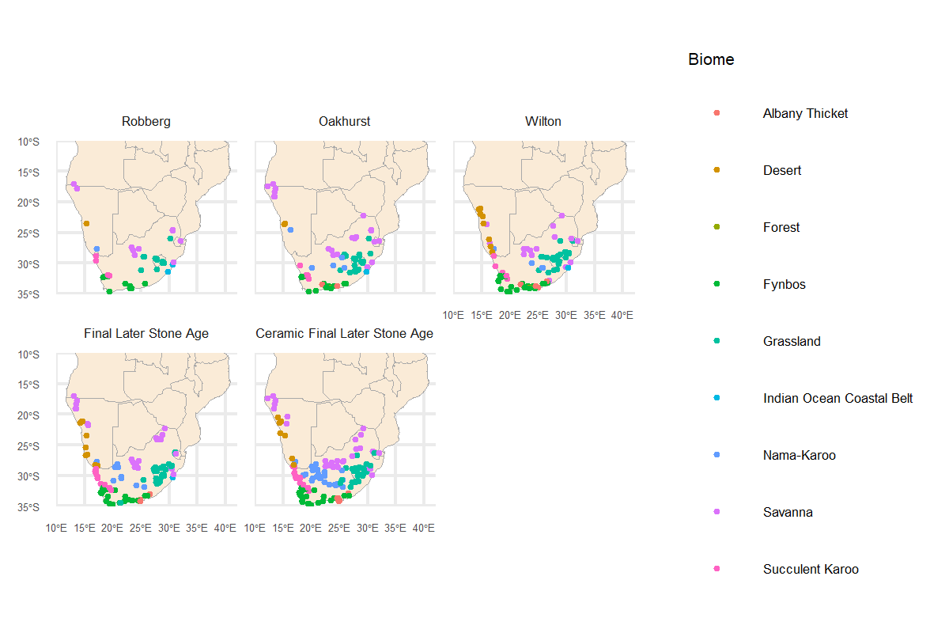
Figure 1 Map of site distributions based on technological industry assigned in the SASSI database colored by modern biome.

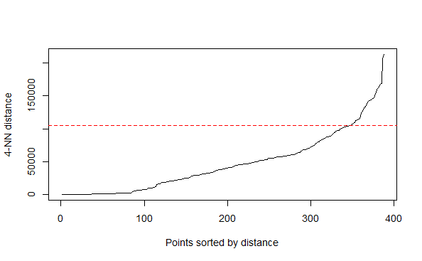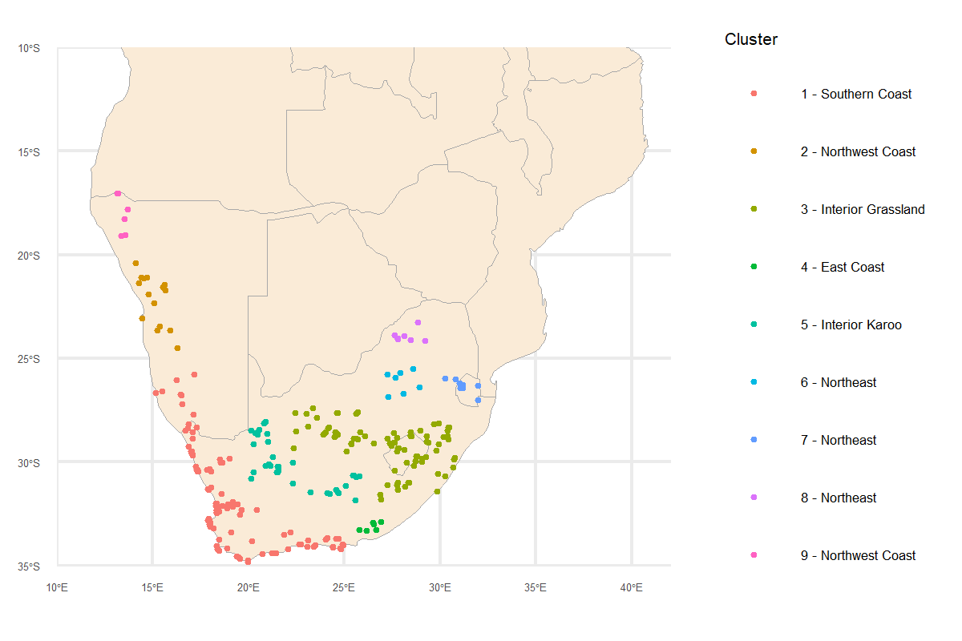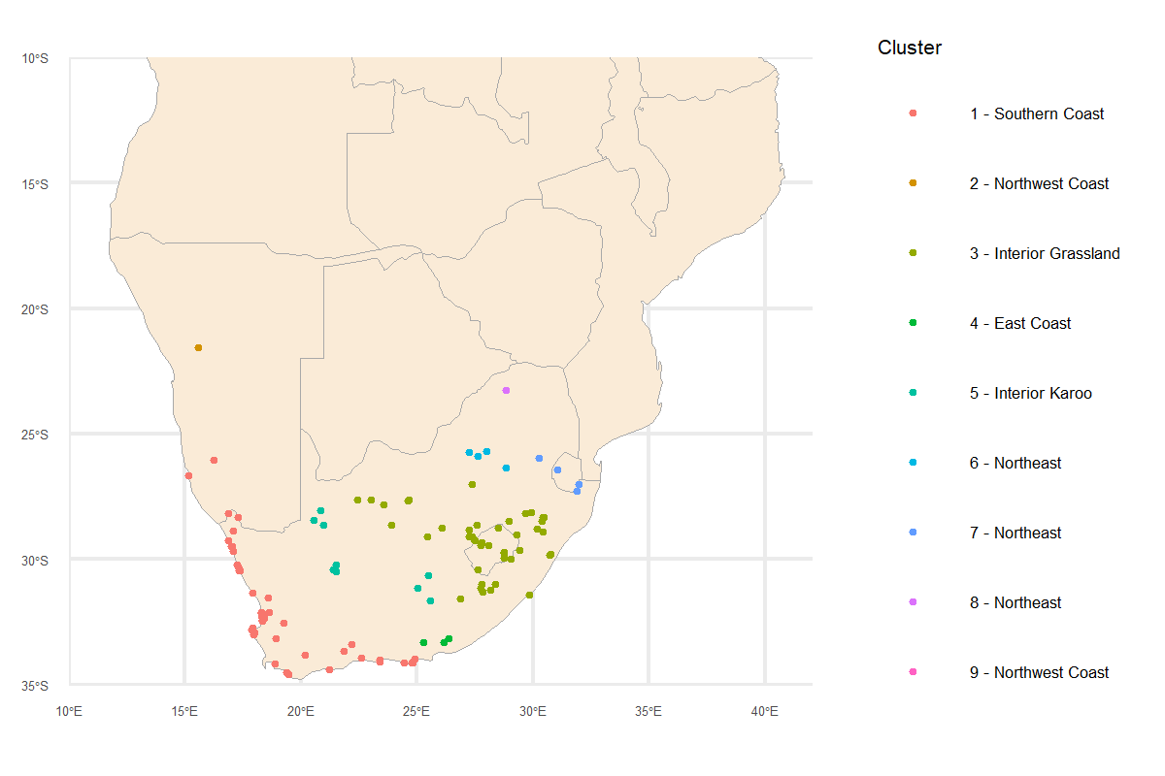Figure 2 Map of assigned clusters from the SASSI (left) and the joined SARD database (right) (A) with the assigned epsilon neighborhood identified via the elbow-plot with four k-nearest neighbors (B).
SASSI
SARD
B
A
Table 2 Counts for sites that lie within the regional aggregates determined via density-based clustering on the SASSI.
Database | East Coast | Interior-Grassland | Interior-Karoo | Northeast | Southern Coast
SASSI | 188 | 97 | 43 | 25 | 188
SARD | 3 | 23 | 9 | 4 | 31
  - Chronological sampling within the SARD
Heaton et al.’s (2025) novel approach, which builds on Carleton (2021), samples from the calibrated radiocarbon datasets via a Poisson distribution. Poisson distributions require one parameter, much like the mean for a normal distribution, namely lambda. Lambda defines the intensity, or frequency, of observing a sampled point during a given time period. We need to first figure out what lambda should be to use in our Poisson sampler, then we keep track of the number of times that the distribution samples the calibrated dates, and this makes up our count data. Even though we take after Heaton et al. (2025), we found that their function did not sample over calibrated dates and did not account for the effect of binning the radiocarbon data. So, to have full control and transparency over this process, we created our own script to estimate the Poisson parameters and then estimate over the calibrated radiocarbon data.
We first randomly sampled our calibrated data set based on the summed distribution to produce randomly chosen count data that we can use to estimate our Poisson parameter. We binned the random count data into equally sized bins at 100-year intervals. The bin-wise means reflect the lambda Poisson parameter for the respective interval. We then used the newly defined lambda to randomly sample within each bin via a Poisson distribution. To account for individual site differences, we do this for each individual site and then combine all site samples into one dataset grouped by regional aggregate (Figure 3). These accumulated count data reflect the radiocarbon intensity expected at each site that we then add to a generalized linear model as our response variable (e.g., Stewart et al., 2021).
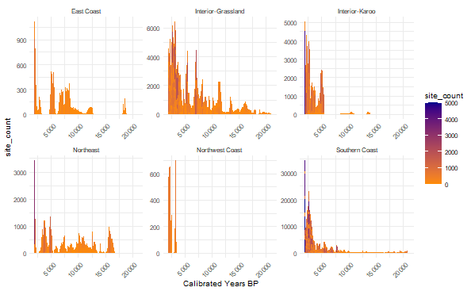
Figure 3 Expected radiocarbon counts per regional aggregate based on 5,000 probabilistic sampling of the sites within the SARD.
Since we sampled from the same set of sites, our accumulated counts now reflect a negative binomial distribution with each count being a successful trial out of 5,000 iterations. We use the negative binomial family within our generalized linear models that treat time (scaled) as a random slope and the regional aggregates as random intercepts. We use a 95% credible interval (CI) centered on the median for the posterior distributions to describe the range of values for the model coefficients. The median and 95% CI are advantageous here because, unlike typical frequentist statistics, we can use these values to directly interpret the probability that radiocarbon data and additional covariates are correlated. The observed patterns followed statistically sound principles and showed high variance in credible intervals for smaller bins. At the same time, the credible intervals shrank towards zero. This is a well-known statistical property that emphasizes the tradeoff between lower sample sizes and reduced noise in the data.
  - Issues with sampling biases
Radiocarbon data are an inherently biased collection of data and for archaeological assemblages this is a three-fold problem in stratigraphic ordering, site selection, and material sampling biases. First, since archaeological sites begin with excavating the most recent point in time, barring erosional events, it is more probable that a site will collect radiocarbon material from the top stratigraphic layers. It then takes more time and funding for those same sites to extend their excavations into the deeper cultural contexts, biasing the radiocarbon collection towards the present. Second, it is easier to excavate sites within politically calm, temperate, accessible, and already well-known regions. This shifts the spatial location in sites are excavated. For instance, southern African sites have been focused on the coastal and montane regions as opposed to the less accessible interior regions (Refs; Bamforth). This biases sites within the spatial realm. Finally, funding determines the ability to date the sampled radiocarbon materials in which some sites have a lot of funding and others do not. This causes a heterogeneous sample of radiocarbon data that are either sampled through entire site contexts, clustered around a single point in time, or are sparsely sampled. This particularly would bias our probability distributions for selecting certain sites at specific periods of time.
Luckily the last bias is easily accounted for by creating bins via the rcarbon R package, which groups materials dating within the bin into the same sample; however, it is much more difficult to account for the inherent temporal and spatial bias that lies within the archaeological discipline. The main question that arises is whether the absence of sites or older carbon materials truly reflects the absence of site occupation or archaeological sampling bias. The SASSI has started to merge radiocarbon databases but still shows 307 undated sites while the SARD contains 635 dated sites. So, future amendments would be to continue building the SASSI to reflect where undated sites are located to evaluate spatial biases. Additional information on each sites’ stratigraphic context would further allow researchers to know which sites ended before recovering deeper carbon materials and which ended in bedrock or sterile contexts. However, for the purpose of this study, we work under the assumption that the sites and data we use are up-to-date and reflect the current knowledge of where and when hunter-gatherers occupied southern African sites.
- Preliminary Results
  - Do radiocarbon intensity rates vary through time in southern Africa?
Figure 4 shows the accumulated counts and regression over the past 21,000 years in southern Africa with an apparent increase in radiocarbon counts towards the present. A negative binomial model confirms that for each 1,000 year interval, the radiocarbon intensity increases by a rate of 1.22 (CI [1.21, 1.25]) during this interval. Since Lombard et al. (2022) classify the past 21,000 years into mutually exclusive temporal periods (i.e., Robberg, Oakhurst, Wilton, and Final Later Stone Age), we cannot compare the radiocarbon intensities within each period but can confirm that the rate exponentially increased during these periods (Figure 4B). In particular, the mean rate is 0.96 for Robberg period, 9.63 for the Oakhurst period, 31.4 for the Wilton period, and 78.5 for the Final Later Stone Age period.
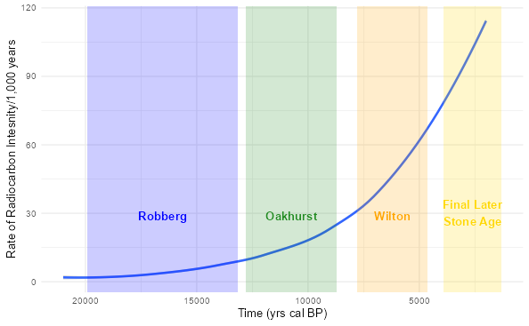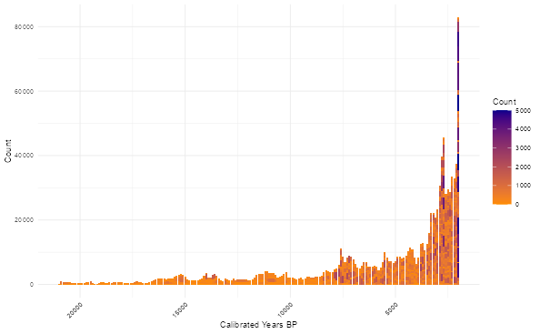
B
A
Figure 4 Expected radiocarbon counts based on 5,000 probabilistic sampling of the sites within the SARD over the past 21,000 years (A), and the regression model from a negative binomial for radiocarbon intensity against time, cantered and scale to 1,000 year bins.
Figure 5 shows the model results from the technological classifications of each site overlaid the expected period that Lombard et al. (2022) predict we should see the corresponding technologies. There are extreme differences in the radiocarbon intensity of the technological industries than simply through time. In particular, the Robberg (rate = 27.2, CI [16, 47.8]) and Oakhurst (rate = 24.9, CI [11, 55.8]) have similar rates over the past 20,000 years, but the Wilton (rate = 136, CI [33.9, 571]) and Final Later Stone Age (rate = 52, CI [22.8, 124]) sites do not begin to accumulate until the beginning of Lombard et al.’s (2022) assigned period. However, given the large credible intervals, there is weak evidence that any rate is significantly different for these technological classes.
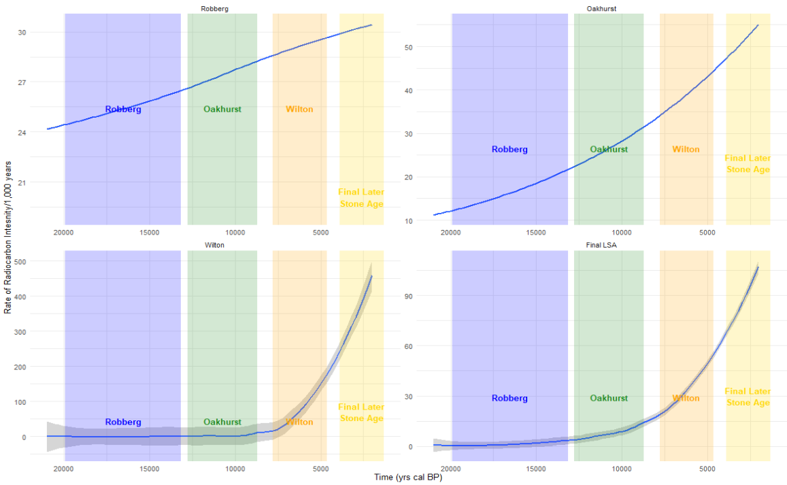
Figure 5 Linear curves for the technological classifications of each site overlaid Lombard et al.’s (2022) period in which we should see each corresponding technology dominate.
  - Are radiocarbon intensity rates regionally distinct?
Figure 6 shows the posterior estimate for expected radiocarbon intensity during each period by regional aggregate. These data show 1) the interior-Karoo and the Northeast follow similar radiocarbon trends and 2) there is a sudden shift from lower radiocarbon intensity in the interior-Karoo and Northeast regions during the Robberg interval to the Oakhurst. At the same time, the interior-Karoo and Northeast regions exceed the expected radiocarbon intensity for all other regions after the Oakhurst period. Figure 7 shows the modelled relationship through time for all sites, emphasizing that the interior-Karoo and Northeast sites during the Oakhurst period intercept all other regions just before 11 ka cal BP. These curves remain above all other regions through the Holocene.
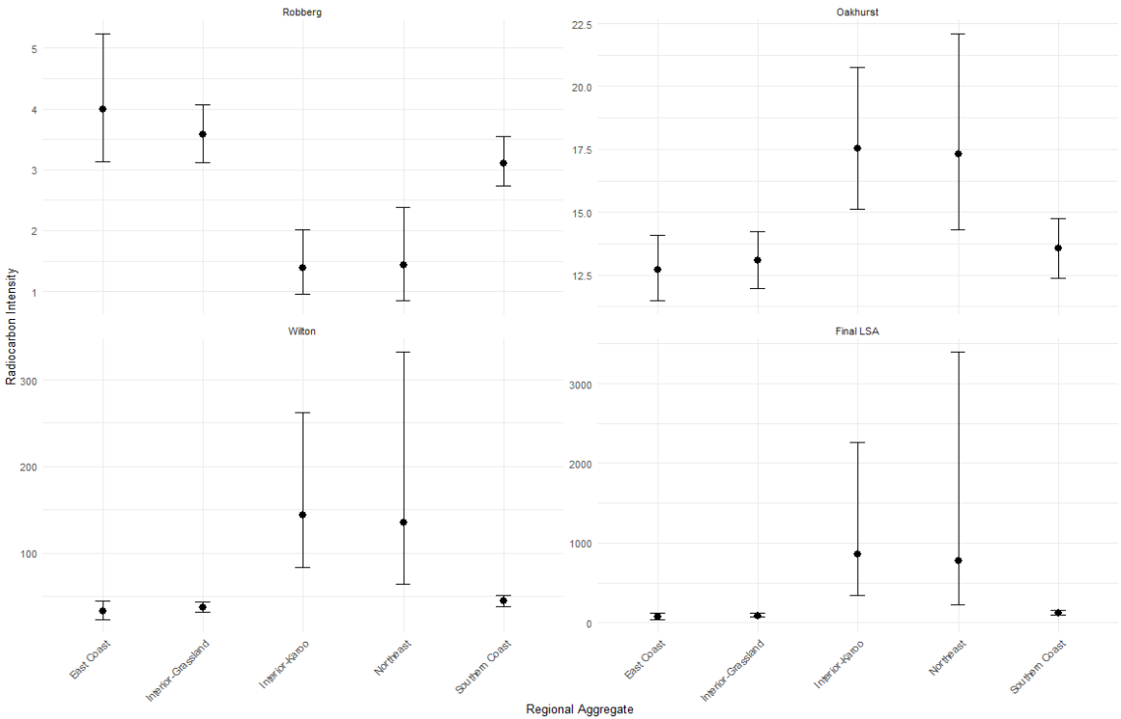
Figure 6 Posterior estimate for the relationship between regional aggregates, times, and radiocarbon intensity.
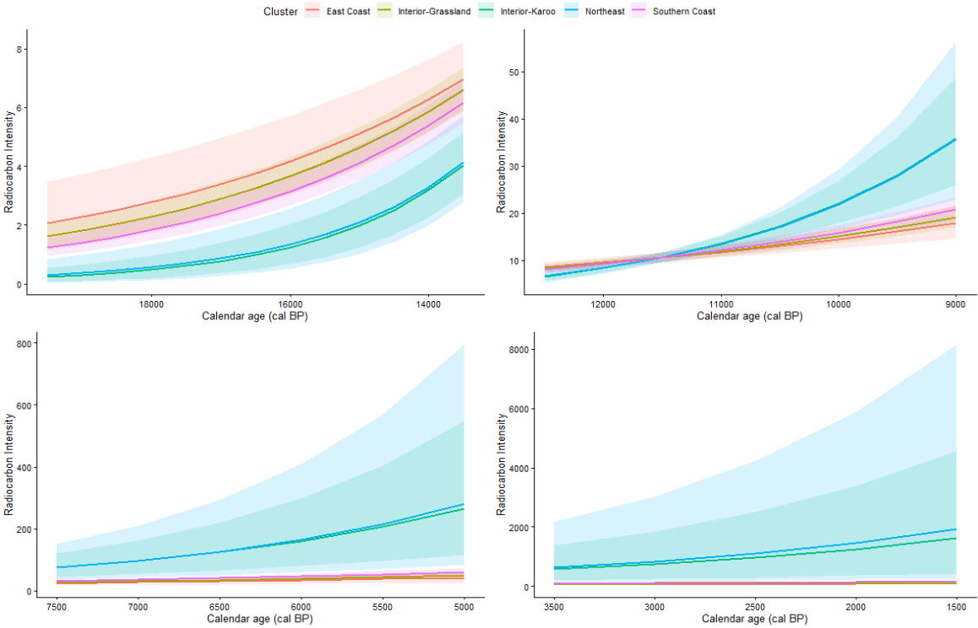
Figure 7 Modeled relationship between temporal period and the radiocarbon intensity through the regional aggregates along continuous time.
Figure 8 shows the relationship between the technological classifications through time to evaluate if there are regionally distinct occupation patterns associated with a specific technology. These data show no regional distinction between technological strategies, suggesting similar occupation regardless of technology. However, the Robberg and Oakhurst radiocarbon expectations remain the only two comparisons that show little evidence for being distinct between regions. Figure 9 confirms this relationship and shows similar rates and patterns associated with the Robberg and Oakhurst technologies, implying expected radiocarbon intensities, which are consistently lower than the East Coast, Northeast, and Southern Coast after ~11 ka cal BP.

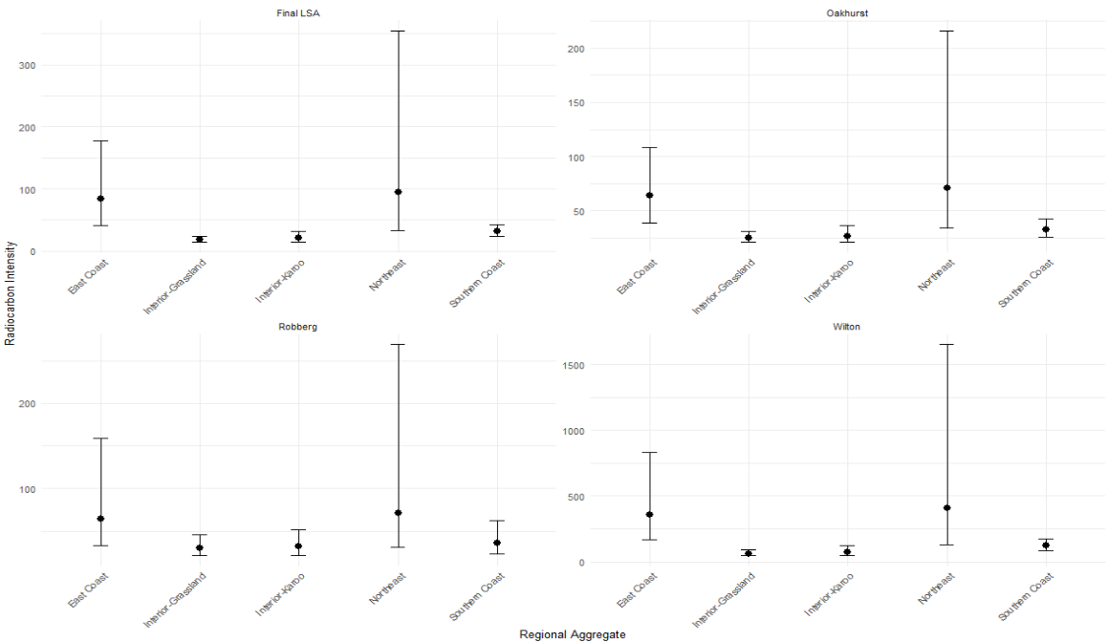
Figure 8 Posterior estimate for the relationship between regional aggregates, technological classifications, and radiocarbon intensity.
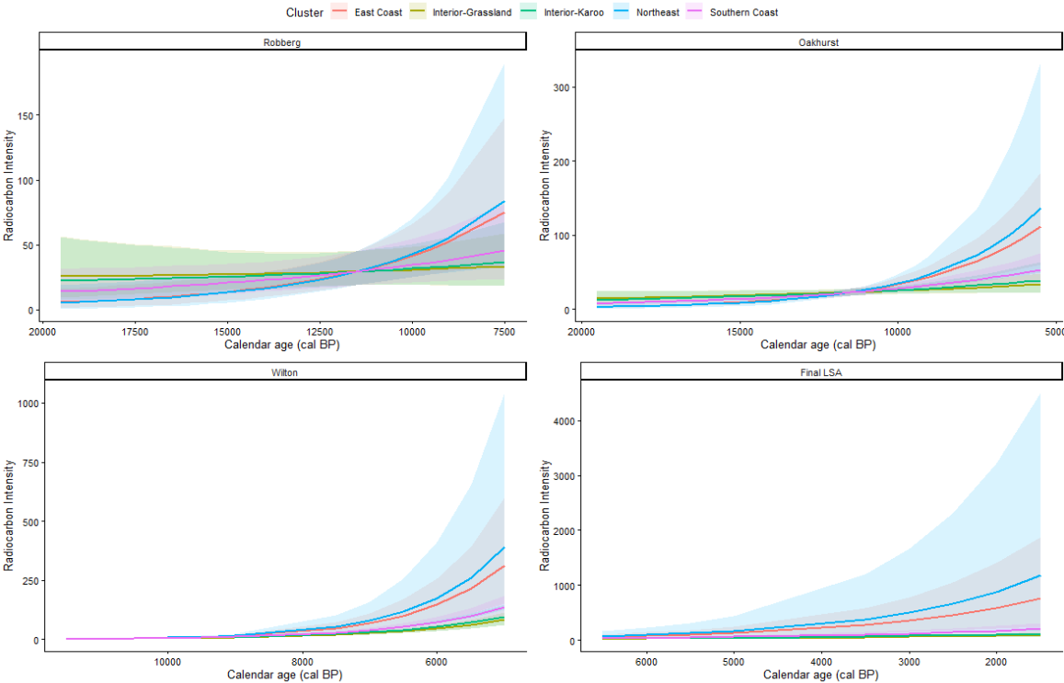
Figure 7 Modeled relationship between technological classification and the radiocarbon intensity through the regional aggregates along continuous time.

References
Carleton, W. (2021). Evaluating Bayesian Radiocarbon‐dated Event Count (REC) models for the study of long‐term human and environmental processes. Journal of Quaternary Science, 36, 110-123.
Carleton, W., & Groucutt, H. (2021). Sum things are not what they seem: Problems with point-wise interpretations and quantitative analyses of proxies based on aggregated radiocarbon dates. The Holocene, 31, 630-643.
Codding, B., Meyer, J., Brewer, S., Kelly, R., & Jones, T. (2024). Do counts of radiocarbon-dated archaeological sites reflect human population density? A preliminary empirical validation examining spatial variation across late Holocene California. Radiocarbon, 66, 610-623.
Crema, E., & Shoda, S. (2021). A Bayesian approach for fitting and comparing demographic growth models of radiocarbon dates: A case study on the Jomon-Yayoi transition in Kyushu (Japan). PLoS One, 16, e0251695.
Crema, E. R., Bevan, A., & Shennan, S. (2017). Spatio-temporal approaches to archaeological radiocarbon dates. Journal of Archaeological Science, 87, 1-9.
Deacon, J. (1974). Patterning in the radiocarbon dates for the Wilton/Smithfield complex in southern Africa. The South African Archaeological Bulletin, 29, 3-18.
Dreassi, E. (2014). Poisson models. In Michalos, A. (Ed.) Encyclopedia of Quality of Life and Well-Being Research (pp. 4848-4850), Springer.
Hallinan, E. (2026). The Southern African Stone Age Site Index (SASSI): a spatial, chronological and contextual resource for archaeological research. Journal of Open Archaeology Data, 14, 2-2.
Heaton, T., Al-Assam, S., & Bard, E. (2025). A new approach to radiocarbon summarisation: Rigorous identification of variations/changepoints in the occurrence rate of radiocarbon samples using a Poisson process. Journal of Archaeological Science, 182, 106237.
Loftus, E., Mitchell, P. J., & Ramsey, C. B. (2019). An archaeological radiocarbon database for southern Africa. Antiquity, 93, 870-885.
Lombard, M., Bradfield, J., Caruana, M., Makhubela, T., Dusseldorp, G., Kramers, J., & Wurz, S. (2022). The Southern African stone age sequence updated (II). The South African Archaeological Bulletin, 77, 172-212.
Low, M. A. (2018). Understanding the character and organisation of early microlithic systems during the last glacial peak (~ 29–12 ka) in the Western Cape, South Africa (Doctoral dissertation, University of Wollongong).
Low, M. (2019). Continuity, variability and the nature of technological change during the Late Pleistocene at Klipfonteinrand Rockshelter in the Western Cape, South Africa. African Archaeological Review, 36(1), 67-88.
Low, M., & Pargeter, J. (2020). Regional variability in lithic miniaturization and the organization of technology in Late Glacial Southern Africa (~ 18-11 kcal BP). Journal of African Archaeology, 18(1), 38-66.
Mackay, A., Stewart, B. A., & Chase, B. M. (2014). Coalescence and fragmentation in the late Pleistocene archaeology of southernmost Africa. Journal of human evolution, 72, 26-51.
Mills, S. C., Grab, S. W., Rea, B. R., Carr, S. J., & Farrow, A. (2012). Shifting westerlies and precipitation patterns during the Late Pleistocene in southern Africa determined using glacier reconstruction and mass balance modelling. Quaternary Science Reviews, 55, 145-159.\
Mitchell, P. J. (1995). Revisiting the Robberg: new results and a revision of old ideas at Sehonghong Rock Shelter, Lesotho. The South African Archaeological Bulletin, 50, 28-38.
Mitchell, P. J. (2017). Discontinuities in hunter-gatherer prehistory in southern African drylands. Journal of Anthropological Archaeology, 46, 40-52.
Palmisano, A., Lawrence, D., de Gruchy, M., Bevan, A., & Shennan, S. (2021). Holocene regional population dynamics and climatic trends in the Near East: A first comparison using archaeo-demographic proxies. Quaternary Science Reviews, 252, 106739.
Porraz, G., Igreja, M., Schmidt, P., & Parkington, J. E. (2016). A shape to the microlithic Robberg from Elands Bay Cave (South Africa). Southern African Humanities, 29(1), 203-247.
Price, M., Capriles, J., Hoggarth, J., Bocinsky, R., Ebert, C., & Jones, J. (2021). End-to-end Bayesian analysis for summarizing sets of radiocarbon dates. Journal of Archaeological Science, 135, 105473.
Tryon, C. A., & Faith, J. T. (2016). A demographic perspective on the Middle to Later Stone Age transition from Nasera rockshelter, Tanzania. Philosophical Transactions of the Royal Society B: Biological Sciences, 371(1698), 20150238.
Vaesen, K., Collard, M., Cosgrove, R., & Roebroeks, W. (2016). Population size does not explain past changes in cultural complexity. Proceedings of the National Academy of Sciences, 113(16), E2241-E2247.
Williams, A. (2012). The use of summed radiocarbon probability distributions in archaeology: A review of methods. Journal of Archaeological Science, 39, 578-589.

