Steenbokfontein Preliminary Results

## Raw material distribution

|  | **Quartz** | | | | **Quartzite** | | | | **Silcrete** | | | |
| --- | --- | --- | --- | --- | --- | --- | --- | --- | --- | --- | --- | --- |
|  | **N** | **Core** N = 191*1* | **Flake** N = 1,704*1* | **Retouched tools** N = 207*1* | **N** | **Core** N = 38*1* | **Flake** N = 465*1* | **Retouched tools** N = 24*1* | **N** | **Core** N = 33*1* | **Flake** N = 189*1* | **Retouched tools** N = 68*1* |
| Layer | 2,102 |  |  |  | 527 |  |  |  | 290 |  |  |  |
| 1 |  | 19 (9.9%) | 103 (6.0%) | 7 (3.4%) |  | 6 (16%) | 51 (11%) | 0 (0%) |  | 1 (3.0%) | 7 (3.7%) | 4 (5.9%) |
| 2 |  | 9 (4.7%) | 69 (4.0%) | 15 (7.2%) |  | 11 (29%) | 66 (14%) | 6 (25%) |  | 1 (3.0%) | 9 (4.8%) | 5 (7.4%) |
| 3 |  | 34 (18%) | 282 (17%) | 52 (25%) |  | 5 (13%) | 130 (28%) | 8 (33%) |  | 8 (24%) | 23 (12%) | 19 (28%) |
| 4a |  | 44 (23%) | 374 (22%) | 64 (31%) |  | 5 (13%) | 75 (16%) | 5 (21%) |  | 5 (15%) | 22 (12%) | 8 (12%) |
| 4b |  | 44 (23%) | 579 (34%) | 52 (25%) |  | 3 (7.9%) | 64 (14%) | 3 (13%) |  | 11 (33%) | 54 (29%) | 17 (25%) |
| 5 |  | 41 (21%) | 297 (17%) | 17 (8.2%) |  | 8 (21%) | 79 (17%) | 2 (8.3%) |  | 7 (21%) | 74 (39%) | 15 (22%) |
| *1*n (%) | | | | | | | | | | | | |

png   
 2

png   
 2

### Supp 1-2

png   
 2

### Supp 3-4

png   
 2

### Supp 5-6

png   
 2

## Toolkit composition

png   
 2

## Flake utility and reduction intensity

png   
 2

## Retouched flake utility to retouch intensity

png   
 2

## Cores

png   
 2

## Scraper utility and retouch intensity

png   
 2

## Adzes

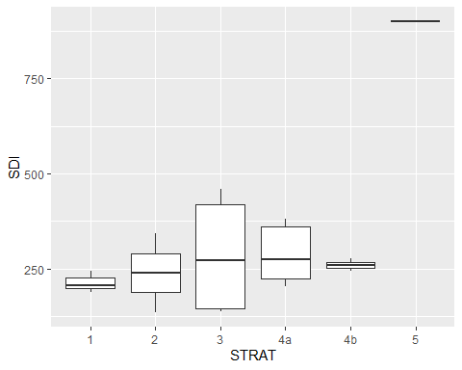

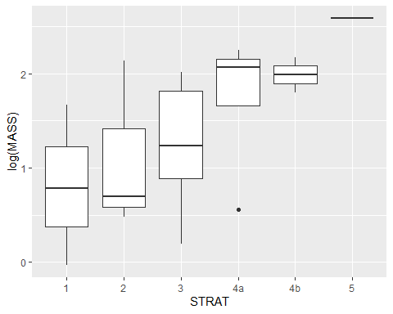

Tukey multiple comparisons of means  
 95% family-wise confidence level  
  
Fit: aov(formula = lm(SDI ~ STRAT, data = df_adze))  
  
$STRAT  
 diff lwr upr p adj  
2-1 25.559433 -249.4692 300.5880 0.9996752  
3-1 70.750983 -144.9992 286.5012 0.9039238  
4a-1 74.717503 -171.2755 320.7106 0.9283531  
4b-1 46.530275 -260.9610 354.0216 0.9966151  
5-1 685.971878 297.0227 1074.9210 0.0002286  
3-2 45.191549 -170.5586 260.9417 0.9849676  
4a-2 49.158070 -196.8350 295.1511 0.9878178  
4b-2 20.970842 -286.5205 328.4622 0.9999290  
5-2 660.412444 271.4633 1049.3616 0.0003652  
4a-3 3.966521 -173.2903 181.2234 0.9999997  
4b-3 -24.220707 -280.0689 231.6275 0.9996445  
5-3 615.220895 265.6657 964.7761 0.0002346  
4b-4a -28.187228 -310.0077 253.6332 0.9995352  
5-4a 611.254374 242.2648 980.2439 0.0004912  
5-4b 639.441602 226.8987 1051.9845 0.0010569