1. Comparative Evaluation of Alternative Models
The proposed CNN–LSTM–Fourier super-hybrid model should be systematically compared with alternative models, including CNN–LSTM, CNN, ANN, LSTM, and Regional Climate Models (RCMs). Their predictive performance should be evaluated using consistent datasets and evaluation criteria. The results should be presented in a comparative graphical format, as illustrated in Figure 1, to demonstrate the advantages and limitations of each model and establish whether the proposed super-hybrid model provides superior predictive performance.

2. Historical Data-Based Model Validation
The predictive accuracy of the CNN–LSTM–Fourier and/or CNN–LSTM model should be validated using historical Sc-PDSI data covering 1990–2025. The dataset should be divided chronologically, using 1990–2010 for model training and 2011–2025 for out-of-sample prediction. The predicted Sc-PDSI values for 2011–2025 should then be compared with the corresponding observed historical values to assess the model's ability to reproduce drought variability and severity.
Model performance should be quantified using three key evaluation metrics: the Pearson correlation coefficient (R), root mean square error (RMSE), and mean absolute error (MAE). The observed and predicted Sc-PDSI time series should be plotted together, accompanied by the evaluation metrics, as illustrated in Figure 2. This validation will provide quantitative evidence of the model's predictive reliability and its suitability for drought forecasting and early warning.

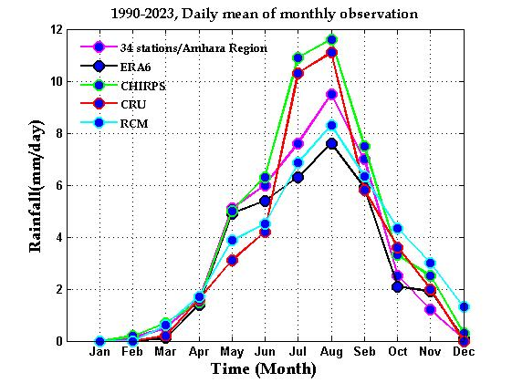
Fig. 1.
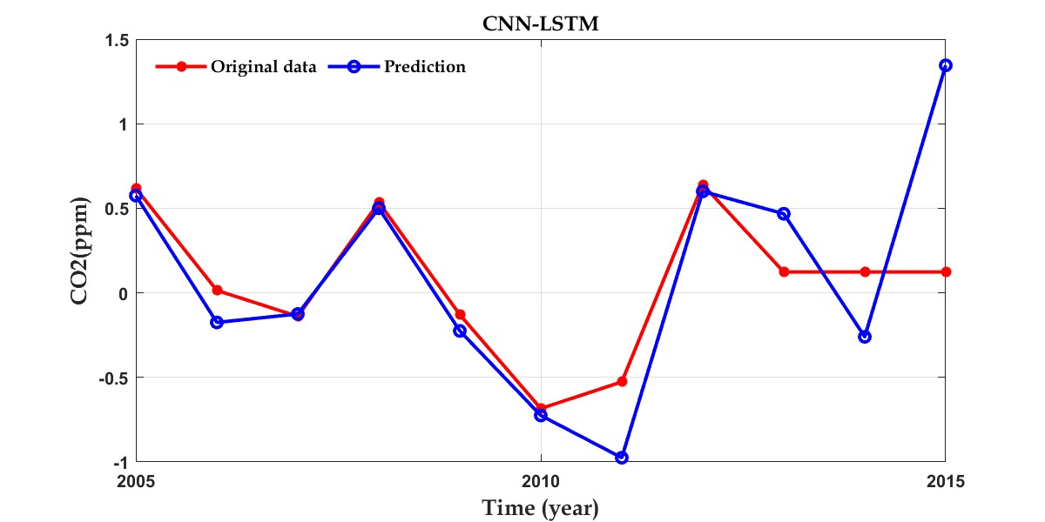
Fig. 2.

