Embarking on a Spiritual Journey: Offbeat Religious Sites in India

India, a land steeped in spiritual heritage, beckons seekers to explore its lesser-known religious sites that resonate with profound spirituality and cultural richness. These offbeat destinations offer tranquil sanctuaries where devotees and spiritual enthusiasts alike can immerse themselves in divine grace and timeless wisdom. Here's a guide to some of India's spiritually enriching offbeat religious sites:

1. Kalugumalai Jain Beds (Tamil Nadu)

Nestled amidst the serene hills of Tamil Nadu, the Kalugumalai Jain Beds are ancient rock-cut sculptures and caves dating back to the 8th century. Adorned with intricate carvings of Jain deities and monks, this site exudes a sense of sacredness and spiritual contemplation.

2. Velankanni Church (Tamil Nadu)

Velankanni Church, known as the Basilica of Our Lady of Good Health, is a sacred pilgrimage site revered for its miraculous healing powers. Devotees seek solace and divine intervention from Mother Mary, experiencing profound spiritual upliftment by the Bay of Bengal.

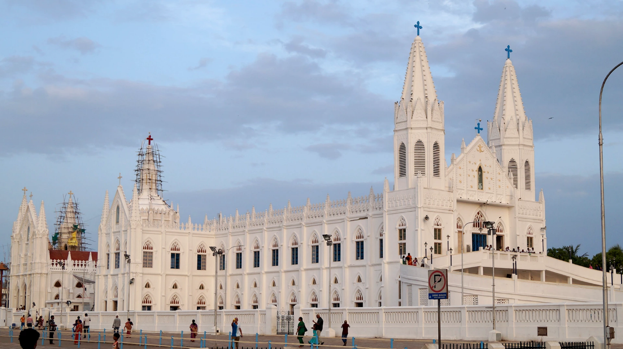

3. Dargah Sharif (Ajmer, Rajasthan)

Dargah Sharif in Ajmer is a cherished Sufi shrine dedicated to the revered saint Moinuddin Chishti. Pilgrims of all faiths visit this spiritual sanctuary to seek blessings, offering prayers that resonate with the essence of love, peace, and harmony.

4. St. John's Church (West Bengal)

St. John's Church in Kolkata is a tranquil Anglican sanctuary dating back to the early 19th century. Set amidst lush gardens, it provides a serene retreat for contemplation and prayer, embodying a sense of divine presence and spiritual reflection.

5. Hemis Monastery (Ladakh)

Perched amidst the breathtaking landscapes of Ladakh, Hemis Monastery stands as a bastion of Tibetan Buddhism. Home to vibrant festivals and ancient teachings, it invites pilgrims to deepen their spiritual practice and connect with the enlightened presence of Guru Padmasambhava.

6. Bodh Gaya (Bihar)

Bodh Gaya, the sacred site where Gautama Buddha attained enlightenment under the Bodhi Tree, radiates with spiritual energy and serenity. Pilgrims from around the globe converge here for meditation, reflection, and to experience the profound teachings of the Buddha.

7. Ratnagiri (Odisha)

Ratnagiri in Odisha is a treasure trove of Buddhist heritage, housing ancient stupas and monastic ruins dating back to the 5th century CE. Surrounded by tranquil landscapes, it offers a spiritual retreat where seekers can delve into Buddhist philosophy and meditative practices.

8. Dilwara Temples (Rajasthan)

The Dilwara Temples in Mount Abu, Rajasthan, showcase exquisite Jain architecture and craftsmanship dedicated to Tirthankaras. These temples, adorned with intricate marble carvings, inspire spiritual devotion and reverence, inviting pilgrims to connect with Jain principles of non-violence and compassion.

Conclusion

Embark on a transformative journey to these offbeat religious sites in India, where spirituality transcends time and space. Whether you seek solace amidst ancient Jain sculptures, divine intervention at a Catholic shrine, or enlightenment under the Bodhi Tree, each destination offers a sacred haven for spiritual growth and inner peace. Embrace the spiritual essence of India's diverse religious traditions and uncover the profound wisdom they impart to all who seek the divine.