Academic Planner
Feature Development & Code Prototype Documentation
1. Introduction
The Academic Planner (StudyFlow) is a weekly study-planning system designed to help students organize academic tasks according to their available time, task priority, estimated effort, and deadlines. Unlike a fixed timetable, the system generates a flexible weekly schedule that can be adjusted when the student's availability or task list changes.
This document focuses on the development prototype of the Rule-Based Weekly Scheduling Engine, which is the core feature responsible for generating and modifying the weekly study schedule. The engine takes inputs such as daily available study time, task deadlines, priority levels, and estimated task duration. It then applies predefined scheduling rules to determine how tasks can be distributed across the remaining available time.
For example, if a student has 3 hours available on Monday and 2 hours on Tuesday, and has a high-priority task requiring 4 hours with a Wednesday deadline, the engine can divide the task across Monday and Tuesday rather than treating it as a single fixed block. If another task is added later in the week, the system considers the remaining availability and deadlines before suggesting changes to the existing schedule.
The feature is designed as a recommendation system rather than an authority. Users can review, modify, or reject the generated schedule. This approach allows the planner to respond to real-world changes while keeping the student in control of the final schedule.
This prototype documents the feature's technical approach, data structures, algorithms, pseudocode, process flow, error handling, efficiency considerations, and implementation structure.
2. Selected Feature — Rule-Based Weekly Scheduling Engine
2.1 Feature Overview
The Rule-Based Weekly Scheduling Engine is the core feature of StudyFlow responsible for generating a practical weekly study schedule from the user's tasks and available study time. It evaluates each task using factors such as deadline, priority, estimated effort, and available time before assigning it to suitable time slots.
The engine does not create a permanent timetable. Instead, it works with the user's current week's availability and can adjust the schedule when tasks are added, completed, or modified. Tasks may also be divided across multiple days when their estimated effort is greater than the available time on a single day.
The generated schedule is presented as a recommendation. The user can accept the schedule or manually modify it according to their preferences.

2.2 Feature Objective
The primary objective of the scheduling engine is to make effective use of the student's available study time while reducing the possibility of missing important deadlines.
The feature aims to:
- Prioritize tasks with closer deadlines.
- Give greater consideration to tasks marked as high priority.
- Allocate sufficient time according to the task's estimated effort.
- Distribute large tasks across multiple available days when necessary.
- Avoid scheduling tasks after their deadlines whenever feasible.
- Recalculate the schedule when the user's availability changes.
- Accommodate newly added tasks during the week.
- Notify the user when the available time is insufficient to complete all tasks.
- Allow the user to modify or override the generated schedule.

2.3 Why This Feature Was Selected
The scheduling engine was selected because it represents the main functional component of the Academic Planner. Basic features such as adding tasks, setting deadlines, or marking tasks as completed can be found in many existing task-management applications. The scheduling engine provides the project with its main planning functionality by converting these inputs into a structured weekly schedule.
It was also selected because it involves clear algorithmic decision-making without requiring machine learning. A rule-based approach is suitable for the current project scope because the scheduling decisions can be defined using understandable conditions based on deadlines, priority, effort, and available time.

2.4 Connection with Project Requirements
The scheduling engine directly implements several requirements identified during the project planning and design stages.
Project Requirement | Scheduling Engine Implementation
User enters available study time | Engine uses daily availability when allocating tasks
User can add tasks | New tasks are evaluated against the existing schedule
Tasks have priorities | Priority influences task ordering and allocation
Tasks have deadlines | Deadline is used to determine scheduling urgency
Tasks have estimated effort | Required time is considered during allocation
Tasks can be completed early | Remaining time can be used for other pending tasks
Availability can change | Schedule can be recalculated using remaining availability
Tasks can be added mid-week | Only remaining days and available time are considered
Insufficient time should be detected | Engine identifies scheduling conflicts and warns the user
User should control the final schedule | Generated recommendations can be accepted or modified
3. Feature Inputs and Outputs
The Rule-Based Weekly Scheduling Engine requires information about the user's tasks and available study time. These inputs are processed according to the defined scheduling rules to produce a recommended weekly schedule. The main inputs and outputs are described below.
3.1 Feature Inputs
Input | Description | Example
Tasks | Academic or personal activities that need to be scheduled. | DAA Assignment
Priority | Indicates how important the task is to the user. | High
Estimated Effort | Approximate time required to complete the task. | 3 hours
Deadline | Date by which the task should be completed. | Wednesday
Daily Availability | Study time available on each day of the week. | Monday: 2 hours
Existing Schedule | Tasks that have already been assigned to time slots. | Monday: Java – 1 hour
Task Status | Indicates whether a task is pending, in progress, or completed. | Pending
3.2 Feature Outputs
The main output of the scheduling engine is a recommended weekly schedule. It specifies which task should be performed, on which day, and for how much time.
For example, if the user provides:
- Monday availability: 2 hours
- Tuesday availability: 3 hours
- Task A: 4 hours, High priority, deadline Wednesday
- Task B: 1 hour, Medium priority, deadline Friday
The engine may produce:
Day | Recommended Schedule
Monday | Task A — 2 hours
Tuesday | Task A — 2 hours + Task B — 1 hour
Wednesday | Available / reserved for other tasks
4. Technical Approach
The Rule-Based Weekly Scheduling Engine uses predefined rules to allocate pending tasks to the user's available study time. The engine considers deadlines, task priority, estimated effort, existing schedule, and remaining availability when generating a schedule.
The scheduling process primarily ensures that tasks can be completed before their deadlines. Once the feasible time window for a task is identified, its priority is used to determine the most suitable time slots. This prevents a high-priority task with a distant deadline from unnecessarily delaying a lower-priority task with an approaching deadline.
The engine uses a rule-based approach rather than machine learning so that its decisions remain understandable, predictable, and easier to modify.
4.1 Scheduling Rules
The scheduling engine follows these rules:
- Deadline Feasibility Rule
The engine first determines whether a pending task can be completed using the available study time before its deadline.
- Deadline Protection Rule
Tasks with approaching deadlines must receive sufficient study time to remain feasible. The engine attempts to prevent tasks from being scheduled after their deadlines.
- Priority-Based Slot Selection
After identifying suitable time slots for a task, its priority is considered when selecting where to place the task. Higher-priority tasks are preferably scheduled earlier when doing so does not put other tasks at risk of missing their deadlines.
- Effort Allocation Rule
The estimated effort of a task determines how much study time needs to be allocated to it.
- Task Splitting Rule
If the required effort cannot fit into one available time slot, the task can be divided across multiple suitable days.
- Remaining-Time Rule
When generating or modifying a schedule, only unused study time is considered for new allocations.
- No-Past-Scheduling Rule
When changes are made during the week, the engine does not assign tasks to days or time slots that have already passed.
- User-Control Rule
The generated schedule is a recommendation. The user can accept, modify, move, or remove suggested tasks.
4.2 Decision-Making Process
The engine follows a sequence of steps to generate the schedule:
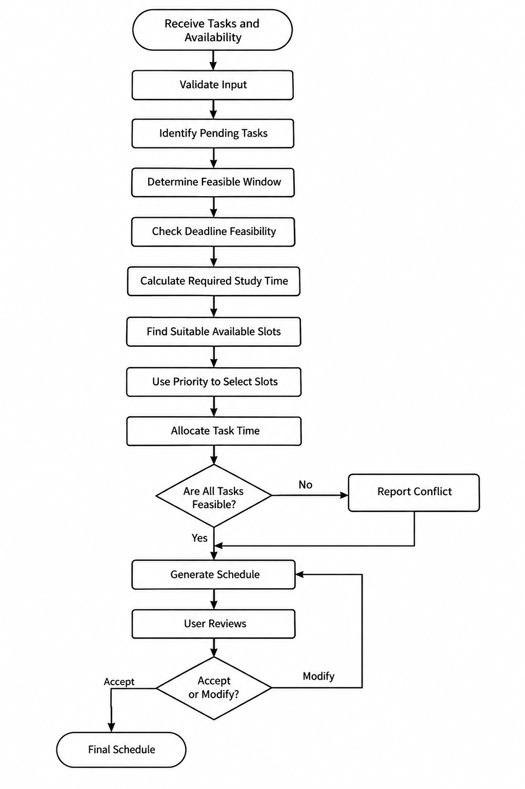
The important decision is that deadline feasibility is checked before priority is used for slot selection. This ensures that priority does not cause a task with an approaching deadline to be neglected.
4.3 User Override
The scheduling engine does not force the generated schedule on the user. After a schedule is generated, the user can:
- Move a task to another available slot.
- Change the allocated duration.
- Remove a task from a suggested slot.
- Add a new task.
- Mark a task as completed.
- Change their available study time.
If a modification affects other pending tasks, the engine can recalculate the affected portion of the schedule and provide an updated recommendation.
This keeps the user in control while allowing the system to assist with planning and rescheduling.

4.4 Remaining-Time Calculation
For each day, the engine calculates the amount of study time that remains available.
Remaining Time = Available Study Time − Already Allocated Time
For example:
Tuesday availability = 4 hours
Already allocated = 2.5 hours
Therefore:
Remaining Time = 4 − 2.5 = 1.5 hours
If a new task requires 3 hours, the engine can allocate up to 1.5 hours on Tuesday and search for additional suitable time on the following available days before the task's deadline.
During mid-week rescheduling, time that has already passed is excluded from this calculation.

4.5 Rescheduling Approach
The engine supports schedule modification when the user's circumstances change. This may occur when:
- A new task is added.
- A task is completed earlier than expected.
- Available study time changes.
- A deadline changes.
- A scheduled task is moved or removed.
The rescheduling process is:
- Identify the change made by the user.
- Preserve completed tasks and past time slots.
- Calculate the remaining available study time.
- Identify pending tasks affected by the change.
- Check their deadlines and required effort.
- Determine feasible time windows.
- Use task priority to select suitable slots within those windows.
- Generate an updated schedule.
- Warn the user if one or more tasks cannot be completed within their deadlines.
Example
Suppose the original schedule is:
Day | Schedule
Monday | DAA — 2 h
Tuesday | Java — 2 h
Wednesday | DBMS — 2 h
On Tuesday, the user adds a 3-hour high-priority assignment with a Thursday deadline.
The engine does not reconsider Monday because that time has already passed. It checks the remaining availability from Tuesday onward, evaluates the deadlines and priorities of the pending tasks, and suggests an updated allocation.
If sufficient time is unavailable, the system reports the conflict rather than silently creating an unrealistic schedule.
5. Algorithms and Scheduling Logic
The Rule-Based Weekly Scheduling Engine uses a constraint-first approach. Deadlines are treated as constraints that must be satisfied whenever sufficient study time is available, while priority is used as a preference when selecting among feasible time slots. The estimated effort determines how much time a task requires, and the available study time determines where that effort can be allocated.
The engine continuously works with the remaining available time rather than treating the weekly schedule as fixed. This allows the schedule to respond to new tasks, completed tasks, and changes in availability.
5.1 Deadline Handling
The deadline is used to determine the feasible scheduling window for a task.
For each pending task, the engine:
- Identifies the current date and the task's deadline.
- Considers only available study time between the current date and the deadline.
- Calculates whether the required effort can fit within this period.
- If sufficient time exists, the task is considered feasible.
- If insufficient time exists, the system identifies a potential scheduling conflict and informs the user.
Example
A task requires 4 hours and has a deadline on Thursday.
Available remaining study time before Thursday:
Day | Available Time
Monday | 1 h
Tuesday | 2 h
Wednesday | 2 h
Thursday | 1 h
The engine has 5 hours available before the deadline, so the 4-hour task is feasible.
One possible allocation is:

Day | Task Allocation
Monday | 1 h
Tuesday | 2 h
Wednesday | 1 h
Thursday | —
The engine therefore completes the task before its deadline without requiring all of Thursday's available time.
5.2 Priority Handling
Priority does not override an approaching deadline. Instead, it is used when selecting between suitable time slots after deadline feasibility has been considered.
The priority levels can be represented as:
- High
- Medium
- Low
A higher-priority task is preferably assigned to an earlier suitable slot when doing so does not prevent another task from meeting its deadline.
Example
Consider:
Task | Effort | Priority | Deadline
Task A | 2 h | High | Friday
Task B | 2 h | Low | Tuesday
If Monday has 2 hours available, the engine should not automatically assign Task A simply because it has higher priority.
Task B has the more urgent deadline, so its deadline requirement should be protected first.
After ensuring Task B can be completed by Tuesday, the remaining suitable slots can be used to schedule Task A.
Therefore:
Deadline = constraint
Priority = preference
This distinction is central to the scheduling algorithm.

5.3 Time Allocation
The engine allocates task time by comparing the task's remaining effort with the available time in suitable slots.
The basic calculation is:
Allocated Time = Minimum(Remaining Task Effort, Available Slot Time)
After allocation:
Remaining Task Effort = Previous Effort − Allocated Time
Example
A task requires 3 hours.
The available slots are:
- Monday: 1 hour
- Tuesday: 2 hours
- Wednesday: 2 hours
The engine can allocate:
Day | Allocated | Remaining Effort
Monday | 1 h | 2 h
Tuesday | 2 h | 0 h
The task is therefore completed using Monday and Tuesday.
The unused Wednesday time remains available for other tasks.
5.4 Task Splitting
A task can be divided across multiple available time slots when its estimated effort is greater than the available time in a single slot.
For example, a 5-hour project cannot fit into a day with only 2 hours of available study time.
Instead, the engine can distribute it:
Day | Available | Task Allocation
Monday | 2 h | 2 h
Tuesday | 2 h | 2 h
Wednesday | 1 h | 1 h
Total allocated = 5 hours
Task splitting helps the system use available time more effectively while keeping the task within its deadline.
The engine should avoid splitting a task unnecessarily when a sufficiently large suitable slot is available.
5.5 New-Task Handling
A new task can be added at any point during the week.
When a new task is added, the engine does not rebuild the entire week from the beginning. It considers:
- The current date and time.
- Remaining available study time.
- Existing scheduled tasks.
- New task's estimated effort.
- New task's deadline.
- New task's priority.
The process is:
- Add the new task.
- Validate its details.
- Identify the remaining scheduling period.
- Check whether the task can be completed before its deadline.
- Find suitable available slots.
- Consider priority when selecting among those slots.
- Recalculate affected pending tasks if necessary.
- Generate an updated recommendation.
- Report a conflict if sufficient time is unavailable.
Example
Suppose it is Tuesday, and the user adds a new 3-hour high-priority task with a Thursday deadline.
The engine must ignore Monday because it has already passed.

It checks:
Tuesday remaining time + Wednesday available time + Thursday available time
and uses only this remaining window to determine whether the task can be scheduled.
5.6 Availability Changes
The user may change their available study time after the schedule has already been generated.
For example, the original availability might be:
Day | Original Availability
Monday | 2 h
Tuesday | 3 h
Wednesday | 2 h
If the user later changes Tuesday's availability from 3 hours to 1 hour, the engine identifies the resulting reduction of 2 hours and checks which scheduled tasks are affected.
The engine then:
- Updates the availability data.
- Preserves completed tasks and past time slots.
- Calculates the new remaining availability.
- Identifies affected pending tasks.
- Rechecks their deadlines.
- Reallocates the affected task time.
- Uses priority to select suitable replacement slots.
- Generates an updated schedule.
- Warns the user if the new availability makes one or more deadlines infeasible.
This prevents the system from continuing to use outdated availability information.
5.7 Completed-Task Handling
When a task is completed earlier than expected, the time originally reserved for the task becomes available again.
The engine can use this newly available time to recommend another pending task.
Example
Suppose:
Monday: 3 hours available
Task A was scheduled for 2 hours
Task A is completed in 1.5 hours
This creates:
3 − 1.5 = 1.5 hours of newly available time
The engine can examine pending tasks and recommend a suitable task for the remaining 1.5 hours, while still respecting their deadlines and priorities.
Completed tasks are not rescheduled, and their completed status is preserved.
5.8 Overall Scheduling Logic
The overall logic can therefore be summarized as:
1. Collect tasks and available study time.
2. Validate the input data.
3. Identify pending tasks.
4. Determine each task's feasible period based on its deadline.
5. Check whether sufficient time exists to complete each task.
6. Protect tasks whose deadlines require earlier allocation.
7. Find suitable available time slots.
8. Use priority to select preferred slots among feasible options.
9. Allocate the required task time.
10. Split tasks when a single slot is insufficient.
11. Recalculate remaining availability.
12. Continue until all tasks are processed.
13. Report conflicts for tasks that cannot be scheduled feasibly.
14. Generate the recommended weekly schedule.
15. Allow the user to accept or modify the recommendation.

6. Data Structures
The scheduling engine requires data structures to store tasks, available study time, scheduled time slots, and the generated weekly schedule. The structures are designed to allow the system to access and modify scheduling information efficiently when tasks or availability change.
6.1 Task
The Task structure represents an individual task that needs to be scheduled.
Attribute | Description | Example
taskId | Unique identifier of the task | T01
title | Name of the task | DAA Assignment
priority | Importance assigned by the user | High
estimatedEffort | Total time required | 3 hours
deadline | Task completion deadline | 18-Sep-2026
status | Current state of the task | Pending
A task object allows the scheduling engine to access all information required to determine when and how the task should be scheduled.
6.2 DailyAvailability
The DailyAvailability structure stores the amount of study time the user has available on a particular day.
Attribute | Description | Example
date | Day for which availability is recorded | Monday
availableMinutes | Total study time available | 180 minutes
usedMinutes | Time already allocated | 60 minutes
remainingMinutes | Unused available time | 120 minutes
The remaining time can be calculated as:
Remaining Minutes = Available Minutes − Used Minutes
This structure is particularly important when the user changes their availability during the week.

6.3 TimeSlot
The TimeSlot structure represents a specific period assigned to a task.
Attribute | Description | Example
date | Date of the slot | Monday
startTime | Starting time | 5:00 PM
endTime | Ending time | 6:30 PM
taskId | Task assigned to the slot | T01
duration | Allocated task time | 90 minutes
A task requiring several hours can have multiple TimeSlot objects when it is split across different days.
For example:
T01 — DAA Assignment
Monday: 5:00 PM – 7:00 PM → 2 hours
Tuesday: 6:00 PM – 7:00 PM → 1 hour
6.4 Schedule
The Schedule structure represents the generated weekly schedule. It contains the collection of time slots assigned to different tasks.
A simplified representation is:
Schedule
|
+-- Monday
| +-- TimeSlot 1
| +-- TimeSlot 2
|
+-- Tuesday
| +-- TimeSlot 3
| +-- TimeSlot 4
|
+-- Wednesday
+-- TimeSlot 5
The schedule can be modified when a task is completed, a new task is added, or the user's availability changes.
6.5 Collection of Tasks
The scheduling engine needs to process multiple tasks. A list can be used to store the user's tasks.
For example:
tasks = [Task A, Task B, Task C, Task D]
A list is suitable because tasks can be added or removed during the week.
The engine can iterate through the list to:
- Identify pending tasks.
- Check deadlines.
- Calculate required effort.
- Evaluate priority.
- Allocate available time.

6.6 Collection of Time Slots
A list can also be used to store generated time slots:
timeSlots = [Slot 1, Slot 2, Slot 3, Slot 4]
This allows the system to search for available slots, modify existing allocations, and remove or replace slots during rescheduling.
6.7 Data Structure Selection
The initial prototype can use Java classes combined with lists because the project requires structured task objects and dynamically changing collections.
A simplified representation is:
Task
↓
List<Task>
↓
Scheduling Engine
↓
List<TimeSlot>
↓
Schedule
This approach keeps the data model simple while supporting the main operations required by the scheduling engine.

7. Code Architecture
The Rule-Based Weekly Scheduling Engine is organized into separate modules so that task management, availability management, scheduling logic, and schedule handling remain independent. This separation makes the system easier to understand, test, modify, and maintain.

The proposed architecture consists of the following components:
User Interface
↓
Task / Availability Manager
↓
Scheduling Engine
↓
Schedule Manager
↓
Data Storage
7.1 User Interface
The User Interface (UI) provides the interaction between the user and the Academic Planner.
The user can:
- Add, edit, and remove tasks.
- Set task priority, estimated effort, and deadline.
- Enter or modify daily study availability.
- View the generated weekly schedule.
- Mark tasks as completed.
- Accept or modify scheduling recommendations.
The UI sends the user's inputs to the appropriate management module and displays the generated schedule and any conflict warnings.

7.2 Task / Availability Manager
This module manages the information required by the scheduling engine.
Task management includes:
- Creating new tasks.
- Updating task details.
- Removing tasks.
- Changing task status.
- Maintaining task priority, deadline, and estimated effort.
Availability management includes:
- Recording daily available study time.
- Updating availability.
- Calculating remaining available time.
- Preventing invalid availability values.
The module provides validated task and availability data to the Scheduling Engine.
7.3 Scheduling Engine
The Scheduling Engine is the core component of the feature.
It receives pending tasks and available study time and applies the scheduling rules defined in Section 5.
Its main responsibilities are:
- Identify pending tasks.
- Determine feasible scheduling periods based on deadlines.
- Check whether sufficient study time is available.
- Find suitable time slots.
- Use priority when selecting between suitable slots.
- Allocate task effort.
- Split tasks when necessary.
- Detect scheduling conflicts.
- Generate scheduling recommendations.
- Recalculate affected tasks when the schedule changes.
The engine does not directly handle user interface operations or permanent data storage. This separation keeps the scheduling logic independent from other parts of the application.
7.4 Schedule Manager
The Schedule Manager handles the schedule produced by the Scheduling Engine.
Its responsibilities include:
- Storing generated time-slot allocations.
- Displaying the weekly schedule.
- Updating the schedule after user modifications.
- Removing completed or cancelled allocations.
- Passing relevant changes back to the Scheduling Engine when recalculation is required.
For example, if the user moves a task from Tuesday to Wednesday, the Schedule Manager records the change and the Scheduling Engine can check whether the modified schedule still satisfies the affected task's deadline.

7.5 Data Storage
The Data Storage component stores the application's persistent information.
The stored data may include:
- Task details.
- Task status.
- Deadlines and priorities.
- Estimated effort.
- Daily availability.
- Generated schedule information.
The storage layer provides data to the management modules when required and saves updates made by the user.
For the initial implementation, the exact database technology can be selected based on the final application architecture. The prototype focuses on defining what information must be stored and how the modules interact with it, rather than committing prematurely to a specific database system.

7.6 Module Interaction
The modules work together as follows:
- The User Interface receives task and availability information.
- The Task / Availability Manager validates and organizes the information.
- The Scheduling Engine processes the data using the defined scheduling rules.
- The generated allocations are passed to the Schedule Manager.
- The Schedule Manager presents the recommended schedule to the user.
- User modifications are sent back through the relevant module.
- If the modification affects scheduling feasibility, the Scheduling Engine recalculates the affected schedule.
- Updated information is saved through the Data Storage component.
Example interaction
A user adds:
DBMS Assignment — 3 hours — High Priority — Friday deadline
The flow is:
User
↓
User Interface
↓
Task Manager
↓
Scheduling Engine
↓
Check Friday deadline
↓
Find feasible available slots
↓
Consider High Priority
↓
Allocate 3 hours
↓
Schedule Manager
↓
Display recommendation
This architecture keeps the Scheduling Engine as the central decision-making component while allowing the other modules to handle input, data management, schedule presentation, and storage separately.
8. Pseudocode
This section should translate our scheduling logic into a clear implementation-independent algorithm. The pseudocode should match the rules we already established—especially the important distinction that deadlines are constraints, while priority helps select the preferred time slot.
8.1 Main Scheduling Algorithm
Algorithm GenerateWeeklySchedule

Input:
List of tasks
Daily study availability
Current date

Output:
Recommended weekly schedule
Scheduling conflict warnings

1. Validate all task and availability information.
2. Identify all pending tasks.
3. For each pending task:
a. Determine the task's deadline.
b. Calculate the remaining effort required.
c. Identify available study time from the current date
until the task's deadline.
d. Check whether the available time is sufficient.
4. If sufficient time is not available:
a. Mark the task as a scheduling conflict.
b. Continue processing the remaining tasks.
5. If sufficient time is available:
a. Identify suitable available time slots before the deadline.
b. Consider the task's priority when selecting between
suitable slots.
c. Prefer earlier slots for higher-priority tasks when
other deadlines are not affected.
d. Allocate available time to the task.

6. If the task cannot fit into one slot:
a. Split the task across multiple suitable slots.
b. Continue allocation until the required effort is fulfilled
or no suitable time remains.
7. Update the remaining available time after each allocation.
8. Repeat the process until all pending tasks have been processed.
9. Generate the recommended weekly schedule.
10. Display any tasks that could not be scheduled before their deadlines.
11. Allow the user to accept or modify the generated schedule.
End Algorithm
8.2 Rescheduling Algorithm
The system also needs a separate process for situations where the existing schedule changes.
Algorithm Reschedule

Input:
Existing schedule
Updated task or availability information
Current date

Output:
Updated recommended schedule

1. Identify the change made by the user.
2. Preserve:
a. Completed tasks.
b. Time slots that have already passed.
3. Update the task or availability information.
4. Calculate the remaining available study time.
5. Identify pending tasks affected by the change.
6. For each affected task:
a. Check its remaining effort.
b. Check its deadline.
c. Determine its feasible scheduling period.
d. Check available time before the deadline.
7. If sufficient time is available:
a. Find suitable remaining slots.
b. Use priority to select preferred slots.
c. Allocate or split the remaining effort.
8. If sufficient time is not available:
a. Mark the task as a scheduling conflict.
b. Notify the user.
9. Update the schedule.
10. Present the revised recommendation to the user.
End Algorithm

Example
If a task requires 5 hours, but only 3 hours of suitable study time remain before its deadline:
Required Effort = 5 hours
Available Time = 3 hours

3 < 5
→ Task is not currently feasible
→ Scheduling conflict is reported
The system should then inform the user rather than pretending that the task can be completed.
8.3 Why This Algorithm Fits Academic Planner (Study Flow)
The pseudocode follows the project's original design decisions:
- Deadlines are protected first.
- Priority influences slot selection rather than overriding deadlines.
- Tasks can be split when required.
- Only remaining time is used during rescheduling.
- Completed and past activities are preserved.
- Conflicts are reported instead of being hidden.
- The user remains responsible for accepting or modifying the recommendation.
9. Concrete Scheduling Examples
The following examples demonstrate how the Rule-Based Weekly Scheduling Engine applies its scheduling rules to different situations. The examples use specific task durations, deadlines, priorities, and available study time to illustrate the expected behaviour of the system.
9.1 Example 1 — Basic Weekly Scheduling
Assume a student has the following available study time:
Day | Available Time
Monday | 3 hours
Tuesday | 2 hours
Wednesday | 4 hours
The student has two pending tasks:
Task | Estimated Effort | Priority | Deadline
DAA Assignment | 3 hours | High | Wednesday
Java Practice | 2 hours | Medium | Friday
Processing
Step 1: The engine checks whether the DAA Assignment can be completed before Wednesday.
Available time before/on Wednesday = 3 + 2 + 4 = 9 hours
Required effort = 3 hours
Therefore, the task is feasible.
Step 2: The engine identifies suitable slots for both tasks.
Since the DAA Assignment has a High priority, the engine prefers an earlier suitable slot while still considering the deadline of the other task.
Recommended Schedule
Day | Scheduled Tasks
Monday | DAA Assignment — 3 hours
Tuesday | Java Practice — 2 hours
Wednesday | Available — 4 hours
The DAA Assignment is completed early because its priority is high, while Java Practice still has sufficient time before its Friday deadline.

9.2 Example 2 — Task Splitting
Suppose a student has:
Day | Available Time
Monday | 2 hours
Tuesday | 2 hours
Wednesday | 1 hour
A project requires 5 hours, has High priority, and must be completed by Wednesday.
Processing
The required effort is:
5 hours
Total available time:
2 + 2 + 1 = 5 hours
Since no single day provides 5 hours, the engine splits the task across multiple days.
Recommended Schedule
Day | Task Allocation
Monday | Project — 2 hours
Tuesday | Project — 2 hours
Wednesday | Project — 1 hour
Total allocated = 5 hours
The task is therefore completed within its deadline.

9.3 Example 3 — Deadline vs Priority
This example demonstrates the most important scheduling rule.
Available study time:
Day | Available Time
Monday | 2 hours
Tuesday | 2 hours
Wednesday | 2 hours
Pending tasks:
Task | Effort | Priority | Deadline
DBMS Assignment | 2 hours | Low | Tuesday
Software Engineering Project | 2 hours | High | Friday
Although the Software Engineering Project has a higher priority, the DBMS Assignment has the earlier deadline.
Processing
The engine first ensures that the DBMS Assignment can be completed by Tuesday.
It can therefore allocate:
Day | Scheduled Task
Monday | DBMS Assignment — 2 hours
Tuesday | Software Engineering Project — 2 hours
Wednesday | Available — 2 hours
The high-priority project is then placed in an earlier suitable slot after protecting the approaching DBMS deadline.
This demonstrates that priority does not override deadline feasibility.

9.4 Example 4 — New Task Added Mid-Week
Assume the following schedule already exists:
Day | Existing Schedule
Monday | DAA — 2 hours
Tuesday | Java — 2 hours
Wednesday | DBMS — 2 hours
On Tuesday, the student adds:
CNS Assignment — 3 hours — High Priority — Thursday deadline
The engine must not use Monday because that time has already passed.

Assume the remaining availability is:
Day | Remaining Availability
Tuesday | 1 hour
Wednesday | 2 hours
Thursday | 2 hours
Total remaining time before the deadline:
1 + 2 + 2 = 5 hours
The new task requires 3 hours, so it is feasible.
The engine may recommend:
Day | Updated Schedule
Tuesday | CNS Assignment — 1 hour
Wednesday | CNS Assignment — 2 hours
Thursday | Existing/other work
The task is completed before its Thursday deadline without modifying the already-passed Monday schedule.

9.5 Example 5 — Insufficient Available Time
Consider a task requiring 6 hours with a deadline on Wednesday.
Remaining availability:
Day | Available Time
Monday | 1 hour
Tuesday | 2 hours
Wednesday | 1 hour
Total available time:
1 + 2 + 1 = 4 hours
Required effort:
6 hours
Since:
4 < 6
the task cannot currently be completed within the available time.
System Response
The engine should:
- Mark the task as not feasible under the current availability.
- Generate a conflict warning.
- Inform the user that 2 additional hours are required.
- Allow the user to modify their availability, task estimate, or schedule.
The system should not simply allocate 6 hours when only 4 hours are available.

9.6 Example 6 — Task Completed Earlier Than Expected
Suppose:
Monday availability = 3 hours
DAA Assignment scheduled = 2 hours
The student completes the assignment in 1 hour 30 minutes.
The unused time is:
2 hours − 1.5 hours = 0.5 hours
Therefore, 30 minutes becomes available again.
The engine can examine pending tasks and recommend a suitable 30-minute task or task segment for that time.
This demonstrates how early completion can improve the use of available study time instead of leaving the released time unused.

9.7 Summary of Examples
These scenarios demonstrate that the scheduling engine can handle different real-world situations:
Scenario | Demonstrated Behaviour
Basic scheduling | Allocates tasks according to available time
Large task | Splits task across multiple days
Deadline vs priority | Protects approaching deadlines
New task | Reschedules using remaining days
Insufficient time | Detects and reports conflicts
Early completion | Reuses newly available time
These examples provide concrete evidence of how the proposed scheduling rules are expected to operate under different conditions.

10. Flowcharts and Process Diagrams
The following flowcharts represent the major processes performed by the Rule-Based Weekly Scheduling Engine. They provide a visual representation of the initial scheduling, rescheduling, and conflict-handling processes.

10.1 Initial Scheduling Flowchart
This flowchart represents the process used when the system generates a schedule for the first time.

Flow:
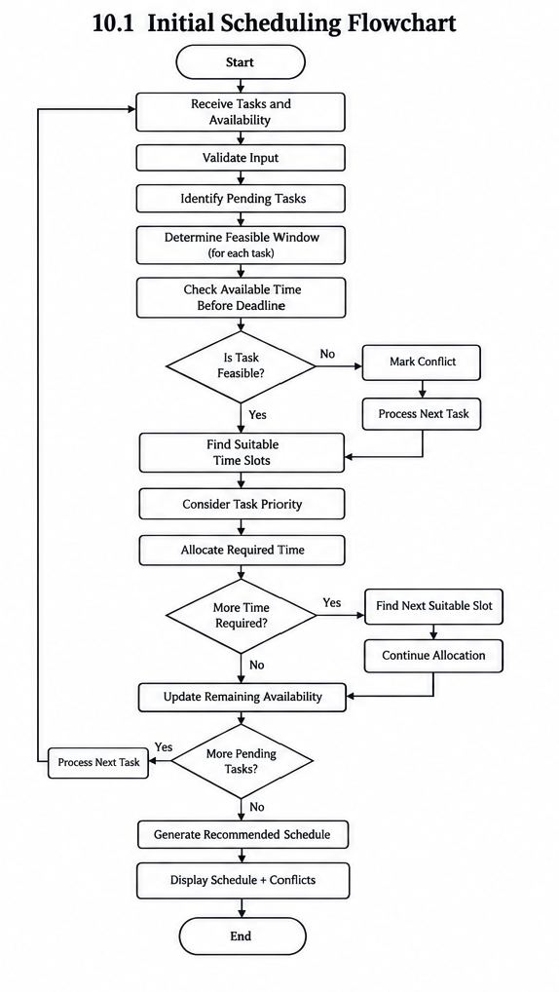

This shows the evaluator that the scheduling engine isn't simply "sorting tasks." It actually checks feasibility, finds slots, allocates time, updates remaining availability, and handles conflicts.

10.2 Rescheduling Flowchart
This process is triggered when the user changes something after a schedule has already been generated.
Examples include:
- Adding a new task.
- Changing availability.
- Completing a task.
- Changing a deadline.
- Moving or removing a scheduled task.
Flow:
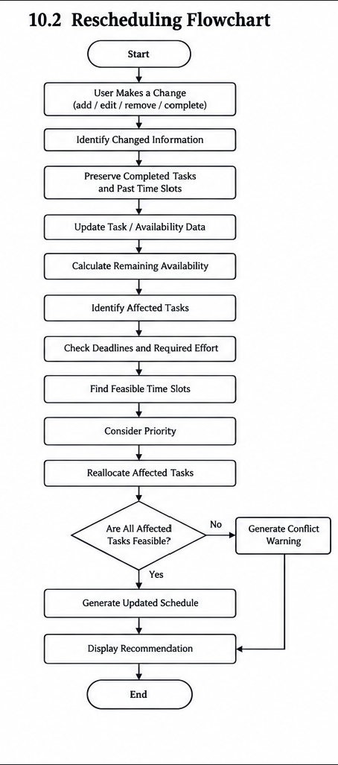

The important part here is that past time is never reused. The engine works only with the remaining portion of the week.

10.3 Conflict Handling Flowchart
Conflict handling is used when the engine determines that a task cannot currently be completed before its deadline.
Flow:
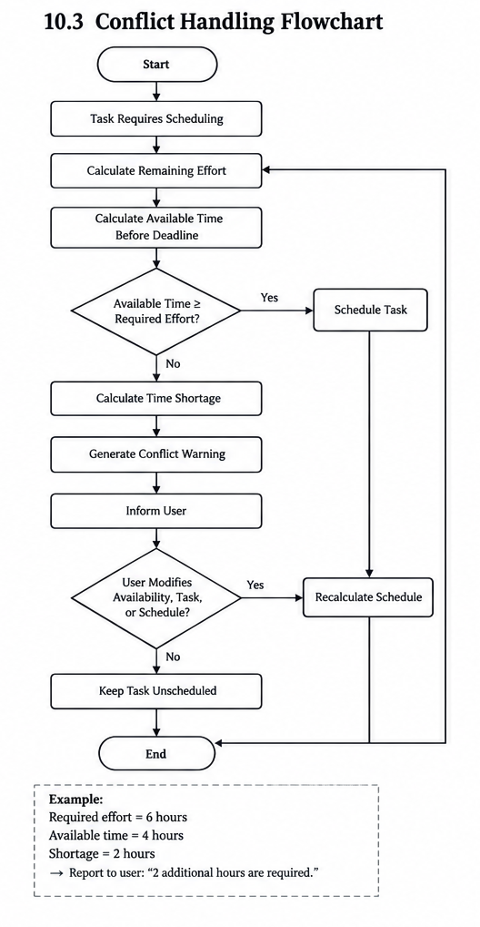

Example
If:
Required effort = 6 hours
Available time before deadline = 4 hours
Then:
Shortage = 6 − 4 = 2 hours
The system reports that 2 additional hours are required rather than creating an impossible schedule.

10.4 Relationship Between the Processes
These three processes work together:
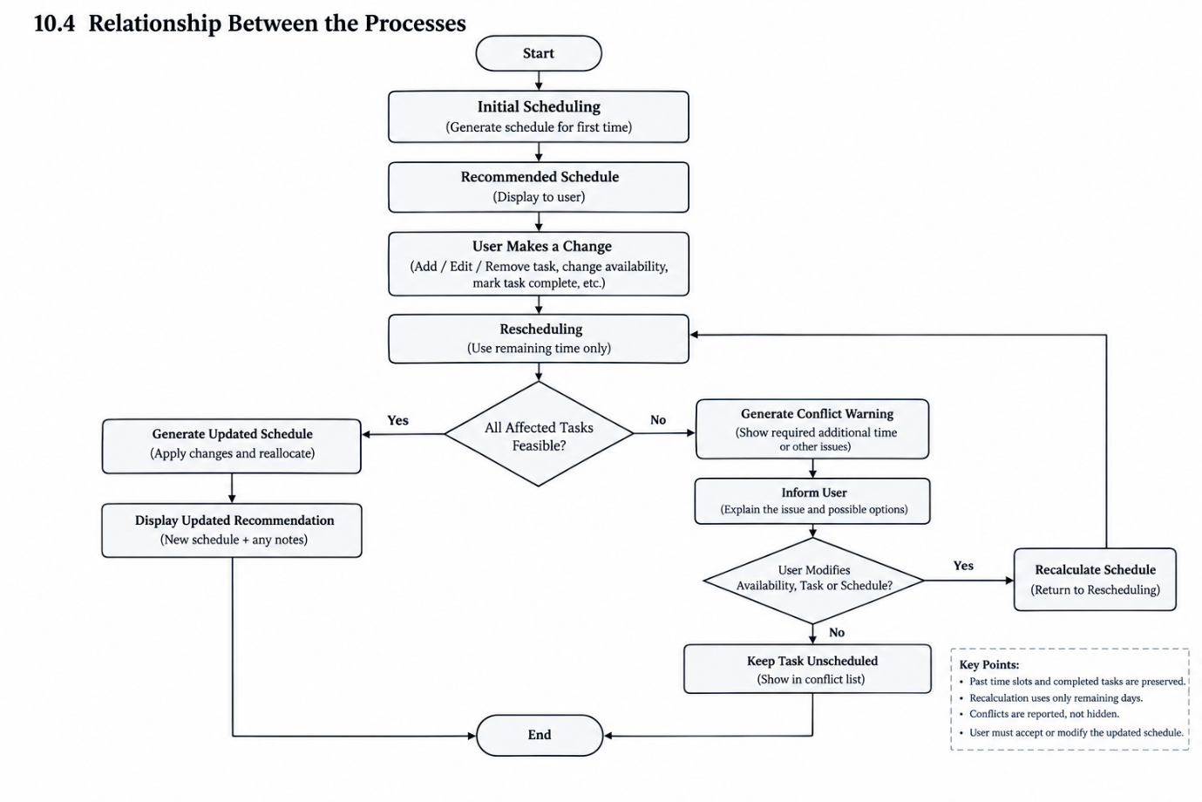
This ensures that the scheduling engine can handle both normal scheduling and changes that occur during the week, while clearly communicating situations where the available time is insufficient.

11. Error Handling
The scheduling engine must handle invalid inputs and scheduling situations where a valid schedule cannot be generated. Instead of producing an unrealistic schedule, the system identifies the problem, informs the user, and provides an opportunity to correct the input or modify the schedule.
11.1 Invalid Input
Invalid or incomplete task information can prevent the scheduling engine from making a reliable recommendation.
Examples include:
- Empty task name.
- Missing deadline.
- Negative or zero estimated effort.
- Invalid priority value.
- Negative daily availability.
- Invalid date or time information.
Handling
The system validates the input before passing it to the scheduling engine.
For example:
If estimatedEffort <= 0
Display "Estimated effort must be greater than zero."
Do not add the task.
Similarly, availability values cannot be negative.
The user is asked to correct the invalid information before the task is processed.

11.2 Insufficient Available Time
A task may require more time than the user has available before its deadline.
For example:
Required effort = 6 hours
Available time = 4 hours
The engine calculates:
Time shortage = 6 − 4 = 2 hours
Handling
The system:
- Identifies the shortage.
- Marks the task as potentially infeasible.
- Displays a conflict warning.
- Shows the additional time required.
- Allows the user to modify availability, task effort, or other scheduling decisions.
The engine should not assign more time than the user has actually made available.

11.3 Conflicting Deadlines
Multiple tasks may have deadlines that compete for the same limited study time.
For example:
Task | Effort | Deadline
Task A | 4 h | Tuesday
Task B | 4 h | Tuesday
If only 5 hours are available before Tuesday, the total required effort is:
4 + 4 = 8 hours
Since only 5 hours are available, both tasks cannot be completed within their deadlines under the current availability.
Handling
The engine:
- Calculates the available time.
- Calculates the total required effort.
- Identifies the conflict.
- Attempts to allocate available time while protecting deadline feasibility.
- Reports the affected task(s) if the conflict cannot be resolved.
- Allows the user to increase availability or modify the schedule.
This prevents the system from silently dropping a task or creating an impossible schedule.

11.4 New Task Does Not Fit
A new task may be added when most of the week's available study time has already been allocated.
For example:
New task effort = 3 hours
Remaining suitable availability = 1.5 hours
The engine cannot allocate the complete task without exceeding the user's available time.
Handling
The system checks the remaining scheduling window and:
- Allocates the task if sufficient time exists.
- Splits it across suitable remaining slots if possible.
- Otherwise reports a scheduling conflict.
- Shows the user that additional time is required.
Previously completed tasks and past time slots are not modified simply to accommodate the new task.

11.5 Changed Availability
The user may reduce or increase their available study time after a schedule has already been generated.
For example:
Original Tuesday availability = 3 hours
Updated Tuesday availability = 1 hour
The available time has decreased by 2 hours.
Handling
The engine:
- Updates the availability information.
- Identifies scheduled tasks affected by the change.
- Preserves completed tasks and past time slots.
- Recalculates the remaining available time.
- Checks affected task deadlines.
- Attempts to move or split affected tasks into other suitable slots.
- Uses priority when selecting alternative slots.
- Generates a conflict warning if the updated availability makes a task infeasible.

11.6 Error Handling Principle
The scheduling engine follows three main principles:
Validate → Detect → Inform
Validate: Check user input before processing.
Detect: Identify scheduling conflicts or infeasible conditions during scheduling.
Inform: Clearly communicate the problem and allow the user to make the final decision.
This approach ensures that StudyFlow does not hide scheduling problems or generate recommendations that contradict the user's actual available time.

12. Efficiency Considerations
The scheduling engine is designed to use available study time efficiently while avoiding unnecessary recalculation. Since the schedule may change during the week, the system should process only the information affected by a change whenever possible.

12.1 Avoid Unnecessary Recalculation
When a user makes a change, the system should avoid rebuilding the entire schedule if the change affects only a small portion of it.
For example, if a task scheduled for Friday is marked as completed on Wednesday, the engine can release its allocated time and reconsider the affected remaining tasks rather than recalculating already completed work.

12.2 Process Only Remaining Days
During mid-week rescheduling, the engine should consider only the current day and future available days.
Past days and completed time slots do not need to be processed again.
For example, if the current day is Wednesday, the engine considers:
Wednesday → Thursday → Friday → remaining days
This reduces unnecessary processing and also prevents the algorithm from assigning new tasks to time that has already passed.

12.3 Efficient Task Processing
The prototype will use collections such as List<Task> to store tasks. The scheduling engine can iterate through pending tasks and evaluate their deadlines, effort, and available time.
Tasks that are already completed do not need to be considered for new allocation.
As the project moves into implementation, the task-processing method can be optimized if testing shows that the number of tasks or scheduling operations creates a performance issue.

12.4 Minimizing Unused Available Time
The engine should attempt to use available study time effectively without creating unrealistic schedules.
After allocating a task, the remaining time in each day is updated and can be considered for other suitable tasks.
For example:
Available time = 3 hours
Task allocation = 2 hours
The remaining 1 hour can be considered for another pending task rather than being unnecessarily left unused.
The system may also leave a small buffer between tasks when required for practical scheduling, rather than filling every minute of the user's availability.

12.5 Efficiency Objective
The efficiency goal of the scheduling engine is therefore:
Complete feasible tasks before their deadlines while making effective use of the user's available study time and minimizing unnecessary schedule recalculation.
This keeps the efficiency requirements realistic for the prototype while leaving room for optimization during actual implementation and testing.

13. Code Prototype
The following code prototype demonstrates the proposed structure and core logic of the Rule-Based Weekly Scheduling Engine. The code is not intended to represent the complete application; instead, it provides representative classes and functions showing how the planned scheduling logic can be implemented.
13.1 Task Class
The Task class represents a task entered by the user.
Java:
class Task {
String taskId;
String title;
String priority;
int estimatedMinutes;
LocalDate deadline;
String status;

Task(String taskId, String title, String priority,
int estimatedMinutes, LocalDate deadline) {

this.taskId = taskId;
this.title = title;
this.priority = priority;
this.estimatedMinutes = estimatedMinutes;
this.deadline = deadline;
this.status = "Pending";
}
}

The class stores the basic information required by the scheduling engine, including the task's priority, estimated effort, deadline, and completion status.

13.2 Daily Availability Class
The DailyAvailability class stores the amount of time available for study on a particular day.

Java:
class DailyAvailability {
LocalDate date;
int availableMinutes;
int usedMinutes;

DailyAvailability(LocalDate date, int availableMinutes) {
this.date = date;
this.availableMinutes = availableMinutes;
this.usedMinutes = 0;
}

int getRemainingMinutes() {
return availableMinutes - usedMinutes;
}
}

The getRemainingMinutes() function allows the scheduling engine to determine how much unused study time remains on a particular day.

13.3 Time Slot Class
A TimeSlot represents the portion of a task assigned to a particular period.
Java:
class TimeSlot {
LocalDate date;
String taskId;
int allocatedMinutes;

TimeSlot(LocalDate date, String taskId, int allocatedMinutes) {
this.date = date;
this.taskId = taskId;
this.allocatedMinutes = allocatedMinutes;
}
}

A task can have multiple TimeSlot objects if its estimated effort needs to be divided across multiple days.
For example:
Task T01 — DAA Assignment

Monday → 120 minutes
Tuesday → 60 minutes
This represents a total allocation of 180 minutes (3 hours).

13.4 Feasibility Checking Function
Before allocating time, the engine checks whether enough study time exists before the task's deadline.
Java:
boolean isFeasible(Task task, int availableMinutes) {

if (availableMinutes >= task.estimatedMinutes) {
return true;
}

return false;
}

This is a simplified prototype of the feasibility check. In the complete implementation, availableMinutes would be calculated from all suitable remaining days before the task's deadline.

13.5 Time Allocation Function
The following function demonstrates how a task can be allocated to an available slot.

Java:
int allocateTime(Task task, DailyAvailability day) {

int remainingTaskTime = task.estimatedMinutes;
int availableTime = day.getRemainingMinutes();

int allocatedTime = Math.min(remainingTaskTime, availableTime);

day.usedMinutes += allocatedTime;

return allocatedTime;
}

The use of Math.min() ensures that the system does not allocate more time than either:
- the task requires, or
- the user has available on that day.

13.6 Priority-Based Slot Selection
Priority is considered after identifying slots that are feasible with respect to deadlines.
A simplified priority function can be represented as:

Java:
int getPriorityValue(String priority) {

if (priority.equals("High")) {
return 3;
}
else if (priority.equals("Medium")) {
return 2;
}
else {
return 1;
}
}

The scheduling engine can use this value when choosing between multiple suitable slots.
For example:
High priority → 3
Medium priority → 2
Low priority → 1
This does not mean that a high-priority task automatically takes a slot from a task with an approaching deadline. Deadline feasibility remains the primary constraint.

13.7 Basic Scheduling Logic
The following prototype demonstrates the overall allocation process:

Java:
for (Task task : tasks) {

if (task.status.equals("Completed")) {
continue;
}

int availableBeforeDeadline =
calculateAvailableTime(task, availability);

if (!isFeasible(task, availableBeforeDeadline)) {
reportConflict(task);
continue;
}

for (DailyAvailability day : availability) {

if (!isBeforeDeadline(day, task)) {
break;
}

int allocated = allocateTime(task, day);

if (allocated > 0) {
addTimeSlot(task, day, allocated);
}

task.estimatedMinutes -= allocated;

if (task.estimatedMinutes == 0) {
break;
}
}
}

This prototype demonstrates the main workflow:
- Ignore completed tasks.
- Calculate available time before the deadline.
- Check feasibility.
- Find suitable days.
- Allocate available time.
- Split the task if necessary.
- Continue until the task is completed or a conflict is detected.

13.8 Conflict Reporting
When sufficient time is unavailable, the system should report the problem instead of generating an unrealistic schedule.
Java:
void reportConflict(Task task) {

System.out.println(
"Scheduling conflict: " + task.title +
" cannot be completed before its deadline."
);
}

The final application would display this information through the user interface rather than only printing it to the console.

13.9 Prototype Architecture
The relationship between the prototype components can be represented as:
Task
↓
Task List
↓
Scheduling Engine
├Feasibility Check
├ Priority Evaluation
├ Time Allocation
└── Conflict Detection
↓
TimeSlot List
↓
Schedule

Prototype Scope
This prototype intentionally focuses on the core scheduling logic rather than implementing the complete application. Features such as database connectivity, graphical user interface, authentication, and permanent storage can be integrated during later development.
The prototype demonstrates that the proposed data structures and scheduling rules can be translated into executable program logic while maintaining the project's main principle:
The system attempts to keep tasks feasible before their deadlines, while priority helps select the preferred placement among feasible time slots.

14. Project Risks and Mitigation
The development of the Academic Planner involves several technical and functional risks. These risks may affect the correctness of the generated schedule, system reliability, development progress, or user experience. Identifying them early allows appropriate mitigation strategies to be planned.

14.1 Identified Risks
Risk | Possible Impact | Mitigation
Incorrect scheduling logic | Tasks may be placed in unsuitable time slots or deadlines may be missed | Test the scheduling rules using different task, deadline, priority, and availability combinations
Insufficient available time | Some tasks may not be completed before their deadlines | Detect the shortage and display a scheduling conflict instead of creating an unrealistic schedule
Conflicting deadlines | Multiple tasks may require the same limited study time | Check deadline feasibility and report conflicts when all tasks cannot be accommodated
Frequent schedule changes | Repeated changes may make the schedule inconsistent or difficult to maintain | Recalculate affected pending tasks while preserving completed tasks and past time slots
Incorrect effort estimates | The generated schedule may not match the actual time required | Allow the user to modify estimated effort and update the schedule when necessary
User enters invalid data | Invalid dates, negative time values, or missing information may cause incorrect scheduling | Validate task and availability inputs before processing
Excessive unused time | Available study time may not be utilized effectively | Recalculate remaining time after every allocation and consider suitable pending tasks
Over-complicated scheduling logic | Complex rules may make the system difficult to implement and debug within the project duration | Keep the initial implementation rule-based and modular
Changes affect existing tasks unexpectedly | Adding or modifying a task could unnecessarily disrupt the whole schedule | Recalculate only the affected portion of the remaining schedule where possible
Algorithm produces unrealistic recommendations | Users may lose confidence in the planner | Keep recommendations editable and allow the user to override generated allocations

14.2 Risk Mitigation Strategy
The project will use incremental testing and validation to reduce these risks.
The scheduling engine will first be tested using simple cases, such as:
- One task and one available day.
- Multiple tasks with different deadlines.
- Tasks requiring more time than one day provides.
- Multiple tasks with conflicting deadlines.
- New tasks added during the week.
- Changes in daily availability.
- Tasks completed earlier than estimated.
- Insufficient available time.
After the basic cases work correctly, more complex combinations can be tested.
This approach reduces the risk of discovering major scheduling errors only after the complete application has been developed.

14.3 High-Priority Risks
The following risks require particular attention during implementation:
1. Incorrect Deadline Handling
This is the most important functional risk because the primary purpose of the scheduling engine is to help users complete tasks before their deadlines.
Mitigation:
Test deadline calculations extensively and ensure that the engine only considers valid time slots before a task's deadline.
2. Unrealistic Schedule Generation
The engine should not allocate more study time than the user has actually provided.
Mitigation:
Maintain accurate remaining-time calculations and generate conflict warnings when sufficient time is unavailable.
3. Rescheduling Errors
Changes made during the week could accidentally modify completed work or assign tasks to past time slots.
Mitigation:
Explicitly separate past/completed time from remaining scheduling time during rescheduling.
4. Incorrect Interaction Between Deadline and Priority
A high-priority task with a distant deadline should not automatically displace a lower-priority task whose deadline is approaching.
Mitigation:
Treat deadline feasibility as a constraint and use priority for selecting preferred slots among feasible options. Test cases where deadline and priority conflict should be included in validation.

14.4 Risk Monitoring
Risks will be reviewed throughout implementation and testing. If testing reveals that a scheduling rule does not produce the expected result, the rule can be modified without redesigning the entire application because the scheduling engine is separated from the user interface and data-management components.
This modular approach reduces the impact of changes to the scheduling logic and makes debugging easier.

15. Resource Planning
The development of the Academic Planner requires software, hardware, development tools, and human resources. The resources selected are sufficient for developing and testing the proposed rule-based scheduling feature within the project duration.

15.1 Development Resources
The main development resources required are:
- Programming Language: Java
- Development Environment: IntelliJ IDEA
- Version Control: Git and GitHub
- Database: A suitable relational database for storing tasks, availability, and schedules
- Documentation: Microsoft Word
- Diagram Tools: Tools for creating architecture diagrams and flowcharts
The final database and application framework can be selected during implementation based on the requirements of the complete application.

15.2 Software and Tools
Resource | Purpose
Java | Implementation of scheduling logic and application components
IntelliJ IDEA | Writing, running, and debugging Java code
Git | Version control
GitHub | Repository and project documentation management
Microsoft Word | Preparing project documentation
Diagram/Flowchart Tool | Creating system diagrams and flowcharts
Database Management System | Storing application data

15.3 Hardware Requirements
The project can be developed using a standard personal computer or laptop.
Minimum practical requirements include:
- Modern multi-core processor.
- At least 8 GB RAM.
- Sufficient storage for the development environment and project files.
- Stable internet connection for downloading development tools and using GitHub.
- Keyboard and mouse/input device.
No specialized hardware is required because the scheduling engine is rule-based and does not require GPU-based machine learning or high-performance computing resources.

15.4 Human Resources
The project primarily requires the following roles:
Role | Responsibility
Developer | Design and implement the application and scheduling engine
Tester | Test scheduling rules, edge cases, and system behaviour
Documentation/Project Coordinator | Maintain technical documentation and track project progress
For a small academic project, these responsibilities may be handled by the same person or distributed among team members depending on the project structure.

15.5 Resource Adequacy
The proposed resources are sufficient for the initial prototype and planned implementation. Since the scheduling engine uses predefined rules rather than machine learning, the project does not require specialized computational resources.
The resource plan can be updated during implementation if additional software, database tools, libraries, or hardware requirements are identified.

16. Development Timeline and Milestones
The Academic Planner is planned as a six-week development project. Each week focuses on a specific stage of development, with defined deliverables and milestones. The timeline allows the system to be developed incrementally, starting with requirements and design before moving to implementation and testing.

16.1 Six-Week Development Timeline
Week | Development Phase | Major Activities | Expected Deliverable / Milestone
Week 1 | Project Planning & Requirements Analysis | Define project objectives, scope, stakeholders, functional requirements, assumptions, constraints, and initial plan | Milestone 1: Requirements and project plan completed
Week 2 | Design Documentation & Architecture Planning | Define system architecture, components, data flow, interfaces, and initial design decisions | Milestone 2: System design and architecture completed
Week 3 | Technical Design & Algorithm Planning | Define scheduling rules, algorithms, data structures, code architecture, pseudocode, examples, flowcharts, risks, and resource requirements | Milestone 3: Technical design and scheduling logic completed
Week 4 | Core Implementation | Implement task management, availability management, data structures, and basic scheduling engine | Milestone 4: Core scheduling prototype implemented
Week 5 | Integration & Testing | Integrate system components and test scheduling, deadline handling, priority handling, rescheduling, and conflict detection | Milestone 5: Integrated system tested
Week 6 | Refinement & Final Documentation | Fix identified issues, improve usability, perform final testing, prepare documentation and demonstration | Milestone 6: Final system and documentation completed

16.2 Development Sequence
The development follows the sequence:

Week 1
Requirements
↓
Week 2
System Design
↓
Week 3
Technical Design
↓
Week 4
Implementation
↓
Week 5
Integration & Testing
↓
Week 6
Refinement & Finalization

This sequence ensures that the implementation is based on documented requirements and technical decisions rather than beginning development without a defined structure.

16.3 Key Milestones
The major project milestones are:
Milestone 1 — Requirements Completed
The project's objectives, scope, stakeholders, and requirements are defined.
Milestone 2 — Architecture Completed
The major system components and their interactions are documented.
Milestone 3 — Scheduling Logic Completed
The scheduling rules, data structures, pseudocode, flowcharts, and technical approach are defined.
Milestone 4 — Core Prototype Completed
The main scheduling functionality is implemented.
Milestone 5 — System Testing Completed
The system is tested against normal cases, edge cases, conflicts, and rescheduling scenarios.
Milestone 6 — Final Submission Completed
The refined system, documentation, and demonstration materials are prepared.

17. Expected Feature Behaviour
The Rule-Based Weekly Scheduling Engine is expected to generate practical weekly study recommendations based on the user's tasks, deadlines, priorities, estimated effort, and available study time.
The expected behaviour of the feature is as follows:
- Task-Based Scheduling
The system should allocate pending tasks according to their estimated effort, deadline, priority, and available study time.
- Deadline Awareness
The system should attempt to ensure that feasible tasks are completed before their deadlines.
- Priority-Based Placement
Among suitable time slots, higher-priority tasks should preferably be scheduled earlier, provided that doing so does not compromise other tasks' deadlines.
- Task Splitting
Tasks requiring more time than a single available slot should be divided across multiple suitable slots.
- Dynamic Rescheduling
When a task is added, completed, moved, or when availability changes, the system should update the affected portion of the remaining schedule.
- Conflict Detection
When the available time is insufficient to complete a task before its deadline, the system should display a conflict instead of generating an unrealistic schedule.
- Remaining-Time Utilization
When scheduled work is completed earlier than expected, the newly available time should be considered for other suitable pending tasks.
- User Control
The generated schedule should remain a recommendation. The user should be able to modify the suggested schedule according to their actual circumstances.
The expected result is a flexible weekly schedule that helps the user use available study time effectively while keeping deadlines and user-defined priorities in consideration.

18. Conclusion
This technical design defines the proposed implementation approach for the Academic Planner's Rule-Based Weekly Scheduling Engine.
The design establishes the required scheduling rules, data structures, code architecture, algorithms, pseudocode, flowcharts, error-handling mechanisms, efficiency considerations, and development resources. The scheduling approach treats deadlines as important feasibility constraints while using task priority to determine preferred placement among suitable time slots.
The design also supports practical situations such as task splitting, new tasks added during the week, changes in availability, early task completion, and scheduling conflicts. User control remains an important part of the system, ensuring that the generated schedule acts as a recommendation rather than a fixed instruction.
The proposed architecture and prototype provide a foundation for the implementation phase. During the following development stages, the scheduling logic can be implemented, tested with the scenarios defined in this document, and refined based on observed results.

19. References
The following resources were consulted during the preparation of the technical design and for understanding the programming and software-engineering concepts used in the project.
- Oracle. Java Documentation — Java programming language and standard library documentation.
- Oracle. Java Platform, Standard Edition API Specification — Reference for Java classes and APIs such as LocalDate and collection classes.
- Sommerville, Ian. Software Engineering. Pearson. — Reference for software requirements, architecture, design, and development practices.
- Pressman, Roger S. and Maxim, Bruce R. Software Engineering: A Practitioner's Approach. McGraw-Hill. — Reference for software engineering processes and design practices.
- GitHub Documentation. — Reference for repository management and version control practices.

