Academic Planner
Code Debugging, Refactoring, and Technical Analysis
1. Introduction
StudyFlow has progressed from the initial planning and design stages into a functional Minimum Viable Product (MVP). The current implementation provides the core functionality of an academic planner, including task creation, task editing and deletion, priority and deadline management, weekly availability input, and automatic generation of a recommended schedule.
This week's work focuses on examining the implemented StudyFlow codebase from a software maintenance perspective. The objective is to identify potential bugs, edge cases, performance concerns, code readability issues, and areas where the existing implementation can be improved through refactoring. The functional behavior of the application will first be tested using different task, deadline, priority, and availability combinations. The results of these tests will then be used to identify areas requiring further investigation.
The debugging process will involve reproducing issues, tracing their causes through the relevant components, applying appropriate corrections, and retesting the affected functionality. Refactoring will focus on improving code organization, reducing unnecessary complexity or duplication, and making the scheduling logic easier to understand and maintain without changing its intended behavior.
Unlike the earlier design stages, this analysis is based on the actual StudyFlow implementation. This allows the debugging and refactoring process to be evaluated using practical test cases and observable application behavior. The findings, changes, and testing results will be documented throughout this week's work to provide a technical assessment of the current implementation and identify possible improvements for future versions.
2. Current System and Codebase Overview
2.1 System Overview
StudyFlow is currently implemented as a web-based academic planning application using Java with Spring Boot for the backend and a browser-based interface for user interaction. The application follows a layered structure in which different responsibilities are separated into controllers, models, repositories, and services. This structure makes the application easier to understand, test, debug, and modify as new functionality is introduced.
The current MVP allows users to create academic tasks by providing a task name, deadline, priority, and estimated time requirement. Users can also define their available time for each day of the week. Based on these inputs, the application generates a recommended schedule while considering task deadlines, priority, estimated effort, and available time. Tasks can also be edited or deleted after being created.
2.2 Current Code Structure
The main Java codebase is organized under the com.studyflow package:
StudyFlow
│
├ src
│ ├ main
│ │ ├ java
│ │ │ └ com.studyflow
│ │ │ │
│ │ │ ├ controller
│ │ │ │ ├ TaskController
│ │ │ │ └ ScheduleController
│ │ │ │
│ │ │ ├ model
│ │ │ │ ├ Availability
│ │ │ │ ├ Priority
│ │ │ │ ├ ScheduleEntry
│ │ │ │ ├ ScheduleResponse
│ │ │ │ ├ Task
│ │ │ │ └ TaskStatus
│ │ │ │
│ │ │ ├ repository
│ │ │ │ └ TaskRepository
│ │ │ │
│ │ │ └ service
│ │ │ └ Scheduling Logic
│ │ │
│ │ └ resources
│ │
│ └── test
│
├ pom.xml
└ README.md
3. Functional Testing of the Current MVP
3.1 Testing Approach
Functional testing was performed on the current StudyFlow MVP to verify whether the implemented features behave according to the requirements established during the earlier planning and design stages. The initial testing focused on the core task-management and scheduling functions before making further changes to the codebase.
Different combinations of task information, priorities, deadlines, estimated effort, and daily availability were used to observe how the application responds. The purpose of this testing was to establish a baseline for the current implementation and provide a reference point for the debugging and refactoring activities performed later in the week.
3.2 Initial Functional Test Results
Feature | Test Performed | Result
Task creation | Created tasks with a name, priority, deadline, and estimated effort | Pass
Multiple tasks | Added multiple tasks with different priorities and effort requirements | Pass
Weekly availability | Entered different amounts of available time for individual days | Pass
Schedule generation | Generated a weekly schedule using the entered tasks and availability | Pass
Deadline handling | Tested a task with a close deadline and limited availability before the deadline | Pass
Task splitting | Tested a task requiring more time than was available on a single day | Pass
Priority handling | Added tasks with different priority levels and observed their scheduling order | Pass
Task editing | Modified task information after creating the task | Pass
Task deletion | Removed an existing task from the task list | Pass
Schedule regeneration | Changed task information after scheduling and generated an updated schedule | Pass
3.3 Observations
The initial tests showed that the current MVP successfully performs the primary functions expected from the Academic Planner. In particular, the scheduling engine is able to distribute a task across multiple days when sufficient time is available instead of requiring the entire task to be completed in one session.
The deadline test also demonstrated that the scheduler considers the available time up to the task's deadline rather than treating all available time in the week as usable for that task. For example, when a task requiring 180 minutes had only 120 minutes available before its Monday deadline, the system allocated the available 120 minutes and reported the remaining effort instead of scheduling the task after its deadline.
Task editing and deletion were also tested after being added to the MVP. These operations allow the user to modify or remove tasks without having to recreate the entire task list.
3.4 Baseline for Further Testing
The results provide a baseline for the next stage of Week 5. Since the main functionality is currently operational, further testing will focus on edge cases, invalid inputs, scheduling conflicts, and code-level issues rather than simply verifying that the basic features work.
The next stage will therefore investigate whether the current implementation remains reliable when unusual or conflicting conditions are introduced. Any issue identified during these tests will be reproduced, analyzed, and documented before a correction or refactoring is made.
4. Bug and Issue Identification
After completing the functional and edge-case testing, the StudyFlow MVP was examined for reproducible bugs, unexpected behavior, validation issues, and areas that could be improved. The objective was not to introduce artificial defects, but to distinguish between actual problems and behavior that is already handled correctly by the current implementation.
4.1 Identified Issues
The following observations were made during testing:
Issue / Observation | Observed Behavior | Classification
Invalid task effort | The system does not accept an effort value below the allowed range | Correct validation
Insufficient weekly availability | The system schedules available portions and reports remaining effort | Correct handling
Same deadline for multiple tasks | Tasks are scheduled according to the scheduling logic, with shorter/earlier work being handled first | Acceptable behavior
Past deadline | The task is excluded from the generated schedule, but no explanation is displayed | Usability improvement
No weekly availability | The system reports that there is insufficient time rather than failing | Correct handling
Large task effort | The system handles very large effort values and reports the remaining unscheduled time | Correct handling
Editing a scheduled task | The updated task requirements are considered when the schedule is generated again | Correct behavior
Deleting a scheduled task | Removing a task allows the remaining tasks to be scheduled using the freed time | Correct behavior
Adding a task | The task can be added and included when the schedule is generated | Correct behavior
4.2 Main Issue Identified
The main issue identified during testing was insufficient user feedback for tasks with expired deadlines.
When a task's deadline has already passed, the scheduling engine correctly avoids assigning time to that task. However, the user is not explicitly informed that the task was excluded because its deadline has passed. This could make the behavior appear as though the task was accidentally ignored.
This is therefore classified as a usability and feedback issue rather than a scheduling logic bug.
A possible improvement is to display a message such as:
"Task 'Database Assignment' could not be scheduled because its deadline has passed."
This would make the scheduler's decision clearer to the user without changing the underlying scheduling logic.
4.3 Issues Not Classified as Bugs
Several potentially problematic cases were deliberately tested but were found to be handled appropriately. When the total required effort exceeds the available weekly time, StudyFlow informs the user that there is insufficient time and reports the remaining effort. Similarly, deleting a task correctly frees time for the remaining tasks.
Therefore, these cases were not classified as bugs. They demonstrate that the current scheduling logic can handle resource limitations without crashing or producing invalid schedule entries.
4.4 Maintenance Focus
Since the functional tests did not reveal major defects, the remaining maintenance work will focus on improving the identified user feedback issue and examining the code for opportunities to improve readability, organization, duplication, and maintainability without unnecessarily changing working scheduling behavior.
5. Codebase Review and Technical Analysis
5.1 Overall finding
The application follows a basic layered structure:
Frontend
↓
Controllers
↓
Services
↓
Repository
↓
In-memory data

- TaskController → task API endpoints
- ScheduleController → schedule generation endpoint
- TaskService → task operations
- SchedulingService → scheduling algorithm
- TaskRepository → temporary task storage
- model → data structures/enums
- app.js → frontend interaction/API communication

5.2 Actual issues
Issue 1 — Past-deadline tasks are silently ignored
This is the issue we already discovered during testing.
In SchedulingService, tasks are filtered with:
.filter(t -> !t.getDeadline().isBefore(LocalDate.now()))
A task whose deadline has passed is therefore removed from pendingTasks.
The problem isn't the scheduling decision — that's correct.
The problem is that no warning is generated.
Recommended change
Instead of silently removing the task, the scheduler could add something like:
Task "Database Assignment" could not be scheduled because its deadline has passed.
Classification: Usability improvement
Priority: Medium

Issue 2 — ScheduleController does not validate availability input
This is a genuine code-level issue I noticed.
TaskController correctly uses:
@Valid @RequestBody Task task
But ScheduleController currently has:
public ScheduleResponse generate(@RequestBody List<Availability> availability)
There is no @Valid here.
That means the validation annotations inside Availability:
@NotNull
private DayOfWeek day;

@Min(0)
private int availableMinutes;
aren't automatically enforced when the schedule endpoint receives the request.
The browser prevents negative values through:
<input ... type="number" min="0">
but someone calling the REST API directly could potentially send invalid availability data.
Recommended change
Change the controller to:
public ScheduleResponse generate(
@Valid @RequestBody List<Availability> availability) {
return schedulingService.generateSchedule(
taskService.getAll(), availability);
}
and import:
import jakarta.validation.Valid;
Classification: Validation improvement
Priority: Medium

Issue 3 — Duplicate availability days can cause an exception
This is another code-level edge case.
The scheduler creates the availability map using:
Collectors.toMap(
Availability::getDay,
Availability::getAvailableMinutes
);
If the API receives:
MONDAY → 120
MONDAY → 60
there are two entries for the same key.
Collectors.toMap() doesn't know which value to use and can throw an IllegalStateException.
The current frontend will never normally create this situation because it generates exactly one input for each day.
So again:
Not a current UI bug.
But the backend isn't robust against malformed/duplicated API input.
Possible future improvement
Either validate that each day occurs only once or define how duplicate values should be handled.
Classification: Backend robustness improvement
Priority: Low/Medium

Issue 4 — Scheduling algorithm is tightly tied to Monday → Sunday
This is something we already discussed.
The scheduler does:
for (DayOfWeek day : DayOfWeek.values())
and:
if (day.getValue() > task.getDeadline().getDayOfWeek().getValue()) break;
Therefore the scheduling cycle is fundamentally:
Monday → Tuesday → Wednesday → Thursday
→ Friday → Saturday → Sunday
This isn't a bug because that's how we currently designed the MVP.
But it means the algorithm doesn't yet support something like:
Thursday → Friday → Saturday → Sunday
→ Monday → Tuesday → Wednesday
which would be needed for a customizable planning-week start.

Issue 5 — Scheduling priority behavior should be documented clearly
The sorting logic is:
.sorted(Comparator
.comparing(Task::getDeadline)
.thenComparing(t -> priorityRank(t.getPriority()))
.thenComparing(Task::getEstimatedMinutes,
Comparator.reverseOrder()))
So the order is:
1. Deadline
2. Priority
3. Estimated effort
And because of reverseOrder(), when deadline and priority are the same, the larger task is considered first, not the smaller task.
That's worth noting because earlier we described one of your manual tests as the "shorter task first." Looking at the actual code, that isn't what the comparator says.
So for the report, don't write that the system deliberately prioritizes the shorter task unless your actual test demonstrated a case where another factor caused that result.
The actual algorithm is:
Earlier deadline → higher priority → larger estimated effort.
Whether the final tie-breaking rule should prefer larger or smaller tasks is a design decision, not automatically a bug.

Issue 6 — Unit-test coverage is still limited
This is probably the biggest useful Week 5 observation.
There are currently only:
SchedulingServiceTest
- Splitting a task across days
- Insufficient available time
TaskServiceTest
- Updating task
- Deleting task
- Updating nonexistent task
That's a good starting point, but several important behaviors don't have automated tests yet:
- Past deadline
- Zero/no availability
- Priority ordering
- Same deadline
- Very large effort
- Multiple tasks competing for availability
- Adding a task after schedule generation
- Regeneration after editing
- Regeneration after deletion
- Duplicate availability
- Invalid availability
Issue 7 — Error handling on the frontend is basic
app.js generally does:
if (!response.ok) {
alert('Could not generate the schedule.');
return;
}
That's perfectly acceptable for an MVP, but it doesn't tell the user what actually went wrong.
For example, if backend validation rejects something, the user gets:
"Could not add task. Check the entered values."
rather than the actual validation reason.

6. Refactoring Analysis
6.1 Purpose of Refactoring
Refactoring analysis was performed on the current StudyFlow codebase to identify opportunities for improving code readability, maintainability, and separation of responsibilities without changing the existing functionality. Since the current MVP is relatively small and the core scheduling behavior is already functioning correctly, the objective was to make targeted improvements rather than restructure the entire application.
The analysis focused primarily on the scheduling service, controllers, validation logic, and supporting classes. Particular attention was given to method responsibilities, conditional logic, repeated operations, naming, and the separation of scheduling-related tasks. Any changes were considered only when they provided a clear improvement without affecting the existing scheduling behavior.

6.2 Scheduling Service Analysis
The important point is that the scheduling service already has a reasonable structure. It contains separate logic for things such as:
- filtering tasks
- ordering tasks
- creating the availability map
- allocating task time
- generating schedule entries
- calculating remaining effort

The scheduling service was examined because it contains the most important business logic in StudyFlow. The existing implementation already separates several scheduling operations into individual methods, reducing the need for a complete restructuring. The analysis therefore focused on improving clarity and ensuring that each method retained a focused responsibility.
The scheduling process can be understood as a sequence of filtering eligible tasks, ordering them according to deadline and priority, determining available time, allocating task effort across available days, and producing the final schedule response. This separation makes the scheduling algorithm easier to trace and maintain.

6.3 Validation Refactoring
The availability input handling was identified as an area where validation could be improved. Task requests already use Jakarta Bean Validation through @Valid, while the availability request received by the schedule controller did not explicitly apply the same validation mechanism.
Adding request validation to the schedule endpoint would make the backend more consistent with the task endpoint and prevent invalid availability values from reaching the scheduling logic. This improvement strengthens the separation between input validation and scheduling operations.

6.4 Code Readability and Maintainability
The codebase uses descriptive class and method names such as TaskController, ScheduleController, TaskService, and SchedulingService, making the main responsibilities of the components clear. Enumerations such as Priority and TaskStatus also make the application logic easier to understand than using raw string values.
The existing layered structure was therefore retained rather than replaced. Refactoring was limited to targeted improvements where they provided measurable benefits to validation, readability, or maintainability.

6.5 Before and After
Area | Before | After
Availability validation | Request was not explicitly validated at controller level | Request validation added using @Valid
Past-deadline feedback | Task silently excluded | User receives an explanation
Automated testing | Limited coverage of edge cases | Additional targeted tests
Overall architecture | Layered MVP structure | Structure retained; unnecessary restructuring avoided

7. Debugging Strategy
7.1 Debugging Approach
The debugging process for StudyFlow will follow a systematic approach to identify, reproduce, diagnose, and resolve issues in the application. Since the current MVP has already passed the main functional and edge-case tests, debugging will focus primarily on the identified usability and validation issues rather than introducing unnecessary changes to working functionality.
Each issue will first be reproduced using a controlled test case. The expected behavior will then be compared with the actual application behavior. The relevant component will be identified by tracing the flow of data from the frontend through the controller and service layers. IntelliJ IDEA debugging tools, including breakpoints and variable inspection, will be used where necessary to examine the program state during execution.
After identifying the cause, the smallest appropriate modification will be applied. The affected test will then be repeated, followed by related regression tests to ensure that the correction has not introduced new problems.
7.2 Step-by-Step Debugging Process
The following process will be followed during debugging:
- Reproduce the issue
Execute the same input or sequence of actions that produced the observed behavior.
- Determine expected behavior
Compare the observed result with the requirements and intended StudyFlow behavior.
- Identify the responsible component
Determine whether the issue originates in the frontend, controller, service, repository, or model layer.
- Trace the data flow
Follow the input from the web interface through the REST controller and service logic to determine where the unexpected behavior occurs.
- Use IntelliJ debugging tools
Set breakpoints at relevant locations and inspect variables, conditions, and method execution when normal code inspection is insufficient.
- Identify the root cause
Determine the specific condition, missing validation, incorrect logic, or other implementation detail responsible for the behavior.
- Apply the smallest appropriate fix
Modify only the relevant code so that the existing functionality and architecture remain stable.
- Repeat the original test
Run the same test case again to verify that the identified issue has been resolved.
- Perform regression testing
Test related functionality to ensure that the change has not affected other scheduling, task-management, or validation features.
- Document the result
Record the original behavior, identified cause, implemented change, and final test result for comparison.
7.3 Debugging Scope
The primary debugging scope for this iteration includes past-deadline task handling, availability validation, and related scheduling behavior. The debugging process will also be used when evaluating the additional automated test cases introduced during this maintenance phase.
Issues that are determined to be future enhancements rather than defects, such as customizable planning-week start days or persistent schedule storage, will not be treated as debugging targets in the current iteration.

8. Performance and Maintainability Analysis
8.1 Scheduling Algorithm Performance
The scheduling algorithm was reviewed to determine whether its current implementation introduces unnecessary processing or performance concerns. The current StudyFlow MVP operates on a relatively small number of academic tasks and a fixed seven-day planning period. Therefore, the scheduling workload is expected to remain small for normal use.
Before scheduling, tasks are filtered and then sorted according to their deadline, priority, and estimated effort. If there are $n$tasks, the sorting operation has a typical time complexity of O(n log n). The scheduler then examines the available planning days while allocating task effort. Since the planning period currently contains only seven days, this portion of the algorithm is effectively bounded by a small constant.
As a result, the current implementation should perform efficiently for the expected MVP workload. No significant performance bottleneck was identified during functional and edge-case testing.

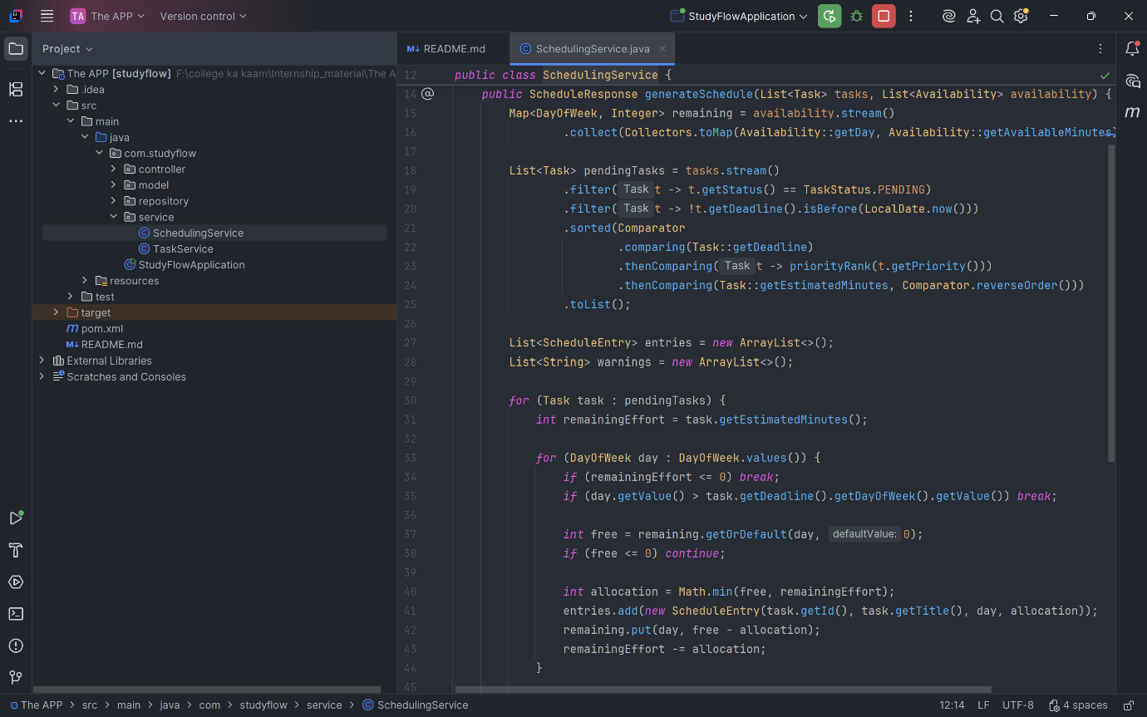
Figure 8.1: Scheduling service logic for task ordering and time allocation

8.2 Unnecessary Iterations and Calculations
The scheduling logic was also examined for unnecessary iterations and repeated calculations. The current implementation creates an availability map before allocating task effort, allowing daily availability to be accessed efficiently during scheduling.
The algorithm processes each task according to the established scheduling order and allocates available time until the task is completed or the applicable deadline is reached. No major repeated calculation was identified that would significantly affect the performance of the current MVP.
Because the application currently targets a weekly schedule with a limited number of tasks, further optimization would provide little practical benefit at this stage.
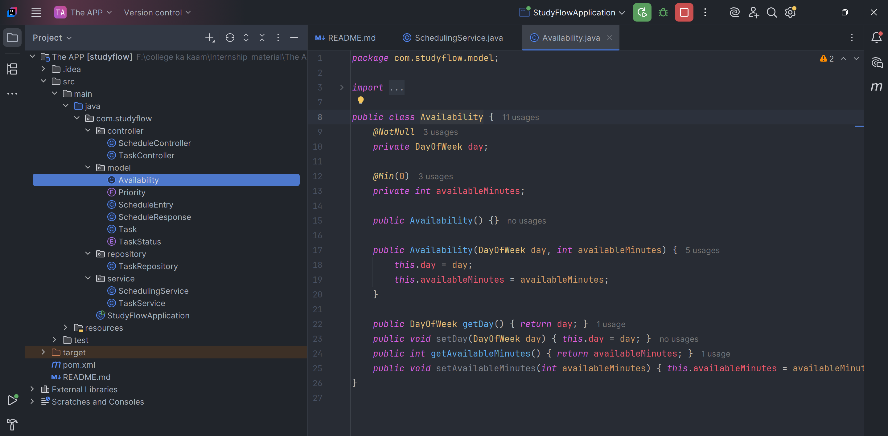
8.3 Scalability Considerations
Although the current scheduling implementation is suitable for the MVP, scalability was considered during the analysis. As the number of tasks increases, the sorting operation will become the primary component whose processing cost increases with the number of tasks.
For example, processing 10 or 50 tasks would not be expected to create a noticeable performance problem. However, a significantly larger task collection combined with additional scheduling constraints could require further optimization in a future version.
The current in-memory repository also limits long-term scalability because task data is not persisted in a database. The planned integration of MySQL would provide persistent storage and allow the system to handle larger datasets more appropriately.

8.4 Readability and Maintainability
The current codebase follows a layered structure that separates controllers, services, repositories, and model classes. This separation makes individual responsibilities easier to identify and reduces the need to modify unrelated components when a change is required.
The scheduling logic is concentrated within the scheduling service, while task-related operations are handled separately. Enumerations such as Priority and TaskStatus also improve readability by representing predefined values explicitly rather than relying on arbitrary strings.
The code was therefore considered maintainable for the current MVP. Rather than performing a large-scale restructuring, maintenance activities will focus on targeted improvements such as stronger request validation, clearer user feedback, and additional automated test coverage.

8.5 Performance and Maintainability Findings
Area | Finding | Assessment
Task sorting | Uses sorting based on deadline, priority and effort | Acceptable
Daily scheduling | Processes a fixed seven-day planning period | Efficient for MVP
Repeated calculations | No significant unnecessary calculations identified | Acceptable
Large task effort | Handles very large effort values without crashing | Acceptable
Number of tasks | Current workload is small | No significant concern
Code organization | Layered structure separates responsibilities | Good
Data persistence | Currently uses temporary in-memory storage | Future improvement
Database scalability | MySQL planned for future persistence | Future improvement

8.6 Conclusion of Analysis
The performance analysis indicates that the current StudyFlow implementation is appropriate for its intended MVP scope. The scheduling algorithm has acceptable computational complexity, and the fixed weekly planning period limits the amount of daily scheduling work required. No performance bottleneck requiring immediate optimization was identified.
From a maintainability perspective, the existing layered architecture provides a suitable foundation for further development. Future versions may require additional optimization as the number of users, tasks, scheduling constraints, and persistent data increases. For the current implementation, targeted improvements are more appropriate than premature performance optimization.

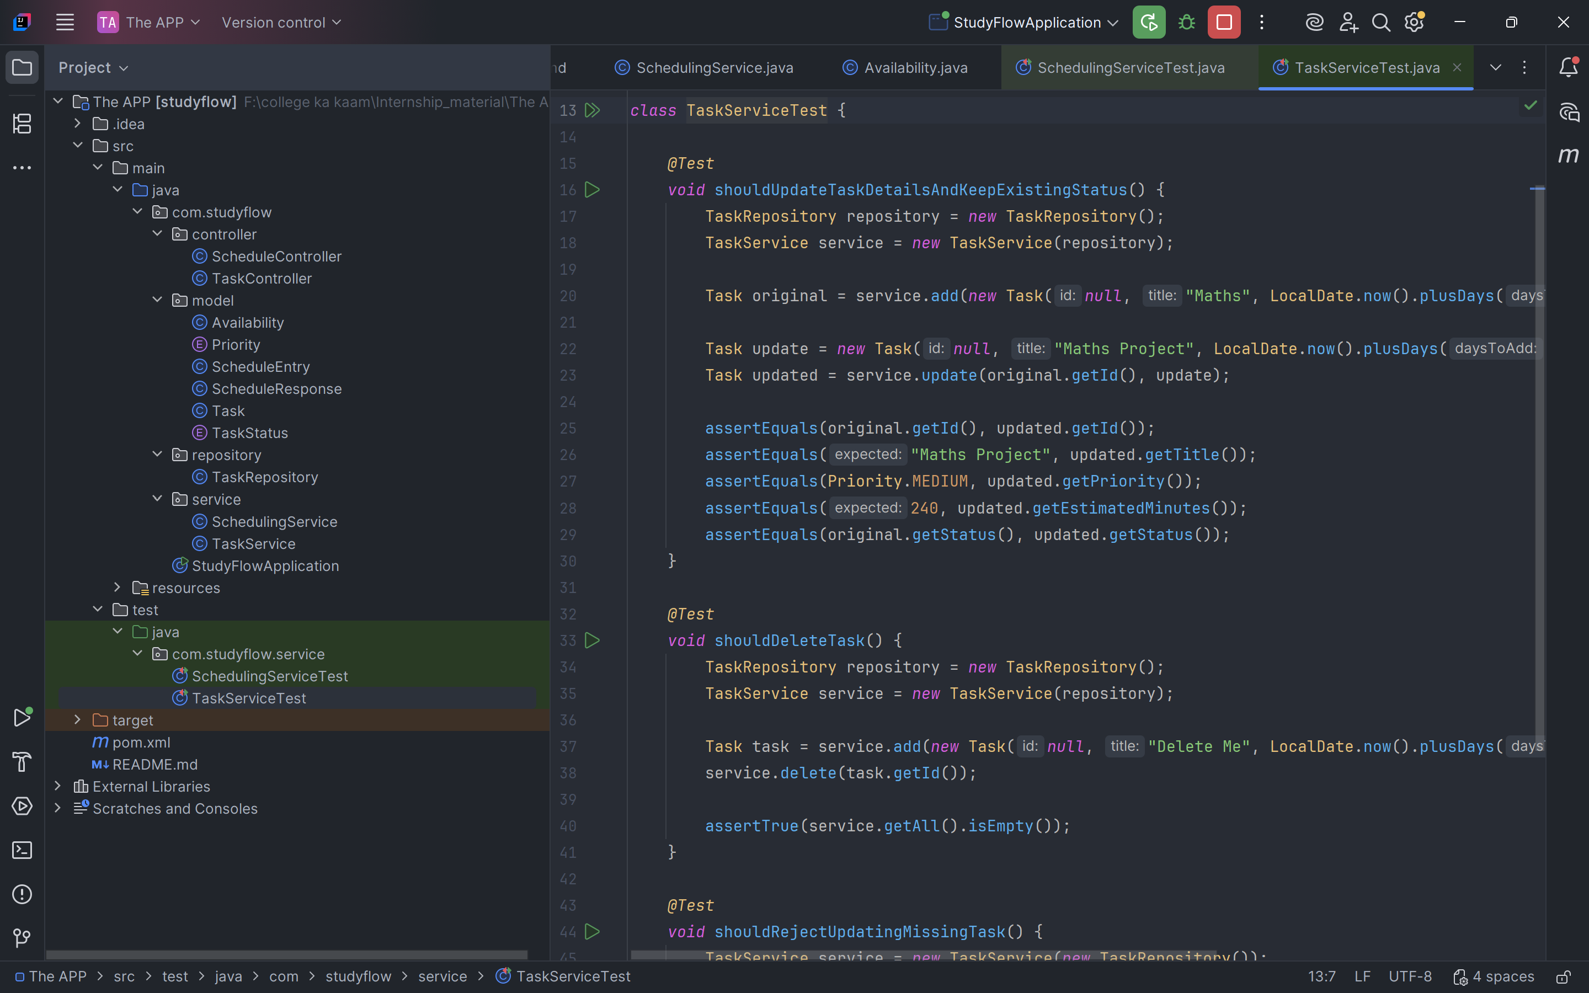
Figure 8.4: Automated unit tests for StudyFlow scheduling and task services

9. Before-and-After Comparison
9.1 Maintenance Changes
Area | Before Maintenance | After Maintenance | Result
Past-deadline tasks | Task was excluded without explaining why | Task is excluded and a warning explains that its deadline has passed | Improved
Availability validation | Availability request was not explicitly validated at controller level | Request validation added using @Valid | Improved
Scheduling logic | Existing scheduling behavior | Scheduling behavior retained | No regression
Task management | Add, edit and delete functionality | Same functionality after changes | Passed
Insufficient availability | System reported insufficient time | Same behavior retained | Passed
Task splitting | Tasks could be distributed across available days | Same behavior retained | Passed
9.2 Regression Testing
After the maintenance changes were implemented, the StudyFlow application was restarted and tested again to verify that the modifications had not affected existing functionality. The application launched successfully, and the newly added past-deadline feedback behaved as expected. Previously implemented task management and scheduling features, including task creation, editing, deletion, deadline handling, task splitting, availability processing, and insufficient-time handling, continued to operate correctly.
The regression testing therefore indicated that the targeted maintenance changes did not introduce observable problems into the existing MVP functionality.
9.3 Final Result
The maintenance process resulted in a small but meaningful usability improvement while preserving the existing scheduling behavior. The past-deadline condition is now communicated to the user instead of being silently ignored. Backend availability validation was also strengthened. Since the core functionality continued to operate correctly after the changes, no further restructuring of the existing scheduling architecture was considered necessary for the current MVP.

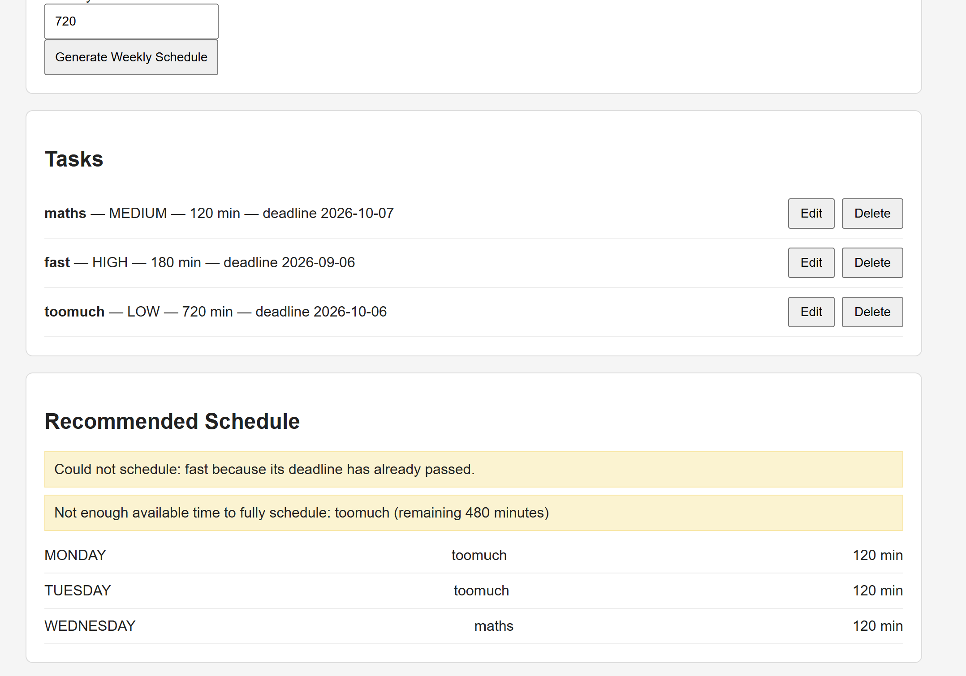
Figure 9.1: StudyFlow displaying the warning for a task with a past deadline
10. Results and Conclusion
10.1 Results
During Week 5, the StudyFlow MVP was tested using normal functional cases as well as several edge cases involving task effort, deadlines, priorities, availability, task editing, and task deletion. The testing showed that the existing scheduling functionality handles insufficient availability, task splitting, deadline restrictions, and task management correctly without introducing crashes or unexpected behavior.
During edge-case testing, one usability issue was identified with tasks whose deadlines had already passed. Such tasks were correctly excluded from the generated schedule, but the application did not clearly explain the reason for their exclusion. This behavior was improved by adding a warning message to inform the user that the task could not be scheduled because its deadline had already passed.
Backend validation was also strengthened by applying request validation to the availability input in the scheduling controller. Additional automated test cases were included to improve coverage of deadline and availability-related scenarios.
After the maintenance changes, the application was tested again. The updated application ran successfully, the past-deadline warning worked as expected, and previously implemented features such as task creation, editing, deletion, scheduling, task splitting, deadline handling, and insufficient-availability handling continued to function correctly.
10.2 Limitations and Future Enhancements
The current implementation is suitable for the MVP but still has some limitations. The application currently uses a fixed Monday–Sunday planning cycle, so allowing users to choose their preferred planning-week start day could be considered in a future version.
The current MVP also uses temporary in-memory task storage. Persistent MySQL-based storage can be added in a later development stage. Other possible improvements include more detailed frontend error messages, stronger handling of duplicate availability entries, and more personalized scheduling recommendations based on previous user behavior.
10.3 Conclusion
Week 5 focused on maintenance, debugging, testing, and technical analysis of the existing StudyFlow implementation. The testing process confirmed that the core scheduling and task-management features are functioning as intended. The identified past-deadline feedback issue was addressed, backend validation was strengthened, and additional automated tests were introduced.
The maintenance process was intentionally limited to targeted improvements rather than unnecessary restructuring. Regression testing confirmed that the changes did not negatively affect existing functionality. Overall, the current StudyFlow MVP provides a stable foundation for further development, with persistence, customizable planning cycles, and additional scheduling improvements remaining as future enhancements.

