Academic Planner
Design Documentation and Architecture Planning
1. Introduction
1.1 Purpose of the Document
This document presents the design documentation and architectural plan for the Academic Planner (StudyFlow). It translates the requirements identified during the project planning and requirements analysis phase into a structured technical design.
The document describes the overall system architecture, major system components, interactions between components, data flow, database design, and the scheduling mechanism used by the system. It also provides detailed explanations of the design decisions made to support the functionality and objectives of the Academic Planner.
The purpose of this document is to provide a clear technical reference for understanding how the proposed system will be organized and how its different components will work together during implementation.
1.2 Project Overview
The Academic Planner (StudyFlow) is a web-based academic planning system designed to help students organize their academic tasks according to their available study time, task priorities, deadlines, and estimated effort.
Unlike a conventional task-management system that primarily stores and displays tasks, StudyFlow uses a rule-based scheduling engine to generate a recommended weekly schedule. The user provides their available study time along with task information such as deadlines, priorities, and estimated effort. The scheduling engine processes these inputs and allocates tasks to suitable time slots while considering constraints such as available time, deadline requirements, and user-defined buffer time.
The generated schedule is presented to the user as a recommendation. The user can review, modify, reschedule, accept, or reject recommendations before finalizing the schedule. This approach allows the system to assist the user with planning while still giving the user control over the final schedule.
The system is planned using a layered architecture consisting of a Presentation Layer (Frontend), Application Layer (Backend), and Data Layer (Database). The backend contains separate modules for task management, availability management, scheduling, schedule management, and validation.

1.3 Objectives of the Design
The primary objectives of the system design are:
- To define a clear system architecture that separates the user interface, application logic, and data storage responsibilities.
- To provide modular system components so that major functionalities such as task management, availability management, scheduling, and validation can be developed and maintained independently.
- To design a rule-based scheduling mechanism that considers task deadlines, priorities, estimated effort, available study time, and buffer time when generating recommendations.
- To ensure proper data flow between the user interface, backend modules, scheduling engine, and database.
- To support flexible weekly planning by allowing users to define and update their available study time.
- To allow user control over generated schedules by providing options to review, modify, reschedule, accept, or reject recommendations.
- To handle scheduling constraints and conflicts by identifying situations where tasks cannot be reasonably accommodated within the available time.
- To provide a suitable database structure for storing user information, tasks, availability data, and generated schedules.
1.4 Scope of the Design
The scope of this design document covers the major technical aspects required to develop the Academic Planner. This includes:
- Overall system architecture and its three major layers.
- Frontend components through which the user interacts with the system.
- Backend application modules and their responsibilities.
- Communication between the frontend and backend through HTTP/REST APIs.
- Rule-based scheduling engine and its scheduling process.
- Management of tasks, weekly availability, and generated schedules.
- Input validation and constraint checking.
- Data access through the database access layer.
- Storage of users, tasks, availability, and schedules using MySQL.
- Data flow between the major components of the system.
- Database structure and entity relationships, which will be represented through the ER diagram.
- Design decisions, assumptions, and constraints relevant to the proposed system.
The document focuses on the system design and architectural planning of StudyFlow rather than the detailed implementation of individual source-code classes, database queries, or user-interface styling.
2. System Design Overview
2.1 Overall Approach
The Academic Planner (StudyFlow) is designed as a modular, layered web-based system in which different responsibilities are separated into distinct parts of the application. The design focuses on making the system easy to understand, maintain, modify, and extend during future development.
The system receives academic task information and the user's available study time through the web interface. This information is processed by the backend, where validation and scheduling operations are performed. The rule-based Scheduling Engine uses factors such as deadline, priority, estimated effort, available time, and buffer time to generate a recommended schedule. The resulting schedule can then be reviewed and modified by the user before it is finalized.
The design separates the user-facing functionality from the underlying business logic and data storage. This prevents the frontend from directly handling scheduling or database operations and allows each part of the system to focus on its specific responsibility.
2.2 Design Principles
The system design follows several principles to support a structured and maintainable implementation.
1. Modularity
The application is divided into separate modules based on functionality. Task management, availability management, scheduling, schedule management, and validation are handled as distinct modules.

2. Separation of Responsibilities
Each layer and module has a defined responsibility. The frontend handles user interaction, the backend handles application logic, and the database handles persistent data storage.
3. User Control
The schedule generated by the Scheduling Engine is treated as a recommendation rather than a fixed decision. The user can review and modify the generated schedule according to their actual circumstances.
4. Constraint-Based Planning
Scheduling decisions are made using defined rules and constraints rather than relying on artificial intelligence or machine learning. The engine considers factors such as deadlines, priorities, estimated effort, availability, and buffer time.
5. Data Consistency and Validation
User inputs and scheduling constraints are validated before being processed or stored. This helps maintain consistent data and prevents invalid information from affecting the generated schedule.
6. Maintainability
The separation of components allows individual modules to be modified or improved without requiring major changes to unrelated parts of the system.
2.3 Working of the Academic Planner
The general working process of StudyFlow can be described as follows:
- The user enters and manages academic tasks through the web interface.
- The user provides their available study time for the week.
- Task information and availability data are sent to the backend through the API.
- The backend validates the received information and processes it through the appropriate application modules.
- The Scheduling Engine retrieves the required task and availability information.
- The engine applies the predefined scheduling rules and attempts to allocate tasks to suitable available time slots.
- If necessary, tasks can be divided across multiple time slots, while user-defined buffer time is considered.
- The engine checks deadlines and identifies scheduling conflicts or tasks that cannot be accommodated.
- A recommended schedule is generated and returned to the frontend.
- The user reviews the recommendation and may modify, reschedule, accept, or reject the suggested schedule.
- The finalized schedule is stored in the database and displayed to the user.
This process allows StudyFlow to combine task management and automated schedule recommendation while keeping the user involved in the final planning decision.
2.4 Layered Architecture
StudyFlow uses a three-layer architecture consisting of:
1. Presentation Layer — Frontend
The Presentation Layer provides the web interface through which the user interacts with the system. It includes functions such as:
- Dashboard
- Task Management
- Weekly Availability
- Generated Schedule
- Settings / Profile
This layer is responsible primarily for displaying information and receiving user input. It communicates with the backend through HTTP/REST API requests.
2. Application Layer — Backend
The Application Layer contains the core logic of StudyFlow. It processes requests received from the frontend and coordinates the system's main functions.
The layer contains modules for:
- Task Management
- Availability Management
- Rule-Based Scheduling
- Schedule Management
- Validation
It also contains supporting services and the database access mechanism required to process requests and interact with stored data.
3. Data Layer — Database
The Data Layer provides persistent storage for the information used by the system. MySQL is planned as the database system.
The major data categories include:
- Users
- Tasks
- Availability
- Schedules
The backend communicates with the database through the Database Access Layer, which is responsible for performing operations such as creating, retrieving, updating, and deleting data.
2.5 Rationale for Using Layered Architecture
A layered architecture was selected because the Academic Planner contains several different responsibilities that should not be tightly coupled.
For example, the scheduling algorithm should not need to directly handle webpage elements, while the frontend should not directly manipulate database records. By separating these responsibilities, changes to one part of the system can be made with less impact on other parts.
This architecture also provides a clear structure for implementation:
User → Presentation Layer → Application Layer → Data Layer
and for responses:
Data Layer → Application Layer → Presentation Layer → User
The layered approach therefore provides a suitable foundation for StudyFlow by improving organization, maintainability, scalability, and separation of concerns.

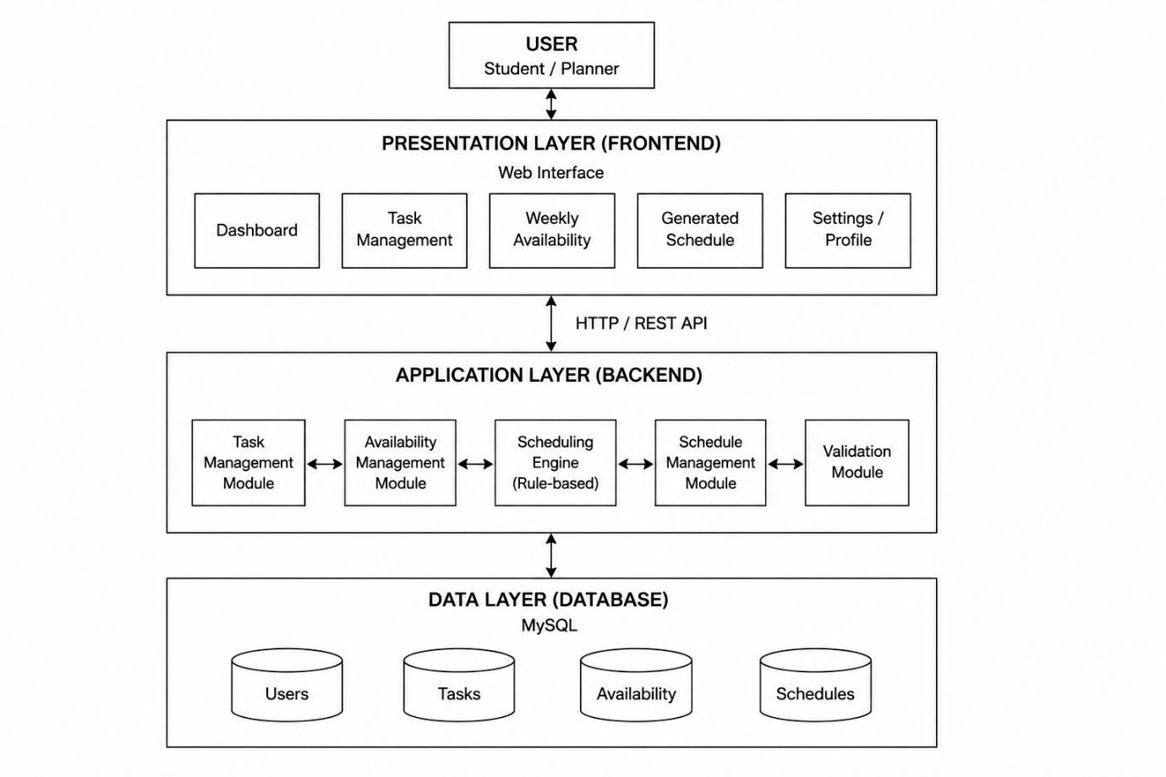Figure 1: High-Level System Architecture of the Academic Planner (StudyFlow)
3. System Architecture
3.1 Architectural Approach
The Academic Planner (StudyFlow) follows a three-layer architecture consisting of the Presentation Layer, Application Layer, and Data Layer. Each layer is responsible for a specific part of the system, which helps maintain a clear separation of responsibilities.
The three layers are:
3.1.1 Presentation Layer (Frontend)
The Presentation Layer is the user-facing part of the system. It provides the web interface through which the student or planner interacts with StudyFlow.
The main components of this layer are:
- Dashboard — Provides an overview of the user's academic planning information.
- Task Management — Allows the user to add, edit, delete, and manage academic tasks.
- Weekly Availability — Allows the user to specify the amount of time available for study during the week.
- Generated Schedule — Displays the schedule recommended by the Scheduling Engine.
- Settings / Profile — Provides options for managing user-related settings and profile information.
The frontend communicates with the Application Layer using HTTP/REST API requests. It is responsible for presenting information and collecting user input, while the processing of that information is handled by the backend.
3.1.2 Application Layer (Backend)
The Application Layer contains the main business logic of StudyFlow. It receives requests from the frontend, processes them, coordinates the different modules, and communicates with the database when required.
The major components of the Application Layer are:
- Task Management Module — Handles the creation, modification, deletion, and retrieval of task information.
- Availability Management Module — Manages the user's weekly available study time.
- Scheduling Engine (Rule-Based) — Processes task and availability information and generates a recommended schedule according to predefined scheduling rules.
- Schedule Management Module — Handles the generated schedule and allows the user to review, modify, reschedule, accept, or reject recommendations.
- Validation Module — Validates user inputs and checks whether the provided information satisfies the required constraints.
The Application Layer acts as the central processing layer of the system. It coordinates the information received from the frontend and determines how that information should be processed or stored.
3.1.3 Data Layer (Database)
The Data Layer is responsible for the persistent storage of system information. MySQL is planned as the database management system for StudyFlow.
The major categories of data stored in the database are:
- Users — Stores information related to system users.
- Tasks — Stores academic task details such as deadlines, priorities, estimated effort, and status.
- Availability — Stores the user's available study time.
- Schedules — Stores generated and finalized schedule information.
The Application Layer communicates with the Data Layer when information needs to be stored, retrieved, updated, or deleted.
3.2 System Architecture Diagram
Figure 1: High-Level System Architecture of the Academic Planner (StudyFlow)
[Insert Diagram 1 here]
Figure 1 Description
The system architecture diagram illustrates the high-level organization of StudyFlow and the interaction between the user, frontend, backend, and database.
At the top of the architecture is the User, represented as the student or planner who interacts with the system. The user accesses the system through the Presentation Layer, which provides the web interface and its major functional sections.
The Presentation Layer communicates with the Application Layer through HTTP/REST API communication. The Application Layer contains the core modules responsible for managing tasks, managing availability, generating schedules, managing schedules, and validating information.
The Scheduling Engine is the central processing component responsible for applying the predefined scheduling rules. It considers factors such as deadlines, priority, estimated effort, available study time, and buffer time when generating schedule recommendations.
The Application Layer communicates with the Data Layer, which uses MySQL for persistent storage. The database contains information related to users, tasks, availability, and schedules.
Therefore, the overall interaction can be represented as:
User → Presentation Layer → Application Layer → Data Layer
and information can be returned through the reverse direction:
Data Layer → Application Layer → Presentation Layer → User
This separation ensures that the frontend does not directly access the database and that the scheduling logic remains within the backend.
3.3 Interaction Between the Layers
The interaction between the three layers follows a controlled flow.
Step 1 — User Interaction
The user performs an operation through the web interface, such as adding a task or requesting a schedule.
Step 2 — API Communication
The frontend sends the required information to the backend through an HTTP/REST API request.
Step 3 — Backend Processing
The Application Layer receives the request and passes it to the appropriate module. Validation is performed where required before further processing.
Step 4 — Business Logic
The relevant business logic is executed. For example, when a schedule is requested, the Scheduling Engine processes the available task and availability information according to the defined scheduling rules.
Step 5 — Database Access
When persistent information is required, the backend communicates with the database to retrieve or update the relevant data.
Step 6 — Response
The processed result is returned through the backend API to the frontend, where it is presented to the user.
This structure ensures that each layer communicates through defined interfaces rather than directly depending on the internal implementation of another layer.
3.4 Architectural Benefits
The selected architecture provides several benefits for StudyFlow:
- Separation of concerns: Each layer has a clearly defined responsibility.
- Modularity: Individual backend modules can be developed and modified independently.
- Maintainability: Changes to one layer have less impact on unrelated components.
- Data security: The frontend does not directly communicate with the database.
- Scalability: Additional functionality can be incorporated into the existing architecture more easily.
- Clear implementation structure: The architecture provides a defined organization for implementing the frontend, backend, scheduling logic, and database.
The architecture therefore provides a structured foundation for implementing the Academic Planner while keeping the core scheduling functionality separate from the user interface and data storage.
4. Internal Application Architecture
4.1 Application Layer Overview
The Application Layer forms the core of the Academic Planner (StudyFlow). It is responsible for processing requests received from the frontend, applying the system's business rules, managing application data, and generating schedule recommendations.
To provide a clear separation of responsibilities, the Application Layer is divided into multiple functional modules supported by common services and a dedicated database access layer.
Figure 2: Internal Application Architecture of the Academic Planner (StudyFlow)
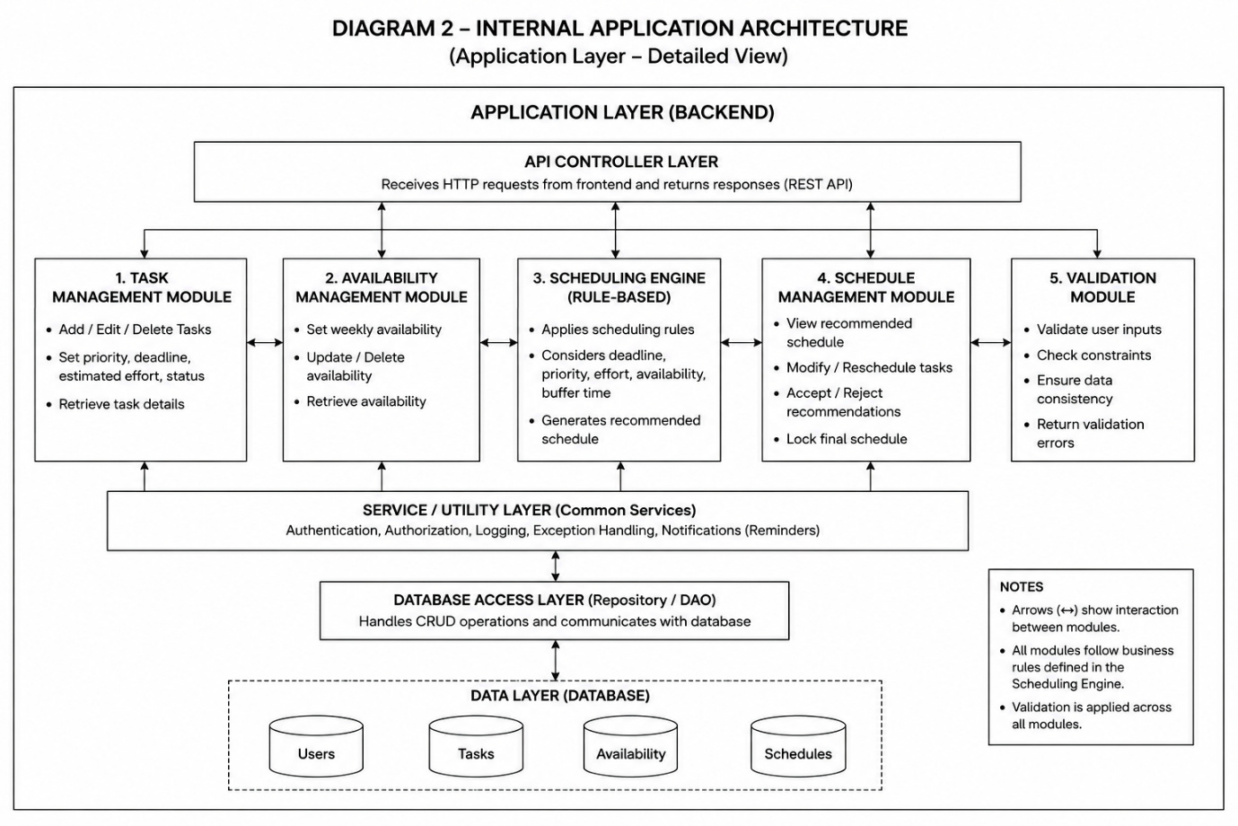The internal architecture consists of the following major components:
- API Controller Layer
- Task Management Module
- Availability Management Module
- Scheduling Engine
- Schedule Management Module
- Validation Module
- Service / Utility Layer
- Database Access Layer
The modules communicate with each other where required, while the common services provide functionality that can be used across multiple modules.
4.2 API Controller Layer
The API Controller Layer acts as the entry and exit point between the frontend and the Application Layer.
It receives HTTP requests from the frontend through the REST API and forwards them to the appropriate backend module for processing. After the requested operation is completed, the controller returns the appropriate response to the frontend.
Its main responsibilities include:
- Receiving HTTP requests from the frontend.
- Identifying the requested operation.
- Forwarding requests to the appropriate application module.
- Returning processed results or validation errors to the frontend.
- Providing a controlled interface between the Presentation Layer and Application Layer.
The API Controller therefore prevents the frontend from directly interacting with individual backend modules or the database.
4.3 Task Management Module
The Task Management Module is responsible for managing the academic tasks entered by the user.
Its primary operations include:
- Adding new tasks.
- Editing existing tasks.
- Deleting tasks.
- Retrieving task details.
- Managing task attributes such as priority, deadline, estimated effort, and status.
The module provides task information to other parts of the application when required. In particular, the Scheduling Engine uses task information when generating the recommended schedule.
4.4 Availability Management Module
The Availability Management Module manages the amount of study time available to the user.
The user can define their available time for different days of the week, allowing the scheduling system to work with the user's actual circumstances rather than assuming a fixed study routine.
The module is responsible for:
- Setting weekly availability.
- Updating availability information.
- Deleting availability information when required.
- Retrieving available time for scheduling.
- Providing availability data to the Scheduling Engine.
Availability information is particularly important because the Scheduling Engine must ensure that tasks are allocated only within the time that the user has made available.
4.5 Scheduling Engine (Rule-Based)
The Scheduling Engine is the core processing component of StudyFlow. It generates recommended schedules using predefined scheduling rules rather than artificial intelligence or machine learning.
The engine considers factors including:
- Deadline urgency.
- Task priority.
- Estimated effort.
- Available study time.
- Existing scheduled work.
- User-defined buffer time.
- Scheduling constraints.
The engine retrieves the required task and availability information, processes the tasks according to the defined rules, allocates available time slots, and generates a recommended schedule.
If a task requires more time than can fit into a single available slot, the scheduling process can distribute the task across multiple suitable slots. The engine also checks whether deadlines can be satisfied and identifies assignments that cannot be accommodated within the available constraints.
The detailed operation of this component is described separately in Section 7: Scheduling Engine Design.
4.6 Schedule Management Module
The Schedule Management Module manages the schedule produced by the Scheduling Engine and provides the user with control over the recommendation.
Its responsibilities include:
- Displaying the recommended schedule.
- Allowing tasks to be modified or rescheduled.
- Allowing recommendations to be accepted or rejected.
- Managing changes made by the user.
- Locking the final schedule once it has been finalized.
This module is important because StudyFlow does not treat the algorithm's output as an absolute schedule. Instead, the generated schedule acts as a recommendation that the user can review and adjust according to their actual needs.
4.7 Validation Module
The Validation Module ensures that information entering or being processed by the system satisfies the required conditions.
Its responsibilities include:
- Validating user inputs.
- Checking scheduling constraints.
- Detecting invalid or inconsistent information.
- Ensuring data consistency.
- Returning appropriate validation errors.
Validation is applied across the application modules rather than being restricted to a single user operation. This helps prevent invalid information from affecting task management, availability management, or schedule generation.
4.8 Service / Utility Layer
The Service / Utility Layer provides common functionality that can be used by multiple application modules.
The services represented in the architecture include:
- Authentication.
- Authorization.
- Logging.
- Exception handling.
- Notifications and reminders.
Keeping these functions in a common layer avoids unnecessarily duplicating the same functionality across individual modules. It also provides a central location for managing cross-cutting application concerns.
4.9 Database Access Layer
The Database Access Layer, represented as the Repository / DAO layer in the architecture, provides the connection between the Application Layer and the MySQL database.
Its main responsibility is to handle database operations required by the application modules, including:
- Creating data records.
- Retrieving stored data.
- Updating existing records.
- Deleting records.
- Communicating with the MySQL database.
The application modules do not directly perform database operations. Instead, they use the Database Access Layer to access the required data. This provides an additional separation between business logic and data storage.
The major categories of information stored in the database are Users, Tasks, Availability, and Schedules.
4.10 Interaction Between Application Components
The components of the Application Layer work together to complete user requests.
For example, when a user requests a new schedule:
- The API Controller receives the request from the frontend.
- The request is validated by the Validation Module.
- The Task Management Module provides the relevant task information.
- The Availability Management Module provides the user's available time.
- The Scheduling Engine processes the information according to the scheduling rules.
- The generated recommendation is passed to the Schedule Management Module.
- The required information is stored or retrieved through the Database Access Layer.
- The resulting schedule is returned through the API Controller and displayed to the user.
The Service / Utility Layer can support these operations where required, for example through logging, exception handling, authentication, authorization, or notifications.
4.11 Architectural Characteristics
The internal application architecture provides the following characteristics:
- Modularity: Major functions are separated into dedicated modules.
- Separation of concerns: Each component has a defined responsibility.
- Reusability: Common services can be shared by multiple modules.
- Maintainability: Individual modules can be modified without redesigning the entire backend.
- Controlled database access: Database operations are handled through a dedicated access layer.
- Centralized scheduling logic: Scheduling rules are maintained within the Scheduling Engine.
- User flexibility: The Schedule Management Module allows users to modify algorithm-generated recommendations.
Overall, this internal architecture provides a structured organization for the backend and establishes clear interactions between the system's business logic, supporting services, and database.
5. System Components and Responsibilities
The Academic Planner is composed of several interconnected components, each responsible for a specific function within the system. The separation of responsibilities allows the system to remain modular and makes individual components easier to develop, maintain, and modify.
Component | Primary Responsibility
API Controller Layer | Handles communication between the frontend and backend by receiving API requests and returning appropriate responses.
Task Management Module | Creates, updates, deletes, and retrieves academic tasks and their associated information.
Availability Management Module | Manages the user's available study time for different days of the week.
Scheduling Engine | Generates recommended schedules using predefined rules based on deadlines, priority, estimated effort, availability, and other scheduling constraints.
Schedule Management Module | Manages generated schedules and allows users to review, modify, reschedule, accept, or reject recommendations.
Validation Module | Validates user input and checks data and scheduling constraints before information is processed or stored.
Service / Utility Layer | Provides common supporting functions such as authentication, authorization, logging, exception handling, and notifications.
Database Access Layer | Handles communication between the application modules and the database for storing, retrieving, updating, and deleting data.
MySQL Database | Provides persistent storage for user, task, availability, and schedule information.

5.1 Component Interaction Summary
Although each component has a specific responsibility, the components work together to complete the system's operations. The API Controller Layer receives requests from the frontend and directs them to the appropriate module. The functional modules process the request and use the Validation Module and Service / Utility Layer where required. When persistent data is needed, the modules communicate with the MySQL Database through the Database Access Layer.
The Scheduling Engine acts as the primary decision-making component for schedule generation. It uses task and availability information to produce a recommended schedule, which is then handled by the Schedule Management Module before being presented to the user.
This division of responsibilities ensures that the system remains organized and that individual components can be developed or modified without unnecessarily affecting other parts of the application.
6. Data Flow Design
6.1 Data Flow Overview
The Data Flow Design describes how information moves through the different components of the Academic Planner (StudyFlow). It shows how data entered by the user is received by the system, processed by the appropriate application components, stored or retrieved from the database, and eventually returned to the user.
The data flow is designed so that the frontend communicates with the backend through the API Controller Layer, while the backend handles the required processing and database operations. The Scheduling Engine uses task and availability information to generate a recommended schedule based on the defined scheduling rules.
6.2 Data Flow Diagram
Figure 3: Data Flow Diagram of the Academic Planner (StudyFlow)
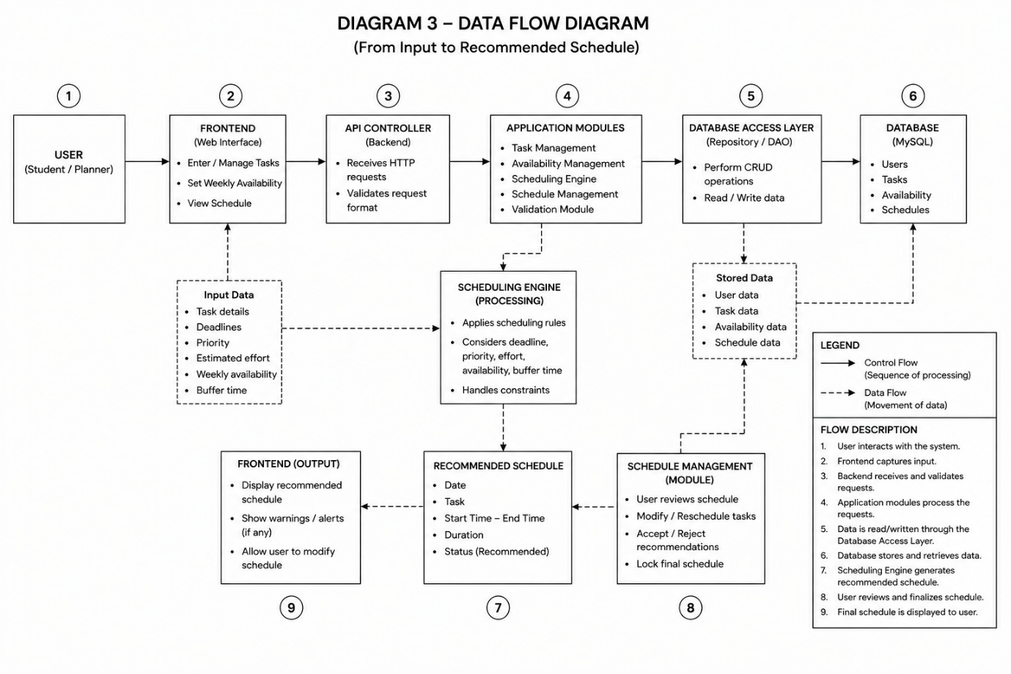Figure 3 Description
Figure 3 illustrates the movement of information between the user interface, backend application components, database access layer, and MySQL database. The diagram represents the major data exchanges that occur during task management, availability management, schedule generation, and schedule management.
The primary data flow can be described as follows:
- User Interaction
The user interacts with the StudyFlow frontend to perform operations such as managing tasks, setting availability, or requesting a schedule.
- Frontend Data Collection
The frontend collects the information provided by the user and prepares it for communication with the backend.
- API Request
The frontend sends the relevant information to the backend through the API Controller Layer.
- Request Processing and Validation
The backend processes the request through the appropriate application module. The Validation Module checks whether the received information satisfies the required conditions.
- Database Access
When persistent information is required, the relevant application module communicates with the Database Access Layer.
- Data Storage and Retrieval
The Database Access Layer communicates with the MySQL database to store new information or retrieve existing information such as tasks, availability, and schedules.
- Scheduling Process
When schedule generation is requested, the Scheduling Engine receives the required task and availability information and processes it according to the predefined scheduling rules.
- Schedule Generation
The Scheduling Engine produces a recommended schedule based on the available information and applicable constraints.
- Schedule Review and Modification
The generated schedule is returned to the frontend, where the user can review and modify the recommendation before finalizing it.
- Schedule Storage
Once the schedule is finalized or updated, the relevant schedule information can be stored in the database through the Database Access Layer.
6.3 Major Data Flows
The major types of information exchanged within the system include:
Task Data
Task information flows from the frontend to the Task Management Module and, when required, to the database. This information may include the task name, deadline, priority, estimated effort, and completion status.
Availability Data
The user's available study time is submitted through the frontend and processed by the Availability Management Module. The information is stored in the database and later provided to the Scheduling Engine when schedule generation is performed.
Scheduling Data
The Scheduling Engine uses relevant task, availability, and existing schedule information as inputs. After applying the scheduling rules, it produces a recommended schedule.
Schedule Data
Generated or user-modified schedule information is passed to the Schedule Management Module. The finalized schedule can then be stored in the database and retrieved for future display.
6.4 Data Flow Characteristics
The data flow design follows several important principles:
- Controlled communication: The frontend communicates with the backend through the API Controller rather than directly accessing the database.
- Validation before processing: User-provided information is checked before being processed or stored.
- Centralized data storage: Persistent information is maintained in the MySQL database.
- Separation of processing and storage: Application logic is separated from database operations through the Database Access Layer.
- Scheduling based on available data: The Scheduling Engine uses stored task and availability information to generate recommendations.
- User-controlled output: Generated schedules are returned to the user for review and modification rather than being automatically treated as final.
This design provides a clear and controlled path for information to move through StudyFlow while maintaining separation between the user interface, application processing, and data storage.
7. Scheduling Engine Design
7.1 Purpose of the Scheduling Engine
The Scheduling Engine is the core decision-making component of the Academic Planner (StudyFlow). Its purpose is to generate a practical weekly study schedule by allocating academic tasks to the user's available study time.
The engine does not use artificial intelligence or machine learning. Instead, it follows a rule-based scheduling approach in which predefined conditions and priorities are applied to the available tasks and time slots.
The scheduling process considers factors such as task deadlines, priority, estimated effort, available study time, existing scheduled work, and user-defined buffer time. The resulting schedule is intended to be a recommendation that assists the user in planning rather than an automatically enforced timetable.
7.2 Scheduling Inputs
The Scheduling Engine requires several types of information to generate a schedule.
7.2.1 Task Details
Each task provides the basic information required for scheduling, including its name, deadline, priority, estimated effort, and current status.
7.2.2 Deadline
The deadline indicates when a task needs to be completed. Tasks with deadlines that are approaching require greater consideration during schedule generation.
7.2.3 Priority
The priority assigned to a task indicates its relative importance. Priority is used by the scheduling process when multiple tasks compete for the same available time.
7.2.4 Estimated Effort
Estimated effort represents the amount of study time expected to be required to complete a task. This allows the engine to determine whether a task can fit into a particular available time slot or needs to be divided across multiple slots.
7.2.5 Available Study Time
The user specifies the amount of time they are available to study during each day of the week. This information establishes the time slots within which tasks can be scheduled.
7.2.6 Buffer Time
The user may define a buffer before or after scheduled tasks. Buffer time provides additional flexibility and prevents the schedule from being packed too tightly.
7.2.7 Task Status
The current status of a task is considered to determine whether it still requires scheduling. Completed tasks, for example, should not continue to consume future study time.
7.2.8 Existing Scheduled Work
Previously scheduled tasks are considered when generating or modifying a schedule. This prevents the engine from allocating the same time period to multiple tasks.
7.3 Scheduling Process
The Scheduling Engine follows a sequence of steps to transform task and availability information into a recommended schedule.
Figure 4: Scheduling Engine Flowchart of the Academic Planner (StudyFlow)
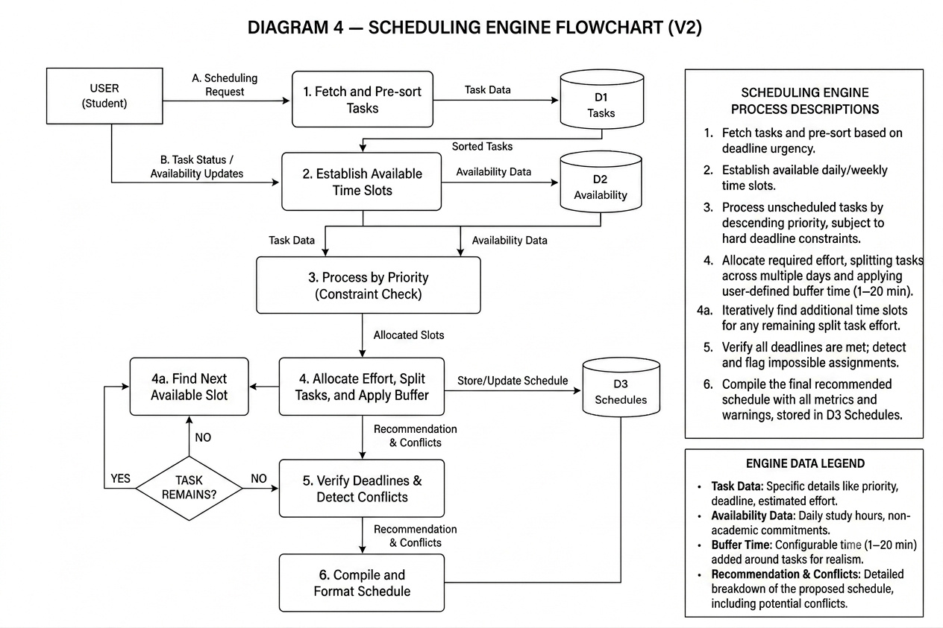Figure 4 Description
Figure 4 illustrates the flow of the rule-based scheduling process used by StudyFlow. The process begins by obtaining and organizing the relevant task information and then identifying the available time slots for the week. Tasks are processed according to their scheduling requirements, and available time is allocated while considering deadlines, priorities, estimated effort, and existing constraints.
The major stages of the scheduling process are described below.
7.3.1 Fetch and Pre-Sort Tasks
The engine first retrieves the tasks that require scheduling. The tasks are then organized according to the scheduling criteria so that tasks requiring greater attention can be processed appropriately.
7.3.2 Establish Available Time Slots
The engine identifies the user's available study periods for the week. Existing scheduled work and other unavailable periods are taken into account so that only suitable time slots are considered.
7.3.3 Process Tasks According to Constraints
The engine evaluates each task using its deadline, priority, estimated effort, and other relevant constraints. Tasks with more immediate deadlines receive greater consideration during allocation.
7.3.4 Allocate Effort and Split Tasks
The engine attempts to allocate the required study time to suitable available slots. If the estimated effort of a task cannot fit into one available slot, the task may be divided across multiple suitable slots.
7.3.5 Find Additional Available Slots
If the current available slot cannot accommodate the remaining effort of a task, the engine searches for other suitable slots within the planning period.
7.3.6 Verify Deadlines and Detect Conflicts
After allocating tasks, the engine checks whether the resulting assignments satisfy the relevant deadlines and constraints. If sufficient time is not available, the system identifies the scheduling problem rather than silently producing an unrealistic schedule.
7.3.7 Compile the Recommended Schedule
Once the allocation process is completed, the generated assignments are compiled into a structured weekly schedule. The resulting schedule is then made available to the user for review and modification.
7.4 Scheduling Rules
The Scheduling Engine follows a set of predefined rules to determine how tasks should be allocated.

Rule 1 — Deadline Consideration
Tasks with approaching deadlines receive higher consideration during scheduling. This helps reduce the possibility of leaving urgent work until insufficient time remains.
Rule 2 — Priority Consideration
Task priority is considered when allocating available time, particularly when multiple tasks have competing scheduling requirements.
Rule 3 — Estimated Effort
The estimated effort of a task determines approximately how much available study time needs to be allocated to it.
Rule 4 — Availability Constraint
Tasks can only be assigned to time periods that the user has identified as available for study.
Rule 5 — Task Splitting
A task requiring more time than a single available slot can provide may be divided across multiple suitable slots, provided that doing so remains consistent with its deadline and other constraints.
Rule 6 — Buffer Time
User-defined buffer time is incorporated into scheduling where applicable. This helps provide flexibility between scheduled tasks and reduces the likelihood of creating an overly rigid timetable.
Rule 7 — Existing Schedule
Existing scheduled work must be considered before assigning new tasks. The engine should not allocate overlapping time periods to multiple tasks.
Rule 8 — Past Time Slots
The system should not allocate new tasks to time periods that have already passed.
Rule 9 — Impossible Deadlines
If the available study time is insufficient to complete a task before its deadline, the system should identify the problem and notify the user rather than generating a misleading schedule.
Rule 10 — User Override
The generated schedule is a recommendation. The user remains in control and can modify or reschedule tasks according to their actual circumstances.
7.5 Handling Changes During the Week
StudyFlow is designed to accommodate changes after the initial weekly schedule has been generated.
For example, when a user adds a new task during the middle of the week, the system can:
- Add the new task to the task list.
- Check the user's remaining available time.
- Examine already scheduled work.
- Evaluate the new task's deadline, priority, and estimated effort.
- Determine whether the task can be accommodated.
- Suggest changes to the existing schedule if required.
- Allow the user to accept or modify the recommendation.
The engine should only consider current and future available time slots when making such changes and should not attempt to schedule work in the past.
7.6 Handling Completed Tasks
When a task is completed earlier than expected, the completed task no longer requires the remaining scheduled time. The system can identify the newly available time and, where appropriate, recommend another suitable task from the current week's remaining workload.
This allows unused study time to be utilized without requiring the user to manually rebuild the entire schedule.
7.7 Handling Insufficient Available Time
There may be situations where the total required effort of the user's tasks exceeds their available study time.
In such cases, the Scheduling Engine should not simply force every task into the schedule. Instead, it should identify the conflict and inform the user that the current availability is insufficient.
The user may then increase their available study time, modify task priorities, change estimated effort, or manually adjust the schedule.
This approach ensures that the system provides a realistic recommendation rather than presenting an apparently complete schedule that cannot actually be followed.

7.8 Scheduling Output
The primary output of the Scheduling Engine is a recommended weekly schedule containing the tasks allocated to available study periods.
The output should provide sufficient information for the user to understand:
- Which task is scheduled.
- On which day it is scheduled.
- The allocated study period.
- How much of the task's estimated effort is being completed in that period.
- Any relevant scheduling warnings or conflicts.
The recommendation is then passed to the Schedule Management component, where the user can review and modify it before finalizing the schedule.
8. Database Design
8.1 Database Overview
The Data Layer of the Academic Planner (StudyFlow) is responsible for storing and managing the information required by the system. MySQL is planned as the database management system for persistent data storage.
The database provides storage for user information, academic tasks, weekly availability, and generated schedules. The Application Layer accesses the database through the Database Access Layer, which separates database operations from the application's business logic.
This separation allows the application modules to interact with stored information without directly depending on the underlying database implementation. It also provides a structured approach for performing operations such as creating, retrieving, updating, and deleting records.
8.2 Data Entities
The major categories of data required by StudyFlow are described below.
8.2.1 Users
The Users entity represents the students who use the Academic Planner.
It is expected to contain information required to identify and manage a user's account and associate the user's tasks, availability, and schedules with the appropriate user.
8.2.2 Tasks
The Tasks entity stores the academic tasks created by users.
A task may contain information such as:
- Task identifier
- Task name or description
- Deadline
- Priority
- Estimated effort
- Completion status
- Associated user
Task information is used by the Scheduling Engine when generating schedule recommendations.
8.2.3 Availability
The Availability entity stores the user's available study time.
Availability information may include:
- Availability identifier
- Associated user
- Day/date
- Available start time
- Available end time
- Available study duration
This information allows the Scheduling Engine to determine when tasks can be allocated during the planning period.
8.2.4 Schedules
The Schedules entity stores information related to generated or finalized schedules.
It may contain information such as:
- Schedule identifier
- Associated user
- Associated task
- Scheduled date
- Start time
- End time
- Allocated effort
- Schedule status
Schedule information allows generated recommendations and subsequent user modifications to be maintained for future access.

8.3 Entity Relationship Diagram
The Entity Relationship (ER) Diagram represents the logical structure of the StudyFlow database and illustrates the relationships between the major data entities.
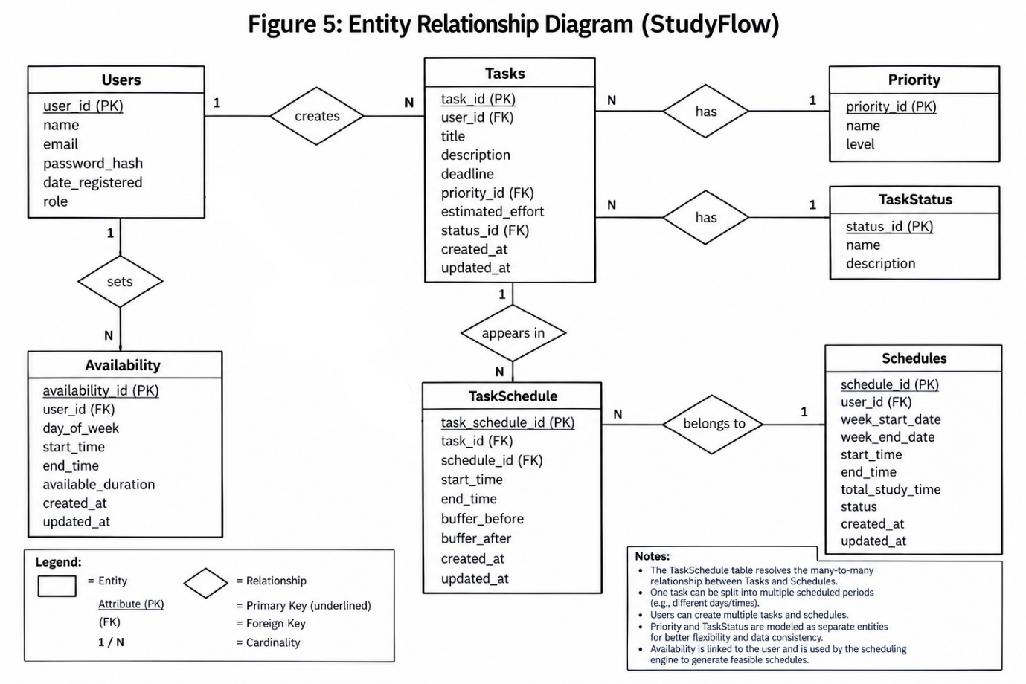
Figure 5: Entity Relationship Diagram of the Academic Planner (StudyFlow)
The ER diagram will be added after the database entities and their relationships have been finalized. It will provide a visual representation of the database structure and will be used to verify that the relationships between users, tasks, availability, and schedules are correctly defined.
8.4 Entity and Relationship Description
The database entities are interconnected to represent the relationship between a user and their academic planning information.
A User is associated with the tasks they create, the availability they define, and the schedules generated for them. A Task can be associated with one or more schedule entries when the task needs to be divided across multiple study periods. Similarly, availability records define the time periods that can be considered by the Scheduling Engine when assigning tasks.
The exact cardinality and relationships between these entities will be finalized and documented using the ER diagram.

8.5 Database Access
StudyFlow does not allow the frontend to directly communicate with the MySQL database. Database operations are performed through the backend's Database Access Layer.
When an application module requires data, the request is passed through this layer. The Database Access Layer performs the required database operation and returns the result to the requesting module.
This approach provides:
- Separation between business logic and data access.
- Centralized database operations.
- Easier maintenance of database-related functionality.
- Controlled access to persistent data.
- Reduced coupling between application modules and the database.
9. User Interaction and Schedule Management
9.1 User Interaction Overview
The Academic Planner (StudyFlow) is designed around direct interaction between the user and the planning system. The user provides task information and available study time, while the system processes this information and generates a recommended schedule.
The system does not completely automate the planning process. Instead, it follows a user-assisted approach, where the Scheduling Engine provides recommendations and the user retains control over the final schedule.
The major user interactions include task management, availability management, schedule generation, schedule review, schedule modification, and schedule finalization.
9.2 Task Management
The user can manage academic tasks through the Task Management interface.
The following operations are supported:
- Add Task: The user can create a new academic task by providing the required task information.
- Edit Task: Existing task information can be modified when requirements or circumstances change.
- Delete Task: Tasks that are no longer required can be removed.
- View Task: The user can view the details and current status of their tasks.
- Update Task Status: The user can indicate whether a task is pending, in progress, or completed.
Task information such as deadline, priority, and estimated effort is used by the Scheduling Engine when generating recommendations.
9.3 Setting Weekly Availability
The user can specify the amount of time they are available for studying during each day of the week.
The availability information is used to define the time within which the Scheduling Engine can allocate academic tasks.
The user can:
- Add available study periods.
- Modify existing availability.
- Remove availability when necessary.
- Update availability when their weekly routine changes.
This allows the system to adapt to changing schedules instead of relying on a fixed study timetable.
9.4 Generating a Schedule
After providing the required task and availability information, the user can request the generation of a weekly schedule.
The system retrieves the relevant task and availability data and passes it to the Scheduling Engine. The engine applies the predefined scheduling rules and attempts to allocate tasks to suitable available time slots.
The generated schedule is then returned to the user as a recommendation.
9.5 Reviewing Schedule Recommendations
The user can review the schedule generated by the Scheduling Engine before making it final.
The recommendation allows the user to examine:
- Scheduled tasks.
- Assigned dates and time periods.
- Allocated study time.
- Tasks divided across multiple study periods.
- Scheduling conflicts or warnings, if any.
This review stage ensures that the user can determine whether the recommended schedule is practical according to their actual circumstances.
9.6 Modifying and Rescheduling Tasks
The user is not required to follow the generated recommendation exactly. Tasks can be modified or rescheduled when the user determines that the proposed allocation is unsuitable.
For example, the user may need to move a task because of:
- An unexpected commitment.
- A change in available study time.
- A change in task priority.
- A change in the estimated effort required.
- Personal preference regarding the timing of a task.
When changes are made, the updated schedule should continue to respect the applicable scheduling constraints where possible.
9.7 Accepting or Rejecting Recommendations
The generated schedule is treated as a recommendation rather than an automatically finalized schedule.
The user can:
- Accept the recommendation if it is suitable.
- Reject the recommendation if it does not meet their requirements.
- Modify the recommendation before accepting it.
This approach keeps the user involved in the planning process and prevents the scheduling algorithm from making decisions without user approval.

9.8 Finalizing and Locking the Schedule
After reviewing and making any necessary changes, the user can finalize the schedule.
Once finalized, the schedule can be locked so that it represents the user's current confirmed plan. Further changes can require the schedule to be explicitly reopened or modified through the appropriate schedule-management functionality.
The purpose of locking the schedule is to distinguish between a generated or editable recommendation and a confirmed schedule.
9.9 Handling Changes During the Week
StudyFlow is designed to accommodate changes even after a weekly schedule has been generated.
If the user adds a new task or changes their availability during the week, the system can consider the remaining available time and existing scheduled work before generating an updated recommendation.
The system should not attempt to assign new work to time periods that have already passed. Instead, scheduling changes should be based on the user's remaining available time and future schedule.
This allows the planner to remain useful even when the user's actual week differs from their original plan.
9.10 User Control and Flexibility
A key design principle of StudyFlow is that automation assists the user rather than replacing the user's decision-making.
The Scheduling Engine provides a structured recommendation based on predefined rules, but the user has the final authority over the schedule. This allows the system to provide the benefits of automated planning while still accommodating situations that cannot always be represented through scheduling rules.
Therefore, the interaction between the user and the system can be summarized as:
Provide Information → Generate Recommendation → Review → Modify if Required → Accept/Reject → Finalize
This interaction model forms an important part of StudyFlow's design and ensures that the generated schedule remains practical and adaptable to the user's changing academic requirements.

10. Design Decisions and Rationale
The design of the Academic Planner (StudyFlow) is based on several decisions made to ensure that the system remains practical, flexible, and suitable for the needs of students. The following decisions explain the reasoning behind the major design choices made during the architecture and scheduling design process.
10.1 Rule-Based Scheduling
A rule-based scheduling approach was selected instead of artificial intelligence or machine learning.
The scheduling requirements of StudyFlow can be handled using clearly defined factors such as deadlines, task priorities, estimated effort, available study time, and existing scheduled work. Using predefined rules makes the scheduling process easier to understand, test, and modify.
It also allows the system to provide predictable results based on the information supplied by the user. The decision to avoid AI/ML keeps the project focused on solving the scheduling problem through a transparent algorithm rather than introducing unnecessary complexity.
10.2 Weekly Availability
StudyFlow uses weekly availability rather than assuming that the user follows a fixed study timetable.
A student's available time can change from one week to another due to classes, examinations, projects, personal commitments, or other activities. Allowing the user to specify their available study time at the beginning of each week enables the Scheduling Engine to generate recommendations based on their current circumstances.
The availability can also be modified during the week when the user's schedule changes.
10.3 User Override
The schedule generated by the Scheduling Engine is treated as a recommendation rather than a mandatory schedule.
Although the algorithm can allocate tasks according to predefined rules, it cannot account for every personal circumstance or preference of the user. Therefore, the user should be able to review the generated schedule and make changes when necessary.
This decision keeps the user in control while still providing the convenience of automated scheduling.

10.4 Task Splitting
StudyFlow allows larger tasks to be split across multiple available study periods.
A task may require more time than the user has available in a single session. Forcing the entire task into one slot could result in an unrealistic schedule or prevent other tasks from being scheduled.
By allowing task effort to be distributed across multiple suitable slots, the Scheduling Engine can make better use of the user's available time while still considering the task's deadline.
10.5 Buffer Time
The system allows buffer time to be considered before or after scheduled tasks.
A schedule with no flexibility can become difficult to follow when a task takes slightly longer than expected or when there is a small delay between activities. Buffer time provides additional flexibility and prevents the schedule from becoming excessively tightly packed.
The buffer is configurable so that users can select an amount that suits their planning needs.
10.6 Handling Impossible Deadlines
The system is designed to identify situations where a task cannot reasonably be completed within the user's available study time before its deadline.
Rather than assigning tasks to unavailable periods or producing an unrealistic schedule, the Scheduling Engine should notify the user when the available time is insufficient.
This allows the user to respond by increasing available study time, modifying priorities, adjusting estimated effort, or manually changing the schedule.
10.7 No Scheduling of Past Time
The system should not assign newly added or rescheduled tasks to time periods that have already passed.
This is particularly important when changes are made during the middle of a week. The Scheduling Engine should consider only the remaining available time when generating an updated recommendation.
This ensures that the schedule remains practically usable rather than containing assignments that are already impossible to complete.

10.8 Design Summary
The above decisions were made to keep StudyFlow practical, transparent, flexible, and user-controlled. The system uses a rule-based scheduling mechanism rather than unnecessary AI/ML complexity, while features such as weekly availability, task splitting, buffer time, and user override allow the generated schedule to adapt to real-world changes.
Together, these decisions provide the foundation for a scheduling system that assists students in organizing their academic workload without removing their control over how that workload is planned.
Technology Stack and Technology Selection Rationale
Covers the explicit internship requirement we currently haven't fully satisfied.
Risk Assessment
For example:
Risk | Probability | Impact | Mitigation
Unrealistic user availability | Medium | High | Validate availability and warn user
Impossible deadlines | Medium | High | Detect insufficient available time
Incorrect effort estimates | Medium | Medium | Allow user modification
Scheduling conflicts | Medium | High | Conflict detection in Scheduling Engine
Database failure/data loss | Low | High | Database backup/recovery strategy
Algorithm produces unsuitable schedule | Medium | High | User review and manual override

11. Assumptions and Constraints
The design of the Academic Planner (StudyFlow) is based on several assumptions about the information provided by the user and the limitations within which the system will operate. These assumptions and constraints help define the expected behavior and boundaries of the system.
11.1 Assumptions
11.1.1 User Provides Accurate Task Information
The system assumes that users provide reasonably accurate information about their tasks, particularly the deadline, priority, and estimated effort. The quality of the generated schedule depends partly on the accuracy of this information.
11.1.2 User Provides Available Study Time
The system assumes that the user provides their actual or reasonably estimated study availability for the planning period. The Scheduling Engine uses this information to determine which time slots can be used for task allocation.
11.1.3 User Reviews Generated Recommendations
The system assumes that users will review the generated schedule before treating it as their final plan. Since the schedule is a recommendation, the user is responsible for making any necessary adjustments.
11.1.4 Scheduling Is Rule-Based
The system assumes that scheduling decisions are made using the predefined rules and constraints implemented in the Scheduling Engine. The system does not depend on machine learning or AI-based predictions.
11.2 Constraints
11.2.1 Limited Available Study Time
The system cannot create additional study time when the user's available time is insufficient. If the total required effort exceeds the available time, the system can identify and report the conflict but cannot guarantee that every task will be scheduled before its deadline.
11.2.2 User-Dependent Information
The quality of scheduling recommendations is dependent on the information supplied by the user. Incorrect deadlines, unrealistic effort estimates, or inaccurate availability may result in less suitable recommendations.
11.2.3 Rule-Based Scheduling Limitations
Because the Scheduling Engine uses predefined rules, it does not automatically learn from the user's behavior or adapt its rules through machine learning. Any improvements to the scheduling logic must be implemented explicitly as changes to the scheduling rules or algorithm.

11.2.4 No Guarantee of Deadline Completion
The system can attempt to allocate tasks according to their deadlines and available time, but it cannot guarantee that all deadlines are achievable. External circumstances, insufficient availability, or excessive workload may make some deadlines impossible to meet.
11.2.5 Project Scope Constraints
The implementation is limited to the functionality defined within the current project and internship scope. Advanced features that are not part of the current design may be considered for future versions rather than being included in the initial implementation.
11.3 Design Boundary
The assumptions and constraints establish an important boundary for StudyFlow. The system is intended to assist with academic planning and provide practical scheduling recommendations, rather than guarantee academic performance or automatically manage every aspect of a student's schedule.
The Scheduling Engine can organize the information provided by the user and identify potential scheduling problems, but the user remains responsible for validating the information and deciding whether the recommended schedule is appropriate.
12. Conclusion
The design of the Academic Planner (StudyFlow) provides a structured foundation for implementing a flexible academic scheduling system. The proposed three-layer architecture separates the Presentation Layer, Application Layer, and Data Layer, allowing each part of the system to perform its specific responsibilities independently.
The internal application architecture further divides the backend into dedicated modules for task management, availability management, scheduling, schedule management, and validation. The Data Flow Design defines how information moves between these components, while the database design provides persistent storage for the information required by the system.
The rule-based Scheduling Engine forms the central part of the system's planning functionality. By considering deadlines, priorities, estimated effort, available study time, buffer time, and existing schedules, it can generate practical weekly scheduling recommendations. At the same time, allowing users to review and modify these recommendations ensures that the system remains flexible and user-controlled.
Overall, the proposed architecture and design provide a clear foundation for the implementation of StudyFlow. The modular structure allows the system to be developed systematically while also providing opportunities for future improvements and additional functionality.
13. References
The following resources were consulted during the design and architectural planning of the Academic Planner:
- Ian Sommerville, Software Engineering, Pearson — for concepts related to software architecture, system design, requirements, and software engineering practices.
- R. S. Pressman and B. R. Maxim, Software Engineering: A Practitioner's Approach, McGraw-Hill — for software design and architectural concepts.
- MySQL Documentation — for database concepts and relational database design.
- MDN Web Docs — for web architecture and HTTP/API-related concepts.
- Project Requirements and SRS Documentation — for the functional and non-functional requirements used as the basis for the system design.

